Instructions

Controls:
- 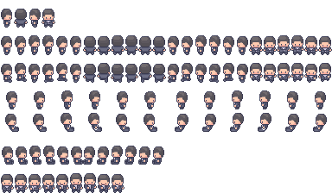: WASD/Arrow Keys/Joystick
Collectibles:
- : Spend at the shop
- 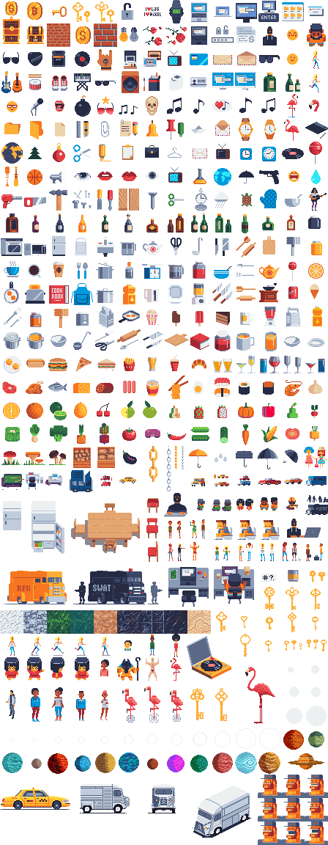: Full vision for a given duration
- : Increased movement speed for a given duration
Weapons:
- : Shoot notes
- : Blow fire when facing horizontally
- : Drop an explosive cocktail at your current position
Player Levels:
- Every 5 levels HP is fully recovered
- upgrades:
  - Lvl 3: Shoots backwards
  - Lvl 6: Deals more damage
  - Lvl 9: Is not destroyed on contact

Installation:
Download the executable or play via web at https://hail-seitan.itch.io/feupocalypse.

Game Description:
The apocalypse has taken hold, and as the monsters close in, there is little hope left for the student at FEUP. Try to survive long enough in this hellish place surrounded by a horde of grotesque monsters that seemed to have crawled their way up from the underworld.

Credits:
Programming:
- Fábio Huang
- Luís Guimarães
UI:
- Fábio Huang
Audio Work:
- Luís Guimarães
Visual/Animation assets:
- PixiVan - https://pixivan.itch.io/
- Pimen - https://pimen.itch.io/
- "Mega PixelArt Icons" - https://poloviiinkin.itch.io/mega-pixel-art-32x32-px-icons-sprite-sheet
- “Modern Interiors" - https://limezu.itch.io/moderninteriors/devlog/244045/free-version-overview-18042021-update
- "Coin" - https://www.pixilart.com/art/coin-sprite-sheet-c7f297523ce57fc
- "WASD" - http://pixelartmaker.com/art/c0e14b48a37d57f
- "Arrow Keys" - http://pixelartmaker.com/art/7efa119103ffc71

