Documentation

Controls:
- 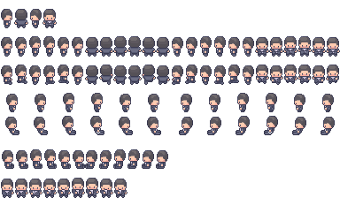: WASD/Arrow Keys/Joystick
- Select: 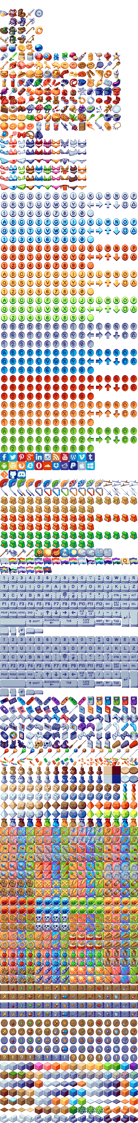 (ENTER)
- Go Back: / (Backspace or ESC)
Collectibles:
- : Spend at the shop
- 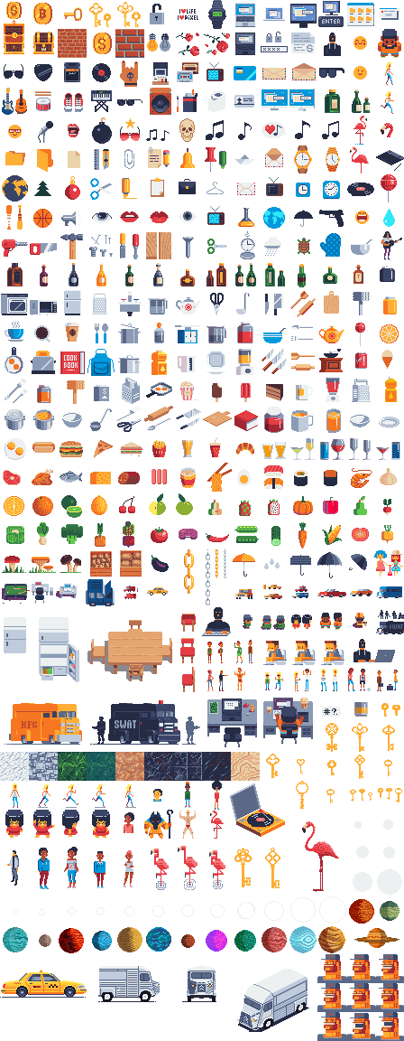: Full vision for a given duration
- : Increased movement speed for a given duration
Weapons:
- : Shoot notes
- : Blow fire when facing horizontally
- : Drop an explosive cocktail at your current position
Player Levels:
- Every 5 levels HP is fully recovered
- upgrades:
  - Lvl 3: Shoots backwards
  - Lvl 6: Deals more damage
  - Lvl 9: Is not destroyed on contact

Installation:
Download the executable or play via web at https://hail-seitan.itch.io/feupocalypse.

Game Description:
The apocalypse has taken hold, and as the monsters close in, there is little hope left for the student at FEUP. Try to survive long enough in this hellish place surrounded by a horde of grotesque monsters that seemed to have crawled their way up from the underworld.

Development:
Tools:
- Game Engine: Unity
- Version Control: Git
- Host Platform: GitHub
- Communication: Discord
Design:
- The auto-attack was inspired by Vampire Survivors.
- The shop as an RPG element was inspired by Pokémon.
- The static/well-defined map as well as a spawning system based on waves were chosen in order to facilitate development. Our initial idea, again inspired by Vampire Survivors, was to have a procedurally generated map and have enemies spawn from every direction in relation to the player.
Difficulties:
- The store was developed in a different scene which seemed like the most logical choice at first, but carried the requirement of connecting between scenes which presented itself as a challenge.

Credits:
Programming:
- Fábio Huang
- Luís Guimarães
UI:
- Fábio Huang
Audio Work:
- Luís Guimarães
Visual/Animation assets:
- PixiVan - https://pixivan.itch.io/
- Pimen - https://pimen.itch.io/
- "Mega PixelArt Icons" - https://poloviiinkin.itch.io/mega-pixel-art-32x32-px-icons-sprite-sheet
- “Modern Interiors" - https://limezu.itch.io/moderninteriors/devlog/244045/free-version-overview-18042021-update
- "Coin" - https://www.pixilart.com/art/coin-sprite-sheet-c7f297523ce57fc
- "WASD" - http://pixelartmaker.com/art/c0e14b48a37d57f
- "Arrow Keys" - http://pixelartmaker.com/art/7efa119103ffc71

