CCP4 DUI Cloud

Requirements Specification

1. Introduction
This document describes how DUI Cloud differs from DUI1. It is aimed towards the Dials and CCP4 developers and familiarity with DUI1 is expected.
The main purpose of the DUI Cloud app is to allow users to integrate data remotely. The images will be on a server (probably where they were obtained) while, elsewhere, a user with a less potent laptop launches Dials commands on the server to integrate images.

Overall Description

Product Perspective
DUI Cloud should run Dials commands similarly to DUI1 but with two new features: being able to run remotely and processing multicrystal datasets. To run DUI Cloud remotely, two separate tools will be programmed: the client and the server. To process multi crystal datasets, we are changing the way DUI will control the connection between nodes.

Product Functions
The main use cases that DUI Cloud can help with are:
- When data is too big to process on an underpowered user’s PC.
- If there are multiple crystals in the same data set that should be treated with joint refinement
- For weak and/or pathological data need manual processing

User Classes and Characteristics
The most common type of user will be users with intermediate or advanced skill levels who know how integration works and want to control the way Dials integrate in detail. The less frequent type of users will be novices who will learn about integration and Dials with the help of DUI Cloud.

Operating Environment
To be able to run DUI Cloud, CCP4 will need to be installed on the client and the server. The server OS should be Linux. However, the client OS could be either Linux, Mac OS or Windows as long as it has CCP4 with Python 3 and PySide 2 installed.

Design and Implementation Constraints
The server should be able to run as many threads as the number of users multiplied by the number of processes running at that time. The images should be stored as close as possible to the server running DUI Cloud, preferably in the same room and optimally on the same motherboard. The only constraint on the client is the need to have a reliable network connection and the same version of CCP4 as the server.

User Documentation
The tutorial on how to run DUI will be similar and in the same place as it is now (https://dials.diamond.ac.uk/documentation/tutorials/processing_in_detail_betalactamase_dui.html).
Assumptions and Dependencies
The client app should run as a desktop app and CCP4 should be installed on the client’s computer. We do not intend to make an app that runs on a browser in this project.

User Interface
There are two main differences between the layout of the old and new DUI which are:
- What used to be the “tree” now is a graph with “fork” and “merge” capabilities
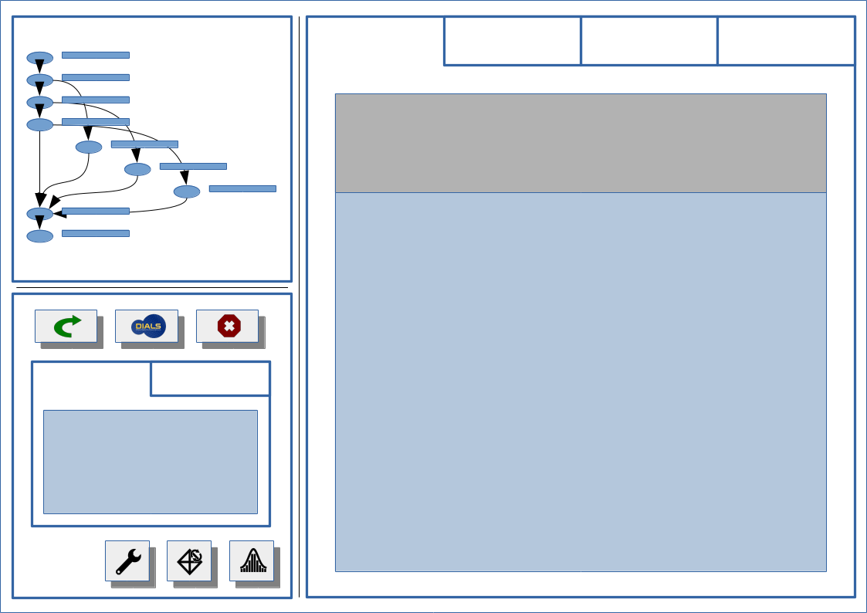
- Each individual step widget now has the buttons for creating the next steps
DUI Cloud will allow the user to do the following:
- Navigate through the control graph (what used to be the tree in DUI1)
- Either fork or merge the control graph
- Launch a command and be able to navigate elsewhere in the graph to launch more commands without interrupting the running command
- View the results of different nodes without interrupting running nodes

Software Interfaces

On the client side, the code will rely on Requests, PySide 2 and some other modules included in the Python standard library (which does not include Dials). This will allow us to replace the client implementation with some technology that will run on a web browser in a future project.
On the server side, the code will rely on Python’s http library, Dials and some other Python libraries already installed on CCP4.
The communication between client and server should use http requests as the REST API approach states. This means that the client app should do a new http request to the server whenever the user navigates to a new position in the graph or launches a new command. The server should answer with a stream of data or a JSON file.

System Features
According to the REST API principle, the server should be stateless and consequently capable to recover from a power down or any unexpected system crash. To keep track of the integration process for each session, the server program should write a JSON file with the updated state of the session after any step that it finishes.
Every component and function of the server should be easy to test in an automated and programmable manner so there is no need to run the client manually to test the server. However, the client can be tested manually.

