Regression on GO Terms

Luis Pedro Coelho

Instituto de Medicina Molecular, Faculdade de Medicina da Universidade de Lisboa, Lisboa, Portugal

**Summary Sentence**: The assumption is that two drugs will act in a synergistic fashion if they disturb different genes with similar functionality.

**Background/Introduction**

**Methods**

First, the media and DMSO data was used to determine a baseline variation and genes were considered disturbed if they moved more than 1.5 standard deviations away from the mean at any time point. This is a noisy measurement, but it will only be used very indirectly. Genes were also grouped together by GO terms.

Each drug was thus characterized by two signatures:

1. A set of disturbed genes, represented as a binary vector,.
2. A set of disturbed molecular function GO terms, equally represented as a binary vector, .

For each pair of drugs, we computed the Pearson correlation of the gene perturbation vectors, , and its GO terms perturbation vector, .

There is a roughly linear correlation between these two values:

as can be seen in Figure 1.

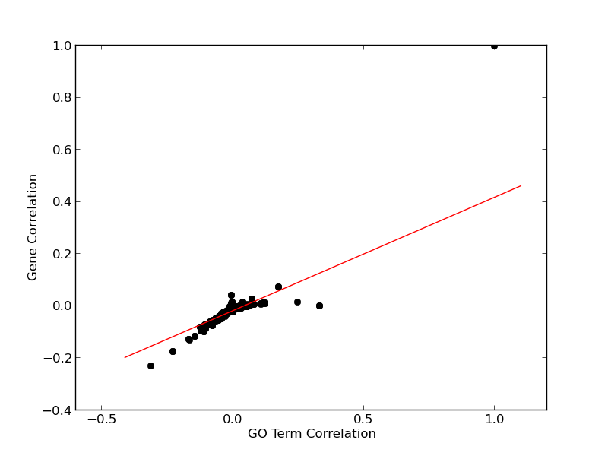

*Figure 1: Gene correlations as a function of GO term correlations. Each circle represents a drug pair, the straight line is the best least-squares fit.*

However, the is not perfect. the distance to the regression line is our measure of synergy. Drugs pairs for which the genes are less correlated than predicted by the correlation at the GO term were predicted to be synergistic.

**Conclusion/Discussion**

With the benefit of the testing data, which was not available at the time of the competition, we can test a few variations and measure whether they would have been better than the submission. In particular, the restriction to the Molecular Function vocabulary was somewhat arbitrary and we can test other GO vocabularies. In total, there are 6 possible combinations of vocabularies. The best result is the combination of the molecular function and the biological process vocabularies, but the p-value is 16%. The best single vocabulary is not molecular function, but biological process. In retrospect, this may have been a better embodiment of the idea that was underlying this method, but the result is still of limited value, as the resulting p-value is 21%.

**References**

Cokol, Murat, Hon Nian Chua, Murat Tasan, Beste Mutlu, Zohar B. Weinstein, Yo Suzuki, Mehmet E. Nergiz et al. "Systematic exploration of synergistic drug pairs." *Molecular systems biology* 7, no. 1 (2011).

Yeh PJ, Hegreness MJ, Aiden AP, Kishony R (2009) Drug interactions and the evolution of antibiotic resistance. *Nat Rev Microbiol* **7**: 460–466

**Authors Statement**

LPC developed the methodology, implemented it, and wrote the report.