

Can Diversified Investment Portfolios Hedge Against Inflation and Market Volatility?

"Do Diversified Portfolios Effectively Hedge Inflation and Volatility Risks?”

Luís Peixoto

Dissertation written under the supervision of Professor Eva Schliephake

Dissertation submitted in partial fulfilment of requirements for the MSc in Finance, at the Universidade Católica Portuguesa, June 2nd 2025.

Can Diversified Investment Portfolios Hedge Against Inflation and Market Volatility?

Luís Peixoto

Abstract

Can Diversified Investment Portfolios Hedge Against Inflation and Market Volatility?

Luís Peixoto

Resumo

Table of Contents

1. **Introduction**

Inflation and Market Volatility are at the core of every investment decision-making process. Inflation will diminish the purchasing-power of your income and the real value of your portfolio’s returns, while market volatility will introduce uncertainty and risk that you may be unwilling to take. Shocks in any of these macroeconomic variables are a major concern for money managers and retail investors. Bodie (1976), defines the effectiveness of common stocks as inflation hedge, as the extent to which they can be used to diminish or eliminate the risk of the portfolio’s real return in what concerns the future levels of the consumer price index (CPI). In this paper we use the same approach for inflation and, as well, for market volatility. Additionally, not only for stocks is this methodology employed, but for all asset classes and portfolios. In that sense, the effectiveness of these instruments as a hedge, will be measured to the extent they can reduce or eliminate the risk that the portfolio’s real returns, will be eroded by uncertainty in future changes in the CPI and in the market’s volatility.

Over the past century, the world has experienced periods of high inflation, such as the German hyperinflation post-World War I, the “Great Inflation” of the 1970s and the post-COVID inflation surge. Volatility has also played a major role in recent financial history. Periods, such as, the Great Depression of 1929, Black Monday on October 1987, the Dot-com crash, the Global Financial Crisis and the latest, the COVID-19 crash, being the most remarkable ones. However, some of these periods are marked for both phenomena being observed, namely the 1970s Stagflation and the post-COVID period. The latest so-called reciprocal tariffs announced by the US highlight the relevance of the studying the topic in this paper.

Many studies have been conducted regarding the effectiveness of certain asset classes in hedging inflation. Bodie (1976), Nelson (1976), Jaffe and Mandelker (1976), Gultekin (1983) and more recently, Boudoukh and Richardson (1993) and Anari and Kolari (2001), all studied common stocks’ characteristic as inflation hedges. Jaffe (1989), Baur and McDermott (2010) and Ghosh et al. (2004) examined Gold and Gold’s characteristics as a hedge and as a safe-haven asset. Fixed-income securities have also been subject to the study of their hedging ability in Fama (1976), Fama and Schwert (1977) and Campbell et al. (2009). Other fixed-income assets, designed with the purpose of protecting the returns against inflation, commonly referred as TIPS (Treasury Inflation-Protected Securities) were studied in Bodie (1988) and Kothari and Shanken (2004). Real Estate studies as inflation hedges were pioneered by Fama and Schwert (1977), and maintained their momentum throughout the years, as in Huang and Hudson-Wilson (2007). Concerning the study of market volatility hedges the literature is not so diverse, and most of it like, Brenner, Ou, and Zhang (2006), primarily aims at short-term hedging, and Dew-Becker, Giglio, and Kelly (2021) and Bakshi and Kapadia (2001) focus on the use of complex and structured derivative products, such as options on straddles and delta hedging. Yet, there are some studies that try to find assets that may be good hedges against equity market risk, such as Campbell, Serfaty‐De Medeiros, and Viceira (2010) for Foreign Currencies in the case of world equity markets.

The contribution of this paper to the literature resides in the creation of an optimal hedging portfolio that includes different asset classes within different geographies. In other words, there are assets that are effective hedges against inflation, effective hedges against market volatility and effective hedges against both variables. Here we look for the optimal combination of these assets that can increase the effectiveness of these assets as hedges. For that rationale, based on Markowitz (1952) diversification concept, we create an efficient frontier of portfolios that reduces the degree of risk associated to an individual security, without changing the expected return that an investor may get for their investment. Let’s say that the investor has considered to allocate their money into an asset that is a great inflation hedge, but this asset is subject to an idiosyncratic risk that a portfolio of assets that are effective inflation hedges may not be. This asset may also be a good hedge in periods where inflation is, above the central bank’s inflation target, but, overall, at a moderate level. However, when inflation reaches unforeseen levels, the asset fails to maintain the investor’s purchasing power levels. The same logic can be applied to assets that are effectively hedging inflation innovations or even shocks but perform poorly in stable periods. Let us now consider that there is another asset that hedges stock market volatility risk throughout the whole sample period, especially when it carries “bad” uncertainty. Nonetheless, this asset is not an inflation hedging asset, per se. And, if inflation and volatility are two sources of risk that are not perfectly correlated, as we see in this paper, the investor surely wants to find the optimal combination of these assets that allows them to keep returns at the same level while reducing the expected level of risk of the individual assets. As Modern Portfolio Theory (MPT) indicates, it is not the security’s own risk that is important but the impact it makes on the portfolio’s overall variance.

These portfolios will allow to trace an efficient frontier that is built on the shoulders of Markowitz (1952) own. While MPT plots the optimal portfolio is designed in a two-dimensional expected returns-variance (E-V) space. We introduce the three-dimensional plane, adding inflation in the third axis. Bringing this contribution the paper presents this novelty to the finance and portfolio theory literature. For Inflation Hedging literature, this study contributes by studying geographically disperse assets, stock indices, foreign currencies, and comparing the hedging ability of TIPS to multiple asset classes. To the stock market risk hedging literature, the main contributions lie on the study of diverse assets, not including options or swaps, as volatility hedges while focusing on long-term hedging.

Investors care about maintaining purchasing-power, not only regarding the level of risk that affects their portfolio. The marginal increase in adding an inflation and volatility hedging asset can then be measured in the framework we propose. The efficient surface built allows for investors to spot portfolios that provide the same level of return while hedging against another source of risk that is not perfectly correlated with volatility risk.

To build these portfolios, we use strategic asset allocation with a short-selling constraint. The investor buys and holds the same assets at the same weights throughout the whole investment horizon.

Nonetheless, for the hypotheses in this paper to hold, it is strictly necessary that inflation and volatility exhibit some degree of orthogonality.

Section 2.3 discusses this in a much more detailed manner, but, in a nutshell, it seems that the orthogonality appears to hold for both variables, supporting the variable split and the testing of the proposed hypotheses, even though there is some level of ambiguity in Granger-causality.

Overcoming the most immediate problem with the explanatory variables, the risk of them being highly correlated, we can then present the different questions addressed in this paper.

The main goal of the paper is to find the optimal combination of assets that effectively hedge inflation and volatility consistently, not only during inflationary and/or volatile periods, and that produce a good trade-off between expected return and risk, i.e., that lie on the efficient surface created by the three axes. This allows the investor to make an optimal choice between earning higher returns for the same level of risk or lower risk for the same degree of returns. Additionally, this study builds on the literature of decomposition of macroeconomic variables into anticipated and unanticipated component, to check whether these portfolios are able to effectively hedge innovations in both inflation and volatility. It is almost impossible to talk about inflation and not mentioning the Fisher Hypothesis. Introduced by Irving Fisher (1930), poses that nominal interest is, approximately, the sum of the real interest with the expected inflation rate, or, in other words, only the unexpected/unanticipated inflation rate can influence real returns, and with this, laying the foundation for further studies on the impact of the unexpected inflation rate. Bodie (1976), Fama and Schwert (1977), and Boudoukh and Richardson (1993), and all relevant literature on inflation hedging ability of certain assets, have all studied with the decomposition of expected and unexpected inflation. In volatility literature, past studies have also focused on this split, French, Schwert and Stambaugh (1987). Furthermore, comparison tests between commonly regarded inflation-hedging, volatility-hedging and safe-haven assets with the built portfolios have been conducted, with the intention of providing further robustness in the results. These tests also focus on comparison with benchmark portfolios (e.g. 60/40 portfolios) and on the possibility of the portfolios to generate alpha, i.e., an abnormal rate of return, beyond standard factor models (FF3, Carhart, FF5). Finally, we study the effectiveness of diversified portfolios - both across asset classes and geographies – in outperforming the hedging effectiveness and return generating ability of concentrated portfolios.

**What the paper finds**.

**Extensions/heterogeneity analyses/mechanisms (“extensions+”)**

**Structure of the Paper**

1. **Data**

**2.1 Data Description**

The period that serves as input is the start of 1980 until the last trading day of December 2024, and all data is analysed and aggregated on a monthly frequency. Inflation rates are estimated using the log difference of monthly values in the US Consumer Price Index for All Urban Consumers from FRED, either in a one-month interval or a twelve-month interval. Throughout the thesis, inflation is reported on a year-over-year basis. Its evolution from 1980 to 2024 is shown in Figure I. Volatility data is calculated from the monthly returns on MSCI World Index, obtained from LSEG. The returns for this series are calculated as the log differential from the monthly closing prices of the index. Two volatility estimates were calculated, an Historical (realized) Volatility Variable, computed from a rolling twelve-month standard deviation of the index continuously compounded monthly returns, and a GARCH (conditional) Volatility variable, using a GARCH (1,1) model, meaning, an order one autoregressive term and an order one moving average term. A GARCH (1,1) model is used to estimate monthly volatility in MSCI World Index returns, capturing the expected volatility clustering. This variable will be mainly used for robustness. Figure I exhibits the small difference between the two volatility measures and highlights the GARCH model’s impact on return tails.

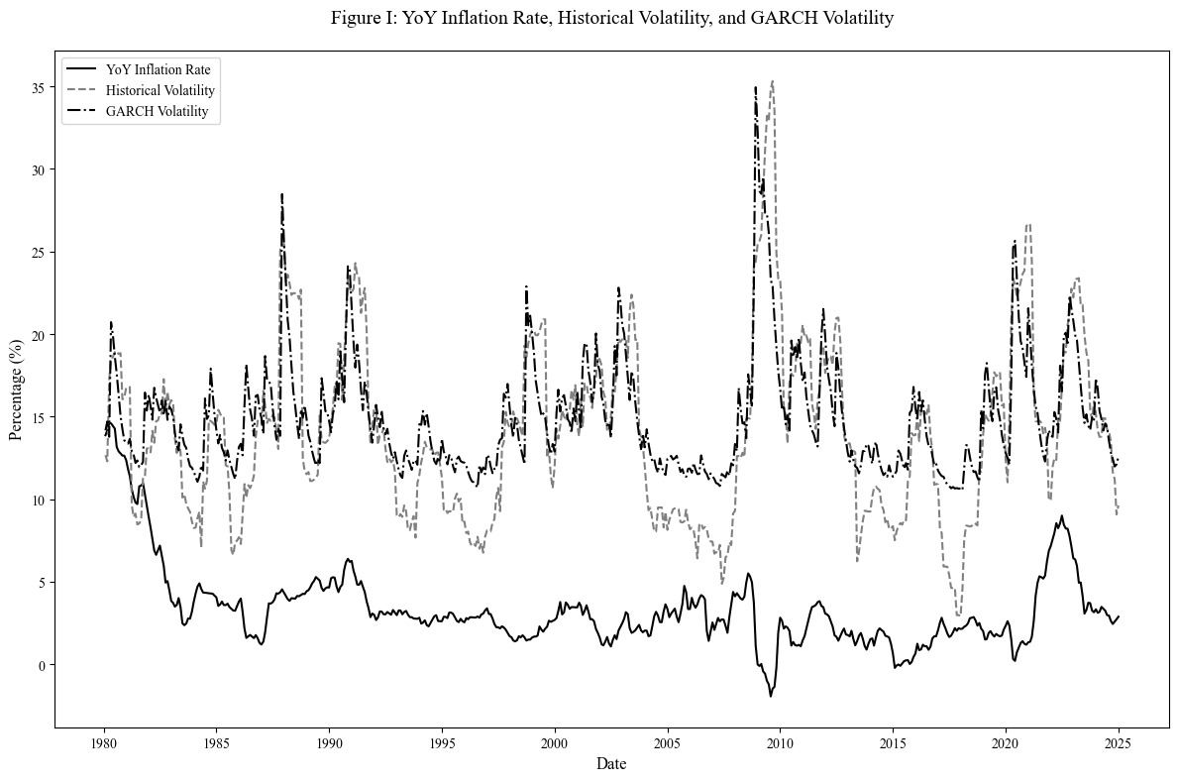To build the diversified investment portfolios, and efficient surface, several assets were selected. The rationale behind the choices resides in the fact that most of the individual assets have previously been studied in inflation or volatility hedging literature. This selection was, also, done to have as much diversification as possible, on the one hand to have a wide exposure to different asset classes, on the other hand, so that this diversification also happens geographically. For all assets, continuously compounded returns were calculated, allowing an easier computation of cumulative returns, through its additive properties, whilst its statistical properties allow greater symmetry and its approximation to normal distribution, catalysing an increasingly reliable regression analysis and hypotheses testing. The equity indexes chosen are the S&P 500 Index, the Russell 2000 Index, the tech heavy NASDAQ Composite Index, the FTSE 100 Index, the DAX 40 Index, the Euro Stoxx 50 Index, and the Nikkei 225 Index. The reasoning for the choice of these specific assets lies in a mix between most observable data available and market capitalization level, with geographical diversification in mind. These indices’ data was obtained mainly from LSEG Workspace, whilst the S&P 500 data was extracted from CRSP and the Nikkei 225 data was retrieved from Compustat in WRDS. For Real Estate Investment Trusts (REITs), the selection was the FTSE Nareit U.S. Real Estate Index Series, from National Association of Real Estate Investment Trusts database.

Gold, commonly regarded by the average investor as the obvious hedge against inflation risk, is one of the key assets in this paper, its spot price in US Dollars is also extracted from LSEG Workspace. For Oil, the most traded commodity worldwide, this paper will study the NYMEX Light Sweet Crude Oil (WTI) Electronic Energy Future Continuation 1 (CLc1). On Foreign Exchange pair territory, the EUR/USD, JPY/USD, CHF/USD spot rates were selected for the portfolios construction. The reader may argue that the EURO was only launched in 1999, that’s why Refinitiv uses a synthetic rate, following the European Central Bank’s approach, of a weighted average of the currencies of the eleven countries that originally constituted the Eurozone. Due to limited access to Treasury Inflation-Protected Securities data, as a proxy, for the total return index, the chosen asset was the iShares TIPS Bond ETF which tracks the results of an index composed by Treasury Inflation-Protected Securities bonds with different maturities. To conclude the disclosure of the sources for the universe of assets, for the 10-Year Treasury Bond, we selected the data from CRSP on the Total Return Index and the Risk-Free Rate is extracted from Kenneth French’s Data Library.

Data for Expected Inflation is obtained from the University of Michigan Inflation Expectations, a consumer survey that measures the market sentiment for the changes on prices over the next 12 months, the data provider is FRED. Due to the lack of measure of implied volatility for the MSCI World Index, Expected Volatility is derived from the VIX Index, as a proxy, which is retrieved from FRED. The computation is based on the rule of 16, further details available on Section 3.2. It is worth mentioning that the VIX Index data is only available from January 1990, which contrasts with other inflation and volatility measures’ data sources used in this paper. This limitation is taken into account in the relevant empirical results analysis.

Finally, to control for systematic risk exposures, the study uses factor returns from Kenneth French’s data library. This includes the Fama-French three-factor model (Market, SMB, HML), the Carhart four-factor model (adding Momentum), and Fama-French five-factor model, which includes the market risk premium, size (SMB), value (HML), profitability (RMW), and investment (CMA) factors. The data are retrieved from Kenneth French’s online data library.

* 1. **Summary Statistics**

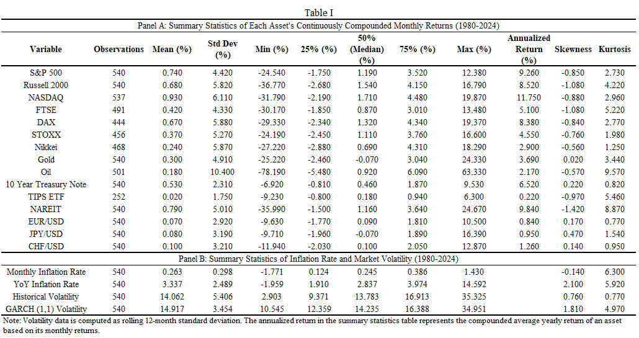

Table I presents the summary statistics for all the assets selected for portfolio construction and for the two macroeconomic variables this paper studies. The study is conducted on 540 months of data and most assets have observable data on all these months, in fact, 15 of the 16 assets have data on more than 82% of the period’s months.

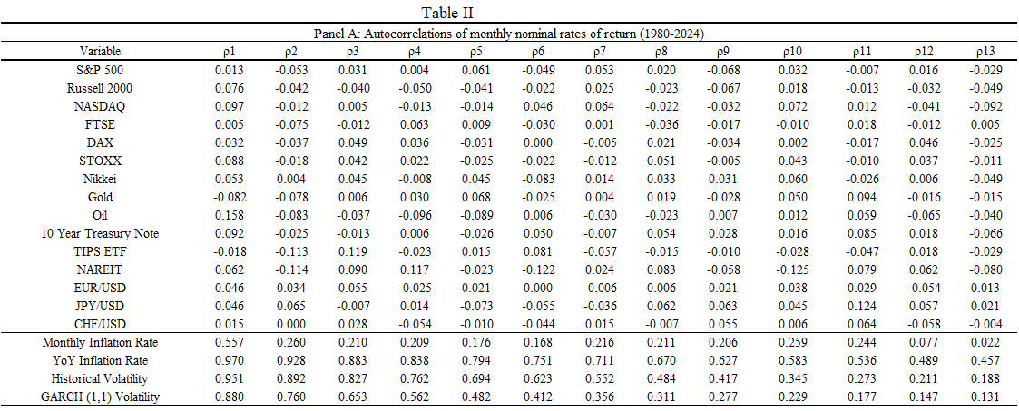The Table shows that, based on annualized nominal returns from 1980 to 2024, the best-performing assets were the Equity Indexes from the United States and Germany, along with the NAREIT Index. Whilst the ones that exhibited the lowest level of returns were the currencies and the iShares TIPS Bond ETF. In what concerns volatility of these assets, one can immediately observe that the instruments with lowest performance throughout this period are also the ones with the lowest volatility.

Table II displays the estimation of the first thirteen autocorrelations of the CPI year-over-year Inflation Rate, estimates of the rolling 12-month standard deviation of returns of the MSCI World Index and the monthly nominal rates of return of the different assets. An analysis of this table shows that autocorrelations at all lags are low and near zero for most assets – except for oil at the first lag – supporting the efficient market hypothesis for equity indexes. Small-cap index Russell 2000 exhibits some short-term mean reversion, since its first order autocorrelation lags are mildly negative. Commodities on the other hand, vary slightly, whilst Oil, has positive and high (when compared to other asset classes) first order autocorrelation, which indicates that its returns gain from momentum from supply or demand shocks. Gold has negative autocorrelation, which may suggest a slight tendency towards mean-reversion over short horizons. The analysis for the 10-year treasury note demonstrates that there is a modest positive autocorrelation, which tends to decay over 1 or 2 lags, meaning that yields usually change gradually and its ability to reflect policy changes. Currencies experience a random walk throughout the 13 order lags reflecting its rather inherent unpredictable behaviour. Finaly, the results for the NAREIT Index show some cyclicality throughout the period under analysis. In any case, the results hold little significance, as all values are very close to 0.

However, the results for Inflation and Volatility are much more interesting to analyse. Monthly Inflation Rate and YoY Inflation rate have very high and significantly different from zero sample autocorrelations, particularly in the short-term ones, suggesting that there is a very significant degree of persistence, with slow movements and small fluctuations, a clear argument that supports the idea that, in the short-term, current inflation influences next month’s inflation, and, in the longer-term and strong memory. The same can be inferred for Historical and GARCH Volatility, high or low levels of volatility tend to stay in that way for months.

Following Fama and Schwert (1977) approach, Table III, contrasts the average annualized continuously compounded nominal rates of return with the average inflation and volatility rates in different subperiods, which, provides a general picture of these assets’ ability to hedge against inflation and market volatility.

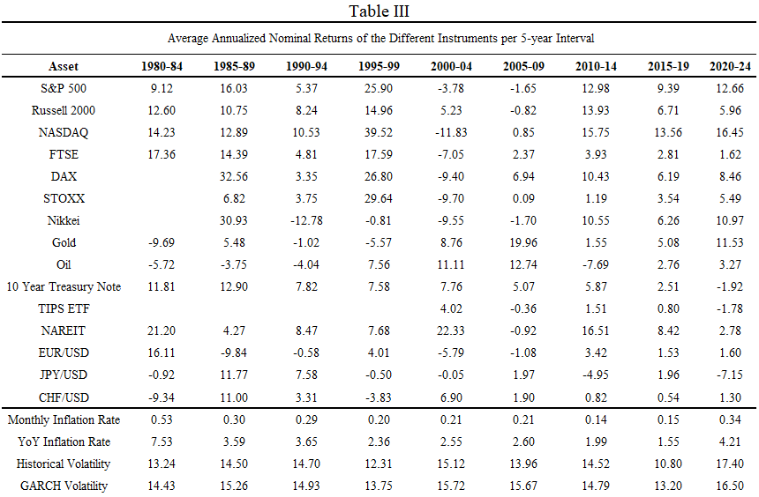From this table, we can immediately conclude that all Equity Indices fail to consistently hedge

inflation and/or volatility. The returns exhibited vary substantially in the different sub-periods and suffer when there are highly inflationary and volatile episodes (e.g. 2000-09, 2020-24), indicates the expected relationship between stocks and inflation and/or volatility. Gold, however, provides protection against both macroeconomic shocks, performing remarkably in periods of high inflation, such as the period 2000-09. This reinforces its status as a safe-haven asset, in the way that Baur and McDermott (2010), have defined it. For Oil, though the relationships are less clear, but there is a positive correlation with both inflation and volatility – supporting our expectation that oil is a poor inflation hedge and reflecting its commodity nature, where supply-driven price increases raise production costs and fuel further inflation. Additionally, as we saw in Table I, Oil is the most volatile asset in this universe. The Fixed-income securities in our universe, are expected to have different behaviours during inflationary times, due to the increase in interest rates, whilst Treasury Inflation-Protected Securities (TIPS) are designed to naturally hedge inflation. Furthermore, during volatile periods, fixed-income securities are considered natural safe-havens and hedges. Real Estate, commonly regarded as an inflation hedge, like shown by Fama and Schwert (1977) for the period 1953-71, exhibits good and sustained returns in all sub-sample periods except for the turbulent period of the subprime crisis, as expected. Finally, currencies, display inconsistent behaviours during volatile and inflationary periods, albeit the Swiss Franc which is commonly regarded as a safe-haven asset, can be described in the same manner during these periods, matching the results of Campbell, Serfaty‐De Medeiros, and Viceira (2010). These inconsistencies may be related to some idiosyncratic and/or country specific risks that are beyond the scope of this paper.

* 1. **Inflation and Volatility: Independent Forces?**

A natural next step is to address the relationship of inflation and market volatility. To do so, we must question whether they evolve independently, and are orthogonal, or if they are correlated or exhibit some degree of Granger-causality. I perform a correlation analysis and a Granger causality test. These two approaches are complimentary. For instance, two variables can have a significantly low correlation or even be totally uncorrelated, and Granger-causality can still detect the predictive relationship between the variables that correlation fails to capture.

The correlation analysis was done to assess the power and path of the linear relationship between inflation rate and volatility rate. This would test if changes in the rate of inflation are associated with simultaneous changes in the volatility rate, i.e., if the variables exhibit a positive correlation, moving together; negative correlation, opposite movements; or independent movements with no significant correlation. This test helps validate the strategy and overall hypothesis in this paper. For this to happen, the explanatory variables need to be weakly correlated or weakly uncorrelated. If the variables are strongly correlated, treating them as separate risk sources may introduce multicollinearity issues to our model. If, conversely, they are uncorrelated or negatively correlated, it provides validity to our approach of separating the two variables into distinct sources of risk in the hedging framework.

The actual result of the correlation test carries practical relevance for this validation. For instance, if the correlation estimate is close to zero, i.e., orthogonal, this implies that inflation and volatility shocks are distinct and occur independently from one another. In this situation, the optimal solution for an investor may be to allocate into assets that hedge each source of risk separately, as we study in this paper. If, however, the correlation coefficient is a strong positive, it indicates that both variables rise together. In this case, the investor should build a portfolio composed by assets that effectively hedge both sources of risk simultaneously. Finally, if the correlation is significantly negative, it suggests that inflation and volatility risks can offset each other. In such a scenario, a 50/50 split between an inflation-hedging asset and a volatility-hedging asset would be the optimal allocation for the investor.

In summary, this study fills the gap in the literature that is the study of this macroeconomic risk sources simultaneously. While many studies have studied volatility independently, , Brenner, Ou, and Zhang (2006), Dew-Becker, Giglio, and Kelly (2021), Bakshi and Kapadia (2001) and Campbell, Serfaty‐De Medeiros, and Viceira (2010); and others have studied inflation, Bodie (1976), Nelson (1976), Jaffe and Mandelker (1976), Gultekin (1983), and Boudoukh and Richardson (1993); none has studied both variables at the same time.

variable YoY Inflation Rate with both measurements of volatility. For Historical Volatility the result was -0.0063, whilst for GARCH Volatility the result was -0.0287. Actually, the number of months that exhibit positive rolling 12-month correlation, on average for both volatility estimates, is 225, whilst the number of the ones with negative is 304. The pattern is quite clear, a negligible and very weak negative relationship between the inflation rate and volatility rates. Figure 2 helps us visualize this. It tells us that the correlation levels fluctuate significantly over time, oscillating between strong positive and negative values. Which may indicate some degree of influence from exogenous factors. Even though, there is not a perfect alignment between both measures of volatility, they tend to move in similar directions, capturing similar dynamics of correlation. Essentially, changes in the Inflation Rate do not have a meaningful impact on volatility, which highlights the fact that they are pretty much independent from each other on our data sample. We can therefore conclude that these variables are orthogonal.

It is now required to address the causality that can be exhibited by the variables, in other words, whether one of the variables leads or is able to predict the behaviour of the other. To achieve this, the Granger Causality test assesses the potential of past values of one of the time series to provide statistically significant information to predict future values of another time series. Before proceeding, it is worth noting that Granger-Causality tests are dependent on the fact that both Inflation and Volatility Data are stationary. This stationarity of our variables was verified through an Augmented Dickey-Fuller (ADF) test. The null hypotheses tested here is if any of the variables contains a unit root, i.e., is non-stationary. The p-values for all variables tests are all smaller than 0.05, meaning that we reject the null hypothesis, and confirms that all variables are, therefore, stationary. Granger (1969) proposed a statistical framework to test whether a time series past values may be able to predict another time series’ future values. In this study, the test was conducted on both directions of our variables, that is, if inflation’s past values can predict future values of volatility and vice-versa. The application consisted of performing the Granger-causality test at four lags and through all of them, the p-values are high, and well above the 0.05 threshold, confirming that we fail to reject the null hypotheses of “inflation does not Granger-cause volatility”. Meaning that there is no statistically significant evidence that sustains the null hypothesis, i.e., no statistical proof for past values of inflation improving the forecasting of future values of volatility. This applies to both measurements of volatility. It is worth mentioning that the p-values decrease as the lags increase, even though they remain statistically insignificant. This further validates the correlation analysis results, indicating that inflation and volatility are largely independent. More perplexing are the results for the other hypothesis tested. While we would expect some degree of forecasting in inflation data towards volatility, it is actually the other way around on our sample data, as can be seen on Table IV, which displays the results of the conducted tests. It does appear that on longer lags, historical volatility, is Granger-causing inflation, and with past volatility data, one may be able to predict, in the long-term, the future levels of inflation. However, the exact opposite is verified for GARCH Volatility, which indicates that on the short-term lag it rejects the null hypothesis but on the long-term lags it fails to reject it. This suggests that conditional volatility may only contain short-term foretelling power over future levels of inflation, whereas realized volatility appears to provide a more persistent predictive power over longer horizons.

This inconsistency between both “Volatilities”, makes the study of our hypotheses even more interesting. It suggests that different measures of volatility capture different properties of market risk, emphasizing the need to test the robustness of the optimal portfolios hedging different volatility frameworks. The Granger-causality test results indicate that inflation and volatility, depending on the measure, behave as independent variables. Their weak correlation and lack of consistent Granger-causality underscore that they should be addressed as two separate sources of risk, validating the analysis done in this paper. Nevertheless, for investors, however, it does not matter if one can predict the other, or even if they are totally independent from one another. If they are independent, so be it, the goal is finding the optimal portfolio that can effectively hedge them separately or together.

|  |  |  |  |  |  |
| --- | --- | --- | --- | --- | --- |
| Table IV | | | | | |
| Granger Causality Test Results for Different Lags | | | | | |
| Causality Direction | Null Hypothesis | Lag | F-Statistic | P-Value | Decision |
| Inflation -> Volatility (Hist) | Inflation does not Granger-cause Volatility | 1 | 0.9335 | 0.3344 | Fail to Reject |
| Inflation -> Volatility (Hist) | Inflation does not Granger-cause Volatility | 2 | 1.4190 | 0.2429 | Fail to Reject |
| Inflation -> Volatility (Hist) | Inflation does not Granger-cause Volatility | 3 | 1.5102 | 0.2109 | Fail to Reject |
| Inflation -> Volatility (Hist) | Inflation does not Granger-cause Volatility | 4 | 1.7926 | 0.1289 | Fail to Reject |
| Volatility (Hist) -> Inflation | Volatility does not Granger-cause Inflation | 1 | 3.3763 | 0.0667 | Fail to Reject |
| Volatility (Hist) -> Inflation | Volatility does not Granger-cause Inflation | 2 | 17.0269 | 0.0000 | Reject |
| Volatility (Hist) -> Inflation | Volatility does not Granger-cause Inflation | 3 | 11.8282 | 0.0000 | Reject |
| Volatility (Hist) -> Inflation | Volatility does not Granger-cause Inflation | 4 | 9.4804 | 0.0000 | Reject |
| Inflation -> Volatility (GARCH) | Inflation does not Granger-cause GARCH Volatility | 1 | 2.0662 | 0.1512 | Fail to Reject |
| Inflation -> Volatility (GARCH) | Inflation does not Granger-cause GARCH Volatility | 2 | 1.8816 | 0.1534 | Fail to Reject |
| Inflation -> Volatility (GARCH) | Inflation does not Granger-cause GARCH Volatility | 3 | 1.3434 | 0.2594 | Fail to Reject |
| Inflation -> Volatility (GARCH) | Inflation does not Granger-cause GARCH Volatility | 4 | 1.7756 | 0.1323 | Fail to Reject |
| Volatility (GARCH) -> Inflation | GARCH Volatility does not Granger-cause Inflation | 1 | 5.3869 | 0.0207 | Reject |
| Volatility (GARCH) -> Inflation | GARCH Volatility does not Granger-cause Inflation | 2 | 0.4426 | 0.6426 | Fail to Reject |
| Volatility (GARCH) -> Inflation | GARCH Volatility does not Granger-cause Inflation | 3 | 0.4614 | 0.7094 | Fail to Reject |
| Volatility (GARCH) -> Inflation | GARCH Volatility does not Granger-cause Inflation | 4 | 0.6086 | 0.6566 | Fail to Reject |

1. **Methodology**

**3.1 Measuring a Hedge**

As initially highlighted in the introduction of the paper, we followed Bodie (1976) approach

to measure an effective hedge. While Bodie (1976) focus solely on inflation, I extend the method to measure the effectiveness of the diversified portfolio or asset against volatility. The definition indicates that for our portfolios or individual assets to hedge inflation and / or volatility risks their goal is to minimize the influence of the risk factors associated with these variables on the excess returns of the diversified portfolios or the individual assets used on our hypothesis.

Empirically, our methodology will be primarily based on the equation in (1) and will, upon the course of the analysis, evolve into different equations with additional independent variables or incorporate the lagged data around YoY Inflation Rate and both the realized and conditional estimates of volatility. The baseline equation aims to quantify the sensitivity of the assets or portfolios to contemporaneous levels of inflation and volatility. These coefficients will be estimated through an OLS (Ordinary Least Squares) regression. On the left-hand side of equation (1), is the nominal rate of return of the portfolio or asset *i,* at time *t*, whereas represents the risk-free rate at time *t*. On the right-hand side of the equation, stands for the coefficient of the YoY Inflation Rate at time *t*, or, in other words, the sensitivity of the excess returns of the asset/portfolio *i* to changes in the inflation rate. Similarly, represents the coefficient of the Historical (realized) Volatility at time *t*, meaning, the sensitivity of the excess returns of asset/portfolio *i* to changes in the volatility. , the intercept, denotes the average excess returns of asset/portfolio *i* after accounting for the impact of inflation and volatility. Finally, , represents, the error term, which captures the variations of the excess returns of asset/portfolio *i* that are not captured by the model. This methodology helps answering the main goal of the paper, to assess whether any of the diversified investment portfolios constructed effectively hedges inflation and volatility. It also fosters the testing of the remaining hypotheses proposed. Questioning whether assets commonly regarded as inflation hedges, safe-haven assets, or volatility hedges exhibit these qualities better than any of the optimal portfolios built. Additionally, if these newly created efficient portfolios overperform while hedging volatility and inflation, more traditional portfolios, such as the 60/40 portfolio.

The “hedge” is measured, as seen, by the degree of sensitivity of the excess returns of portfolios, to either inflation and/or volatility. It is imperative that for the instrument to effectively hedge both variables, the coefficients of and need to be close 1 for inflation beta, meaning that the nominal return of the portfolio increases in line with inflation, hence preserving the purchasing-power of the investor; the volatility beta, however, must be close to 0, implying that return of the portfolio will be independent from stock market volatility shocks. The primary objective of this study is to identify portfolios that simultaneously hedge against both inflation and volatility, while delivering returns comparable to those of traditional inflation-hedging or safe-haven assets, but with reduced exposure to inflationary erosion and volatility-induced risk. Moreover, the presence of a statistically significant and positive 𝛼 in these portfolios would further validate the robustness and reliability of the results.

* 1. **Inflation and Volatility Decomposition**

To assess the implications of the unexpected inflation rate on the return of the assets, it is primarily important to determine the market’s expectations for inflation, i.e., the expected inflation rate. Fama (1975) developed a framework for the use of short-term interest rates on US Treasury Bills to predict the inflation rate of the subsequent months, on which he finds a market efficiency, where nominal interest rates contain all the information pertaining to future inflation rates. Hafer and Hein (1985) studied this and other forecasting procedures and concluded that surveying forecasts are the most accurate inflation predictors. It is with this conclusion in mind that on our split of the expected and unexpected component of the inflation rate happens. Expected inflation rate is obtained from the *University of Michigan Inflation Expectations,* a median expected price change of the 12 subsequent months, representing the consumer sentiment regarding future inflation levels. The unexpected component is then derived from the difference between the actual Year-over-year inflation rate and the expected inflation rate. The rationale is that investors may have already priced in expected inflation, whereas unexpected inflation represents a surprise to the markets and thus carries greater explanatory power for abnormal returns.

Innovations in volatility are model exactly in the same sense, the residual between realized or conditional volatility and the expected volatility rate. In the case of volatility, though, the expected component is fetched from the VIX Index, which captures the market participants’ expectations on the next 30 days equity markets volatility. According to some literature, namely Christensen and Prabhala (1998), implied volatility, outperforms past volatility in forecasting the future rates of volatility. To calculate the daily implied volatility, we have applied the Rule of 16, which is a simple way to convert an annualized implied volatility measure like the VIX into daily moves. The number 16 comes from the fact that, there are 252 trading days in a month, so to de-annualize the daily moves we should divide the value of the index by the square root of 252, which is, approximately, 16. We then calculate the monthly expected volatility by scaling the daily reads, or in other words, we multiply it by the square root of the number of trading days in a month, approximately, 21.

By isolating these effects, this study aims to better assess how diversified portfolios respond to both anticipated and innovations in inflation and volatility.

* 1. **Avoiding Simultaneity Bias and Endogeneity**

In Section 3.1, equation (1) we laid the foundations for the methodology that allows us to measure the sensitivity of the assets or portfolios to inflation and volatility. The exposition of the equation in this manner is strictly because it allows to clearly understand the conceptual model built. However, this contemporaneity, will lead to simultaneity bias and could introduce endogeneity. The regressions performed in this paper will, in fact, rely on lagged explanatory variables, extending up to 5 lags, to mitigate the issues discussed above. In addressing, the simultaneity bias, as Schwert (1981) puts it, for instance, there is a delay of more than a month between the time it takes for the data collectors at the Bureau of Labor Statistics and the time when CPI data is published and the time it takes for investors to adjust their portfolios to the news. Similarly, and again emphasizing the importance of the decomposition in expected and unexpected components, volatility data, historical or GARCH-based estimates, are inherently calculated based on prior return observations and are not immediately in the realm of the investor’s current information set. Moreover, even forward-looking measures such as the VIX, which reflects market expectations of future volatility, may not capture immediate investor reactions due to behavioural biases and information processing delays. Therefore, using lagged variables will help to make endogeneity free regressions, that may have been caused by contemporaneous feedback effects from volatility and / or inflation.

Endogeneity and robustness would not be fully addressed if we did not induce further explanatory power to our models. To that end, in this paper we will base it on the common practice in empirical finance, that is, to use asset pricing factor models in the control variables, to fully capture the anomalies in the portfolios’ excess returns. The methodology of the paper will then employ the following models, the Fama-French 3 (FF3) Factor Model from Fama and French (1993) which includes systematic sources of risk such as market risk premium, size and value, that intends to capture the outperformance of small-sized companies compared to large-cap companies and the premium exhibited by the firms with high book-to-market ratio when compared with the ones with a smaller ratio. The Carhart four-factor model Carhart (1997) which builds on the FF3 Model and introduces the Momentum factor, which aims to translate the tendency of substantial asset returns to be followed by a continuation of the observed outperformance. Lastly, Fama and French (2015) Five-factor model (FF5), which also builds on the FF3 but, adds two different dimensions than the one proposed by Carhart, namely, profitability, that seizes the amplitude between firms with robust and weak operating profitability, and investment patterns, gauging the investment strategy of different firms, comparing firms with aggressive and conservative strategies. It is very clear that failing to control for these variables, i.e. omitting them would lead to biased estimates and thwart the true hedging ability of our portfolios. In summary, these factors will help to isolate the true influence that inflation and volatility as return drivers.

After the above discussions around inflation and volatility decompositions, lagged variables and factor models, all the pieces are now set on the board, and it presents the perfect timing to present the equations on which our model will be based.

To avoid duplication of information, the explanation around the terms in the equations above will only focus on the terms that were not present in (1) and/or in the prior equations.

Equation (2) presents the result of section 3.2. Where, and represents, respectively, the expected inflation rate and the unexpected inflation rate for time *t*. Likewise, the same approach is done for volatility with and , standing for the expected volatility rate and the unexpected volatility rate for time *t*.

Equation (3) showcases the much-needed implementation of lagged control variables, of up to 5 lags, and, in that same rationale, and are the lagged Year-over-year inflation and the lagged rolling 12 month standard deviation of returns, correspondingly.

For equation (4), the only innovation not seen in the previous equations concerns the , the coefficient of factor *k* at time *t*, and , the representation of each of the *k* factors at time *t*.

* 1. **The Benchmark Asset Allocation**

Idiosyncratic risk is the main reason behind investor’s decision to allocate their funds into portfolios instead of into a single asset. The reasoning is quite intuitive, if we think about our day-to-day life. Individual risk is very difficult to forecast, however the frequency of these risks in a larger pool of events is easier to predict. Let’s say we have decided to allocate one hundred percent of our funds into a single stock. The company’s stock we just bought, has performed quite well over the past years, and is in the business of selling combustion engine vehicles. However, some weeks after we bought the stock, the company announces a plant to pursue a new venture that will expand its production of combustion engines. A few months later, a competitor announces a groundbreaking technology that makes the use of combustion engines inefficient, and the price of the stock of the company we are exposed to, immediately drops. This was not foreseeable for us, as an investor, and for the company who’s stock we just bought. This is an example of how idiosyncratic risk can affect our investments. The solution would be to invest in many companies, not just this one. The intuition of our portfolios is the same. In finance, the investors require a certain amount of return for the risk they are willing to take. So, if, according to the aforementioned logic, we increase the number of assets owned and, in turn, the number of asset classes and geographies, the greater the probability of elimination of the idiosyncratic risk. Nevertheless, correlation has a word here. Haim and Sarnat (1970) argue that if returns are not correlated, diversification can eliminate the idiosyncratic risk, however, if there is correlation between the assets’ returns, no degree of correlation can change risk.

Then, forming portfolios with assets that are uncorrelated and can effectively hedge inflation and market volatility’s risk, while improving the hedging asset’s risk-return profile, should be the best asset allocation strategy possible.

Complimentarily, to the hedging assets and the hedging portfolios comparison, we use different benchmark portfolios based on common strategic investment strategies. These benchmark portfolios are not optimized in any way, reflecting the usual allocation strategies chosen by investors. All these portfolios are subject to full investment, have a short-selling constraint, are rebalanced monthly and its returns are adjusted to reflect the transaction costs of rebalancing.

First, we built a series of equal-weighted portfolios, using the 1/n approach. DeMiguel, Garlappi, and Uppal (2009) concluded that out-of-sample this allocation strategy is not consistently outperformed by the 14 models analysed in their study, including the optimal portfolios. And the reasoning behind resides on the fact that this approach avoids the estimation error that other models are subject to. The equal-weighted portfolios created span from a portfolio that includes all assets in our universe to portfolios that include same asset class assets, and assets that have been proven to be individually effectively at hedging inflation or volatility, or the combination of both. Secondly, we chose one of the most mainstream strategic allocation strategies. A 60/40 portfolio, or a portfolio that allocates 60% into equites and the remaining 40% into government bonds.

The third benchmark portfolio created was one that followed Markowitz (1952) approach, optimizing the trade-off between the mean and variance of portfolio returns.

**What else? Value-Weighted portfolios, Black-litterman, Bayesian approach, risk parity,**

**Treynor-Black model** **The fourth and fifth benchmarks are tilted portfolios, designed to emphasize specific hedging dimensions. The inflation-tilted portfolio gives higher weights to assets historically perceived as inflation hedges, including TIPS, commodities, and real estate investment trusts (REITs), in line with findings from Bekaert and Wang (2010) and Baur and Lucey (2010). Similarly, the volatility-tilted portfolio is constructed by overweighting assets with low historical sensitivity to market volatility, such as low-beta equities and investment-grade bonds, reflecting strategies proposed in risk-parity and defensive investing literature (Asness, Frazzini, & Pedersen, 2012).**

The choice of strategic asset allocation to the detriment of more dynamic allocation, lies on the fact that dynamic allocations, usually require further adjustments in comparison to the strategic allocation models. Dynamic allocations also bring other sets of problems, like misspecification and overfitting, that strategic allocations are less susceptible to. Finally, it aligns with the objectives of the paper, allowing to focus on long-term hedging rather than on adjusting our positions based on short-term fluctuations.

* 1. **Optimal Portfolio with Inflation Constraint**

This section describes the methodology used to build the efficient portfolios that account for market volatility risk and inflation risk. Building on Markowitz (1952), mean-variance optimization framework, this study introduces two nuances into the asset allocation problem. First, instead of minimizing only the volatility of the portfolios, its goal is to minimize the sensitivity of portfolio returns to global market volatility and, at the same time, having a beta to inflation that is close to 1 since we are dealing with nominal excess returns. In visualization terms, excess returns, as in the mean-variance context are represented in the y axis, whilst market volatility risk is represented in the x axis. Finally, inflation risk is plotted on the z axis. The efficient surface allows the investor, based on their risk aversion profile, to choose a portfolio that achieves an optimal trade-off between return, market volatility and inflation sensitivity. The efficient frontier that emerges from this study is not a curve, as in the mean-variance optimization, but instead a convex surface in a three-dimensional space as we saw earlier. The solution obtained, a Pareto-like, is a set of portfolios, and in each point lies a portfolio that cannot be improved in all three dimensions simultaneously. The surface introduces new trade-offs and interactions between asset returns and macroeconomic variables that are overlooked in a two-dimensional framework. Investors with a high degree risk aversion to both inflation and stock market volatility risks, may select portfolios closer to the origin. Whereas investors with higher risk tolerance for inflation, may place themselves in allocations where inflation’s beta is closer to one. The innovation of this framework, as already highlighted, resides not only on the analytical evaluation but also on its practical relevance. Over the past years, inflation has been elected, by both consumers in the US and Europe, as their main concern. Having proved that inflation and volatility pose different risks to the investors, establishing this trade-off scenario is quite valuable. The optimization problem is defined in:

Subject to:

This expression describes our multi-objective optimization, where the investor maximizes the expected returns while minimizing the sensitivity to the two independent risk sources in inflation and volatility. stands for the vector of portfolio weights, one for each asset in our universe. represents the vector of the expected nominal excess returns for each asset. The combination of these two terms, while transposing the vector of the weights, represents a matrix multiplication that has as output the portfolio’s expected return. and , are the vectors of each assets’ beta with respect to volatility and inflation, respectively. and are the investor’s risk aversion coefficient to volatility and inflation. A higher value in each of these coefficients means that the investor has less risk tolerance for the risk source, penalizing the corresponding variable strongly in the optimization problem. The absolute value in the volatility array ensures that both positive and negative exposures to volatility are considered unwanted. A similar reasoning is applied to the inflation array, it punishes the squared deviation from the optimal inflation beta of 1. This optimization is subject to some constraints, similarly to the ones imposed in the previous section. Meaning that there is a short-selling restriction and rebalancing once per month. In that sense, the optimization involves a constrained search for efficient weights that minimize the impact of inflation and volatility risk on the portfolio’s returns. A volatility-inflation-return relationship. Portfolios that occupy the efficient region in the three-dimensional surface achieve the desired hedging properties that our paper looks in this asset universe. Their effectiveness will be measured in-sample and out-of-sample using portfolio performance measurement metrics such as alpha, Sharpe Ratio, Information Ratio, Jensen’s alpha and Treynor Ratio and the hedging assessment tools, betas.

Ultimately, the goal is to evaluate if diversified portfolios can successfully hedge inflation and stock market volatility without compromising the target returns.

For investors, this extended framework, builds long-term resilience in periods of rising inflation and considerable market volatility.

1. **Empirical Results**

This section aims at presenting the empirical findings of the methodology employed by our study. It begins by exhibiting the regression results of the single assets and how they respond to inflation and volatility risks. Starting with the estimation of the betas of each asset, in the investment universe, individually, through time-series regressions. These regressions form the backbone of our portfolio optimization methodology. In quantifying the changes of the asset returns in response to changes in the macroeconomic variables studied, we can capture the hedging ability of the securities against purchasing power erosion and / or stock market uncertainty. This sensitivity estimates (betas) allows for an informed decision upon the construction of the diversified portfolios with the goal of an effective and consistent hedging of inflation and volatility risk. Each equation enumerated on section 3.3 will have a dedicated sub-section illustrating the regression results together with its economic interpretation.

* 1. **Estimating Single Asset Betas**
     1. **Expected and Unexpected Components Regression**

Here we report the regression results for the regression equation in (2) for the induvial assets in the investment universe.

|  |  |  |  |  |  |  |  |  |  |  |
| --- | --- | --- | --- | --- | --- | --- | --- | --- | --- | --- |
| Table V | | | | | | | | | | |
| **Regressions of Nominal Excess Returns on Expected and Unexpected Rates of Inflation and Realized Volatility** | | | | | | | | | | |
| **Asset** | **α** | **βei** | **βui** | **βev** | **βuv** | **R²** | **N** | **RMSE** | **SE_α** | **DW** |
| **S&P 500** | 0.0560*** (0.000) | -0.6296** (0.036) | -0.1449 (0.400) | -0.9877*** (0.000) | 0.2897*** (0.000) | 0.281 | 420 | 0.0367 | 0.0108 | 1.998 |
| **Russell 2000** | 0.0762*** (0.000) | -1.1593*** (0.004) | -0.0133 (0.954) | -1.2162*** (0.000) | 0.3932*** (0.000) | 0.256 | 420 | 0.0496 | 0.0145 | 1.925 |
| **NASDAQ** | 0.0809*** (0.000) | -1.2753*** (0.006) | -0.1289 (0.625) | -1.1495*** (0.000) | 0.3640*** (0.000) | 0.198 | 420 | 0.0563 | 0.0165 | 1.834 |
| **FTSE** | 0.0457*** (0.000) | -0.5743** (0.047) | 0.0871 (0.599) | -0.8130*** (0.000) | 0.2410*** (0.000) | 0.218 | 420 | 0.0353 | 0.0103 | 2.005 |
| **DAX** | 0.0690*** (0.000) | -0.7240* (0.096) | -0.1585 (0.524) | -1.1760*** (0.000) | 0.2831*** (0.000) | 0.196 | 420 | 0.0532 | 0.0156 | 1.949 |
| **STOXX** | 0.0625*** (0.000) | -0.7287* (0.056) | -0.0627 (0.773) | -1.0776*** (0.000) | 0.2750*** (0.000) | 0.213 | 420 | 0.0465 | 0.0136 | 1.856 |
| **Nikkei** | 0.0514*** (0.001) | -0.5423 (0.226) | -0.4072 (0.112) | -1.0557*** (0.000) | 0.2672*** (0.000) | 0.166 | 420 | 0.0547 | 0.0160 | 2.025 |
| **Gold** | 0.0113 (0.374) | -0.2946 (0.406) | -0.0254 (0.901) | -0.0296 (0.771) | 0.0431 (0.354) | 0.004 | 420 | 0.0433 | 0.0127 | 2.196 |
| **Oil** | 0.0132 (0.661) | 0.7031 (0.402) | -0.5663 (0.239) | -1.0502*** (0.000) | 0.2881*** (0.009) | 0.055 | 420 | 0.1025 | 0.0301 | 1.696 |
| **10 Year Treasury Note** | 0.0075 (0.204) | -0.2209 (0.181) | -0.0110 (0.907) | 0.0965** (0.042) | -0.0267 (0.218) | 0.018 | 420 | 0.0202 | 0.0059 | 1.869 |
| **TIPS ETF** | 0.0161** (0.012) | -0.4984*** (0.006) | -0.0004 (0.997) | -0.0906* (0.061) | 0.0579*** (0.010) | 0.078 | 252 | 0.0169 | 0.0064 | 2.105 |
| **NAREIT** | 0.0596*** (0.000) | -0.5876 (0.126) | -0.1266 (0.564) | -1.1186*** (0.000) | 0.3264*** (0.000) | 0.231 | 420 | 0.0468 | 0.0137 | 1.981 |
| **EUR/USD** | -0.0065 (0.414) | 0.1628 (0.466) | 0.1196 (0.350) | 0.1299** (0.043) | -0.0594** (0.043) | 0.022 | 420 | 0.0273 | 0.0080 | 1.864 |
| **JPY/USD** | -0.0050 (0.575) | -0.1523 (0.538) | -0.1107 (0.434) | 0.1273* (0.074) | 0.0212 (0.514) | 0.016 | 420 | 0.0302 | 0.0089 | 1.928 |
| **CHF/USD** | -0.0004 (0.959) | 0.0121 (0.960) | -0.1540 (0.268) | -0.0593 (0.395) | 0.0466 (0.144) | 0.010 | 420 | 0.0297 | 0.0087 | 1.992 |
| Notes: p-values are reported in parentheses below each coefficient. ***, **, and * indicate statistical significance at the 1%, 5%, and 10% levels, respectively. | | | | | | | | | | |
|  |

Table V presents the results of the regressions where the expected and unexpected components of inflation and realized volatility rates are the explanatory variables. The betas for the expected inflation and volatility rates measure how much the asset’s excess returns change, on average, in response to a percentage point change in the expected inflation rate and in the monthly expected market volatility rate, respectively. In its turn, the beta coefficients for the unexpected components, quantify how much, on average, inflation and volatility innovations impact excess returns. For the assets to effectively hedge inflation, their beta coefficients need to be close to one, whereas for volatility the hedge is effective for assets with betas close to zero. The R-squared column indicates how much of the variation of the excess returns of each asset is explained by our model. A higher value means a higher explanatory power. The column named “N” provides the number of observations considered for each regression performed in this model. The number of observations in this model is considerably smaller than the number of observations in other models due to the limitation of data for the VIX index. RMSE (Root Mean Squared Error) measures the average significance of the residuals between the observed value and the predicted values in our regression model. A lower RMSE indicates that the predicted values are close to the actual data. The second to last column informs regarding the Standard Error (SE) of the constant, *α*, measuring its precision. A lower SE reveals a more precise estimate of the constant. Finally, the last columned denominated DW, displays the Durbin-Watson statistic test of autocorrelation in the residuals of the regression models, which ranges from zero to four. If the amount of the statistic is approximately two, there is no evidence of autocorrelation in the residuals. However, if the amount is smaller than two, the residuals are positively correlated over time. Conversely, if the amount is higher than two, the residuals are negatively correlated over time. In the case of amounts below 1.5 or above the 2.5 threshold, the statistic indicates that there may be some problems with the model, such as omitted variables or misspecification. Having provided the intuition behind every coefficient and estimate, an economic inference is needed. Thus, from this table we can conclude that for all equity indices, the coefficient of expected inflation is negative and highly significant, except the Nikkei index value that is not significant in any of the three levels of significance testes. None of these assets seems to be an effective hedge against expected inflation, as expected. The interpretation for these same stock market indices in the unexpected inflation context is quite similar. Except for the small-cap Russell 2000 index, even if the coefficient is not statistically significant, that can be considered a moderately good unexpected inflation hedge.

Start here, make analysis per asset class first for all components and then move to the next asset class (see copilot analysis)

1. See statistical stuff like heterogeneity, heteroskedasticity and autocorrelation topics on the thesis structure
2. New section on methodology for portfolio construction, why static/strategic asset allocation instead of dynamic asset allocation. See Faias asset allocation lectures for further papers on portfolio construction methodologies
3. Need to specify hypotheses better in introduction.
4. Papers talking about creating alpha

H1: Inflation and Volatility Hedging Effectiveness

Portfolios constructed in-sample are able to effectively hedge both inflation and market volatility not only during extreme periods (e.g., high inflation or high volatility) but consistently over time, including during the out-of-sample period.

H2: Hedging Innovations in Inflation and Volatility

Portfolios that effectively hedge inflation and volatility also hedge the unanticipated (unexpected) components of these macroeconomic variables, as identified through decomposition methodologies.

H3: Comparative Hedging Performance

The constructed portfolios provide superior hedging effectiveness compared to traditionally regarded inflation-hedging, volatility-hedging, and safe-haven assets (e.g., gold, TIPS, or the VIX as a hedging proxy).

H4: Benchmark Outperformance

The constructed portfolios outperform benchmark portfolios—such as the conventional 60/40 equity-bond portfolio—in terms of return generation and hedging performance during both normal and stressed market conditions.

H5: Alpha Generation Beyond Factor Models

The constructed portfolios generate statistically significant positive alpha when evaluated against common asset pricing models (e.g., Fama-French 3-factor, Carhart 4-factor, and Fama-French 5-factor models), indicating excess returns unexplained by systematic risk factors.

H6: Diversification Advantage

Broadly diversified portfolios—across both asset classes and geographies—offer superior risk-adjusted returns and hedging performance compared to more concentrated portfolios (e.g., single-asset or single-region portfolios).

**10. References**

Bodie, Zvi. "Common stocks as a hedge against inflation." *The journal of finance* 31.2 (1976): 459-470.

Carhart, Mark M. "On persistence in mutual fund performance." *The Journal of finance* 52.1 (1997): 57-82.

Fama, Eugene F., and G. William Schwert. "Asset returns and inflation." *Journal of financial economics* 5.2 (1977): 115-146.

Fama, Eugene F., and Kenneth R. French. "Common risk factors in the returns on stocks and bonds." *Journal of financial economics* 33.1 (1993): 3-56.

Fama, Eugene F., and Kenneth R. French. "A five-factor asset pricing model." *Journal of financial economics* 116.1 (2015): 1-22.

Granger, Clive WJ. "Investigating causal relations by econometric models and cross-spectral methods." *Econometrica: journal of the Econometric Society* (1969): 424-438.

Fisher, Irving. *The Theory of Interest: As Determined by Impatience to Spend Income and Opportunity to Invest It*. Macmillan, 1930.

Fama, Eugene F. "Short-term interest rates as predictors of inflation." *American Economic Review* 65.3 (1975): 269-282.

Hafer, Rik W., and Scott E. Hein. "On the accuracy of time-series, interest rate, and survey forecasts of inflation." *Journal of Business* (1985): 377-398.

Christensen, Bent J., and Nagpurnanand R. Prabhala. "The relation between implied and realized volatility." *Journal of financial economics* 50.2 (1998): 125-150.

Schwert, G. William. "The adjustment of stock prices to information about inflation." *the Journal of Finance* 36.1 (1981): 15-29.

Lintner, John. "Inflation and security returns." *The journal of finance* 30.2 (1975): 259-280.

Brenner, Menachem, Ernest Y. Ou, and Jin E. Zhang. "Hedging volatility risk." *Journal of Banking & Finance* 30.3 (2006): 811-821.

Dew-Becker, Ian, Stefano Giglio, and Bryan Kelly. "Hedging macroeconomic and financial uncertainty and volatility." *Journal of Financial Economics* 142.1 (2021): 23-45.

Nelson, Charles R. "Inflation and rates of return on common stocks." *The journal of Finance* 31.2 (1976): 471-483.

Gultekin, N. Bulent. "Stock market returns and inflation: evidence from other countries." *the Journal of Finance* 38.1 (1983): 49-65.

Jaffe, Jeffrey F., and Gershon Mandelker. "The" Fisher effect" for risky assets: An empirical investigation." *The Journal of finance* 31.2 (1976): 447-458.

Boudoukh, Jacob, and Matthew Richardson. "Stock returns and inflation: A long-horizon perspective." *The American economic review* 83.5 (1993): 1346-1355.

Anari, Ali, and James Kolari. "Stock prices and inflation." *Journal of Financial Research* 24.4 (2001): 587-602.

Jaffe, Jeffrey F. "Gold and gold stocks as investments for institutional portfolios." *Financial Analysts Journal* 45.2 (1989): 53-59.

Baur, Dirk G., and Thomas K. McDermott. "Is gold a safe haven? International evidence." *Journal of Banking & Finance* 34.8 (2010): 1886-1898.

Ghosh, Dipak, et al. "Gold as an inflation hedge?." *Studies in Economics and Finance* 22.1 (2004): 1-25.

Fama, Eugene F. "Inflation uncertainty and expected returns on treasury bills." *Journal of political economy* 84.3 (1976): 427-448.

Bodie, Zvi. "Inflation, index-linked bonds, and asset allocation." (1988).

Kothari, S. P., and Jay Shanken. "Asset allocation with inflation-protected bonds." *Financial Analysts Journal* 60.1 (2004): 54-70.

Campbell, John Y., Adi Sunderam, and Luis M. Viceira. *Inflation bets or deflation hedges? The changing risks of nominal bonds*. No. w14701. National Bureau of Economic Research, 2009.

Huang, Haibo, and Susan Hudson-Wilson. "Private commercial real estate equity returns and inflation." *Journal of portfolio management* (2007): 63.

Campbell, John Y., Karine Serfaty‐De Medeiros, and Luis M. Viceira. "Global currency hedging." *The Journal of Finance* 65.1 (2010): 87-121.

Markowitz, Harry. “Portfolio Selection.” *The Journal of Finance*, vol. 7, no. 1, (1952), pp. 77–91

French, Kenneth R., G. William Schwert, and Robert F. Stambaugh. "Expected stock returns and volatility." *Journal of financial Economics* 19.1 (1987): 3-29.

Bakshi, Gurdip, and Nikunj Kapadia. "Delta-hedged gains and the negative market volatility risk premium." *The Review of Financial Studies* 16.2 (2003): 527-566.

Levy, Haim, and Marshall Sarnat. "International diversification of investment portfolios." *The American Economic Review* 60.4 (1970): 668-675.

DeMiguel, Victor, Lorenzo Garlappi, and Raman Uppal. "Optimal versus naive diversification: How inefficient is the 1/N portfolio strategy?." *The review of Financial studies* 22.5 (2009): 1915-1953.