
Item Picker
Considerations & recommended improvements
Worldpanel by Numerator | 26 October 2026

Purpose: raise concerns about market-scope filtering, attribute discovery and purchase-count computation in Item Picker, and propose a simpler, consistent selection and validation workflow.
Status: discussion proposal based on reported behaviour. Implementation details, data relationships and performance have not been verified against application code or live data.

Executive summary
Item Picker currently requires country, service, client and market scope before users can prepare attribute lists and obtain purchase counts. The main concern is that deriving market scope from the first hierarchy attribute can couple scope definition to attribute discovery, making relevant product, retailer and panelist attributes difficult to find and potentially creating inconsistent data universes.
The recommended approach is to start from Total Market by default, keep market scope visible and changeable, and make attribute availability depend on the purchases eligible for the selected context. Users should browse and select multiple attributes rather than type names from memory. Purchase counts and empty-branch pruning should preferably run during file validation, using a configurable reference period.

1. Current issues and why they matter
Reported issue | Consideration / risk
Mandatory country, service, client and market scope | These controls define context, but a narrow market scope should not be forced as the starting point.
First attribute from dim_hierarchy becomes market scope | Using an attribute to derive scope can restrict which other attributes users can discover. Scope selection and list construction need distinct steps.
Attributes must be typed from memory | Without a display list, users cannot reliably discover available attributes or prepare lists efficiently.
Filtering spans product, retailer and panelist attributes | If discovery and counting use different purchase universes or join rules, available values and resulting counts may differ.
Counts computed while selecting attributes | Repeated counts across large or high-cardinality combinations may make selection slow. The actual cost needs measurement.
Empty branches and unclear reference period | Lists can contain values with no eligible purchases; without an explicit period, users cannot interpret availability or counts consistently.

2. Market scope: default and selection rules
Total Market should be the default starting scope for every supported dimension. Here, Total Market means the full eligible purchase universe within the selected country, service, client permissions and reference period. It does not bypass client access restrictions or combine unrelated countries or services.
- Select country, service and client to establish the permitted context; initialise market scope to Total Market.
- Offer an explicit market-scope selector before attribute selection. Users may retain Total Market or choose a narrower scope.
- Keep the selector available throughout the flow, including an easy return to Total Market.
- Resolve eligible purchases for the selected scope first, then derive the attributes and values available from that purchase universe.
- When context, scope or time period changes, refresh availability and mark existing selections for revalidation. Do not silently remove selections.
“Always Total Market” is interpreted as the default baseline, while preserving the requested option to select a specific market scope. Confirm this interpretation before implementation.

3. Recommended user flow
Step | Expected behaviour
1. Establish context | Choose country, service and client; show Total Market as the default scope and display the reference period.
2. Select scope | Keep Total Market or explicitly select a narrower market scope. dim_hierarchy may support scope resolution, without making the first selected output attribute define scope implicitly.
3. Browse available attributes | Display searchable attribute lists grouped by dimension, filtered by the eligible purchase universe and client access.
4. Build the list | Select multiple attributes in one action; prepare a hierarchical or flat output. Preserve supported cross-dimension selections.
5. Validate | Calculate purchase counts for the configured reference period; identify invalid selections and prune zero-purchase values or branches by default.
6. Review and save | Show the validated result, counts, removed branches and the context used. Save or export the hierarchical or flat list.

4. Attribute discovery and materialised availability
Create a materialised availability view, or equivalent maintained table, for each supported dimension. Expose country, service, market scope and attribute identity, with Total Market represented consistently across dimensions. Include attribute values where the picker needs value-level selection; distinguish an attribute definition from its selectable values.
- Use dim_hierarchy for explicit scope resolution and the applicable dimension tables for selectable attributes.
- Build availability from purchases eligible for the selected scope. A dimension-only catalogue may contain attributes or values with no purchases in that context.
- Apply the client access table before showing attributes or counts. Decide whether access is incorporated in materialisation or applied at query time; either approach must prevent unauthorised visibility.
- Separate availability from optional stored counts. Materialising discoverable attributes does not require precomputing every possible attribute combination.
- Define refresh ownership and freshness. If availability is period-dependent, include the reference period in its key or derive availability from period-grained data; otherwise label discovery as provisional until validation.
Materialised views are the preferred design proposal, not a confirmed platform capability or final physical schema. Grain, join keys, refresh strategy and storage cost require design validation.

5. Purchase counts, validation and pruning
Prefer purchase-count computation during file validation rather than on every selection change. This should reduce repeated work and keep list building responsive. It is a performance hypothesis to benchmark, not an established result. On-demand counts can remain an optional alternative where measured response times are acceptable.
- Make the purchase reference period configurable. Define a standard default later and always display the effective dates or periods used.
- Use one agreed purchase-count definition and grain across discovery, validation and output. Decide explicitly whether the count represents purchase records, distinct purchase events or another business unit; do not equate it with weighted measures or occasions by assumption.
- Guard against duplicated purchases from hierarchy, attribute, volume or effective-dated joins. Use verified keys and deduplication rules appropriate to the agreed count grain.
- Prune zero-purchase leaves by default, then remove parents left with no populated descendants. For flat lists, remove zero-purchase entries.
- Distinguish a genuine zero from missing mappings, access restrictions, incomplete data or a failed count. Failed or unresolved checks must not cause silent pruning.
- Show a validation summary with retained and removed entries, the reference period, market scope and count definition. Keep pruning reviewable and the pre-validation selection recoverable.

6. List building and cross-dimension selections
Present available attributes as a searchable display list with dimension labels and multi-selection controls. Allow users to prepare several attributes together, choose hierarchical or flat output, and review the selected items before validation. Hierarchical and flat lists are reported as potentially already supported; this should be checked before redesigning them.
Support the requested combinations involving panelist and purchase dimensions where relationships are valid. Define the allowed combinations, join paths and output grain before enabling them. Cross-dimension counts should use the same eligible purchase universe and reference period; unsupported or ambiguous combinations should produce a clear validation message.

7. Reference tables and access dependencies
All named tables are located at {catalog}.{schema}. The supplied PRISM Gold reference describes the relationships below. Its example deployment is `prismetl_prod_01`.`gold-live`; keep deployment names configurable. No live schema or application-code verification was performed.
Table | Reference role / design consideration
dim_hierarchy | Resolve selectable market scopes and hierarchy membership; keep scope definition separate from output-attribute selection.
dim_product | Discover product attributes and values, including attributes used as segments.
dim_retailer | Discover retailer attributes and values.
dim_purchase | Discover purchase-level attributes and values.
dim_demographic | Discover demographic / panelist attributes; confirm period alignment and identity rules.
dim_product_volume | Reference volume-equivalence attributes if relevant to the picker; avoid multiplying purchase counts through equivalence joins.
fact_occasion_purchase | Purchase-line fact: key (dp_country_code, purchase_bk). Not service-specific; service eligibility comes from weight tables.
fact_purchase_weight | Purchase-weight reference where required; determine whether weights affect eligibility or a separate weighted measure.
fact_demographic_weight | Panelist eligibility / weight reference where required; confirm country, service and period alignment.
Client access table (name not supplied) | Restrict the permitted scopes, attributes and values before display and counting. Location, schema and rules remain to be specified.

8. Decisions required before implementation
- Confirm Total Market as the default, with explicit narrower scopes supported throughout the flow.
- Agree the purchase-count business definition, unique grain and treatment of eligibility and weights.
- Choose the standard reference period and supported date or period overrides.
- Confirm scope-to-purchase and cross-dimension join keys, including effective-date handling where applicable.
- Define materialisation grain, refresh cadence and whether client access is resolved during refresh or at query time.
- Confirm supported hierarchical / flat output behaviour and allowed cross-dimension combinations.
- Set validation latency targets and compare validation-time counts with optional interactive counts on representative data.

9. Acceptance criteria
- A new selection starts at Total Market within the selected country, service and client permissions; scope remains editable.
- Users can discover and select multiple attributes without knowing or typing their names in advance.
- Displayed attributes reflect the selected scope and permitted context; validation explicitly resolves any difference caused by freshness or reference-period changes.
- Validation uses a visible, configurable reference period and one agreed purchase-count definition, without duplication from joins.
- Zero-purchase entries and empty hierarchy branches are pruned by default, with a reviewable summary; failed checks are clearly distinguished from zero counts.
- Hierarchical and flat outputs remain available, and supported cross-dimension combinations preserve the agreed purchase grain.
- Changing context or reference period invalidates stale counts and requires revalidation before the result is treated as validated.

Recommended position
Raise market-scope coupling and attribute discoverability as priority concerns. Establish Total Market as the default, provide materialised dimension-availability surfaces, enable visible multi-attribute selection, and move purchase counts and default empty-branch pruning to validation with an explicit, configurable time reference.

10. PRISM Gold reference: implications for Item Picker

Purchase universe
The supplied reference describes purchase lines, not shopping occasions. Use distinct (dp_country_code, purchase_bk) as the proposed unweighted count basis, subject to business approval. Service and period eligibility come from purchase and demographic weights; Total Market must preserve these restrictions.

EAV availability
Product, retailer, purchase and demographic attributes use entity-attribute-value rows. Retain attribute_type_bk, attribute_value_bk and display labels in availability surfaces. dim_hierarchy stores levels wide; dim_product_volume is a structured equivalence lookup, not an EAV attribute catalogue.

Market-scope resolution
dim_hierarchy levels map to attribute type codes. Resolve hierarchy suffixes consistently, then use distinct products carrying the scoped attribute. Total Market should not require a product to carry a particular scope attribute; the precise baseline eligibility contract must be agreed.

Join keys and live records
Include dp_country_code and use business keys. Product joins require both product_bk and product_barcode. Apply live-row rules, including dp_is_deleted = N on dimensions, and compare service_name case-insensitively.

Weights and duplicate prevention
Select the latest applicable fact_purchase_weight version by dp_update_time within country, purchase, service and period. EAV rows, multiple periods and multiple volume equivalences must not multiply the final purchase count.

Time alignment
period_name uses YYYYPnn, with 13 four-week periods. Resolve purchase-date boundaries through fact_demographic_weight.first_date / last_date. The fact purchase periodicity columns are weekly and must not be used as four-week period filters.

Panelist attributes
Use dim_demographic; there is no dim_panelist in the supplied reference. A demographic value must cover the whole selected period. Apply the approved household identity rule consistently where relevant, without collapsing member identities for other services.

Purchase-key conversion
dim_purchase.purchase_bk is STRING while the fact key is BIGINT. Use safe conversion and report rejected keys separately. Invalid keys are a data-quality condition, not evidence of zero purchases.

Missing attributes
The supplied reference describes LEFT joins for volume and attribute enrichment after the eligible base purchase universe. Preserve eligible purchases with missing attributes; distinguish missing assignments from genuine zero-count values during validation.

Source limitation
The supplied local note was used as the primary implementation reference. A general Gold-schema skill differs on default-volume, product-pivot and demographic join types. Confirm these behaviours against the deployed GoldMining version before implementation; the document does not resolve that discrepancy by assuming either version is live.

11. Current flow — reported concerns
Reported behaviour supplied by the requester. This is not a verified application trace.
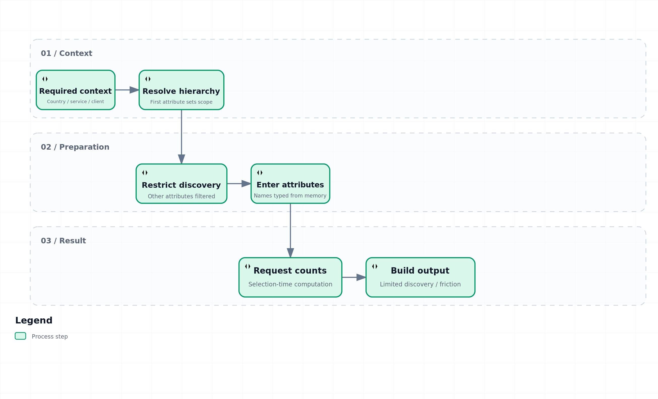
Created with Archify. Static diagram embedded for Word; interactive HTML and editable JSON supplied separately. Schema, layout and HTML checks passed. Automated browser verification was blocked by the environment navigation policy.
Interactive companion: current-flow.html

12. Proposed selection workflow
Proposed design: Total Market is the default; narrower scope selection remains available. Client access applies before attributes or counts are displayed.
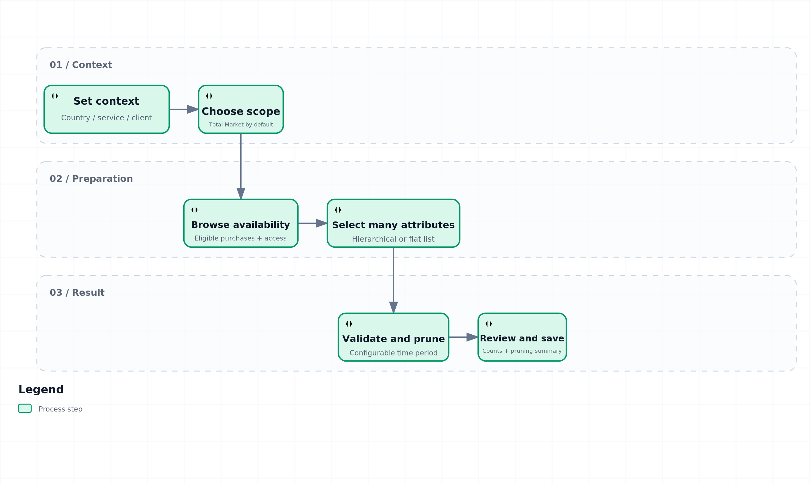
Created with Archify. Static diagram embedded for Word; interactive HTML and editable JSON supplied separately. Schema, layout and HTML checks passed. Automated browser verification was blocked by the environment navigation policy.
Interactive companion: proposed-flow.html

13. Proposed validation workflow
Proposed design: calculate counts before pruning. Errors stop the affected validation; never prune unresolved entries as though they were zero.
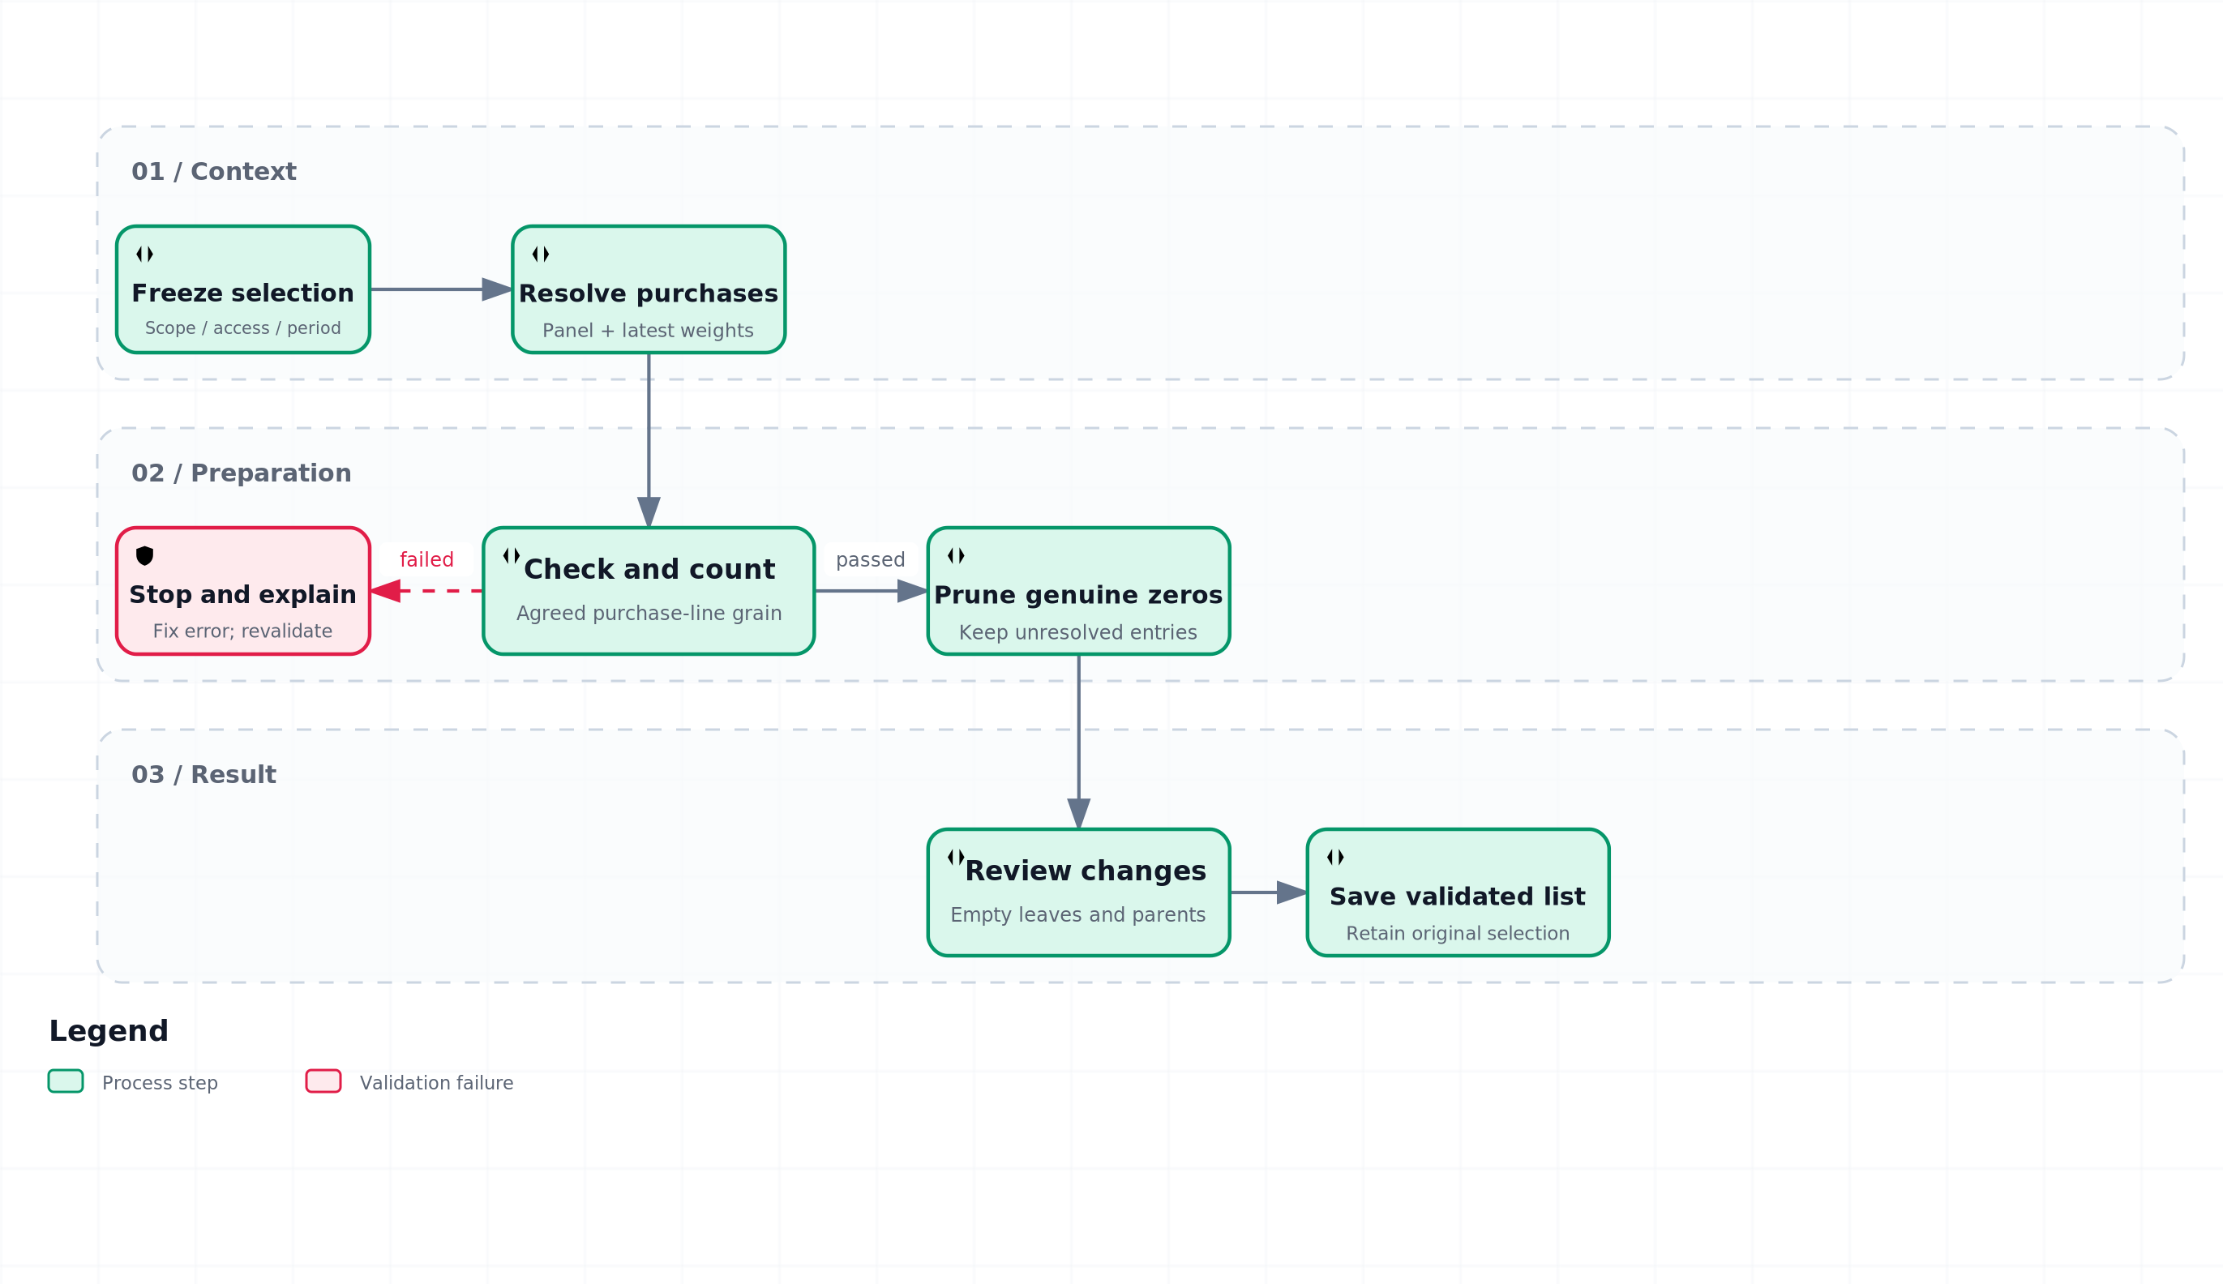
Created with Archify. Static diagram embedded for Word; interactive HTML and editable JSON supplied separately. Schema, layout and HTML checks passed. Automated browser verification was blocked by the environment navigation policy.
Interactive companion: validation-flow.html

