Circuits Description

Luís Paulo Santos, Jul.2025

# Summary

This document describes the classes of quantum circuits and respective data, available at <https://github.com/luisps/ExperimentalData.git>

Índice

Summary 1

Class SU – variational EfficientSU2 1

Circuit SU5: 5 qubits, 1 rep 2

Circuit SU15: 15 qubits, 2 rep 2

Circuit SU25: 25 qubits, 2 rep 2

Class HSC – Hidden Shift Circuits 3

Circuit 41256- Hidden shift: 256 qubits, hidden string = 1023 3

Circuit 411024- Hidden shift: 1024 qubits, hidden string = 1023 3

Circuit 414096- Hidden shift: 4096 qubits, hidden string = 1023 3

Class IQP Inversion test 3

Circuit IQP5: 5 qubits 3

Circuit IQP15: 15 qubits 4

Circuit IQP25: 25 qubits 4

Class RND – Random Circuits 4

Circuit RND8- Random: 8 qubits, nCycles = 6 4

Circuit RND10- Random: 10 qubits, nCycles = 7 4

Circuit RND512- Random: 12 qubits, nCycles = 8 5

# Class SU – variational EfficientSU2

This class of circuits corresponds to the so-called “hardware efficient” ansatz for variational circuits. It is obtained with the Qiskit method:

EfficientSU2(num_qubits, entanglement='linear', reps=reps)

The number of qubits and the number of layer repetitions is varied for the different circuit instances below.

## Circuit SU5: 5 qubits, 1 rep

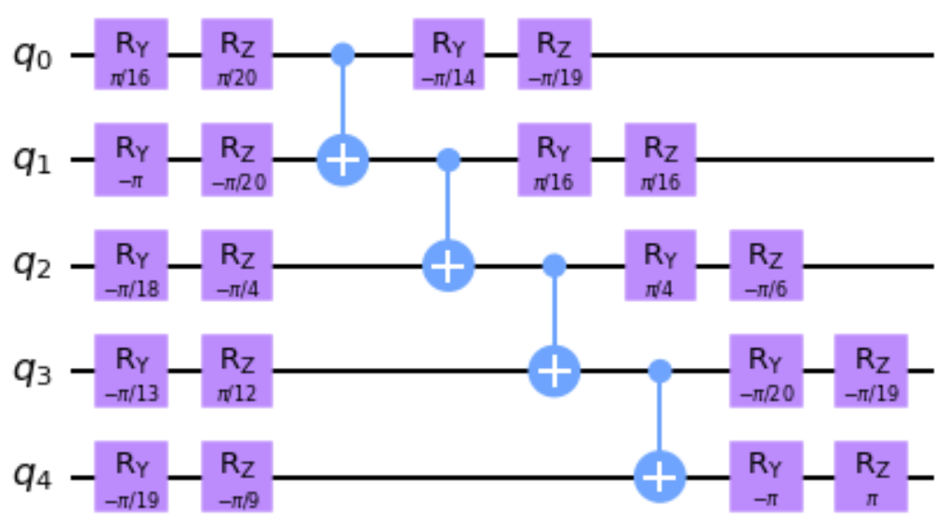

8 layers

3.436e+10 paths = $2^{\left(5*\left(8-1\right)\right)}=2^{35}$

$〈0|U|0〉=$-0.00172150+0.00127863j

## Circuit SU15: 15 qubits, 2 rep

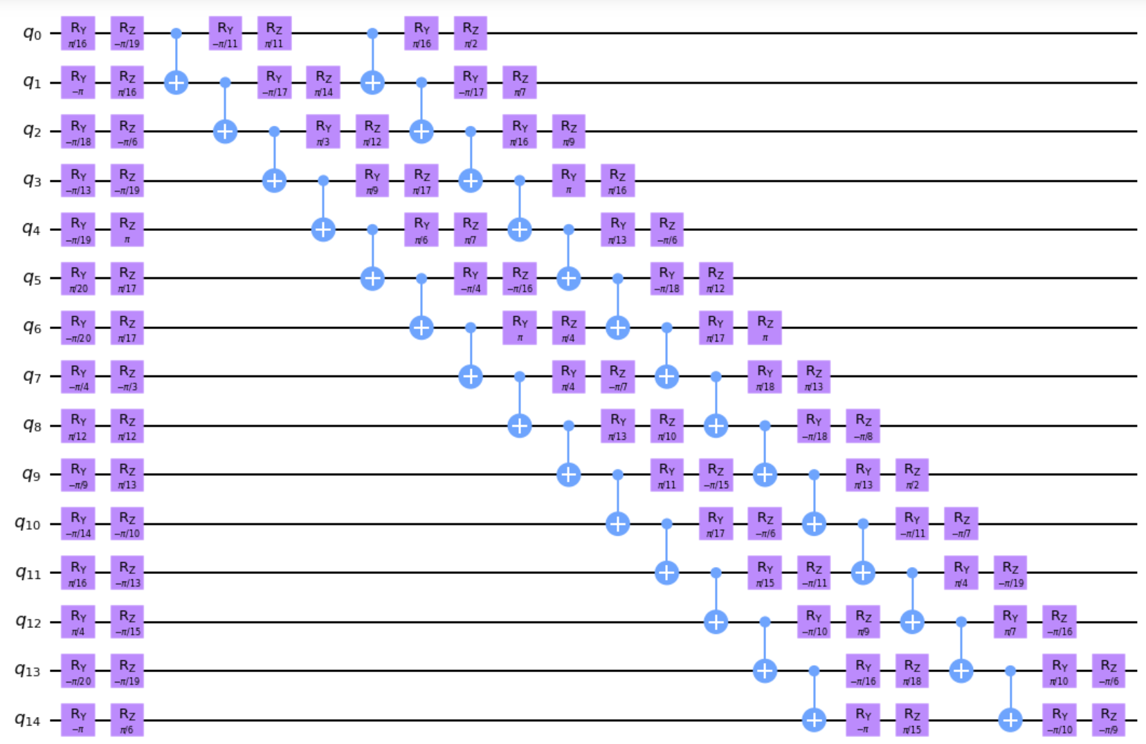

22 layers

6.675e+94 paths = $2^{\left(15*\left(22-1\right)\right)}=2^{315}$

$〈0|U|0〉=$ 0.00364578+0.00060584j

## Circuit SU25: 25 qubits, 2 rep

32 layers

2.e+233 paths = $2^{\left(25*\left(32-1\right)\right)}$

$〈0|U|0〉=$ −0.00012 + 0.00007j

# Class HSC – Hidden Shift Circuits

Deterministic circuits, in the sense that only one basis state in the output has an amplitude different from 0 (= 1.0).

These are based on the algorithm (and code) presented in Peres, Filipa 2023 (sec 4.1)

<https://arxiv.org/pdf/2203.01789.pdf>

## Circuit 41256- Hidden shift: 256 qubits, hidden string = 1023

43 layers

paths = $2^{\left(256*\left(43-1\right)\right)}$

$〈1023|U|0〉=$ 1.0 + 0.0j

## Circuit 411024- Hidden shift: 1024 qubits, hidden string = 1023

43 layers

paths = $2^{\left(1024*\left(43-1\right)\right)}$

$〈1023|U|0〉=$ 1.0 + 0.0j

## Circuit 414096- Hidden shift: 4096 qubits, hidden string = 1023

43 layers

$$2^{\left(4096*\left(43-1\right)\right)}$$

$〈1023|U|0〉=$ 1.0 + 0.0j

# Class IQP Inversion test

Inversion test of two random states encoded using IQP.

The probability of P(|0>n) is the overlap between the states.

## Circuit IQP5: 5 qubits

Uma imagem com file, recibo, texto, diagrama

Os conteúdos gerados por IA podem estar incorretos.

17 layers

1.209e+24 paths = $2^{\left(5*\left(17-1\right)\right)}=2^{80}$

$〈0|U|0〉=$-0.104462+0.106694j

## Circuit IQP15: 15 qubits

55 layers

6.828e+243 paths = $2^{\left(15*\left(55-1\right)\right)}=2^{810}$

$〈0|U|0〉=$-0.00128171-0.00008649j

## Circuit IQP25: 25 qubits

97 layers

paths = $2^{\left(25*\left(97-1\right)\right)}=2^{2400}$

$〈0|U|0〉=$-0.00013443-0.00022139j

# Class RND – Random Circuits

Randomly generated circuits. These are based on the algorithm (and code) presented in Peres, Filipa 2023 (sec 4.2)

<https://arxiv.org/pdf/2203.01789.pdf>

## Circuit RND8- Random: 8 qubits, nCycles = 6

Uma imagem com file, diagrama

Os conteúdos gerados por IA podem estar incorretos.

9 layers

1.845e+19 paths = $2^{\left(8*\left(9-1\right)\right)}=2^{64}$

$〈0|U|0〉=$-0.04419417+0.10669417j

## Circuit RND10- Random: 10 qubits, nCycles = 7

13 layers

paths = $2^{\left(10*\left(13-1\right)\right)}=2^{120}$

$〈0|U|0〉=$ 0.02209709+0.05334709j

## Circuit RND512- Random: 12 qubits, nCycles = 8

15 layers

paths = $2^{\left(12*\left(15-1\right)\right)}=2^{168}$

$〈16|U|0〉=$ 0.009153-0.022097j