Circuits for Benchmarking

Luís Paulo Santos, 28.Feb.2024

# Summary

This document describes the classes of quantum circuits and respective data, available at <https://github.com/luisps/QCircuits_BenchTest.git>.

Each circuit class is identified by a number (usually an exact thousand, hundred or dozen. Particular circuits are then identified by the lower digits.

Índice

Summary 1

Class 19 – variational EfficientSU2 2

Circuit 19 - variational EfficientSU2: 3 qubits, 1 rep 2

Circuit 191- variational EfficientSU2: 3 qubits, 2 rep 2

Circuit 192- variational EfficientSU2: 4 qubits, 2 layers 3

Circuit 193- variational EfficientSU2: 5 qubits, 1 rep 4

Circuit 194- variational EfficientSU2: 6 qubits, 1 rep 4

Circuit 195- variational EfficientSU2: 6 qubits, 2 rep 5

Circuit 196- variational EfficientSU2: 15 qubits, 2 rep 5

Class 4100 – Hidden Shift Circuits 6

Circuit 4100- Hidden shift: 100 qubits, hidden string = 1023 6

Circuit 4101- Hidden shift: 8 qubits, hidden string = 7 6

Circuit 4150- Hidden shift: 50 qubits, hidden string = 1023 6

Circuit 4160- Hidden shift: 60 qubits, hidden string = 1023 8

Circuit 4170- Hidden shift: 70 qubits, hidden string = 1023 8

Circuit 4180- Hidden shift: 80 qubits, hidden string = 1023 8

Circuit 4190- Hidden shift: 90 qubits, hidden string = 1023 8

Class 300 – IQP Inversion test 8

Circuit 305- IQP: 5 qubits 9

Circuit 315- IQP: 15 qubits 9

Circuit 325- IQP: 25 qubits 9

Class 500 – Random Circuits 9

Circuit 508- Random: 8 qubits, nCycles = 6 10

Circuit 516 - Random: 16 qubits, nCycles = 12 10

Circuit 525 - Random: 25 qubits, nCycles = 18 10

# Class 19 – variational EfficientSU2

This class of circuits corresponds to the so-called “hardware efficient” ansatz for variational circuits. It is obtained with the Qiskit method:

EfficientSU2(num_qubits, entanglement='linear', reps=reps)

The number of qubits and the number of layer repetitions is varied for the different circuit instances below.

## Circuit 19 - variational EfficientSU2: 3 qubits, 1 rep

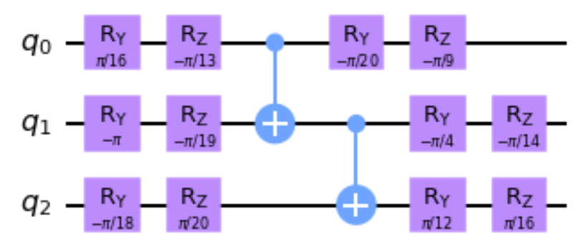

6 layers

32768 paths =

Non zero paths for = 4

|  |  |
| --- | --- |
| Available Files | |
| circuit_19.data | The circuit definition |
| circuit_19.csv | Exact amplitudes for different transitions |
| circuit_19-raw-values.csv | Non zero paths for |
| circuit_19.data_stats_IS_0_0.csv | Amplitudes and variances as a function of the number of samples for Importance Sampling and |
| circuit_19.data_stats_BD_0_0.csv | Amplitudes and variances as a function of the number of samples for Bidirectional Sampling and |
| circuit_19.data_stats_BD_MIS_0_0.csv | Amplitudes and variances as a function of the number of samples for Bidirectional Sampling with MIS and |

## Circuit 191- variational EfficientSU2: 3 qubits, 2 rep

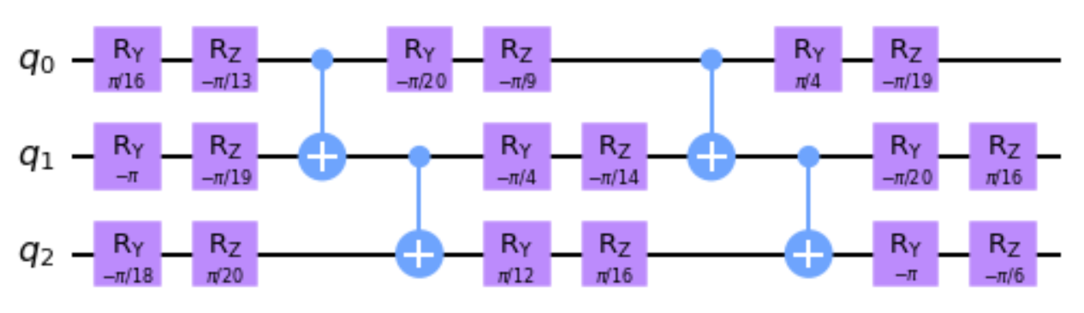

10 layers

1.342 * 108 paths =

|  |  |
| --- | --- |
| Available Files | |
| circuit_191.data | The circuit definition |
| circuit_191.csv | Exact amplitudes for different transitions |
| circuit_191.data_stats_IS_0_0.csv | Amplitudes and variances as a function of the number of samples for Importance Sampling and |
| circuit_191.data_stats_BD_0_0.csv | Amplitudes and variances as a function of the number of samples for Bidirectional Sampling and |
| circuit_191.data_stats_BD_MIS_0_0.csv | Amplitudes and variances as a function of the number of samples for Bidirectional Sampling with MIS and |

## Circuit 192- variational EfficientSU2: 4 qubits, 2 layers

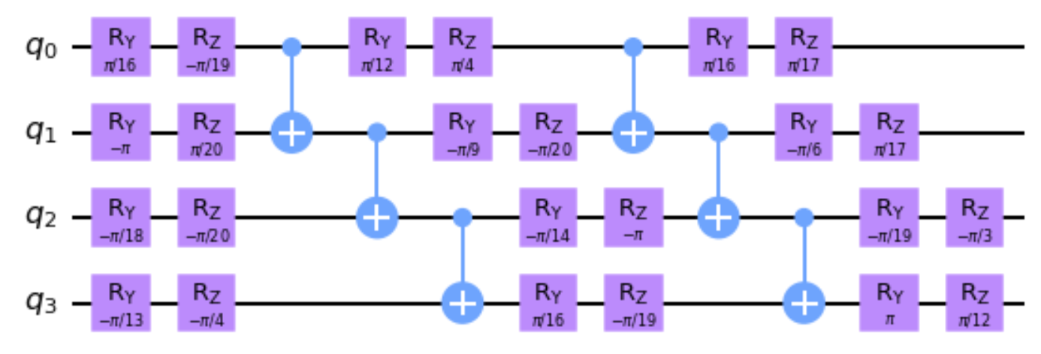

11 layers

1.1 * 1012 paths =

| Available Files | |
| --- | --- |
| circuit_192.data | The circuit definition |
| circuit_192.csv | Exact amplitudes for different transitions |
| circuit_192.data_stats_IS_0_0.csv | Amplitudes and variances as a function of the number of samples for Importance Sampling and |
| circuit_192.data_stats_BD_0_0.csv | Amplitudes and variances as a function of the number of samples for Bidirectional Sampling and |
| circuit_192.data_stats_BD_MIS_0_0.csv | Amplitudes and variances as a function of the number of samples for Bidirectional Sampling with MIS and |

## Circuit 193- variational EfficientSU2: 5 qubits, 1 rep

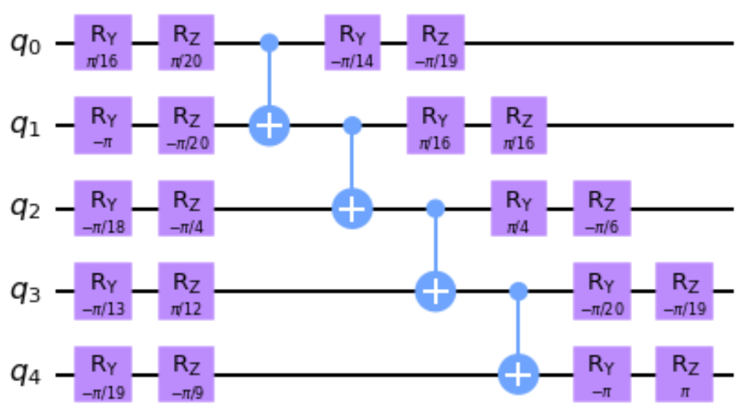

8 layers

3.436e+10 paths =

-0.00172150+0.00127863j

| Available Files | |
| --- | --- |
| circuit_193.data | The circuit definition |
| circuit_193.csv | Exact amplitudes for different transitions |
| circuit_193.data_stats_IS_0_0.csv | Amplitudes and variances as a function of the number of samples for Importance Sampling and |
| circuit_193.data_stats_BD_0_0.csv | Amplitudes and variances as a function of the number of samples for Bidirectional Sampling and |
| circuit_193.data_stats_BD_MIS_0_0.csv | Amplitudes and variances as a function of the number of samples for Bidirectional Sampling with MIS and |

## Circuit 194- variational EfficientSU2: 6 qubits, 1 rep

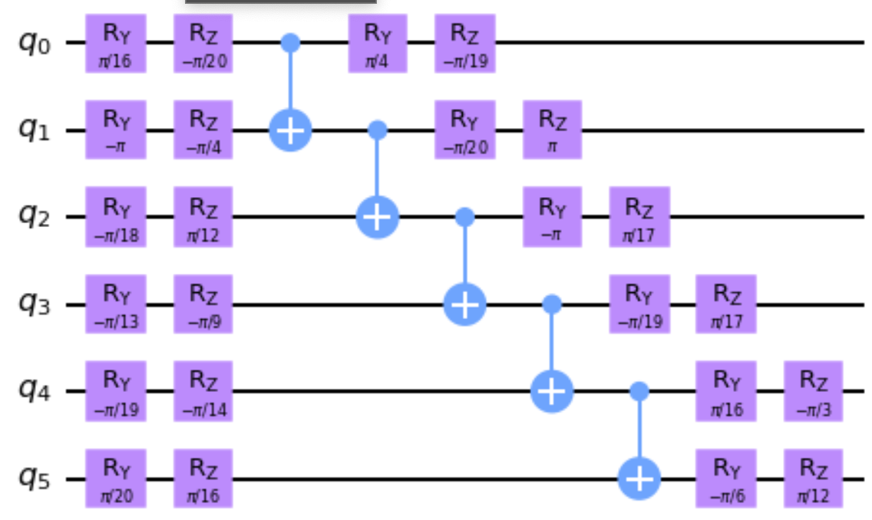

9 layers

2.815e+14 paths =

-0.00273768-0.00909492j

| Available Files | |
| --- | --- |
| circuit_194.data | The circuit definition |
| circuit_194.csv | Exact amplitudes for different transitions |

## Circuit 195- variational EfficientSU2: 6 qubits, 2 rep

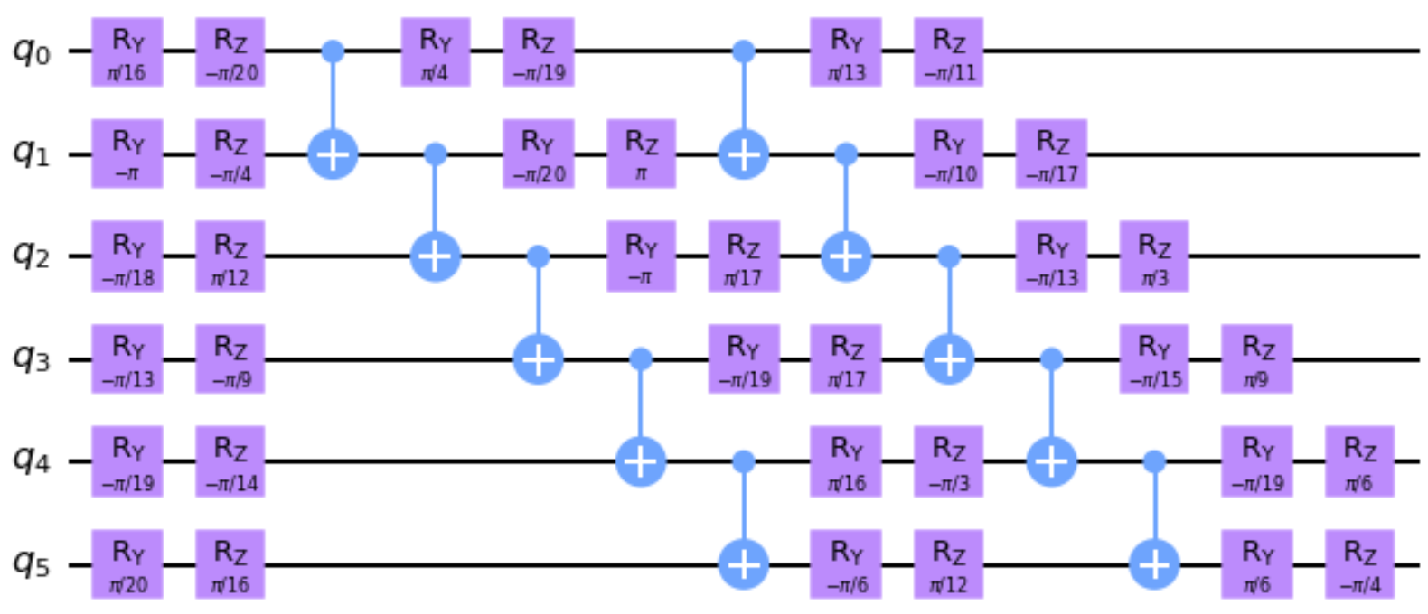

13 layers

4.722e+21 paths =

-0.00514611-0.02104634j

| Available Files | |
| --- | --- |
| circuit_195.data | The circuit definition |
| circuit_195.csv | Exact amplitudes for different transitions |

## Circuit 196- variational EfficientSU2: 15 qubits, 2 rep

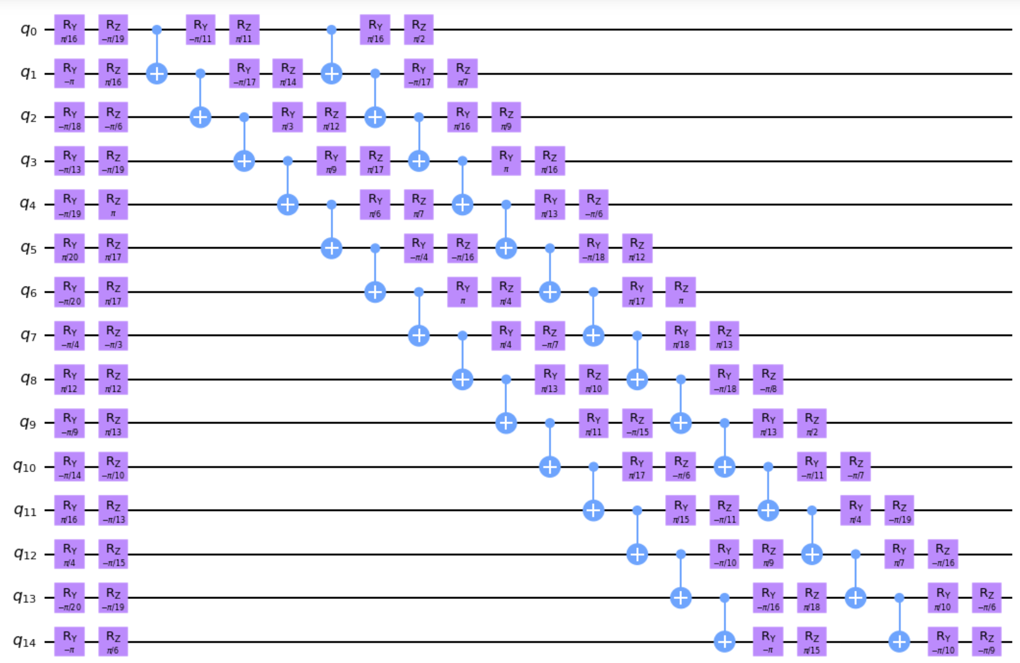

22 layers

6.675e+94 paths =

0.00364578+0.00060584j

| Available Files | |
| --- | --- |
| circuit_196.data | The circuit definition |
| circuit_196.jpg | Circuit diagram |
| circuit_196.csv | Exact amplitudes for different transitions |
| circuit_196.data_stats_IS_0_0.csv | Amplitudes and variances as a function of the number of samples for Importance Sampling and |
| circuit_196.data_stats_BD_0_0.csv | Amplitudes and variances as a function of the number of samples for Bidirectional Sampling and |
| circuit_196.data_stats_BD_MIS_0_0.csv | Amplitudes and variances as a function of the number of samples for Bidirectional Sampling with MIS and |

# Class 4100 – Hidden Shift Circuits

Deterministic circuits, in the sense that only one basis state in the output has an amplitude different from 0 (= 1.0).

These are based on the algorithm (and code) presented in Peres, Filipa 2023 (sec 4.1)

<https://arxiv.org/pdf/2203.01789.pdf>

## Circuit 4100- Hidden shift: 100 qubits, hidden string = 1023

43 layers

paths =

1.0 + 0.0j

| Available Files | |
| --- | --- |
| circuit_4100.data | The circuit definition |
| circuit_4100.jpg | Circuit diagram |

## Circuit 4101- Hidden shift: 8 qubits, hidden string = 7

53 layers

1.692e+125 paths =

1.0 + 0.0j

| Available Files | |
| --- | --- |
| circuit_4101.data | The circuit definition |
| circuit_4101.jpg | Circuit diagram |
| circuit_4101.csv | Exact amplitudes for different transitions |

## Circuit 4110- Hidden shift: 10 qubits, hidden string = 1023

56 layers

1.0 + 0.0j

| Available Files | |
| --- | --- |
| circuit_4110.data | The circuit definition |
| circuit_4110.jpg | Circuit diagram |

## Circuit 4120- Hidden shift: 20 qubits, hidden string = 1023

46 layers

1.0 + 0.0j

| Available Files | |
| --- | --- |
| circuit_4120.data | The circuit definition |
| circuit_4120.jpg | Circuit diagram |

## Circuit 4130- Hidden shift: 30 qubits, hidden string = 1023

43 layers

1.0 + 0.0j

| Available Files | |
| --- | --- |
| circuit_4130.data | The circuit definition |
| circuit_4130.jpg | Circuit diagram |

## Circuit 4140- Hidden shift: 40 qubits, hidden string = 1023

43 layers

1.0 + 0.0j

| Available Files | |
| --- | --- |
| circuit_4140.data | The circuit definition |
| circuit_4140.jpg | Circuit diagram |

## Circuit 4150- Hidden shift: 50 qubits, hidden string = 1023

43 layers

1.0 + 0.0j

| Available Files | |
| --- | --- |
| circuit_4150.data | The circuit definition |
| circuit_4150.jpg | Circuit diagram |

## Circuit 4160- Hidden shift: 60 qubits, hidden string = 1023

43 layers

paths =

1.0 + 0.0j

| Available Files | |
| --- | --- |
| circuit_4160.data | The circuit definition |
| circuit_4160.jpg | Circuit diagram |

## Circuit 4170- Hidden shift: 70 qubits, hidden string = 1023

43 layers

paths =

1.0 + 0.0j

| Available Files | |
| --- | --- |
| circuit_4170.data | The circuit definition |
| circuit_4170.jpg | Circuit diagram |

## Circuit 4180- Hidden shift: 80 qubits, hidden string = 1023

43 layers

paths =

1.0 + 0.0j

| Available Files | |
| --- | --- |
| circuit_4180.data | The circuit definition |
| circuit_4180.jpg | Circuit diagram |

## Circuit 4190- Hidden shift: 90 qubits, hidden string = 1023

43 layers

paths =

1.0 + 0.0j

| Available Files | |
| --- | --- |
| circuit_4190.data | The circuit definition |
| circuit_4190.jpg | Circuit diagram |

# Class 300 – IQP Inversion test

Inversion test of two random states encoded using IQP.

The probability of P(|0>n) is the overlap between the states.

## Circuit 305- IQP: 5 qubits

17 layers

1.209e+24 paths =

-0.104462+0.106694j

| Available Files | |
| --- | --- |
| circuit_305.data | The circuit definition |
| circuit_305.jpg | Circuit diagram |
| circuit_305.csv | Exact amplitudes for different transitions |

## Circuit 315- IQP: 15 qubits

55 layers

6.828e+243 paths =

-0.00128171-0.00008649j

| Available Files | |
| --- | --- |
| circuit_315.data | The circuit definition |
| circuit_315.jpg | Circuit diagram |
| circuit_315.csv | Exact amplitudes for different transitions |

## Circuit 325- IQP: 25 qubits

97 layers

paths =

-0.00013443-0.00022139j

| Available Files | |
| --- | --- |
| circuit_325.data | The circuit definition |
| circuit_325.jpg | Circuit diagram |
| circuit_325.csv | Exact amplitudes for different transitions |

# Class 500 – Random Circuits

Randomly generated circuits. The output state should follow a quasi-uniform distribution.

These are based on the algorithm (and code) presented in Peres, Filipa 2023 (sec 4.2)

<https://arxiv.org/pdf/2203.01789.pdf>

## Circuit 508- Random: 8 qubits, nCycles = 6

9 layers

1.845e+19 paths =

-0.04419417+0.10669417j

| Available Files | |
| --- | --- |
| circuit_508.data | The circuit definition |
| circuit_508.jpg | Circuit diagram |
| circuit_508.csv | Exact amplitudes for different transitions |
| circuit_508.data_stats_BD_MIS_0_0.csv | Amplitudes and variances as a function of the number of samples for Bidirectional Sampling with MIS and |

## Circuit 516 - Random: 16 qubits, nCycles = 12

22 layers

1.400e+101 paths =

-0.00040451-0.00138107j

| Available Files | |
| --- | --- |
| circuit_516.data | The circuit definition |
| circuit_516.jpg | Circuit diagram |
| circuit_516.csv | Exact amplitudes for different transitions |

## Circuit 525 - Random: 25 qubits, nCycles = 18

31 layers

5.922e+225 paths =

0.00035204+0.00038255j

| Available Files | |
| --- | --- |
| circuit_525.data | The circuit definition |
| circuit_525.jpg | Circuit diagram |
| circuit_525.csv | Exact amplitudes for different transitions |