PSOC™ Control C3 M/P 7/8 Training lab manual for security introduction
PSC3x7, PSC3x8

About this document
Scope and purpose
This document is a training manual for getting started with PSOC™ Control C3 M/P 7/8 MCU security using ModusToolbox™
Intended audience
The intended audiences for this document are design engineers, technicians, and developers of electronic systems

Table of contents
About this document 1
Table of contents 2
1 Introduction 4
2 Required Development Tools 5
3 Prerequisites 6
4 Code example: Secure Boot application 8
4.1 Objective 8
4.2 Description 8
4.3 Hardware diagram 8
4.4 Project Creation 9
4.5 Normal Boot 11
4.6 Ownership transfer 13
4.6.1 Set-up Edge Protect Tools 13
4.6.2 Create Certificate Signing Request 13
4.6.3 Get CSR signed from Infineon EPSS 13
4.6.4 Provision device with your certificate and keys 15
4.7 Enable Secure Boot in Policy 15
4.8 Enable signing of all three application images 17
4.9 Secure Boot 18
4.10 Conclusion 18
4.11 Revert to default configuration 18
References 20
Glossary 21
Revision history 22
Disclaimer 23

Introduction
This manual provides specific instructions to create, configure, build, and run the application code examples on the PSOC™ Control C3 M/P 7/8. It covers the full secure-boot workflow: key generation, device provisioning, image signing, and verification

Required Development Tools
- ModusToolbox™ software v3.8 or later − Recommended installation via ModusToolbox™ Setup tool
- Eclipse IDE for ModusToolbox™ v2025.8.0 or later− Recommended installation via ModusToolbox™ Setup tool
- Edge Protect Tools (edgeprotecttools)− Available in ModusToolbox™ Edge Protect Security Suite, v2.3.0 or later. Recommended installation via ModusToolbox™ Setup tool
- ModusToolbox™ Programming Tools v1.9.0 or later− Installed as a dependency by ModusToolbox™ Setup tool
- Board Support Package (BSP)− KIT_PSC3M8_EVK: v2.2.0 or later
- Terminal emulator− Instructions in this document use Tera Term
- PSOC™ Control C3M8 Evaluation Kit (KIT_PSC3M8_EVK)

Prerequisites
Do the following
- Install the software and obtain the hardware listed in the Required Development Tools section.
- Add the Edge Protect tools executable path to the environment path variable of the host PC. Default installation path of the Edge Protect Tools is C:/Users/<user>/Infineon/Tools/ModusToolbox-Edge-Protect-Security-Suite-x.y.z./tools/edgeprotecttools/bin
- Open the Windows Control Panel and look for the option to Edit environment variable.
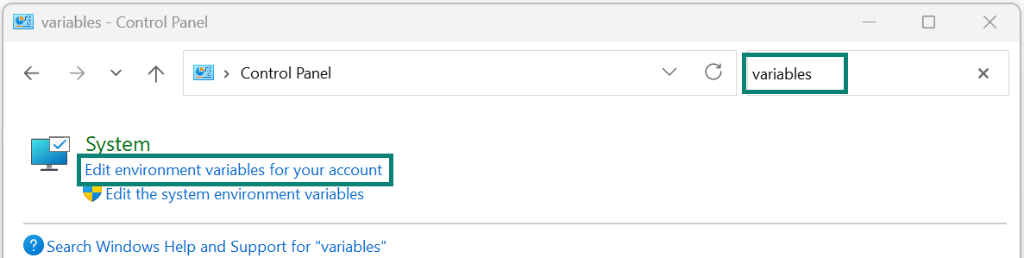
Figure 1 Open settings to change environment variables
- Select the system variable Path and click Edit.
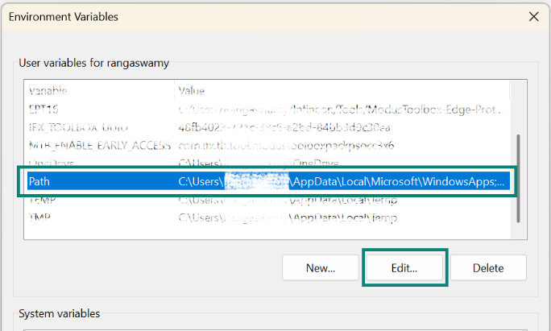
Figure 2 Modify the path variable
- Add new path pointing to the Edge Protect Tools executable. Click OK.
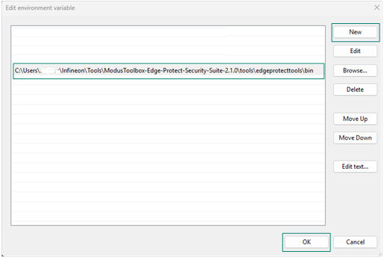
Figure 3 Add EPT path

Code example: Secure Boot application

Objective
This code example guides the user to sign all three application images (main_cm33_s, ppca_cm33_0, and ppca_cm33_1) and activate secure boot in the BootROM. With secure boot enabled, the BootROM validates the authenticity of every application image before handing over execution, ensuring only trusted firmware is launched.

Description
The PSOC™ Control C3 M/P 7/8 device is a three-core MCU consisting of:
- Main CM33 core – ARM Cortex-M33 with TrustZone security extension. Runs the primary secure application (main_cm33_s).
- PPCA Core 0 – PowerPC Architecture (PPCA) core based on ARM Cortex-M33 but without TrustZone. Runs the ppca_cm33_0 application.
- PPCA Core 1 – Second PPCA core, also CM33-based without TrustZone. Runs the ppca_cm33_1 application.
The code example demonstrates the chain of trust and secure-boot flow with "secure boot" enabled in the BootROM policy.

Hardware diagram
Figure 5 shows the hardware block diagram:
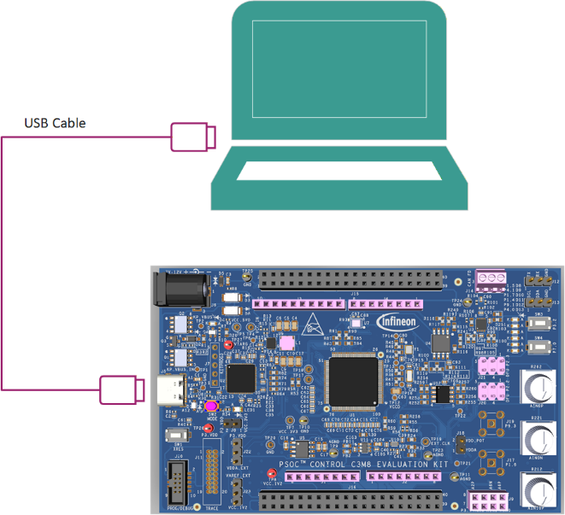
Figure 4 KIT_PSC3M8_EVK hardware block diagram

Project Creation
- Open the ModusToolbox™ Dashboard and launch the Eclipse IDE for ModusToolbox™.
If you have not installed ModusToolbox™, see the Required development tools section

Figure 5 ModusToolbox™ Dashboard
- Choose a workspace directory for your project. Click Launch.
Keep the workspace path short to avoid Windows path-length issues. This document uses C:/WS/Security as the workspace.
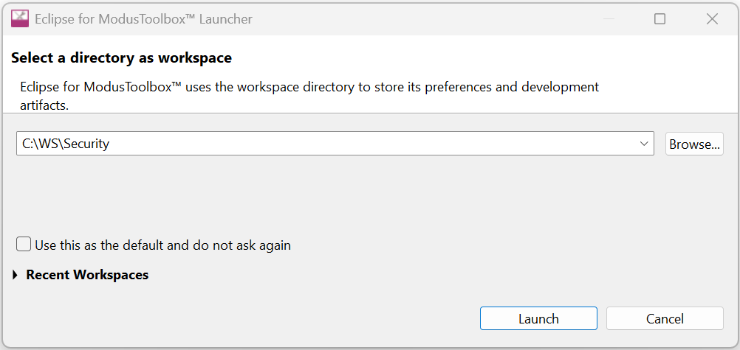
Figure 6 Choose workspace directory
- Select New Application from the Quick Panel, or go to File → New → ModusToolbox™ application to open Project Creator Tool
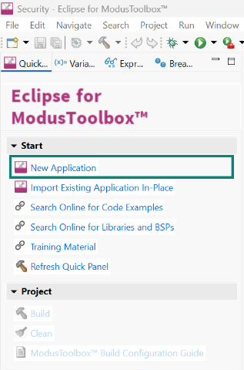
Figure 7 New application Creation
- Once Projector Creator launches, on the Choose Board Support Package (BSP) page, select KIT_PSC3M8_EVK under the PSOC™ Control BSPs and click Next
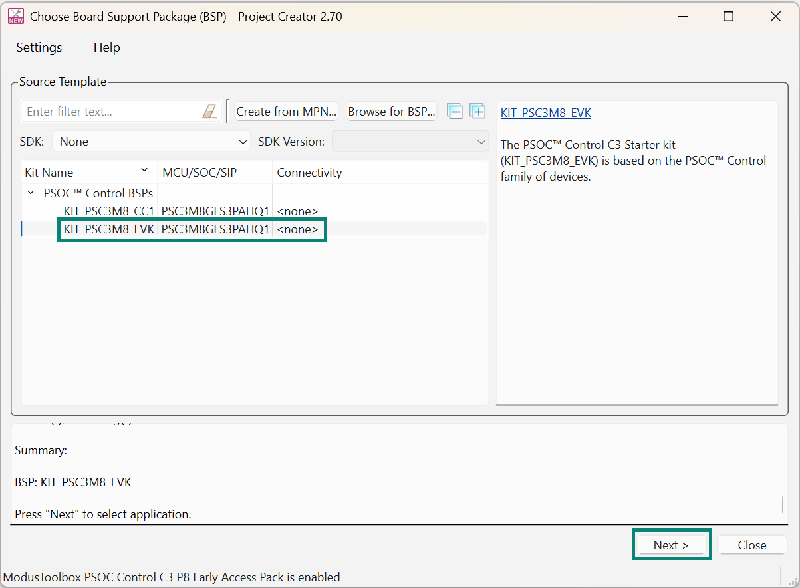
Figure 8 Project Creator – BSP selection (KIT_PSC3M8_EVK)
- On the Select Application page, find and select Secure Boot application. Click Create
To prevent Windows path-length issues it is recommended to shorten the project name if your workspace path is long. This document uses the default project name "Secure_Boot_Application"
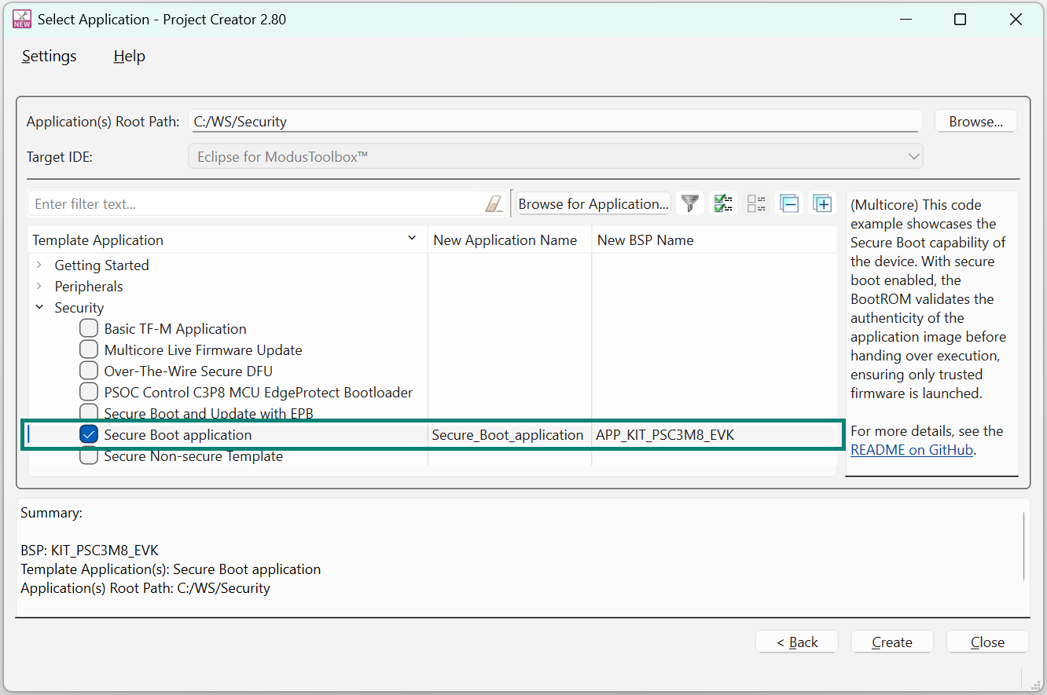
Figure 9 Application selection – Secure Boot application
- After creation, the three sub-projects appear in the Project Explorer: main_cm33_s, ppca_cm33_0, and ppca_cm33_1.
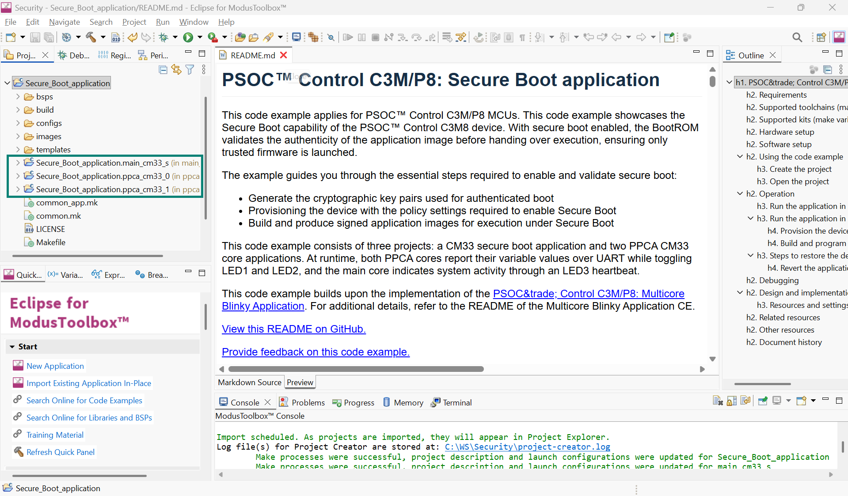
Figure 10 Three-project structure in Project Explorer
The three-project structure reflects the three physical cores of the device: one CM33 main core and two PPCA cores

Normal Boot
Build and Program the application in normal mode (Image signing is not enabled by default - SECURED_BOOT = FALSE) by clicking Run / Program in the Quick Panel
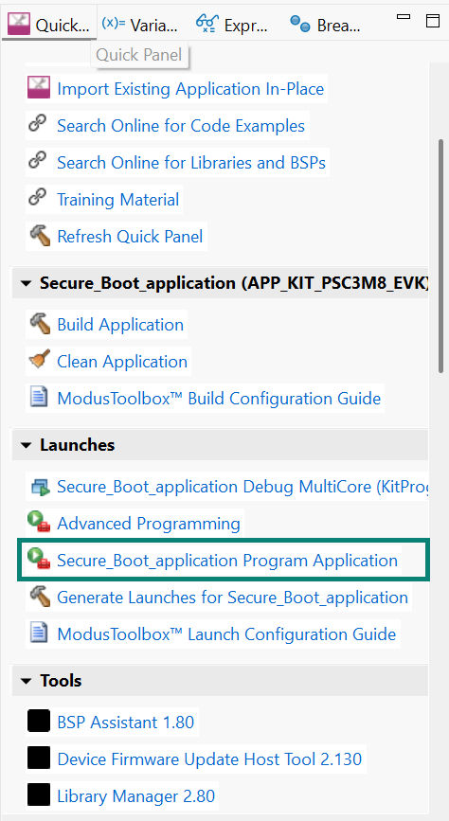
Figure 11 Program and Run the application
After programming is successful, open the serial terminal and configure it for 115200 8-N-1. Then press the kit reset button. The message "PSoC™ Control C3M8: Secure Boot Code Example" is printed, and the kit LEDs blink as configured.
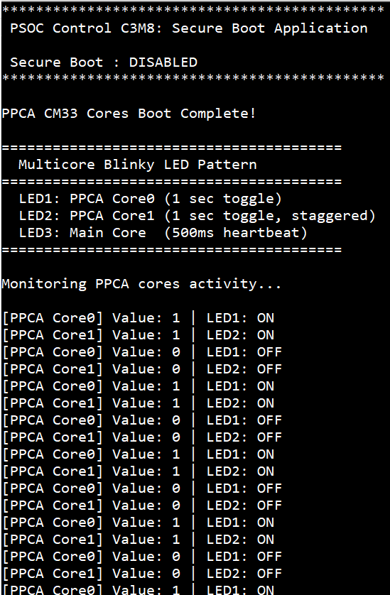
Figure 12 Terminal output – startup message

Ownership transfer
Before changing the OEM policy, ownership of the device must be transferred to yourself using Edge Protect Tools (edgeprotecttools).

Set-up Edge Protect Tools
- Open modus-shell from the Windows Start Menu.
- Navigate to the application directory in modus-shell
cd C:/WS/Security/Secure_Boot_Application
- Initialize edgeprotecttools
edgeprotecttools -t psoc_c3x8 init
- Configure the openOCD path:
edgeprotecttools set-ocd --name openocd --path <openocd_path>
Replace <openocd_path> with the path to the openocd directory: Typically, this will be C:/infineon/Tools/ModusToolboxProgtools-x.y/openocd

Create Certificate Signing Request
Generate a key pair (private + public) and use it to create a CSR needed to produce a signed OEM certificate.
- Create a private/public ECDSA-P521 key pair:
edgeprotecttools --no-interactive-mode create-key --key-type ECDSA-P521 -o keys/oem_dev_priv_key.pem keys/oem_dev_pub_key.pem
- Generate the CSR:
edgeprotecttools -t psoc_c3x8 oem-csr --public-key-0 keys/oem_dev_pub_key.pem --public-key-1 keys/oem_dev_pub_key.pem --sign-key-0 keys/oem_dev_priv_key.pem --sign-key-1 keys/oem_dev_priv_key.pem --oem "Company Name" --project "Project Name" --project-number 12345678 --cert-type development --output keys/oem_csr_development.bin

Get CSR signed from Infineon EPSS
- Sign up for an Infineon Online Software Tools and Services (OSTS) account at https://osts.infineon.com/epss/home
- Log in and click Edge Protect Signing Service.

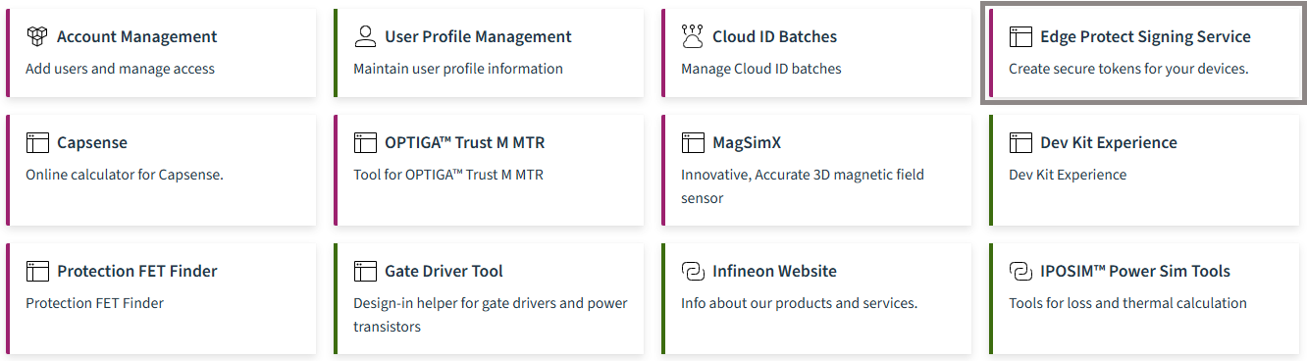
Figure 13 EPSS
- Click Upload New Certificate Request.
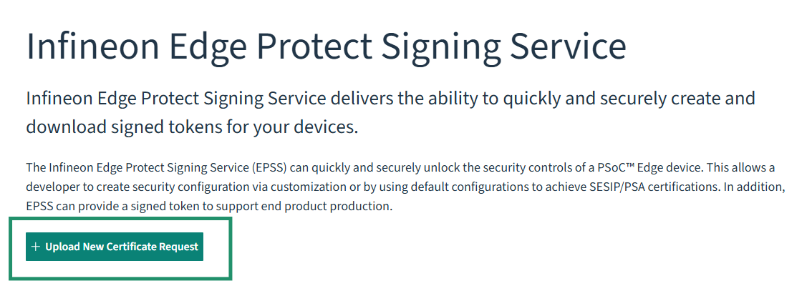
Figure 14 Upload new certificate request
- Enter the certificate details:
- Enter a certificate name without spaces or special characters.
- Select PSOCC3X8 as the Silicon Revision.
- Enter a description so you can identify this certificate later.
- Upload the CSR file located at: C:/WS/Security/Secure_Boot_Application/keys/ oem_csr_development.bin
- Click Submit.
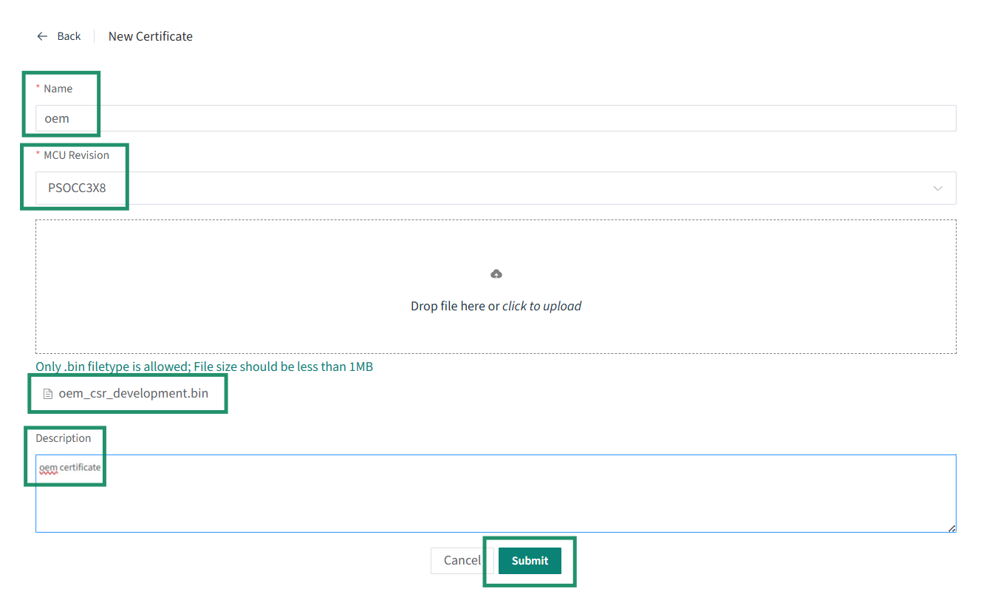
Figure 15 Enter certificate details and upload CSR
- Download the signed certificate from Manage Certificates. The file will be named <cert-name>_cert.bin (e.g., oem_cert.bin if the name was "oem"). Creating the certificate may take a few minutes – click Refresh List if needed
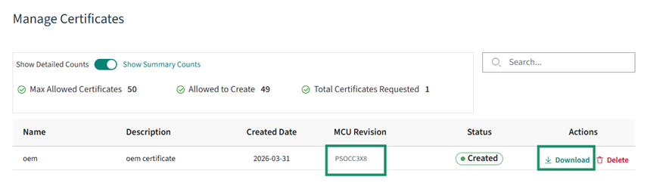
Figure 16 Manage Certificates – download signed certificate
- Copy the downloaded certificate to C:/WS/Security/Secure_Boot_Application/keys/ folder as oem_cert_development.bin

Provision device with your certificate and keys
Run the provisioning command to transfer ownership to yourself:
edgeprotecttools -t psoc_c3x8 provision-device -p policy/policy_oem_provisioning.json --ifx-oem-cert keys/oem_cert_development.bin --key keys/oem_dev_priv_key.pem

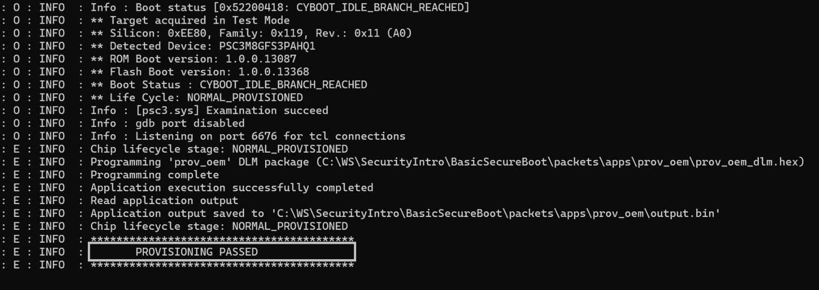
Figure 17 Successful provisioning

Enable Secure Boot in Policy
To enable secure boot, the OEM policy must be updated to set the boot configuration identifier to SECURE_APP and to provide the memory layout for all three application images.
- Open the OEM policy file created when edgeprotecttools was initialized with any text editor. The file is located at C:/WS/Security/Secure_Boot_Application/policy/policy_oem_provisioning.json.
- Set device_policy → boot → boot_cfg_id → value to SECURE_APP: Update device_policy → boot → boot_app_layout to provide start address and size for each of the three images.
Code listing 1 Policy file boot_cfg_id
- "boot": {
- "boot_cfg_id": {
- "description": "A behavior for BOOT_APP_LAYOUT",
- "applicable_conf": "SIMPLE_APP, SECURE_APP, DUAL_BANK_SIMPLE_APP, ...",
- "value": "SECURE_APP"
- },

- Update device_policy → boot → boot_app_layout to provide start address and size for each of the three images.
Code listing 2 Policy file boot_app_layout
- "boot_app_layout": {
- "description": "The memory layout for the applications defined by BOOT_CFG_ID. 0x32000000 -
- 0x33FFFFFF for secure addresses; 0x22000000 - 0x23FFFFFF for non-secure addresses",
- "value": [
- {
- "address": "0x32000000",
- "size": "0x6E000"
- },
- {
- "address": "0x3206E000",
- "size": "0x9000"
- },
- {
- "address": "0x32077000",
- "size": "0x9000"
- },
- {
- "address": "0x00000000",
- "size": "0x00"
- },
- {
- "address": "0x00000000",
- "size": "0x00"
- }
- ]
- },
The address range 0x32000000–0x33FFFFFF corresponds to secure (S-bus) addresses. There are five slots in the layout structure, but only the first three are used here
- Provision the device with the updated policy

edgeprotecttools -t psoc_c3x8 provision-device -p policy/policy_oem_provisioning.json --ifx-oem-cert keys/oem_cert_development.bin --key keys/oem_dev_priv_key.pem

Reset the EVK and observe that the application no longer boots. This confirms secure boot is active. The BootROM now expects signed images.

Enable signing of all three application images
In Secure Boot Application code example, signing of all three images is automated as a post-build step controlled by the SECURED_BOOT flag.
- Open common.mk in the application root directory
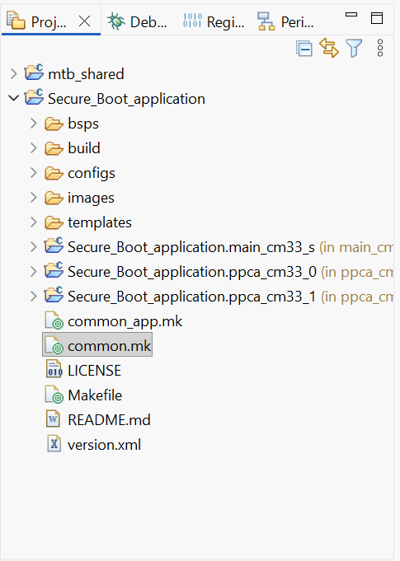
Figure 18 Open common.mk in the application
- Set SECURED_BOOT to TRUE:
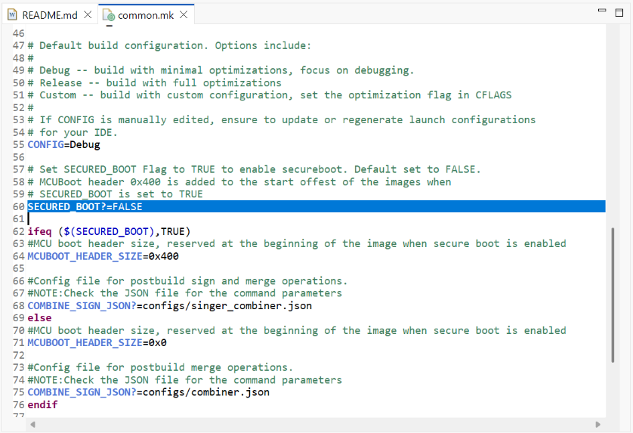
Figure 19 Enable Image Signing
When SECURED_BOOT=TRUE the build system uses configs/singer_combiner.json, which signs all three images (main_cm33_s, ppca_cm33_0, ppca_cm33_1) using the key at keys/oem_dev_priv_key.pem and prepends a 0x400-byte MCUboot header to each image. It then merges all three signed images into a single app_combined.hex file.

Secure Boot
Build and Program the application by clicking Run / Program in the Quick Panel (SECURED_BOOT is TRUE). Verify successful booting on the terminal. The BootROM validates all three images before any core starts executing
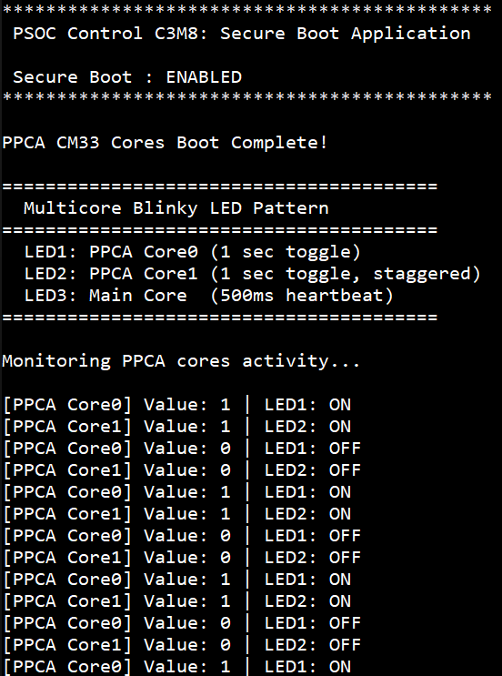
Figure 20 Terminal output after enabling Secure Boot

Conclusion
We have successfully completed the following:
- Generated an ECDSA-P521 key pair and CSR
- Obtained a signed OEM certificate from Infineon OSTS
- Transferred ownership of the device via provisioning
- Enabled 'secure boot' in the BootROM by setting boot_cfg_id to SECURE_APP
- Signed all three application images (main_cm33_s, ppca_cm33_0, ppca_cm33_1)
- Launched a fully verified three-core application
(Try it yourself) Use a wrong key to sign one of the images and verify that none of the applications execute – confirming that the BootROM enforces the chain of trust for all cores

Revert to default configuration
The changes made during this training may impact other code examples. It is recommended to revert all changes unless you plan to continue working with a secure device.
- Revert the OEM policy to disable secure boot and restore the default boot_app_layout:
Code listing 4 Policy file boot_cfg_id default
- "boot": {
- "boot_cfg_id": {
- "description": "A behavior for BOOT_APP_LAYOUT (BOOT_SIMPLE_APP applicable to
- NORMAL_PROVISIONED only)",
- "applicable_conf": "SIMPLE_APP, SECURE_APP, DUAL_BANK_SIMPLE_APP,
- DUAL_BANK_SECURE_APP, PROT_FW",
- "value": "SIMPLE_APP"
- },

Code listing 5 Policy file boot_app_layout default
- "boot_app_layout": {
- "description": "The memory layout for the applications defined by BOOT_CFG_ID. 0x32000000 -
- 0x33FFFFFF for secure addresses; 0x22000000 - 0x23FFFFFF for non-secure addresses",
- "value": [
- {
- "address": "0x32000000",
- "size": "0x40000"
- },
- {
- "address": "0x00000000",
- "size": "0x00"
- },
- {
- "address": "0x00000000",
- "size": "0x00"
- },
- {
- "address": "0x00000000",
- "size": "0x00"
- },
- {
- "address": "0x00000000",
- "size": "0x00"
- }
- ]
- },

- Save the policy file and provision the device:
edgeprotecttools -t psoc_c3x8 provision-device -p policy/policy_oem_provisioning.json --ifx-oem-cert keys/oem_cert_development.bin --key keys/oem_dev_priv_key.pem

References
- AN241270: Getting started with PSOC™ Control C3 (P/M) (8/7) on ModusToolbox™ software; Available Online
- AN242836: Getting started with PSOC™ Control C3 (P/M)(8/7) MCU security; Available Online
- AN242919: PSOC™ Control C3 (P/M)(8/7) MCU provisioning specification; Available Online

Glossary
PPCA
Programable Power Control Accelerator (PPCA)
BSP
Board Support Package (BSP)
OEM
Original Equipment Manufacturer (OEM)
IDE
Integrated Development Environment (IDE)
EPT
Edge Protect Tools (EPT)
Python-based CLI tool provide by Infineon for device security operations like key generation, provisioning, image signing etc.
OSTS
Online Software Tools and Services (OSTS)
Website which hosts many software tools and services offered by Infineon.
EPSS
Edge Protect Signing Service (EPSS)
Infineon Edge Protect Signing Service delivers the ability to quickly and securely create and download signed certificates for your devices.
CSR
Certificate Signing Request (CSR)
An encoded text block containing your public keys and identifying details (such as organization and project name) that you submit to a Certificate Authority to obtain a signed certificate. It is not a certificate itself, but the application required to generate one.
ECC
Eliptica Curve Cryptography (ECC)
Cryptographic method which utilizes the algebraic structure of elliptic curves over finite fields.

Revision history
Document revision | Date | Description of changes
1.00 | 2026-06-15 | Initial release
2.00 | 2026-10-08 | Removed references to Early access pack

Disclaimer

