E2 - Getting started with the Development ecosystem for PSOC™ Edge E84 training manual

About this document
Scope and purpose
This training manual provides a comprehensive guide to getting started with the PSOC™ Edge E84 MCU, including detailed instructions on creating, configuring, building, and running application code examples using ModusToolbox™.

Table of contents
About this document 1
Table of contents 2
1 Introduction 3
2 Pre-requisite 4
3 Required development tools 5
4 Code example: Hello world + Blinky 6
4.1 Objective 6
4.2 Description 6
4.3 Flow chart 6
4.4 Hardware diagram 7
4.5 Project creation 8
4.5.1 Output 9
4.6 Configure/rename a pin using Device Configurator 9
4.7 Conclusion 14
5 Code example: IPC semaphore using PDL 15
5.1 Objective 15
5.2 Description 15
5.3 Flow chart 16
5.4 Hardware diagram 17
5.5 Project creation 17
5.6 Enabling retarget-io on CM55 18
5.6.1 Output 23
5.7 Implement the GPIO button and print messages using both CPUs 23
5.7.1 Output 25
5.8 Use IPC semaphore to synchronise access to UART 25
5.8.1 Output 31
5.9 Conclusion 31
6 Appendix A: Creating a PSOC™ Edge application in ModusToolbox™ 32
7 Appendix B: KIT_PSE84_EVAL details 35
Revision history 36
Disclaimer 37

Introduction
PSOC™ Edge E84 series of Arm® Cortex®-M MCUs feature high-performance, low-power, secured MCUs with advanced machine learning (ML) acceleration for next-generation AI/ML applications.
The PSOC™ Edge E84 MCUs are based on Arm® Cortex®-M55, with Helium DSP support paired with Ethos-U55 NPU as well as a low-power Cortex®-M33 paired with Infineon’s ultra-low power NNLite hardware accelerator and advanced HMI interfaces, including graphics.
This introductory course to the PSOC™ Edge development ecosystem delivers a thorough overview of its software and hardware tools, with detailed, step-by-step guidance to help you quickly build your first application.

Pre-requisite
Install the software and obtain the hardware listed in the Required development tools section.
This is an introductory training to PSOC™ Edge and ModusToolbox™; however, it is not intended to cover all basic concepts.
- For an introduction to PSOC™, including a getting started guide to ModusToolbox™, go to:
- https://www.infineon.com/product-information/psocdeveloper
- For PSOC™ Edge trainings, from beginner tutorials to advanced trainings, go to:
- PSOC™ Edge E84 Training Collection

Required development tools
- ModusToolbox™ software v3.6 or later
- Recommended installation via ModusToolbox™ Setup tool
- Eclipse IDE for ModusToolbox™ v2025.4.0 or later
- Recommended installation via ModusToolbox™ Setup tool
- Edge Protect Security Suite v1.6 or later
- Installed by ModusToolbox™ Setup tool as a dependency to ModusToolbox™ v3.6
- ModusToolbox™ Programming Tools v1.5.0 or later
- Installed by ModusToolbox™ Setup tool as a dependency to ModusToolbox™ v3.6
- Board support package (BSP):
- KIT_PSE84_EVAL_EPC2: v1.0.0 or later (available with ModusToolbox™ v3.6)
- Serial terminal emulator
- Eclipse IDE for ModusToolbox™ includes a serial terminal. Other options include Tera Term, PuTTY, and so on
- PSOC™ Edge E84 Evaluation Kit (KIT_PSE84_EVAL)
- Ensure BOOT SW (SW6) should be in 'High'/ON position
For KIT_PSE84_EVAL rev. G, BOOT SW pin is BOOT.1 (P17.6)
- Ensure J20 and J21 should be in the Tristate/Not-Connected (NC) position
- See Appendix B: KIT_PSE84_EVAL details for more details

Code example: Hello world + Blinky

Objective
This code example shows how to implement simple UART communication by printing a Hello world message on a terminal. It also blinks an LED using a timer resource in the PSOC™ Edge E84 MCU. The code example uses the Peripheral driver library (PDL) and Device Configurator included in ModusToolbox™.

Description
This code example demonstrates the following algorithm flow:
Step 1: Initialise peripherals such as UART and GPIO
Step 2: Print “Hello World” on the serial terminal using UART
Step 3: Blink the LED through the GPIO

Flow chart
Figure 1 explains the flow of the PSOC™ Edge MCU: Hello world project:
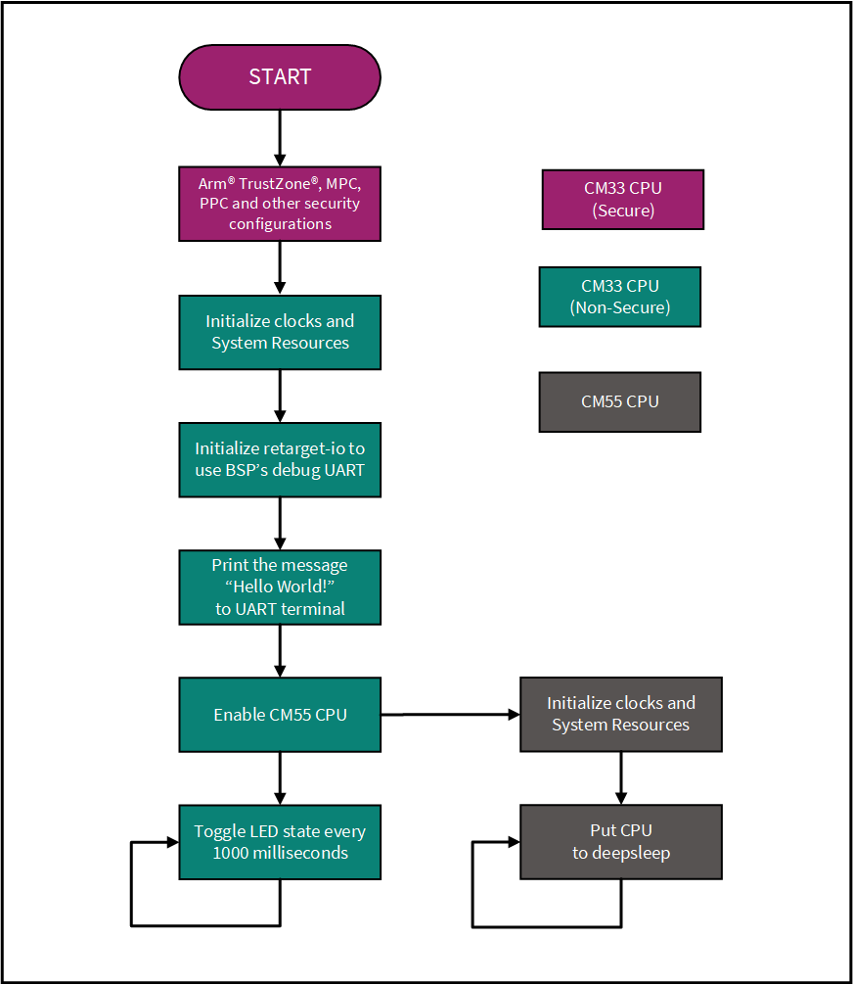
Figure 1 Flow chart of Hello World project

Hardware diagram
Below is the hardware block diagram for this example:
- UART pins:
- P6_7 (UART_TX)
- P6_5 (UART_RX)
- GPIO LED pin:
- P16_7 (LED)
This example requires BOOT SW in the ON position.
See Appendix B: KIT_PSE84_EVAL for more details.
Figure 2 Hardware diagram for Hello World example

Project creation
- Follow steps 1-4 in Appendix A: Creating a PSOC™ Edge application in ModusToolbox™ to create a new application
- When creating the application, select the PSOC™ Edge Hello World application under the Getting Started section
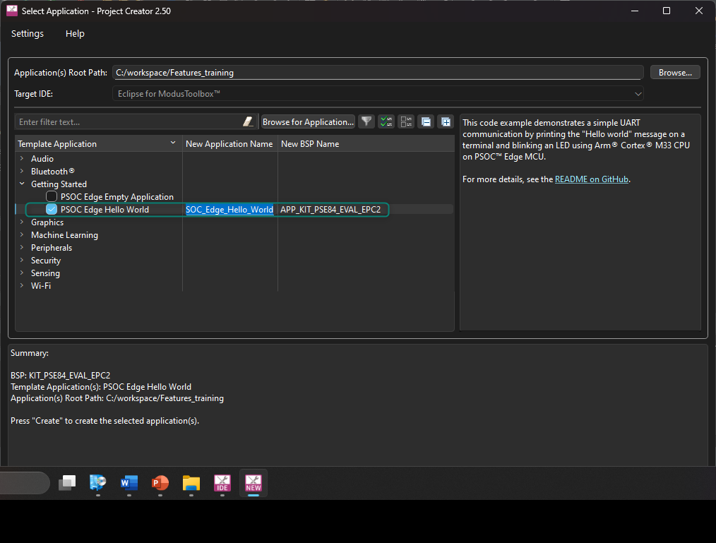
Figure 3 Selecting application
- Run the application by clicking on the Run option in the Quick Panel. Note that this step will also build the project
Make sure the top level of the project is selected in the project workspace to ensure all three applications are built and programmed. If one of the three applications (cm33_s, cm33_ns, or cm55) is selected, then ModusToolbox™ will build and program the selected application.
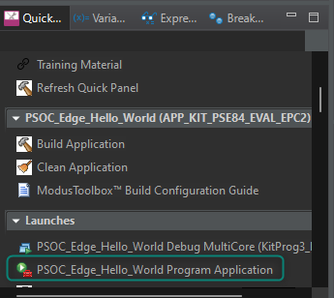
Figure 4 Build and program the application

Output
After the program runs successfully, open the serial terminal and configure the baud rate to 115200-8-N-1. Then press the kit reset button. A message is printed as in Figure 5, and the kit LED blinks at approximately
1 Hz.
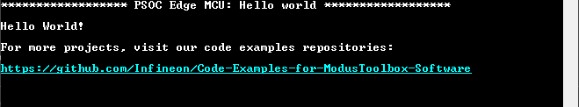
Figure 5 Output of the Hello World program

Configure/rename a pin using Device Configurator
The Device Configurator provides a graphical view of device peripherals, and it generates macros, data structures, and initialization functions based on your selections. The BSP function cybsp_init() calls the generated functions to set up the clocks, pins, and internal routing. It is typically called from the main() function before using on-chip peripherals such as serial blocks and timer/counters.
When you launch the Device Configurator from Eclipse, you are opening the project’s design.modus file, which is responsible for holding all the BSP configuration information. It contains the following:
- Selected device
- Resource parameters
- Constraints
Now, let us look at how to configure or rename the pins using the Device Configurator.
- Open the Device Configurator tool that can be found in the Quick Panel area under the BSP Configurators section
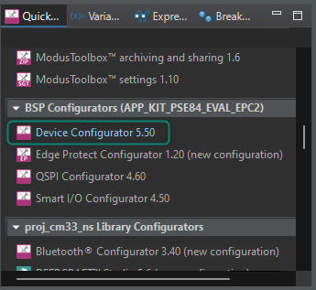
Figure 6 Opening Device Configurator

- [INFO] The Device Configurator includes the following tabs:
- Peripherals: configures peripherals, including communication, digital and system
- Analog: configures analog modules, including the autonomous analog, which includes ADC, PTComps, autonomous controller, CTBs, and PRB; and the low-power comparators
- Pins: configures the GPIOs, including Smart IO functionality
- Clocks: configures the device clock tree, including all clock inputs and outputs
- System: configures security, protection, and system settings such as debug and power modes
- Memory: configures the memory allocation and provides a graphical view of the memory map
- DMA: configures the device’s DMAs
Feel free to navigate through the different tabs. The Device Configurator will only generate code when the design.modus file is saved.
- In the Device Configurator, go to the Pins tab
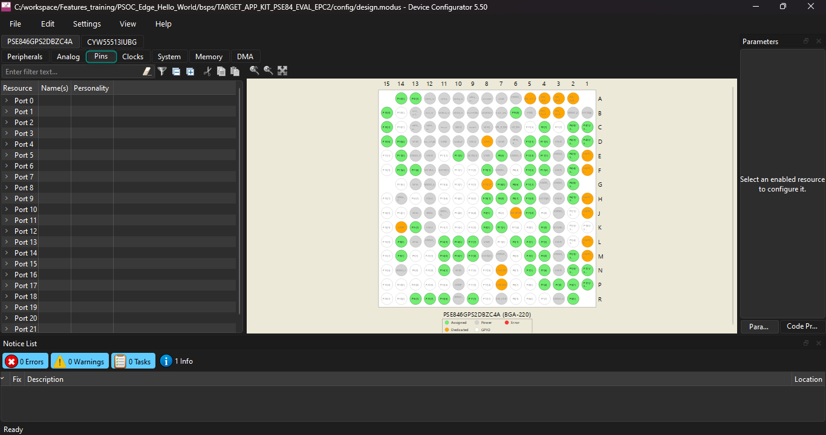
Figure 7 Pins tab in Device Configurator
- [INFO] In this particular development kit, the three user LEDs are connected to Port 16, pins 5, 6 and 7, as per the kit schematic.
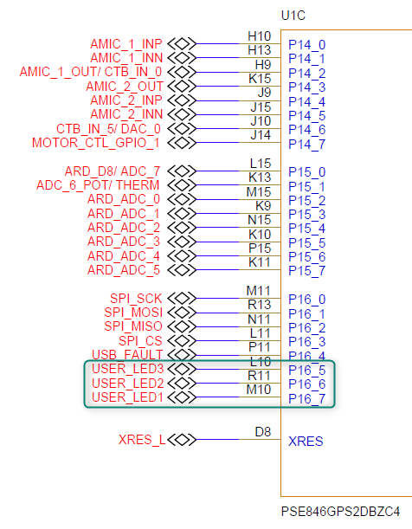
Figure 8 Connection of LEDs in EVK schematics
Each pin can be uniquely identified by giving it a name of your choice. These names are known as aliases. In the code, aliases can be used to refer to pins instead of using explicit PINs.
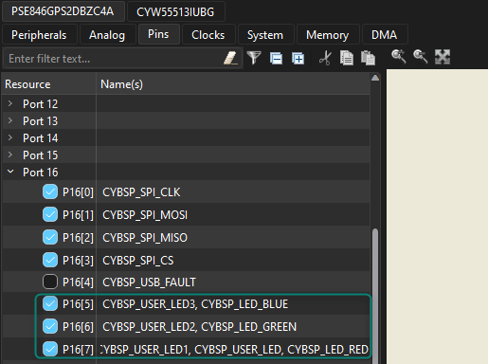
Figure 9 Pin alias in Device Configurator
- Rename Port 16[7] as TRAINING_LED. We will be using this LED in our application
Select File→Save or press Ctrl+S to save the change and regenerate source files.
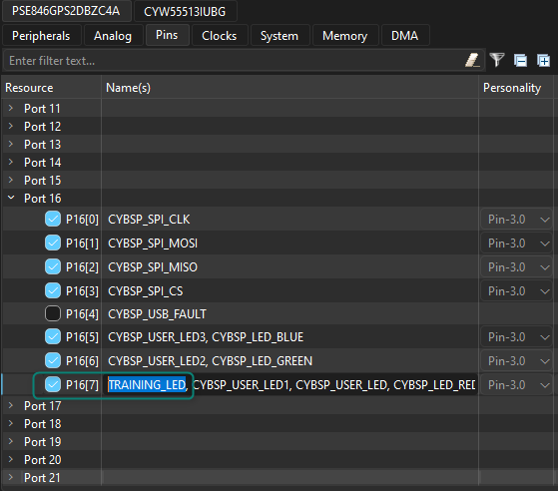
Figure 10 Renaming P16[7] as TRAINING_LED
- [INFO] Changes made in the Device Configurator are enabled once you save the file.
Try opening the cycfg_pins.h file (located at <application-directory>\bsps\TARGET_APP_KIT_PSE84_EVAL_EPC2\config\GeneratedSource\cycfg_pins.h), and you should be able to observe the pin definitions and aliases.
The changes we have made are reflected in the file as in Figure 11:
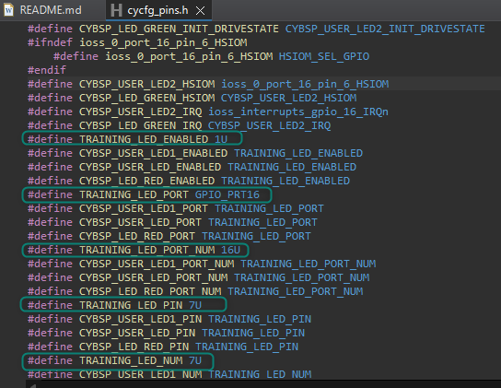
Figure 11 Code generation from Device Configurator
- [INFO] The Device Configurator includes links to documentation. Click the link in the Parameters window to open and navigate through the GPIO documentation. Alternatively, the documentation is also available in PSOC™ E8XXGP Device Support Library

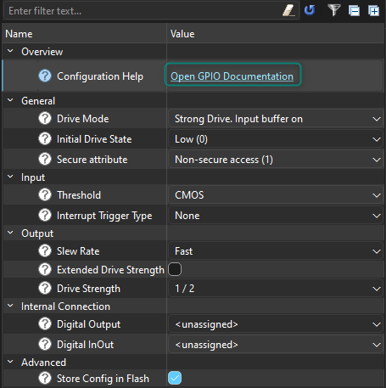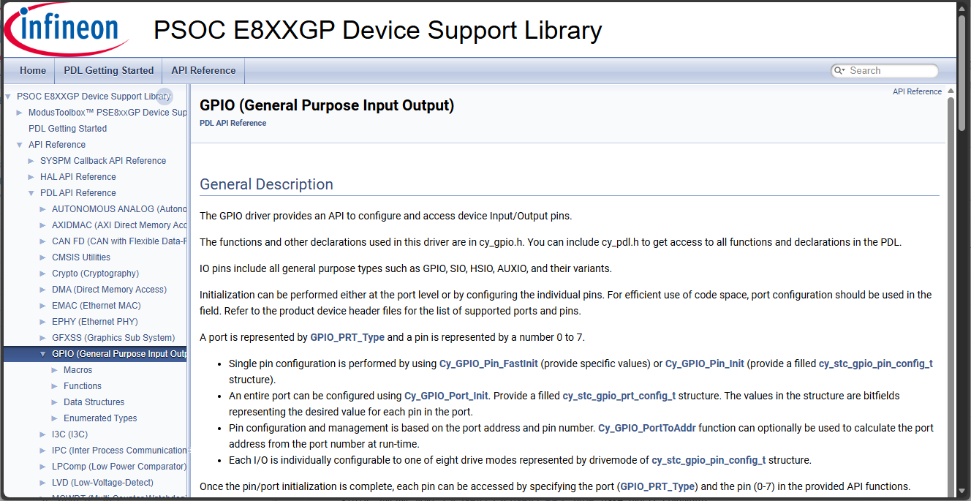
Figure 12 Documentation for GPIO PDL
- [INFO] In the Project Explorer, you should be able to observe three folders named PSOC_Edge_Hello_World.proj_cm33_ns, PSOC_Edge_Hello_World.proj_cm33_s, and PSOC_Edge_Hello_World.proj_cm55
Each folder contains a main.c file which contains application code for each corresponding project.
- Open the main.c file under PSOC_Edge_Hello_World.proj_cm33_ns
We will modify the code to align with the new LED alias
Inside the main.c file, under the infinite for loop, change the CYBSP_USER_LED_PORT to TRAINING_LED_PORT and CYBSP_USER_LED_PIN to TRAINING_LED_PIN as shown in code lisitng 1.
Code listing 1 Modification for Hello World application
for(;;)
{
Cy_GPIO_Inv(TRAINING_LED_PORT, TRAINING_LED_PIN);
Cy_SysLib_Delay(BLINKY_LED_DELAY_MSEC);
}

- Save the file. We are done with adding the application code for proj_cm33_ns
- Rebuild by clicking on the Build Application option in the Quick Panel
- After the build is successfully completed, program the Evaluation kit by clicking the Launch button in the Quick Panel
- After the program runs successfully, open the serial terminal and configure the baud rate to 115200-8-N-1. Then reset the kit. The same application should be executed, and the kit LED should continue blinking at approximately 1 Hz

Conclusion
We successfully created our first PSOC™ Edge E84 MCU application using ModusToolbox™, modified code using PDL libraries, printed a message in a terminal, and blinked an LED.
This confirms that the device, EVK, and tools are functional.

Code example: IPC semaphore using PDL

Objective
This lab exercise demonstrates how to use the inter-processor communication (IPC) PDL driver to implement a simple semaphore scheme with PSOC™ Edge. A semaphore is used to manage access to a common resource, such as a UART, between the CPUs.
This guide utilizes the Hello World example to show the step-by-step process to add IPC semaphores and shows features like the Library Manager and software documentation; however, ModusToolbox™ includes the mtb-example-psoc-edge-ipc-sema code example, which showcases this functionality in a ready-to-use project.

Description
A shared IPC semaphore is used to coordinate access to a common resource between the two CPUs. In this example, the resource is the UART: each CPU prints a message to the computer terminal over the UART whenever the user button is pressed. Before printing, both CPUs try to acquire the semaphore. If successful, the CPU prints the message and then releases the semaphore. If the semaphore is already held, it keeps trying until it can acquire it.
Without the semaphore to synchronize access to the UART, messages from both CPUs will overlap. See the flowchart to see visually how the code will operate.

Flow chart
Figure 13 IPC semaphore code example flow

Hardware diagram
Below is the hardware block diagram for this example:
- UART pins:
- P6_7 (UART_TX)
- P6_5 (UART_RX)
- GPIO LED pin:
- P16_7 (LED)
- Buton pin:
- P8_3 (USER_BTN1)
This example requires BOOT SW in the ON position.
See Appendix B: KIT_PSE84_EVAL details for more details.
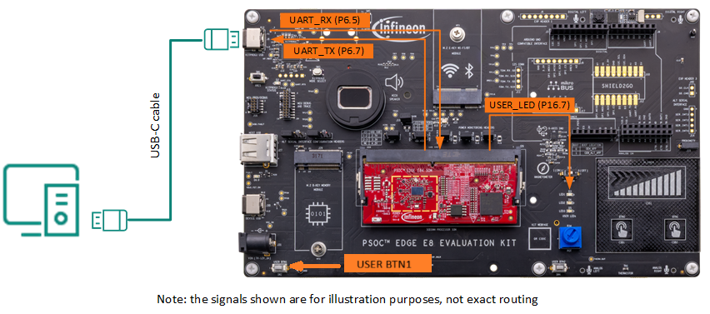
Figure 14 Hardware diagram for Hello World example

Project creation
This lab utilizes the same hello world example from Code example: Hello world + Blinky. Alternatively, create a new Hello World example and name it differently.

Enabling retarget-io on CM55
The Hello World example utilizes the retarget-io library to print debug information from the CM33 project using UART. In this section, we will show how to use the Library Manager to do the same using the CM55 core.
- Open the Library Manager from the Quick Panel
The Library Manager provides a GUI to select which Board Support Package (BSP) should be used when building a ModusToolbox™ application. The tool collects a list of available and currently selected BSPs and libraries, as well as all the necessary metadata from a webservice. The tool allows you to add and remove BSPs and libraries, as well as change their versions.
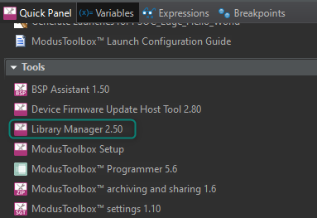
Figure 15 Opening Library Manager
- [INFO] Observe that the project already includes multiple libraries for the CM33 secure, CM33 non-secure, and CM55 projects. Libraries worth highlighting for this example are:
- mtb-dsl-pse8xxgp: provides all necessary device-specific components to be used during software development for the PSE8xxGP family of devices, including HAL and PDL drivers
- mtb-ipc: allows communication between multiple CPUs or between multiple tasks operating in different domains within a single CPU
- retarget-io: retargets the standard input/output (STDIO) messages to a UART port
mtb-dsl-pse8xxgp is included for all PSOC™ Edge examples in ModusToolbox™.
This lab requires mtb-ipc on proj_cm33_ns and proj_cm55 since we will communicate between both cores. Observe that the library is enabled for both projects.
On the other hand, retarget-io is enabled for proj_cm33_ns and not for proj_cm55. This library is not required for IPC semaphores; however, we will show how to move this library to utilize printf in proj_cm55.

- In the proj_cm33_ns, click the cross icon to remove the retarget-io, since we will not be using this library on the CM33. Click Add Library
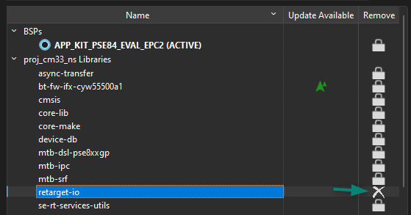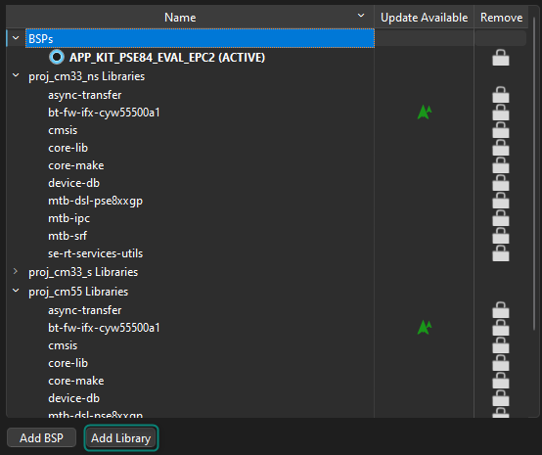
Figure 16 Remove retarget-io from proj_cm33_ns
- Select proj_cm55 as the Target Project, then enable the retarget-io library by clicking on the checkbox, and click OK
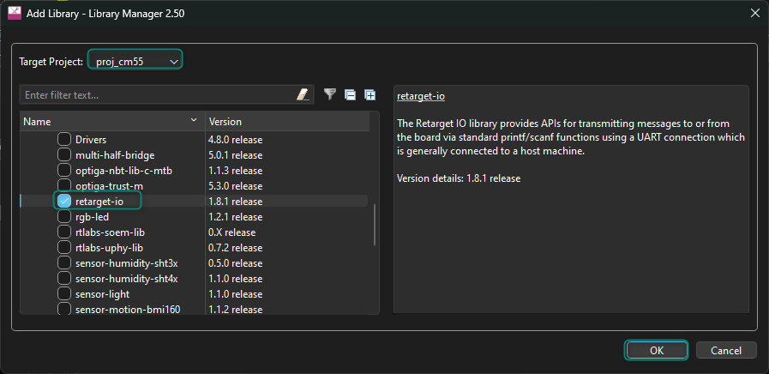
Figure 17 Add the retarget-io library to proj_cm55
- In the main Library Manager window, observe that the retarget-io library was removed from proj_cm33_ns and added to proj_cm55, then click Update. This will effectively add the library to the project
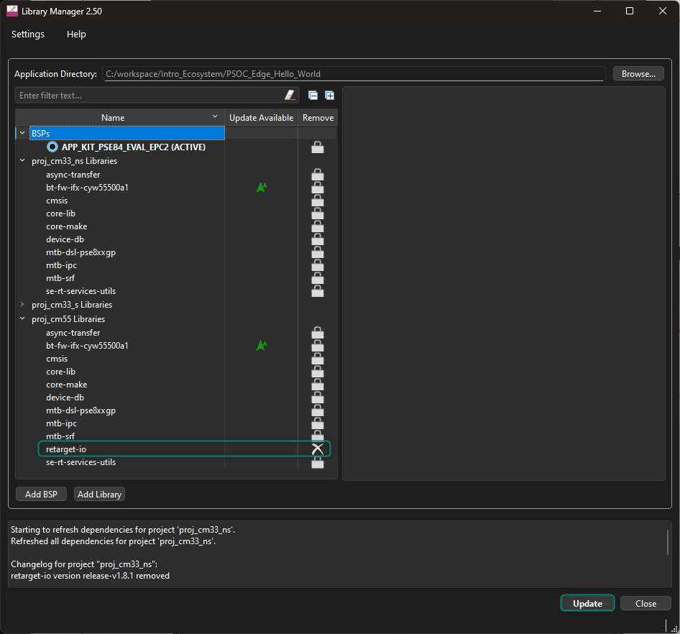
Figure 18 Update libraries in project
- Close the Library Manager after completing the update process
- The cm33_ns project includes retarget_io_init.c/h files to initialize the retarget-io library. These files can be reused for the cm55 project by either cutting-and-pasting them, or drag-and-dropping them in the project explorer
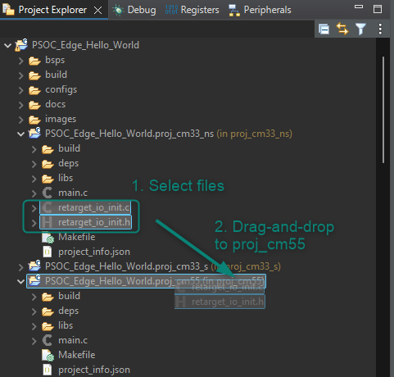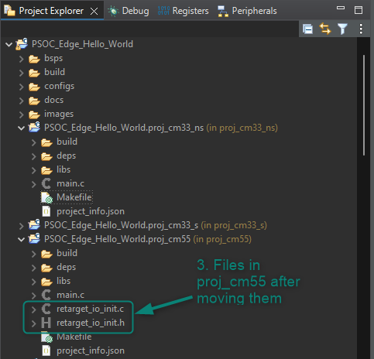
Figure 19 Move retarget_io_init files from proj_cm33_ns to proj_cm55
- Open proj_cm33_ns/main.c and modify it to avoid using retarget-io and printf
Code listing 2 Remove retarget_io_init.h from cm33_ns
/*******************************************************************************
* Header Files
*******************************************************************************/
#include "cybsp.h"
//#include "retarget_io_init.h"
Code listing 3 Remove retarget-io and printf in main function of cm33_ns
int main(void)
{
cy_rslt_t result = CY_RSLT_SUCCESS;

/* Initialize the device and board peripherals. */
result = cybsp_init();

/* Board initialization failed. Stop program execution. */
if (CY_RSLT_SUCCESS != result)
{
__disable_irq(); /* Disable all interrupts. */
CY_ASSERT(0);
while(true); /* Infinite loop */
}

/* Enable global interrupts */
__enable_irq();

/**** retarget-io initialization and printf removed ****/

/* Enable CM55. */
/* CM55_APP_BOOT_ADDR must be updated if CM55 memory layout is changed.*/
Cy_SysEnableCM55(MXCM55, CM55_APP_BOOT_ADDR, CM55_BOOT_WAIT_TIME_USEC);

for(;;)
{
Cy_GPIO_Inv(CYBSP_USER_LED1_PORT, CYBSP_USER_LED1_PIN);
Cy_SysLib_Delay(BLINKY_LED_DELAY_MSEC);
}
}

- Now, initialise retarget-io in proj_cm55/main.c, and use printf to display a message
Code listing 4 Include retarget_io_init.h in cm55
/*******************************************************************************
* Header File
*******************************************************************************/
#include "cybsp.h"
#include "retarget_io_init.h"

Code listing 5 Initialize retarget-io and use printf in main function of cm55
int main(void)
{
cy_rslt_t result;

/* Initialize the device and board peripherals. */
result = cybsp_init();

/* Board init failed. Stop program execution. */
if (CY_RSLT_SUCCESS != result)
{
handle_app_error();
}

/* Enable global interrupts. */
__enable_irq();

init_retarget_io();
/* \x1b[2J\x1b[;H - ANSI ESC sequence for clear screen */
printf("\x1b[2J\x1b[;H");
printf("********** PSOC Edge MCU: IPC Semaphore Example ********** \r\n");
printf("CM55 initialization \r\n\n");
/* Wait for UART traffic to stop */
while(!(Cy_SCB_UART_IsTxComplete(CYBSP_DEBUG_UART_HW))) {}
/* Put the CPU to Deep Sleep. */
for (;;)
{
Cy_SysPm_CpuEnterDeepSleep(CY_SYSPM_WAIT_FOR_INTERRUPT);
}
}

- Build and program the application

Output
After the program runs successfully, open the serial terminal and configure the baud rate to 115200-8-N-1. Then press the kit reset button.
Observe that the CM55 CPU prints the welcome message, while the CM33 CPU is still blinking the LED at approximately 1 Hz.
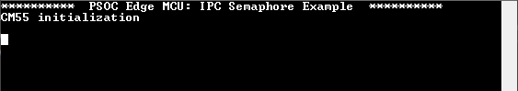
Figure 20 Output after using retarget-io on CM55

Implement the GPIO button and print messages using both CPUs
In the previous section, we moved the retarget-io library to CM55; however, it is still possible for the CM33 to utilise the same UART. In this section, we will send UART messages from both CPUs when an EVK button is pressed.
- Open the Device Configurator from the Quick Panel area under the BSP Configurators section
- In the Device Configurator, go to the Pins tab
- In the PSOC™ Edge EVK user buttons are connected to P8.3 and P8.7, per the kit schematic in Figure 21
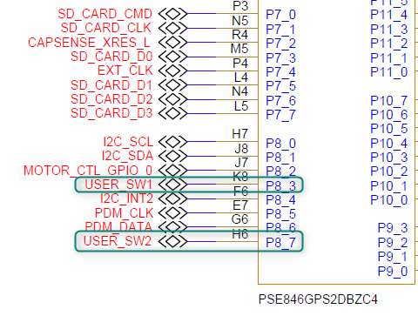
Figure 21 Connection of buttons in EVK schematics
- We will be utilizing USER BTN1 to print messages in our application, which is connected to P8.3.
Rename Port8[3] as TRAINING_BUTTON
Select File→Save or press Ctrl+S to save design.modus and regenerate source files.
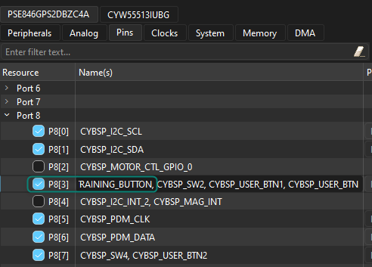
Figure 22 Renaming P8[3] as TRAINING_BUTTON
- Open proj_cm33_ns/main.c and modify the code to use the new button alias to print a message to the terminal
Observe that we are using a UART PDL function since the CM33 project doesn’t include retarget-io. PDL functions for GPIO and UART, which are available in the mtb-dsl-pse8xxgp library.
Code listing 6 Update proj_cm33_ns/main.c to print UART message when button is pressed
for(;;)
{
if (Cy_GPIO_Read(TRAINING_BUTTON_PORT, TRAINING_BUTTON_PIN) == 0)
{
Cy_SCB_UART_PutString(CYBSP_DEBUG_UART_HW, "Message sent from CM33 \r\n");
}
}

- Now, open proj_cm55/main.c and modify the code to implement a similar functionality
Observe that we are using printf for CM55 since retarget-io was included.
Code listing 7 Update proj_cm55 /main.c to print UART message when button is pressed
for (;;)
{
if (Cy_GPIO_Read(TRAINING_BUTTON_PORT, TRAINING_BUTTON_PIN) == 0)
{
printf("Message sent from CM55 \r\n");
}
}

- Save the files, rebuild the project and program the device

Output
After the program runs successfully, open the serial terminal and configure the baud rate to 115200-8-N-1. Then press the kit reset button.
Press USER_BTN1 on the EVK and observe that both devices will attempt to send messages to the terminal; however, the output is incorrect since no semaphores are implemented to synchronize access to UART.
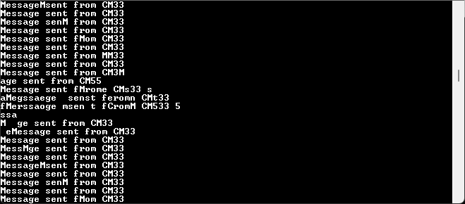
Figure 23 Output sending messages from both CPUs without semaphores

Use IPC semaphore to synchronise access to UART
We previously observed that both CPUs can access the UART concurrently; however, this can result in problems when both cores attempt to write at the same time without synchronisation.
In this section, we will use IPC semaphores to synchronise access.
- Create a shared folder to facilitate sharing parameters between projects.
In Eclipse’s Project Explorer, right-click on the top level of the project and select New→Folder, then name the folder as shared
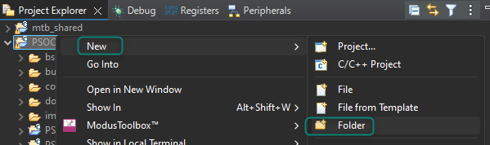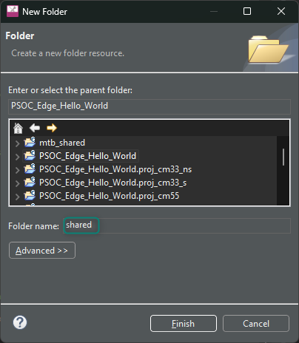
Figure 24 Create a shared folder
- Repeat the process to create an include folder inside shared folders should look as in Figure 25
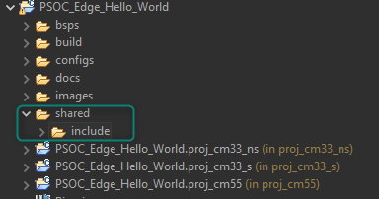
Figure 25 Shared folders
- Right-click in the shares/include folder, and select New→File, then name the file as ipc_def.h
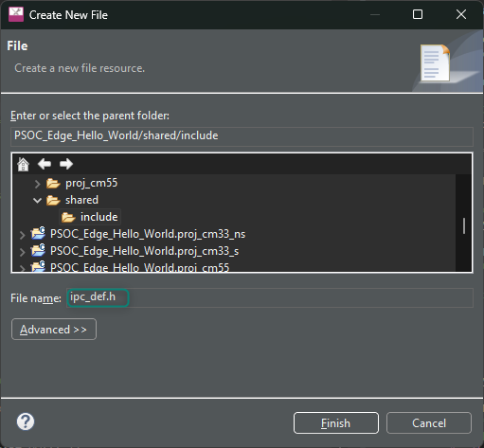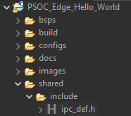
Figure 26 Create ipc_def.h
- Add the following code to the newly created ipc_def.h file
Code listing 8 ipc_def.h code
#ifndef IPC_DEF_H
#define IPC_DEF_H

/* IPC Channel to use */
#define IPC_CHANNEL_NUM 8U

/* Semaphore number to be used in this example. Semaphores 0-15 are reserved
for system use. */
#define MAX_SEMA_NUM 32U
#define MY_SEMA_NUM 16U

/* Delay to allow other core to acquire the semaphore */
#define SEMA_DELAY 10U

#endif /* IPC_DEF_H */

- Add the shared/include path to proj_cm33_ns/Makefile and proj_cm55/Makefile
The Makefile for both projects needs to be updated since we will access ipc_def.h from both projects.
Code listing 9 Add shared include path to Makefile of proj_cm33_ns and proj_cm55
# Like SOURCES, but for include directories. Value should be paths to
# directories (without a leading -I).
INCLUDES+=../shared/include

- Open proj_cm33_ns/main.c and add code to initialize the semaphore
Observe that a region in shared memory is used to declare the semaphore variable since it needs to be accessed by both CPUs.
Code listing 10 Include shared file and declare sema_data in proj_cm33_ns/main.c
/*******************************************************************************
* Header Files
*******************************************************************************/
#include "cybsp.h"
#include "ipc_def.h"

/*******************************************************************************
* Global variables
*******************************************************************************/
CY_SECTION_SHAREDMEM uint32_t sema_data[CY_IPC_SEMA_COUNT / CY_IPC_SEMA_PER_WORD];
Code listing 11 Initialize semaphore in proj_cm33_ns/main.c
int main(void)
{
cy_rslt_t result = CY_RSLT_SUCCESS;
cy_en_ipcsema_status_t ipc_status;

/* Initialize the device and board peripherals. */
result = cybsp_init();

/* Board initialization failed. Stop program execution. */
if (CY_RSLT_SUCCESS != result)
{
__disable_irq(); /* Disable all interrupts. */
CY_ASSERT(0);
while(true); /* Infinite loop */
}

/* Enable global interrupts */
__enable_irq();

/**** retarget-io initialization and printf removed ****/

ipc_status = Cy_IPC_Sema_Init(IPC_CHANNEL_NUM, CY_IPC_SEMA_COUNT, sema_data);

if (CY_IPC_SEMA_SUCCESS != ipc_status)
{
__disable_irq(); /* Disable all interrupts. */
CY_ASSERT(0);
while(true); /* Infinite loop */
}

/* Enable CM55. */
/* CM55_APP_BOOT_ADDR must be updated if CM55 memory layout is changed.*/
Cy_SysEnableCM55(MXCM55, CM55_APP_BOOT_ADDR, CM55_BOOT_WAIT_TIME_USEC);
Cy_SysLib_Delay(SEMA_DELAY);

for(;;)

- Then, add the code to synchronize access to the UART
Code listing 12 Use IPC semaphore in proj_cm33_ns/main.c
for(;;)
{
if (Cy_GPIO_Read(TRAINING_BUTTON_PORT, TRAINING_BUTTON_PIN) == 0)
{
/* Acquire semaphore */
while (Cy_IPC_Sema_Set(MY_SEMA_NUM, false) != CY_IPC_SEMA_SUCCESS)
;
Cy_SCB_UART_PutString(CYBSP_DEBUG_UART_HW, "Message sent from CM33 \r\n");
while(!(Cy_SCB_UART_IsTxComplete(CYBSP_DEBUG_UART_HW))) {}
/* Release semaphore */
while (Cy_IPC_Sema_Clear(MY_SEMA_NUM, false) != CY_IPC_SEMA_SUCCESS)
;
}
}

- Now, open proj_cm55/main.c and add code to initialize the semaphore
Observe that the sema_data variable does not need to be declared again.
Code listing 13 Include shared file in proj_cm55/main.c
/*******************************************************************************
* Header File
*******************************************************************************/
#include "cybsp.h"
#include "retarget_io_init.h"
#include "ipc_def.h"

Code listing 14 Initalize semaphore in proj_cm55/main.c
int main(void)
{
cy_rslt_t result;
cy_en_ipcsema_status_t ipc_status;

/* Initialize the device and board peripherals. */
result = cybsp_init();

/* Board init failed. Stop program execution. */
if (CY_RSLT_SUCCESS != result)
{
handle_app_error();
}

/* Enable global interrupts. */
__enable_irq();

ipc_status = Cy_IPC_Sema_Init(IPC_CHANNEL_NUM, 0UL, NULL);

if(ipc_status != CY_IPC_SEMA_SUCCESS)
{
handle_app_error();
}

init_retarget_io();

- Lastly, use the semaphore to synchronize access to UART
Code listing 15 Use IPC semaphore in proj_cm55/main.c
for (;;)
{
if (Cy_GPIO_Read(TRAINING_BUTTON_PORT, TRAINING_BUTTON_PIN) == 0)
{
/* Acquire semaphore */
while (Cy_IPC_Sema_Set(MY_SEMA_NUM, false) != CY_IPC_SEMA_SUCCESS)
;
printf("Message sent from CM55 \r\n");
while(!(Cy_SCB_UART_IsTxComplete(CYBSP_DEBUG_UART_HW))) {}
/* Release semaphore */
while (Cy_IPC_Sema_Clear(MY_SEMA_NUM, false) != CY_IPC_SEMA_SUCCESS)
;
}
}

- Save the files, rebuild the project, and reprogram the device

Output
After the program runs successfully, open the serial terminal and configure the baud rate to 115200-8-N-1. Then press the kit reset button.
Press USER_BTN1 on the EVK and observe that both devices will send messages to the terminal and now that IPC semaphores are used to synchronize access, both cores can print the complete message successfully.
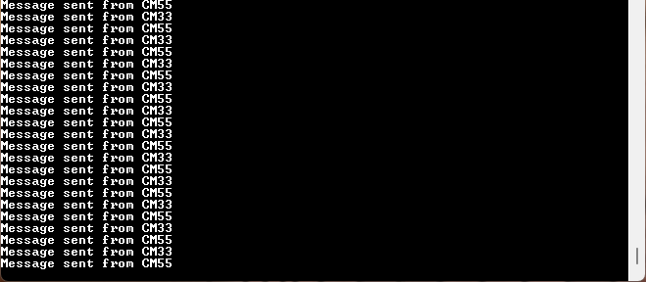
Figure 27 Output sending messages from both CPUs using IPC semaphores

Conclusion
We successfully learned how to use the Library Manager to add and remove libraries on both CPUs, implemented code to access a shared resource, and synchronized that access with an IPC semaphore.
This demonstrates IPC’s effectiveness for coordinating access between processors, and it can also be used to exchange messages between them.

Appendix A: Creating a PSOC™ Edge application in ModusToolbox™
The following steps show how to create a new project for PSOC™ Edge in ModusToolbox™.
- Open the ModusToolbox™ Dashboard 3.6 and launch the Eclipse IDE for ModusToolbox™
If you have not installed ModusToolbox™ or Eclipse IDE, see Required development tools section.
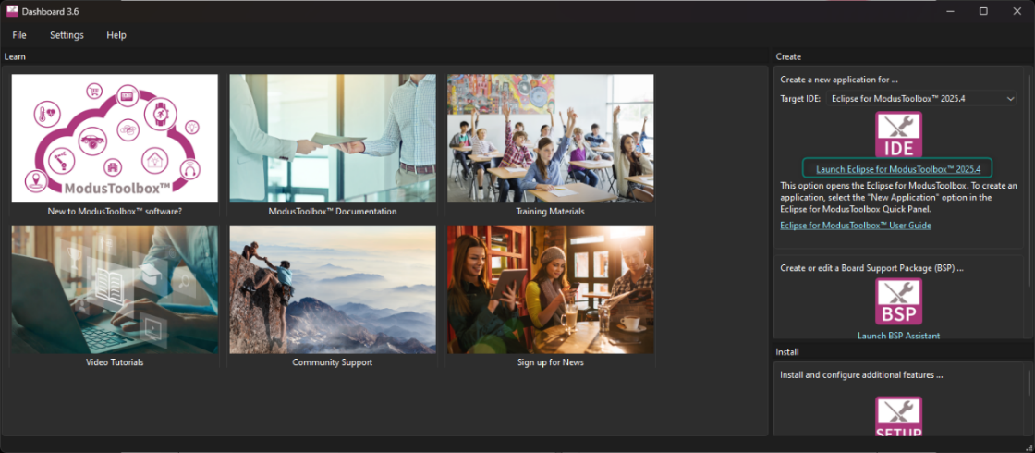
Figure 28 Open Eclipse IDE for ModusToolbox™ from Dashboard
- Choose a workspace directory for your project. A folder will be created if the workspace does not exist.
After selecting a suitable directory, click the Launch button
It is recommended to keep the workspace path short. Windows has a 260-character path length limit, and a long workspace path may cause build issues when creating some applications.
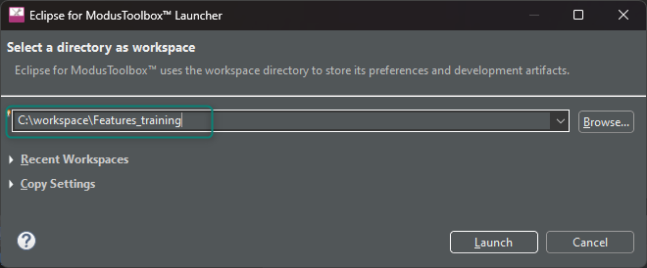
Figure 29 Choose workspace directory

- Select New Application from the Quick Panel. Alternatively, go to File> New> ModusToolbox™ application.
This will launch the Project Creator Tool
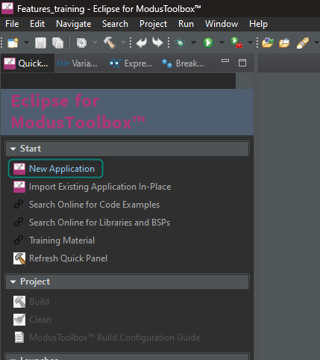
Figure 30 Create a new application
- Once Projector Creator is launched, you will be prompted to select a board support package (BSP).
Select the KIT_PSE84_EVAL_EPC2 BSP under the PSOC™ Edge BSPs and click Next
BSPs are aligned with our development/evaluation kits; they provide files for basic device functionality. A BSP typically has a design.modus file that configures clocks and other board-specific capabilities. That file is used by the ModusToolbox™ configurators. A BSP also includes the required device support code for the device on the board. You can modify the configuration to suit your application.
Observe that ModusToolbox™ also includes BSPs for PSOC™ Edge EPC4 devices (KIT_PSE84_EVAL_EPC4), and for the PSOC™ Edge AI Kit (KIT_PSE84_AI); however, this training is intended to be used with the KIT_PSE84_EVAL, which includes EPC2 devices by default.
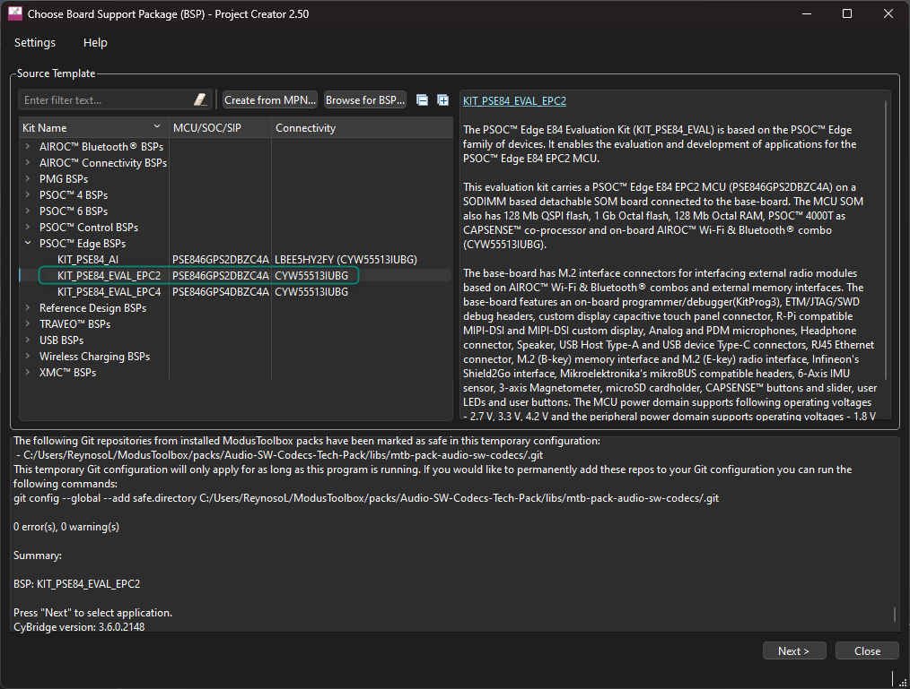
Figure 31 Selecting BSP in Project Creator
- A new window opens to select an application. The Project Creator includes categories and a search field to make it easier to find and select different examples. Click the checkbox near the application, optionally rename the project, and then click Create. Figure 32 shows the creation of the PSOC™ Edge Hello World application under the Getting Started section
Windows has a 260-character path length limit. A long workspace path and/or a long project name may cause build issues when creating some applications.
Figure 32 Selecting application
- A new project is being created, as shown in Figure 33, all the files in the Project Explorer window are displayed
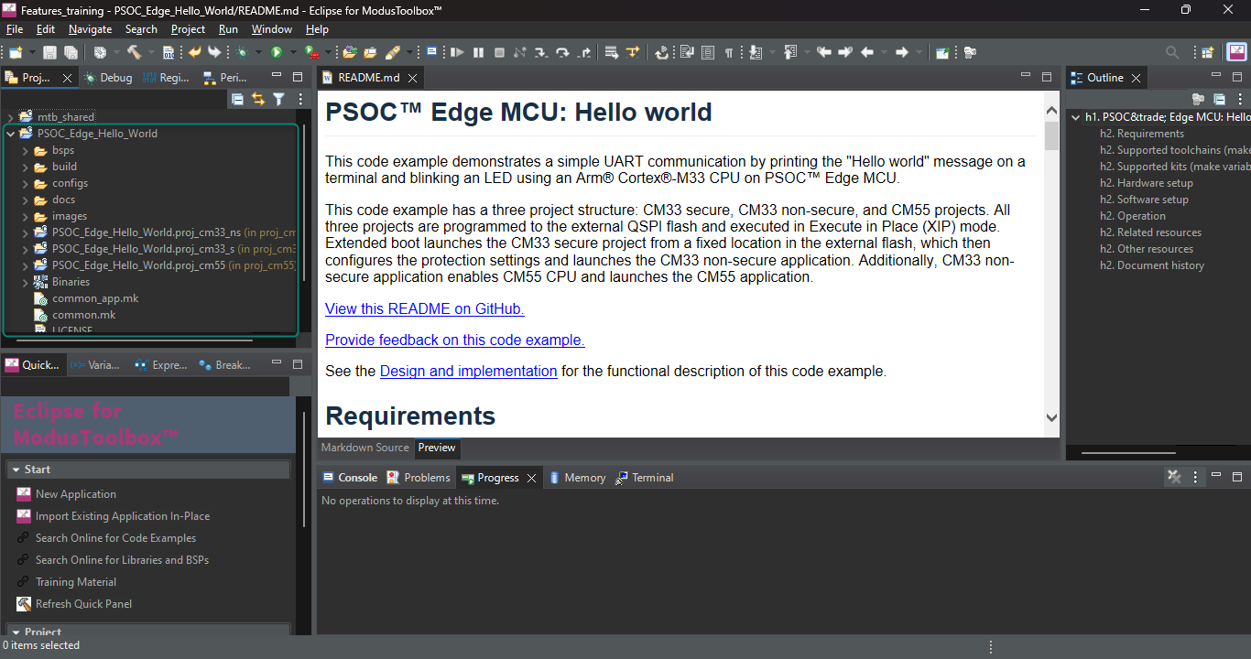
Figure 33 New application created

Appendix B: KIT_PSE84_EVAL details
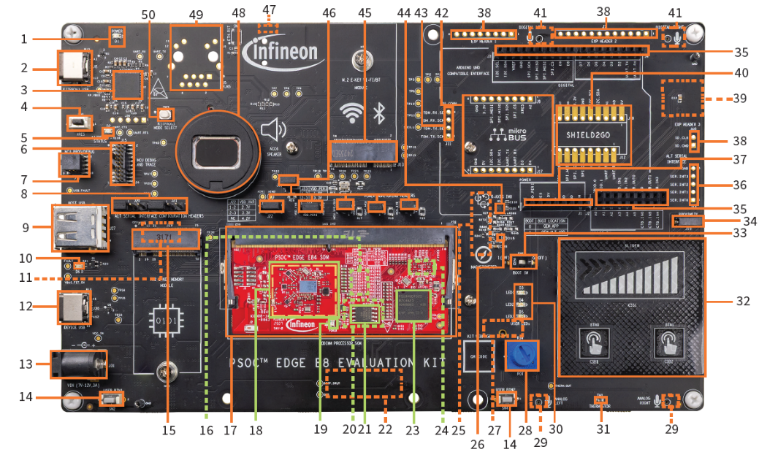
Figure 34 PSOC™ Edge evaluation kit (EVK) details
28 Linear potentiometer (R34)
29 Analog microphones (IM73A135V01XTSA1, U36 and U37)**
30 User LEDs (D3, D4, D5)
31 Thermistor (TH1)
32 CAPSENSE™ buttons and slider (CSB1, CSB2, CSS1)
33 BOOT configuration switch (SW6)
34 Proximity sense connector (J19)
35 I/O headers compatible with Arduino UNO R3 (J2, J3, J4)
36 Alternative serial interface I/O header (J14)*
37 Power header compatible with Arduino UNO R3 (J1)
38 PSOC™ Edge E84 MCU expansion I/O headers (J6, J7, J40)*
39 MicroSD card holder (J35)**
40 Infineon Shield2Go interface headers (J10, J12)*
41 PDM microphones (IM72D128V01XTMA1, U7 and U8)**
42 mikroBUS compatible headers by Mikroelektronika (J9, J17)*
43 Extended I2S header (J11)*
44 6-axis accelerometer and gyroscope IMU (U5)
45 M.2 (E-key) radio interface connector (J13)
46 PSOC™ Edge E84 MCU power selection/monitoring headers (J18, J22, J23, J24, J25, J26)
47 Headphone connector (J34)*
48 Speaker (ACC6)
49 RJ45 ethernet magjack connector (J5)*
50 KitProg3 programming mode selection button (SW3)
1 Baseboard power LED (D1)
2 KitProg3 program/debug USB Type-C connector (J8)
3 PSOC™ 5LP-based KitProg3 programmer and debugger (CY8C5868LTI-LP039, U2)
4 Reset button (SW1)
5 KitProg3 status LED (D2)
6 PSOC™ Edge E84 MCU ETM/JTAG debug and trace header (J15)
7 PSOC™ Edge E84 MCU 10-pin SWD/JTAG program and debug header (J16)
8 Alternative serial interface configuration headers (J20, J21)
9 PSOC™ Edge E84 MCU USB host Type-A connector (J27)
10 USB Type-C Power Delivery (PD) fault LED (D6)
11 Custom display capacitive touch panel connector (J37)**
12 PSOC™ Edge E84 MCU USB device Type-C connector (J30)
13 External power supply VIN connector (J31)
14 PSOC™ Edge E84 MCU user buttons (SW2, SW4)
15 M.2 (B-key) memory interface connector (J29)
16 128 Mb Octal-SPI HYPERRAM™ (S70KS1283GABHI020, U12)***
17 Processor system-on-module (SoM) 260-pin SODIMM connector (J28)
18 AIROC™ CYW55513 tri-band (Wi-Fi & Bluetooth®) combo radio (U3) section
19 Processor system-on-module (SoM) power LED (D3)
20 1 Gb Octal-SPI NOR flash (S28HS01GTGZBH1030, U10)***
21 128 Mb Quad-SPI NOR flash (S25FS128SAGMFB100, U11)
22 MIPI-DSI custom display connector (J38)**
23 PSOC™ Edge E84 MCU (PSE846GPS2DBZC4A, U1)
24 PSOC™ 4000T CAPSENSE™ Co-processor (U9)***
25 Raspberry Pi-compatible MIPI-DSI display connector (J39)**
26 3-axis magnetometer (U4)
27 Raspberry Pi compatible display capacitive touch connector (J41)**

* Footprint only, not populated on the board
** Component at the bottom side of the Baseboard
*** Component on the bottom side of the SoM

Revision history
Document revision | Date | Description of changes
** | 2026-03-15 | Initial release.

Disclaimer

