Computer programming

Final Project

I.E.S. San Vicente
San Vicente del Raspeig (Alicante)

Teachers:
José Ignacio Cabanes / Ignacio Iborra

Student:
Luis Sellés

1. Introduction
Project name
Ludo game

Made by
Luis Sellés Blanes

Short description of the project
This is a game that can be played by 2 to 4 players. It will be a console application.

2. Functionality of the project
After entering the program, it will show us a menu with the following options:

- Multiplayer in the same PC
- Multiplayer without end (Each kill counts 1… till they get bored)
- ¿Multiplayer in LAN?
- Player against computer.

If the user chooses from 1st to 3rd option they will be asked which color they want to play: blue, red, green or yellow. The first option and the 3rd one are the traditional mode of the ludo, the first one who gets all of his “chips” inside his home will win. The 2nd option will have a counter, the game will ask the players what will be the limit to reach, for example, if the player says 10, the first player to kill 10 chips of the other player will win.

The 4th option is the same as the first, but playing against the computer, 1vs1.

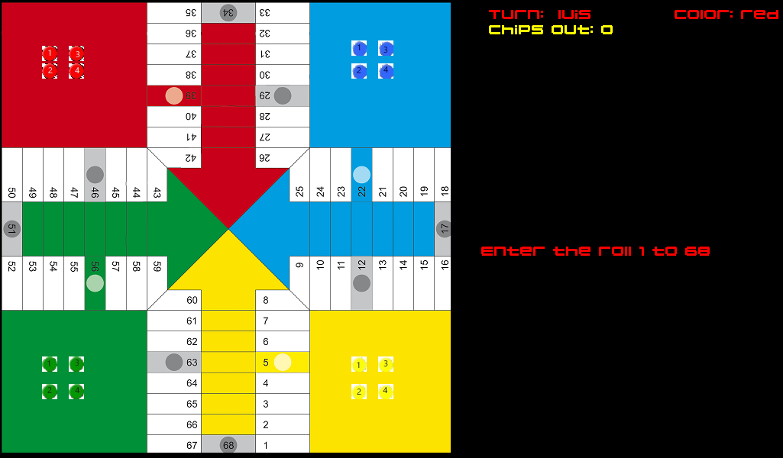

3. Screen prototype
The game screen will look like this:

4.Analysis

4a. Requisites
Requisite | Date achieved
The program will allow a player to choose an option from the menu | Done
The program will allow a player to type his name and color | Semi-done
The program will allow a player to play with another or 2,3 friends at the same time in the same PC
The program will allow a player to play Ludo.
The program will allow a player to play Goose.
The program will allow a player to play against IA.
The intro screen will allow he user to enter a Credits screen, which will display data about the programmer | Done
The intro screen will allow he user to enter a Rule screen, which will display data about how to play the game | Done
The game will use SDL graphics library. | Done
The game will be sended throught internet to a server. | Done

5. Initial planning and expected deliveries

5a. Expected deliveries

V-1 - Creating ALL the classes with it's methods and attributes.

V-2 - Initial image at the start showing the Game's name, my name, click to continue and the menu with the options Multiplayer, LAN, 1v1 against PC, Credits and Exit.

V-3 - Set the background images of the multiples modes, adding the "Rules" to the 1st menu to show the player how to play the game. The rules will be readed from a file.

V-4 - Creating the array of the boxes with its X and Y. I'll set a distinct value to each box because there are distinct type of boxes. Home, normal ones and secures.

V-5 - When playing the multiplayer game, it will ask how many players and then will ask us for the name of each player and the color that they want to be. It will be selected from a list of predefined colours.

V-6 – Create a menu inside the Multiplayer / Multiplayer LAN and the limitless mode. The menu will contain a couple of options to Roll the dice, Load and Send data to server (LAN mode).

V-7 - Roll a random number. Showing the animation of the number I got and an animation of the dice. I will make another method called “DeveloperDice” so I can get the number i want, I will do this because it will be easier for making tests when I have to kill another chips or when I have to get the chip inside of the finish box.

V-8 - Making the movements of the chips in the arrayboxes. I want to make them move with an animation from its box to the selected one. Each colour must have different moves (not all of them starts at the same box
and not all of them got the same home). Here the user will select which chip is going to move by typing the chip number or by clicking the image.

V-9 - Roll dice numbers. If I get a 5 I must get a chip out of the home…
if I got a 6 i can repeat, and if I got the 3rd 6 in a row my chip goes to home (is killed). If I got a wall and I get a 6 I must move the wall. If I got 6 and i have no pieces at home i can count 12 or 7… If I get more than i need to enter a chip into the finish, it will come back or it will be a null.

V-10 - Kill chips. The one who kill another chip will count 20 boxes. It will show an animation of which player kill and which one got killed. If theres a secure box the chip cannot be killed.

V-11 - Loop of the game, the turns will pass by clicking the space, check if there are 4 of the same color in the finish. If a player won, it will show an animation of which one won

V-12 - The second type of game is a game WITHOUT COLOUR boxes and no SAFE boxes so there will be a LIMIT asked to the players just when they select the mode. I will make another methods for the movements without checking home boxes, and I will write on screen a counter of how many kills have each player.

V-13 - Making the IA of the IA mode. It will know which chip to move instead of another, If its going to kill a chip it will move it instead of another. It will pick a random colour and will get a name from a file with 1000 names.

V-14 - I will start with "The goose" mode. Will add the mode to the menu, ask number of players and. Will create an array of the boxes, with the prison, the goose boxes and the stairs.

V-15 - Movements of "the goose". If i get into a "goose box" it will jump to the next one. If i get into the prison i will stay 3 turns there. If i get into a stair i will jump to the other one or get back to the first one. If i get into the death one i will die. I will make the animation of the winner one.

V-16 – Public Mode. Upload the data to a server created by me in my Work. I’ll send data about the array of boxes, where are each piece and the turns. I’ll create a function to receive the data too.

5b. Real deliveries

V-1 : Creating the following classes and its methods:
Box, chip, dice, Hardware (New class to draw images, check key pressed..), Player, Welcome Screen and testing it in the main in class Program.

V-2: Creating the rest of the classes I couldnt do in the 1st delivery (font, image, some methods of hardware, ended WelcomeScreen, CreditScreen reading data from a file) and making the MenuGame with the options. If i choose an option it will display what it does (only working with credit screen now)

V-3: Made the background of ludoGame, playerSelect, PlayerSelect in limitless mode, PlayerSelectAgainstIA, and the rules readed from a File with OpenText and tryed to scroll up and down with the keys but i couldnt do it.

V-4: Creating the array of the boxes with its X and Y. I'll set a distinct value to each box because there are distinct type of boxes. Home, normal ones and secures.

V-5: Created a method to let the users enters his name one my one so therefore can be shown in the ludoScreen.

V-6: Added new class called MenuLudo, with the two firsts steps that the user must follow to play. Changed the default loop at the LudoGame class, user must press 1 to pass the 1st step then shows the rolled number he got. Made half of the method to upload to FTP the data of the arrayBoxes. Changed image of the menu, and a bit of corrections, it will be showed at Git.

V-7: Finished the methods to download and upload from FTP. Added new method to read the data of the array of boxes from a file. Added DevRollValue to the Dice class, and changed the main loop of the LudoGame to let player select the developer mode, now the user can write the number he wants to roll. Correction of the names of the classes: ShowPlayerSelect, ShowPlayerSelectAgainstIA, ShowCredits, ShowRules. Commented unnecesary variables and code (that actually i dont use but i will). Changed name of the project to LudoGoose. I commented the GetRollValue because for making tests i will use GetDevRoll, so now it wont show the number rolled.

V-8: Added players creation, added the turns on the right of the LudoGame screen. Method to load the chips from a file called chipdata.txt. Displayed data of chips of a player down the turn. Added the 3rd step to skip the turn.

V-9: Added method to draw all the chips, method to draw black rectangle on the screen to delete the wrong rolls or wrong chips. Added method to move the chips, only works with roll 5.

V-10: I made an error in the last deliver so I correct it. Made the screen content of the GooseController, the screen content of the Ludo’s limitless mode, and the content of the playerSelect vs the IA (1vs1). Added texts to guide the players at MenuScreen, PlayerSelectScreen and LudoGame. Added new variables to player, RepeatTurn, if player gets a 6, he will Repeat, if player wants to move a chip that is home and he got other roll than 5, he will repeat...

V-11: Modified file access methods box.SaveData, box.LoadData, CreditsScreen.Show and RulesScreen.Show. Added method to let the user enter players from 2 to 4. It checks if the user enters another number or character. Adapted the PlayerScreen.Show method to show only “Enter name player X” based on the number of players that the user selected previously.
Added texts to help player when he enters an incorrect chip number to move.

V-12: Method to display the chips, now if a specific box got 2 chips, it will display both instead of 1. Added heritage to classes MenuScreen, RulesScreen, CreditsScreen, WelcomeScreen, PlayerSelect, LudoGame, MenuLudo Added method to get the limit of the Ludo limitless Mode. More movement of chips, if player gets 6, he repeats. Added almost finished limitless method, only need to check kills. Now it shows the limit introduced by the user.

V-13: Added player select to Goose. Modified Loadchips and load Boxes of the ludo to use a parameter, it loads goose or ludo things depending on the string “mode” passed. Now red chips can enter the finish boxes.

6. File Formats

6a. Plain files format

The data of the boxes (array of structs) is on the file called boxArrayData.txt and its format is:

x,y,color,isMultipiece,isHouse,isFinishBox,isEmpty --→
100,200,blue,false,true,false,true

The position 0 of the array of boxes wont have any data, it will start with the arrayBox[1], so from this till arrayBox[68] will be the white boxes. After that, from 70 to 76 will be the finishes boxes of the red, from 77 to 83 the yellow ones, from 84 to 90 the green ones and from 91 to 97 the blue ones.
Then, the houses will be positions 100-103 for red, 104-107 for blue, 108-111 for green and 112-115 for yellow.

The rules are loaded from a file called rules.txt and the format will be:

“1 – this will be the rule number one”
“2 – this will be the rule number two”
“3 - this rulle is too large so this will
be its format”

The credits are loaded from a file called credits.txt and will display data about the developer of the game (me):

“producer – luis”
“developer – luis”

The data uploaded to the FTP server will be saved on the file called boxesData.txt and its format will be the same as boxArrayData.txt. It can’t be the same file because the first will be for the multiplayer at the same PC and can’t be changed and this one will be modified by the method to save data on it.

x,y,color,isMultipiece,isHouse,isFinishBox,isEmpty --→
100,200,blue,false,true,false,true

6b. Class diagram.

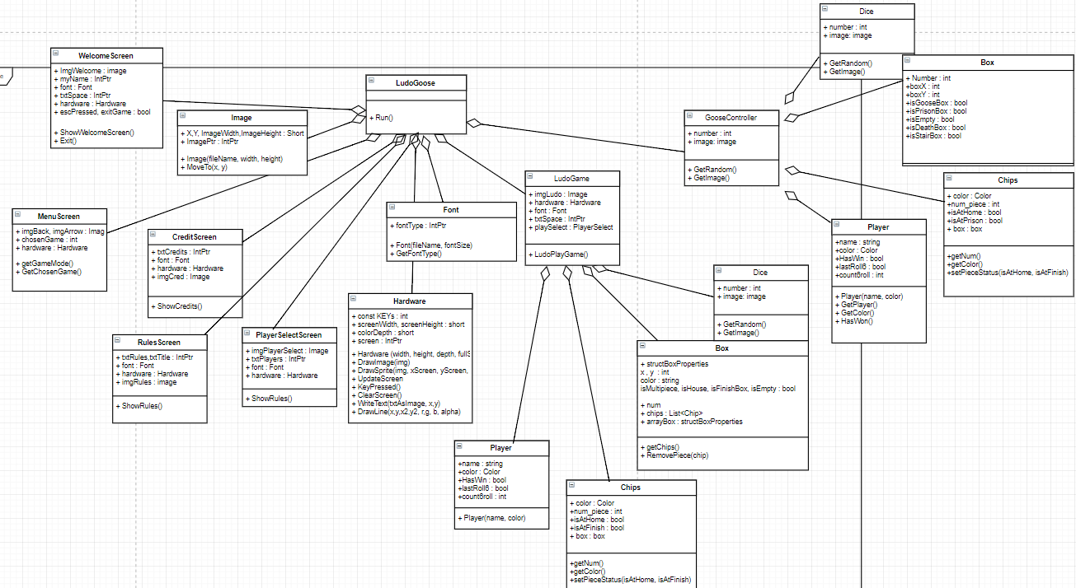

7. Problems found.

With the readletter method I made on Hardware class i found the problem that i couldn’t delete the last letter. I will try to solve this problem on the nexts delivers.

I was spent too much time to try to draw 2 chips in the same box. TOO MUCH HOURS. But Nacho helped me, it was a problem of the object that i was calling.

8. Improvements or restrictions.

Actually i couldnt made that the user selects the cuantity of players.

Solved the 1st problem found with the Clear method. It draws a black rectangle so its like the characters are deleted.

