CountingReport Issue

Counting is a very common pattern with hash maps. By "counting", we are referring to tracking the frequency of things. This means our hash map will be mapping keys to integers. Anytime you need to count anything, think about using a hash map to do it.
Recall that when we were looking at sliding windows, some problems had their constraint as limiting the amount of a certain element in the window. For example, longest substring with at most k 0s. In those problems, we could simply use an integer variable curr because we are only focused on one element (we only cared about 0). A hash map opens the door to solving problems where the constraint involves multiple elements. Let's start by looking at a sliding window example that leverages a hash map.

Example 1: You are given a string s and an integer k. Find the length of the longest substring that contains at most k distinct characters.
For example, given s = "eceba" and k = 2, return 3. The longest substring with at most 2 distinct characters is "ece".
This problem deals with substrings and has a constraint on the substrings (at most k distinct characters). These characteristics let us know that we should consider sliding window. Remember, the idea of a sliding window is to add elements by sliding to the right until the window violates the constraint. Once it does, we shrink the window from the left until it no longer violates the constraint. In this problem, we are concerned with the number of distinct characters in the window. The brute force way to check for this constraint would be to check the entire window every time, which could take $O\left(n\right)$ time. Using a hash map, we can check the constraint in $O\left(1\right)$.
Let's use a hash map counts to keep count of the characters in the window. This means we will map letters to their frequency. The length (number of keys) in counts at any time is the number of distinct characters. When we remove from the left, we can decrement the frequency of the elements being removed. When the frequency becomes 0, we know this character is no longer part of the window, and we can delete the key.
Click here for a more detailed explanation if needed
Please review the sliding window article if you have forgotten the sliding window algorithm.
In this problem, the constraint metric is "how many unique characters are in the window". The numeric restriction is <= k. We can use a hash map counts that keeps track of the frequency of each character in the window. The length of counts is the number of keys, which is also the constraint metric. Therefore the window is invalid when counts.length > k.
When we add a character s[right], we increment its frequency in counts by one. If it doesn't exist in counts, we insert a new key value pair s[right]: 1.
When we remove a character s[left], we decrement its frequency in counts by one. If the frequency becomes 0, we know that this character no longer exists. Therefore we delete the key from the hash map, which also decreases the length of counts.
Recall that the length of a window is right - left + 1.

In Python, the collections module provides very useful data structures. We will be using a defaultdict in the Python code. Functionality-wise, a defaultdict is the same as a hash map, it's just more pleasant to work with.

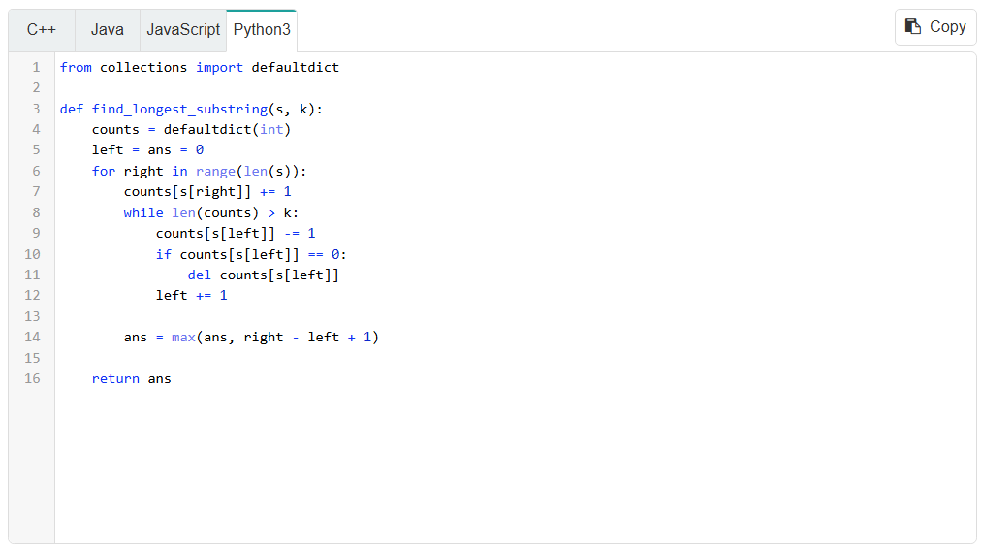
As you can see, using a hash map to store the frequency of any key we want allows us to solve sliding window problems that put constraints on multiple elements. We know from earlier that the time complexity of sliding window problems are $O\left(n\right)$ if the work done inside each for loop iteration is amortized constant, which is the case here due to a hash map having $O\left(1\right)$ operations. The hash map occupies $O\left(k\right)$ space, as the algorithm will delete elements from the hash map once it grows beyond $k$.

