ExerciseReport Issue

Multiple Choice Question
Is the following tree a heap?
Yes
No
RedoSubmit
Correct.
This is a complete binary tree, and the value of each node is no larger than its child nodes, so it is a min heap.
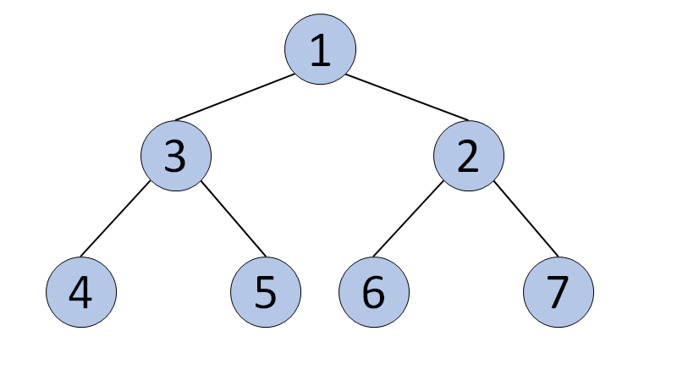

Multiple Choice Question
Is the following tree a heap?
Yes
No
RedoSubmit
Correct.
Although this is a complete binary tree, it is not a Heap, because not all nodes have equal or larger (or equal or smaller) values than their child nodes. For instance, the node in the first row (8) is larger than its child nodes (3 and 2), while the left node in the second row (3) has a smaller value than its child nodes nodes (4 and 5).
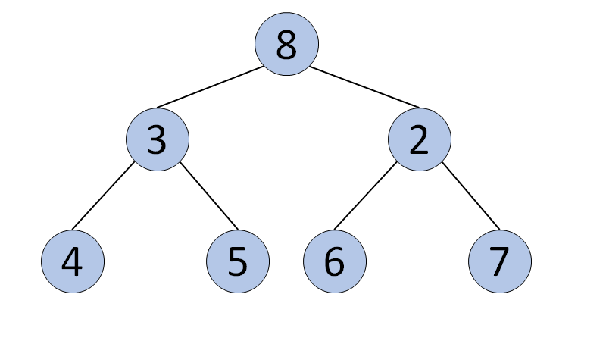

Multiple Choice Question
Is the following tree a heap?
Yes
No
RedoSubmit
Correct.
Although this is a complete binary tree, it is not a Heap because not all nodes have equal or larger (or equal or smaller) values than their child nodes. Take the second row as an example; the node with value 3 is smaller than its child nodes, while the node with value 6 is larger than its left child.
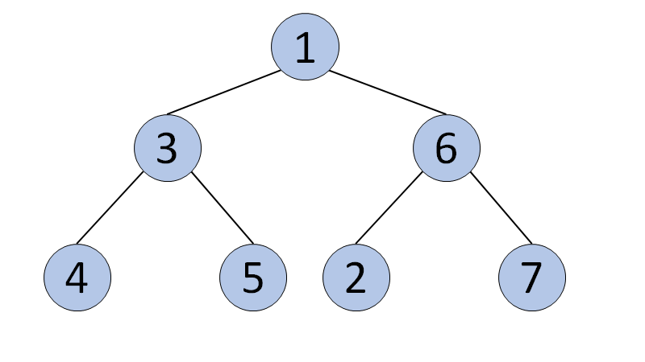

Multiple Choice Question
Is the following tree a heap?
Yes
No
RedoSubmit
Correct.
Although all nodes have smaller values than their child nodes, it is not a complete binary tree.
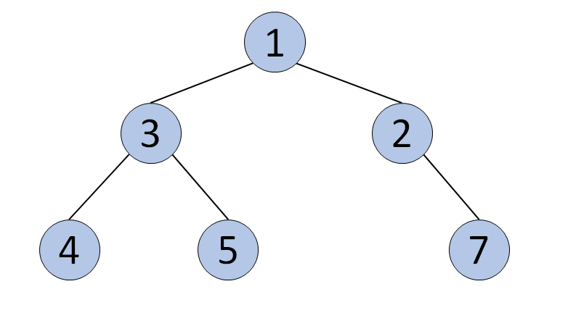

Multiple Choice Question
Is the following tree a heap?
Yes
No
RedoSubmit
Correct.
This is a complete binary tree, and the value of each node is no larger than its child nodes, so it is a min heap.
