|  |  |
| --- | --- |
|  |  |

How is COVID-19 impacting women and men’s working lives in the UK?

Research Summary 1: Unemployment and job loss in the COVID-19 UK: Exploring gender, ethnicity, and class

Luis D. Torres, Tracey Warren, Annegreet Veeken and the UK Women’s Budget Group

June 2021

|  |  |
| --- | --- |
|  |  |

Contents

Introduction 3

Gender impact of COVID-19 on employment trends 3

Men’s unemployment hit the most 3

Highest job loss among young people 4

People from minority ethnic backgrounds have been hit the hardest 5

Employment has not recovered equally for everyone 8

Redundancies were concentrated in professional as well as routine occupations 9

Employers are not being able to keep their staff 10

Conclusions 12

The Project and its Data 13

For more information 15

Acknowledgements 15

Citation 15

# 

# Introduction

The COVID-19 outbreak has had substantial consequences for the working lives of men and women. Generally, economic recessions affect men’s employment levels the most in the UK, but this is not a typical recession. Measures adopted by businesses and governments, such as flexible working and the job retention scheme in the UK, may be mitigating the impacts of the pandemic in ways not comparable to previous social and economic crises.

However, lockdowns and social distancing measures may be having an unequal impact on jobs frequently done by women. While women today have greater access to paid employment, they have historically been more limited in their choices of employment than men, they tend to work in more unstable and precarious conditions than men, and they are over-represented in mid- or low-skilled occupations. These disadvantages in paid work are experienced even more intensely by working class women and/or those women from minority ethnic groups.

In this summary report, we ask if the pandemic is narrowing or reinforcing existing inequalities in levels of unemployment. To answer this question, we use the UK’s largest study on employment circumstances, the Labour Force Survey (LFS), drawing on analysis of the 2019/20/21 releases. More specifically, we ask how unemployment rates have differed between men and women overall, and between different age, ethnic and occupational class groups during the pandemic; and who lost their jobs and why.

Our analyses in this report consider only the economically active population aged between 18-64. Far more women than men are outside the formal labour force, sometimes (problematically) termed ‘economically inactive’ even though they are involved in crucial unpaid domestic work and caring that are both essential to the running of the economy. We address women’s intensified unpaid work and caring during the pandemic in our [sister project](https://www.nottingham.ac.uk/business/who-we-are/case-studies/featured-research-case-studies/covid-19-working-women/index.aspx).

# Gender impact of COVID-19 on employment trends

## Men’s unemployment hit the most

Unemployment among men increased from below 4% up to April/June 2020 to over 5% from June/August 2020, with a peak during summer 2020. From September/November, unemployment among both men and women showed signs of stabilisation and a slight decline. However, in early 2021, unemployment remained 1% over pre-pandemic rates.

This overall trend is useful to understand the extent of the COVID-19 impact on unemployment rates, as well as the months during which those impacts were felt the most (e.g., how unemployment increased after the first lockdown). However, this overall picture glosses over the diversity of the UK population in terms of age, ethnicity, and class. We further explore these factors in the following sections.

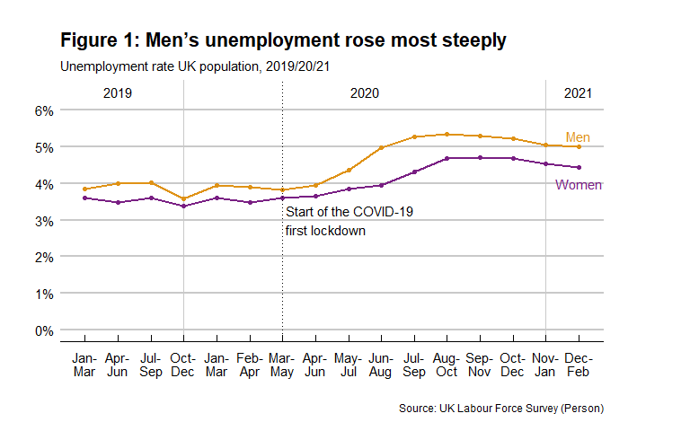

## Highest job loss among young people

Compared to 2019, 2020 had higher levels of unemployment overall. When age groups are considered, there was a concerning growth unemployment for people aged between 18 and 24 (Figure 2). For this age group, the rate of unemployment reached over 17% for men and 12% for women in summer 2020, from a year start of 11% and 9%, respectively. Shops, pubs, restaurants, and entertainment venues, i.e. those businesses where young people are frequently employed, were unable to fully open.

Looking at Figure 2, young men saw an increase in unemployment of up to 4% in July/September 2020 compared to 2019. Similarly, women’s unemployment rose up to 2% in August/October 2020. While younger men’s employment started to show signs of recovery in August/October 2020, unemployment levels for women remained constant until the September/November quarter.

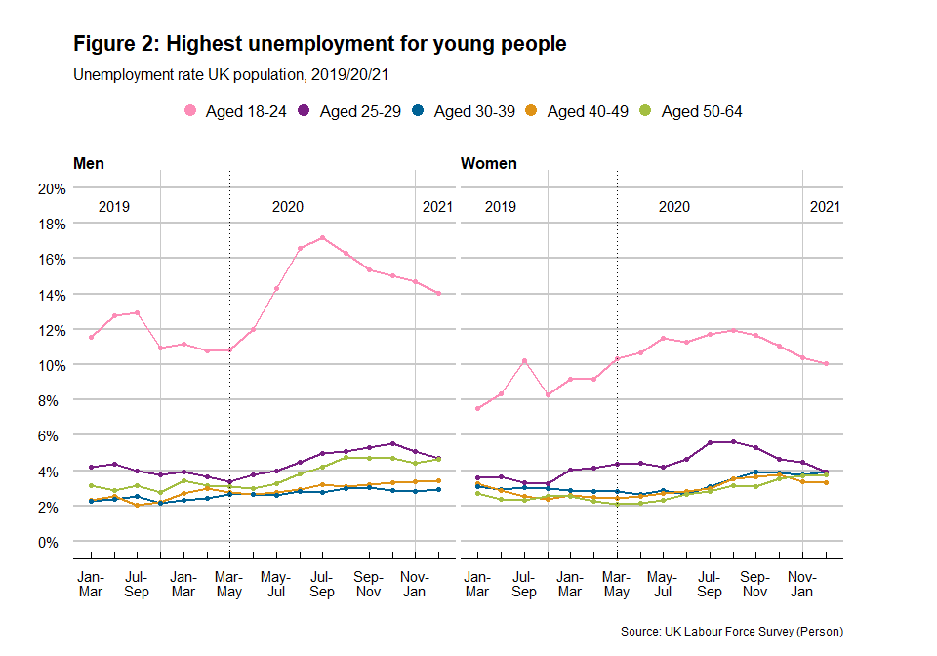

Other age groups also saw higher unemployment during 2020 than in the pre-pandemic year. Men and women aged between 25 and 29 experienced an increase of up to 2%. However, the last two quarters in 2020 showed some signs of recovery for this age group.

Older workers, e.g. those aged between 50 and 64, were not fully protected from the negative impacts of the pandemic. Their unemployment rates also increased (up to 2% if the highest points in 2019 and 2020 are compared). Although early signs of stabilisation can be seen for this group as 2020 came to an end, their road to recovery seems to be slower when compared to the younger age groups.

## People from minority ethnic backgrounds have been hit the hardest

For most minority ethnic groups, the COVID-19 pandemic has led to worrying growths in rates of unemployment. The white and minority-ethnic unemployment gap widened since the start of the pandemic: while 2020 started with a gap of 3%, by the end of 2020 the gap was 5% (Figure 3).

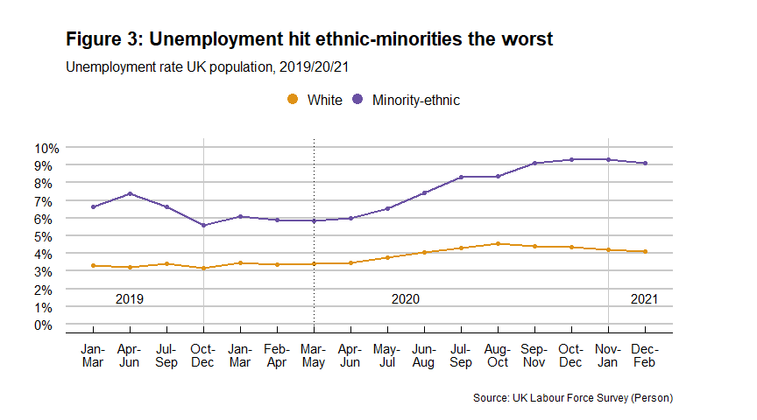

In addition, when specific ethnic groups are examined (Figure 4), we see real gender differences in unemployment levels. As shown in Figure 1, employment did seem to be recovering in the last couple of quarters of 2020 and into 2021, particularly for women. However, this potentially positive picture does not apply across all ethnic groups: women and men in mixed/multiple and other ethnic groups continued to experience rising unemployment into 2021, unlike white women and men. Men from mixed/multiple minority ethnic backgrounds saw by far the sharpest rise in their unemployment (peaking at fully 15% in summer 2020). Unemployment remained constant below 6% for women from mixed/multiple minority ethnic groups, for most time periods examined, but reached 11% in the last two quarters of 2020, edging closer to the high male rates.

A similar but less marked gender trend is shown among people from black backgrounds. Unemployment increased to over 10% from June-August for men and women, with fluctuations between 10% and 14% for the rest of the year. While the last quarter showed a sharp fall for men, women’s unemployment remained constant at 12%.

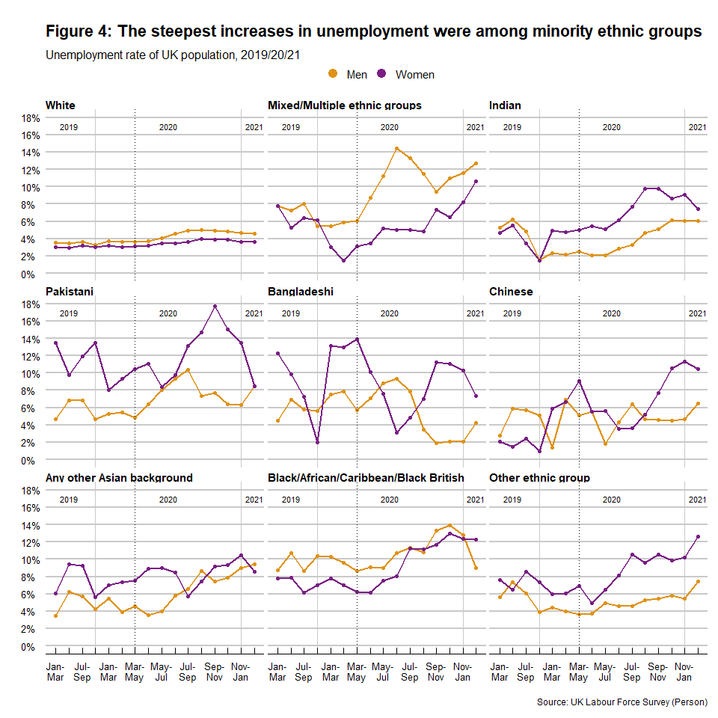

Figure 4 also shows that for most groups, COVID-19 worsened pre-pandemic gender gaps, with women faring worse than men. For example, women from Indian, non-Chinese Asian, and other ethnic backgrounds suffered from lower employment since before the pandemic hit. However, some ethnic minorities have showed particularly unstable and contrasting gender trends. This is the case of the Pakistani, Bangladeshi, and Chinese groups.

* Pakistani women saw a short drop in unemployment during May/July, back to pre-pandemic levels. However, their unemployment increased sharply to a high of 18% in September/November, while men’s remained half that (below 9%). Only in December 2020-February 2021 did women’s unemployment fall to the same level as men’s.
* Bangladeshi men and women experienced very different trends in unemployment levels: while women saw a continuous fall in unemployment from the start of the pandemic until June/August, men saw an increase. This was followed by an increase for women and a decrease for men, which then swapped again.
* Trends in unemployment for Chinese people were also volatile, particularly for men, from the start of the pandemic to August-October but levels then stabilised (at below 6%). Women’s unemployment, on the other hand, doubled in the period when men’s levels were falling.

For most minority ethnic groups, except the Bangladeshis, the COVID-19 pandemic has had a negative impact on employment levels, with real growth in rates of unemployment. However, employment seems to be recovering in the last couple of quarters, particularly for women. This is not the case for women and men from mixed/multiple and other ethnic groups who continue to experience a rise in unemployment.

## 

## Employment has not recovered equally for everyone

As well as age and ethnicity differences, our research also reveals differences by class. Employment rates are not recovering equally for all workers, with those employed in routine and semi routine occupations facing more persistent problems. Yet these are essential workers whose crucial work was highlighted during the pandemic: typical occupations here include cleaners, drivers, assemblers, machine operators, porters and messengers, plumbers, shop workers and care workers.

People in these key occupations saw the steepest fall in their employment, when compared to the employment rate during the pre-pandemic period (Figure 5). This is particularly true for men who saw a decrease of 5% from 2019 to the end of 2020 (87% vs 82%). The equivalent fall for women was 2%. Employment levels for other occupational class categories remained far more stable and, indeed, remained virtually unchanged for management and professional jobs, compared to pre-pandemic rates.

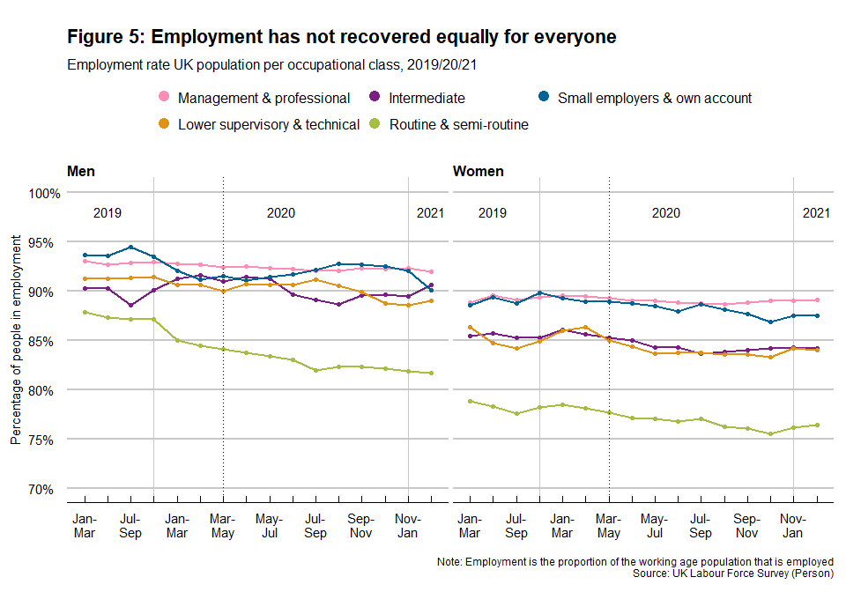

## Redundancies were concentrated in professional as well as routine occupations

While the pandemic barely impacted the overall employment levels of management and professional workers, people in this category were most likely to be made redundant during 2020 (see Figure 6). An estimated 87,553 male workers in management/professional jobs indicated that they had been made redundant within the previous three months (surveyed in October/December 2020). This is 3.2 times higher than the same period in 2019. In the case of similar female workers, the peak was felt in the September/November quarter, with an estimated 63,803 redundancies in the previous three months. This is 2.3 times more redundancies than the last quarter of 2019.

Routine and semi-routine occupations also saw redundancy rates peak in the second half of 2020. However, workers in this occupational class have not seen the same level of recovery as management and professional workers (as shown is Figure 5). We asked if this trend may be explained by comparing voluntary vs non-voluntary redundancies and found that management and professional workers have taken more voluntary redundancies (up to 12% in 2019 and close to 5% in 2020) compared to routine and semi-routine occupations (below 2% for all periods). Voluntary redundancies may suggest that workers are changing companies, starting new projects or leaving the labour force. These reasons seem to be less likely for workers in routine and semi-routine jobs.

Men in lower supervisory and technical occupations saw an increase in redundancies during the pandemic, while for similar women redundancies remained relatively low. However, women in intermediate occupations were considerably more affected than men. Typical intermediate occupations include clerical occupations, administrative assistants, and occupations which involve working alongside managers and professionals in ancillary roles. Women are frequently found in these supporting roles. With management and professional workers being able to work from home, ancillary roles may have been reduced as there were fewer face to face meetings to organise, visitors to host and trips to coordinate.

There was a sharp decline in the number of redundancies as 2020 closed and 2021 began.

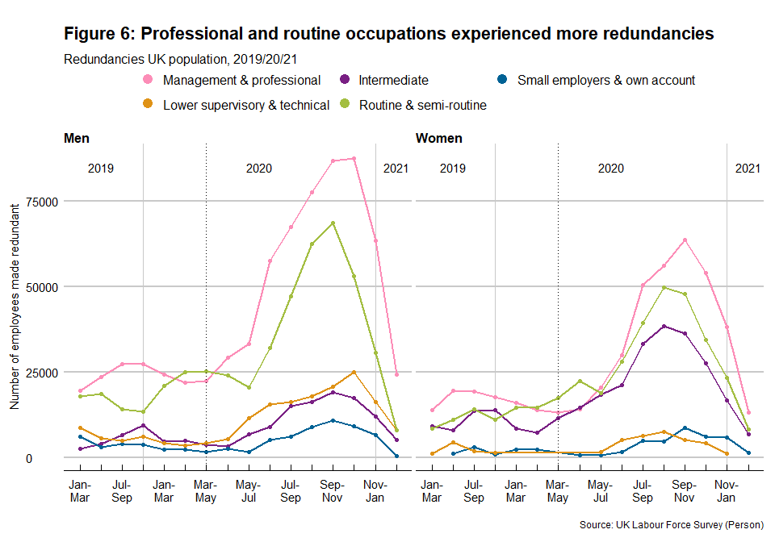

## Employers are not being able to keep their staff

The reasons for redundancies are mostly divided between those workers who were made redundant because employers had to close down fully and those who were made redundant because their employers reduced staffing numbers in the face of reduced demand and/or to maintain profit levels. As non-essential businesses were experiencing long periods of inactivity, as a result of COVID-19 closures and other pressures, many employers opted to retain fewer employees to carry out the available work. The percentage of people who lost their jobs because of workplaces reducing staff shot up rapidly after the first lockdown, peaking at 38% of all redundancies in summer 2020.

This trend has not decreased since its peak in summer 2020, with both men and women similarly affected.

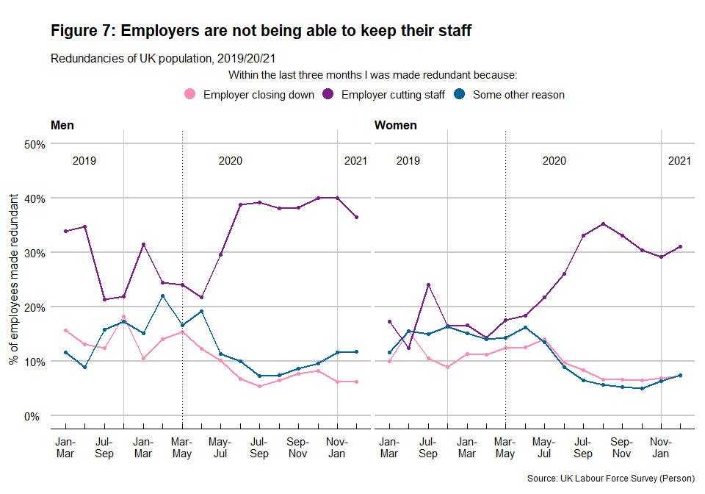

# 

# Conclusions

Men’s rates of formal employment in the UK suffer the most in periods of economic crisis. Our analysis has shown that the COVID-19 pandemic is no different in this respect. Overall, men have been more impacted when unemployment and redundancies are considered. Women are significantly more likely to be employed in public sector roles (particularly health, education, and local government) which have been largely protected against redundancies or have even seen an increase in employment (particularly health).

The aggregate gender unemployment gap varies when age, ethnicity and occupational class are included in the analysis. Women from minority ethnic groups and in intermediate occupations have been greatly affected by unemployment.

Our analyses in this report focus on the economically active population. Far more women than men are outside of the formal labour force, or leave the labour force on job loss, due to their greater responsibilities for essential unpaid domestic work and caring.

By comparing pandemic and pre-pandemic data, our research demonstrates that the pandemic has not created new inequalities in employment levels but reinforced existing ones. Overall, pre-pandemic trends worsened from the first lockdown but were starting to slowly recover by the end of 2020 and the beginning of 2021. There is, however, more variability across ethnic minorities where the recovery has been slower, widening the ethnic gap already present before the pandemic.

As we saw some signs of a jobs’ recovery in 2021, for some groups of workers, we are also approaching the end of the furlough scheme that has protected against higher levels of redundancy. Its looming closure in September 2021 has the potential for higher levels of job losses, with women likely to be impacted heavily.

Rising unemployment levels and the rapidly expanding numbers of people who lost their jobs and livelihoods due to employers cutting back on staff paint a worrying picture about work during the pandemic, including how workers - whose experiences were already shaped by intersecting inequalities of gender, class and ethnicity - fared as the pandemic rolled out. Yet they do not tell the full story. In our next report, we look at precariousness: how precarious has our work become and which groups are most affected?

# 

# The Project and its Data

Our project ‘How is COVID-19 impacting women and men’s working lives in the UK?’ is funded by Health Data Research UK, as part of the rapid funding call to use and enrich the data within the Data & Connectivity National Core Study (NCS) capability. This report draws on the analysis of the 2019/20/21 releases of the UK Labour Force Survey (LFS). Respondents are interviewed for five successive waves at three-months intervals and approximately 20% of the sample is replaced every quarter. Four quarters releases are supported in a typical year: Jan-Mar | Apr-Jun | Jul-Sep | Oct-Dec. From 2020, additional non-calendar quarter data have been released in response to the context of the coronavirus pandemic. Besides the four calendar quarters per year, 2020 included another eight releases of data. The last two quarters also included data for January and February 2021. Our analyses consider only the economically active population between 18-64 years old.

Table 1 summarises the sample size and population estimates for all the data waves considered in this analysis.

Table 1: Sample size and population estimates

| **Quarter** | **Sample** | **Population estimates** | **Economically Active** |
| --- | --- | --- | --- |
| Jan/Mar19 | 52,222 | 39,911,453 | 32,222,551 |
| Apr/Jun19 | 51,536 | 39,931,714 | 32,264,503 |
| Jul/Sep19 | 50,804 | 39,948,976 | 32,388,135 |
| Oct/Dec19 | 50,260 | 39,964,209 | 32,466,408 |
| Jan/Mar20 | 46,355 | 39,979,018 | 32,494,842 |
| Feb/Apr20 | 43,712 | 39,984,367 | 32,337,767 |
| Mar/May20 | 41,756 | 40,002,908 | 32,276,356 |
| Apr/Jun20 | 41,490 | 39,994,599 | 32,275,978 |
| May/Jul20 | 41,066 | 39,999,636 | 32,396,701 |
| Jun/Aug20 | 40,400 | 40,002,744 | 32,482,220 |
| Jul/Sep20 | 40,597 | 40,005,767 | 32,506,920 |
| Aug/Oct20 | 41,407 | 40,008,867 | 32,561,227 |
| Sep/Nov20 | 42,703 | 40,011,993 | 32,587,893 |
| Oct/Dec20 | 43,494 | 40,015,041 | 32,502,080 |
| Nov/Jan21 | 44,640 | 40,018,093 | 32,469,394 |
| Dec/Feb21 | 46,127 | 40,021,374 | 32,490,505 |
| Source: UK Labour Force Survey (Person) | | | |

The economically active population includes those people in employment plus those who are unemployed. We focus on understanding how COVID-19 impacted on:

* Unemployment: the percentage of economically active people between 18-64 years old who are out of work.
* Redundancies: the number of people who reported that they had been made redundant or had taken voluntary redundancy in the last three months.

Our analysis by gender is restricted because far more women than men are outside of the formal labour force (sometimes, problematically, called ‘economically inactive’). For more details on women and men’s paid and unpaid work see our project website at <https://www.nottingham.ac.uk/business/research/carrying-the-work-burden-of-covid-19/>

We follow the trend pre- and post-pandemic, considering March/May 2020 as the reference point. We trace the pre-pandemic trend up to the first 2019 quarter (Jan/March). We do this to identify if the COVID-19 pandemic is narrowing or reinforcing existing inequalities in the UK.

It is important to note that the LFS responses are weighted to official population projections that pre-date the COVID-19 pandemic. This particularly affects estimates for ethnicity. This implies that levels and differences in levels should be used with caution. Despite this, sample level estimates show a similar trend regarding gender differences for each group.

# For more information

* Luis Torres: [luis.torres@nottingham.ac.uk](mailto:luis.torres@nottingham.ac.uk);

Tracey Warren: [tracey.warren@nottingham.ac.uk](mailto:tracey.warren@nottingham.ac.uk);

Annegreet Veeken: [annegreet.veeken@nottingham.ac.uk](mailto:annegreet.veeken@nottingham.ac.uk)

* Project website: <https://www.nottingham.ac.uk/business/research/carrying-the-work-burden-of-covid-19/index.aspx>

# Acknowledgements

* The project ‘How is COVID-19 impacting women and men’s working lives in the UK? Expanding an existing award (on the work of working-class women in the UK) to explore all workers’ is part of the Data and Connectivity National Core Study, led by Health Data Research UK in partnership with the Office for National Statistics and funded by UK Research and Innovation (project ref HDRUK2020.137).
* The research data are distributed by the UK Data Service (safeguarded data version). The original data creators, the depositors, the copyright holders, the funders and the UK Data Archive bear no responsibility for the analysis or interpretation of the data made in this paper.
* We are grateful to Professor Clare Lyonette from the Institute for Employment Research

University of Warwick feedback and Dr Mary-Ann Stephenson and Dr Sara Reis from the UK Women’s Budget Group for their collaboration on the project.

# Citation

Torres L, Warren T, Veeken A and the UK Women’s Budget Group (2021) Unemployment and job loss in the COVID-19 UK: Exploring gender, ethnicity, and class. Research Summary 1, Nottingham: Nottingham University Business School.