Underemployment Levels and Trends: Time, skills, & wages

The Underemployment Project

Publication: December 2023 - | Update: February 2024

Table of Contents

# Background

This report is part of the project entitled: **A sociological investigation of underemployment and the lived experiences of underemployed workers**.

For more information visit [underemployment.info](https://underemployment.info)

**How to cite this report**:

* Torres, L., Munoz, M., Warren, T., Kamerāde, D., Beck, V. Fuertes, V., Magnus, L., & Morris, C. (2023). Underemployment Levels and Trends: Time, Skills, & Wages. The Underemployment Project. Available at: <https://trends.underemployment.info/>

# Updates

* **28 February 2024**:
  1. We have removed the quarter from January to March 2022 in the skills related-underemployment section. The Labour Force Survey had changes related to education variables affecting the analysis in this section.
  2. We have corrected the values in Figure 1.20 and Figure 1.21. The variable including ‘longer hours’ was missing (PREFHR), and it has now been added.

# Executive Summary

**Background**

Underemployment has become a topic of significant interest among policy makers and researchers in recent years. Despite its widespread prevalence and significant economic and social consequences, measuring underemployment has proven to be a challenging task due to its multidimensional nature and the interdisciplinary nature of research on this topic.

In this first project report we address key questions around how we can measure underemployment and track it over time. The report examines trends in the levels of various forms of underemployment for employees and self-employed workers aged 18 to 64 in the UK since 2006. We use the UK’s largest study on employment circumstances, the Labour Force Survey (LFS), describing long-term trends in the prevalence, characteristics of and social inequalities in underemployment and its various dimensions.

**Our approach**

We approach underemployment as a complex and multidimensional phenomenon including insufficient hours of employment, limited use of skills at work and/or low wages as follows:

* Time-related underemployment: The time-related underemployed work fewer hours than they desire. In this report, we count as time-underemployed those part-timers who work part-time because they could not find a full-time job, workers (part- and full-timers) who would like to work longer hours in their current job, and workers seeking a replacement job with more hours.
* Skills-related underemployment: The skills-related underemployed are workers who possess higher levels of skills than their current job requires. In this report, we measure skills-related underemployment via one indicator we construct using education level data where we first group employees into those who have high, intermediate, and low skill levels. Then, we group occupations into three skill levels: those that demand High, Intermediate and Low skills. Finally, employees are considered as skills underemployed when their educational level is higher to the occupational group of their current job.
* Wage-related underemployment: The wage-related underemployed are workers who are underpaid for what they do. In this report, we compare the wages of workers with others in their occupational grouping. We define being underpaid as earning wages that are at least 20% lower than the median for that occupation.

**Findings**

* The groups facing higher levels of time-related underemployment include younger workers and workers from minority ethnic groups, as well as people employed in routine/semi-routine occupations and on precarious contracts.
* Younger workers, minority ethnic workers, precarious workers, those with degrees, and people employed in intermediate occupations or in hospitality, alongside slightly more women than men, were more likely to have skills greater than their jobs need.
* Wage-underemployment is prevalent in the UK affecting over a fifth of working men and almost a third of working women, with levels persistent over time. It impacts most heavily on younger workers, people working in accommodation and food service industries, and, perhaps surprisingly, managers and professionals.

**Conclusions**

Our findings show which groups face higher levels of underemployment and who is better protected from it. Overall, women, younger workers, workers with lower qualification levels and those from ethnic minorities are most affected by underemployment in all three dimensions. Yet the different measures of underemployment can provide quite different pictures. Although they mostly agree on who is most affected by underemployment, they do show some different trends and levels. The varying indicators match less on regional trends, for example, and on which occupational groups are more affected by underemployment.

These first findings raise fascinating questions about the most appropriate indicators to use to capture underemployment as a whole. Our second report will focus on exploring these indicators in combination.

# The data

This report maps underemployment trends for employees and self-employed workers aged 18 to 64 in the UK. We use the UK’s largest study on employment circumstances, the Labour Force Survey (LFS), drawing on analysis from 2006 to 2022.

We describe long-term trends in the prevalence, characteristics of and social inequalities in underemployment and its various dimensions.

The report first examines time-related underemployment, followed by skills underutilisation, and wage-related underemployment.

See Technical Appendix 1: The Data for more details.

# Introduction

Underemployment is an increasingly concerning feature of the UK labour market. Workers who are underemployed are working below their potential or preference in terms of the hours spent in work, the wages earned and/or the skills they use in their jobs. Our study is tracking underemployment levels in the UK and across Europe. We are identifying the demographic characteristics of underemployed workers, determining the predictors of underemployment and its consequences, and highlighting the lived experiences of underemployed individuals in four UK cities.

In this first project report we address key questions around how we can measure underemployment and track it over time. The report examines trends in the levels of various forms of underemployment since 2006, analysing gender, ethnic, occupational, qualification, regional and industry disparities in these trends. We approach underemployment as a complex and multidimensional phenomenon including insufficient hours of employment, limited use of skills at work and/or low wages.

Our approach advances the understanding of the measurement of underemployment. Most official measures of underemployment are limited to hours worked. Time-related underemployment exists when the hours of work of an employed person are insufficient in relation to an alternative employment situation in which the person is willing and available to engage. While time-related underemployment is very important, a one-dimensional understanding of underemployment does not provide any information on the adequacy of a person’s wages and skills usage. The limitation of time-related underemployment is evident, for instance, in the case of workers who, although having a full-time job and are happy with the number of hours that they work, have low wages or may feel that their skills as underutilised. In this report, we innovatively consider all these three indicators to provide a complete picture of underemployment in the UK. Our second report will focus on exploring these indicators in combination.

# 1 Time-related underemployment

Time-related underemployment refers to individuals who work fewer hours than they desire (Bell and Blanchflower 2013; Wang 2018).

We measure time-related underemployment using three main indicators:

1. Part-timers who work part-time because they could not find a full-time job.
2. Workers who would like to work longer hours in their current job.
3. Workers seeking a replacement job with more hours.

See Technical Appendix 2: Time-related underemployment for more details.

## 1.1 Time-underemployment indicator 1: Involuntary part-time

People in employment can work either full-time or part-time. A part-time worker is someone who works fewer hours than a full-time worker. In the UK there is no specific number of hours that makes someone full or part-time, and the full-time/part-time threshold is debated, but a full-time worker will usually work 30 or 35 hours or more a week (Government n.d.). In the UK Labour Force Survey, the split between full-time and part-time employment is based on respondents’ self-classification (ONS 2023). The average hours worked by part-timers, for all the periods included in this analysis, is 20 hours.

Part-time jobs are of lower quality (including being lower paid) than full-time jobs, on the whole, and they bring a range of career penalties (ILO 2013a; Nightingale 2019; Warren and Lyonette 2018). Yet part-time employment is extensive in the UK, especially among women, as can be seen in Figure 1.1. The Labour Force Survey disaggregates part-time employment by reason as follows:

* **those who could not find full-time jobs**
* those who did not want full-time jobs
* those who were ill or were disabled
* those who were students or were at school

**We focus on those workers who could not find a full-time job** as our first indicator of underemployment.

### 1.1.1 Time-underemployed part-time workers by sex

More female than male workers in the UK are employed part-time. Figure 1.1 shows which of those part-timers work part-time because they could not find a full-time job. In absolute numbers, there are more female part-timers in this situation (see bottom figure in Figure 1.1). One contributing factor is that, even after taking into account the gender of workers, underemployment is more common in female- dominated occupations, and less prevalent in male-dominated occupations and industries. The percentage of part-timers unable to find full-time work is significantly lower for women than it is for men: it is around 10% in most periods for women compared with a range from 20% to 40% for men (as shown in the top figure of Figure 1.1). Most female part-timers say they do not want full-time jobs, whereas the majority of male part-timers desire full-time employment but cannot find it. A key factor contributing to this disparity is that women often work part-time to fit around other roles in their lives, including caring for children and others (Warren and Lyonette 2018).

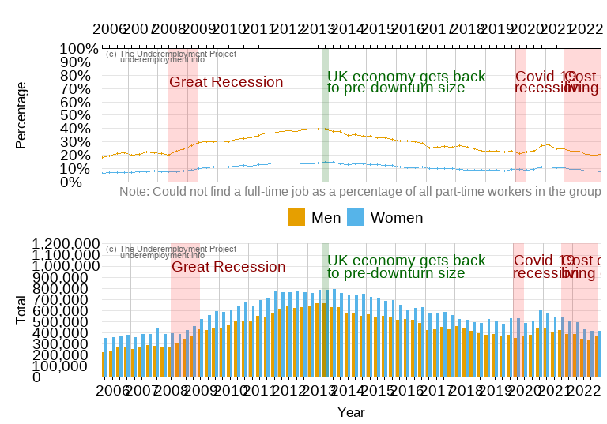

FIGURE 1.1: Part-time workers who could not find a full-time job by sex

### 1.1.2 Time-underemployed part-time workers by age group

Figure 1.2 shows the part-time workers who could not find full-time work divided by age groups. Part-timers aged between 18 to 24 years old were most likely to find themselves involuntarily working part-time. Time-underemployment among the young increased following economic recessions (in 2008-9 and 2020) but the ongoing cost of living crisis from 2021 has not yet significantly worsened involuntary part-time work for this age group. Trends over time show similar peaks and troughs for other age groups, albeit with notably lower levels of involuntary part-time employment.

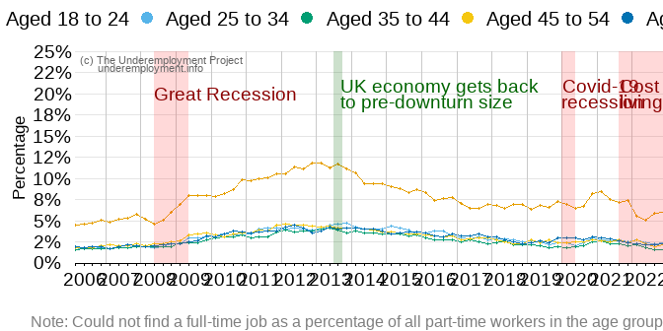

FIGURE 1.2: Young part-time workers struggle the most to find full-time jobs

### 1.1.3 Time-underemployed part-time workers by ethnic group

Work-time in the UK is shaped by ethnic background. Figure 1.3 shows that part-time workers from minority-ethnic groups, grouped together, are more likely to work part-time involuntarily than are white workers. During the period under study both groups experienced similar trends with increases in underemployment following recessions and decreases during economic recoveries. However, minority-ethnic groups were disproportionately affected during recessions, experiencing a larger increase of involuntary part-time work than white groups after each economic crisis.

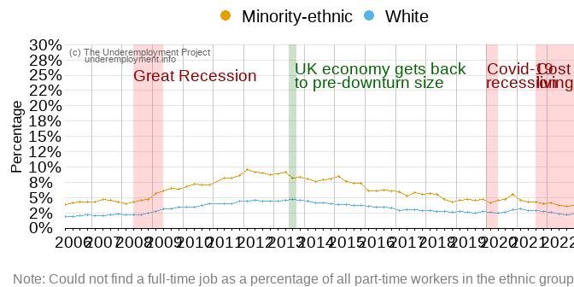

FIGURE 1.3: Ethnic-minority groups more likely to find themselves in involuntary part-time jobs

### 1.1.4 Time-underemployed part-time workers by qualification level

Qualification levels are a key factor shaping who is time-related underemployed. Figure 1.4 shows higher rates of involuntary part-time working among lower/no qualified part-timers. This suggests that across all years of our analysis, workers with no qualifications or lower-level qualifications find it more difficult to find full-time employment than do those with higher qualifications.

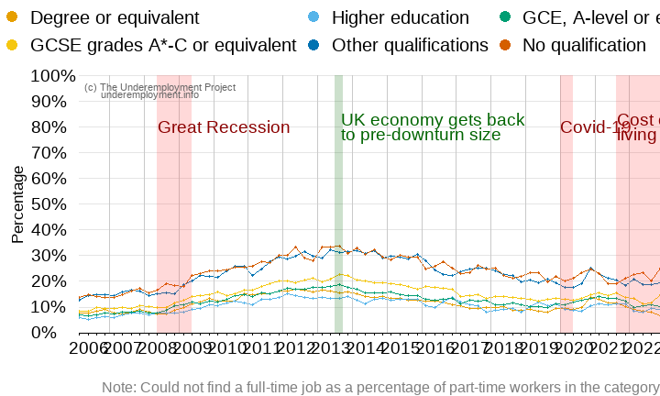

FIGURE 1.4: : Workers with no formal qualification find it difficult to find full-time work

### 1.1.5 Time- underemployed part-time workers by occupational group

Part-time employment is concentrated in lower waged occupations, and with fewer opportunities to work part-time in more senior positions. Figure 1.5 shows which occupations feature the most involuntary part-time working among part-timers. Routine occupations (e.g., HGV driver, van driver, cleaner, porter, packer, sewing machinist, messenger, waiter or waitress, or bar staff), semi-routine (e.g., postal worker, machine operative, security guard, caretaker, farm worker, catering assistant, receptionist or sales assistant) and lower supervisory/technical (e.g., motor mechanic, fitter, inspector, plumber, printer, tool maker, electrician, gardener or train driver) stand out with higher rates of time-underemployment than managers/professionals and those in intermediate roles. Economic downturns affected these groups the most too, intensifying their underemployment.

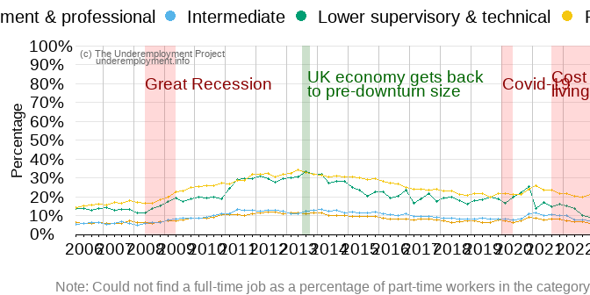

FIGURE 1.5: Routine, semi-routine and technical part-timers more likely to be in involuntary part-time work

### 1.1.6 Time-underemployed part-time workers by contract type

In recent years, the UK has seen a decline in the number of employees with a so-called ‘standard employment relationships’, characterized by a secure and full-time job contract with their employers. The proliferation of alternative contract types, such as flexi-work, term-time working, raises many questions about the quality of that work and workers’ experiences. Perhaps the most contentious form of work, especially relevant for our focus on temporal underemployment, is the zero-hours contract, in which workers are not guaranteed any hours of work at all from their employer. Zero hours contracts give employers a great deal of flexibility, but there is debate over whether workers opt positively into zero hours jobs for flexibility themselves or must agree to such precarious work in a limited labour market. We show here that part-timers with more precarious contracts are more likely to be in part-time work because they could not find a full-time job than are other workers (Figure 1.6: workers with zero-hours contracts have had the highest levels of involuntary part-time work since 2008.

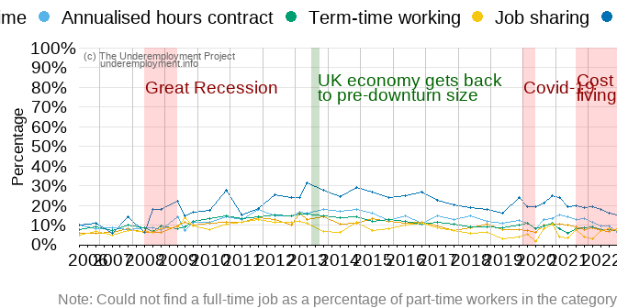

FIGURE 1.6: Workers in zero hours contracts struggle more to find full-time work

### 1.1.7 Regional trends in time-underemployment among part-time workers

Our project provides analysis of underemployment across the UK, but it focuses too on the four cities of Bristol, Glasgow, Nottingham and Salford. Figure 1.7 shows the distribution of workers in involuntary part-time employment in regions of England and Scotland that are in the scope of this project plus the rest of England. The North West of England (including Salford) and Scotland (including Glasgow) have the highest proportion of workers working part-time because they could not find a full-time work, while the South West (including Bristol) consistently has the lowest proportions, and this pattern has remained consistent over time . Meanwhile, the East Midlands Region (including Nottingham) saw an increase in involuntary part-time working during 2022.

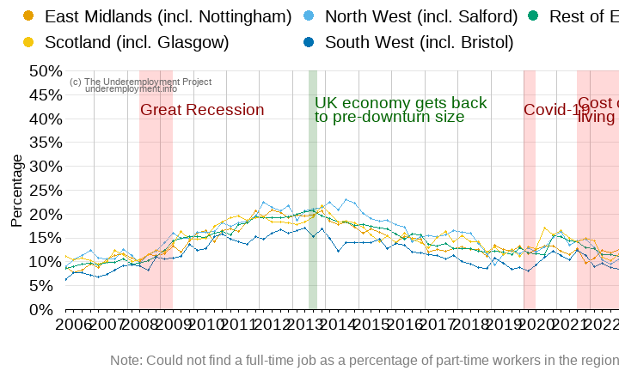

FIGURE 1.7: Workers in the North West of England and Scotland struggle more to find full-time work

### 1.1.8 Industry trends in time-underemployment among part-time workers

In addition to its concern with underemployment across the whole labour force in the UK, the project focuses upon two industry sectors: Wholesale and retail trade, and Human health and social work. We are examining the extent of diverse and intersecting forms of underemployment there and the lived experiences of workers. Figure 1.8 shows the distribution of workers in involuntary part-time in six service-related sectors. Involuntary part-time work is particularly prevalent among part-timers employed in the Retail as well as Hospitality (accommodation and food service) sectors, justifying their inclusion in our research going forward. Human health and social work activities show lower levels compared to the two sectors mentioned above, and similar rates with sectors such as Education. Very few part-timers working in finance and insurance are doing so involuntarily.

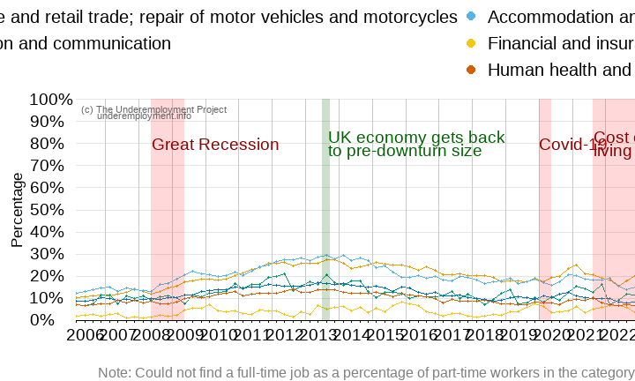

FIGURE 1.8: Involuntary part-time is high in the Retail and Hospitality sectors

## 1.2 Time-underemployment indicator 2: Wanting longer hours

Our second indicator of time-related underemployment moves beyond the focus only on part-time workers. We explore next all workers who say that they would like to work longer hours in their jobs (at their current basic rate of pay). The following sections look at this group of workers by gender, age, ethnicity and so on.

### 1.2.1 Wanting more hours by sex

The second indicator of time-related underemployment produces similar findings to the first one (involuntary-part-time). Figure 1.9 shows women and men who wish to work longer hours in their current jobs. Female workers are slightly more likely than are men to say they want more hours. The trends over time follow a similar pattern for male and female workers characterised by periods of increased underemployment during and after economic recessions.

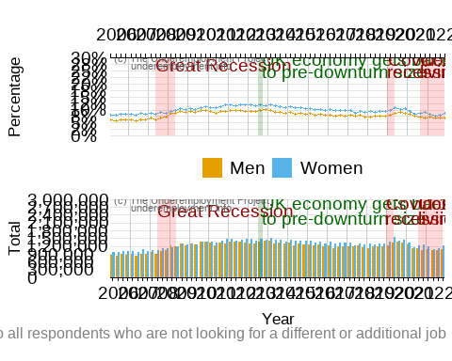

FIGURE 1.9: Women slightly more represented among workers wanting more hours

### 1.2.2 Wanting more hours by age group

The second indicator of underemployment again reiterates our earlier finding of higher levels of underemployment among younger workers. Figure 1.10 shows that the younger the worker is, the more likely they are to want longer hours in their current jobs. As with involuntary part-time, this form of underemployment peaked after economic recessions, particularly among younger workers.

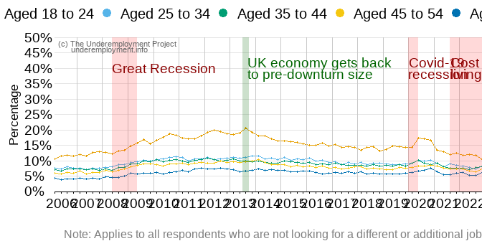

FIGURE 1.10: Young workers wish to work more hours

### 1.2.3 Wanting more hours by ethnic group

Figure 1.11 shows preferences for more hours of work by ethnic group. Minority-ethnic workers are again more likely to want more hours than are the white majority each year, and with slightly fluctuating levels over time.

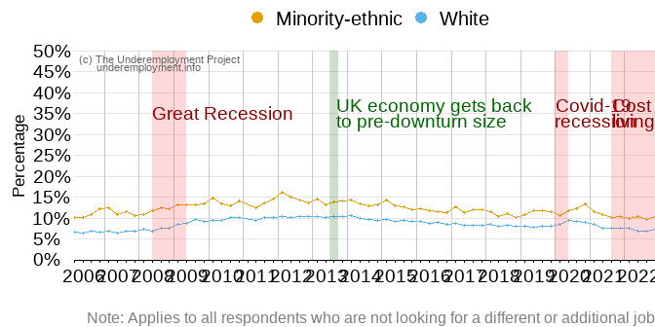

FIGURE 1.11: Ethnic-minority group are up to two times more likely to wish for more hours of work

### 1.2.4 Wanting more hours by qualification level

Figure 1.12 compares preferences for more hours in the current job by qualification. Overall, workers with lower level and no qualifications are substantially more likely to want to work more hours, certainly when compared with those with degrees who are again the group least likely to be underemployed.

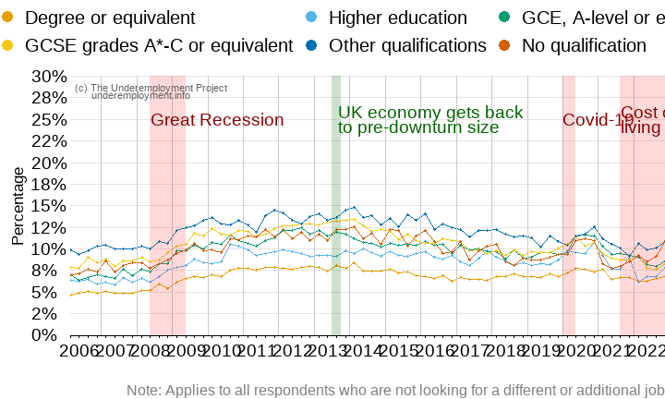

FIGURE 1.12: The lower the qualification, the more likely to want more hours

### 1.2.5 Wanting more hours by occupational group

That the risks of being underemployed are shaped by occupational group is also shown with this second indicator. Workers in routine and semi-routine occupations are more likely to report wanting to work more hours in their current jobs than are other workers (Figure 1.13), peaking at almost one-fifth of the workers in 2013 and starting to rise again in 2022 after a post-pandemic dip.

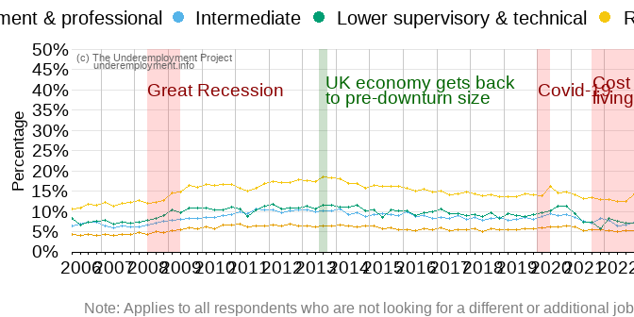

FIGURE 1.13: Routine and semi-routine workers would like to work more hours in their current jobs

### 1.2.6 Wanting more hours by contract type

When we examine who would like to work longer hours in their current jobs, we see again the higher proportions of those on zero hours contracts who are time-underemployed (Figure 1.14). This was especially true in the years following the great recession when around a third reported wanting to work more.

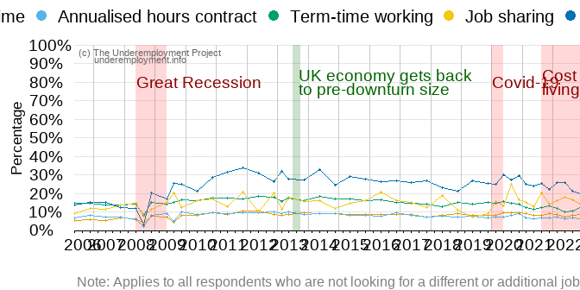

FIGURE 1.14: Workers in zero hours contracts more likely to want more hours of work

### 1.2.7 Wanting more hours by part-time and full-time employment

It is expected that those part-time workers who say they work part-time because they could not find full-time jobs would like to work more hours: Figure 1.15 shows that over half would like more hours. However, less is known about workers in full-time jobs and those workers who say that they are voluntarily working part-time. Are they fine with their current hours or would some also like more? Figure 1.15 shows further that one in ten of those part-timers who work part-time because they do not want a full-time job would still like to work more hours. The ‘part-time’ hours category is a wide one, with shorter hours part-time jobs often associated with lower quality (Warren and Lyonette 2015). It is notable that a smaller proportion of full-time workers express a desire for more hours compared to both groups of part-timers.

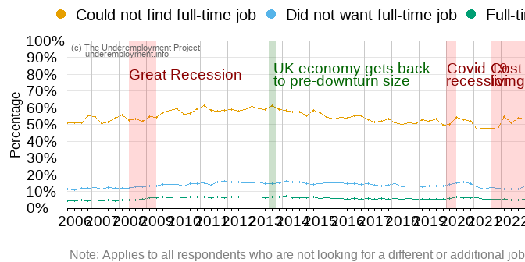

FIGURE 1.15: Some voluntary part-timers and full-time workers would like to work more hours

Knowing whether workers want to work more hours, or not, is a valuable indicator of time-related underemployment. It tells us little, however, about ‘how’ underemployed workers are, the intensity of their underemployment, and how far workers are away from achieving their hours preferences. Figure 1.16 shows that full and part-time workers who would like additional hours differ in the number of extra hours they would like to work. While full-time workers would like between 7 to 10 additional hours a week, those part-timers who could not find full-time would like up to 15 extra hours. Those who did not want full-time work would still like around 10 additional hours, with little change over time. Given that average hours worked by part-timers in the UK is 20 a week, this is evidence of persistent and wide actual/preferred hours gaps and deep time-related underemployment especially among part-timers.

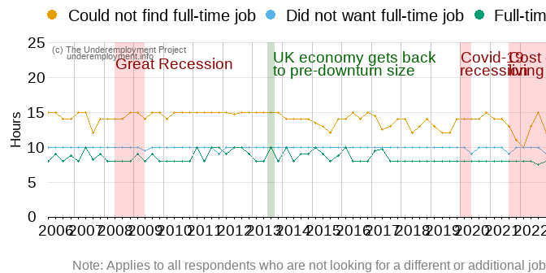

FIGURE 1.16: Extra hours wished to work by part-time and full-time workers

### 1.2.8 Wanting more hours by region

All regions of the UK experienced similar levels of workers wanting to work more hours and all saw slight increases after economic recessions (Figure 1.17).

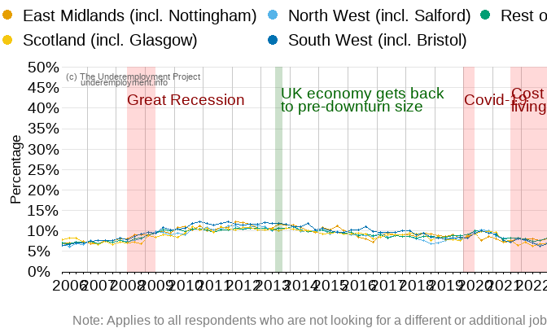

FIGURE 1.17: Slight increase in workers wanting extra hours after economic recessions and in all regions

### 1.2.9 Wanting more hours by industry

Similar to the involuntary part-time indicator, Figure 1.18 shows that the two sectors this project focuses on (Hospitality and Retail) have the highest proportion of workers wishing to work longer hours (followed by Education). The financial and information sectors again have low levels of underemployment, maintained over time, aside from a slight increase during the cost-of-living crisis.

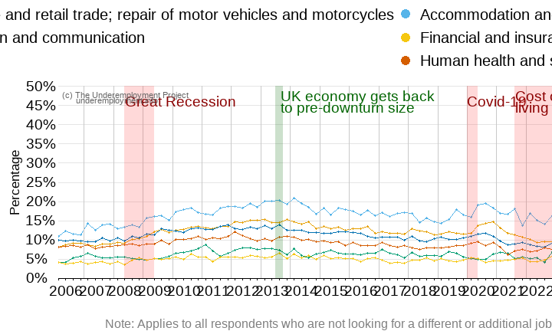

FIGURE 1.18: Involuntary part-time is concentrated in the Retail and Hospitality sectors

## 1.3 Time-underemployment indicator 3: Seeking a replacement job with more hours

The third and final time-related underemployment indicator identifies those workers who are looking for a replacement job with more hours. For this, the Labour Force Survey asks participants whether they are looking for a different or additional paid job. If they answer yes, they are asked to clarify if it is an additional job or a replacement job. According to the definition of time-related underemployment, in this case we only consider those who are looking to replace their current job.

Among those looking to change their job, between 15% to 20% would like to work longer hours in their new job. In addition, the percentage of employees in this situation increased after the Great Recession. However, since 2020 this trend has reverted, which could be linked to developments such as the UK pilot experience of reducing the work week to four days, as shown in Figure 1.19.

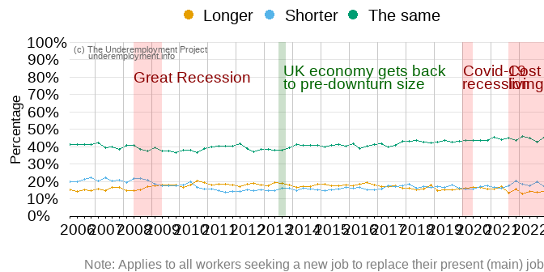

FIGURE 1.19: Preferred working hours in the job being looked for

### 1.3.1 Seeking a replacement job with more hours by sex

Figure 1.20 shows that between the period of 2006 to 2022 slightly more male than female workers sought a replacement job with more hours. Such differences reduced after the start of the cost of living crisis when female workers were more likely to look for a replacement job with more hours. This difference can be explained by the higher participation of men in the labour market compared to women, and the effects of the cost of living on female workers.

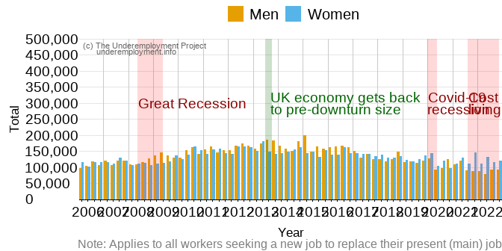

FIGURE 1.20: More male than female workers are seeking a replacement job

### 1.3.2 Seeking a replacement job with more hours by age group

Considering the trends in the three indicators of time-related underemployment, younger workers could be considered more at risk of falling under this category than older workers. Specifically, Figure 1.21 shows that the majority of workers looking to replace their jobs are between 18 to 24 year old, followed by those between 25 to 34 years old.

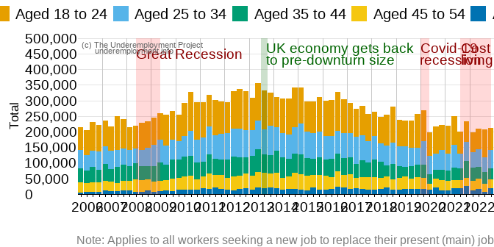

FIGURE 1.21: Younger workers are more likely to look for a replacement job

Furthermore, as shown in Figure 1.22 the group with the highest proportion of workers seeking to replace their jobs with one that has longer hours is concentrated among those between 18 and 24 years old.

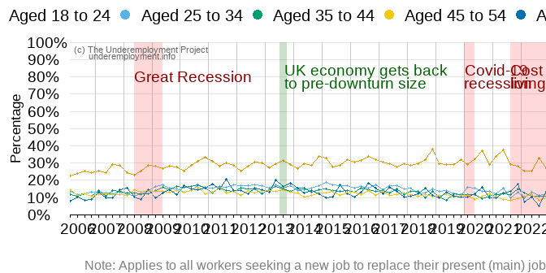

FIGURE 1.22: Workers between 18 to 24 years old looking for a replacement job with longer hours

### 1.3.3 Seeking a replacement job with more hours by ethnic group

As Figure 1.23 shows, the percentage of white workers looking to replace their jobs has consistently remained below 20% and relatively stable. In contrast, ethnic minority workers have consistently maintained percentages above only dropping below 20% at the onset of the cost-of-living crisis.

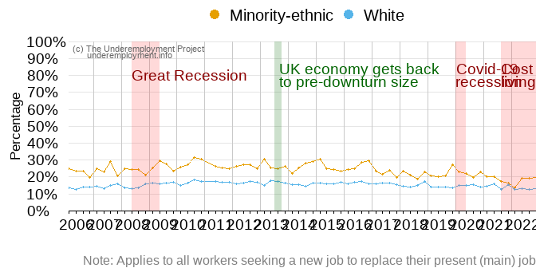

FIGURE 1.23: Ethnic-minority workers more likely to look for replacement jobs with longer hours

### 1.3.4 Seeking a replacement job with more hours by occupational group

Lastly, workers in routine and semi-routine occupations are more interested in replacing their current job than are other workers. Figure 1.24 shows furthermore that this group is considerably more likely to look for a replacement job with longer hours compared to management and professional occupations.

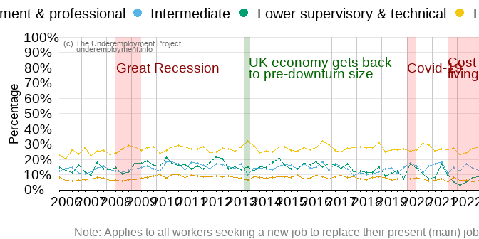

FIGURE 1.24: Working class workers more likely to seek replacement jobs with longer hours

## 1.4 Summary: Time-related underemployment

The time-related underemployed work fewer hours than they desire. In this report, we count as time-underemployed those part-timers who work part-time because they could not find a full-time job, workers (part- and full-timers) who would like to work longer hours in their current job, and workers seeking a replacement job with more hours. Approaching underemployment using three different measures gives us better insights into UK levels of this first form of underemployment and trends over time. We show which groups face higher levels of time-related underemployment and who is better protected from it. Results from the three indicators affirm that the groups facing higher levels of time-related underemployment include younger workers and workers from minority ethnic groups, as well as people employed in routine/semi-routine occupations and on precarious contracts. We move to skills-related underemployment next.

# 2 Skills-related underemployment

Our second dimension of underemployment is skills-related underemployment. We examine levels and trends over time in the number of workers who have skills that are greater than those required in their current job. We measure skills-related underemployment via one indicator we construct as follows:

* Using education level data, we first group employees into those who have High, Intermediate and Low skill levels.
* We group occupations into three skill levels: those that demand High, Intermediate and Low skills.
* We consider employees as being skills-related underemployed when their education level is higher than the skill level required in their current occupation.

(See Technical Appendix 3: Skills-related underemployment for full details).

## 2.1 Skills-related underemployment by sex

Figure 2.1 shows that the proportion of individuals categorised as underemployed in terms of their skills steadily increased between 2006 and 2022. Skills related underemployment considerably increased since 2006. The number of overqualified employees increased from over 1.5 million in 2006, to over 3.7 million in 2022. From 2006 to 2008 the percentage of overqualified male and female workers was similar, however since 2009 the gap between women and men has widened.

In the quarter from January to March 2022 the LFS questionnaire had changes related to education variables. This implies that values from previous waves were not brought forward to this period (ONS 2022b). Therefore, we have removed the quarter from January to March 2022 in this section.

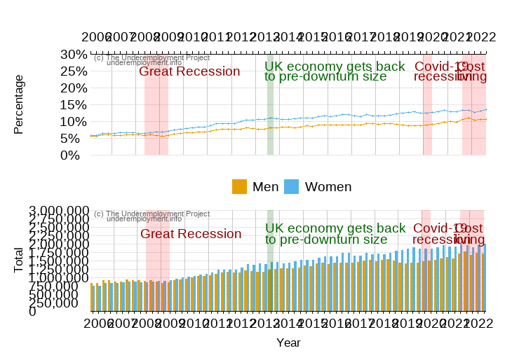

FIGURE 2.1: Workers with qualifications exceeding the requirements for their occupation

## 2.2 Skills-related underemployment by age group

Figure 2.2 shows that the younger the worker, the more likely they are to be overqualified in their current jobs. The age group between 18 to 24 years old has a particularly higher proportion of workers holding a qualification above the one required at their jobs.

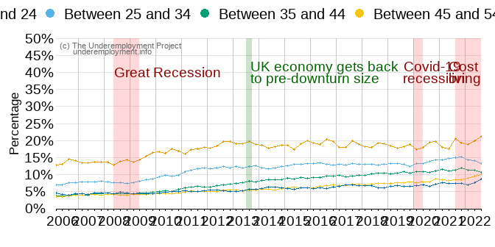

FIGURE 2.2: Younger workers are more likely to be overqualified in their jobs

## 2.3 Skills-related underemployment by ethnic group

Figure 2.3 shows workers from ethnic-minority groups are more likely to find themselves in jobs for which they are overqualified than are white workers. Furthermore, after the great recession underemployment grew among ethnic-minority groups: the percentage overqualified increased and then remained steady at a higher level. Underemployment among white workers rose steadily from 2010.

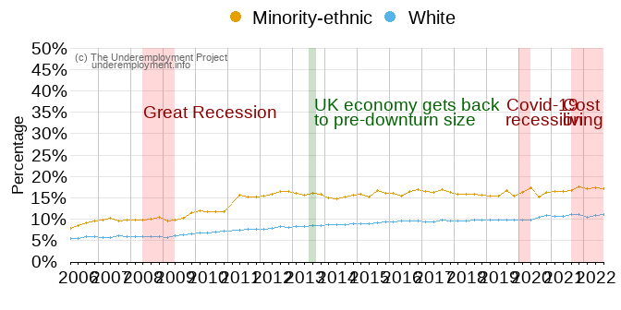

FIGURE 2.3: Ethnic-minority groups are more likely to find themselves in jobs for which they are overqualified

## 2.4 Skills-related underemployment by qualification level

Workers with a degree or equivalent level of education are substantially more likely to be overqualified for their current job than are other workers (Figure 2.4). Their underemployment grew after the great recession and it has not returned to pre-2008 levels. The percentage of overqualified workers among those with a “Higher education” and “GCE, A-level or equivalent” did not change in the period under study.

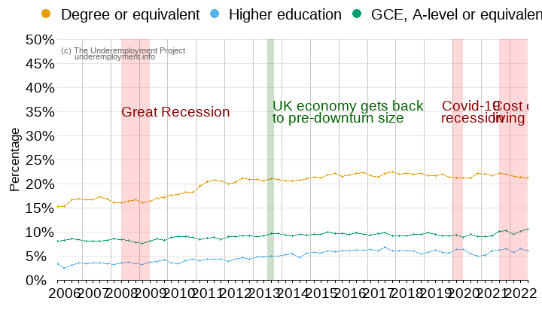

FIGURE 2.4: Workers with a university degree are more likely to be overqualified for their jobs

## 2.5 Skills-related underemployment by occupational group

Figure 2.5 shows that the female-dominated ‘intermediate’ occupational group (covering such occupations as secretary, personal assistant, clerical worker, office clerk, call centre agent, nursing auxiliary or nursery nurse) have a larger proportion of overqualified employees than do other occupations. Between 2006 and 2022, all occupations saw an increase in skills-related underemployment. The exception here is managers/professionals among whom skills-related underemployment is negligible.

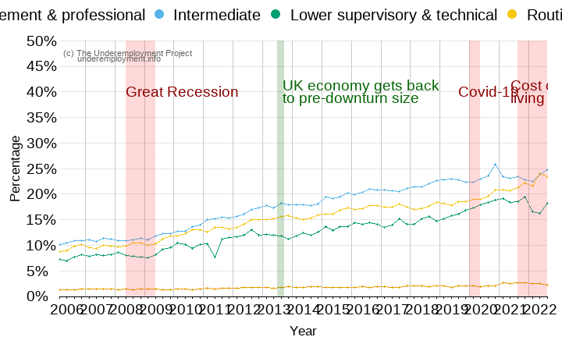

FIGURE 2.5: Intermediate occupations have the largest proportion of overqualified employees

## 2.6 Skills-related underemployment by contract type

As Figure 2.6 shows, workers in a non-permanent job are more likely to be over-qualified for their jobs than are permanent workers. The proportion of overqualified workers increased over time for both groups.

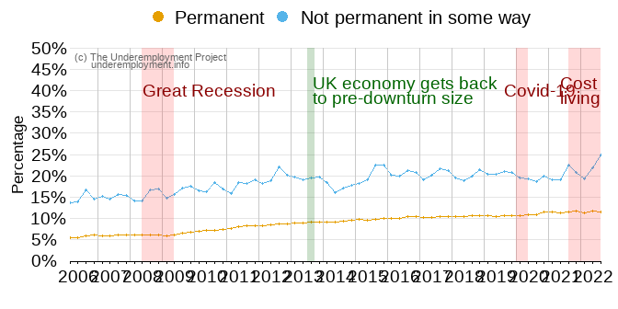

FIGURE 2.6: Workers in non-permanent jobs likely to be overqualified

In times of economic unrest, more employees might enter into jobs that require lower qualifications than they possess and they might accept more precarious working arrangements to avoid unemployment. As Figure 2.7 shows, this can be observed in the increase in flexible employment arrangements over time. The proportion of overqualified workers with zero-hours contracts in particular increased substantially during the cost-of-living crisis.

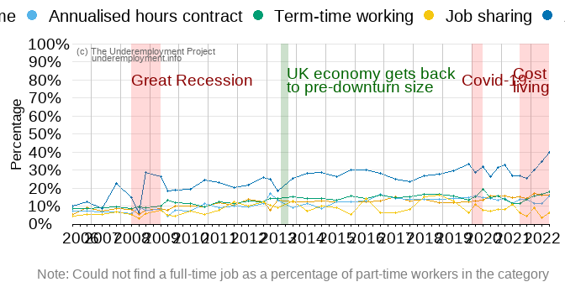

FIGURE 2.7: Zero-hours workers are more likely to be overqualified

## 2.7 Skills-related underemployment by region

Figure 2.8 shows that the mismatch between the skills held by workers and the requirements of their jobs increased steadily in all regions. Scotland (including Glasgow) shows a slightly higher proportion of overqualified workers in most periods between 2006 and 2022 while the East Midlands (including Nottingham) currently has one of the lowest levels of skills-related underemployment in the UK, but the regional gap is narrow.

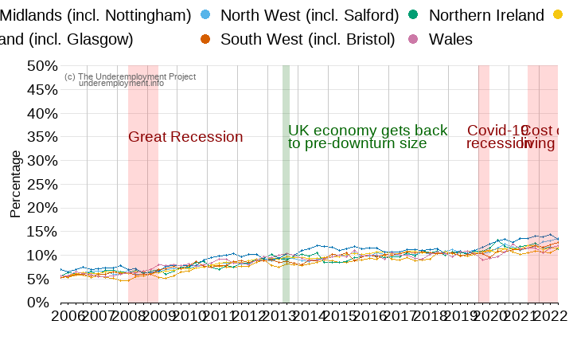

FIGURE 2.8: The mismatch between skills and job requirements has increased steadily in all regions

## 2.8 Skills-related underemployment by industry

Hospitality (accommodation and food service activities) stands out as the sector with most skills-related underemployment and the highest growth over time (Figure 2.9). The proportion of overqualified employees steadily increased in the six industries related to the provision of services.

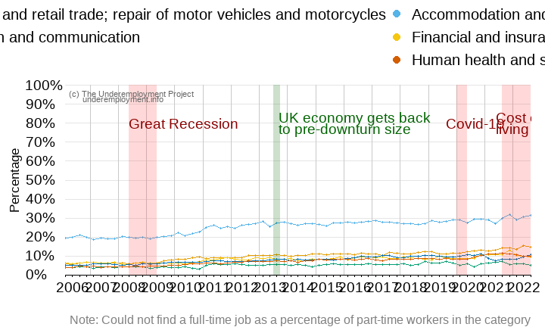

FIGURE 2.9: Skills-related underemployment is concentrated in the Retail and Hospitality sectors

## 2.9 Summary: Skills-related underemployment

The skills-related underemployed are workers who possess higher levels of skills than their current job requires. Younger workers, minority ethnic workers, precarious workers, those with degrees, and people employed in intermediate occupations or in hospitality, alongside slightly more women than men, were more likely to have skills greater than their jobs needs. We next discuss wage-related underemployment.

# 3 Wage-related underemployment

Wage-related underemployment occurs when workers are underpaid for the work that they are doing. This is a complex notion. It is not typically reported in national statistics, and there is no one standard method for its estimation. We measure wage-related underemployment as being underpaid in comparison to other employees in the same occupation. An underpaid employee is defined as someone earning wages at least 20% lower than the median in their occupational category (See Technical Appendix 4: Wage-related underemployment for details).

## 3.1 Wage-related underemployment by sex

Female employees are more likely to be underpaid than are male. Figure 3.1 shows the underpayment rate and totals for women and men: underpayment levels stood at just above 20% for men and just below 30% for women in most time periods. However, almost a third (32%) of women were underpaid in April/June 2020. The highest wage-underemployment level for men reached 24% (in April/June 2010). This rate represented a difference of up to 960,516 more underpaid female than male employees in the UK.

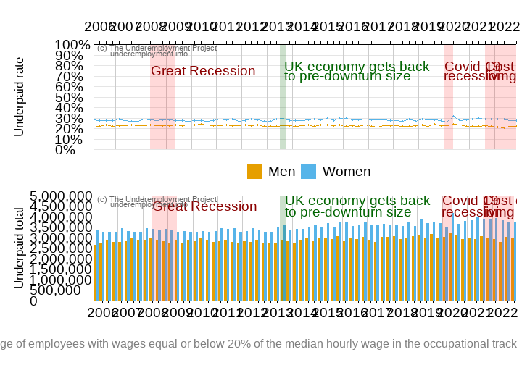

FIGURE 3.1: Female employees are the most affected by wage-related underemployment

## 3.2 Wage-related underemployment by age group

Figure 3.2 shows that younger employees are by far the most affected by wage-related underemployment. This is particularly the case for employees between 18 to 24 who experience rates approaching and even above 50% in some periods. Yet other age groups are not fully protected against being underpaid either: levels of a fifth or more of wage-underemployment persist among the older workforce.

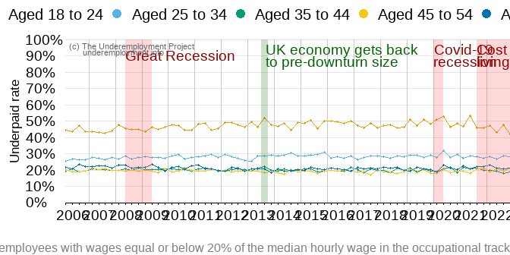

FIGURE 3.2: Employees ages under 25 are more likely to be underpaid

## 3.3 Wage-related underemployment by ethnic group

Figure 3.3 shows the rate of underpayment among employees according to their ethnic group. Overall, the gap is not large, though the proportion of underpaid minority-ethnic employees is slightly higher than the white majority employees for most periods. Even the small differences reduced after the Covid-19 pandemic hit.

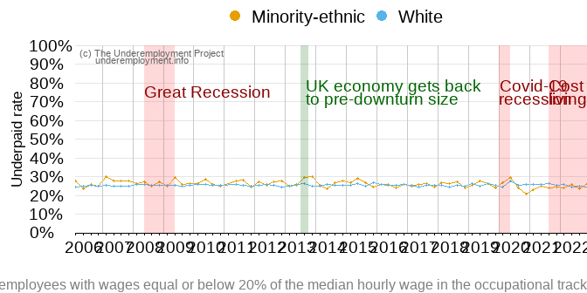

FIGURE 3.3: The proportion of underpaid minority-ethnic employees is slightly higher than their white counterparts

## 3.4 Wage-related underemployment by qualification level

Employees with a degree and higher education qualifications are less affected by wage underemployment than are those without a qualification, as Figure 3.4 shows. Levels for those employees without a qualification during 2022, but show again an increase in its last quarter.

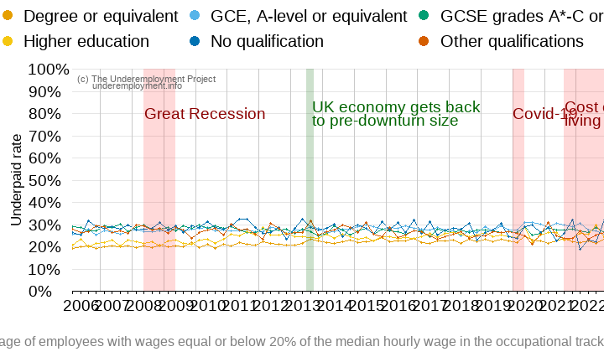

FIGURE 3.4: More employees without qualification are underpaid compared to those with a degree

## 3.5 Wage-related underemployment by occupational group

As Figure 3.5 show, employees in managerial and professional occupations are more likely to experience wage-related underemployment than are other workers. Routine and semi-routine occupations are also affected, but this dimension of underemployment standards apart from time- and skills-related underemployment where levels were highest among this occupational group.

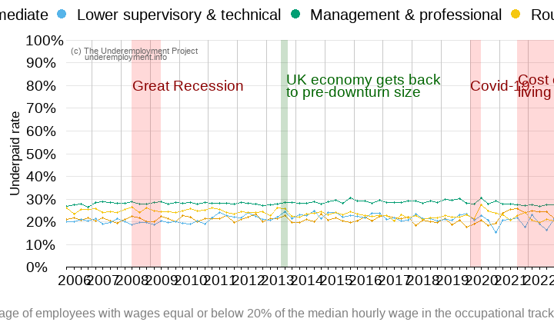

FIGURE 3.5: Higher proportion of underpaid employees among management and professional occupations

## 3.6 Wage-related underemployment by region

Wage-related underemployment is high across all UK regions, especially the East Midlands, North West and South West (Figure 3.6). Scotland shows slightly lower levels. These regional levels fluctuate greatly over time.

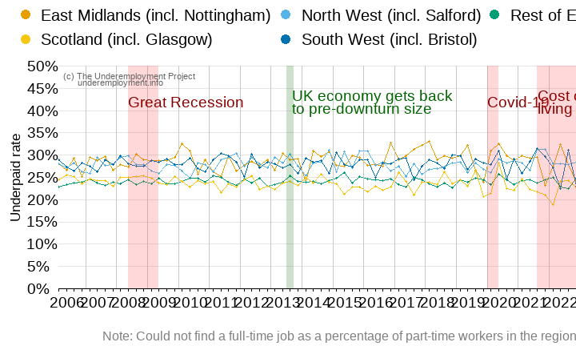

FIGURE 3.6: All regions affected by wage-related underemployment

## 3.7 Wage-related underemployment by industry

As Figure 3.7 shows, wage underemployment is most pervasive in the accommodation and food service sector where, in most years, over a third of workers are underpaid (earning at least 20% lower than the median in their occupational category). Employees in education, retail and human health and social work are also affected while the finance and insurance industry group stand out again with the lowest levels of underemployment.

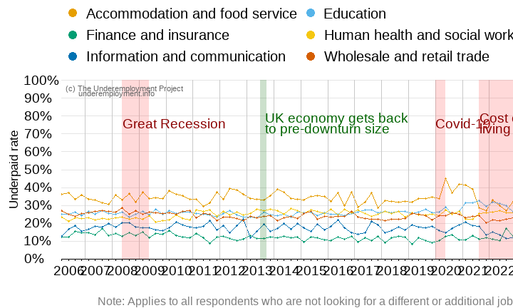

FIGURE 3.7: More underpaid employees in the hospitality, human health, education, and retail sectors

## 3.8 Summary: Wage-related underemployment

The wage-related underemployed are workers who are underpaid for what they do. In this report, we compare the wages of workers with others in their occupational grouping: we define being underpaid as earning wages that are at least 20% lower than the median for that occupation. We show that wage-underemployment is prevalent in the UK affecting over a fifth of working men and almost a third of working women, with levels persistent over time. It impacts most heavily on younger workers, people working in accommodation and food service industries, and, perhaps surprisingly, managers and professionals.

# Conclusions and the way forward

*The Underemployment Project* approaches underemployment as a complex and multidimensional phenomenon including insufficient hours of employment, limited use of skills at work and/or low wages. This first project report examines trends in the levels of these three forms of underemployment in the UK since 2006. We explore gender, age, ethnic, occupational, qualification, regional and industry disparities in levels of underemployment and trends over time.

Our findings show that women, younger workers, workers with lower qualification levels and those from ethnic minorities are most affected by underemployment. Yet our report also shows that the different indicators of underemployment can provide quite different pictures. Although they mostly agree on who is most affected by underemployment, they do show some different trends and levels. The varying indicators match less on regional trends, for example, and on which occupational groups are more affected by underemployment.

These first findings from *The Underemployment Project* raise fascinating questions about the most appropriate indicators to use in order to capture underemployment as a whole. Our second report will focus on exploring these indicators in combination. This will allow us to understand if and how the three dimensions of underemployment accumulate and whether our indicators overlap regarding the workers that are identified as underemployed. It will also provide a view on the nature of the relationships between indicators, for instance, does wage-related underemployment impact time or skills-related underemployment?

# Technical Appendix 1: The Data

We use the UK’s largest study on employment circumstances, the Labour Force Survey (LFS), drawing on analysis from the 2006 to 2022 releases (calendar quarters). We take a pseudo-longitudinal approach, where we analyse repeated cross-sectional data (Table 1). It is important to note the following:

* We calculate the underemployment rate based on the employed population rather than the total active population. Between wave 2 (April-June) of 2020 and wave 1 (January-March) of 2022, sample sizes were significantly affected by the Covid-19 pandemic, potentially affecting results from this period.
* From wave 2 (April-June) in 2011, the ethnicity variable was modified in accordance to Census data. In this report we have recorded the variable to ensure consistency across all quarters in the dataset.
* The job arrangements have also been recorded to ensure consistency across all quarters in the dataset, as this variable was modified three times during the periods included in this analysis.

Table 1: **Table 1: Calendar quarters from 2006 to 2022**

Population weights are used.

| Year | Calendar quarter | Total active*1* | Total in employment | Female workers | Male workers |
| --- | --- | --- | --- | --- | --- |
| 2006 | Jan/Mar | 29,239,473 | 27,681,476 | 12,821,692 | 14,859,784 |
| 2006 | Apr/Jun | 29,371,385 | 27,747,666 | 12,835,894 | 14,911,772 |
| 2006 | Jul/Sep | 29,645,623 | 27,970,967 | 12,864,870 | 15,106,097 |
| 2006 | Oct/Dec | 29,521,041 | 27,909,681 | 12,857,295 | 15,052,386 |
| 2007 | Jan/Mar | 29,468,688 | 27,813,369 | 12,827,710 | 14,985,659 |
| 2007 | Apr/Jun | 29,566,066 | 27,979,389 | 12,873,256 | 15,106,133 |
| 2007 | Jul/Sep | 29,825,269 | 28,213,100 | 12,978,851 | 15,234,249 |
| 2007 | Oct/Dec | 29,768,095 | 28,240,403 | 13,017,774 | 15,222,629 |
| 2008 | Jan/Mar | 29,824,469 | 28,211,365 | 13,051,041 | 15,160,324 |
| 2008 | Apr/Jun | 29,906,241 | 28,279,465 | 13,075,946 | 15,203,519 |
| 2008 | Jul/Sep | 30,149,630 | 28,341,057 | 13,114,297 | 15,226,760 |
| 2008 | Oct/Dec | 30,118,039 | 28,232,827 | 13,098,562 | 15,134,265 |
| 2009 | Jan/Mar | 30,124,386 | 27,954,873 | 13,003,123 | 14,951,750 |
| 2009 | Apr/Jun | 30,072,195 | 27,710,078 | 12,936,808 | 14,773,270 |
| 2009 | Jul/Sep | 30,300,832 | 27,874,141 | 13,050,591 | 14,823,550 |
| 2009 | Oct/Dec | 30,158,925 | 27,825,554 | 13,051,077 | 14,774,477 |
| 2010 | Jan/Mar | 30,063,433 | 27,594,657 | 12,975,532 | 14,619,125 |
| 2010 | Apr/Jun | 30,166,668 | 27,747,817 | 12,991,727 | 14,756,090 |
| 2010 | Jul/Sep | 30,547,846 | 28,069,042 | 13,095,008 | 14,974,034 |
| 2010 | Oct/Dec | 30,349,620 | 27,968,186 | 13,034,431 | 14,933,755 |
| 2011 | Jan/Mar | 30,359,216 | 27,926,787 | 13,066,321 | 14,860,466 |
| 2011 | Apr/Jun | 30,431,882 | 27,993,024 | 13,063,539 | 14,929,485 |
| 2011 | Jul/Sep | 30,641,523 | 28,045,411 | 13,125,080 | 14,920,331 |
| 2011 | Oct/Dec | 30,546,604 | 27,998,299 | 13,088,326 | 14,909,973 |
| 2012 | Jan/Mar | 30,510,778 | 27,920,452 | 13,072,756 | 14,847,696 |
| 2012 | Apr/Jun | 30,638,187 | 28,080,603 | 13,109,979 | 14,970,624 |
| 2012 | Jul/Sep | 30,907,698 | 28,313,468 | 13,219,581 | 15,093,887 |
| 2012 | Oct/Dec | 30,897,088 | 28,407,761 | 13,303,827 | 15,103,934 |
| 2013 | Jan/Mar | 30,766,144 | 28,225,158 | 13,303,600 | 14,921,558 |
| 2013 | Apr/Jun | 30,802,005 | 28,286,905 | 13,297,060 | 14,989,845 |
| 2013 | Jul/Sep | 31,130,078 | 28,560,745 | 13,352,486 | 15,208,259 |
| 2013 | Oct/Dec | 31,023,847 | 28,736,842 | 13,476,698 | 15,260,144 |
| 2014 | Jan/Mar | 31,032,653 | 28,835,623 | 13,552,486 | 15,283,137 |
| 2014 | Apr/Jun | 31,086,831 | 29,037,236 | 13,619,344 | 15,417,892 |
| 2014 | Jul/Sep | 31,301,924 | 29,283,929 | 13,704,475 | 15,579,454 |
| 2014 | Oct/Dec | 31,164,432 | 29,364,359 | 13,805,039 | 15,559,320 |
| 2015 | Jan/Mar | 31,192,860 | 29,367,737 | 13,791,954 | 15,575,783 |
| 2015 | Apr/Jun | 31,230,056 | 29,396,377 | 13,823,950 | 15,572,427 |
| 2015 | Jul/Sep | 31,512,676 | 29,703,821 | 13,928,264 | 15,775,557 |
| 2015 | Oct/Dec | 31,511,648 | 29,880,053 | 13,998,156 | 15,881,897 |
| 2016 | Jan/Mar | 31,497,492 | 29,808,870 | 13,987,609 | 15,821,261 |
| 2016 | Apr/Jun | 31,605,376 | 29,987,221 | 14,091,456 | 15,895,765 |
| 2016 | Jul/Sep | 31,837,950 | 30,175,140 | 14,166,896 | 16,008,244 |
| 2016 | Oct/Dec | 31,722,959 | 30,180,283 | 14,214,003 | 15,966,280 |
| 2017 | Jan/Mar | 31,709,863 | 30,174,885 | 14,244,930 | 15,929,955 |
| 2017 | Apr/Jun | 31,856,173 | 30,386,067 | 14,341,240 | 16,044,827 |
| 2017 | Jul/Sep | 31,960,419 | 30,487,231 | 14,397,619 | 16,089,612 |
| 2017 | Oct/Dec | 31,967,249 | 30,547,910 | 14,426,221 | 16,121,689 |
| 2018 | Jan/Mar | 32,028,097 | 30,632,531 | 14,494,156 | 16,138,375 |
| 2018 | Apr/Jun | 31,982,603 | 30,654,148 | 14,477,655 | 16,176,493 |
| 2018 | Jul/Sep | 32,236,288 | 30,822,241 | 14,546,336 | 16,275,905 |
| 2018 | Oct/Dec | 32,246,195 | 30,937,928 | 14,617,174 | 16,320,754 |
| 2019 | Jan/Mar | 32,222,551 | 30,902,685 | 14,666,200 | 16,236,485 |
| 2019 | Apr/Jun | 32,264,503 | 30,946,114 | 14,730,895 | 16,215,219 |
| 2019 | Jul/Sep | 32,388,135 | 31,030,081 | 14,681,748 | 16,348,333 |
| 2019 | Oct/Dec | 32,466,408 | 31,219,321 | 14,802,616 | 16,416,705 |
| 2020 | Jan/Mar | 32,455,914 | 31,100,919 | 14,818,571 | 16,282,348 |
| 2020 | Apr/Jun | 32,169,627 | 30,837,099 | 14,695,677 | 16,141,422 |
| 2020 | Jul/Sep | 32,381,882 | 30,707,941 | 14,705,823 | 16,002,118 |
| 2020 | Oct/Dec | 32,315,481 | 30,556,275 | 14,665,129 | 15,891,146 |
| 2021 | Jan/Mar | 32,188,928 | 30,552,937 | 14,720,966 | 15,831,971 |
| 2021 | Apr/Jun | 32,109,049 | 30,642,233 | 14,742,229 | 15,900,004 |
| 2021 | Jul/Sep | 32,286,615 | 30,816,057 | 14,728,552 | 16,087,505 |
| 2021 | Oct/Dec | 32,198,053 | 30,834,378 | 14,775,182 | 16,059,196 |
| 2022 | Jan/Mar | 32,104,182 | 30,872,831 | 14,819,261 | 16,053,570 |
| 2022 | Apr/Jun | 32,049,968 | 30,837,748 | 14,772,770 | 16,064,978 |
| 2022 | Jul/Sep | 32,198,846 | 30,956,584 | 14,773,150 | 16,183,434 |
| 2022 | Oct/Dec | 32,258,620 | 30,973,657 | 14,842,690 | 16,130,967 |
| *1*Active population includes employed and unemployed persons | | | | | |
| Source: UK Labour Force Survey. | | | | | |

# Technical Appendix 2: Time-related underemployment

Time-related underemployment is broadly defined as a situation where people are working fewer hours than they wish (Wang 2018; Bell and Blanchflower 2013). Time-related underemployment is often measured in terms of the number of people who could not find a full-time job, in other words, people involuntarily working part-time hours. However this approach overlooks the current hours worked or the desired additional hours and it fails to recognise that full-time workers may also want additional hours. The International Labour Organisation (ILO 2013b) improves upon this definition by considering as underemployed those wanting to work more hours, are available to do so, and are currently working a number of hours below a specified threshold. The Office of National Statistics (ONS 2022a) in the UK draws upon this approach and considers as underemployed those who:

* are looking for an additional job or replacement job with longer hours, or who wanted to work longer hours in their current (main) job.
* were available to start working longer hours within two weeks.
* whose usual weekly hours were 40 or less for people aged under 18 years or 48 or less for people aged 18 years and over.

The official underemployment rate is then calculated as the proportion of underemployed people among the total active population.

We follow a similar approach to the ONS by measuring time-related underemployment using three main indicators:

1. Part-timers who work part-time because they could not find a full-time job.
2. Workers who would like to work longer hours in their current job.
3. Workers seeking a replacement job with more hours.

We calculate the underemployment rate based on individuals who are employed (both employees and self-employed) rather than considering the entire active population.

# Technical Appendix 3: Skills-related underemployment

Researchers have defined skills-related underemployment (or skills underutilisation or overqualification) as a situation of mismatch between the skills needed for a job and the skills available in the labour market, in which the skills an individual possesses surpasses the requirements of a job (Rafferty 2020).Skills-related underemployment is measured by comparing the highest qualification held by an employee with their current occupation (Green and Henseke 2016). In national surveys such as the LFS, this can be measured through a so-called normative approach or a statistical approach (ILO 2014).

We use the normative approach because it allows us to standardise the categories of “overqualified”, “matched” and “underqualified” through time. The normative approach is operationalised as follows:

* Employees’ highest qualification is categorised according to the first digit of the International Standard Classification of Education (ISCED-97) and then classified into three categories. Later, ISCED levels 1 and 2 are assigned as “Low-skilled”, levels 3 and 4 are considered “Intermediate”, and levels 5 and 6 as “High-skilled”.
* Occupations are classified based on the first digit of the International Standard Classification of Occupations (ISCO-88) and categorised into three groups. In this case, occupations with 9 ISCO code are considered “low-skilled”, occupations related to ISCO codes 4, 5, 6, 7 and 8 are assigned to “intermediate” and occupations coded 1, 2 and 3 as “high-skilled”.
* Then, employees are considered as “overeducated” when their educational level is higher to the occupational group of their current job.

# Technical Appendix 4: Wage-related underemployment

A range of approaches to wage-related underemployment have been developed. Feldman (1996), for example, suggests that wage-related underemployment can be measured by looking at those workers who earn wages 20% or less than they did in their previous job. For new graduates/school-leavers who have not yet been employed, he argues that we might use wages 20% or less than average of their graduating cohort in same major occupation track. Clogg, Sullivan, and Mutchler (1986) propose instead that low-income measures can be used as indicators of wage underemployment. They discuss two measures: what they term ‘poverty workers’ and ‘inequitable pay’. The poverty workers measure is calculated based on the previous year earning compared to a normative weekly wage defined as 1.25 times the poverty threshold. The ‘inequitable pay’ measure is based on a regression equation predicting “fair pay” taking white males earning as the standard. In contract, McKee-Ryan and Harvey (2011) refer to pay/hierarchical underemployment. This concept represents workers who are underpaid or at a lower hierarchical status compared with their previous job (for workers made redundant) or than similarly skilled employees.

We measure wage-related underemployment as being underpaid in comparison to other employees in the same occupation. An underpaid employee is defined as someone earning wages at least 20% lower than the median in their occupational category. Our measure is based on:

* only employees as the LFS does not include wage information for self-employed workers.
* only current earnings instead of past earning in previous jobs because this allows us to provide an overall updated picture of income underemployment in the UK.
* the median instead of the average because the average is sensitive to outliers (extremely low or high values), while the median is much less affected by them.
* the gross (before tax) hourly pay.

Table 2 summarises the baseline data we use in our analysis. We consider nine main occupational tracks (main jobs only) and calculate an “underpaid median wage” based on the 20% and less of the median wage per hour. Then, we estimate the number of underpaid employees and its proportion considering all employees in the occupational track (underpaid rate). Following this procedure, we are able to estimate the underpaid rate for each period.

Table 1: **Table 2: Underpaid employees baseline data**

Values based on gross hourly pay

| Year | Calendar quarter | Occupational track (main job) | Median wage | Underpaid median wage | Underpaid employees | Underpaid rate |
| --- | --- | --- | --- | --- | --- | --- |
| 2006 | Jan/Mar | Managers, Directors And Senior Officials | 14.79 | 11.83 | 1,241,445 | 34% |
| 2006 | Jan/Mar | Professional Occupations | 15.75 | 12.60 | 885,168 | 28% |
| 2006 | Jan/Mar | Associate Professional Occupations | 11.54 | 9.23 | 900,572 | 26% |
| 2006 | Jan/Mar | Administrative And Secretarial Occupations | 8.15 | 6.52 | 706,053 | 22% |
| 2006 | Jan/Mar | Skilled Trades Occupations | 8.73 | 6.98 | 579,358 | 29% |
| 2006 | Jan/Mar | Caring, Leisure And Other Service Occupations | 6.60 | 5.28 | 468,202 | 24% |
| 2006 | Jan/Mar | Sales And Customer Service Occupations | 6.00 | 4.80 | 325,806 | 17% |
| 2006 | Jan/Mar | Process, Plant And Machine Operatives | 7.66 | 6.13 | 446,803 | 25% |
| 2006 | Jan/Mar | Elementary Occupations | 5.92 | 4.74 | 430,162 | 16% |
| 2006 | Apr/Jun | Managers, Directors And Senior Officials | 14.43 | 11.54 | 1,215,380 | 33% |
| 2006 | Apr/Jun | Professional Occupations | 15.88 | 12.70 | 921,101 | 29% |
| 2006 | Apr/Jun | Associate Professional Occupations | 11.54 | 9.23 | 989,516 | 28% |
| 2006 | Apr/Jun | Administrative And Secretarial Occupations | 8.07 | 6.46 | 734,832 | 23% |
| 2006 | Apr/Jun | Skilled Trades Occupations | 8.81 | 7.05 | 559,986 | 28% |
| 2006 | Apr/Jun | Caring, Leisure And Other Service Occupations | 6.86 | 5.49 | 466,151 | 24% |
| 2006 | Apr/Jun | Sales And Customer Service Occupations | 5.81 | 4.65 | 249,453 | 13% |
| 2006 | Apr/Jun | Process, Plant And Machine Operatives | 7.50 | 6.00 | 427,154 | 24% |
| 2006 | Apr/Jun | Elementary Occupations | 6.00 | 4.80 | 444,033 | 16% |
| 2006 | Jul/Sep | Managers, Directors And Senior Officials | 14.80 | 11.84 | 1,244,598 | 34% |
| 2006 | Jul/Sep | Professional Occupations | 15.75 | 12.60 | 898,246 | 28% |
| 2006 | Jul/Sep | Associate Professional Occupations | 12.03 | 9.62 | 1,008,773 | 29% |
| 2006 | Jul/Sep | Administrative And Secretarial Occupations | 8.08 | 6.46 | 657,914 | 20% |
| 2006 | Jul/Sep | Skilled Trades Occupations | 8.58 | 6.86 | 602,116 | 30% |
| 2006 | Jul/Sep | Caring, Leisure And Other Service Occupations | 6.84 | 5.47 | 496,145 | 25% |
| 2006 | Jul/Sep | Sales And Customer Service Occupations | 5.92 | 4.74 | 275,591 | 14% |
| 2006 | Jul/Sep | Process, Plant And Machine Operatives | 8.09 | 6.47 | 524,999 | 29% |
| 2006 | Jul/Sep | Elementary Occupations | 6.00 | 4.80 | 468,582 | 16% |
| 2006 | Oct/Dec | Managers, Directors And Senior Officials | 14.92 | 11.94 | 1,192,479 | 33% |
| 2006 | Oct/Dec | Professional Occupations | 15.59 | 12.47 | 851,973 | 26% |
| 2006 | Oct/Dec | Associate Professional Occupations | 11.95 | 9.56 | 974,901 | 28% |
| 2006 | Oct/Dec | Administrative And Secretarial Occupations | 8.33 | 6.66 | 744,788 | 23% |
| 2006 | Oct/Dec | Skilled Trades Occupations | 9.00 | 7.20 | 585,740 | 29% |
| 2006 | Oct/Dec | Caring, Leisure And Other Service Occupations | 6.84 | 5.47 | 488,143 | 24% |
| 2006 | Oct/Dec | Sales And Customer Service Occupations | 5.95 | 4.76 | 259,505 | 13% |
| 2006 | Oct/Dec | Process, Plant And Machine Operatives | 7.76 | 6.21 | 429,792 | 24% |
| 2006 | Oct/Dec | Elementary Occupations | 6.07 | 4.86 | 478,163 | 17% |
| 2007 | Jan/Mar | Managers, Directors And Senior Officials | 15.18 | 12.14 | 1,261,976 | 35% |
| 2007 | Jan/Mar | Professional Occupations | 16.07 | 12.86 | 956,567 | 30% |
| 2007 | Jan/Mar | Associate Professional Occupations | 12.14 | 9.71 | 1,015,617 | 29% |
| 2007 | Jan/Mar | Administrative And Secretarial Occupations | 8.42 | 6.74 | 686,355 | 21% |
| 2007 | Jan/Mar | Skilled Trades Occupations | 9.05 | 7.24 | 604,559 | 30% |
| 2007 | Jan/Mar | Caring, Leisure And Other Service Occupations | 6.93 | 5.54 | 495,512 | 25% |
| 2007 | Jan/Mar | Sales And Customer Service Occupations | 6.08 | 4.86 | 295,202 | 15% |
| 2007 | Jan/Mar | Process, Plant And Machine Operatives | 7.89 | 6.31 | 450,376 | 26% |
| 2007 | Jan/Mar | Elementary Occupations | 6.11 | 4.89 | 445,488 | 16% |
| 2007 | Apr/Jun | Managers, Directors And Senior Officials | 15.00 | 12.00 | 1,224,896 | 34% |
| 2007 | Apr/Jun | Professional Occupations | 16.49 | 13.19 | 954,632 | 30% |
| 2007 | Apr/Jun | Associate Professional Occupations | 12.08 | 9.66 | 1,053,402 | 30% |
| 2007 | Apr/Jun | Administrative And Secretarial Occupations | 8.41 | 6.73 | 736,646 | 23% |
| 2007 | Apr/Jun | Skilled Trades Occupations | 8.94 | 7.15 | 573,918 | 28% |
| 2007 | Apr/Jun | Caring, Leisure And Other Service Occupations | 6.94 | 5.55 | 472,245 | 24% |
| 2007 | Apr/Jun | Sales And Customer Service Occupations | 6.00 | 4.80 | 250,207 | 13% |
| 2007 | Apr/Jun | Process, Plant And Machine Operatives | 8.03 | 6.42 | 460,708 | 25% |
| 2007 | Apr/Jun | Elementary Occupations | 6.15 | 4.92 | 417,409 | 15% |
| 2007 | Jul/Sep | Managers, Directors And Senior Officials | 15.40 | 12.32 | 1,289,604 | 35% |
| 2007 | Jul/Sep | Professional Occupations | 16.34 | 13.07 | 939,341 | 29% |
| 2007 | Jul/Sep | Associate Professional Occupations | 12.16 | 9.73 | 1,034,028 | 29% |
| 2007 | Jul/Sep | Administrative And Secretarial Occupations | 8.43 | 6.74 | 685,775 | 21% |
| 2007 | Jul/Sep | Skilled Trades Occupations | 9.21 | 7.37 | 599,578 | 29% |
| 2007 | Jul/Sep | Caring, Leisure And Other Service Occupations | 6.94 | 5.55 | 439,860 | 21% |
| 2007 | Jul/Sep | Sales And Customer Service Occupations | 6.15 | 4.92 | 285,147 | 14% |
| 2007 | Jul/Sep | Process, Plant And Machine Operatives | 7.89 | 6.31 | 493,641 | 27% |
| 2007 | Jul/Sep | Elementary Occupations | 6.17 | 4.94 | 414,973 | 14% |
| 2007 | Oct/Dec | Managers, Directors And Senior Officials | 15.40 | 12.32 | 1,273,181 | 34% |
| 2007 | Oct/Dec | Professional Occupations | 16.26 | 13.01 | 902,327 | 28% |
| 2007 | Oct/Dec | Associate Professional Occupations | 12.49 | 9.99 | 1,071,711 | 29% |
| 2007 | Oct/Dec | Administrative And Secretarial Occupations | 8.51 | 6.81 | 664,992 | 21% |
| 2007 | Oct/Dec | Skilled Trades Occupations | 9.24 | 7.39 | 569,798 | 28% |
| 2007 | Oct/Dec | Caring, Leisure And Other Service Occupations | 7.06 | 5.65 | 478,926 | 23% |
| 2007 | Oct/Dec | Sales And Customer Service Occupations | 6.23 | 4.98 | 262,000 | 14% |
| 2007 | Oct/Dec | Process, Plant And Machine Operatives | 8.23 | 6.58 | 455,768 | 26% |
| 2007 | Oct/Dec | Elementary Occupations | 6.32 | 5.06 | 461,125 | 16% |
| 2008 | Jan/Mar | Managers, Directors And Senior Officials | 15.38 | 12.30 | 1,252,122 | 33% |
| 2008 | Jan/Mar | Professional Occupations | 16.71 | 13.37 | 942,485 | 29% |
| 2008 | Jan/Mar | Associate Professional Occupations | 12.64 | 10.11 | 1,037,811 | 28% |
| 2008 | Jan/Mar | Administrative And Secretarial Occupations | 8.72 | 6.98 | 709,896 | 23% |
| 2008 | Jan/Mar | Skilled Trades Occupations | 9.40 | 7.52 | 657,476 | 33% |
| 2008 | Jan/Mar | Caring, Leisure And Other Service Occupations | 7.19 | 5.75 | 486,602 | 24% |
| 2008 | Jan/Mar | Sales And Customer Service Occupations | 6.25 | 5.00 | 294,240 | 16% |
| 2008 | Jan/Mar | Process, Plant And Machine Operatives | 8.16 | 6.53 | 425,402 | 24% |
| 2008 | Jan/Mar | Elementary Occupations | 6.25 | 5.00 | 483,332 | 17% |
| 2008 | Apr/Jun | Managers, Directors And Senior Officials | 15.77 | 12.62 | 1,303,988 | 34% |
| 2008 | Apr/Jun | Professional Occupations | 16.43 | 13.14 | 969,339 | 30% |
| 2008 | Apr/Jun | Associate Professional Occupations | 12.46 | 9.97 | 1,042,569 | 28% |
| 2008 | Apr/Jun | Administrative And Secretarial Occupations | 8.61 | 6.89 | 715,745 | 23% |
| 2008 | Apr/Jun | Skilled Trades Occupations | 9.11 | 7.29 | 567,656 | 28% |
| 2008 | Apr/Jun | Caring, Leisure And Other Service Occupations | 7.21 | 5.77 | 477,666 | 23% |
| 2008 | Apr/Jun | Sales And Customer Service Occupations | 6.27 | 5.02 | 335,356 | 17% |
| 2008 | Apr/Jun | Process, Plant And Machine Operatives | 8.13 | 6.50 | 431,311 | 25% |
| 2008 | Apr/Jun | Elementary Occupations | 6.27 | 5.02 | 517,480 | 18% |
| 2008 | Jul/Sep | Managers, Directors And Senior Officials | 15.86 | 12.69 | 1,338,147 | 35% |
| 2008 | Jul/Sep | Professional Occupations | 16.49 | 13.19 | 896,294 | 27% |
| 2008 | Jul/Sep | Associate Professional Occupations | 12.50 | 10.00 | 1,059,377 | 29% |
| 2008 | Jul/Sep | Administrative And Secretarial Occupations | 8.57 | 6.86 | 667,431 | 21% |
| 2008 | Jul/Sep | Skilled Trades Occupations | 9.43 | 7.54 | 589,509 | 29% |
| 2008 | Jul/Sep | Caring, Leisure And Other Service Occupations | 7.14 | 5.71 | 479,298 | 22% |
| 2008 | Jul/Sep | Sales And Customer Service Occupations | 6.33 | 5.06 | 288,942 | 15% |
| 2008 | Jul/Sep | Process, Plant And Machine Operatives | 8.28 | 6.62 | 397,127 | 23% |
| 2008 | Jul/Sep | Elementary Occupations | 6.35 | 5.08 | 481,001 | 17% |
| 2008 | Oct/Dec | Managers, Directors And Senior Officials | 16.02 | 12.82 | 1,307,429 | 34% |
| 2008 | Oct/Dec | Professional Occupations | 17.02 | 13.62 | 913,575 | 28% |
| 2008 | Oct/Dec | Associate Professional Occupations | 12.82 | 10.26 | 1,016,573 | 28% |
| 2008 | Oct/Dec | Administrative And Secretarial Occupations | 8.87 | 7.10 | 680,999 | 22% |
| 2008 | Oct/Dec | Skilled Trades Occupations | 9.50 | 7.60 | 596,459 | 30% |
| 2008 | Oct/Dec | Caring, Leisure And Other Service Occupations | 7.29 | 5.83 | 506,917 | 23% |
| 2008 | Oct/Dec | Sales And Customer Service Occupations | 6.42 | 5.14 | 324,811 | 16% |
| 2008 | Oct/Dec | Process, Plant And Machine Operatives | 8.55 | 6.84 | 411,071 | 25% |
| 2008 | Oct/Dec | Elementary Occupations | 6.50 | 5.20 | 479,756 | 17% |
| 2009 | Jan/Mar | Managers, Directors And Senior Officials | 15.86 | 12.69 | 1,298,312 | 34% |
| 2009 | Jan/Mar | Professional Occupations | 16.89 | 13.51 | 974,384 | 29% |
| 2009 | Jan/Mar | Associate Professional Occupations | 13.08 | 10.46 | 1,045,403 | 29% |
| 2009 | Jan/Mar | Administrative And Secretarial Occupations | 8.85 | 7.08 | 680,653 | 22% |
| 2009 | Jan/Mar | Skilled Trades Occupations | 9.23 | 7.38 | 556,386 | 29% |
| 2009 | Jan/Mar | Caring, Leisure And Other Service Occupations | 7.21 | 5.77 | 421,968 | 19% |
| 2009 | Jan/Mar | Sales And Customer Service Occupations | 6.43 | 5.14 | 277,332 | 15% |
| 2009 | Jan/Mar | Process, Plant And Machine Operatives | 8.46 | 6.77 | 386,228 | 24% |
| 2009 | Jan/Mar | Elementary Occupations | 6.58 | 5.26 | 451,843 | 17% |
| 2009 | Apr/Jun | Managers, Directors And Senior Officials | 16.10 | 12.88 | 1,307,675 | 35% |
| 2009 | Apr/Jun | Professional Occupations | 16.83 | 13.46 | 949,468 | 28% |
| 2009 | Apr/Jun | Associate Professional Occupations | 13.00 | 10.40 | 1,014,554 | 28% |
| 2009 | Apr/Jun | Administrative And Secretarial Occupations | 8.95 | 7.16 | 748,480 | 25% |
| 2009 | Apr/Jun | Skilled Trades Occupations | 9.62 | 7.70 | 554,480 | 29% |
| 2009 | Apr/Jun | Caring, Leisure And Other Service Occupations | 7.38 | 5.90 | 444,981 | 21% |
| 2009 | Apr/Jun | Sales And Customer Service Occupations | 6.48 | 5.18 | 276,590 | 15% |
| 2009 | Apr/Jun | Process, Plant And Machine Operatives | 8.55 | 6.84 | 417,126 | 26% |
| 2009 | Apr/Jun | Elementary Occupations | 6.43 | 5.14 | 429,084 | 16% |
| 2009 | Jul/Sep | Managers, Directors And Senior Officials | 15.73 | 12.58 | 1,280,364 | 34% |
| 2009 | Jul/Sep | Professional Occupations | 17.13 | 13.70 | 963,312 | 29% |
| 2009 | Jul/Sep | Associate Professional Occupations | 12.71 | 10.17 | 948,797 | 27% |
| 2009 | Jul/Sep | Administrative And Secretarial Occupations | 9.09 | 7.27 | 681,744 | 22% |
| 2009 | Jul/Sep | Skilled Trades Occupations | 9.62 | 7.70 | 523,149 | 28% |
| 2009 | Jul/Sep | Caring, Leisure And Other Service Occupations | 7.50 | 6.00 | 482,307 | 23% |
| 2009 | Jul/Sep | Sales And Customer Service Occupations | 6.48 | 5.18 | 365,261 | 19% |
| 2009 | Jul/Sep | Process, Plant And Machine Operatives | 8.52 | 6.82 | 385,279 | 24% |
| 2009 | Jul/Sep | Elementary Occupations | 6.48 | 5.18 | 428,079 | 16% |
| 2009 | Oct/Dec | Managers, Directors And Senior Officials | 16.16 | 12.93 | 1,334,796 | 35% |
| 2009 | Oct/Dec | Professional Occupations | 17.22 | 13.78 | 1,000,033 | 30% |
| 2009 | Oct/Dec | Associate Professional Occupations | 13.20 | 10.56 | 969,443 | 27% |
| 2009 | Oct/Dec | Administrative And Secretarial Occupations | 9.11 | 7.29 | 707,386 | 24% |
| 2009 | Oct/Dec | Skilled Trades Occupations | 9.81 | 7.85 | 581,002 | 30% |
| 2009 | Oct/Dec | Caring, Leisure And Other Service Occupations | 7.27 | 5.82 | 447,454 | 20% |
| 2009 | Oct/Dec | Sales And Customer Service Occupations | 6.59 | 5.27 | 300,436 | 16% |
| 2009 | Oct/Dec | Process, Plant And Machine Operatives | 8.58 | 6.86 | 391,264 | 25% |
| 2009 | Oct/Dec | Elementary Occupations | 6.42 | 5.14 | 377,657 | 14% |
| 2010 | Jan/Mar | Managers, Directors And Senior Officials | 16.49 | 13.19 | 1,289,907 | 35% |
| 2010 | Jan/Mar | Professional Occupations | 17.30 | 13.84 | 971,677 | 29% |
| 2010 | Jan/Mar | Associate Professional Occupations | 13.16 | 10.53 | 989,833 | 28% |
| 2010 | Jan/Mar | Administrative And Secretarial Occupations | 9.29 | 7.43 | 711,211 | 24% |
| 2010 | Jan/Mar | Skilled Trades Occupations | 10.00 | 8.00 | 554,919 | 30% |
| 2010 | Jan/Mar | Caring, Leisure And Other Service Occupations | 7.16 | 5.73 | 465,730 | 21% |
| 2010 | Jan/Mar | Sales And Customer Service Occupations | 6.50 | 5.20 | 285,665 | 15% |
| 2010 | Jan/Mar | Process, Plant And Machine Operatives | 8.39 | 6.71 | 391,775 | 25% |
| 2010 | Jan/Mar | Elementary Occupations | 6.67 | 5.34 | 438,583 | 16% |
| 2010 | Apr/Jun | Managers, Directors And Senior Officials | 16.28 | 13.02 | 1,299,184 | 35% |
| 2010 | Apr/Jun | Professional Occupations | 17.68 | 14.14 | 1,019,432 | 30% |
| 2010 | Apr/Jun | Associate Professional Occupations | 13.18 | 10.54 | 1,009,371 | 28% |
| 2010 | Apr/Jun | Administrative And Secretarial Occupations | 9.13 | 7.30 | 668,063 | 22% |
| 2010 | Apr/Jun | Skilled Trades Occupations | 9.40 | 7.52 | 558,632 | 30% |
| 2010 | Apr/Jun | Caring, Leisure And Other Service Occupations | 7.69 | 6.15 | 532,678 | 25% |
| 2010 | Apr/Jun | Sales And Customer Service Occupations | 6.60 | 5.28 | 288,706 | 15% |
| 2010 | Apr/Jun | Process, Plant And Machine Operatives | 8.66 | 6.93 | 381,517 | 25% |
| 2010 | Apr/Jun | Elementary Occupations | 6.67 | 5.34 | 481,540 | 18% |
| 2010 | Jul/Sep | Managers, Directors And Senior Officials | 16.56 | 13.25 | 1,254,532 | 34% |
| 2010 | Jul/Sep | Professional Occupations | 17.57 | 14.06 | 994,025 | 29% |
| 2010 | Jul/Sep | Associate Professional Occupations | 13.19 | 10.55 | 984,796 | 27% |
| 2010 | Jul/Sep | Administrative And Secretarial Occupations | 9.11 | 7.29 | 617,553 | 21% |
| 2010 | Jul/Sep | Skilled Trades Occupations | 9.63 | 7.70 | 577,247 | 32% |
| 2010 | Jul/Sep | Caring, Leisure And Other Service Occupations | 7.50 | 6.00 | 483,629 | 22% |
| 2010 | Jul/Sep | Sales And Customer Service Occupations | 6.60 | 5.28 | 312,982 | 16% |
| 2010 | Jul/Sep | Process, Plant And Machine Operatives | 8.38 | 6.70 | 390,189 | 25% |
| 2010 | Jul/Sep | Elementary Occupations | 6.54 | 5.23 | 486,155 | 17% |
| 2010 | Oct/Dec | Managers, Directors And Senior Officials | 16.84 | 13.47 | 1,299,501 | 35% |
| 2010 | Oct/Dec | Professional Occupations | 17.63 | 14.10 | 971,157 | 28% |
| 2010 | Oct/Dec | Associate Professional Occupations | 13.36 | 10.69 | 1,063,107 | 29% |
| 2010 | Oct/Dec | Administrative And Secretarial Occupations | 9.18 | 7.34 | 659,953 | 23% |
| 2010 | Oct/Dec | Skilled Trades Occupations | 9.61 | 7.69 | 511,968 | 28% |
| 2010 | Oct/Dec | Caring, Leisure And Other Service Occupations | 7.50 | 6.00 | 478,324 | 22% |
| 2010 | Oct/Dec | Sales And Customer Service Occupations | 6.60 | 5.28 | 298,575 | 16% |
| 2010 | Oct/Dec | Process, Plant And Machine Operatives | 8.54 | 6.83 | 385,021 | 25% |
| 2010 | Oct/Dec | Elementary Occupations | 6.57 | 5.26 | 428,087 | 15% |
| 2011 | Jan/Mar | Managers, Directors And Senior Officials | 16.83 | 13.46 | 848,091 | 36% |
| 2011 | Jan/Mar | Professional Occupations | 16.71 | 13.37 | 1,395,972 | 28% |
| 2011 | Jan/Mar | Associate Professional Occupations | 13.38 | 10.70 | 1,000,213 | 30% |
| 2011 | Jan/Mar | Administrative And Secretarial Occupations | 9.36 | 7.49 | 667,709 | 22% |
| 2011 | Jan/Mar | Skilled Trades Occupations | 9.90 | 7.92 | 632,985 | 32% |
| 2011 | Jan/Mar | Caring, Leisure And Other Service Occupations | 7.58 | 6.06 | 574,240 | 26% |
| 2011 | Jan/Mar | Sales And Customer Service Occupations | 6.94 | 5.55 | 328,734 | 16% |
| 2011 | Jan/Mar | Process, Plant And Machine Operatives | 8.81 | 7.05 | 420,313 | 28% |
| 2011 | Jan/Mar | Elementary Occupations | 6.67 | 5.34 | 390,485 | 15% |
| 2011 | Apr/Jun | Managers, Directors And Senior Officials | 15.49 | 12.39 | 778,112 | 35% |
| 2011 | Apr/Jun | Professional Occupations | 17.21 | 13.77 | 1,410,913 | 29% |
| 2011 | Apr/Jun | Associate Professional Occupations | 13.41 | 10.73 | 981,266 | 30% |
| 2011 | Apr/Jun | Administrative And Secretarial Occupations | 9.40 | 7.52 | 729,292 | 24% |
| 2011 | Apr/Jun | Skilled Trades Occupations | 9.78 | 7.82 | 629,765 | 31% |
| 2011 | Apr/Jun | Caring, Leisure And Other Service Occupations | 7.68 | 6.14 | 557,457 | 24% |
| 2011 | Apr/Jun | Sales And Customer Service Occupations | 6.75 | 5.40 | 357,896 | 17% |
| 2011 | Apr/Jun | Process, Plant And Machine Operatives | 8.65 | 6.92 | 403,396 | 27% |
| 2011 | Apr/Jun | Elementary Occupations | 6.67 | 5.34 | 429,730 | 16% |
| 2011 | Jul/Sep | Managers, Directors And Senior Officials | 17.30 | 13.84 | 816,745 | 37% |
| 2011 | Jul/Sep | Professional Occupations | 17.57 | 14.06 | 1,412,050 | 29% |
| 2011 | Jul/Sep | Associate Professional Occupations | 13.65 | 10.92 | 989,555 | 30% |
| 2011 | Jul/Sep | Administrative And Secretarial Occupations | 9.40 | 7.52 | 704,298 | 23% |
| 2011 | Jul/Sep | Skilled Trades Occupations | 9.63 | 7.70 | 596,161 | 29% |
| 2011 | Jul/Sep | Caring, Leisure And Other Service Occupations | 7.56 | 6.05 | 557,805 | 24% |
| 2011 | Jul/Sep | Sales And Customer Service Occupations | 6.75 | 5.40 | 298,505 | 14% |
| 2011 | Jul/Sep | Process, Plant And Machine Operatives | 8.91 | 7.13 | 389,318 | 26% |
| 2011 | Jul/Sep | Elementary Occupations | 6.67 | 5.34 | 453,607 | 17% |
| 2011 | Oct/Dec | Managers, Directors And Senior Officials | 16.35 | 13.08 | 799,226 | 36% |
| 2011 | Oct/Dec | Professional Occupations | 17.47 | 13.98 | 1,301,706 | 27% |
| 2011 | Oct/Dec | Associate Professional Occupations | 13.66 | 10.93 | 985,585 | 30% |
| 2011 | Oct/Dec | Administrative And Secretarial Occupations | 9.50 | 7.60 | 704,404 | 23% |
| 2011 | Oct/Dec | Skilled Trades Occupations | 9.80 | 7.84 | 586,847 | 29% |
| 2011 | Oct/Dec | Caring, Leisure And Other Service Occupations | 7.55 | 6.04 | 460,247 | 20% |
| 2011 | Oct/Dec | Sales And Customer Service Occupations | 6.90 | 5.52 | 284,511 | 13% |
| 2011 | Oct/Dec | Process, Plant And Machine Operatives | 8.50 | 6.80 | 369,777 | 25% |
| 2011 | Oct/Dec | Elementary Occupations | 6.67 | 5.34 | 484,264 | 18% |
| 2012 | Jan/Mar | Managers, Directors And Senior Officials | 17.61 | 14.09 | 818,309 | 37% |
| 2012 | Jan/Mar | Professional Occupations | 17.30 | 13.84 | 1,373,414 | 28% |
| 2012 | Jan/Mar | Associate Professional Occupations | 13.45 | 10.76 | 1,001,243 | 30% |
| 2012 | Jan/Mar | Administrative And Secretarial Occupations | 9.60 | 7.68 | 697,966 | 23% |
| 2012 | Jan/Mar | Skilled Trades Occupations | 9.82 | 7.86 | 563,037 | 29% |
| 2012 | Jan/Mar | Caring, Leisure And Other Service Occupations | 7.58 | 6.06 | 508,458 | 23% |
| 2012 | Jan/Mar | Sales And Customer Service Occupations | 7.00 | 5.60 | 327,121 | 15% |
| 2012 | Jan/Mar | Process, Plant And Machine Operatives | 8.70 | 6.96 | 405,734 | 27% |
| 2012 | Jan/Mar | Elementary Occupations | 6.83 | 5.46 | 452,361 | 17% |
| 2012 | Apr/Jun | Managers, Directors And Senior Officials | 16.48 | 13.18 | 830,664 | 36% |
| 2012 | Apr/Jun | Professional Occupations | 17.71 | 14.17 | 1,408,313 | 29% |
| 2012 | Apr/Jun | Associate Professional Occupations | 13.74 | 10.99 | 1,010,607 | 30% |
| 2012 | Apr/Jun | Administrative And Secretarial Occupations | 9.61 | 7.69 | 662,888 | 22% |
| 2012 | Apr/Jun | Skilled Trades Occupations | 10.00 | 8.00 | 580,427 | 30% |
| 2012 | Apr/Jun | Caring, Leisure And Other Service Occupations | 7.69 | 6.15 | 500,923 | 22% |
| 2012 | Apr/Jun | Sales And Customer Service Occupations | 6.94 | 5.55 | 359,070 | 17% |
| 2012 | Apr/Jun | Process, Plant And Machine Operatives | 8.69 | 6.95 | 366,515 | 25% |
| 2012 | Apr/Jun | Elementary Occupations | 6.67 | 5.34 | 498,776 | 18% |
| 2012 | Jul/Sep | Managers, Directors And Senior Officials | 17.30 | 13.84 | 814,311 | 36% |
| 2012 | Jul/Sep | Professional Occupations | 17.54 | 14.03 | 1,414,811 | 29% |
| 2012 | Jul/Sep | Associate Professional Occupations | 14.00 | 11.20 | 1,022,948 | 30% |
| 2012 | Jul/Sep | Administrative And Secretarial Occupations | 9.85 | 7.88 | 758,023 | 26% |
| 2012 | Jul/Sep | Skilled Trades Occupations | 10.02 | 8.02 | 625,569 | 32% |
| 2012 | Jul/Sep | Caring, Leisure And Other Service Occupations | 7.51 | 6.01 | 447,306 | 19% |
| 2012 | Jul/Sep | Sales And Customer Service Occupations | 7.00 | 5.60 | 334,106 | 15% |
| 2012 | Jul/Sep | Process, Plant And Machine Operatives | 8.51 | 6.81 | 349,651 | 23% |
| 2012 | Jul/Sep | Elementary Occupations | 6.73 | 5.38 | 464,599 | 17% |
| 2012 | Oct/Dec | Managers, Directors And Senior Officials | 17.25 | 13.80 | 829,589 | 36% |
| 2012 | Oct/Dec | Professional Occupations | 17.30 | 13.84 | 1,362,232 | 28% |
| 2012 | Oct/Dec | Associate Professional Occupations | 13.88 | 11.10 | 957,798 | 28% |
| 2012 | Oct/Dec | Administrative And Secretarial Occupations | 9.86 | 7.89 | 664,657 | 23% |
| 2012 | Oct/Dec | Skilled Trades Occupations | 9.85 | 7.88 | 620,298 | 32% |
| 2012 | Oct/Dec | Caring, Leisure And Other Service Occupations | 7.56 | 6.05 | 469,061 | 20% |
| 2012 | Oct/Dec | Sales And Customer Service Occupations | 7.10 | 5.68 | 299,156 | 14% |
| 2012 | Oct/Dec | Process, Plant And Machine Operatives | 8.83 | 7.06 | 375,227 | 25% |
| 2012 | Oct/Dec | Elementary Occupations | 6.86 | 5.49 | 448,184 | 16% |
| 2013 | Jan/Mar | Managers, Directors And Senior Officials | 16.15 | 12.92 | 826,160 | 36% |
| 2013 | Jan/Mar | Professional Occupations | 17.68 | 14.14 | 1,357,997 | 27% |
| 2013 | Jan/Mar | Associate Professional Occupations | 13.71 | 10.97 | 959,525 | 28% |
| 2013 | Jan/Mar | Administrative And Secretarial Occupations | 9.61 | 7.69 | 696,939 | 24% |
| 2013 | Jan/Mar | Skilled Trades Occupations | 9.85 | 7.88 | 495,755 | 26% |
| 2013 | Jan/Mar | Caring, Leisure And Other Service Occupations | 7.66 | 6.13 | 501,247 | 21% |
| 2013 | Jan/Mar | Sales And Customer Service Occupations | 7.06 | 5.65 | 333,529 | 16% |
| 2013 | Jan/Mar | Process, Plant And Machine Operatives | 9.09 | 7.27 | 375,662 | 26% |
| 2013 | Jan/Mar | Elementary Occupations | 7.00 | 5.60 | 459,350 | 17% |
| 2013 | Apr/Jun | Managers, Directors And Senior Officials | 17.00 | 13.60 | 846,024 | 35% |
| 2013 | Apr/Jun | Professional Occupations | 17.64 | 14.11 | 1,420,160 | 28% |
| 2013 | Apr/Jun | Associate Professional Occupations | 13.75 | 11.00 | 985,435 | 29% |
| 2013 | Apr/Jun | Administrative And Secretarial Occupations | 9.67 | 7.74 | 722,995 | 24% |
| 2013 | Apr/Jun | Skilled Trades Occupations | 10.00 | 8.00 | 624,878 | 32% |
| 2013 | Apr/Jun | Caring, Leisure And Other Service Occupations | 7.75 | 6.20 | 539,927 | 23% |
| 2013 | Apr/Jun | Sales And Customer Service Occupations | 7.08 | 5.66 | 304,794 | 15% |
| 2013 | Apr/Jun | Process, Plant And Machine Operatives | 9.33 | 7.46 | 371,437 | 26% |
| 2013 | Apr/Jun | Elementary Occupations | 6.98 | 5.58 | 419,489 | 16% |
| 2013 | Jul/Sep | Managers, Directors And Senior Officials | 17.30 | 13.84 | 800,651 | 34% |
| 2013 | Jul/Sep | Professional Occupations | 17.71 | 14.17 | 1,489,622 | 29% |
| 2013 | Jul/Sep | Associate Professional Occupations | 13.81 | 11.05 | 1,038,386 | 30% |
| 2013 | Jul/Sep | Administrative And Secretarial Occupations | 9.73 | 7.78 | 742,252 | 25% |
| 2013 | Jul/Sep | Skilled Trades Occupations | 9.63 | 7.70 | 613,590 | 31% |
| 2013 | Jul/Sep | Caring, Leisure And Other Service Occupations | 7.82 | 6.26 | 558,506 | 24% |
| 2013 | Jul/Sep | Sales And Customer Service Occupations | 7.19 | 5.75 | 372,158 | 18% |
| 2013 | Jul/Sep | Process, Plant And Machine Operatives | 9.00 | 7.20 | 361,343 | 24% |
| 2013 | Jul/Sep | Elementary Occupations | 6.98 | 5.58 | 534,252 | 20% |
| 2013 | Oct/Dec | Managers, Directors And Senior Officials | 17.30 | 13.84 | 798,031 | 35% |
| 2013 | Oct/Dec | Professional Occupations | 17.41 | 13.93 | 1,505,587 | 29% |
| 2013 | Oct/Dec | Associate Professional Occupations | 14.05 | 11.24 | 1,041,868 | 30% |
| 2013 | Oct/Dec | Administrative And Secretarial Occupations | 9.73 | 7.78 | 649,309 | 22% |
| 2013 | Oct/Dec | Skilled Trades Occupations | 9.77 | 7.82 | 597,388 | 30% |
| 2013 | Oct/Dec | Caring, Leisure And Other Service Occupations | 7.70 | 6.16 | 479,610 | 20% |
| 2013 | Oct/Dec | Sales And Customer Service Occupations | 7.00 | 5.60 | 345,592 | 16% |
| 2013 | Oct/Dec | Process, Plant And Machine Operatives | 8.80 | 7.04 | 330,028 | 22% |
| 2013 | Oct/Dec | Elementary Occupations | 6.88 | 5.50 | 458,988 | 17% |
| 2014 | Jan/Mar | Managers, Directors And Senior Officials | 16.92 | 13.54 | 844,184 | 36% |
| 2014 | Jan/Mar | Professional Occupations | 17.30 | 13.84 | 1,426,310 | 28% |
| 2014 | Jan/Mar | Associate Professional Occupations | 13.74 | 10.99 | 982,997 | 29% |
| 2014 | Jan/Mar | Administrative And Secretarial Occupations | 10.03 | 8.02 | 708,788 | 24% |
| 2014 | Jan/Mar | Skilled Trades Occupations | 10.09 | 8.07 | 591,558 | 30% |
| 2014 | Jan/Mar | Caring, Leisure And Other Service Occupations | 7.70 | 6.16 | 460,989 | 20% |
| 2014 | Jan/Mar | Sales And Customer Service Occupations | 7.23 | 5.78 | 336,002 | 16% |
| 2014 | Jan/Mar | Process, Plant And Machine Operatives | 8.87 | 7.10 | 350,524 | 24% |
| 2014 | Jan/Mar | Elementary Occupations | 6.88 | 5.50 | 416,811 | 15% |
| 2014 | Apr/Jun | Managers, Directors And Senior Officials | 17.30 | 13.84 | 785,707 | 35% |
| 2014 | Apr/Jun | Professional Occupations | 17.57 | 14.06 | 1,477,700 | 29% |
| 2014 | Apr/Jun | Associate Professional Occupations | 13.74 | 10.99 | 1,033,433 | 30% |
| 2014 | Apr/Jun | Administrative And Secretarial Occupations | 9.87 | 7.90 | 710,924 | 24% |
| 2014 | Apr/Jun | Skilled Trades Occupations | 10.00 | 8.00 | 613,419 | 31% |
| 2014 | Apr/Jun | Caring, Leisure And Other Service Occupations | 7.69 | 6.15 | 492,948 | 21% |
| 2014 | Apr/Jun | Sales And Customer Service Occupations | 7.14 | 5.71 | 323,046 | 15% |
| 2014 | Apr/Jun | Process, Plant And Machine Operatives | 8.82 | 7.06 | 363,388 | 24% |
| 2014 | Apr/Jun | Elementary Occupations | 6.93 | 5.54 | 498,791 | 18% |
| 2014 | Jul/Sep | Managers, Directors And Senior Officials | 16.56 | 13.25 | 808,777 | 36% |
| 2014 | Jul/Sep | Professional Occupations | 17.71 | 14.17 | 1,456,822 | 28% |
| 2014 | Jul/Sep | Associate Professional Occupations | 14.10 | 11.28 | 1,112,207 | 31% |
| 2014 | Jul/Sep | Administrative And Secretarial Occupations | 9.97 | 7.98 | 718,897 | 24% |
| 2014 | Jul/Sep | Skilled Trades Occupations | 9.88 | 7.90 | 623,362 | 30% |
| 2014 | Jul/Sep | Caring, Leisure And Other Service Occupations | 7.70 | 6.16 | 477,336 | 20% |
| 2014 | Jul/Sep | Sales And Customer Service Occupations | 7.29 | 5.83 | 380,103 | 18% |
| 2014 | Jul/Sep | Process, Plant And Machine Operatives | 8.80 | 7.04 | 386,252 | 26% |
| 2014 | Jul/Sep | Elementary Occupations | 6.94 | 5.55 | 453,240 | 16% |
| 2014 | Oct/Dec | Managers, Directors And Senior Officials | 17.30 | 13.84 | 848,922 | 36% |
| 2014 | Oct/Dec | Professional Occupations | 17.57 | 14.06 | 1,466,637 | 28% |
| 2014 | Oct/Dec | Associate Professional Occupations | 14.31 | 11.45 | 1,021,096 | 29% |
| 2014 | Oct/Dec | Administrative And Secretarial Occupations | 10.13 | 8.10 | 746,629 | 24% |
| 2014 | Oct/Dec | Skilled Trades Occupations | 10.13 | 8.10 | 558,835 | 27% |
| 2014 | Oct/Dec | Caring, Leisure And Other Service Occupations | 7.91 | 6.33 | 576,503 | 24% |
| 2014 | Oct/Dec | Sales And Customer Service Occupations | 7.32 | 5.86 | 357,675 | 17% |
| 2014 | Oct/Dec | Process, Plant And Machine Operatives | 9.22 | 7.38 | 371,919 | 24% |
| 2014 | Oct/Dec | Elementary Occupations | 7.00 | 5.60 | 513,555 | 18% |
| 2015 | Jan/Mar | Managers, Directors And Senior Officials | 17.92 | 14.34 | 896,280 | 38% |
| 2015 | Jan/Mar | Professional Occupations | 17.63 | 14.10 | 1,531,840 | 30% |
| 2015 | Jan/Mar | Associate Professional Occupations | 13.95 | 11.16 | 992,483 | 29% |
| 2015 | Jan/Mar | Administrative And Secretarial Occupations | 10.00 | 8.00 | 704,065 | 23% |
| 2015 | Jan/Mar | Skilled Trades Occupations | 10.48 | 8.38 | 654,923 | 32% |
| 2015 | Jan/Mar | Caring, Leisure And Other Service Occupations | 7.80 | 6.24 | 456,735 | 18% |
| 2015 | Jan/Mar | Sales And Customer Service Occupations | 7.51 | 6.01 | 402,886 | 19% |
| 2015 | Jan/Mar | Process, Plant And Machine Operatives | 9.24 | 7.39 | 400,075 | 26% |
| 2015 | Jan/Mar | Elementary Occupations | 7.10 | 5.68 | 413,675 | 15% |
| 2015 | Apr/Jun | Managers, Directors And Senior Officials | 18.30 | 14.64 | 901,190 | 37% |
| 2015 | Apr/Jun | Professional Occupations | 17.96 | 14.37 | 1,534,334 | 29% |
| 2015 | Apr/Jun | Associate Professional Occupations | 14.43 | 11.54 | 1,033,259 | 30% |
| 2015 | Apr/Jun | Administrative And Secretarial Occupations | 9.86 | 7.89 | 742,827 | 24% |
| 2015 | Apr/Jun | Skilled Trades Occupations | 9.88 | 7.90 | 631,306 | 30% |
| 2015 | Apr/Jun | Caring, Leisure And Other Service Occupations | 7.86 | 6.29 | 577,167 | 23% |
| 2015 | Apr/Jun | Sales And Customer Service Occupations | 7.50 | 6.00 | 437,050 | 21% |
| 2015 | Apr/Jun | Process, Plant And Machine Operatives | 9.20 | 7.36 | 364,999 | 24% |
| 2015 | Apr/Jun | Elementary Occupations | 7.13 | 5.70 | 441,037 | 16% |
| 2015 | Jul/Sep | Managers, Directors And Senior Officials | 17.09 | 13.67 | 863,206 | 36% |
| 2015 | Jul/Sep | Professional Occupations | 17.71 | 14.17 | 1,494,228 | 28% |
| 2015 | Jul/Sep | Associate Professional Occupations | 14.16 | 11.33 | 1,065,362 | 31% |
| 2015 | Jul/Sep | Administrative And Secretarial Occupations | 9.89 | 7.91 | 678,874 | 22% |
| 2015 | Jul/Sep | Skilled Trades Occupations | 10.05 | 8.04 | 644,142 | 30% |
| 2015 | Jul/Sep | Caring, Leisure And Other Service Occupations | 7.73 | 6.18 | 479,728 | 19% |
| 2015 | Jul/Sep | Sales And Customer Service Occupations | 7.33 | 5.86 | 326,528 | 15% |
| 2015 | Jul/Sep | Process, Plant And Machine Operatives | 9.12 | 7.30 | 394,352 | 26% |
| 2015 | Jul/Sep | Elementary Occupations | 7.10 | 5.68 | 441,113 | 15% |
| 2015 | Oct/Dec | Managers, Directors And Senior Officials | 17.30 | 13.84 | 909,958 | 37% |
| 2015 | Oct/Dec | Professional Occupations | 18.00 | 14.40 | 1,600,402 | 30% |
| 2015 | Oct/Dec | Associate Professional Occupations | 14.30 | 11.44 | 1,053,460 | 30% |
| 2015 | Oct/Dec | Administrative And Secretarial Occupations | 10.08 | 8.06 | 747,456 | 25% |
| 2015 | Oct/Dec | Skilled Trades Occupations | 10.24 | 8.19 | 661,569 | 31% |
| 2015 | Oct/Dec | Caring, Leisure And Other Service Occupations | 7.91 | 6.33 | 523,123 | 21% |
| 2015 | Oct/Dec | Sales And Customer Service Occupations | 7.47 | 5.98 | 363,002 | 16% |
| 2015 | Oct/Dec | Process, Plant And Machine Operatives | 9.38 | 7.50 | 392,474 | 25% |
| 2015 | Oct/Dec | Elementary Occupations | 7.23 | 5.78 | 511,788 | 18% |
| 2016 | Jan/Mar | Managers, Directors And Senior Officials | 16.78 | 13.42 | 889,230 | 36% |
| 2016 | Jan/Mar | Professional Occupations | 17.82 | 14.26 | 1,585,832 | 29% |
| 2016 | Jan/Mar | Associate Professional Occupations | 14.43 | 11.54 | 1,095,227 | 31% |
| 2016 | Jan/Mar | Administrative And Secretarial Occupations | 10.13 | 8.10 | 652,236 | 23% |
| 2016 | Jan/Mar | Skilled Trades Occupations | 10.26 | 8.21 | 604,406 | 30% |
| 2016 | Jan/Mar | Caring, Leisure And Other Service Occupations | 7.89 | 6.31 | 515,026 | 21% |
| 2016 | Jan/Mar | Sales And Customer Service Occupations | 7.75 | 6.20 | 382,123 | 17% |
| 2016 | Jan/Mar | Process, Plant And Machine Operatives | 9.00 | 7.20 | 317,258 | 21% |
| 2016 | Jan/Mar | Elementary Occupations | 7.29 | 5.83 | 500,073 | 18% |
| 2016 | Apr/Jun | Managers, Directors And Senior Officials | 19.24 | 15.39 | 930,774 | 37% |
| 2016 | Apr/Jun | Professional Occupations | 17.96 | 14.37 | 1,570,418 | 29% |
| 2016 | Apr/Jun | Associate Professional Occupations | 14.16 | 11.33 | 1,030,129 | 29% |
| 2016 | Apr/Jun | Administrative And Secretarial Occupations | 10.13 | 8.10 | 684,776 | 23% |
| 2016 | Apr/Jun | Skilled Trades Occupations | 10.28 | 8.22 | 567,291 | 28% |
| 2016 | Apr/Jun | Caring, Leisure And Other Service Occupations | 8.00 | 6.40 | 469,648 | 19% |
| 2016 | Apr/Jun | Sales And Customer Service Occupations | 7.78 | 6.22 | 400,189 | 18% |
| 2016 | Apr/Jun | Process, Plant And Machine Operatives | 9.43 | 7.54 | 382,880 | 25% |
| 2016 | Apr/Jun | Elementary Occupations | 7.36 | 5.89 | 448,460 | 16% |
| 2016 | Jul/Sep | Managers, Directors And Senior Officials | 17.89 | 14.31 | 853,918 | 35% |
| 2016 | Jul/Sep | Professional Occupations | 18.21 | 14.57 | 1,585,727 | 29% |
| 2016 | Jul/Sep | Associate Professional Occupations | 14.21 | 11.37 | 1,039,567 | 29% |
| 2016 | Jul/Sep | Administrative And Secretarial Occupations | 10.08 | 8.06 | 646,947 | 23% |
| 2016 | Jul/Sep | Skilled Trades Occupations | 10.58 | 8.46 | 648,815 | 31% |
| 2016 | Jul/Sep | Caring, Leisure And Other Service Occupations | 7.94 | 6.35 | 427,049 | 17% |
| 2016 | Jul/Sep | Sales And Customer Service Occupations | 7.86 | 6.29 | 387,570 | 17% |
| 2016 | Jul/Sep | Process, Plant And Machine Operatives | 9.38 | 7.50 | 385,845 | 24% |
| 2016 | Jul/Sep | Elementary Occupations | 7.50 | 6.00 | 545,393 | 19% |
| 2016 | Oct/Dec | Managers, Directors And Senior Officials | 17.30 | 13.84 | 900,085 | 36% |
| 2016 | Oct/Dec | Professional Occupations | 18.04 | 14.43 | 1,626,421 | 29% |
| 2016 | Oct/Dec | Associate Professional Occupations | 14.16 | 11.33 | 1,138,984 | 32% |
| 2016 | Oct/Dec | Administrative And Secretarial Occupations | 10.18 | 8.14 | 618,538 | 22% |
| 2016 | Oct/Dec | Skilled Trades Occupations | 10.50 | 8.40 | 627,584 | 30% |
| 2016 | Oct/Dec | Caring, Leisure And Other Service Occupations | 8.25 | 6.60 | 553,616 | 22% |
| 2016 | Oct/Dec | Sales And Customer Service Occupations | 7.90 | 6.32 | 394,337 | 18% |
| 2016 | Oct/Dec | Process, Plant And Machine Operatives | 9.40 | 7.52 | 342,438 | 21% |
| 2016 | Oct/Dec | Elementary Occupations | 7.67 | 6.14 | 527,731 | 18% |
| 2017 | Jan/Mar | Managers, Directors And Senior Officials | 17.26 | 13.81 | 899,988 | 36% |
| 2017 | Jan/Mar | Professional Occupations | 18.29 | 14.63 | 1,628,036 | 29% |
| 2017 | Jan/Mar | Associate Professional Occupations | 13.97 | 11.18 | 967,052 | 27% |
| 2017 | Jan/Mar | Administrative And Secretarial Occupations | 10.41 | 8.33 | 730,169 | 25% |
| 2017 | Jan/Mar | Skilled Trades Occupations | 10.50 | 8.40 | 596,932 | 29% |
| 2017 | Jan/Mar | Caring, Leisure And Other Service Occupations | 8.25 | 6.60 | 485,006 | 20% |
| 2017 | Jan/Mar | Sales And Customer Service Occupations | 8.00 | 6.40 | 335,004 | 16% |
| 2017 | Jan/Mar | Process, Plant And Machine Operatives | 9.62 | 7.70 | 357,645 | 23% |
| 2017 | Jan/Mar | Elementary Occupations | 7.86 | 6.29 | 457,447 | 16% |
| 2017 | Apr/Jun | Managers, Directors And Senior Officials | 19.24 | 15.39 | 911,565 | 37% |
| 2017 | Apr/Jun | Professional Occupations | 17.96 | 14.37 | 1,527,089 | 28% |
| 2017 | Apr/Jun | Associate Professional Occupations | 14.53 | 11.62 | 1,101,154 | 29% |
| 2017 | Apr/Jun | Administrative And Secretarial Occupations | 10.25 | 8.20 | 695,298 | 23% |
| 2017 | Apr/Jun | Skilled Trades Occupations | 10.91 | 8.73 | 560,546 | 28% |
| 2017 | Apr/Jun | Caring, Leisure And Other Service Occupations | 8.41 | 6.73 | 497,666 | 20% |
| 2017 | Apr/Jun | Sales And Customer Service Occupations | 8.11 | 6.49 | 323,890 | 15% |
| 2017 | Apr/Jun | Process, Plant And Machine Operatives | 9.63 | 7.70 | 333,009 | 21% |
| 2017 | Apr/Jun | Elementary Occupations | 7.63 | 6.10 | 437,835 | 16% |
| 2017 | Jul/Sep | Managers, Directors And Senior Officials | 17.30 | 13.84 | 923,071 | 37% |
| 2017 | Jul/Sep | Professional Occupations | 18.14 | 14.51 | 1,671,829 | 30% |
| 2017 | Jul/Sep | Associate Professional Occupations | 14.58 | 11.66 | 1,113,688 | 30% |
| 2017 | Jul/Sep | Administrative And Secretarial Occupations | 10.40 | 8.32 | 619,319 | 21% |
| 2017 | Jul/Sep | Skilled Trades Occupations | 10.13 | 8.10 | 568,026 | 28% |
| 2017 | Jul/Sep | Caring, Leisure And Other Service Occupations | 8.33 | 6.66 | 463,349 | 18% |
| 2017 | Jul/Sep | Sales And Customer Service Occupations | 8.13 | 6.50 | 368,472 | 17% |
| 2017 | Jul/Sep | Process, Plant And Machine Operatives | 10.00 | 8.00 | 421,905 | 27% |
| 2017 | Jul/Sep | Elementary Occupations | 7.80 | 6.24 | 494,367 | 17% |
| 2017 | Oct/Dec | Managers, Directors And Senior Officials | 18.15 | 14.52 | 960,651 | 38% |
| 2017 | Oct/Dec | Professional Occupations | 18.47 | 14.78 | 1,694,546 | 31% |
| 2017 | Oct/Dec | Associate Professional Occupations | 14.43 | 11.54 | 1,080,198 | 29% |
| 2017 | Oct/Dec | Administrative And Secretarial Occupations | 10.60 | 8.48 | 697,490 | 23% |
| 2017 | Oct/Dec | Skilled Trades Occupations | 11.03 | 8.82 | 581,626 | 29% |
| 2017 | Oct/Dec | Caring, Leisure And Other Service Occupations | 8.41 | 6.73 | 399,001 | 16% |
| 2017 | Oct/Dec | Sales And Customer Service Occupations | 8.11 | 6.49 | 367,222 | 16% |
| 2017 | Oct/Dec | Process, Plant And Machine Operatives | 10.00 | 8.00 | 408,454 | 25% |
| 2017 | Oct/Dec | Elementary Occupations | 7.89 | 6.31 | 442,853 | 16% |
| 2018 | Jan/Mar | Managers, Directors And Senior Officials | 18.40 | 14.72 | 943,141 | 36% |
| 2018 | Jan/Mar | Professional Occupations | 18.70 | 14.96 | 1,651,120 | 30% |
| 2018 | Jan/Mar | Associate Professional Occupations | 14.29 | 11.43 | 1,099,112 | 29% |
| 2018 | Jan/Mar | Administrative And Secretarial Occupations | 10.23 | 8.18 | 670,451 | 22% |
| 2018 | Jan/Mar | Skilled Trades Occupations | 11.13 | 8.90 | 601,155 | 30% |
| 2018 | Jan/Mar | Caring, Leisure And Other Service Occupations | 8.50 | 6.80 | 461,927 | 18% |
| 2018 | Jan/Mar | Sales And Customer Service Occupations | 8.38 | 6.70 | 365,909 | 16% |
| 2018 | Jan/Mar | Process, Plant And Machine Operatives | 9.68 | 7.74 | 350,983 | 22% |
| 2018 | Jan/Mar | Elementary Occupations | 7.86 | 6.29 | 492,871 | 17% |
| 2018 | Apr/Jun | Managers, Directors And Senior Officials | 18.09 | 14.47 | 973,376 | 37% |
| 2018 | Apr/Jun | Professional Occupations | 18.75 | 15.00 | 1,622,342 | 29% |
| 2018 | Apr/Jun | Associate Professional Occupations | 15.18 | 12.14 | 1,108,304 | 29% |
| 2018 | Apr/Jun | Administrative And Secretarial Occupations | 10.49 | 8.39 | 600,849 | 20% |
| 2018 | Apr/Jun | Skilled Trades Occupations | 11.45 | 9.16 | 544,377 | 28% |
| 2018 | Apr/Jun | Caring, Leisure And Other Service Occupations | 8.52 | 6.82 | 460,769 | 19% |
| 2018 | Apr/Jun | Sales And Customer Service Occupations | 8.47 | 6.78 | 349,744 | 16% |
| 2018 | Apr/Jun | Process, Plant And Machine Operatives | 9.78 | 7.82 | 339,439 | 21% |
| 2018 | Apr/Jun | Elementary Occupations | 8.11 | 6.49 | 457,443 | 16% |
| 2018 | Jul/Sep | Managers, Directors And Senior Officials | 18.97 | 15.18 | 1,001,496 | 37% |
| 2018 | Jul/Sep | Professional Occupations | 18.56 | 14.85 | 1,687,955 | 29% |
| 2018 | Jul/Sep | Associate Professional Occupations | 15.18 | 12.14 | 1,168,921 | 30% |
| 2018 | Jul/Sep | Administrative And Secretarial Occupations | 10.69 | 8.55 | 650,475 | 21% |
| 2018 | Jul/Sep | Skilled Trades Occupations | 11.53 | 9.22 | 606,977 | 31% |
| 2018 | Jul/Sep | Caring, Leisure And Other Service Occupations | 8.50 | 6.80 | 475,851 | 19% |
| 2018 | Jul/Sep | Sales And Customer Service Occupations | 8.42 | 6.74 | 350,517 | 16% |
| 2018 | Jul/Sep | Process, Plant And Machine Operatives | 10.00 | 8.00 | 356,086 | 23% |
| 2018 | Jul/Sep | Elementary Occupations | 8.33 | 6.66 | 418,690 | 15% |
| 2018 | Oct/Dec | Managers, Directors And Senior Officials | 19.23 | 15.38 | 983,659 | 36% |
| 2018 | Oct/Dec | Professional Occupations | 18.70 | 14.96 | 1,697,408 | 28% |
| 2018 | Oct/Dec | Associate Professional Occupations | 15.08 | 12.06 | 1,231,337 | 32% |
| 2018 | Oct/Dec | Administrative And Secretarial Occupations | 10.50 | 8.40 | 576,923 | 20% |
| 2018 | Oct/Dec | Skilled Trades Occupations | 11.67 | 9.34 | 540,764 | 28% |
| 2018 | Oct/Dec | Caring, Leisure And Other Service Occupations | 8.74 | 6.99 | 418,149 | 17% |
| 2018 | Oct/Dec | Sales And Customer Service Occupations | 8.67 | 6.94 | 333,597 | 15% |
| 2018 | Oct/Dec | Process, Plant And Machine Operatives | 10.18 | 8.14 | 322,227 | 21% |
| 2018 | Oct/Dec | Elementary Occupations | 8.00 | 6.40 | 506,437 | 18% |
| 2019 | Jan/Mar | Managers, Directors And Senior Officials | 19.22 | 15.38 | 970,999 | 36% |
| 2019 | Jan/Mar | Professional Occupations | 19.19 | 15.35 | 1,879,953 | 32% |
| 2019 | Jan/Mar | Associate Professional Occupations | 15.17 | 12.14 | 1,140,190 | 30% |
| 2019 | Jan/Mar | Administrative And Secretarial Occupations | 11.05 | 8.84 | 611,361 | 21% |
| 2019 | Jan/Mar | Skilled Trades Occupations | 11.18 | 8.94 | 602,893 | 30% |
| 2019 | Jan/Mar | Caring, Leisure And Other Service Occupations | 9.00 | 7.20 | 478,935 | 19% |
| 2019 | Jan/Mar | Sales And Customer Service Occupations | 8.65 | 6.92 | 394,889 | 18% |
| 2019 | Jan/Mar | Process, Plant And Machine Operatives | 10.10 | 8.08 | 311,028 | 21% |
| 2019 | Jan/Mar | Elementary Occupations | 8.38 | 6.70 | 550,394 | 19% |
| 2019 | Apr/Jun | Managers, Directors And Senior Officials | 19.63 | 15.70 | 1,062,946 | 39% |
| 2019 | Apr/Jun | Professional Occupations | 19.22 | 15.38 | 1,763,380 | 30% |
| 2019 | Apr/Jun | Associate Professional Occupations | 15.08 | 12.06 | 1,109,103 | 29% |
| 2019 | Apr/Jun | Administrative And Secretarial Occupations | 10.87 | 8.70 | 614,253 | 21% |
| 2019 | Apr/Jun | Skilled Trades Occupations | 11.27 | 9.02 | 549,359 | 27% |
| 2019 | Apr/Jun | Caring, Leisure And Other Service Occupations | 8.81 | 7.05 | 424,831 | 17% |
| 2019 | Apr/Jun | Sales And Customer Service Occupations | 8.80 | 7.04 | 354,426 | 17% |
| 2019 | Apr/Jun | Process, Plant And Machine Operatives | 10.42 | 8.34 | 312,175 | 20% |
| 2019 | Apr/Jun | Elementary Occupations | 8.52 | 6.82 | 442,997 | 16% |
| 2019 | Jul/Sep | Managers, Directors And Senior Officials | 19.23 | 15.38 | 1,073,921 | 38% |
| 2019 | Jul/Sep | Professional Occupations | 19.22 | 15.38 | 1,830,014 | 31% |
| 2019 | Jul/Sep | Associate Professional Occupations | 15.30 | 12.24 | 1,205,787 | 31% |
| 2019 | Jul/Sep | Administrative And Secretarial Occupations | 11.13 | 8.90 | 609,896 | 22% |
| 2019 | Jul/Sep | Skilled Trades Occupations | 11.22 | 8.98 | 609,413 | 30% |
| 2019 | Jul/Sep | Caring, Leisure And Other Service Occupations | 8.97 | 7.18 | 463,422 | 18% |
| 2019 | Jul/Sep | Sales And Customer Service Occupations | 8.97 | 7.18 | 363,709 | 17% |
| 2019 | Jul/Sep | Process, Plant And Machine Operatives | 10.38 | 8.30 | 338,509 | 22% |
| 2019 | Jul/Sep | Elementary Occupations | 8.43 | 6.74 | 408,348 | 15% |
| 2019 | Oct/Dec | Managers, Directors And Senior Officials | 19.23 | 15.38 | 1,022,187 | 36% |
| 2019 | Oct/Dec | Professional Occupations | 19.23 | 15.38 | 1,730,415 | 28% |
| 2019 | Oct/Dec | Associate Professional Occupations | 15.35 | 12.28 | 1,194,283 | 31% |
| 2019 | Oct/Dec | Administrative And Secretarial Occupations | 10.81 | 8.65 | 497,041 | 18% |
| 2019 | Oct/Dec | Skilled Trades Occupations | 11.48 | 9.18 | 588,011 | 29% |
| 2019 | Oct/Dec | Caring, Leisure And Other Service Occupations | 8.95 | 7.16 | 461,639 | 18% |
| 2019 | Oct/Dec | Sales And Customer Service Occupations | 8.97 | 7.18 | 355,873 | 17% |
| 2019 | Oct/Dec | Process, Plant And Machine Operatives | 10.68 | 8.54 | 330,621 | 22% |
| 2019 | Oct/Dec | Elementary Occupations | 8.64 | 6.91 | 499,382 | 18% |
| 2020 | Jan/Mar | Managers, Directors And Senior Officials | 19.34 | 15.47 | 987,518 | 35% |
| 2020 | Jan/Mar | Professional Occupations | 19.23 | 15.38 | 1,789,899 | 29% |
| 2020 | Jan/Mar | Associate Professional Occupations | 15.00 | 12.00 | 1,147,900 | 29% |
| 2020 | Jan/Mar | Administrative And Secretarial Occupations | 11.16 | 8.93 | 522,492 | 19% |
| 2020 | Jan/Mar | Skilled Trades Occupations | 11.51 | 9.21 | 552,065 | 28% |
| 2020 | Jan/Mar | Caring, Leisure And Other Service Occupations | 9.06 | 7.25 | 423,549 | 17% |
| 2020 | Jan/Mar | Sales And Customer Service Occupations | 9.00 | 7.20 | 367,121 | 18% |
| 2020 | Jan/Mar | Process, Plant And Machine Operatives | 10.68 | 8.54 | 314,823 | 22% |
| 2020 | Jan/Mar | Elementary Occupations | 8.64 | 6.91 | 444,671 | 16% |
| 2020 | Apr/Jun | Managers, Directors And Senior Officials | 19.23 | 15.38 | 1,029,941 | 36% |
| 2020 | Apr/Jun | Professional Occupations | 19.72 | 15.78 | 1,967,816 | 32% |
| 2020 | Apr/Jun | Associate Professional Occupations | 15.40 | 12.32 | 1,213,487 | 30% |
| 2020 | Apr/Jun | Administrative And Secretarial Occupations | 11.51 | 9.21 | 627,961 | 22% |
| 2020 | Apr/Jun | Skilled Trades Occupations | 11.55 | 9.24 | 557,876 | 29% |
| 2020 | Apr/Jun | Caring, Leisure And Other Service Occupations | 9.22 | 7.38 | 510,616 | 21% |
| 2020 | Apr/Jun | Sales And Customer Service Occupations | 9.14 | 7.31 | 469,009 | 22% |
| 2020 | Apr/Jun | Process, Plant And Machine Operatives | 10.58 | 8.46 | 263,334 | 19% |
| 2020 | Apr/Jun | Elementary Occupations | 8.65 | 6.92 | 697,608 | 26% |
| 2020 | Jul/Sep | Managers, Directors And Senior Officials | 19.24 | 15.39 | 994,163 | 35% |
| 2020 | Jul/Sep | Professional Occupations | 19.68 | 15.74 | 1,860,672 | 29% |
| 2020 | Jul/Sep | Associate Professional Occupations | 15.38 | 12.30 | 1,136,394 | 28% |
| 2020 | Jul/Sep | Administrative And Secretarial Occupations | 11.55 | 9.24 | 629,186 | 22% |
| 2020 | Jul/Sep | Skilled Trades Occupations | 11.55 | 9.24 | 491,124 | 26% |
| 2020 | Jul/Sep | Caring, Leisure And Other Service Occupations | 9.47 | 7.58 | 418,457 | 17% |
| 2020 | Jul/Sep | Sales And Customer Service Occupations | 9.20 | 7.36 | 377,876 | 17% |
| 2020 | Jul/Sep | Process, Plant And Machine Operatives | 10.78 | 8.62 | 297,559 | 22% |
| 2020 | Jul/Sep | Elementary Occupations | 8.87 | 7.10 | 526,280 | 21% |
| 2020 | Oct/Dec | Managers, Directors And Senior Officials | 20.19 | 16.15 | 1,067,100 | 37% |
| 2020 | Oct/Dec | Professional Occupations | 19.79 | 15.83 | 1,852,913 | 28% |
| 2020 | Oct/Dec | Associate Professional Occupations | 15.59 | 12.47 | 1,213,927 | 29% |
| 2020 | Oct/Dec | Administrative And Secretarial Occupations | 11.55 | 9.24 | 646,702 | 21% |
| 2020 | Oct/Dec | Skilled Trades Occupations | 11.70 | 9.36 | 413,484 | 23% |
| 2020 | Oct/Dec | Caring, Leisure And Other Service Occupations | 9.40 | 7.52 | 457,935 | 20% |
| 2020 | Oct/Dec | Sales And Customer Service Occupations | 9.35 | 7.48 | 360,828 | 17% |
| 2020 | Oct/Dec | Process, Plant And Machine Operatives | 10.63 | 8.50 | 233,641 | 17% |
| 2020 | Oct/Dec | Elementary Occupations | 9.00 | 7.20 | 470,837 | 19% |
| 2021 | Jan/Mar | Managers, Directors And Senior Officials | 20.76 | 16.61 | 1,002,540 | 37% |
| 2021 | Jan/Mar | Professional Occupations | 19.53 | 15.62 | 2,058,442 | 29% |
| 2021 | Jan/Mar | Associate Professional Occupations | 14.43 | 11.54 | 1,158,908 | 30% |
| 2021 | Jan/Mar | Administrative And Secretarial Occupations | 11.55 | 9.24 | 606,647 | 19% |
| 2021 | Jan/Mar | Skilled Trades Occupations | 12.40 | 9.92 | 512,063 | 29% |
| 2021 | Jan/Mar | Caring, Leisure And Other Service Occupations | 9.50 | 7.60 | 428,731 | 20% |
| 2021 | Jan/Mar | Sales And Customer Service Occupations | 9.23 | 7.38 | 326,931 | 16% |
| 2021 | Jan/Mar | Process, Plant And Machine Operatives | 10.95 | 8.76 | 295,785 | 21% |
| 2021 | Jan/Mar | Elementary Occupations | 9.11 | 7.29 | 409,269 | 17% |
| 2021 | Apr/Jun | Managers, Directors And Senior Officials | 20.29 | 16.23 | 1,024,223 | 36% |
| 2021 | Apr/Jun | Professional Occupations | 19.24 | 15.39 | 2,029,943 | 29% |
| 2021 | Apr/Jun | Associate Professional Occupations | 14.70 | 11.76 | 1,251,920 | 32% |
| 2021 | Apr/Jun | Administrative And Secretarial Occupations | 12.16 | 9.73 | 635,701 | 20% |
| 2021 | Apr/Jun | Skilled Trades Occupations | 12.03 | 9.62 | 428,833 | 25% |
| 2021 | Apr/Jun | Caring, Leisure And Other Service Occupations | 9.79 | 7.83 | 390,595 | 18% |
| 2021 | Apr/Jun | Sales And Customer Service Occupations | 9.28 | 7.42 | 366,154 | 19% |
| 2021 | Apr/Jun | Process, Plant And Machine Operatives | 11.05 | 8.84 | 239,526 | 18% |
| 2021 | Apr/Jun | Elementary Occupations | 9.38 | 7.50 | 494,790 | 20% |
| 2021 | Jul/Sep | Managers, Directors And Senior Officials | 20.83 | 16.66 | 988,400 | 36% |
| 2021 | Jul/Sep | Professional Occupations | 20.24 | 16.19 | 2,094,148 | 29% |
| 2021 | Jul/Sep | Associate Professional Occupations | 14.54 | 11.63 | 1,181,953 | 30% |
| 2021 | Jul/Sep | Administrative And Secretarial Occupations | 12.03 | 9.62 | 673,943 | 21% |
| 2021 | Jul/Sep | Skilled Trades Occupations | 12.75 | 10.20 | 514,824 | 29% |
| 2021 | Jul/Sep | Caring, Leisure And Other Service Occupations | 9.63 | 7.70 | 455,171 | 21% |
| 2021 | Jul/Sep | Sales And Customer Service Occupations | 9.38 | 7.50 | 319,730 | 17% |
| 2021 | Jul/Sep | Process, Plant And Machine Operatives | 11.33 | 9.06 | 254,113 | 18% |
| 2021 | Jul/Sep | Elementary Occupations | 9.17 | 7.34 | 468,947 | 18% |
| 2021 | Oct/Dec | Managers, Directors And Senior Officials | 21.50 | 17.20 | 924,355 | 35% |
| 2021 | Oct/Dec | Professional Occupations | 20.78 | 16.62 | 2,237,177 | 31% |
| 2021 | Oct/Dec | Associate Professional Occupations | 14.40 | 11.52 | 1,104,330 | 27% |
| 2021 | Oct/Dec | Administrative And Secretarial Occupations | 12.03 | 9.62 | 581,080 | 18% |
| 2021 | Oct/Dec | Skilled Trades Occupations | 12.66 | 10.13 | 494,541 | 29% |
| 2021 | Oct/Dec | Caring, Leisure And Other Service Occupations | 10.00 | 8.00 | 447,859 | 20% |
| 2021 | Oct/Dec | Sales And Customer Service Occupations | 9.63 | 7.70 | 300,752 | 15% |
| 2021 | Oct/Dec | Process, Plant And Machine Operatives | 11.36 | 9.09 | 260,067 | 19% |
| 2021 | Oct/Dec | Elementary Occupations | 9.38 | 7.50 | 496,477 | 19% |
| 2022 | Jan/Mar | Managers, Directors And Senior Officials | 21.63 | 17.30 | 1,017,126 | 38% |
| 2022 | Jan/Mar | Professional Occupations | 20.24 | 16.19 | 2,126,037 | 29% |
| 2022 | Jan/Mar | Associate Professional Occupations | 14.94 | 11.95 | 1,185,837 | 30% |
| 2022 | Jan/Mar | Administrative And Secretarial Occupations | 12.09 | 9.67 | 619,506 | 20% |
| 2022 | Jan/Mar | Skilled Trades Occupations | 12.50 | 10.00 | 460,908 | 26% |
| 2022 | Jan/Mar | Caring, Leisure And Other Service Occupations | 10.00 | 8.00 | 414,722 | 19% |
| 2022 | Jan/Mar | Sales And Customer Service Occupations | 9.80 | 7.84 | 278,410 | 15% |
| 2022 | Jan/Mar | Process, Plant And Machine Operatives | 11.52 | 9.22 | 290,741 | 21% |
| 2022 | Jan/Mar | Elementary Occupations | 9.25 | 7.40 | 447,423 | 17% |
| 2022 | Apr/Jun | Managers, Directors And Senior Officials | 22.43 | 17.94 | 897,108 | 34% |
| 2022 | Apr/Jun | Professional Occupations | 20.68 | 16.54 | 2,222,177 | 30% |
| 2022 | Apr/Jun | Associate Professional Occupations | 15.45 | 12.36 | 1,152,842 | 29% |
| 2022 | Apr/Jun | Administrative And Secretarial Occupations | 12.49 | 9.99 | 581,794 | 20% |
| 2022 | Apr/Jun | Skilled Trades Occupations | 12.92 | 10.34 | 459,050 | 25% |
| 2022 | Apr/Jun | Caring, Leisure And Other Service Occupations | 10.33 | 8.26 | 381,518 | 17% |
| 2022 | Apr/Jun | Sales And Customer Service Occupations | 10.19 | 8.15 | 260,880 | 14% |
| 2022 | Apr/Jun | Process, Plant And Machine Operatives | 11.55 | 9.24 | 265,271 | 18% |
| 2022 | Apr/Jun | Elementary Occupations | 9.80 | 7.84 | 413,906 | 16% |
| 2022 | Jul/Sep | Managers, Directors And Senior Officials | 22.60 | 18.08 | 907,972 | 33% |
| 2022 | Jul/Sep | Professional Occupations | 20.74 | 16.59 | 2,115,869 | 28% |
| 2022 | Jul/Sep | Associate Professional Occupations | 16.41 | 13.13 | 1,208,234 | 31% |
| 2022 | Jul/Sep | Administrative And Secretarial Occupations | 12.95 | 10.36 | 643,105 | 21% |
| 2022 | Jul/Sep | Skilled Trades Occupations | 12.89 | 10.31 | 403,690 | 23% |
| 2022 | Jul/Sep | Caring, Leisure And Other Service Occupations | 10.00 | 8.00 | 369,669 | 17% |
| 2022 | Jul/Sep | Sales And Customer Service Occupations | 10.00 | 8.00 | 341,185 | 19% |
| 2022 | Jul/Sep | Process, Plant And Machine Operatives | 12.02 | 9.62 | 279,368 | 20% |
| 2022 | Jul/Sep | Elementary Occupations | 9.80 | 7.84 | 467,118 | 18% |
| 2022 | Oct/Dec | Managers, Directors And Senior Officials | 22.86 | 18.29 | 936,720 | 35% |
| 2022 | Oct/Dec | Professional Occupations | 21.26 | 17.01 | 2,201,140 | 29% |
| 2022 | Oct/Dec | Associate Professional Occupations | 16.38 | 13.10 | 1,061,113 | 27% |
| 2022 | Oct/Dec | Administrative And Secretarial Occupations | 12.92 | 10.34 | 553,836 | 19% |
| 2022 | Oct/Dec | Skilled Trades Occupations | 12.73 | 10.18 | 550,065 | 30% |
| 2022 | Oct/Dec | Caring, Leisure And Other Service Occupations | 10.37 | 8.30 | 410,179 | 19% |
| 2022 | Oct/Dec | Sales And Customer Service Occupations | 10.34 | 8.27 | 287,846 | 16% |
| 2022 | Oct/Dec | Process, Plant And Machine Operatives | 11.50 | 9.20 | 204,606 | 15% |
| 2022 | Oct/Dec | Elementary Occupations | 10.00 | 8.00 | 490,522 | 18% |
| Source: UK Labour Force Survey. | | | | | | |

# References

Bell, David N F, and David G Blanchflower. 2013. “Underemployment in the UK Revisited.” *National Institute Economic Review*, F8–22. <https://www.jstor.org/stable/43575526>.

Clogg, Clifford C, Teresa A Sullivan, and Jan E Mutchler. 1986. “Measuring Underemployment and Inequality in the Work Force.” *Social Indicators Research* 18: 375–93.

Feldman, Daniel C. 1996. “The Nature, Antecedents and Consequences of Underemployment.” *Journal of Management* 22: 385–407.

Government, UK. n.d. “Part-Time Workers’ Rights.” n.d. <https://www.gov.uk/part-time-worker-rights>.

Green, Francis, and Golo Henseke. 2016. “Should Governments of OECD Countries Worry about Graduate Underemployment?” *Oxford Review of Economic Policy* 32: 514–37. <https://doi.org/10.1093/oxrep/grw024>.

ILO. 2013a. “In Search of Good Quality Part-Time Employment.” 3. Geneva: International Labour Organisation. <https://www.ilo.org/wcmsp5/groups/public/@ed_protect/@protrav/@travail/documents/publication/wcms_237781.pdf>.

———. 2013b. “Report II of the 19th International Conference of Labour Statisticians.” Geneva: International Labour Organisation. <https://www.ilo.org/wcmsp5/groups/public/---dgreports/---stat/documents/publication/wcms_220535.pdf>.

———. 2014. “Skills Mismatch in Europe: Statistics Brief.” Geneva: International Labour Organisation. <https://www.ilo.org/wcmsp5/groups/public/---dgreports/---stat/documents/publication/wcms_315623.pdf>.

McKee-Ryan, Frances M., and Jaron Harvey. 2011. “"I Have a Job, but. . .": A Review of Underemployment.” *Journal of Management* 37 (July): 962–96. <https://doi.org/10.1177/0149206311398134>.

Nightingale, Madeline. 2019. “Looking Beyond Average Earnings: Why Are Male and Female Part-Time Employees in the UK More Likely to Be Low Paid Than Their Full-Time Counterparts?” *Work, Employment and Society* 33: 131–48. <https://doi.org/10.1177/0950017018796471>.

ONS. 2022a. “Alternative Measures of Underutilisation in the UK Labour Market.” London: Office for National Statistics. <https://www.ons.gov.uk/employmentandlabourmarket/peoplenotinwork/unemployment/articles/alternativemeasuresofunderutilisationintheuklabourmarket/2022-09-05>.

———. 2022b. “User Guide VOLUME 4a – Updates to the LFS Education Derived Variables 2022.” London: Office for National Statistics. <https://www.ons.gov.uk/file?uri=/employmentandlabourmarket/peopleinwork/employmentandemployeetypes/methodologies/labourforcesurveyuserguidance/lfsugvol4aeducationsupplement2022.pdf>.

———. 2023. “Labour Force Survey – User Guidance.” London: Office for National Statistics. <https://www.ons.gov.uk/employmentandlabourmarket/peopleinwork/employmentandemployeetypes/methodologies/labourforcesurveyuserguidance>.

Rafferty, Anthony. 2020. “Skill Underutilization and Under-Skilling in Europe: The Role of Workplace Discrimination.” *Work, Employment and Society* 34 (April): 317–35. <https://doi.org/10.1177/0950017019865692>.

Wang, Jing. 2018. “Hours Underemployment and Employee Turnover: The Moderating Role of Human Resource Practices.” *International Journal of Human Resource Management* 29 (May): 1565–87. <https://doi.org/10.1080/09585192.2016.1203346>.

Warren, Tracey, and Clare Lyonette. 2015. *The Quality of Part-Time Work*. Edited by A. Felstead D. Gallie and F. Green. Oxford: Oxford University Press.

———. 2018. “Good, Bad and Very Bad Part-Time Jobs for Women?” *Work, Employment and Society* 32: 747–67. <https://doi.org/10.1177/0950017018796471>.