Luis Villa

February 18, 2021

Foundations of Programming, Python

Assignment 05

<https://github.com/luisv052/LVintroclassfolder>

# Data Writing with Dictionary Objects

# Introduction

In this paper I will be going over the process in creating a script that takes input from the user and creates a two-dimensional list that uses dictionaries as rows. We will first review some new concepts that were needed. We will then examine the steps I took to craft the scrip, create the “ToDoList” text file, and publish the script online. The purpose of this paper is to properly document my procedure in creating a script that showcases a combination of methods, organization, design intent and community participation.

# Understanding the Concepts

The goal of this assignment is to present the user with a menu that lets them add data to a text file, this time unlike assignment 04 we will be appending data. For a successful run at this we will be using many of the same concepts and methods as last week’s assignment but with the added challenge of using dictionary object, a more complex menu, and starting with a given format.

Lists and Dictionaries

This assignment once again uses lists but this time in combination with Dictionaries and they both require data to be read and written from them. Professor Root introduces dictionaries by writing “Dictionary keys are a lot like columns in a spreadsheet or database. As such, it is helpful think for a dictionary as a row of data. These “rows” can be added to a List to form a collection of rows, which creates a table like two-dimensional collection of data.” [Randal Root, Programming with Python module 05]. For more detailed information and examples on how to manipulate both lists and dictionaries please review [Randal Root, Programming with Python module 05] and [Michael Dawson, “Python Programming”, Course Technology; 3rd edition (January 1, 2010)]. Figure 1 below shows how to use built in functions on dictionaries.

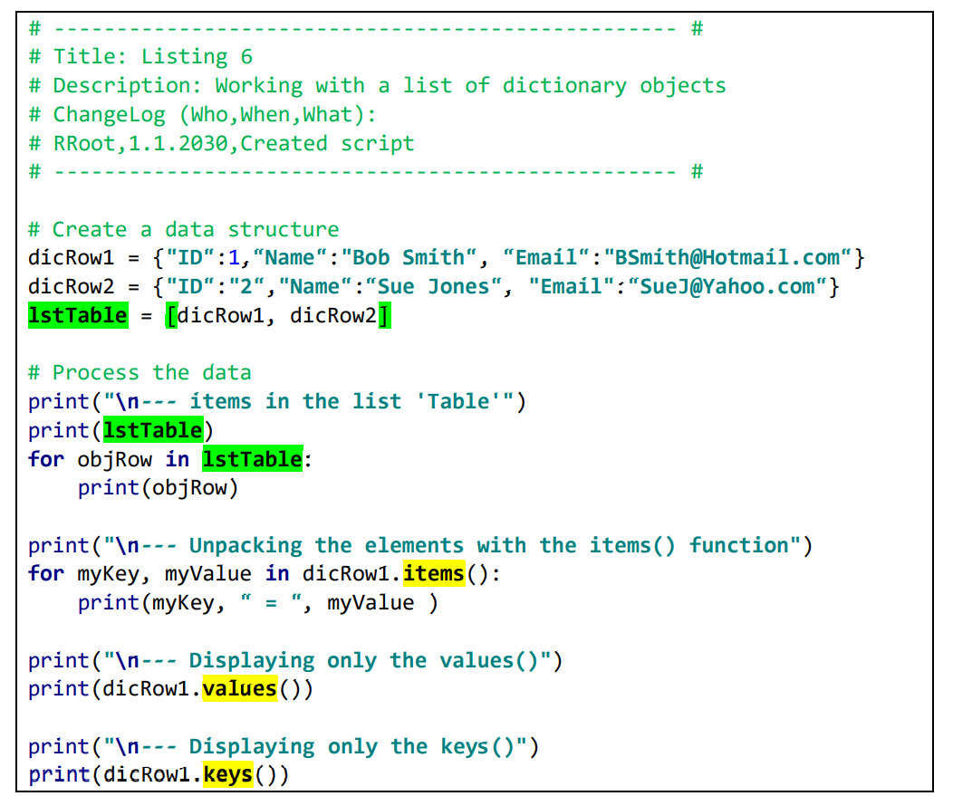

Figure 1: Built in functions for dictionaries example

Script Templates

This week we were also formally introduced to script templates. We have been dividing code and using pseudo code in previous assignments, but we’ve been starting from scratch with every project. Script templates make the ever-important need of organization that much simpler by being able to start with a pre-determined style of your choosing or

someone else’s. Figure 2 demonstrates the template that we were given as a starting point for this assignment.

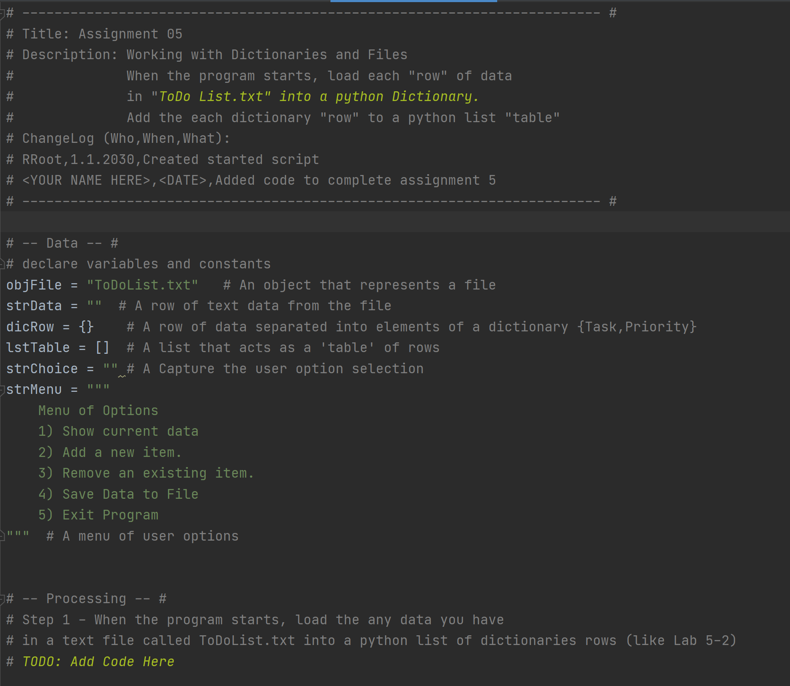

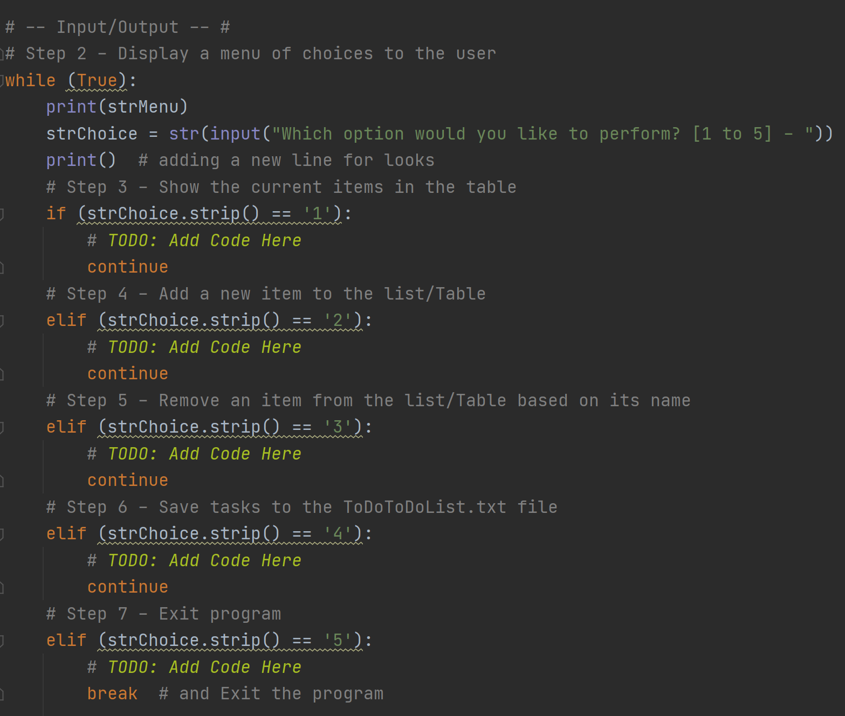

Figure 2: Starter Script Template and Pseudo code provide by Professor Randal Root

# Completing the Script

Design Intent

This week’s assignment is somewhat like the module 04 assignment with some slight modifications which have been mentioned in the previous sections such as working with a starter script template and the introduction of dictionaries. Shown Below in figure 3 is the Pseudo-Code used that demonstrates both the structure and design intent. Th goal here was to provide feedback to the user when changes were made and to prevent accidental closures and script termination as best as possible.

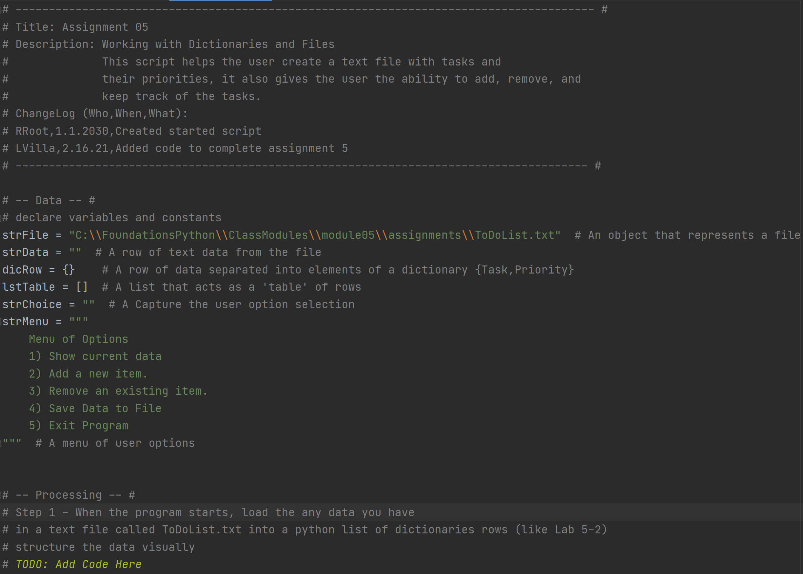

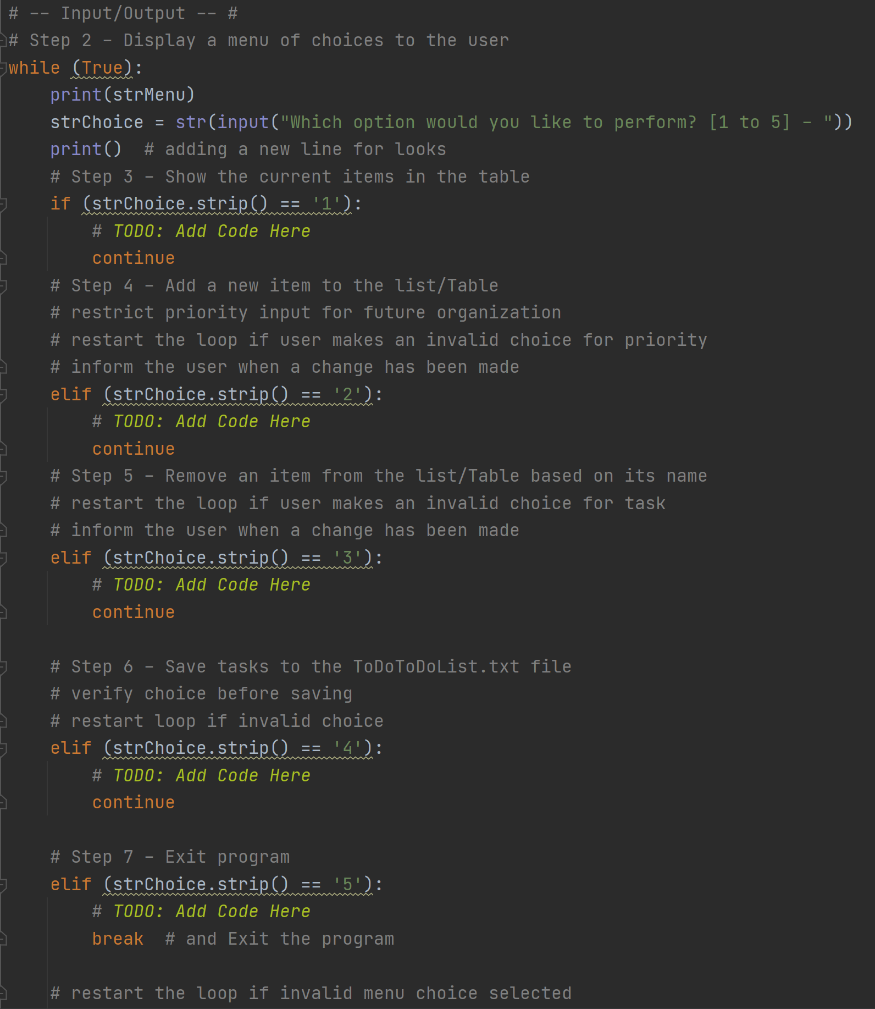

Figure 3: Modified Template

Writing and Testing

After my goals were made clear I proceeded to make use of the new concepts in their respectful sections. This code required even more testing time than the others, the use of nested loops and figuring out a way to satisfy the intent took a lot more time than expected. Different combinations of inputs were used to purposely try and crash the code to ensure as many routes as possible were tested. The completed code can be seen below in figure 4 with the resulting text file in figure 5.

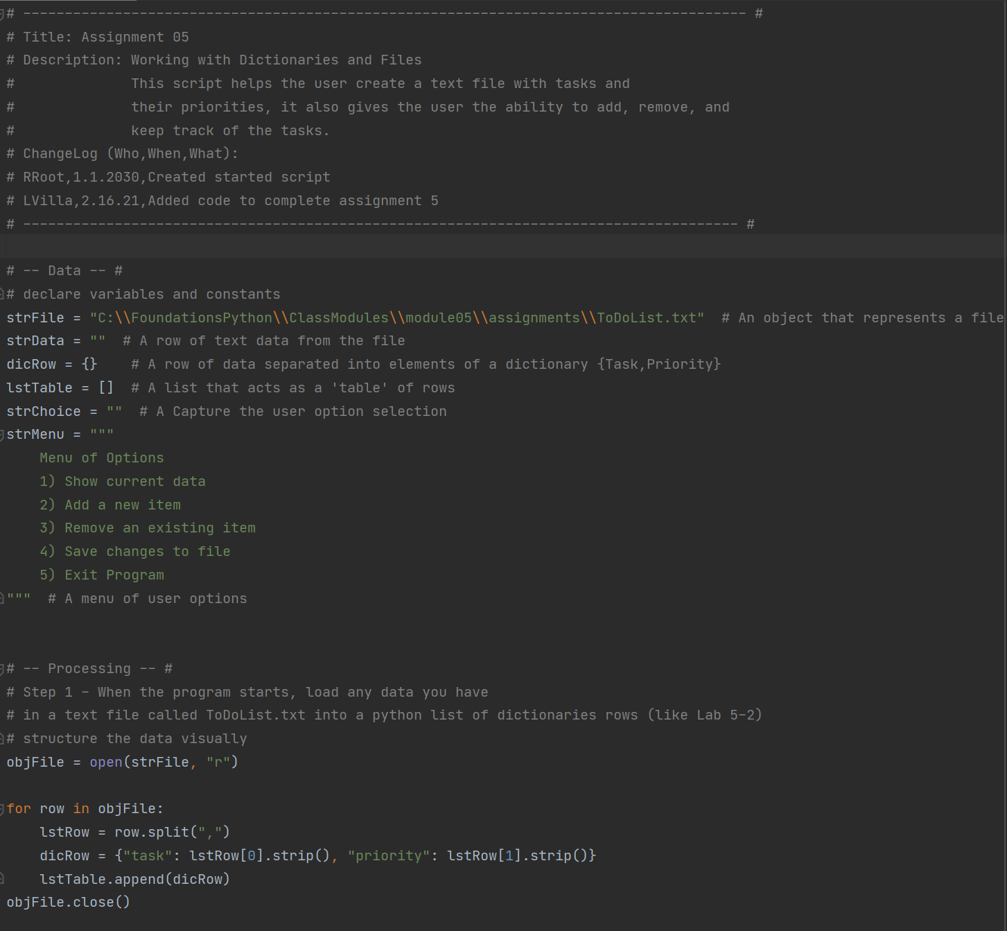

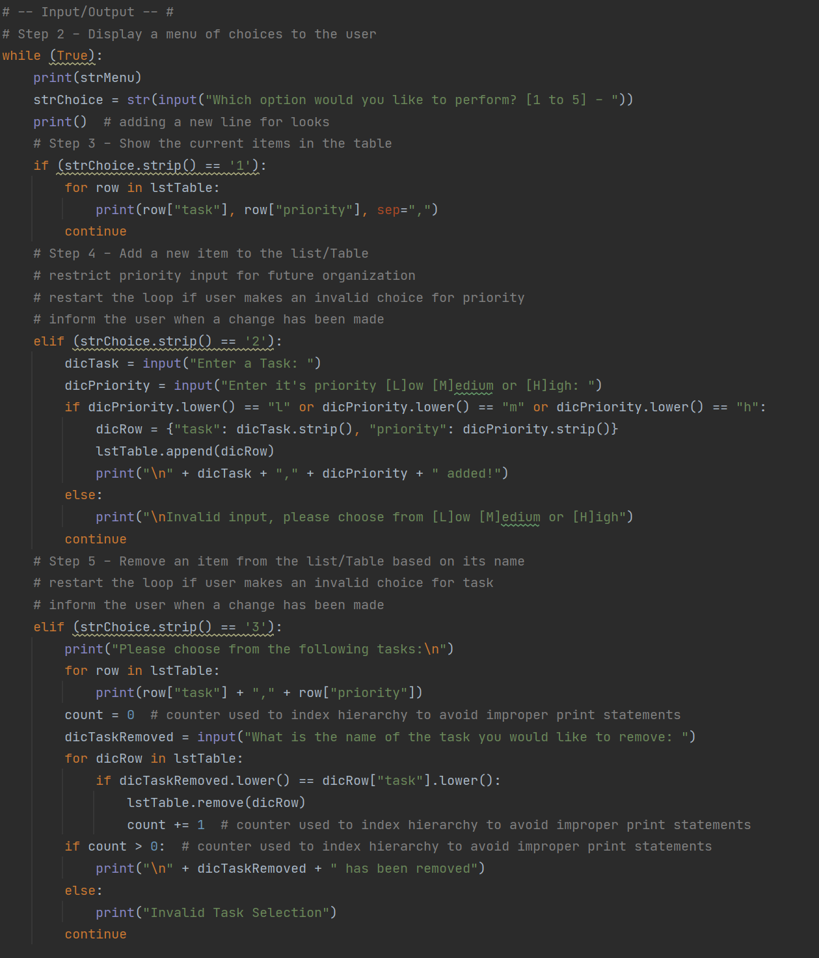

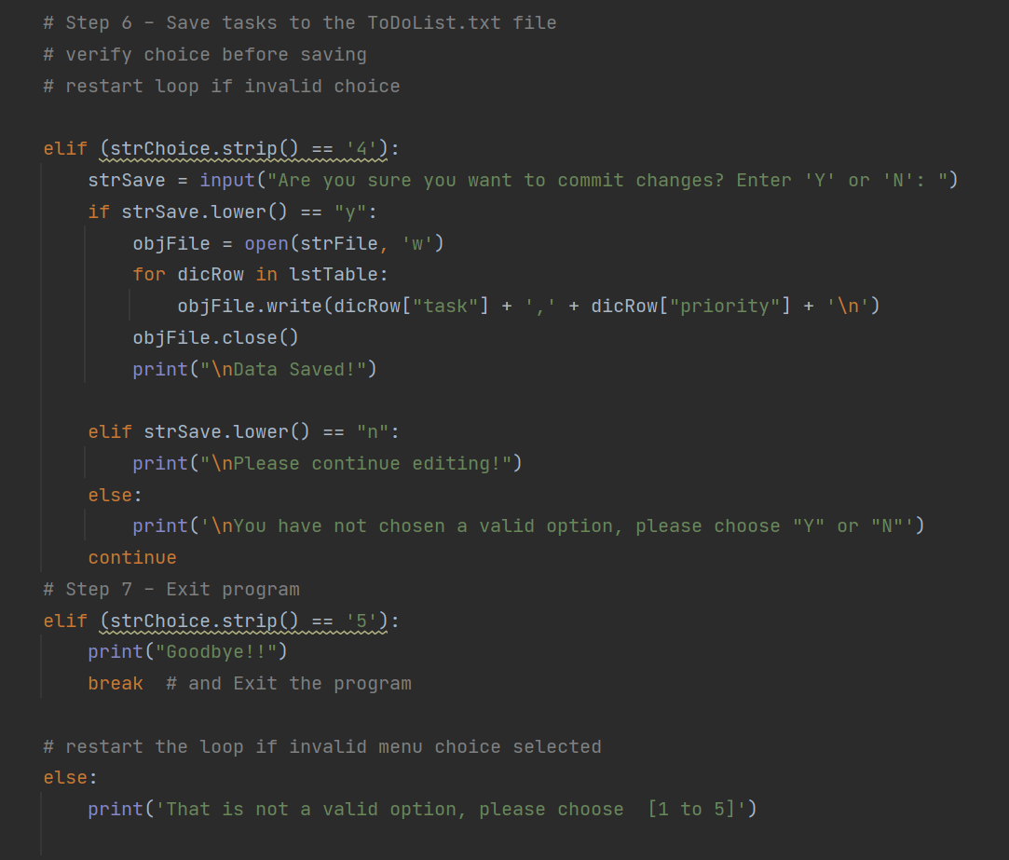

Figure 4: Final script in Pycharm

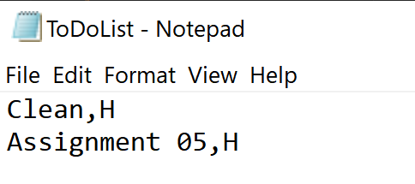

Figure 5: Resulting text file

Running the Script in Command Prompt

At this point the script runs great in the Pycharm IDE (integrated development environment) and the text file is created with the test inputs, it is now time to test it in the command shell. Command Prompt was launched by typing “cmd” in the command menu. Once that was done the file was called by making use of the drag functionality in Microsoft OS, where you can drag the file name from the folder directly to the Command Prompt screen. From there the on-screen instructions were followed, and the program completed its objective seen below in figure 6 and 7. I will also be demonstrating what happens if some invalid options are used.

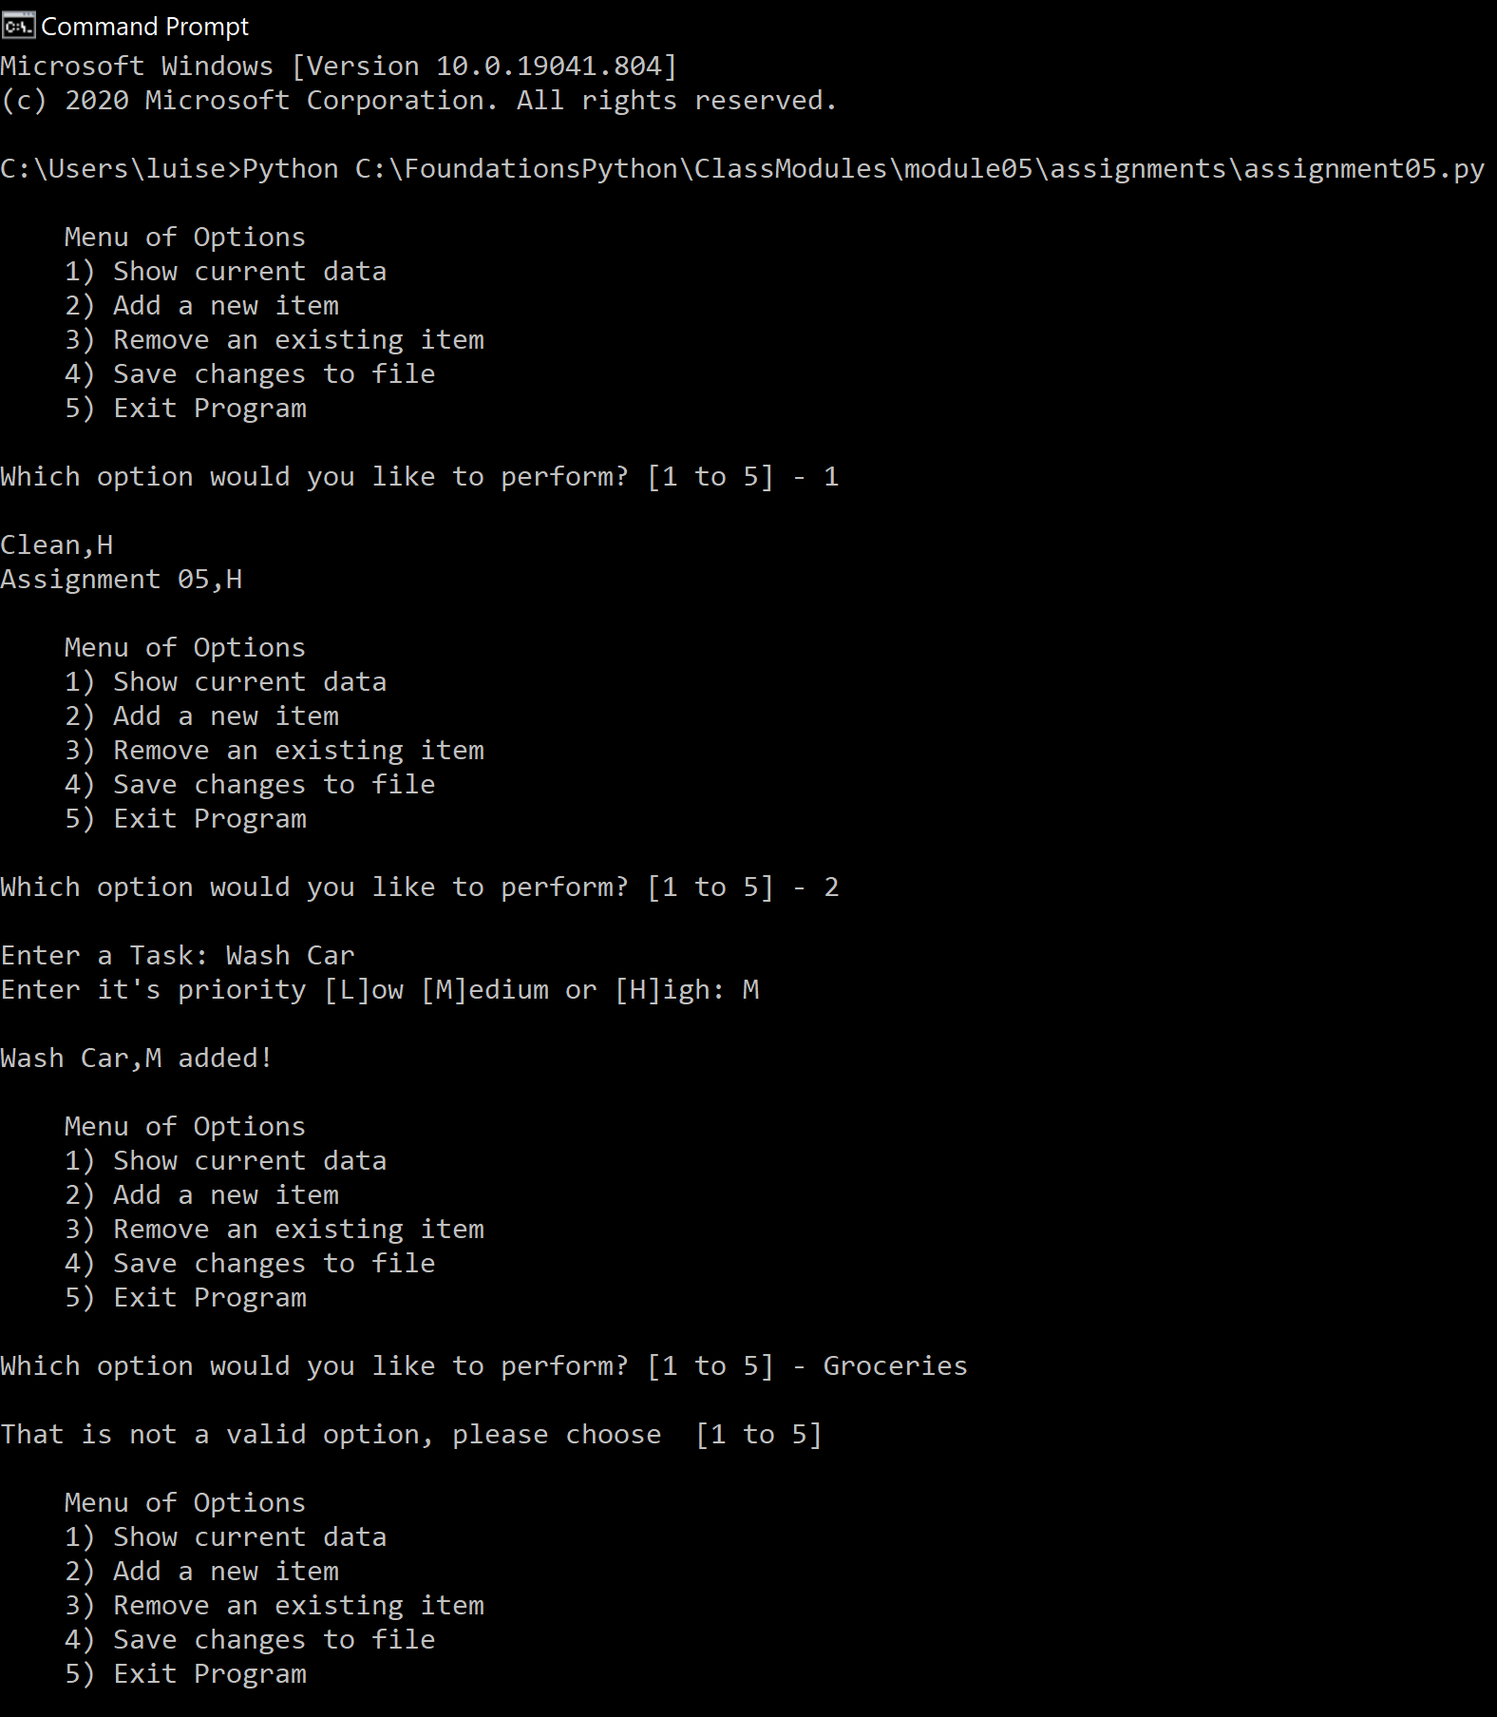

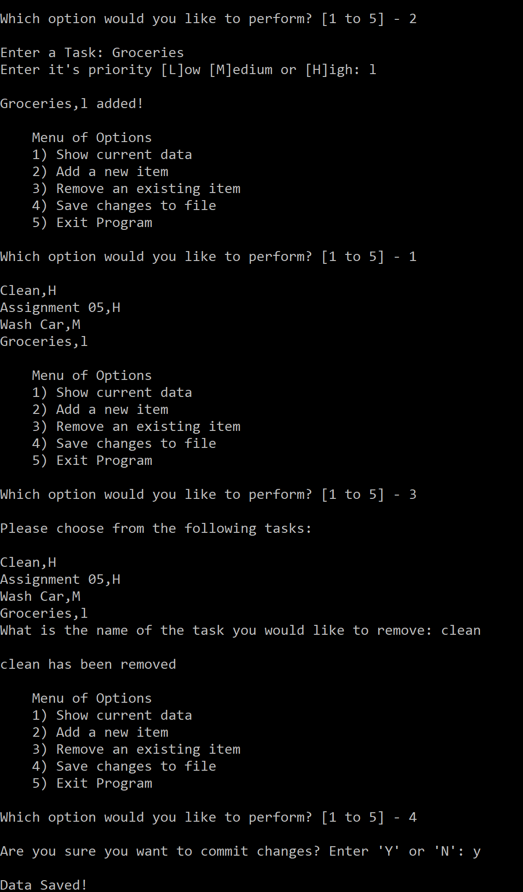

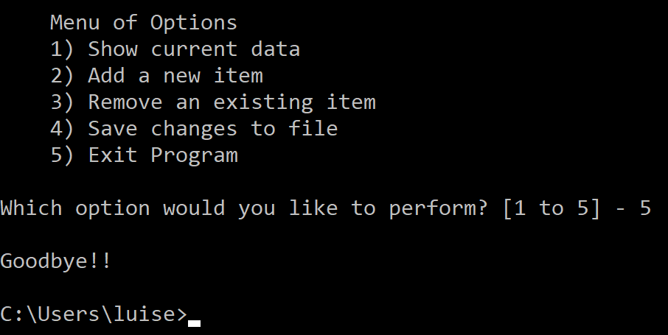

Figure 6: Script running in Command Prompt

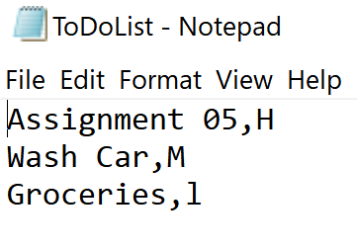

Figure 7: Text File Appended

Publishing in Github

The last step is to upload the file to Github which will serve a role in publishing and making your code public, this way it can be reviewed by peers and will be open for improvement. It also serves a role in configuration control. For better instructions on how to upload to Github please see it’s section in [Randal Root, Programming with Python module 05]. The file for this project can be found through this link (<https://github.com/luisv052/LVintroclassfolder>) external site.

# Summary

For the third assignment in a row writing data to a text file was the main purpose of this assignment but this time even that was challenging. It is very apparent now that mastering the basics and understanding the concept behind each function, concept, or method works individually and with each other is key to being successful.