DAT207x: Analyzing and Visualizing Data with Power BI Course Prerequisites Some experience in working with data from Excel, databases, or text files. Course Schedule This course is available in self-paced format. The deadlines associated with the graded quizzes and labs are set to the end date of the course, which is displayed on the Home page of the course. You should complete the quizzes/labs on your own to fully learn the material before you start the next module.

Week 1 • Understanding key concepts in business intelligence, data analysis, and data visualization • Importing your data and automatically creating dashboards from services such as Marketo, Salesforce, and Google Analytics • Connecting to and importing your data, then shaping and transforming that data • Enriching your data with business calculations

Week 2 • Visualizing your data and authoring reports

Week 3 • Scheduling automated refresh of your reports • Creating dashboards based on reports and natural language queries • Sharing dashboards across your organization • Consuming dashboards in mobile apps • Leveraging your Excel reports within Power BI • Creating custom visualizations that you can use in dashboards and reports • Collaborating within groups to author reports and dashboards • Sharing dashboards effectively based on your organization’s needs

Week 4 • Exploring live connections to data with Power BI • Connecting directly to SQL Azure, HD Spark, and SQL Server Analysis Services • Introduction to Power BI Development API • Leveraging custom visuals in Power BI

Expected Effort

Each week, you should expect to spend 2-4 hours on the course, including: • Viewing the lecture videos and demonstrations • Completing the quizzes • Completing the lab exercises • Further reading

Coursework and Grading

This course includes coursework, some of which is graded. Each module in the course includes lecture videos, graded short quizzes, and graded lab exercises. The quizzes account for 30% of the total grade, the lab exercises accounts for 65% of the total grade, and the two mandatory surveys account for the remaining 5%. You must achieve an overall score of 70% to pass the course. For the quizzes/labs questions, you have between one to four maximum attempts at each question, depending on the type of the question.

Discussion

We encourage all students to submit questions, observations, and comments in the Discussion section. If you have any issues while working on the course, check there first – your fellow students may have already found a resolution! Please remember that the discussion forum is open to all students and staff, and while we love to see passionate engagement, abusive or inflammatory behavior will not be tolerated. Due to the volume of students attending this course, it will not be possible for the course staff to answer every question individually. You should still post questions however, because in many cases, your fellow students may be able to help

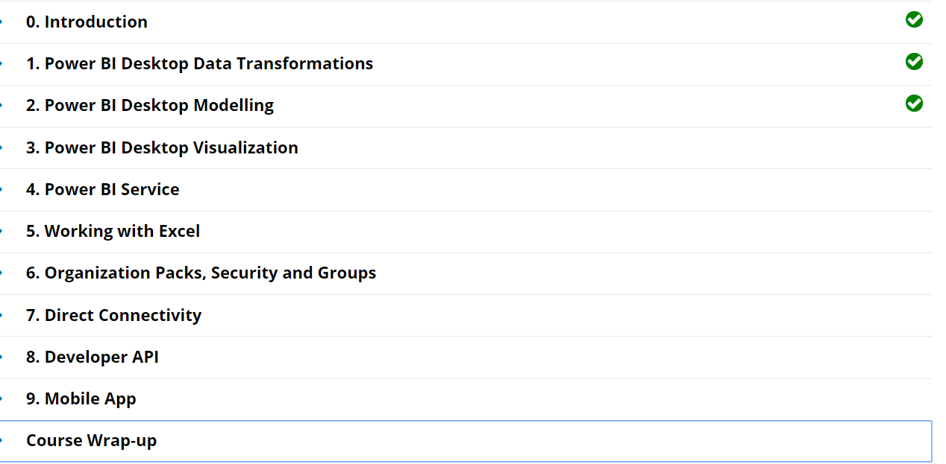

Question 1

1 point possible (graded)

When you connect to an Access database, which entities are shown in the Navigator window?

Users from the Access database

Tables from the Access database OK

Rows in from Access database

Columns from the Access database

unanswered

Submit

You have used 0 of 2 attemptsSome problems have options such as save, reset, hints, or show answer. These options follow the Submit button.

SaveSave Your Answer

Question 2

1 point possible (graded)

Which three statements describe the Applied Steps area in the Query Editor window?

It records the list of steps from connecting to the data source to all the steps applied to the data.

The recorded list is based on the step that has least effect to the the step that has the most effect to the data source.

The recorded list follows **the sequence of steps applied to the data source**.

You can modify the connection to the data source by modifying the Source step settings.

unanswered

Submit

You have used 0 of 2 attemptsSome problems have options such as save, reset, hints, or show answer. These options follow the Submit button.

SaveSave Your Answer

Question 3

1 point possible (graded)

Which three transformations are available when you right-click a column header in the Query Editor window?

Remove

Change Type

Duplicate Column

Count Rows

unanswered

Submit

You have used 0 of 2 attemptsSome problems have options such as save, reset, hints, or show answer. These options follow the Submit button.

SaveSave Your Answer

Question 4

1 point possible (graded)

When using the “Split Column by Delimited” transformation, which option may result in more than **two new columns**?

At the left-most delimiter

At the right-most delimiter

At each occurrence of the delimiter

None of the above

unanswered

Submit

You have used 0 of 2 attemptsSome problems have options such as save, reset, hints, or show answer. These options follow the Submit button.

SaveSave Your Answer

Question 5

1 point possible (graded)

Which three views are available in Power BI Desktop?

Dashboard

Report

Data

Relationships

unanswered

Submit

You have used 0 of 2 attemptsSome problems have options such as save, reset, hints, or show answer. These options follow the Submit button.

SaveSave Your Answer

Question 6

1 point possible (graded)

You have four queries named Query 1, Query 2, Query 3, and Query 4 in the Power BI desktop. You are creating Query 5, which will be appended at the end of Query 3.

When you load the data, which queries will be refreshed?

Query 1 to Query 4

Query 1 to Query 5

Query 3 and Query 5 OK

Only Query 5

unanswered

Submit

You have used 0 of 2 attemptsSome problems have options such as save, reset, hints, or show answer. These options follow the Submit button.

SaveSave Your Answer

Question 7

1 point possible (graded)

Consider the following custom column formula:

**= if [Country] = “USA” then “United States” else [Country]**

Which of the following statements describes the value of the custom column formula?

The value will be “USA”.

The value will be “United States”.

The value will be the same as the Country column.

The value will either be “United States” or whatever the value of the Country column is.

unanswered

Submit

You have used 0 of 2 attemptsSome problems have options such as save, reset, hints, or show answer. These options follow the Submit button.

SaveSave Your Answer

Question 8

1 point possible (graded)

Which transformation option converts rows as columns and columns as rows?

Transpose OK

Pivot Column

Unpivot Columns

Unpivot Other Columns

unanswered

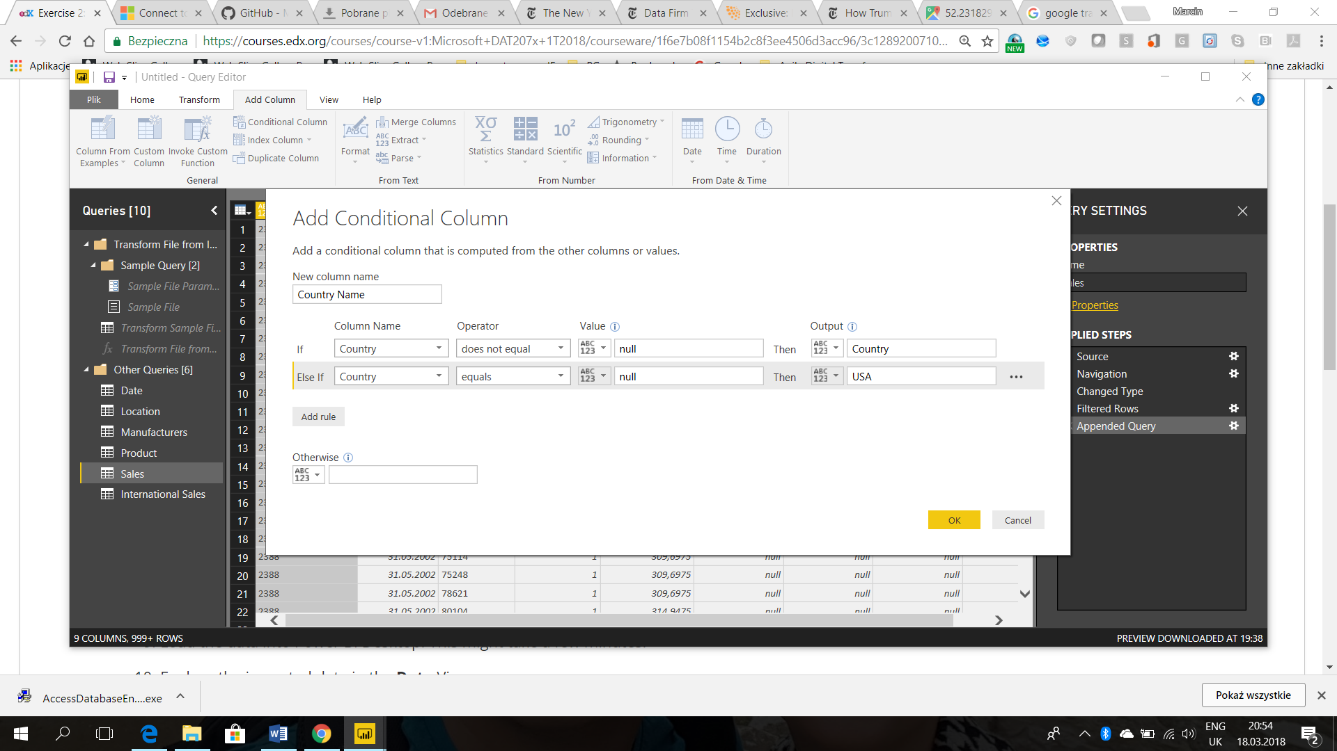

LAB1

## Exercise 1: Import Data from Access Database

 Bookmark this page

VanArsdel's US office stores the sales data on an Access database. You will need to perform analysis on that data, but before you can do so, you need to import the data to Power BI Desktop and perform some transformations.

**IMPORTANT!** Before you start, if your locale settings is not English (United States), you might want to change this, since the data you will import is based on this locale. This is covered in "[Changing Locale](https://courses.edx.org/courses/course-v1:Microsoft+DAT207x+1T2018/jump_to_id/55f1d106646e45ff8cc89591f293ac04" \t "[object Object])".

1. Download the VanArsdel's [Access database](https://github.com/MicrosoftLearning/Analyzing-Visualizing-Data-PowerBI/raw/master/Lab1/PowerBI%20AccessDB.zip). Extract the file to "C:\DAT207x". You can use other folders, but if you are going to use the starter file provided at each lab instead of your own file, then it is recommended to use the absolute path given above in order to successfully perform the schedule refresh in Lab 4.  
     
   **NOTE:** If you are having issues with the direct link, head over to the github repository and download from there. <https://github.com/MicrosoftLearning/Analyzing-Visualizing-Data-PowerBI>
2. Start with a blank Power BI Desktop file.
3. Connect to the Access database by using **Get Data** and select the Access database file.
4. Select the following tables to be imported: **bi_date**, **bi_geo**, **bi_manufacturer**, **bi_product**, and **bi_salesFact**.
5. Edit the query before loading to the data model.
6. Filter the rows on the **bi_salesFact** query to include dates from January 1st, 2000. (Hint: Apply a **Date filter** in the **Date** column to import dates after December 31st, 1999. Before you can apply a date filter, you need to change the **Date** column's **Data Type** to **Date**).
7. Filter the rows on the **bi_date** query to include dates from January 1st, 2000. (Hint: Apply a **Date filter** in the **Date** column to import dates after December 31st, 1999. Before you can apply a date filter, you need to change the **Date**column's **Data Type** to **Date**).
8. Rename the queries as follows:
   * bi_date: **Date**
   * bi_geo: **Locations**
   * bi_manufacturer: **Manufacturers**
   * bi_product: **Products**
   * bi_salesFact: **Sales**
9. Load the data into Power BI Desktop. This might take a few minutes.
10. Explore the imported data in the **Data**View.

### Lab Questions

5/5 points (graded)

Answer the following question by reviewing the imported data in Power BI Desktop. (Hint: Use the Data view).

How many rows were imported from the Date query?  correct

5844 Loading

How many rows were imported from the Locations query?  correct

99618 Loading

How many rows were imported from the Manufacturer query?  correct

14 Loading

How many rows were imported from the Products query?  correct

2412 Loading

How many rows were imported from the Sales table?  correct

9985368 Loading

Submit

## Exercise 2: Import Data from a Folder Containing CSV Files

 Bookmark this page

Continue with your Power BI file from the previous exercise. You want to create a Query for the International sales and append the Query to the Query from US Sales.

1. Download the [zip file](https://github.com/MicrosoftLearning/Analyzing-Visualizing-Data-PowerBI/raw/master/Lab1/InternationalSales.zip) containing VanArsdel's international sales data. Extract the file to "C:\DAT207x". You can use other folders, but if you are going to use the starter file provided at each lab instead of your own file, then it is recommended to use the absolute path given above in order to successfully perform the schedule refresh in Lab 4. You should see 4 CSV files in the "C:\DAT207x\International" folder.
2. Import the data from the file folder by using the **Get Data**. To do this, click the**Get Data / More** option, select **Folder** and click **Connect**. Select the folder where you saved the 4 CSV files containing VanArsdel’s international sales data.
3. Edit the query before loading to the data model.
4. Perform the following steps:
   * Name the query **International Sales**.
   * Select to combine (combined binaries) the content of those 4 files, leave the default settings, and click **OK**.
   * Filter the rows that are after **December 31st, 1999**.
   * Remove the **Source.Name** column.
5. Edit the **Sales** Query from the US Sales.
6. Append the **International Sales** table to the **Sales** query from the US Sales.
7. In the **Sales** query, add a custom column named **Country Name**which takes the value of the **Country** column when it is not null and the value of "USA" when the **Country** column is null.
8. Remove the **Country** column.
9. Load the data into Power BI Desktop. This might take a few minutes.
10. Explore the imported data in the **Data**View.
11. Hide the **International Sales** table from report view.

### Lab Questions

4.0/4.0 points (graded)

Answer the following question by reviewing the imported data in Power BI Desktop. (Hint: Use the Data view).

How many rows were imported from the International Sales query?  unanswered

797244 Loading

How many rows are now in the Sales query?  unanswered

## Exercise 3: Import a Less Structured Data from an Excel File

 Bookmarked

Continue with your Power BI file from the previous exercise. You want to import an Excel report containing population data for the countries that VanArsdel operates.

1. Download the [zip file](https://github.com/MicrosoftLearning/Analyzing-Visualizing-Data-PowerBI/raw/master/Lab1/CountryPopulationByYear.zip) containing the Country Population data. (Data is a subset of the "World Data Bank's Population, total" dataset). Extract the file to "C:\DAT207x". You can use other folders, but if you are going to use the starter file provided at each lab instead of your own file, then it is recommended to use the absolute path given above in order to successfully perform the schedule refresh in Lab 4.
2. Import the data from the file folder by using the **Get Data**. To do this, click the**Get Data / Excel**option. Select the Excel file and select the sheet containing the Country Population data.
3. Edit the query and perform the following steps:
   * Name the Query **Country Population**.
   * Remove the first four rows of the table.
   * Promote the row that represents the title of the column to the table headers.
   * Transform the yearly columns to rows and name the resulting columns appropriately. (Hint: You might find the **Unpivot Columns** or**Unpivot Other Columns** feature useful).
   * Rename the resulting columns to **Year** and **Population** respectively.
   * Filter out the year **1999**.
   * Set the **Data Type** of both the **Year** and **Population** columns to **Whole Number**.
4. Load the data into Power BI Desktop.
5. Explore the imported data in the **Data**View.

### Lab Questions

Answer the following question by reviewing the imported data in Power BI Desktop. (Hint: Use the Data view).

How many rows were imported from the Country Population query? 75

How many distinct values of the Year column were imported from the Country Population query? 15

New column (zlacz tabele)

or more information on calculated columns and DAX in Power BI Desktop, check out the following resources

* <https://powerbi.microsoft.com/en-us/documentation/powerbi-desktop-calculated-columns/>
* <https://powerbi.microsoft.com/en-us/documentation/powerbi-desktop-quickstart-learn-dax-basics/>

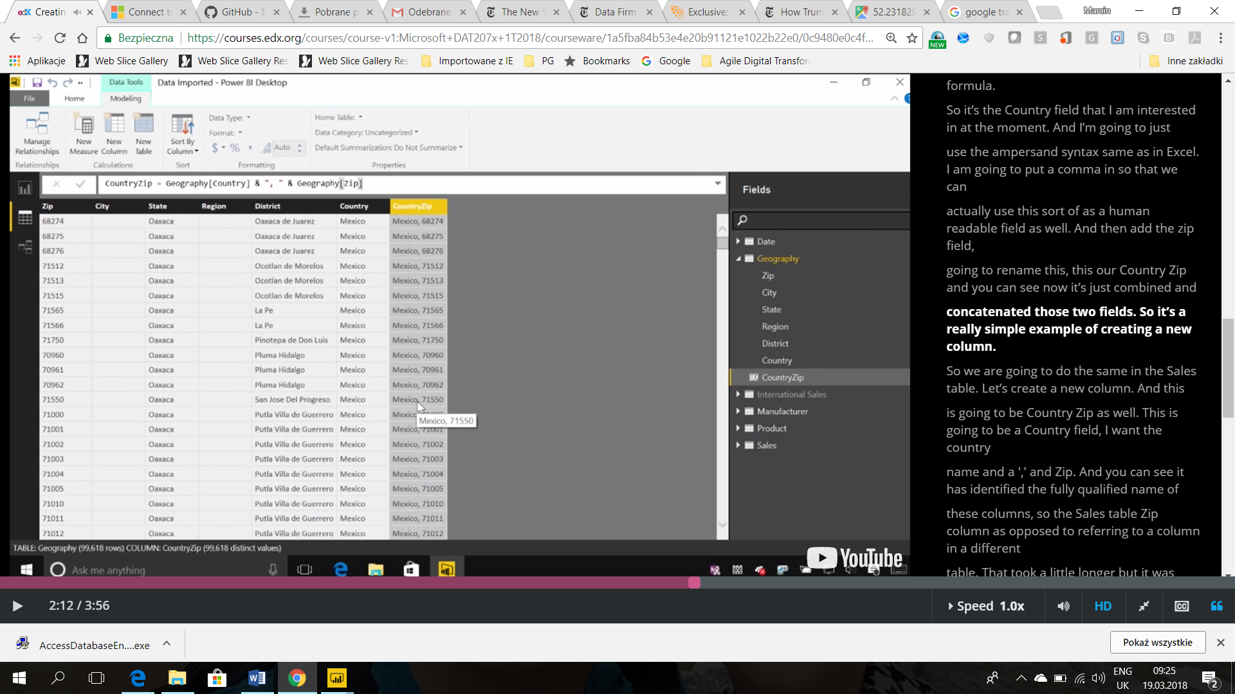

For more information on measures in Power BI Desktop, check out the following resource:

* <https://powerbi.microsoft.com/en-us/documentation/powerbi-desktop-measures/>

For more information about Excel, check out the following resource:

* <https://aka.ms/edx-dat207x-xls>

For more information on calculated tables, check out the following resource:

* <https://powerbi.microsoft.com/en-us/documentation/powerbi-desktop-calculated-tables/>

### Question 1

1 point possible (graded)

Which three cardinalities are available in Power BI table relationships?

Many to One

One to One

One to Many

Many to Many

unanswered

### Question 2

1 point possible (graded)

Which two cross filter directions are available in Power BI table relationships?

Single

Double

Both

Multiple

### Question 3

1 point possible (graded)

Consider the following DAX formula for a calculated column in the Sales table:

**UnitPrice = Sales[Revenue] / Sales[Units]**

Which three statements describe the DAX formula?

The formula creates a calculated column named UnitPrice.

The value of the calculated column is dependent on the Revenue column.

The value of the calculated column is dependent on the Units column.

The Data type of the calculated column is Text.

### Question 4

1 point possible (graded)

Which three options allow you to hide a field from the Report view in Power BI Desktop?

In Power BI Desktop Report view, right-click the field on the Fields list, and click Delete.

In Power BI Desktop Data view, right-click the column header on the respective table, and click Hide in Report View.

In Power BI Desktop Relationships view, right-click the field on the respective table, and click Hide in Report View.

In Power BI Desktop Report view, right-click the field on the Fields list, and click Hide.

### Question 5

1 point possible (graded)

In Power BI Desktop Report view, which three options will create a measure in the Sales table?

Select the Sales table in the Fields list, and then click New Measure in the Modelling ribbon.

Create the measure from any table, and then set the Home Table properties to Sales.

On the Fields list, click the ellipsis next to the Sales table or right-click any field in the Sales table, and then click New Measure.

Click New Measure, and then type in the formula Home Table = Sales.

### Question 6

1 point possible (graded)

What are the three reasons for which you might use calculated tables?

To union tables

To improve the speed and performance of an existing table

To perform different types of merge join

To create a table based on the result of a function or formula

## Exercise 1: Manage Table Relationships

 Bookmark this page

Power BI Desktop has automatically detected and created table relationships. So the first step is to ensure all the relationships are properly created, and if not, create them yourselves.

1. Start with the "[Lab 2 - Starting.pbix](https://github.com/MicrosoftLearning/Analyzing-Visualizing-Data-PowerBI/blob/master/Lab2/Lab%202%20-%20Starting.zip?raw=true)" file.
2. Open the **Relationship** view.
3. Ensure that there is a many to one relationship with both cross directional filtering from the **ProductID**column on the **Sales** table to the **ProductID**column on the **Products**table. If not, create the relationship by dragging the **ProductID** column on the **Sales** table to the**ProductID** column on the **Products** table.
4. Ensure that there is a many to one relationship with both cross directional filtering from the **ManufacturerID**column on the **Products**table to the **ManufacturerID**column on the **Manufacturers**table. If not, create the relationship.
5. Ensure that there is a many to one relationship with both cross directional filtering from the **Date** column on the **Sales** table to the **Date**column on the **Date** table. If not, create the relationship.

Now you want to create a relationship between the **Sales** table and the **Locations** table. First, you merge the **Country** and **Zip** columns in both **Sales** and **Locations** table as a new column, **CountryZip**. Then, you create a relationship on the **CountryZip**column for both tables.

1. Edit the **Locations**table in the **Data** view.
2. Add a new column named  **CountryZip**by concatenating the value from the **Country** column, a comma and a space character, and the value from the **Zip** column. (Hint: the calculated column formula look as follows: CountryZip = Locations[Country] & ", " & Locations[Zip])
3. Edit the **Sales**table in the **Data** view.
4. Add a new column named  **CountryZip**by concatenating the value from the **Country Name** column, a comma and a space character, and the value from the **Zip** column. (Hint: the calculated column formula look as follows: CountryZip = Sales[Country Name] & ", " & Sales[Zip])
5. Open the **Relationship** view.
6. Link the newly created **CountryZip**column on the **Sales** table to the newly created **CountryZip**column on the **Locations** table.

### Lab Questions

4/4 points (graded)

Review the relationship that you have just created on the CountryZip columns. (Hint: Double-click on the newly created relationship).

What is the cardinality of the relationship?

Many to One correct

One to One

One to Many

Many to Many

What is the Cross filter direction of the relationship?

Single

Double

Both correct

## Exercise 2: Last Year Comparison

 Bookmark this page

You want to know how much sales (revenue) in total does the VanArsdel have and to compare this with the figure from the same period last year. You need to create several calculated measures to help with this comparison. To do so, in either the **Report** view or the **Data** view, right-click the **Sales** table, click **New Measure**, and type in the corresponding DAX formulas for the measure you want to create. This will create the measures with the **Home Table** properties set to the **Sales** table.

Specifically, you will create the following measures:

* **Total Sales**: calculates the total sales. Format this measure as **Currency**. (Hint: Check out the **SUM** function).
* **LY Sales**: calculates last year sales. Format this measure as **Currency**. (Hint: You might find the **CALCULATE** and **SAMEPERIODLASTYEAR** function useful).
* **Sales Var**: calculates sales variance between this year and last year sales. Format this measure as **Currency**. (Hint: This is simply the difference between **Total Sales** and **LY Sales**).
* **Sales Var %**: calculates sales variance between this year and last year sales in percentage. Format this measure as **Percentage**. (Hint: This is simply the percentage of **Sales Var** from **LY Sales**. You might find the **DIVIDE** function useful).

### Lab Questions

4/4 points (graded)

Answer the following questions using the measures you created. (Do NOT include currency symbols or thousands separators). The fastest way to do this is to drag the measures you created to the Report view and format them as a table visualization. Do not use any level of filtering to answer the questions.

What is the figure for the Total Sales measure? (to two decimal places)  correct

What is the figure for the Sales Var % measure? (to two decimal places)

 % correct

DAX formulas but on **Units** instead of **Revenue**:

* **Total Units**: Total Units = SUM(Sales[Units])
* **LY Total Units:** LY Total Units = CALCULATE([Total Units],SAMEPERIODLASTYEAR('Date'[Date])
* **Total Units Var**: Total Units Var = [Total Units] - [LY Total Units]
* **Total Units Var %**: Total Units Var % = DIVIDE([Total Units Var],[LY Total Units])

Moje formuły in DAX:

Total Sales = Sum(Sales[Revenue])

LY Sales = CALCULATE(Sales[Total Sales];SAMEPERIODLASTYEAR('Date'[Date]))

Sales Var = [Total Sales] - [LY Sales]

Sales Var % = Sales[Sales Var] / [LY Sales]

## Exercise 3: Year to Date

 Bookmark this page

Year-to-date (YTD) is a period starting from the beginning of the current year and continuing up to the present date. You want to calculate the YTD sales and compare this with the figure from the same period last year. Specifically, you will create the following measures:

* **YTD Sales**: calculates the YTD sales. Format this measure as **Currency**. (Hint: Check out the **TOTALYTD** function).
* **LY YTD Sales**: calculates last year YTD sales. Format this measure as **Currency**. (Hint: You might find the **CALCULATE** and **SAMEPERIODLASTYEAR** function useful).
* **YTD Sales Var**: calculates sales variance between this year and last year YTD sales. Format this measure as **Currency**. (Hint: This is simply the difference between **YTD Sales** and **LY YTD Sales**).
* **YTD Sales Var %**: calculates sales variance between this year and last year YTD sales in percentage. Format this measure as **Percentage**. (Hint: This is simply the percentage of **YTD** **Sales Var** from **LY YTD Sales**. You might find the **DIVIDE** function useful).

### Lab Questions

4/4 points (graded)

Answer the following questions using the measures you created. (Do NOT include currency symbols or thousands separators). The fastest way to do this is to drag the measures you created to the Report view and format them as a table visualization. Do not use any level of filtering to answer the questions.

What is the figure for the LY YTD Sales measure? (to two decimal places)  correct

272629284.10 Loading

What is the figure for the YTD Sales Var % measure? (enter the **absolute** value, to two decimal places)

 % correct

If you're stuck, check out the following DAX expressions to calculate similar measures, but on **Units** instead of **Revenue**.

* **YTD Total Units**: YTD Total Units = TOTALYTD([Total Units],'Date'[Date])
* **LY YTD Total Units:** LY YTD Total Units = CALCULATE([YTD Total Units],SAMEPERIODLASTYEAR('Date'[Date]))
* **YTD Total Units Var**: YTD Total Units Var = [YTD Total Units] - [LY YTD Total Units]
* **YTD Total Units Var %**: YTD Total Units Var % = DIVIDE([YTD Total Units Var],[LY YTD Total Units])

## Exercise 4: Market Share

 Bookmark this page

VanArsdel’s sales comprise of products manufactured by VanArsdel and other companies. You want to know how much of these sales are VanArsdel’s own manufactured products. You decide to show this share in numbers and %. Specifically, you will create the following measures:

* **Total VanArsdel Sales**: calculates sales where the products manufacturer is VanArsdel. Format this measure as **Currency**. (Hint: Use the**CALCULATE** function and filter by Manufacturer).
* **% Sales Market Share**: calculates the percentage of sales of VanArsdel manufactured products from the total sales. Format this measure as**Percentage**.

### Lab Questions

4/4 points (graded)

Answer the following questions using the measures you created. (Do NOT include currency symbols or thousands separators). The fastest way to do this is to drag the measures you created to the Report view and format them as a table visualization. Do not use any level of filtering to answer the questions.

What is the figure for the Total VanArsdel Sales measure? (to two decimal places)  correct

2276898965.00 Loading

What is the figure for the % Sales Market Share measure? (to two decimal places) % correct

If you're stuck, check out the following DAX expressions to calculate similar measures, but on **Units** instead of **Revenue**.

* **Total VanArsdel Units**: Total VanArsdel Units = CALCULATE([Total Units],Manufacturers[Manufacturer]="VanArsdel")
* **% Units Market Share:** % Units Market Share = IF([Total VanArsdel Units]=0,0,DIVIDE([Total VanArsdel Units],[Total Units],0))

Moje formuły in DAX:

**% Sales Market Share** = [Total VanArdels Sales] / [Total Sales]

## Exercise 5: Optimize the Data Model

 Bookmark this page

Now that you have the table relationships defined and the measures created, you want to optimize the data model before you create the visualizations.

1. Open the **Data** view.
2. Ensure both the **International Sales** and **Country Population** table are hidden from the report view.
3. Hide the following fields on the **Date** table from the report view.
   * **MonthNo**
   * **MonthID**
   * **Month**
4. Sort the **MonthName** column by the **MonthNo** column.
5. Hide the **CountryZip**field on the **Locations**table from the report view.
6. Hide the **ManufacturerID** field on the **Manufacturers** table from the report view.
7. Hide the following fields on the **Products**table from the report view.
   * **ProductID**
   * **ManufacturerID**
   * **Manufacturer**
8. Hide the following fields on the **Sales**table from the report view.
   * **ProductID**

* **Date**
* **Zip**
* **Units**
* **Revenue**
* **Country Name**
* **CountryZip**

Question 1

1 point possible (graded)

Which three fields are available when creating a Pie chart for visualization?

Legend

Group

Details

Values

unanswered

Submit

You have used 0 of 2 attemptsSome problems have options such as save, reset, hints, or show answer. These options follow the Submit button.

SaveSave Your Answer

Question 2

1 point possible (graded)

Consider the following chart:

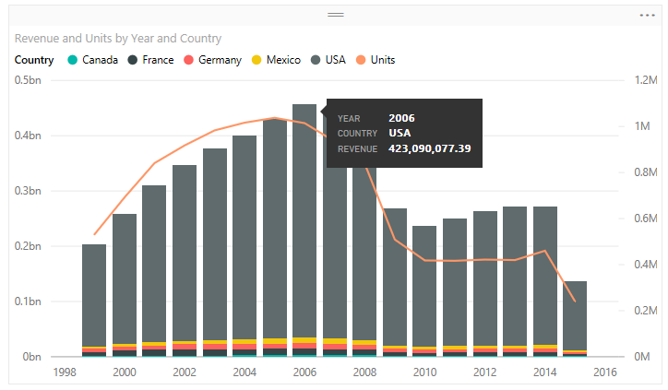

Drag and drop the fields to the corresponding settings to create the above chart.

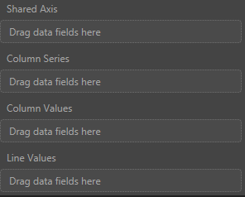

Year

Country

Category

Segment

Revenue

Units

unanswered

Submit

You have used 0 of 2 attemptsSome problems have options such as save, reset, hints, or show answer. These options follow the Submit button.

SaveSave Your Answer

Question 3

1 point possible (graded)

By default, which level of filter behaves the same as a slicer in a report in Power BI Desktop

Visual level filter

Page level filter

Report level filter

Query level filter

unanswered

Submit

You have used 0 of 2 attemptsSome problems have options such as save, reset, hints, or show answer. These options follow the Submit button.

SaveSave Your Answer

Question 4

1 point possible (graded)

Consider the following chart:

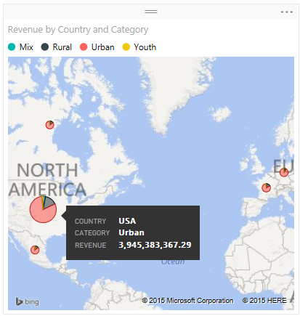

Drag and drop the fields to the corresponding settings to create the above chart.

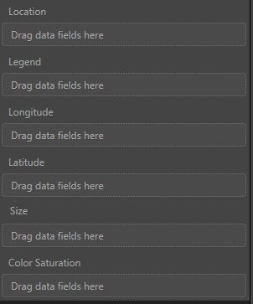

Year

Country

Category

Segment

Revenue

Units

unanswered

Submit

You have used 0 of 2 attemptsSome problems have options such as save, reset, hints, or show answer. These options follow the Submit button.

SaveSave Your Answer

Question 5

1 point possible (graded)

Consider the following chart:

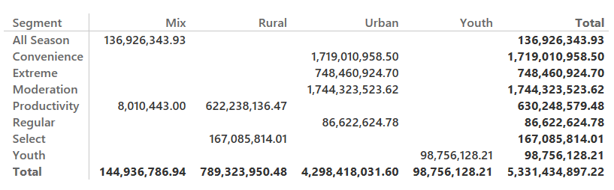

Drag and drop the fields to the corresponding settings to create the above chart.

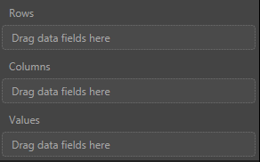

Year

Country

Category

Segment

Revenue

Units

unanswered

Submit

You have used 0 of 2 attemptsSome problems have options such as save, reset, hints, or show answer. These options follow the Submit button.

SaveSave Your Answer

Question 6

1 point possible (graded)

When creating a waterfall chart, which two field options that you need to define?

Category

X Axis

Y Axis

Size

unanswered

Submit

You have used 0 of 2 attemptsSome problems have options such as save, reset, hints, or show answer. These options follow the Submit button.

SaveSave Your Answer

Question 7

1 point possible (graded)

Which visualization would you use to show progress toward a particular target?

Bar chart

Scatter chart

Waterfall

Gauge

unanswered

Submit

You have used 0 of 2 attemptsSome problems have options such as save, reset, hints, or show answer. These options follow the Submit button.

SaveSave Your Answer

Question 8

1 point possible (graded)

Which three shapes can you create using the Insert Shapes feature in Power BI Desktop?

Flowchart

Triangle

Rectangle

Oval

unanswered

Question 1

1 point possible (graded)

From which two options can you customize your report page layout?

From the Report ribbon, New Page option

From the Report ribbon, Page View option

From the Visualizations, Format option

From the Visualizations, Field option

unanswered

Submit

You have used 0 of 2 attemptsSome problems have options such as save, reset, hints, or show answer. These options follow the Submit button.

SaveSave Your Answer

Question 2

1 point possible (graded)

Which of the following option would you use to modify the interactions flow between visuals in a Power BI report?

Edit Queries

Arrange

Page Size

Edit Interactions

unanswered

Submit

You have used 0 of 2 attemptsSome problems have options such as save, reset, hints, or show answer. These options follow the Submit button.

SaveSave Your Answer

Question 3

1 point possible (graded)

When you make a copy of a page in your report by using Duplicate Page, which visualizations from the page are duplicated?

All visualizations

Only the selected visualizations

Only visualizations that have filter relationship

All visualizations, except the static images

unanswered

Submit

You have used 0 of 2 attemptsSome problems have options such as save, reset, hints, or show answer. These options follow the Submit button.

SaveSave Your Answer

Question 4

1 point possible (graded)

Which of the following is not an option for Default Summarization?

Sum

Average

Count

Standard deviation

unanswered

Submit

You have used 0 of 2 attemptsSome problems have options such as save, reset, hints, or show answer. These options follow the Submit button.

SaveSave Your Answer

Question 5

1 point possible (graded)

Which four options you can use to modify the Z order of a visualization?

Send to Back

Bring to Front

Bring Forward

Set Transparent

Send Backward

unanswered

## Lab Overview

 Bookmark this page

## **SCENARIO**

VanArsdel is a company that manufactures and sells sporting goods. The company has offices in the United States (US) and several other countries. Its sales comprise of US sales and International sales. VanArsdel’s sales come from its owned manufactured products, as well as other manufacturers’ products.

## **LAB OVERVIEW**

In this lab, you will create several reports using several visualizations in Power BI Desktop.

Before starting this lab, you should review **Power BI Desktop Visualization** module in this course. Then, if you have not already done so, follow the instructions in the **Set up the Lab Environment** section of this course to set up the lab environment.

## **WHAT YOU’LL NEED**

* A computer with the latest version of Power BI Desktop installed on it.
* The following Power BI Desktop file:
  + The “[Lab 3 - Starting.pbix](https://github.com/MicrosoftLearning/Analyzing-Visualizing-Data-PowerBI/raw/master/Lab3/Lab%203%20-%20Starting.zip)” file

## Exercise 1: Cross-Tabular Report

 Bookmark this page

Let's start with an easy one. You want to show VanArsdel's sales (revenue) and units for each month and year in a single report. You choose to show this using two Matrix visualizations.

1. Start with the "[Lab 3 - Starting.pbix](https://github.com/MicrosoftLearning/Analyzing-Visualizing-Data-PowerBI/raw/master/Lab3/Lab%203%20-%20Starting.zip)" file.
2. Open the **Report** view.
3. Drag the **Total Sales** field from the **Sales** table to the report and create a chart.
4. Drag the **MonthName** and **Year** fields from the **Date** table to the chart.
5. Modify the chart to use the **Matrix** visualization.
6. Arrange so that the month is shown as the rows and the year is shown as the columns of the matrix visualization.
7. Repeat Step 3 to 6, but this time, display the **Total Units** field in the chart.
8. Add a Text Box to the report and enter **VanArsdel Sales and Units** as the text.
9. Rename the report sheet to **Sales and Units.**

You should have something similar to the below:

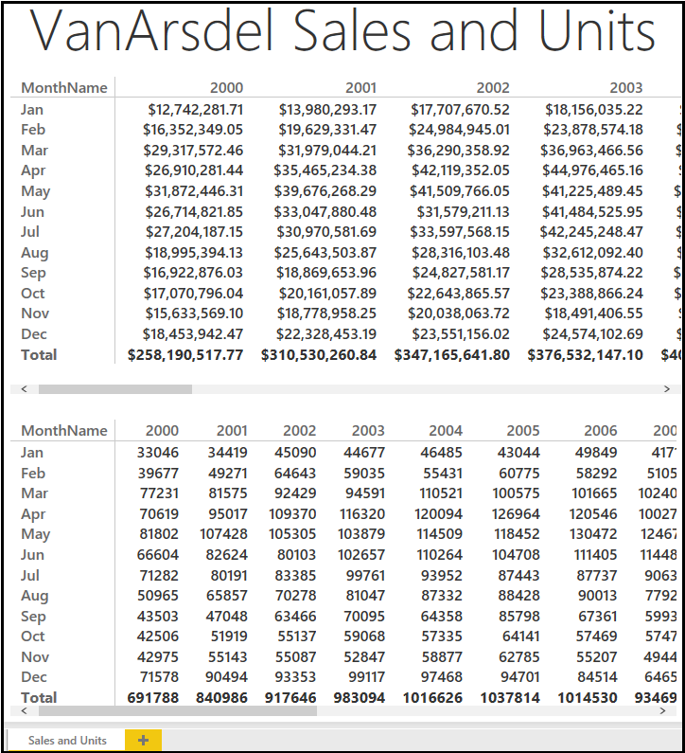

### Lab Questions

0.0/4.0 points (graded)

Answer the following questions using the report you created. (Do NOT include currency symbols or thousands separators). Do not use any level of filtering to answer the questions.

What is VanArsdel's sales for December 2013? (to two decimal places)  unanswered

Loading

What is VanArsdel's total units for the March 2013?

  unanswered

## Exercise 2: Part-to-Whole Report

 Bookmark this page

Now that you have the big picture, let's start analyzing the data sales data by product category, segment and manufacturer.

1. Create a new report page by clicking the Yellow "+" icon at the bottom of the report view.
2. Drag the **Total Sales** field from the **Sales** table to the report and create a chart.
3. Drag the **Category** and **Segment** fields from the **Products** table to the chart.
4. Modify the chart to use the **100% Stacked Bar Chart** visualization.
5. Ensure that the **Category** is shown as the **Axis** and the **Segment** is shown as the **Legend** of the visualization.
6. Customize the format of the visualization and turn on the **Data Labels**. Set the **Decimal Places** to **0**.
7. Drag the **Total Sales** field from the **Sales** table to the report and create a chart.
8. Drag the **Manufacturer** field from the **Manufacturers** table to the chart.
9. Modify the chart to use the **Treemap**visualization.
10. Drag the **MonthName** field from the **Date** table to the report and create a chart.
11. Modify the chart to use the **Slicer**visualization.
12. Drag the **Year** field from the **Date** table to the report and create a chart.
13. Modify the chart to use the **Slicer**visualization.
14. Rename the report sheet to **Sales Breakdown.**

**You should have something similar to the below:**

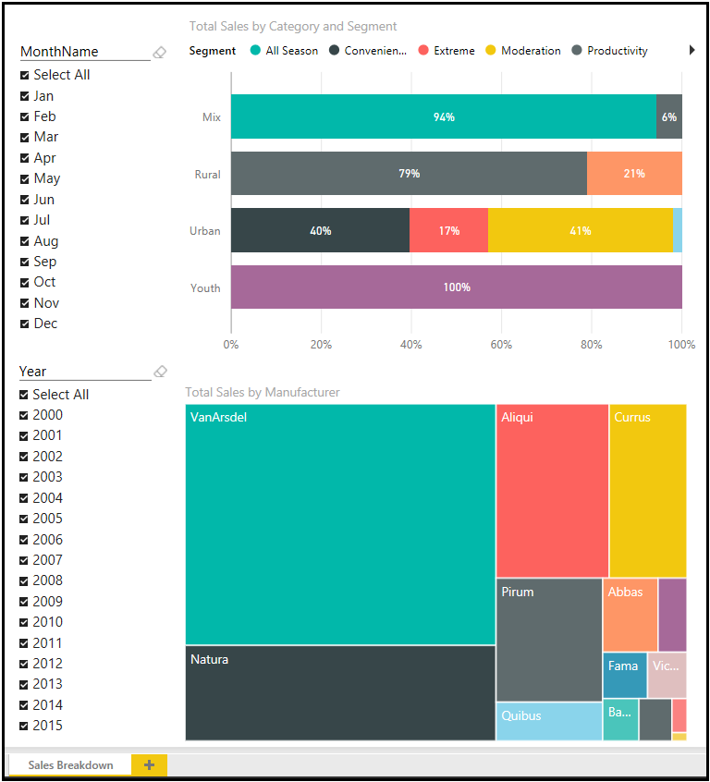

### Lab Question 1

0.0/4.0 points (graded)

Answer the following questions using the report you created. (Do NOT include currency symbols or thousands separators). Do not use any level of filtering to answer the questions.

In January 2014, what is VanArsdel's sales, from all manufacturers, for Urban category and Moderation segment? (to two decimal places) (Hint: Try hovering on the chart)

  unanswered

Loading

In May 2015, what is VanArsdel's sales, from all manufacturers, for Mix category and All Season segment? (to two decimal places) (Hint: Try hovering on the chart)

  unanswered

Loading

Submit

You have used 0 of 2 attemptsSome problems have options such as save, reset, hints, or show answer. These options follow the Submit button.

SaveSave Your Answer

### Lab Question 2

0.0/2.0 points (graded)

Answer the following question by using the treemap chart you created.

Drag the Manufacturer name to its appropriate box, 1 for the one with highest, and 4 for the one with the lowest.

For VanArsdel's sales in 2015, which are the top 4 manufacturers?



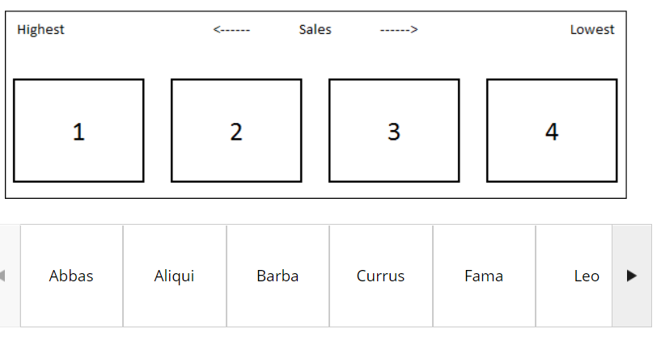Abbas

Aliqui

Barba

Currus

Fama

Leo

Natura

Pirum

Pomum

Quibus

Salvus

VanArsdel

Victoria

## Exercise 3: Relationship Report

 Bookmark this page

You would like to know more about the relationship between total units and total sales by category and segment. You choose to analyze this using scatter chart.

1. Create a new report page by clicking the Yellow "+" icon at the bottom of the report view.
2. Create a chart based on the **Scatter Chart** visualization.
3. Drag the **Total Sales** and **Total Units** fields from the **Sales** table to the chart.
4. Drag the **Category**and **Segment** fields from the **Products** table to the chart.
5. Drag the **YTD Sales** field from the **Sales** table to the chart.
6. Drag the **Year**field from the **Date**table to the chart.
7. Ensure that the following fields are set in the visualization:
   * **Details**: Category
   * **Legend**: Segment
   * **X Axis**: Total Sales
   * **Y Axis**: Total Units
   * **Size**: YTD Sales
   * **Play Axis**: Year

You should have something similar to the below:

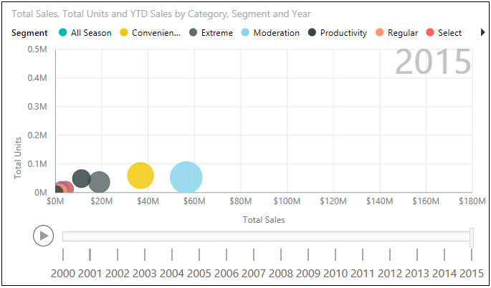

### Lab Questions

0.0/4.0 points (graded)

As you can see, in the year 2015, Moderation segment made the most of VanArsdel's sales. It is not always the case. Use the Play Axis to investigate.

In which year the Moderation segment first took over as the segment with most sales?                                                                                                                                                                                     

unanswered

What about in terms of Units? In which year the Moderation segment first took over as the segment with most units?                                                                                                                                                                                     

## Exercise 4: Trend Report

 Bookmark this page

Let's do some trend analysis. First let's show a chart to compare Total Sales and Total Units throughout the years. And then let's show two more charts showing the Total Sales and Total Units variances throughout the years.

1. Create a new report page by clicking the Yellow "+" icon at the bottom of the report view.
2. Drag the **Year**field from the **Date**table to the report and create the first chart.
3. Drag the **Total Sales** and **Total Units** fields from the **Sales**table to the chart.
4. Modify the chart to use the **Line and Stacked Column Chart** visualization.
5. Ensure that the **Year**is shown as the **Shared Axis**, **Total** **Sales**is shown as the **Column values**, and **Total Units** is shown as the**Line values** of the visualization.
6. Create the second chart based on the **Waterfall Chart** visualization.
7. Drag the **Sales Var** field from the **Sales** table to the chart.
8. Drag the **Year**field from the **Date**table to the chart.
9. Create the third chart, also based on the**Waterfall Chart** visualization.
10. Drag the **Total Units Var** field from the **Sales** table to the chart.
11. Drag the **Year**field from the **Date**table to the chart.
12. Add a Text Box to the report and enter **Yearly Trend** as the text.
13. Rename the report sheet to**Yearly Trend.**

You should have something similar to the below:

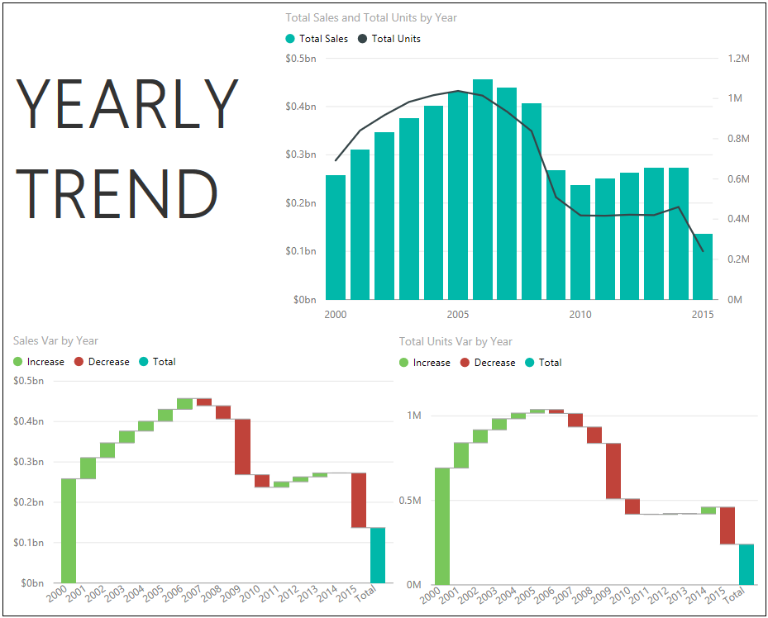

### Lab Question 1

0.0/2.0 points (graded)

In which year the growth of total sales were not matched by the growth of total units?

2005

2006

2007

2008

unanswered

Submit

You have used 0 of 2 attemptsSome problems have options such as save, reset, hints, or show answer. These options follow the Submit button.

SaveSave Your Answer

### Lab Question 2

0.0/4.0 points (graded)

Which year saw the biggest drop in total sales?

2007

2008

2009

2010

unanswered

What about total units? Which year saw the biggest drop in total units?

2007

2008

2009

2010

unanswered

## Exercise 5: Rank Report

 Bookmark this page

You now want to analyze individual products sales (revenue) and volume (units). You decide to show these using two bar charts.

1. Create a new report page by clicking the Yellow "+" icon at the bottom of the report view.
2. Drag the **Total Sales** field from the **Sales** table to the report and create a chart.
3. Drag the **Product**field from the **Products** table to the chart.
4. Modify the chart to use the **Stacked Bar Chart** visualization.
5. Ensure that the chart is sorted by **Total Sales**.
6. Drag the **Total Units**field from the **Sales**table to the report and create a chart.
7. Drag the **Product**field from the **Products** table to the chart.
8. Modify the chart to use the **Stacked Bar Chart** visualization.
9. Ensure that the chart is sorted by **Total Units**.
10. Drag the **Year** field from the **Date** table to the report and create a chart.
11. Modify the chart to use the **Slicer**visualization.
12. Add a Text Box to the report and enter **Top Products**as the text.
13. Rename the report sheet to **Top Products.**

**You should have something similar to the below:**

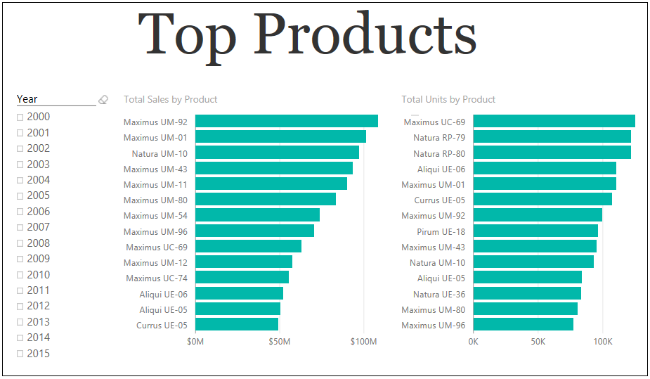

### Lab Questions

0.0/4.0 points (graded)

What is the top product in terms of sales for the year 2010?

Maximus UM-92

Maximus UM-43

Maximus UM-70

Maximus UM-11

Maximus UC-69

unanswered

What about in terms of units? What is the top product in terms of total units for the year 2010?

Maximus UM-92

Maximus UM-43

Maximus UM-70

Maximus UM-11

Maximus UC-69

unanswered

## Knowledge Checks

 Bookmark this page

### Question 1

1 point possible (graded)

By default, where does clicking a tile on a Power BI dashboard take you?

To the latest opened report

To the report where the visual was pinned from

To the report that has the same data source

To the Power BI home page

unanswered

Submit

You have used 0 of 2 attemptsSome problems have options such as save, reset, hints, or show answer. These options follow the Submit button.

SaveSave Your Answer

### Question 2

1 point possible (graded)

When you pin a visual created by the natural language query, to which dashboard is it pinned?

The last dashboard you visited

The last dashboard you created

A new dashboard

The dashboard you selected in the Pin to dashboard window

unanswered

Submit

You have used 0 of 2 attemptsSome problems have options such as save, reset, hints, or show answer. These options follow the Submit button.

SaveSave Your Answer

### Question 3

1 point possible (graded)

You want to share a dashboard with your colleague. What are two possible ways to achieve this goal?

Click the ellipsis next to the dashboard name on the Dashboards list, and then click Share.

Click Share from the upper right of the dashboard you want to share.

From your browser, click Share.

Right-click anywhere in the dashboard, and then click Share.

unanswered

Submit

You have used 0 of 2 attemptsSome problems have options such as save, reset, hints, or show answer. These options follow the Submit button.

SaveSave Your Answer

### Question 4

1 point possible (graded)

You are viewing a Power BI dashboard in a browser window. What happens when you click the Focus mode of a tile?

The tile you selected expands and takes the full space.

The report from which the tile was pinned opens.

The Power BI desktop file gets downloaded.

The Power BI desktop file opens.

unanswered

Submit

You have used 0 of 2 attemptsSome problems have options such as save, reset, hints, or show answer. These options follow the Submit button.

SaveSave Your Answer

### Question 5

1 point possible (graded)

Which three properties of a tile can you edit in the Power BI dashboard from the Tile details window?

Title

Subtitle

Destination link

Color scheme

unanswered

Submit

You have used 0 of 2 attemptsSome problems have options such as save, reset, hints, or show answer. These options follow the Submit button.

SaveSave Your Answer

### Question 6

1 point possible (graded)

What do you need to append to the URL of a Power BI dashboard in order to open it with the navigation pane collapsed by default?

?navigationPane=false

?navigationPane=collapsed

?collapseNavigation=true

?collapseNavigation=collapsed

unanswered

Submit

You have used 0 of 2 attemptsSome problems have options such as save, reset, hints, or show answer. These options follow the Submit button.

SaveSave Your Answer

### Question 7

1 point possible (graded)

You publish a report from Power BI Desktop to Power BI service. You then make changes to your local report in Power BI Desktop by adding some visualizations. When do the changes synchronize to Power BI service?

When you save the Power BI Desktop file

When you click REFRESH NOW in Power BI service

When you re-publish the Power BI Desktop report

When the scheduled refresh is run on Power BI service

unanswered

Submit

You have used 0 of 2 attemptsSome problems have options such as save, reset, hints, or show answer. These options follow the Submit button.

SaveSave Your Answer

### Question 8

1 point possible (graded)

What is the purpose of Power BI Personal Gateway?

To enable publishing reports to Power BI service.

To provide a platform for easily consuming and sharing reports.

To provide quick and secure data transfer between Power BI service and on-premises data sources that support refresh.

To connect and shape data, build robust models, and author well-structured reports.

unanswered

Submit

## Lab Overview

 Bookmark this page

## **SCENARIO**

VanArsdel is a company that manufactures and sells sporting goods. The company has offices in the United States (US) and several other countries. Its sales comprise of US sales and International sales. VanArsdel’s sales come from its owned manufactured products, as well as other manufacturers’ products.

You have created reports with VanArsdel's US and International sales data using Power BI Desktop. Now it's the time to use Power BI service to display this report, create a dashboard, share it, and set a scheduled refresh for the dataset.

## **LAB OVERVIEW**

In this lab, you will upload a Power BI Desktop report to Power BI service. You will then pin several visualizations and create a dashboard. You will also use the natural language queries feature to create and pin new visualizations. To top it off, you will share this newly created dashboard and set a scheduled refresh so that the dashboard is always up-to-date.

Before starting this lab, you should review **Power BI Service** module in this course. Then, if you have not already done so, follow the instructions in the **Set up the Lab Environment** section of this course to set up the lab environment.

## **WHAT YOU’LL NEED**

* A computer with the latest version of Power BI Desktop installed on it.
* The following Power BI Desktop file:
  + The “[Lab 4 - Starting.pbix](https://github.com/MicrosoftLearning/Analyzing-Visualizing-Data-PowerBI/raw/master/Lab4/Lab%204%20-%20Starting.zip)” file
* Power BI service account (You need to have a work / business email to sign up for Power BI service)

## Exercise 1: Upload PBI Report and Pin Visualizations

 Bookmark this page

First, you will upload a Power BI Desktop file to Power BI Service.

1. Start with the "[Lab 4 - Starting.pbix](https://github.com/MicrosoftLearning/Analyzing-Visualizing-Data-PowerBI/raw/master/Lab4/Lab%204%20-%20Starting.zip)" file.
2. Use the **Publish** button to publish the report. Sign in using the account you used to sign up for Power BI service.
3. Once the report is published, go to **http://www.powerbi.com** and sign in using your account.
4. If this is your first time publishing a report to Power BI service, you will notice that you now have a dataset named **Lab 4 - Starting** and a report named **Lab 4 - Starting**. You can rename both of these, but let's just leave them be for now.
5. Go to the **Lab 4 - Starting Report** and explore your published report. It looks similar to the one in Power BI Desktop file. Now you can start creating a dashboard by pinning some visualizations.
6. Go to the **Sales Report** tab and pin the chart showing **Total Sales by Category and Segment** (100% Stacked Bar Chart). Select to create a**New dashboard** and name it **VanArsdel Sales**.
7. Pin the treemap chart, the scatter chart, and the map visualization to the **VanArsdel Sales** dashboard.
8. Go to the **Yearly Trend** tab and pin the waterfall chart that shows the **Sales Var by Year**.
9. Go to the **VanArsdel Sales** dashboard and review what you have created.
10. Resize and arrange the tiles as necessary.

You should have something similar to the below:

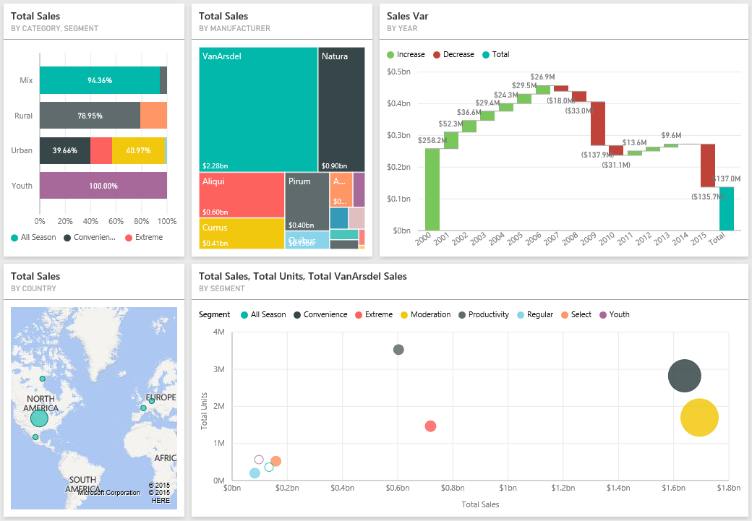

### Question 1

0.0/2.0 points (graded)

You want to pin existing visualizations from a report to a dashboard. What two scenarios can you do when pinning visualizations?

You can pin multiple visualizations to a dashboard but you need to do it one at a time.

You can pin two visualizations to a dashboard by pressing the CTRL key.

You can pin the whole report page to a dashboard in one attempt by pinning a live page.

You can pin three visualizations to a dashboard by pressing the CTRL key.

unanswered

Submit

You have used 0 of 2 attemptsSome problems have options such as save, reset, hints, or show answer. These options follow the Submit button.

SaveSave Your Answer

Let's try the natural language query feature and create a few visualizations for your dashboard.

* 1. Type the question "What is year to date sales" in the text box for Q&A.
  2. Pin the answer to **VanArsdel Sales** dashboard.
  3. Type the question "What is year to date total units"
  4. Pin the answer to **VanArsdel Sales**dashboard.
  5. Type the question "What product has the highest total sales in 2015"
  6. Expand the Fields and Visualizations pane on the right of the screen.
  7. Drag the **Total Units** field from the **Sales** table to the **Color saturation**. Notice that the bar char color saturation changes according to the **Total Units** for that product.
  8. Pin the answer to **VanArsdel Sales**dashboard.
  9. Resize and arrange the tiles as necessary.

You should have something similar to the below:

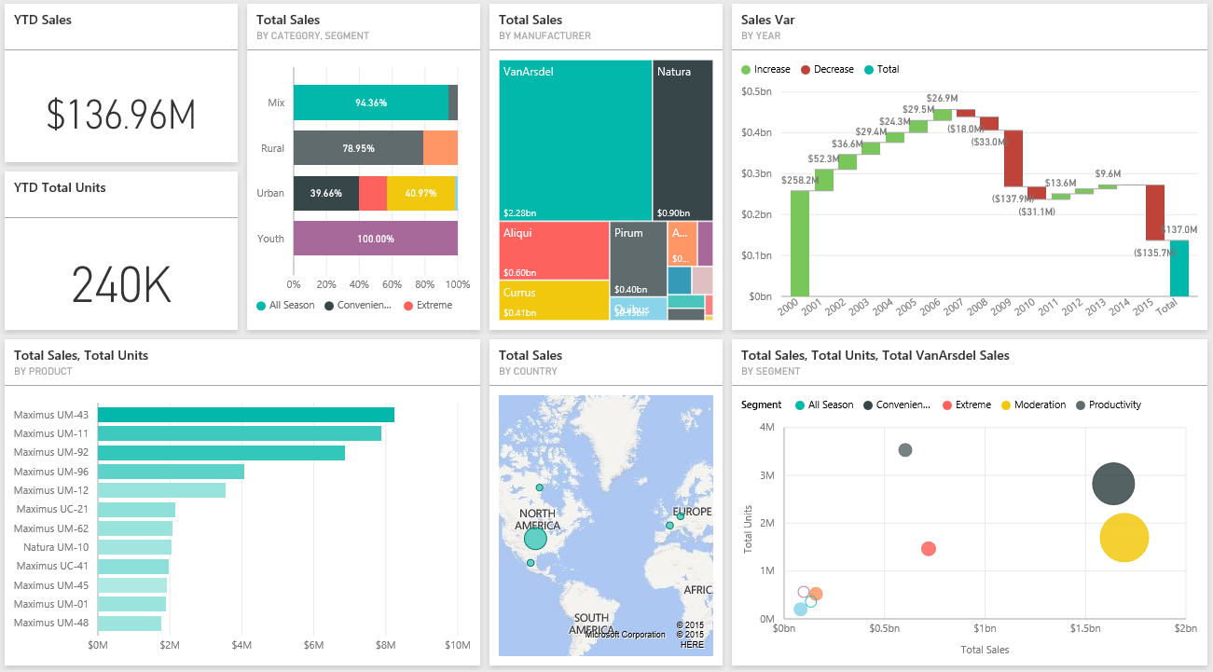

### Question 2

0.0/2.0 points (graded)

Now try answering the following question by using the Q&A. What is the total sales for Germany in 2014?

$4,044,962.47

$6,984,804.82

$3,681,551.21

$6,845,996.87

unanswered

## Exercise 2: Share Dashboard and Update Report

 Bookmark this page

Let's start sharing your newly created dashboard. For simplicity, let's share the dashboard to your own email address.

1. In the **VanArsdel Sales** dashboard, use the **Share** button to share your dashboard.
2. Enter your email address used for Power BI service and click **Share**.
3. Check your inbox to see an invite to view this dashboard.

### Question 1

0.0/2.0 points (graded)

Let's confirm that you received the dahsboard sharing invitation email. What is the sender's name?

Microsoft Learning

Microsoft Power BI

Power BI Service

Microsoft BI

unanswered

Submit

You have used 0 of 2 attemptsSome problems have options such as save, reset, hints, or show answer. These options follow the Submit button.

SaveSave Your Answer

Once you've uploaded your Power BI Desktop file to Power BI service, you can still make changes to it, and re-upload the file so that your changes is reflected in Power BI service.

1. Open the "Lab 4 - Starting.pbix" file.
2. Modify the **Total Sales by Category and Segment** chart (the one displayed using "100% stacked bar chart" visualization) on the **Sales Report**tab to use **Stacked Bar chart** visualization instead.
3. Re-publish the file to Power BI service and replace the existing dataset with this one.
4. Go to Power BI service and review the **Lab 4 - Starting Report** and examine whether the change you made is reflected.

### Question 2

1 point possible (graded)

As you can see, when you update a Power BI Desktop file and re-publish it, the report in Power BI service (that is based on that file) will get updated. What about the Dashboard? Do pinned visualizations (tiles) get updated when the report is updated?

Yes

No

unanswered

## Exercise 3: Schedule Data Refresh

 Bookmark this page

So far, the report you uploaded is rather static. That means, if the data in the Access database changes, the report and dashboard are not updated. You can install Power BI Personal Gateway and schedule data refresh for on-premises data sources, such as the Access database, to keep your report and dashboard on Power BI service up-to-date.

1. Go to the **Lab 4 - Starting**Datasets in Power BI service and click **Schedule Refresh**.
2. Power BI Pro is required to setup scheduled refresh for on-premises data. If you do not have Power BI Pro subscription you can enroll for a 60 day trial.
3. Ensure that you are in the **Datasets** tab and that the **Lab 4 - Starting** dataset is selected. Click **Install now**to download and install the Power BI Personal Gateway, accept the license terms, and wait for the installation to complete.
4. Launch the Gateway, sign in using your Power BI account and click **Finish**.
5. Edit credentials for the Data sources that needs updating.
6. Now you can schedule your data source refresh.

**NOTE:** If you are using the starter file provided in the beginning of Lab 4, in order to be able to successfully refresh the data, please ensure that you have the files from previous labs under the "C:\DAT207x\" folder. This is because the files were developed with this referenced. You might use arbitrary folders in your own scenario or if you are using your own file throughout the labs.

### Question

0.0/2.0 points (graded)

Which two frequencies are available for scheduled refresh?

Hourly

Daily

Weekly

Monthly

Yearly

Connecting and collaborating with EXCEL

## Knowledge Checks

 Bookmark this page

### Question 1

1 point possible (graded)

What do you need to do to prepare an Excel workbook before uploading it to Power BI?

Format all numeric data with two decimal points.

Ensure that the data is following the star schema.

Format the data as an Excel table.

Name the Excel worksheet appropriately.

unanswered

Submit

You have used 0 of 2 attemptsSome problems have options such as save, reset, hints, or show answer. These options follow the Submit button.

SaveSave Your Answer

### Question 2

1 point possible (graded)

What happens when you upload an Excel workbook that has a Power View report to Power BI?

The Excel Power View report will be converted to a Power BI report.

The Excel Power View report will not be imported to Power BI.

The Excel Power View report will have the data model imported, but you need to create the visualizations manually.

The Excel Power View report will be imported as Power BI Dashboard.

unanswered

Submit

You have used 0 of 2 attemptsSome problems have options such as save, reset, hints, or show answer. These options follow the Submit button.

SaveSave Your Answer

### Question 3

1 point possible (graded)

What happens when you connect to an Excel workbook that is hosted at OneDrive for Business from Power BI?

The Excel workbook will be uploaded to Power BI.

The Excel data model will be uploaded to Power BI.

The Excel Report will be created in Power BI.

The Excel Power View report will be converted to a Power BI report.

unanswered

## Lab Overview

 Bookmark this page

## **SCENARIO**

VanArsdel is a company that manufactures and sells sporting goods. The company has offices in the United States (US) and several other countries. Its sales comprise of US sales and International sales. VanArsdel’s sales come from its owned manufactured products, as well as other manufacturers’ products.

Some of your colleagues are using Excel as their primary reporting tool. You want to collaborate with them and use their Excel files using Power BI service.

## **LAB OVERVIEW**

In this lab, you will upload Excel files to Power BI service. First, you will upload an Excel file containing an Excel table, and create quick visualizations based on that data. Next, you will upload an Excel file that contains an Excel data model and Power View report, and use the converted report in Power BI service.

Before starting this lab, you should review **Working with Excel** module in this course. Then, if you have not already done so, follow the instructions in the **Set up the Lab Environment** section of this course to set up the lab environment.

## **WHAT YOU’LL NEED**

* The following Excel files:
  + The “[Lab 5 - Canada.xlsx](https://github.com/MicrosoftLearning/Analyzing-Visualizing-Data-PowerBI/raw/master/Lab5/Lab%205%20-%20Canada.zip)” file
  + The “[Lab 5 - USA.xlsx](https://github.com/MicrosoftLearning/Analyzing-Visualizing-Data-PowerBI/raw/master/Lab5/Lab%205%20-%20USA.zip)” file
* Power BI service account (You need to have a work / business email to sign up for Power BI service)

## Exercise 1: Upload Excel File with an Excel Table

 Bookmark this page

 First, you will upload an Excel file containing an Excel table.

1. Download and extract the the “[Lab 5 - Canada.xlsx](https://github.com/MicrosoftLearning/Analyzing-Visualizing-Data-PowerBI/raw/master/Lab5/Lab%205%20-%20Canada.zip)” file. The file contain VanArsdel's Canada sales. If you have a Microsoft Excel installed, you can open and explore the file (you don't have to).
2. Go to **http://www.powerbi.com** and sign in using your account.
3. Click **Get Data**, select **Files** and click **Get**. Select **Local file** , select the **Lab 5 - Canada.xlsx** file, and select **Import Excel data into Power BI**. The Excel file is imported as a Dataset in Power BI service.
4. Go to the **Lab 5 - Canada**Dataset.
5. Now, answer the following questions by creating visualizations using the skills you learned in the previous module.

### Question1

1 point possible (graded)

What is the total revenue for Canada in 2014? (to two decimal places)  unanswered

Loading

Submit

You have used 0 of 2 attemptsSome problems have options such as save, reset, hints, or show answer. These options follow the Submit button.

SaveSave Your Answer

### Question 2

1 point possible (graded)

In which year VanArsdel sold the most number of units in Canada?  unanswered

Loading

Submit

You have used 0 of 2 attemptsSome problems have options such as save, reset, hints, or show answer. These options follow the Submit button.

SaveSave Your Answer

### Question 3

1 point possible (graded)

Drag the Province to its appropriate box, 1 for the one with highest, and 4 for the one with the lowest.

For VanArsdel's Canada sales (Revenue) in 2012, which are the top 4 Provinces?



Alberta

British Columbia

Manitoba

Ontario

Quebec

unanswered

Submit

You have used 0 of 2 attemptsSome problems have options such as save, reset, hints, or show answer. These options follow the Submit button.

SaveSave Your Answer

### Question 4

1 point possible (graded)

Drag the Province to its appropriate box, 1 for the one with highest, and 4 for the one with the lowest.

What about for the year 2013? For VanArsdel's Canada sales (Revenue) in 2013, which are the top 4 Provinces?



Alberta

British Columbia

Manitoba

Ontario

Quebec

unanswered

## Exercise 2: Upload an Excel File with a Data Model

 Bookmark this page

Now, let's upload an Excel file containing a Data Model and a Power View Report.

1. Download and extract the the “[Lab 5 - USA.xlsx](https://github.com/MicrosoftLearning/Analyzing-Visualizing-Data-PowerBI/raw/master/Lab5/Lab%205%20-%20USA.zip)” file. The file contain VanArsdel's USAsales. If you have a Microsoft Excel installed, you can open and explore the file (you don't have to).
2. Go to **http://www.powerbi.com** and sign in using your account.
3. Click **Get Data**, select **Files** and click **Get**. Select **Local file**, select the **Lab 5 - USA.xlsx** file, and select **Upload your Excel file to Power BI**. The Excel file is uploaded as a Dataset in Power BI service. Since this Excel file also contain a Power View report, the Power View report is converted to a Power BI report.
4. Go to the **Lab 5 - USA** Report.
5. Now, answer the following questions by reviewing the **Power View1** tab in the **Lab 5 - USA** Report.

### Question 1

1 point possible (graded)

Using the Power View1 report, which manufacturer has the most growth in total units between May and June 2015 (for all categories)?

Aliqui

Currus

Natura

Pirum

VanArsdel

unanswered

Submit

You have used 0 of 2 attemptsSome problems have options such as save, reset, hints, or show answer. These options follow the Submit button.

SaveSave Your Answer

### Question 2

1 point possible (graded)

What about for only the Youth category? Which manufacturer has the most growth in total units between May and June 2015, for the Youth category?

Aliqui

Currus

Natura

Pirum

VanArsdel

unanswered

Submit

You have used 0 of 2 attemptsSome problems have options such as save, reset, hints, or show answer. These options follow the Submit button.

SaveSave Your Answer

### Question 3

1 point possible (graded)

Which manufacturer(s) does not have products for the Youth category?

Aliqui

Currus

Natura

Pirum

VanArsdel

unanswered

Note: Make sure you select all of the correct options—there may be more than one!

Submit

You have used 0 of 2 attemptsSome problems have options such as save, reset, hints, or show answer. These options follow the Submit button.

SaveSave Your Answer

### Question 4

1 point possible (graded)

Drag the Manufacturer to its appropriate box, 1 for the one with highest, and 4 for the one with the lowest.

For the Central region in 2015, which are the top 4 Manufacturers (in terms of Total Units)?



Aliqui

Currus

Natura

Pirum

VanArsdel

unanswered

Working with others

## Knowledge Checks

 Bookmark this page

### Question 1

1 point possible (graded)

Which three options can you add as a group member?

Computer Name

Email addresses

Security groups

Distribution Lists

unanswered

Submit

You have used 0 of 2 attemptsSome problems have options such as save, reset, hints, or show answer. These options follow the Submit button.

SaveSave Your Answer

### Question 2

1 point possible (graded)

Which two options you can give access to a content pack?

Power BI User

Power BI Group

Entire Organizations

External Organizations

unanswered

Submit

You have used 0 of 2 attemptsSome problems have options such as save, reset, hints, or show answer. These options follow the Submit button.

SaveSave Your Answer

### Question 3

1 point possible (graded)

Which two of the following happen when you personalize a content pack?

A copy of a content pack where you can make changes is created.

The published version of the content pack is updated.

The published version of the content pack is disconnected from the personalized content pack.

The published version of the content pack is customized.

unanswered

Submit

You have used 0 of 2 attemptsSome problems have options such as save, reset, hints, or show answer. These options follow the Submit button.

SaveSave Your Answer

### Question 4

1 point possible (graded)

When can you update a published content pack?

When the content pack is un-published

When no one has used the content pack

During the refresh period of the content pack

Anytime after you made changes to the published content pack

unanswered

Submit

You have used 0 of 2 attemptsSome problems have options such as save, reset, hints, or show answer. These options follow the Submit button.

SaveSave Your Answer

### Question 5

1 point possible (graded)

You create a Power BI report using Power BI desktop and save the report as .pbix file. You upload the file to OneDrive for Business. Using Power BI service, you connect to the file hosted on OneDrive for Business. What happens when you update the .pbix file on OneDrive for Business?

The corresponding report in Power BI service also gets updated automatically.

The corresponding report in Power BI service needs to be refreshed manually.

The corresponding report in Power BI service does not get updated. You need to reconnect to the file hosted at OneDrive for Business.

The corresponding report in Power BI service gets deleted.

unanswered

Submit

You have used 0 of 2 attemptsSome problems have options such as save, reset, hints, or show answer. These options follow the Submit button.

SaveSave Your Answer

### Question 6

1 point possible (graded)

What are the two privacy levels you can assigned to a group?

Public

Internal

External

Private

unanswered

[Lab 6](https://courses.edx.org/courses/course-v1:Microsoft+DAT207x+1T2018/course/#block-v1:Microsoft+DAT207x+1T2018+type@sequential+block@7911b3587463401c8988f19cd69c6d14)  Exercise: Create, Edit, and Share Content Pack

## Lab Overview

 Bookmark this page

## **SCENARIO**

VanArsdel is a company that manufactures and sells sporting goods. The company has offices in the United States (US) and several other countries. Its sales comprise of US sales and International sales. VanArsdel’s sales come from its owned manufactured products, as well as other manufacturers’ products.

You have uploaded reports created in Power BI Desktop and Microsoft Excel to Power BI service. You have also created dashboards in Power BI service. Now, you'd like to explore how to work with organization content packs.

## **LAB OVERVIEW**

In this lab, you will create an organization content pack and share it with your organization. You will use and personalize the content pack, edit and re-share the content pack.

Before starting this lab, you should review **Organization Packs, Security, and Groups** module in this course. Then, if you have not already done so, follow the instructions in the **Set up the Lab Environment** section of this course to set up the lab environment.

## **WHAT YOU’LL NEED**

* Completed Labs in the previous Modules (**Power BI Service** and **Working with Excel**)
* Power BI service account (You need to have a work / business email to sign up for Power BI service)
* Some steps require Power BI Pro subscription.

## Exercise: Create, Edit, and Share Content Pack

 Bookmark this page

### Create a Group

Make sure you have completed Labs from previous modules (**Power BI Service** and **Working with Excel**).

**IMPORTANT!**

Please note that you might get different answers if you had not followed the steps in the previous modules.

1. Go to **http://www.powerbi.com** and sign in using your account.
2. Create a new **Group**.
3. Name the Group **DAT207xVA** (or choose another name), set it as **Private**, and add your email address as a member of the group.
4. Save the Group.

### Question 1

1 point possible (graded)

Which two types of access to Power BI content, can you give to members of a group?

Admin

Edit

View

Delete

Member

unanswered

Submit

You have used 0 of 2 attemptsSome problems have options such as save, reset, hints, or show answer. These options follow the Submit button.

SaveSave Your Answer

### Create a Content Pack

1. Go to your workspace (not the group workspace).
2. Create a new **Content Pack**.
3. Select to give access to the**entire organization**.
4. Give the content pack appropriate **Title** and **Description**.
5. Select the **VanArsdel Sales** Dashboard, **Lab 5 - USA** Report, and **Lab - 5 Canada** Dataset. Notice that several other reports and datasets are selected since they are required for their corresponding Dashboard and Report.
6. Publish your content pack.

### Question 2

1 point possible (graded)

Which other report/datasets are selected along with your defined selection?

VanArsdel Report

VanArsdel Dataset

Lab 4 - Starting Report

Lab 4 - Starting Dataset

Lab 5 - Canada Report

unanswered

Note: Make sure you select all of the correct options—there may be more than one!

Submit

You have used 0 of 2 attemptsSome problems have options such as save, reset, hints, or show answer. These options follow the Submit button.

SaveSave Your Answer

### Use a Content Pack

1. Go to the **DAT207xVA** Group workspace.
2. Click **Get Data**, select **My Organization** and click **Get**. Select the Content Pack you created and click **Get it Now**. Observe that the content of the content pack are brought to the group workspace.

### Question 3

1 point possible (graded)

How many contents (dashboards, reports, and datasets) are brought into the workspace?

4

5

6

7

unanswered

Submit

You have used 0 of 2 attemptsSome problems have options such as save, reset, hints, or show answer. These options follow the Submit button.

SaveSave Your Answer

### Edit a Content Pack

1. Go to your workspace (not the group workspace).
2. Edit the content pack you created previously.
3. Clear the **Lab 5 - USA** Report and update your content pack.
4. Go to the **DAT207xVA** Group workspace.

### Question 4

1 point possible (graded)

Which content is available in this Group?

VanArsdel Sales Dashboard

Lab 4 - Starting Report

Lab 5 - USA Report

Lab 4 - Starting Dataset

Lab 5 - Canada Dataset

unanswered

Note: Make sure you select all of the correct options—there may be more than one!

[Direct Connectivity](https://courses.edx.org/courses/course-v1:Microsoft+DAT207x+1T2018/course/#block-v1:Microsoft+DAT207x+1T2018+type@sequential+block@06467810ca974ba5bbaa37522f26d0df)

## Knowledge Checks

 Bookmark this page

### Question 1

1 point possible (graded)

Which three data sources allow you to use direct connection from Power BI?

Azure SQL Database

Azure SQL Data Warehouse

Microsoft Access

SQL Server Analysis Services

unanswered

Submit

You have used 0 of 2 attemptsSome problems have options such as save, reset, hints, or show answer. These options follow the Submit button.

SaveSave Your Answer

### Question 2

1 point possible (graded)

When you connect to a model in SQL Server Analysis Service, what is shown in the Navigator window?

List of tables in the model

List of tables and columns in the model

List of tables, columns, and fields in the model

Summary showing the available dimensions and measures

unanswered

## Lab Overview

 Bookmark this page

## **SCENARIO**

VanArsdel is a company that manufactures and sells sporting goods. The company has offices in the United States (US) and several other countries. Its sales comprise of US sales and International sales. VanArsdel’s sales come from its owned manufactured products, as well as other manufacturers’ products.

Your company has decided to move the Access database to the cloud, by migrating the VanArsdel's US sales data to a SQL Server database on Azure. You want to use Power BI Direct connectivity feature to connect directly to the Azure SQL database.

## **LAB OVERVIEW**

In this lab, you will connect to data hosted on Azure SQL database from Power BI service and Power BI desktop using direct connectivity.

## **WHAT YOU’LL NEED**

* A computer with the latest version of Power BI Desktop installed on it.
* Power BI service account (You need to have a work / business email to sign up for Power BI service)

## xercise 1: Direct Connectivity From Power BI Desktop

 Bookmark this page

1. Start with a blank Power BI Desktop file.
2. Connect to the Azure SQL database by using **Get Data** and select the Microsoft Azure SQL database.
3. Enter the following information to connect to the SQL Database.
   * **Server**: msedxeus.database.windows.net
   * **Database**: DAT207x01
4. Ensure **DirectQuery** is selected and click **OK**.
5. Select to use **Database** credentials and enter the following information to login and click **Connect**.
   * **Login**: PBILogin
   * **Password**: P@ssw0rd
6. Select the **bi.salesFact**the**bi.Date**tablesand click**Load**.
7. Create a chart based on the **Card**visualization.
8. Drag the **Revenue**field from the **bi salesFact**table to the chart.
9. Create a slicer based on the **Slicer**visualization.
10. Drag the **Year**field from the **bi Date**table to the slicer.

**IMPORTANT!**If you cannot login, please try the following:

* The data import may take a while depending on the speed of your Internet provider.
* Ensure you are not behind a firewall.
* Try typing the server details and credentials instead of copy pasting.

### Lab Question

0.0/4.0 points (graded)

Select year 2015 from the slicer and review the card visualization. What is the total Revenue for the year 2015?

125.84M

397.5M

4.91bn

251.79M

unanswered

What is the total Revenue for the year 2014?

125.84M

397.5M

4.91bn

251.79M

unanswered

## Exercise 2: Direct Connectivity From Power BI Service

 Bookmark this page

1. Start with the pbix file you created in the previous exercise.
2. Use the **Publish** button to publish the report. Sign in using the account you used to sign up for Power BI service.
3. Go to **http://www.powerbi.com** and sign in using your account.
4. Go to the newly created dataset and edit the credentials required.
5. Enter the following information and click **Sign in**.
   * **Login**: PBILogin
   * **Password**: P@ssw0rd
6. Go to the newly created report. You should already have a card visualization for the Revenue and a slicer for the Year.
7. Create a chart based on the **Card**visualization.
8. Drag the **Units**field from the **salesFact**table to the chart.

### Lab Question

0.0/4.0 points (graded)

Select year 2015 from the slicer and review the card visualization. What is the total Units for the year 2015?

11M

222K

427K

963K

unanswered

What is the total Units for the year 2014?

11M

222K

427K

963K

unanswered

Submit

You have used 0 of 3 attemptsSome problems have options such as save, reset, hints, or show answer. These options follow the Submit button.

SaveSave Your Answer

1. Save the Report and give it a name.
2. Notice that you do not have to refresh this report, because it uses a live connection (DirectQuery) to the Azure SQL database, and always up-to-date.

[Course](https://courses.edx.org/courses/course-v1:Microsoft+DAT207x+1T2018/course/)  [8. Developer API](https://courses.edx.org/courses/course-v1:Microsoft+DAT207x+1T2018/course/#block-v1:Microsoft+DAT207x+1T2018+type@chapter+block@93ae6dd8e03e4a2abcbefa06986a4c9b)  [Developer API](https://courses.edx.org/courses/course-v1:Microsoft+DAT207x+1T2018/course/#block-v1:Microsoft+DAT207x+1T2018+type@sequential+block@487a8a7ac49a4feaa3e90b2416c36c4c)

## Knowledge Checks

 Bookmark this page

### Question 1

1 point possible (graded)

Which programming language you would use to create custom visuals?

C#

Java

TypeScript

Python

unanswered

Submit

You have used 0 of 2 attemptsSome problems have options such as save, reset, hints, or show answer. These options follow the Submit button.

SaveSave Your Answer

### Question 2

1 point possible (graded)

What is the extension of a Power BI custom visual file, downloaded from the Power BI visuals gallery?

.pbix

.pbivis

.pbiv

.pbiviz

unanswered

## Lab Overview

 Bookmark this page

## **SCENARIO**

VanArsdel is a company that manufactures and sells sporting goods. The company has offices in the United States (US) and several other countries. Its sales comprise of US sales and International sales. VanArsdel’s sales come from its owned manufactured products, as well as other manufacturers’ products.

## **LAB OVERVIEW**

In this lab, you will download Power BI custom visuals from the visuals gallery, and use them on your reports.

Before starting this lab, you should review **Developer API** module in this course. Then, if you have not already done so, follow the instructions in the **Set up the Lab Environment** section of this course to set up the lab environment.

## **WHAT YOU’LL NEED**

* A computer with the latest version of Power BI Desktop installed on it.
* The following Power BI Desktop file:
  + The “[Lab 8 - Starting.pbix](https://github.com/MicrosoftLearning/Analyzing-Visualizing-Data-PowerBI/raw/master/Lab8/Lab%208%20-%20Starting.zip)” file

## Exercise: Use Custom Visuals

 Bookmark this page

You have created several reports using the built-in visualizations. Now it's time to further enhance your reports by using custom visualizations.

1. Go to Power BI visuals gallery: <https://aka.ms/edx-dat207x-pbi2>
2. Download the **Sunburst** visual to your local machine.
3. Open the "[Lab 8 - Starting.pbix](https://github.com/MicrosoftLearning/Analyzing-Visualizing-Data-PowerBI/raw/master/Lab8/Lab%208%20-%20Starting.zip)" file.
4. Import the **Sunburst.pbiviz** file downloaded from step 2. You can now use the Sunburst visualization in this Power BI Desktop file.
5. Open the **Report** view and go to the **Sales Report** tab.
6. Select the **Total Sales by Category and Segment** visuals, which is based of **100 % Stacked bar chart**, and modify it to **Sunburst** visualization.

### Lab Question 1

0.0/2.0 points (graded)

How many level(s) of "donut" is created in the Sunburst visual?

One

Two

Three

Four

unanswered

Submit

You have used 0 of 2 attemptsSome problems have options such as save, reset, hints, or show answer. These options follow the Submit button.

SaveSave Your Answer

1. Go to Power BI visuals gallery: <https://aka.ms/edx-dat207x-pbi2>
2. Download **the Radar chart** visual to your local machine.
3. Import the **RadarChart.pbiviz** file downloaded from step 2. You can now use the Radar chart visualization in this Power BI Desktop file.
4. Open the **Report** view and go to the **Sales Report** tab.
5. Create a chart based on the **Radar Chart** visualization.
6. Drag the **Region**field from the **Locations**table to the chart.
7. Drag the**Total Sales**field from the **Sales**table to the chart.

### Lab Question 2

0.0/2.0 points (graded)

Review the Radar chart visual you created. Which Region has the highest Total sales?

Central

West

East

North

unanswered