**COMP229**

**Advanced Web Application Development**

**Team Project**

Luiz Érico de Almeida

Site Lee

Contents

MAIN FUNCTIONALITIES 3

DATABASE DIAGRAM 4

DATABASE STRUCTURE 4

Table Item 4

Table Book 5

Table Movie 5

Table Game 5

Table Review 6

Table Loan 6

Table User 6

FOLDER STRUCTURE 7

TYPOGRAFY 7

COLOR SCHEMA 7

FONT COLORS 8

TABLE COLORS 8

WIREFRAME 8

Mobile 8

Desktop 10

# MAIN FUNCTIONALITIES

* Create, Read, Update, Delete - User
* Create, Read, Update, Delete - Media (Item)
* Comments Item
* User register
* Responsive Design

# DATABASE DIAGRAM

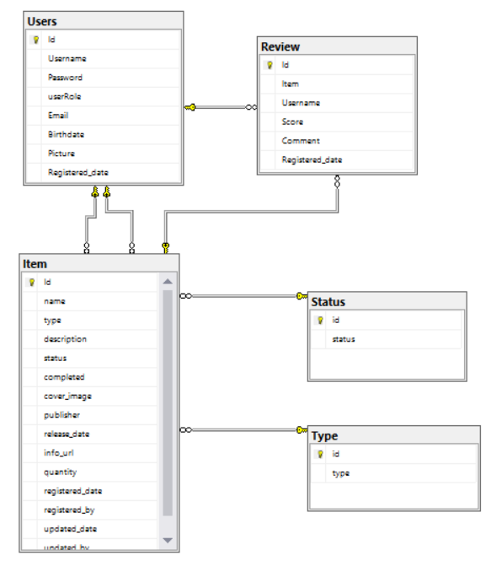

Database Diagram

# DATABASE STRUCTURE

## Table Item

* id
* name
* type -> Table Type (Game, Movie, etc)
* description
* status -> Table status (wanted, loaned, owned)
* cover_image
* publisher
* release_date
* info_url
* language
* quantity
* registered_date
* registered_by
* updated_date
* updated_by

## Table Review

* id
* item_id
* user_id
* registered_datetime
* score (1-10)
* comment

## Table User

* id
* username
* password
* email
* role
* picture

## Table Status

* id
* status

## Table Type

* id
* type

# FOLDER STRUCTURE

The files are organized inside the folder Resources as showed on the image below. Vendors contains all libraries for third part companies (Jquery, Bootstrap, etc)

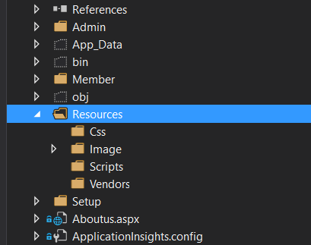

# TYPOGRAFY

Not Defined –

# COLOR SCHEMA

**General Items**

* White - #FFFFFF
* Black - #000000
* Green - #76CA7D
* Blue - # 042DAD

# LOGO



# FONT COLORS

Not Defined

# TABLE COLORS

Not Defined

# WIREFRAME

The result maybe would be present differences from the wireframes showed below due to the framework used and/or programming and security restrictions.

The images are used only with the purpose of evaluate the usability and positions of interface’s elements. The colors presented doesn’t correspond to the product final. Please consult the Color Schema section to be informed about the app color scheme.

## 

## Mobile



C:\Users\luize\AppData\Local\Microsoft\Windows\INetCacheContent.Word\Mobile2.png

## Desktop

