FASTAPI - LEARN
Documentação: https://fastapi.tiangolo.com/learn/

Sumário
Python Types Intro 1
Motivation 2
Edit it 2
Add types 2
More motivation 2
Declaring types 2
Simple types 2
Generic types with type parameters 2
Classes as types 2
Pydantic models 2
Type Hints with Metadata Annotations 2
Type hints in FastAPI 2
Concurrency and async / await 3
Environment Variables 3
Virtual Environments 3
Tutorial - User Guide 3
Advanced User Guide 3
FastAPI CLI 3
Deployment 3
How To - Recipes 3

Python Types Intro

def get_name_with_age(name: str, age: int):
name_with_age = name + " is this old: " + age
return name_with_age

Motivation

def get_full_name(first_name, last_name):
full_name = first_name.title() + " " + last_name.title()
return full_name

print(get_full_name("john", "doe"))

problema no auto completion (Ctrl space)

Edit it

Add types

def get_full_name(first_name: str, last_name: str):
full_name = first_name.title() + " " + last_name.title()
return full_name

print(get_full_name("john", "doe"))

agora fica fácil pegar a função específica do str

More motivation

Error check feito automaticamente ao tentar concatenar int e str

Declaring types

- int
- float
- bool
- bytes

def get_items(item_a: str, item_b: int, item_c: float, item_d: bool, item_e: bytes):
return item_a, item_b, item_c, item_d, item_d, item_e

Simple types

Generic types with type parameters

Tipos que podem conter outros tipos -> dict, list, set and tuple
Python 3.8+
from typing import List

def process_items(items: List[str]):
for item in items:
print(item)

python 3.9+

def process_items(items: list[str]):
for item in items:
print(item)

def process_items(items: list[str]):
for item in items:
print(item)

Newer versions of Python

List

Tuple and Set

process_items(items_t: tuple[int, int, str], items_s: set[bytes]):
return items_t, items_s

Dict

def process_items(prices: dict[str, float]):
for item_name, item_price in prices.items():
print(item_name)
print(item_price)

Union

def process_item(item: int | str):
print(item)

Possibly None

def say_hi(name: str | None = None):

if name is not None:

print(f"Hey {name}!")

else:

print("Hello World")]

def say_hi(name: str | None):
print(f"Hey {name}!")

Using Union or Optional

Generic types

Classes as types

You can also declare a class as the type of a variable.
Let's say you have a class Person, with a name:
class Person:
def __init__(self, name: str):
self.name = name

def get_person_name(one_person: Person):
return one_person.name
Then you can declare a variable to be of type Person:
class Person:
def __init__(self, name: str):
self.name = name

def get_person_name(one_person: Person):
return one_person.name

Pydantic models

Lack of static typing

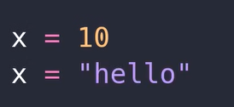



O que é a variável rect?

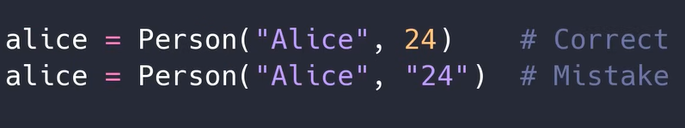

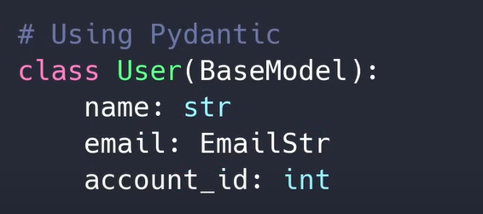





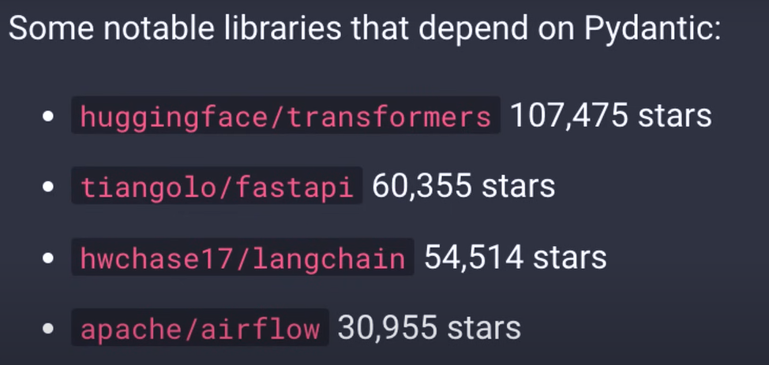

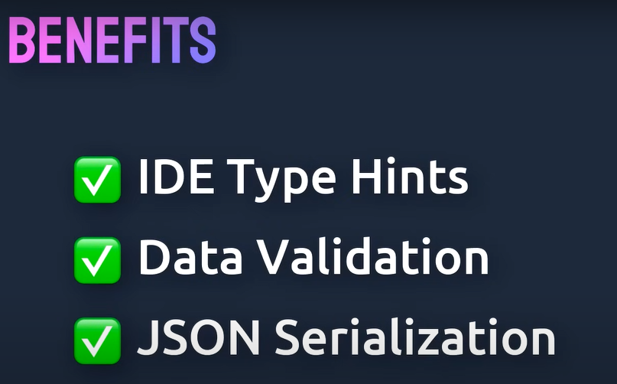



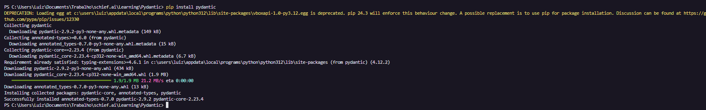

Criando um modelo PyDantic

python -m venv venv
verificando path : CTRL + , code runner, settings.json

code-runner.executorMap": {

// "python.pythonPath": "${workspaceFolder}/venv/Scripts/python.exe",

// "python": "C:/Users/Luiz/AppData/Local/Programs/Python/Python312/python.exe"

"python": "clear ; .\\venv\\Scripts\\python.exe"
},

from pydantic import BaseModel

class User(BaseModel):
name: str
email: str
account_id:str



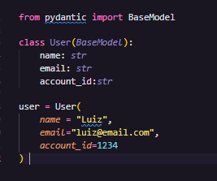

from pydantic import BaseModel

class User(BaseModel):
name: str
email: str
account_id:str

user = User(
name = "Luiz",
email="luiz@email.com",
account_id=1234
)

ao executar um erro é mostrado dado que o account id é um string

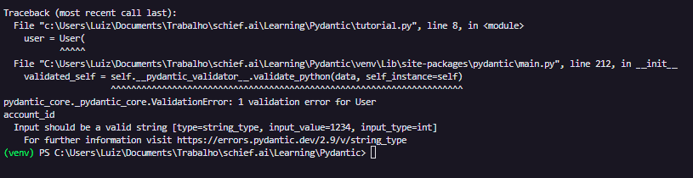

Podemos criar o objeto fazendo unpancking de um dicionário

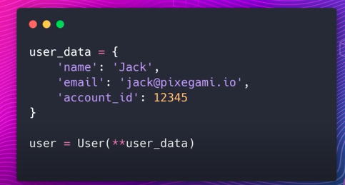

user_data = {
'name': 'Luiz',
'email': 'luiz@email.com',
'account_id': 12345

}

user = User(**user_data)

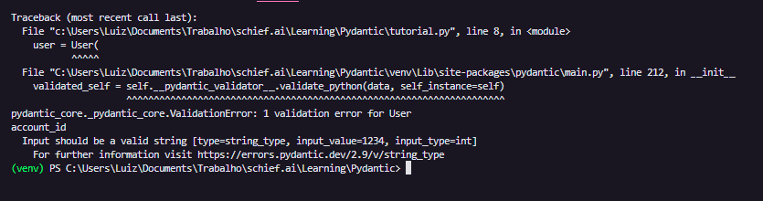

Podemos validar o dado para tipo mais complexos também. Por exemplo, vamos validar de acordo com EmailStr e colocar o account_id como int

from pydantic import BaseModel, EmailStr

class User(BaseModel):
name: str
email: EmailStr
account_id:int

user_data = {
'name': 'Luiz',
'email': 'luiz',
'account_id': 12345

}

user = User(**user_data)

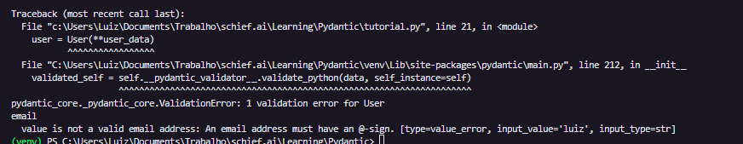

Consertando o email temos:

user_data = {
'name': 'Luiz',
'email': 'luiz@mail.com',
'account_id': 12345

}

user = User(**user_data)
print(user)

Podemos fazer validações customizadas também



Vamos criar uma função para a classe User de validação do campo account id

from pydantic import BaseModel, EmailStr, field_validator

class User(BaseModel):
name: str
email: EmailStr
account_id:int

@field_validator("account_id")
def validate_account(cls, value):
if(value <= 0):
raise ValueError(f"account id must be positive: {value}")
return value

Type Hints with Metadata Annotations

Type hints in FastAPI

Concurrency and async / await

Environment Variables

Virtual Environments

Tutorial - User Guide

Advanced User Guide

FastAPI CLI

Deployment

How To - Recipes

