Lab 5- Javascript1

Student: Luiz Fernando de Andrade Gadelha

ID: 610800

**Logs Report:**

**Problem 1: max of two numbers**

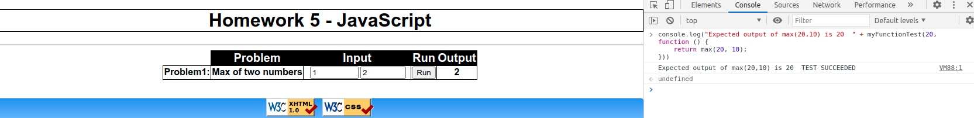**Problem 2: Max of tree numbers**

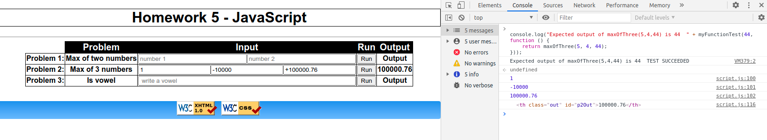

**Problem3: Is vowel**

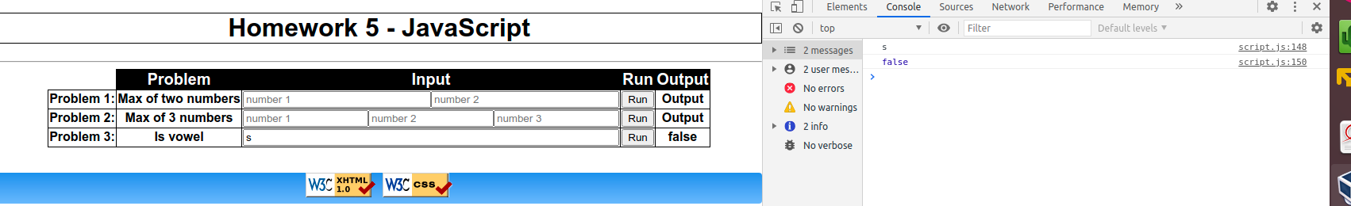

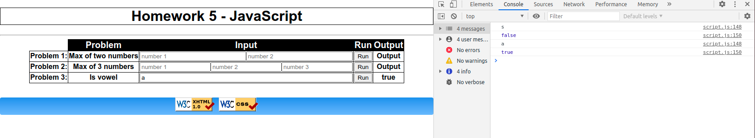

**Problem4.1 Sum of element in array**

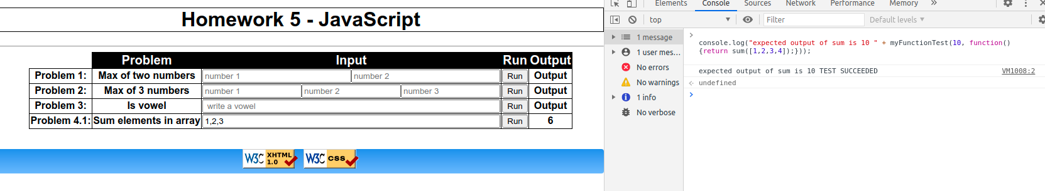

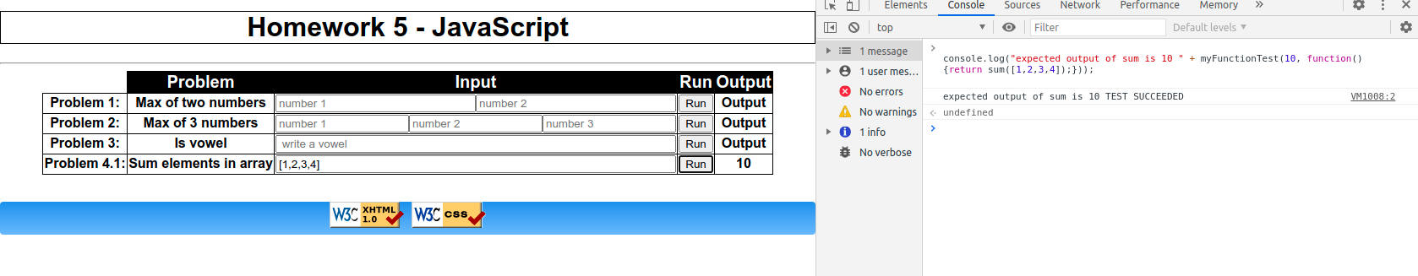

**Problem4_2 Multiply elements in array**

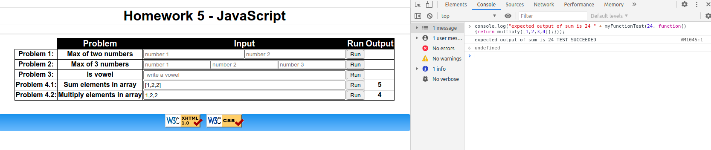

**Problem 5 : reverse string**

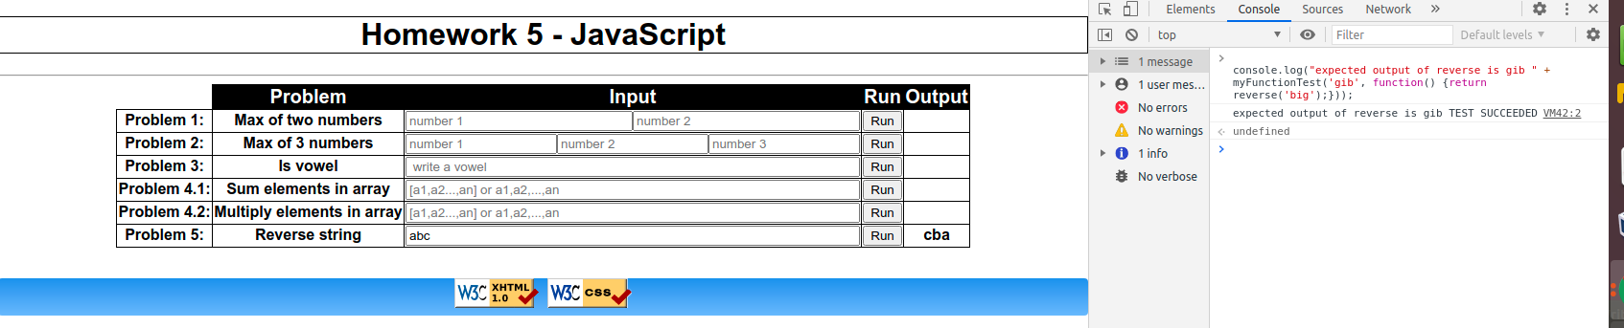

**Problem 6: Longest string in array**

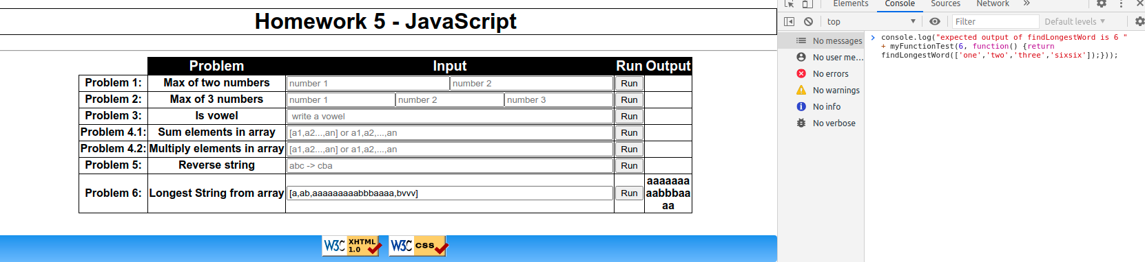

**Problem 7: filter array of string by minimum length**