Lab 8

Student: Luiz Fernando de Andrade Gadelha

ID: 610800

**Logs Report:**

**Exercise 1**

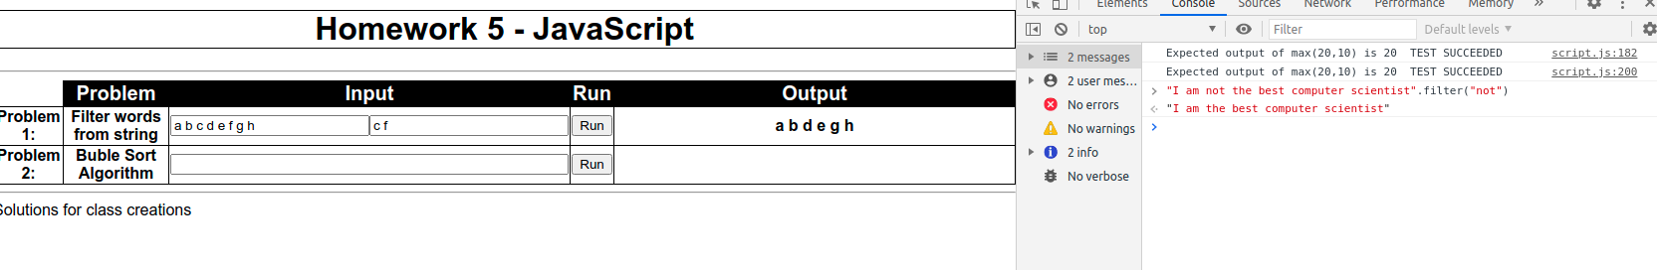

**Exercise 2**



**Exercise 3**

**3.1 Code:**

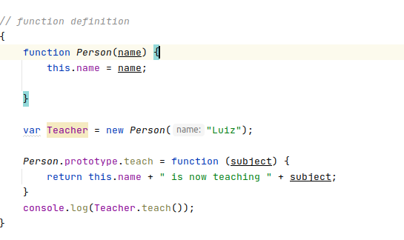

**3.1 Result:**

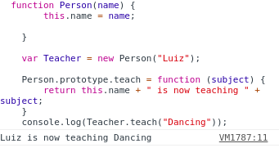

**3.2 Code:**

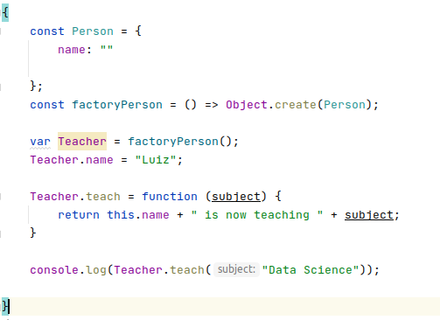

**3.2 Result:**

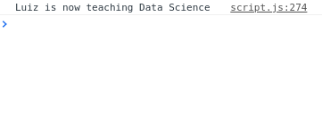

**Exercise 4**

**Object Approach**

**Code:**

*// *************** Person \*\*\*\*\*\*\*\*\*\*\*\*\*\*\*\*\*\*\*\**

const Person = {

name: "Not set",

age: -1

};

Person.greeting = function () {

console.log("Greetings, my name is " + this.name + " and I am " + this.age + " years old")

};

Person.salute = function () {

console.log("Good morning!, and in case I dont see you, good afternoon, good evening and good night!")

};

Person.constructor = function(name,age)

{this.name = name;

this.age = age;}

Person.setName = function (name){

this.name = name;

};

p = Object.create(Person);

p.name = "Luiz";

p.age = 29;

*//*************** Student \*\*\*\*\*\*\*\*\*\*\*\*\*\*\*\*\*\*\*\*\*\**

const Student = Object.create(Person);

Student.prototype = Person.prototype;

Student.constructor = function ( name,age,major){

this.name = name;

this.age = age;

this.major = major;

}

Student.greeting = function () {

console.log("Hey, my name is " + this.name + " and I am studying " + this.major + ".");

};

s = Object.create(Student);

s.constructor("Luiz",29,"Computer Science");

s.greeting();

s.salute();

*// *************** Professor *******************88*

const Professor = Object.create(Person);

Professor.constructor = function (name,age,department){

this.name = name;

this.age = age;

this.department = department;

}

Professor.salute = function () {

console.log("Good day, my name is " + this.name + "and I am in the " + this.department + "department.");

};

p = Object.create(Professor);

p.constructor("Luiz",29,"CS Dept");

s.greeting();

s.salute();

p.greeting();

p.salute();

**Result:**

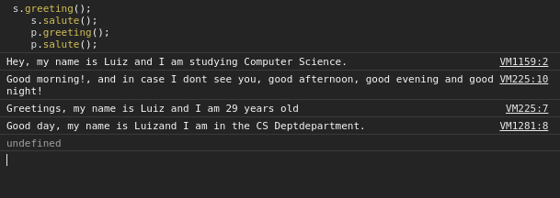

**Function Approach**

**Code:**

**function *Person*(name, age) {**

this.name = name

this.age = age;

};

*Person*.prototype.greeting = function(){ console.log("Greetings, my name is " + this.name + " and I am " + this.age + " years old")};

*Person*.prototype.salute = function() {console.log("Good morning!, and in case I dont see you, good afternoon, good evening and good night!")};

function *Student*(name,age,major)

{

*Person*.call(this,name,age );

this.major = major;

}

*Student*.prototype = Object.create(*Person*.prototype);

Object.defineProperty(*Student*.prototype, 'constructor', {

value: *Student*,

enumerable: false, *// so that it does not appear in 'for in' loop*

writable: true });

*Student*.prototype.greeting = function ()

{

console.log("Hey, my name is " + this.name + " and I am studying " + this.major + ".");

};

*// • Professor objects inherit name, age, and salute from person. They also have a field*

*// ‘department’ and have their own greeting method. Their salutation is “Good day,*

*// my name is [name] and I am in the [department] department.” Output it to the*

*// console.*

*// • Create a professor object and a student object. Call both the greeting and salutation*

*// methods on each.*

*// • Do this exercise once using the object prototype approach for inheritance and then*

*// using the function constructor approach.*

function *Professor*(name,age,department)

{

*Person*.call(this,name,age );

this.department = department;

}

*Professor*.prototype = Object.create(*Person*.prototype);

Object.defineProperty(*Professor*.prototype, 'constructor', {

value: *Professor*,

enumerable: false, *// so that it does not appear in 'for in' loop*

writable: true });

*Professor*.prototype.salute = function ()

{

console.log("Good day, my name is " + this.name + "and I am in the " + this.department + "department.");

};

**Result:**

