Lesson 7

Student: Luiz Fernando de Andrade Gadelha

ID: 610800

**Logs Report:**

**Exercise 4**

**CODE:**

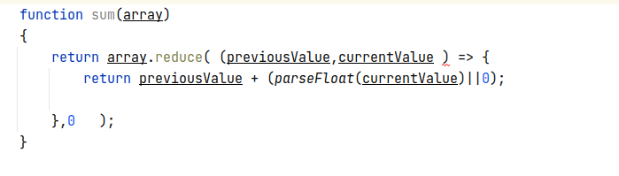

**Exercise 2**

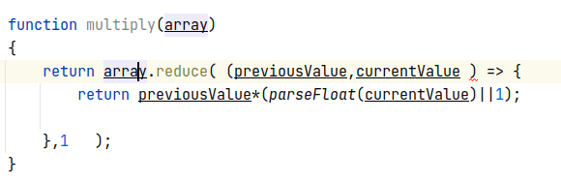

**RESULT:**

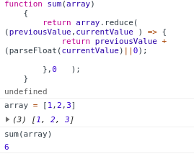

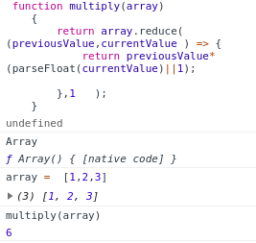

**Exercise 5**

**CODE**

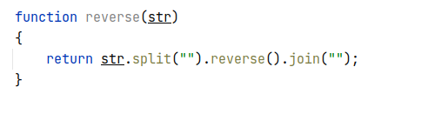

**RESULT**

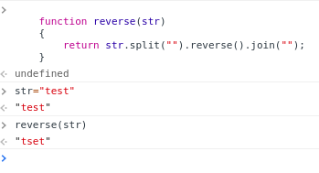

**Exercise 7**

**CODE**

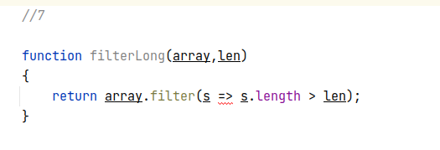

**RESULT**

