Design Patterns
Behavioral
Observer

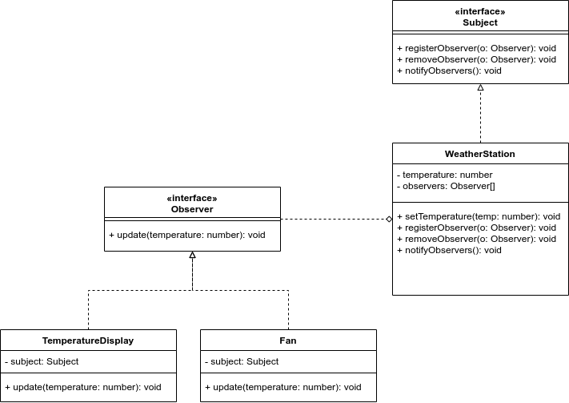

interface Subject {
registerObserver(o: Observer): void;
removeObserver(o: Observer): void;
notifyObservers(): void;
}

interface Observer {
update(temperature: number): void;
}

class WeatherStation implements Subject {
private temperature!: number;
private observers: Observer[] = [];
setTemperature(temp: number): void {
console.log(`WeatherStation: new temperature measurement: ${temp}`);
this.temperature = temp;
this.notifyObservers();
}
registerObserver(o: Observer): void {
if (this.observers.includes(o)) throw new Error("Observer already registered");
this.observers.push(o);
}
removeObserver(o: Observer): void {
let obsItem = this.observers.indexOf(o);
if (obsItem < 0) throw new Error("Observer not registered");
this.observers.splice(obsItem, 1);
}
notifyObservers(): void {
for (const observer of this.observers)
observer.update(this.temperature);
}
}

class TemperatureDisplay implements Observer {
private subject!: Subject;

constructor(weatherStation: Subject) {
this.subject = weatherStation;
weatherStation.registerObserver(this);
}

update(temperature: number): void {
console.log('TemperatureDisplay: I need to update my display.')
//Logic
}
}

class Fan implements Observer {
private subject!: Subject;

constructor(weatherStation: Subject) {
this.subject = weatherStation;
weatherStation.registerObserver(this);
}

update(temperature: number): void {
if (temperature > 25) {
console.log('Fan: Its hot here, turning myself on');
//Logic
} else {
console.log('Fan: Its nice and cool, turning myself off');
//Logic
}
}
}

let weatherStation = new WeatherStation();
let weatherDisplay = new TemperatureDisplay(weatherStation);
let fan = new Fan(weatherStation);
weatherStation.setTemperature(20);
weatherStation.setTemperature(30);

// OUTPUT:
// WeatherStation: new temperature measurement: 20
// TemperatureDisplay: I need to update my display.
// Fan: Its nice and cool, turning myself off
// WeatherStation: new temperature measurement: 30
// TemperatureDisplay: I need to update my display.
// Fan: Its hot here, turning myself on

