**Installing Avida:**

To install avida:

git clone <https://github.com/devosoft/avida>

cd avida

./build_avida

**Load Avida:**

Avida comes installed on the HPCC and can be loaded as a module. To load the avida module:

module load avida

**Required files**:

Avida configuration file

The avida configuration file (also see: [avida.cfg](https://github.com/luizirber/cse845/blob/master/fluc_env/config_files/avida.cfg)) defines all the parameters within the avidian world. The file also specifies the instruction file (also see: [instset-head.org](https://github.com/luizirber/cse845/blob/master/fluc_env/config_files/instset-heads.cfg)) to use for the first avidian.

Events file

Figure 1: Sample event file for a “staggered environment” kind of fluctuation. According to this sample, every one update there will be a high resource inflow of 100 units for four tasks, while the other four inflow at 1 unit. The next update will reverse this cycle and so it will continue till 500,000 updates. This event file has very short fluctuations; one update.

The event file also mentions that every 50 updates outputs files from the run need to be saved.

Similar event files will be required for synchronous environment fluctuation.

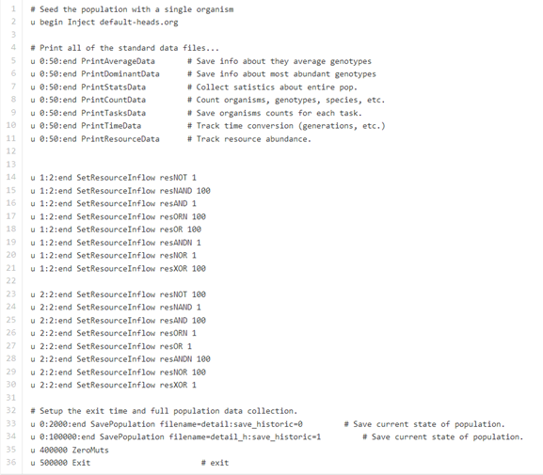

Environment file

Figure 2: Sample environment file. An environment file describes the resource inflow and outflow rates, rewards avidians get when they complete a certain task.

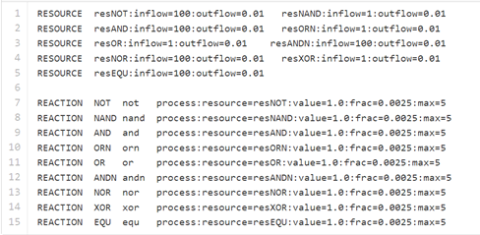

**Being avida run**

Using the above mentioned files and a few others, we can begin our first avida run.

*Step 1: Prepare working directory:*

The working directory or DATA_DIR gives the location where all the above mentioned files must be created and saved so that avida can access each of the files (alternatively all the files in [fluc_env](https://github.com/luizirber/cse845/tree/master/fluc_env/config_files) config files can be directly downloaded into the working directory). Individual runs will be required for each of the sub files.

*Step 2: Submit the run to the cluster*

Once the working directory has been created, a submission file must be created to submit the run to the HPCC cluster.

To submit the run:

qsub avida_stag_1.sub

You should see something like this:

[shettypr@dev-intel10 avida_run]$ qsub avida_stag_1.sub

17788020[].mgr-04.i

The status of the jobs can be monitored using the array id: 17788020[]

Begin runs for the different resource inflows and fluctuation lengths.

Figure 3: Sample sub file to begin avida run. The submission file specifies which event and environment files must be used as an input to avida and will also run 30 copies of the same script there by generating 30 replicates. Output from each of the avida runs will be stored in the folder replicate_*x*, where *x* is the replicate number.

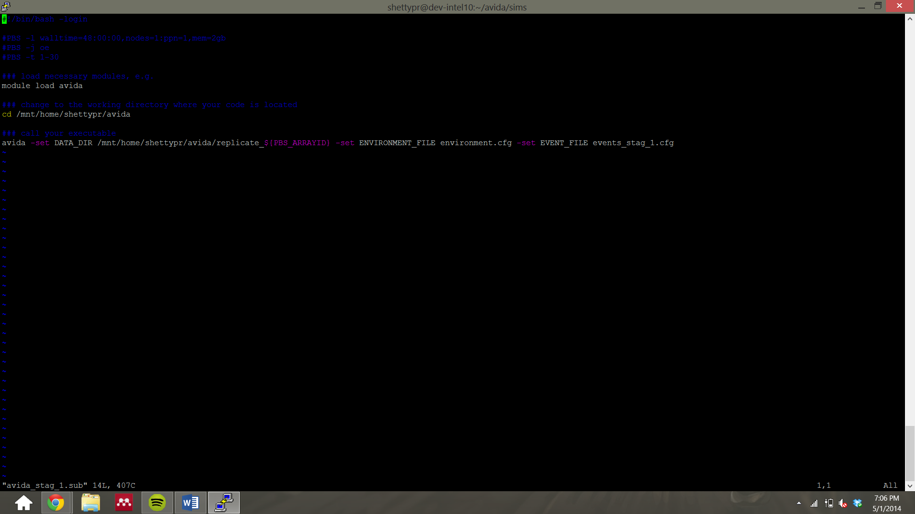

**Clustering avidian populations to identify species richness**

The clustering algorithm can be used to identify species richness. The algorithm was previously used in the Chow et. al. paper (refer [clustering_algorithm](https://github.com/luizirber/cse845/tree/master/fluc_env/clustering)). To run the clustering algorithm:

treeCS <detail_pop_file> <historic_dump_file> <output_file> <cutoff>

**Calculate resource levels, tasks performed**

Call the functions relevant function (i.e get_total_resource_counts and get_total_task_counts) in the python script analysis_code.py (refer [analysis_code.py](https://github.com/luizirber/cse845/blob/master/fluc_env/data_analysis_files/analysis_code.py))

Figure 4: At the end of this, you will have many individual data files for each of the fluctuating lengths and type. The data from this can be used to plot the resource level curves.

