3ª Lista de Exercícios – Circuitos e Máquinas Elétricas
Luiz Carlos Irber Júnior – RA: 254258

Exercício 1:

1.cir
Exercicio 1
Is 2 0 DC 2A
R1 2 0 6
R2 2 1 8
R3 2 1 8
Vab 1 0 DC 0V
.DC Vab 0 0 1
.PRINT DC I(Is) I(R1) I(R2) I(R3) I(Vab)
.END

1.out
**** 05/17/106 12:05:59 ****** NT PSpice 8.0 (July 1997) ****** ID# 308312896

Exercicio 1

CIRCUIT DESCRIPTION
************************************************************************

Is 2 0 DC 2A
R1 2 0 6
R2 2 1 8
R3 2 1 8
Vab 1 0 DC 0V
.DC Vab 0 0 1
.PRINT DC I(Is) I(R1) I(R2) I(R3) I(Vab)

**** 05/17/106 12:05:59 ****** NT PSpice 8.0 (July 1997) ****** ID# 308312896

Exercicio 1

DC TRANSFER CURVES TEMPERATURE = 27.000 DEG C
************************************************************************
Vab I(Is) I(R1) I(R2) I(R3) I(Vab)

0.000E+00 2.000E+00 -8.000E-01 -6.000E-01 -6.000E-01 -1.200E+00

JOB CONCLUDED

TOTAL JOB TIME .03

Exercício 2

2.cir
Exercício 2
Vs 1 3 DC 12
R1 1 2 3
R2 2 3 6
R3 2 0 7
.TF V(3) Vs
.END

2.out
**** 05/17/106 13:01:22 ****** NT PSpice 8.0 (July 1997) ****** ID# 308312896

Exercicio 2

CIRCUIT DESCRIPTION
************************************************************************

Vs 1 3 DC 12
R1 1 2 3
R2 2 3 6
R3 2 0 7
.TF V(3) Vs
.END

**** 05/17/106 13:01:22 ****** NT PSpice 8.0 (July 1997) ****** ID# 308312896

Exercicio 2

SMALL SIGNAL BIAS SOLUTION TEMPERATURE = 27.000 DEG C
************************************************************************
NODE VOLTAGE NODE VOLTAGE NODE VOLTAGE NODE VOLTAGE
( 1) 4.0000 ( 2) 0.0000 ( 3) -8.0000

VOLTAGE SOURCE CURRENTS
NAME CURRENT
Vs -1.333E+00
TOTAL POWER DISSIPATION 1.60E+01 WATTS

**** SMALL-SIGNAL CHARACTERISTICS

V(3)/Vs = -6.667E-01
INPUT RESISTANCE AT Vs = 9.000E+00
OUTPUT RESISTANCE AT V(3) = 9.000E+00

JOB CONCLUDED

TOTAL JOB TIME 0.01

Exercício 3

3.cir
Exercicio 3
L1 0 2 10mH IC=90mA
R1 2 1 20
C1 1 0 2uF IC=-10V
.TRAN 20u 5000u UIC
.PROBE
.END

3.out
**** 05/17/106 13:20:36 ****** NT PSpice 8.0 (July 1997) ****** ID# 308312896

Exercicio 3

CIRCUIT DESCRIPTION
************************************************************************
L1 0 2 10mH IC=90mA
R1 2 1 20
C1 1 0 2uF IC=-10V
.TRAN 20u 5000u UIC
.PROBE

JOB CONCLUDED
TOTAL JOB TIME .02

3.dat (visto no MicroSim Probe)
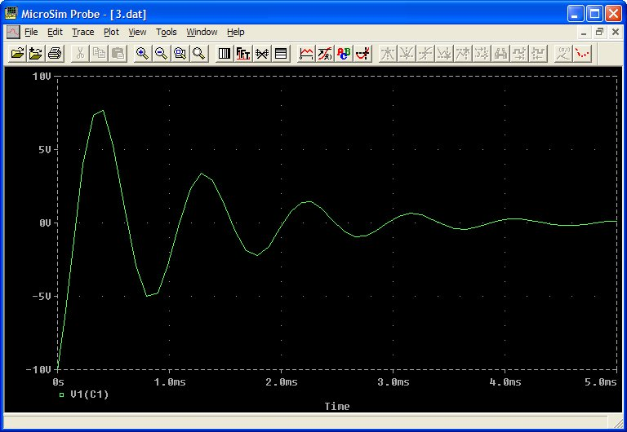
Exercício 4
4.cir
Exercicio 4
L1 0 2 10mH IC=90mA
R1 2 1 20
C1 1 3 2uF IC=-10V
Vs 0 3 DC 21V
.TRAN 20u 5000u UIC
.PROBE
.END

4.out
**** 05/17/106 13:32:12 ****** NT PSpice 8.0 (July 1997) ****** ID# 308312896

Exercicio 4

CIRCUIT DESCRIPTION
************************************************************************
L1 0 2 10mH IC=90mA
R1 2 1 20
C1 1 3 2uF IC=-10V
Vs 0 3 DC 21V
.TRAN 20u 5000u UIC
.PROBE

JOB CONCLUDED
TOTAL JOB TIME 0.01

4.dat (visto no MicroSim Probe)
