Lab exam
lujain Zia
- BSE-034(section A)
Repo link: https://github.com/lujainzia127/lab_exam
Question 1:
Create group:
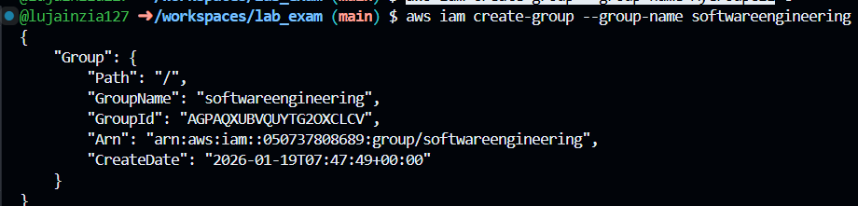

Details:
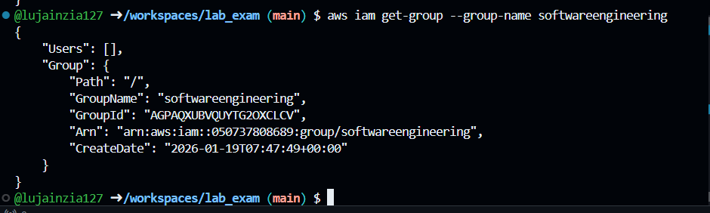

User:
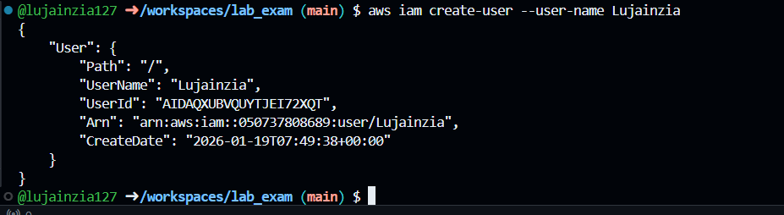

User details:
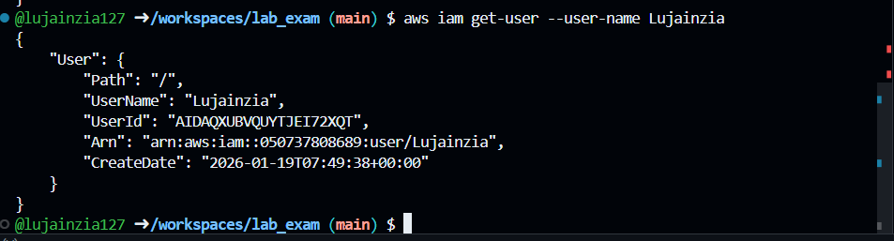
User to group:
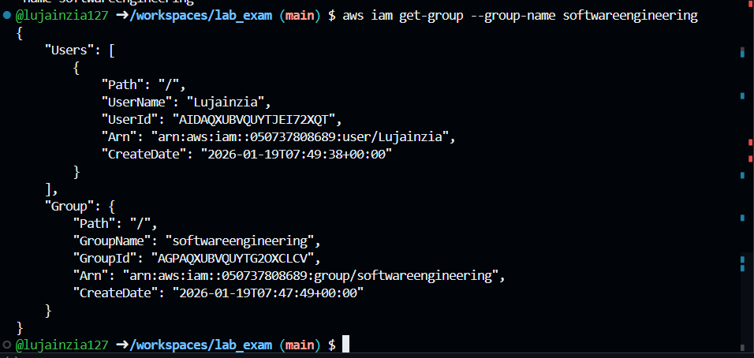
Find policy:
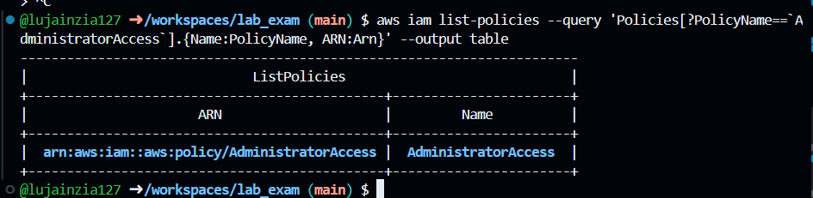
Policy list:
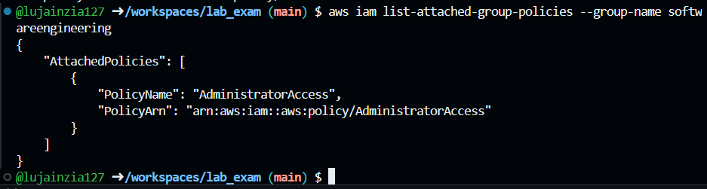
Verify:
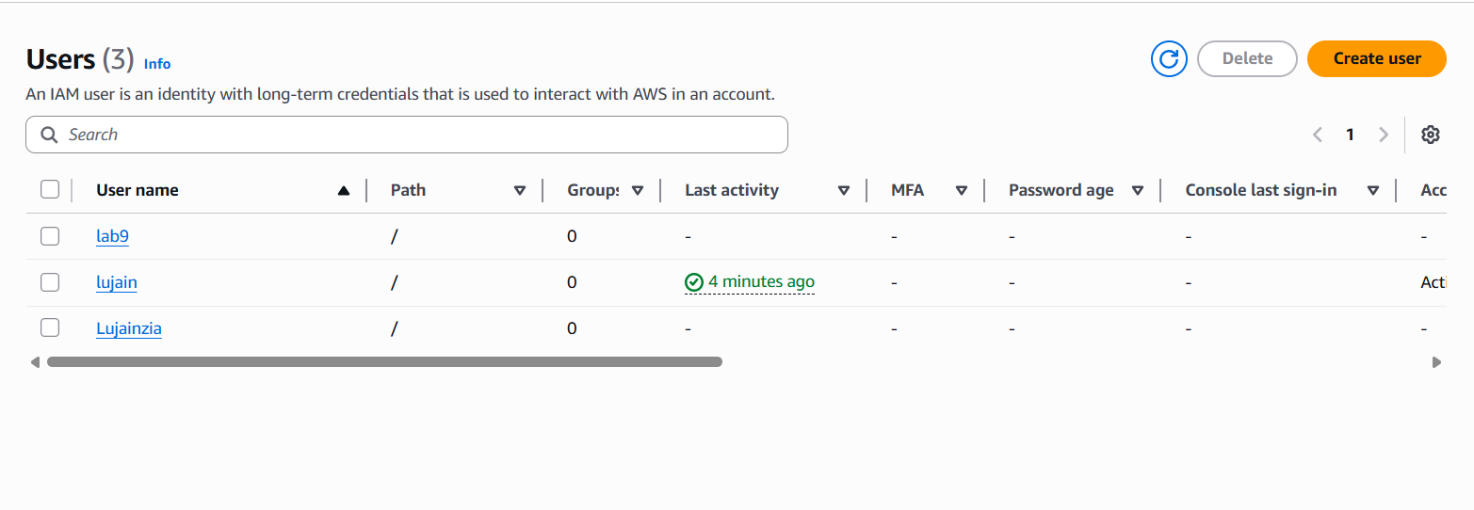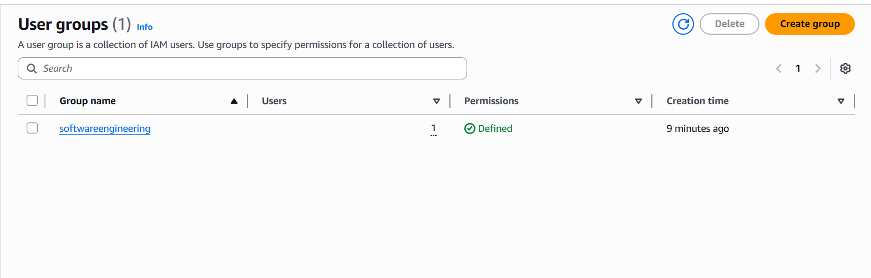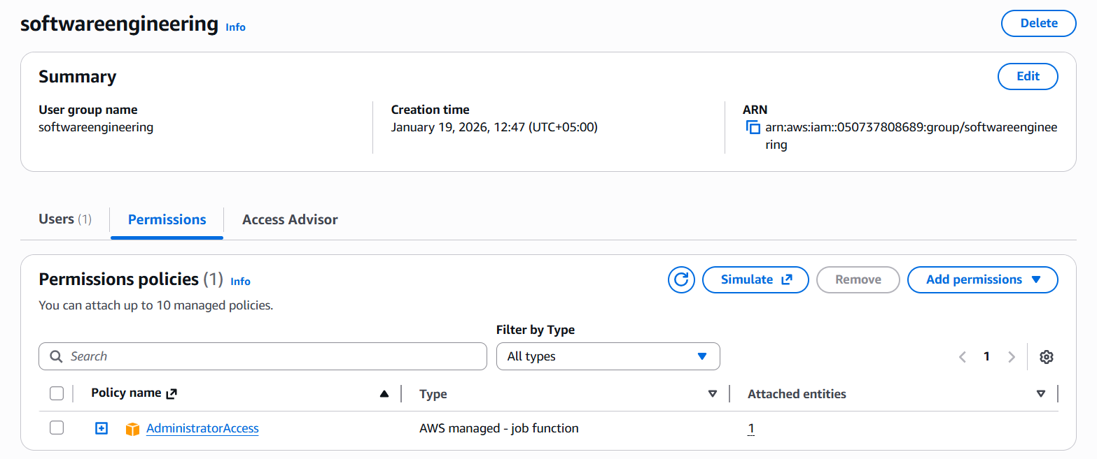
Question 2:
Configure:
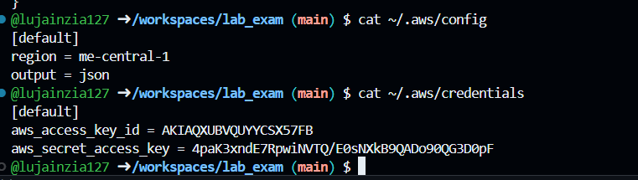
Variable:
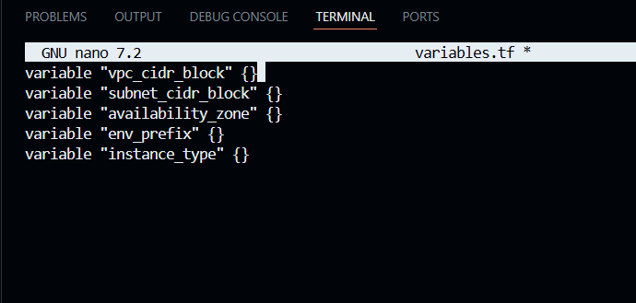
Vpc:
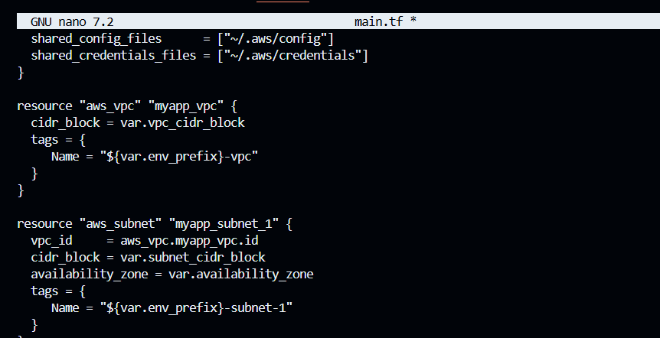gateway and route:
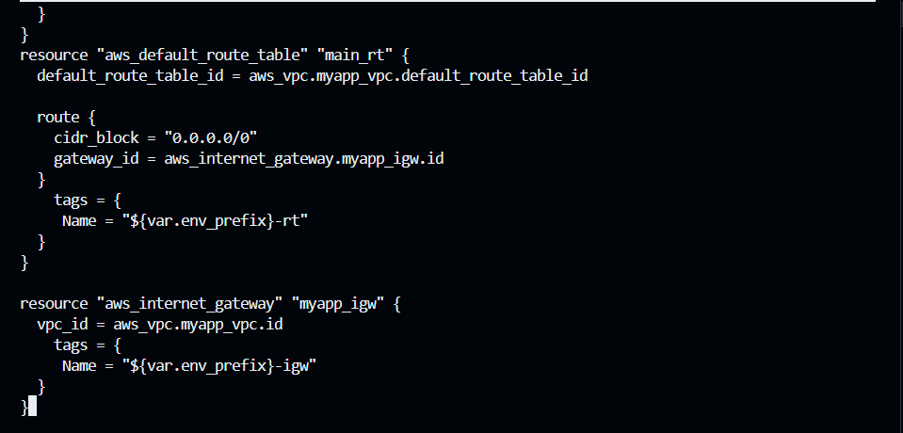

Locals.tf:
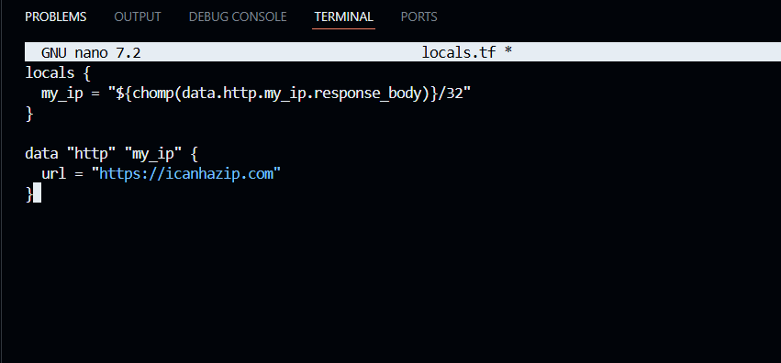

Main.tf:
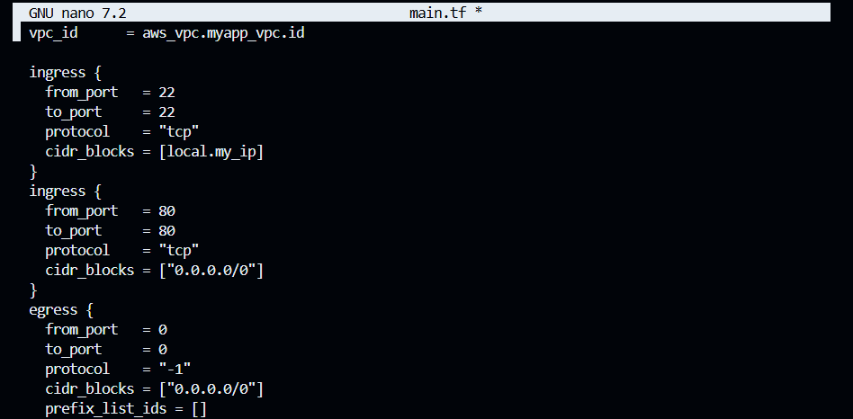
Key pair:
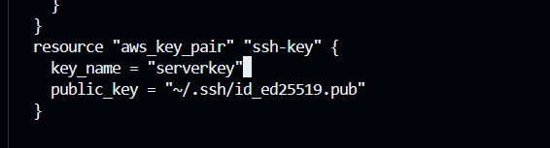

Terraform tfvars:
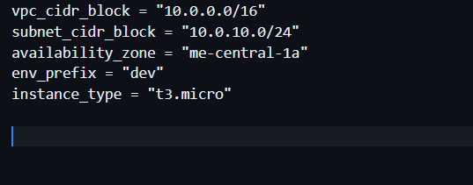
Ec2 instance:

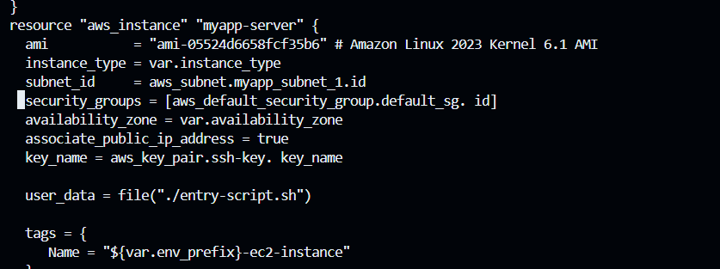

Entry script:
#!/bin/bash
set -e
yum update -y
yum install -y nginx
systemctl start nginx
systemctl enable nginx

# Create directories for SSL certificates if they don't exist
mkdir -p /etc/ssl/private
mkdir -p /etc/ssl/certs

# Get IMDSv2 token
TOKEN=$(curl -s -X PUT "http://169.254.169.254/latest/api/token" \
-H "X-aws-ec2-metadata-token-ttl-seconds: 21600")

# Get current public IP
PUBLIC_IP=$(curl -s -H "X-aws-ec2-metadata-token: $TOKEN" \
http://169.254.169.254/latest/meta-data/public-ipv4)

PUBLIC_HOSTNAME=$(curl -s -H "X-aws-ec2-metadata-token: $TOKEN" \
http://169.254.169.254/latest/meta-data/public-hostname)

# Generate self-signed certificate with dynamic IP
openssl req -x509 -nodes -days 365 -newkey rsa:2048 \
-keyout /etc/ssl/private/selfsigned.key \
-out /etc/ssl/certs/selfsigned.crt \
-subj "/CN=$PUBLIC_IP" \
-addext "subjectAltName=IP:$PUBLIC_IP" \
-addext "basicConstraints=CA:FALSE" \
-addext "keyUsage=digitalSignature,keyEncipherment" \
-addext "extendedKeyUsage=serverAuth"

echo "Self-signed certificate created for IP: $PUBLIC_IP"

# Backup existing nginx. conf
cp /etc/nginx/nginx.conf /etc/nginx/nginx.conf.bak

# Overwrite nginx.conf with the desired content
cat <<EOF > /etc/nginx/nginx.conf
user nginx;
worker_processes auto;
error_log /var/log/nginx/error.log notice;
pid /run/nginx. pid;

events {
worker_connections 1024;
}

http {
log_format main '\$remote_addr - \$remote_user [\$time_local] "\$request"'
'\$status \$body_bytes_sent "\$http_referer"'
'"\$http_user_agent" "\$http_x_forwarded_for"';

access_log /var/log/nginx/access.log main;

sendfile on;
tcp_nopush on;
keepalive_timeout 65;
types_hash_max_size 4096;

include /etc/nginx/mime.types;
default_type application/octet-stream;

upstream backend_servers {
server 158.252.94.241:80;
server 158.252.94.242:80 backup;
}

server {
listen 443 ssl;
server_name $PUBLIC_IP;
ssl_certificate /etc/ssl/certs/selfsigned.crt;
ssl_certificate_key /etc/ssl/private/selfsigned.key;

location / {
root /usr/share/nginx/html;
index index.html;
# proxy_pass http://158.252.94.241:80;
# proxy_pass http://backend_servers;

}
}

server {
listen 80;
server_name _;
return 301 https://\$host\$request_uri;
}
}
EOF

# Test and restart Nginx
systemctl restart nginx
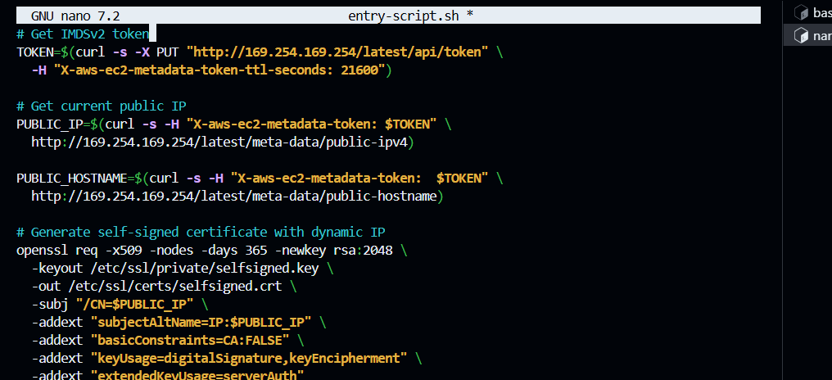

outputs: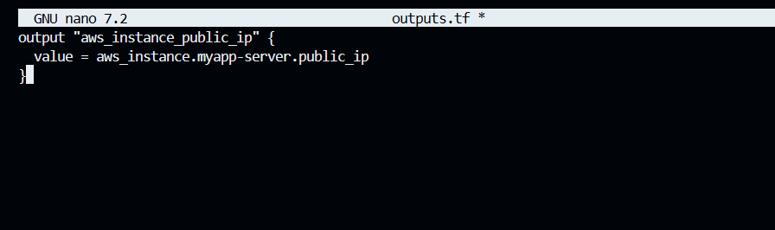
Terraform init:
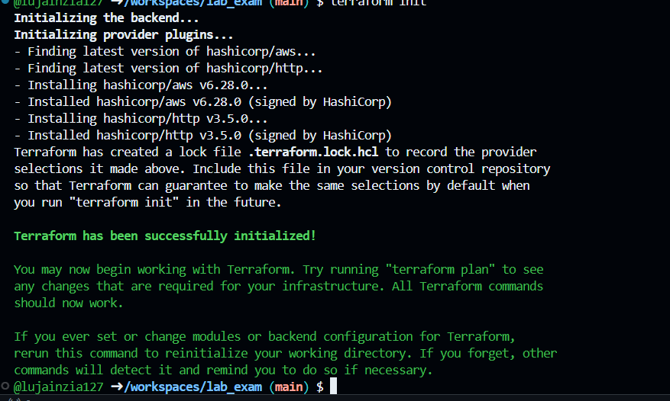
Terraform plan:
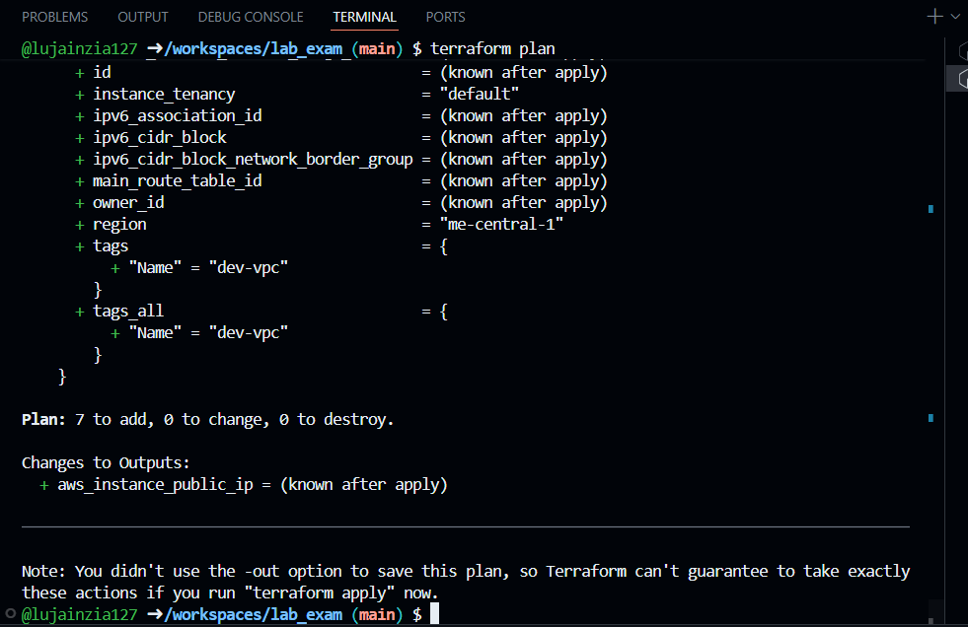
Terrfaorm apply:
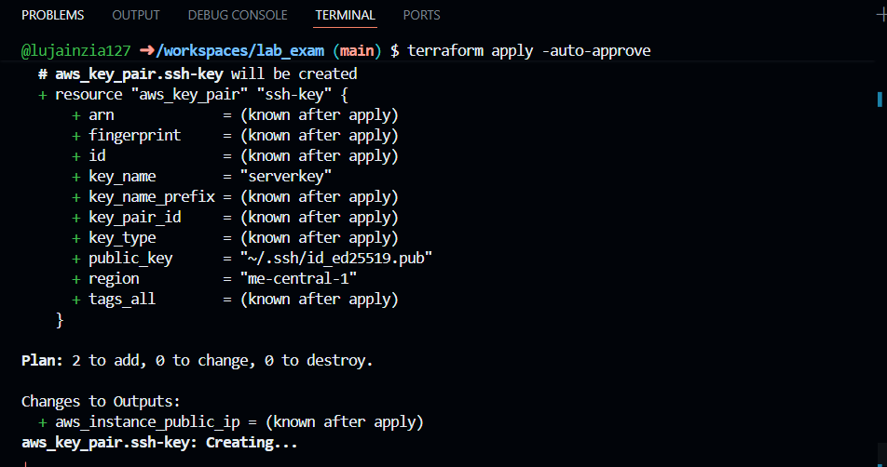
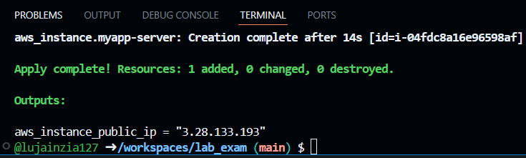
Verify:
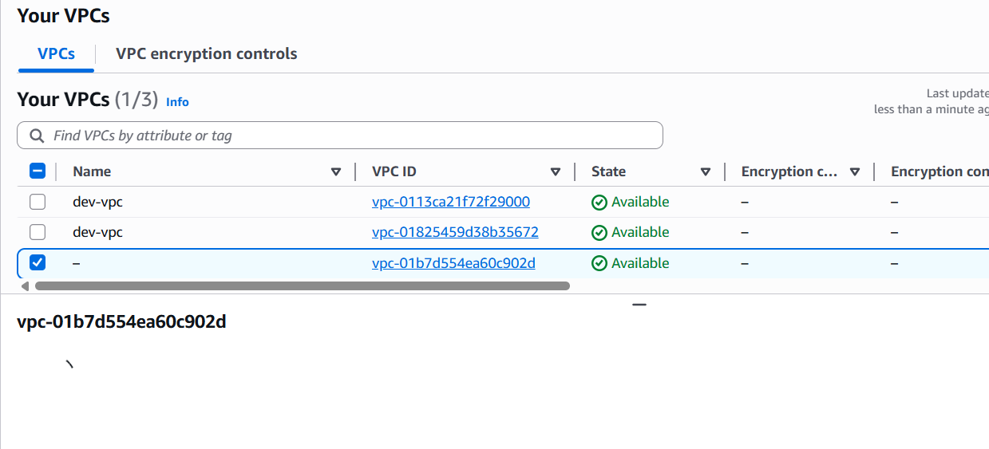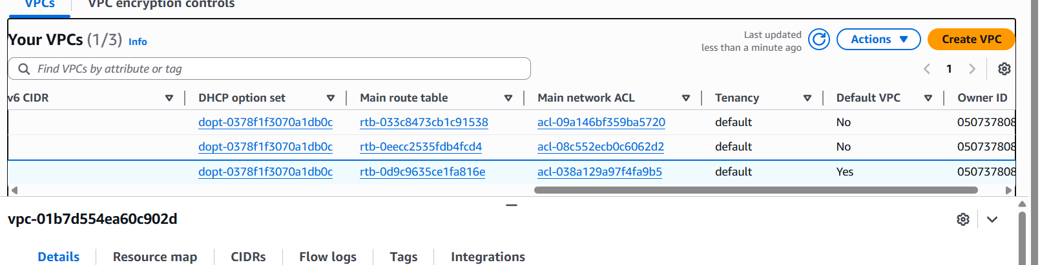
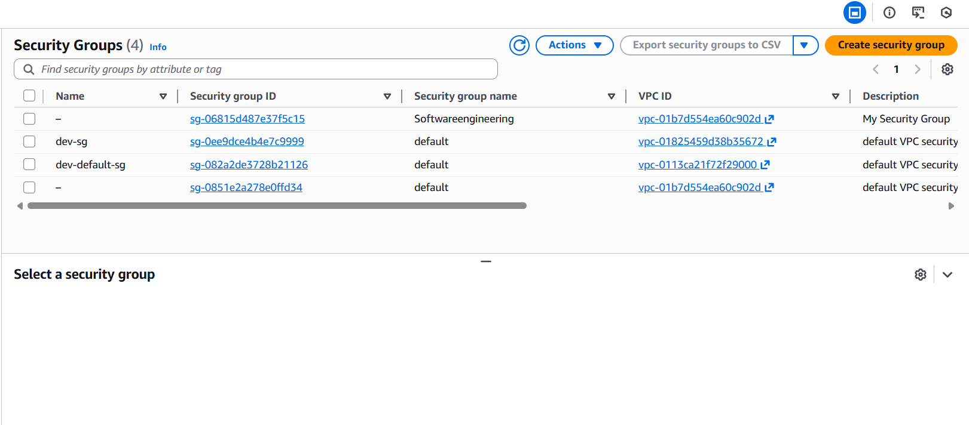
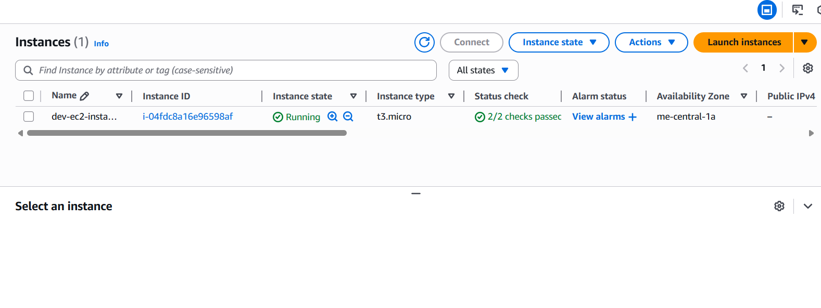
Main.tf:

provider "aws" {
shared_config_files = ["~/.aws/config"]
shared_credentials_files = ["~/.aws/credentials"]
}

resource "aws_vpc" "myapp_vpc" {
cidr_block = var.vpc_cidr_block
tags = {
Name = "${var.env_prefix}-vpc"
}
}

resource "aws_subnet" "myapp_subnet_1" {
vpc_id = aws_vpc.myapp_vpc.id
cidr_block = var.subnet_cidr_block
availability_zone = var.availability_zone
tags = {
Name = "${var.env_prefix}-subnet-1"
}
}
resource "aws_default_route_table" "main_rt" {
default_route_table_id = aws_vpc.myapp_vpc.default_route_table_id

route {
cidr_block = "0.0.0.0/0"
gateway_id = aws_internet_gateway.myapp_igw.id
}
tags = {
Name = "${var.env_prefix}-rt"
}
}

resource "aws_internet_gateway" "myapp_igw" {
vpc_id = aws_vpc.myapp_vpc.id
tags = {
Name = "${var.env_prefix}-igw"
}
}
resource "aws_default_security_group" "default_sg" {
vpc_id = aws_vpc.myapp_vpc.id

ingress {
from_port = 22
to_port = 22
protocol = "tcp"
cidr_blocks = [local.my_ip]
}
ingress {
from_port = 80
to_port = 80
protocol = "tcp"
cidr_blocks = ["0.0.0.0/0"]
}
egress {
from_port = 0
to_port = 0
protocol = "-1"
cidr_blocks = ["0.0.0.0/0"]
prefix_list_ids = []
}
tags = {
Name = "${var.env_prefix}-default-sg"
}
}
resource "aws_key_pair" "ssh-key" {
key_name = "serverkey"
public_key = file(var.public_key)
}
resource "aws_instance" "myapp-server" {
ami = "ami-00c08fcaeeb2de00b" # Amazon Linux 2023 Kernel 6.1 AMI
instance_type = var.instance_type
subnet_id = aws_subnet.myapp_subnet_1.id
security_groups = [aws_default_security_group.default_sg.id]
availability_zone = var.availability_zone
associate_public_ip_address = true
key_name = "serverkey"

user_data = file("./entry-script.sh")

tags = {
Name = "${var.env_prefix}-ec2-instance"
}
}

Question 3:
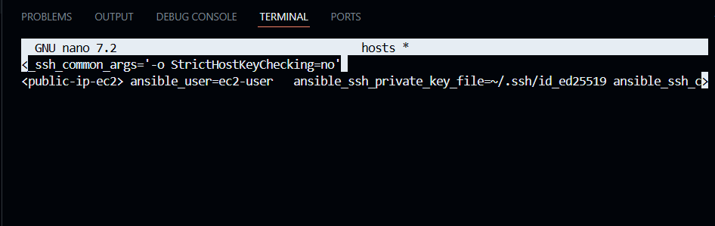
Ansible.cfg
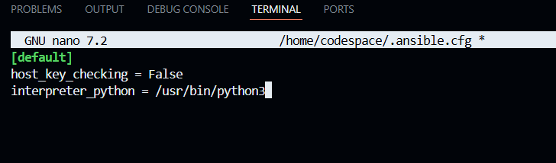
Playbook:
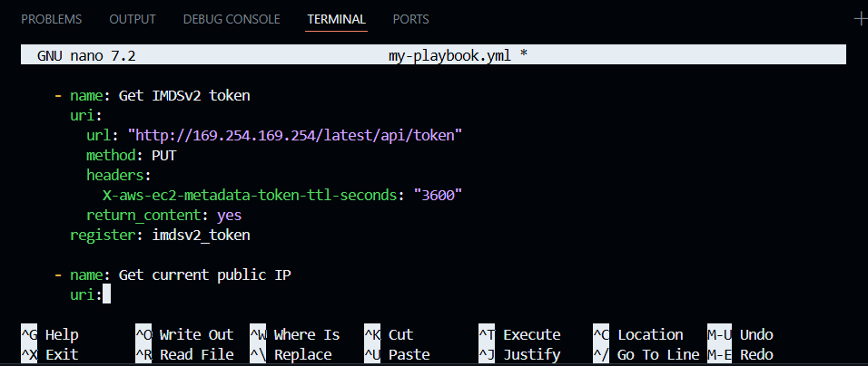
Ping:
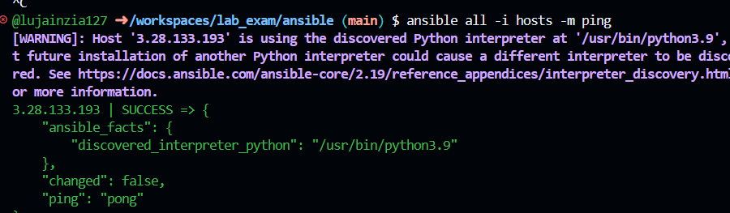
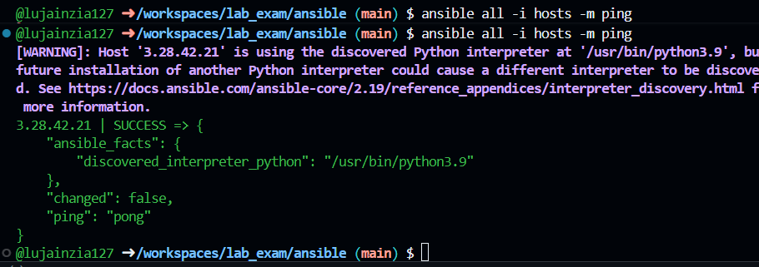
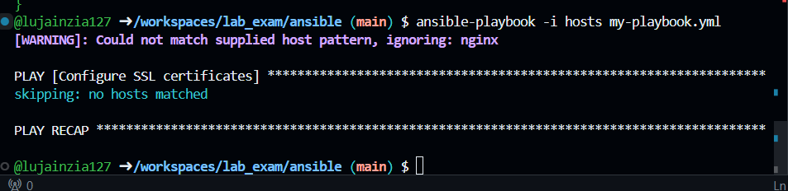

Cleanup:
