


NutriLift
A Fitness and Nutrition Tracking Mobile Application with Community and Gamification Features

Academic Year | Module | Task | Assessment Type
2026 | Project and Professionalism | 1 | Individual Report – Literature Review

Full Name: Luja Ratna Manandhar
Student Number: 2407087
Course: BSc. (Hons) Computer Science
University Email: L.R.Manandhar@wlv.ac.uk
Supervisor: Johan Tandukar
Reader: Yogesh Bikram Shah
Date of Submission: November 27, 2025
Abstract
The rapid growth of mobile health (mHealth) technologies has revolutionized fitness and nutrition management, offering convenient access to personalized health data. Despite this progress, most applications experience low long-term engagement due to poor usability, manual data entry, and lack of motivation. This literature review examines the integration of artificial intelligence (AI), image-based food recognition, gamification, and community support in next-generation mHealth applications to enhance user engagement and clinical outcomes. Recent studies (2021–2024) reveal that AI-driven personalization improves adherence and health outcomes, image-based logging simplifies dietary tracking, gamified designs sustain motivation, and community features foster accountability. Together, these components form a holistic framework for promoting healthy lifestyles. The proposed app, NutriLift, builds upon this evidence to provide a free, beginner-friendly solution that combines intelligent feedback, social connection, and motivational elements for sustainable behavior change.
Keywords: mHealth, Artificial Intelligence, Gamification, Nutrition Tracking, Community Support, Fitness App

Table of Contents
1. Introduction 1
1.1. General Introduction: 1
1.2. Aims and Objectives: 2
2. Literature Review 3
2.1. Research Papers: 3
2.2. Similar Projects: 14
2.3. Summary of Literature Review: 18
References 20

Table of Figures:
Figure 1: MyFitnessPal 14
Figure 2: Yazio 16
Figure 3: Lifesum 18
Figure 4: fitbit 20
Figure 5: PUMATRAC 22

Introduction

General Introduction:
The human gut microbiota plays a pivotal role in determining how individuals metabolize food, respond to dietary interventions, and maintain overall health. Recent advances in precision nutrition highlight that one-size-fits-all dietary guidelines often fail due to biological individuality particularly differences in microbial composition (Abeltino, et al., 2024). This has led to the emergence of personalized nutrition as a key strategy for improving long-term health outcomes.
Digital health technologies have become essential tools in translating complex biological data into actionable insights. Mobile applications now integrate artificial intelligence (AI), image recognition, behavioral science, and social support mechanisms to promote healthier eating behaviors and physical activity. However, despite growing interest, many existing apps suffer from low user engagement, lack of personalization, and fragmented functionality across diet, fitness, and emotional well-being domains.
This project, NutriLift, aims to bridge these gaps by combining evidence-based methodologies with user-centered design principles. Drawing on recent research in AI-driven nutrition, gamification, and community-based behavior change, NutriLift is designed to deliver an adaptive, motivating, and holistic digital wellness experience.
Key concepts underpinning this work include:
- Personalized nutrition using AI and behavioral analytics
- Image-based food logging via convolutional neural networks
- Gamified motivation and habit formation
- Community-driven accountability and emotional support
- Integration of dietary and physical activity tracking for cardiometabolic health improvement.

Aims and Objectives:

Aim:
To design and develop a mobile application “NutriLift” that supports sustainable healthy lifestyle changes through intelligent personalization, effortless food logging, motivational engagement, and peer-supported behavior change.

Objectives:
- To incorporate AI-powered image recognition for simplified meal tracking.
- To implement adaptive feedback systems that evolve based on user behavior and progress.
- To integrate non-competitive gamification elements that enhance motivation and adherence.
- To foster a supportive digital community where users can share experiences and encourage each other.
- To unify nutrition and physical activity tracking within a single platform to improve cardiometabolic health outcomes.
- To ensure accessibility and inclusivity by minimizing reliance on medical testing or premium subscriptions.

Literature Review

Research Papers:

- Unraveling the Gut Microbiota: Implications for Precision Nutrition and Personalized Medicine (Abeltino, et al., 2024)
This paper explores how variations in gut microbiota influence individual responses to food, advocating for precision nutrition strategies tailored to personal biology. It emphasizes the potential of AI to interpret biological data and generate customized dietary recommendations. The authors demonstrate that people metabolize identical meals differently based on their unique microbial profiles, which explains why standardized dietary advice frequently fails across populations. They also highlight how machine learning models can analyze large-scale biological datasets including genomics, metabolomics, and microbiome sequencing to produce highly individualized guidance.
A major strength of this study is its strong scientific foundation linking microbiome diversity to metabolic outcomes, providing robust justification for moving beyond generic nutrition guidelines. It presents compelling evidence that future health tools must adapt to biological uniqueness rather than applying universal rules. However, the approach relies heavily on clinical biomarkers such as stool samples and blood tests, making it inaccessible to most consumers without specialized healthcare access or expensive testing kits. Additionally, the implementation remains largely confined to research settings, limiting real-world scalability.
NutriLift builds upon the core principle of personalization but shifts focus from medical diagnostics to behavioral adaptation. While it does not use lab-based microbiome analysis, it applies the same logic of tailoring recommendations by learning from user choices, preferences, and progress over time. By analyzing patterns in food logging, goal achievement, and consistency, the app delivers guidance that feels personally relevant offering a scalable, consumer-friendly alternative to biologically intensive personalization methods.

- Effects of a Personalized Nutrition Programme on Cardiometabolic Health: A Randomized Controlled Trial (Bermingham, et al., 2024)
Bermingham and colleagues conducted a rigorous randomized controlled trial comparing AI-generated personalized meal plans against standard government dietary guidelines. Participants who followed machine learning–driven nutrition programs showed significant improvements in weight, waist circumference, triglyceride levels, and blood glucose after just 18 weeks. Unlike theoretical models, this study used real participants and measured actual health outcomes, offering strong empirical validation that tailored dietary interventions are more effective than generic advice.
One of the key strengths of this research is its methodological rigor and measurable impact on cardiometabolic markers. It proves that even small, consistent changes in daily habits can lead to meaningful health benefits when guidance is contextually relevant. The integration of AI allowed for dynamic adjustments based on participant feedback and biomarker trends, enhancing adherence and effectiveness. However, the program required extensive biological data inputs including genetic profiles, insulin sensitivity, and gut microbiome composition which limits its feasibility for widespread public use. Furthermore, the trial duration was relatively short (18 weeks), leaving questions about long-term sustainability unanswered.
For NutriLift, this study reinforces the value of adaptive systems grounded in real-world results. Instead of relying on invasive testing, the app achieves personalization through continuous behavioral monitoring tracking what users eat, how often they log meals, and how they respond emotionally and physically to different foods. This enables the system to evolve with the user, ensuring that recommendations remain practical, achievable, and aligned with lifestyle realities, thus bridging the gap between clinical efficacy and everyday usability.

- Digital Innovations for Diet Monitoring and Precision Nutrition: A Review (Mortazavi & Gutierrez-Osuna, 2023)
Mortazavi et al. provide a comprehensive overview of emerging technologies transforming dietary assessment and nutritional science. They emphasize that integrating multiple data streams such as food logs, physical activity, sleep quality, wearable sensor outputs, and mood tracking allows AI models to generate far more accurate and context-aware feedback than any single input alone. Knowing what someone ate is useful, but understanding when, how active they were afterward, and how they felt adds depth to nutritional interpretation.
A major contribution of this review is its synthesis of multi-modal sensing and data fusion techniques, highlighting how modern platforms can move beyond isolated metrics toward holistic health monitoring. The paper identifies trends in real-time tracking, predictive modeling, and closed-loop feedback systems that adjust recommendations dynamically. It also underscores the importance of continuous learning, where algorithms improve over time by recognizing behavioral patterns. However, most cited innovations remain experimental or restricted to academic prototypes, with few translated into accessible consumer products. There is also limited discussion around privacy concerns, algorithmic bias, or equitable access.
NutriLift adopts the holistic framework recommended here by unifying nutrition, activity, and emotional well-being into a single platform. Its adaptive engine uses consistent input to refine suggestions, ensuring relevance and responsiveness. Features like post-meal energy ratings and workout performance correlations allow users to see how food impacts their body beyond calories, promoting mindful decision-making. By focusing on usability and inclusivity, NutriLift translates advanced digital innovations into practical tools for everyday users.
- Applying Image-Based Food-Recognition Systems for Dietary Assessment: A Systematic Review (Dalakleidi , et al., 2022)
Dalakleidi and her team conducted a systematic review of nearly 60 studies on image-based food recognition systems (IBFRS), which use convolutional neural networks (CNNs) to identify meals from photographs. Their findings show that modern AI models can recognize common dishes with up to 96% accuracy under optimal conditions, demonstrating that photo-based logging is both technically viable and highly effective.
The primary strength of this research lies in its broad scope and technical validation of visual food recognition technology. It confirms that replacing manual entry with image capture significantly reduces user burden, increases compliance, and improves data accuracy in dietary tracking. Users report higher satisfaction and lower dropout rates when they can simply take a picture instead of searching databases or estimating portion sizes. However, the accuracy drops considerably with mixed dishes, poor lighting, unusual cuisines, or overlapping foods. Fully automated systems may misclassify items, leading to incorrect nutrient estimations. Moreover, many current implementations lack user verification steps, risking erroneous data entry.
Inspired by these findings, NutriLift implements image recognition as a core feature while incorporating a hybrid model: the AI suggests a food entry based on the uploaded photo, and the user reviews and edits it if necessary. This balance between automation and control ensures ease-of-use without sacrificing reliability. By reducing friction in logging, NutriLift encourages more consistent tracking, enabling better insights and sustained engagement over time.

- An Image-Recognition Dietary Assessment App (E4W): Usability and Feasibility for Adolescents with Obesity (Oei, et al., 2024)
Oei et al. tested an app called E4W that allows teenagers with obesity to photograph their meals instead of manually logging them. The focus was on real-world usability, particularly among a demographic known for low engagement with traditional diet apps. Results showed high acceptability, with participants describing the method as less stressful and more convenient than calorie counting. Many appreciated being able to eat normally without feeling judged by numbers, and clinicians reported gaining honest insights into real eating behaviors.
This study’s main contribution is its emphasis on psychological comfort and reduced anxiety associated with visual tracking. It demonstrates that lowering cognitive load and avoiding obsessive numerical displays increases honesty and participation, especially in vulnerable groups. The app improved adherence because it fit naturally into daily routines. However, the sample size was small and limited to adolescents, so generalizability to broader age groups is uncertain. Additionally, there was no longitudinal follow-up to assess whether usage translated into long-term health improvements.
NutriLift draws directly from E4W’s success by prioritizing simplicity and emotional safety. Rather than displaying calories prominently or enforcing strict rules, the app promotes mindful eating through intuitive photo logging and positive reinforcement. This makes it suitable not only for teens but also for adults who feel overwhelmed or discouraged by conventional fitness tools. By designing for comfort rather than perfection, NutriLift fosters sustainable behavior change rooted in self-awareness rather than restriction.

- Effect of Digital Health Applications with or without Gamification on Physical Activity and Cardiometabolic Risk Factors: A Systematic Review and Meta-Analysis (Nishi , et al., 2024)
Nishi et al. synthesized data from over 30 clinical trials involving more than 10,000 participants to evaluate the impact of gamified health apps on physical activity and heart-related health markers. Their meta-analysis revealed that users of gamified apps walked approximately 500 more steps per day on average and experienced modest but consistent improvements in body weight, BMI, and fat percentage. These benefits were observed across genders and age groups, indicating broad applicability.
The key strength of this research is its large-scale, evidence-based confirmation that gamification enhances motivation and adherence. Small rewards such as earning badges, completing streaks, or unlocking achievements can transform routine actions into lasting habits. Even minimal incentives, like a simple celebration animation, help sustain engagement beyond the initial excitement phase. However, the study notes that long-term retention (>6 months) remains a challenge, and some forms of gamification (e.g., leaderboards) may demotivate certain users, particularly those who dislike competition.
NutriLift incorporates gamification strategically, focusing on intrinsic motivators such as personal milestones, habit streaks, and goal completion. Daily challenges, achievement badges, and progress visualizations serve as behavioral nudges that keep users engaged without inducing pressure. By avoiding public rankings and emphasizing self-improvement, the app creates an inclusive environment conducive to lasting motivation for all users, regardless of background or fitness level.

- Gamification Preferences in Nutrition Apps: Toward Healthier Diets and Food Choices (Berger & Jung, 2024)
Berger and colleagues investigated user preferences in gamification by surveying thousands of nutrition app users. Rather than assuming what motivates people, they collected direct feedback on which features users found most engaging. Findings showed that goal-oriented tasks, milestone celebrations, and personal progress tracking were widely preferred. In contrast, competitive features like leaderboards or public rankings were less popular especially among women and older adults who often felt pressured or demotivated by comparison.
This research provides valuable user-centered insights into effective motivational design. It reveals that motivation works best when focused on internal growth rather than external competition. People are more likely to stay committed when they feel capable of achieving personal wins at their own pace. However, the study relied on self-reported preferences rather than observed behavior, and did not test combinations of multiple gamification mechanics in practice.
NutriLift applies these findings by centering its reward system on non-competitive, self-focused achievements such as maintaining a seven-day streak, trying five new vegetables, or finishing a hydration challenge. There are no public leaderboards or comparative metrics. Instead, the app celebrates effort and consistency, reinforcing resilience over perfection. This inclusive approach ensures that all users feel supported and empowered, fostering a positive relationship with health and wellness.

- Healthy Adults’ Experiences of Behaviour-Change Apps: The Role of Social Support and Community Features (Abdul Khalil, 2023)
Through interviews with adult users of wellness apps, Abdul Khalil et al. uncovered a recurring theme: people do not want to pursue health goals alone. Many described app communities as “virtual gyms,” where mutual encouragement, shared struggles, and collective celebration helped them stay committed during tough times. Some admitted they stayed consistent simply because they didn’t want to let down others in their group, while others said seeing someone else’s small win gave them the push to stick to their plan that day.
This qualitative study highlights the emotional dimension of behavior change, showing that connection, accountability, and belonging are powerful drivers of long-term adherence. Technical tracking is important, but staying committed is deeply human. However, the study involved a relatively small and homogenous group of healthy adults, limiting generalizability. It also lacked quantitative correlation between community use and measurable health outcomes.
NutriLift integrates optional community spaces where users can share updates, cheer each other on, and join friendly group challenges. These interactions build momentum and reduce the loneliness often associated with health journeys. Because real change isn’t just about data—it’s about feeling seen, heard, and supported the app fosters a sense of belonging that complements its functional features.

- The Use of Internet-Based Smartphone Apps to Improve Healthy Eating Behaviours: A Systematic Review ( Seid, et al., 2024)
Seid et al. reviewed dozens of smartphone apps aimed at promoting healthier eating, with a specific focus on those incorporating social features like messaging, forums, or accountability partners. Their conclusion was clear: apps that facilitate peer interaction lead to better eating habits and significantly lower dropout rates. Users who had someone to report to or even just observe others’ progress—were more likely to continue logging meals, avoid junk food, and meet their targets.
The presence of a digital support network transformed passive tracking into active participation. Observing others’ successes created vicarious motivation, while sharing personal wins reinforced commitment. However, the study also noted that poorly moderated communities could backfire—leading to toxic comparisons, misinformation, or discouragement if not carefully managed.
NutriLift addresses this by including guided prompts and basic moderation tools to maintain a constructive atmosphere. Group challenges like “Meatless Monday” or “Hydration Week” encourage participation without pressure. Comment threads and reaction buttons enable positive interaction, while content filters and reporting mechanisms help preserve a safe space. By fostering connection responsibly, NutriLift turns isolation into solidarity.

- Influence of Physical Activity and Diet Mobile Apps on Cardiometabolic Risk Factors: A Systematic Review (Bushey, et al., 2024)
Bushey et al. reviewed mobile apps that combine diet and exercise tracking to assess their impact on heart health. The results showed consistent, measurable benefits: regular users experienced modest reductions in body weight, BMI, and blood pressure. Notably, apps that integrated both domains performed better than those focusing on only one area, suggesting that a unified approach leads to stronger outcomes.
When users can see how their food choices affect energy levels, workouts, and recovery, they’re more likely to make connected, sustainable decisions. The study emphasized that consistency matters more than intensity small, daily efforts add up over time. However, many reviewed apps suffered from poor interface design, fragmentation, or lack of adaptive intelligence, causing disengagement.
NutriLift validates this integrative philosophy by unifying nutrition and fitness tracking in a clean, intuitive dashboard. It shows users how meals influence performance, mood, and recovery, enabling informed choices. By preventing fragmentation and supporting gradual progress, the app helps users build resilient, lifelong habits rather than short-term fixes.

- Usage Profiles and Outcomes of a Mobile App Nutrition Intervention: Results from the MySnapp Trial (Buss, et al., 2024)
Buss et al. analyzed usage patterns from a 12-week mobile nutrition intervention and found that users who logged consistently not perfectly, but regularly achieved moderate weight loss and increased vegetable intake. Those who dropped off early saw little benefit, highlighting that engagement is directly linked to results.
This study underscores that sustainability beats perfection. An app doesn’t need to deliver instant miracles; it needs to help users show up again and again. Features like reminders, gentle nudges, and motivational feedback play a vital role in maintaining momentum. However, the study did not explore which specific app features drove retention, leaving room for further investigation.
NutriLift designs for long-term use from day one. Smart triggers like celebrating a third consecutive healthy lunch or reminding users of their last achievement help re-engage them after missed days. Adaptive notifications, milestone recognition, and effort-based feedback nurture resilience, helping users stay on track even during busy or unmotivated periods.

Similar Projects:

  - MyFitnessPal
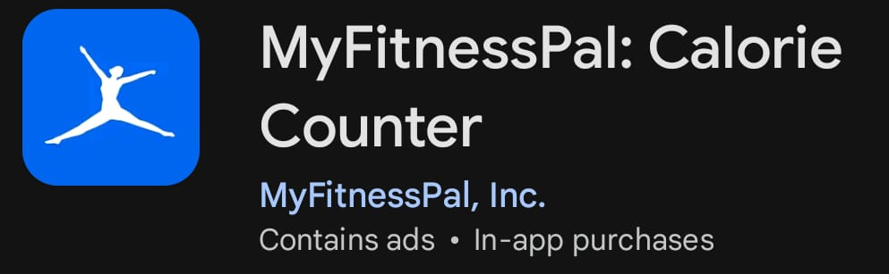
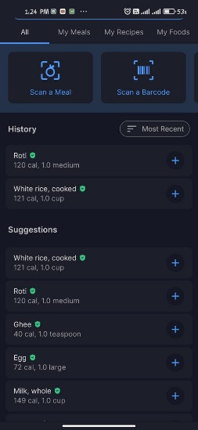 | 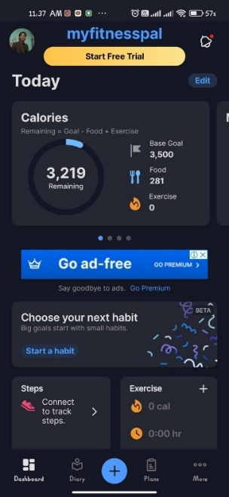

Figure 1: MyFitnessPal
- Main Features & Functionality:
  - Calorie and macronutrient tracking via manual entry or barcode scanning.
  - Large food database and wearable integration.
  - Basic goal setting and progress charts.
- What It Lacks / Areas for Improvement:
  - High friction in logging — repetitive typing leads to fatigue.
  - No automatic workout detection — all activity must be manually logged or synced.
  - Minimal adaptive intelligence or motivational tools.
- How NutriLift Improves Upon It:
  - Replaces manual typing with AI-powered photo logging.
  - Adds motion-based workout detection using smartphone sensors to auto-log home exercises (e.g., squats, push-ups).
  - Delivers adaptive feedback and gamified streaks to sustain engagement.
- Conclusion:
While MyFitnessPal excels at data accuracy, NutriLift transforms tracking into an intelligent, responsive, and motivating experience.

  - Yazio
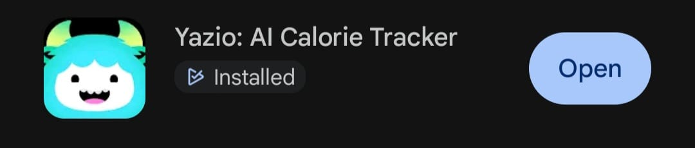
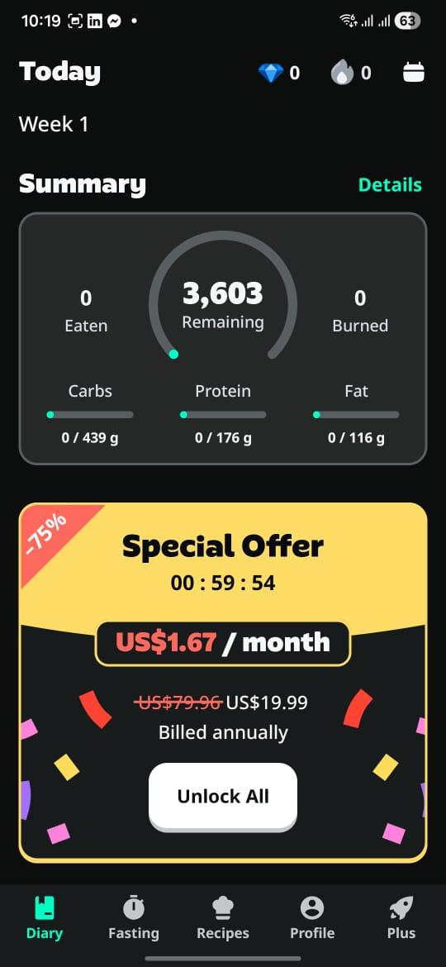 | 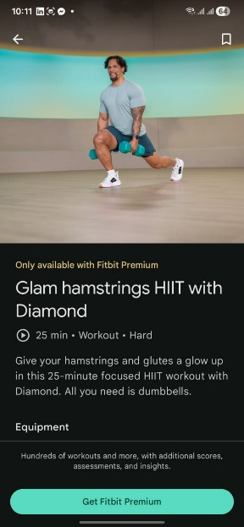
Figure 2: Yazio
- Main Features & Functionality:
  - Personalized meal plans, fasting timers, flexible dieting.
  - Visually appealing UI with macro tracking.
- What It Lacks / Areas for Improvement:
  - No fitness integration or motion sensing.
  - Premium features locked behind paywall.
  - No automatic workout logging.
- How NutriLift Improves Upon It:
  - Keeps core features free and adds passive workout tracking via motion detection.
  - Combines nutrition planning with real-time activity insights.
  - Evolves suggestions based on detected movement patterns and energy levels.
- Conclusion:
Yazio provides structure but lacks dynamism. NutriLift enhances it with automated fitness tracking and adaptive intelligence.

  - Lifesum

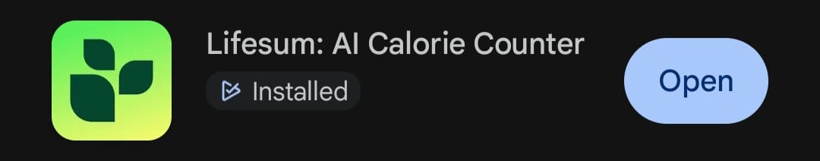
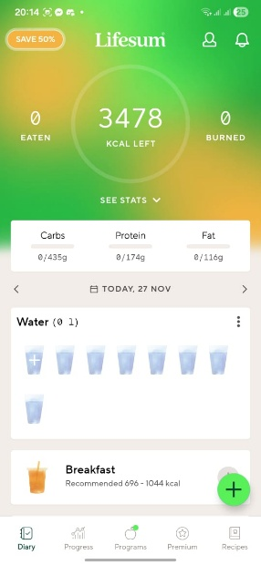 | 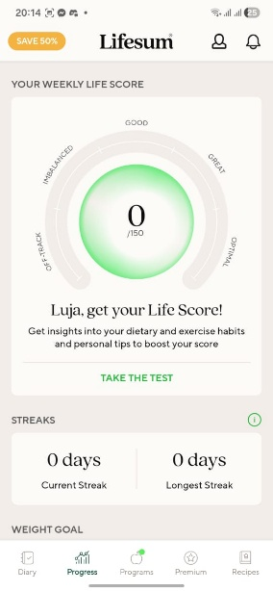
Figure 3: Lifesum
- Main Features & Functionality:
  - Habit tracking, mood-based recommendations, daily goals.
  - Clean interface with practical wellness tools.
- What It Lacks / Areas for Improvement:
  - No built-in motion detection for workouts.
  - Limited AI adaptation — suggestions don’t evolve with user behavior.
  - Weak community engagement.
- How NutriLift Improves Upon It:
  - Implements smartphone-based motion detection to recognize bodyweight exercises and walking.
  - Uses machine learning to personalize feedback based on detected activity and food intake.
  - Strengthens emotional support with peer-led challenges.
- Conclusion:
Lifesum encourages mindfulness but misses opportunities for automation. NutriLift makes tracking effortless and insightful.

  - Fitbit App
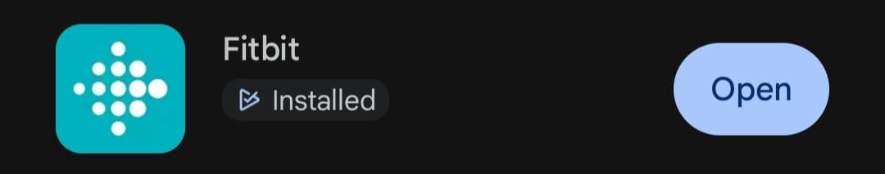
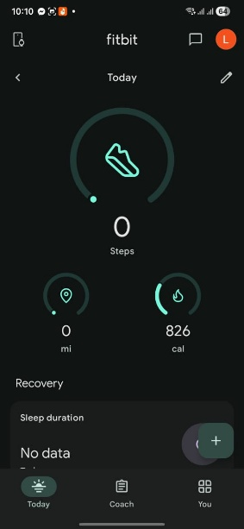 | 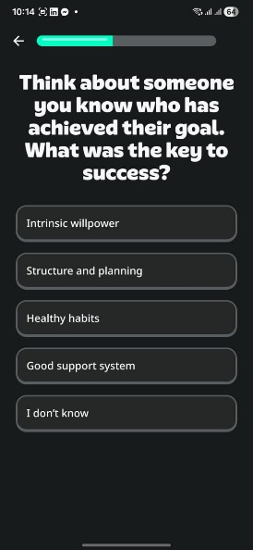
Figure 4: fitbit
- Main Features & Functionality:
  - Fitness tracking via connected devices (steps, heart rate, sleep).
  - Live stats and step counting.
- What It Lacks / Areas for Improvement:
  - Poor nutritional analysis — no image recognition or smart logging.
  - Requires hardware for accurate motion tracking — excludes phone-only users.
  - No native community or social accountability.
- How NutriLift Improves Upon It:
  - Enables hardware-free motion detection using built-in smartphone sensors ideal for home workouts.
  - Enhances nutrition tracking with photo-based logging and AI suggestions.
  - Adds community spaces for peer encouragement.
- Conclusion:
Fitbit relies on wearables; NutriLift empowers all users even without extra devices through intelligent software alone.

  - PUMATRAC Run, Train, Fitness:

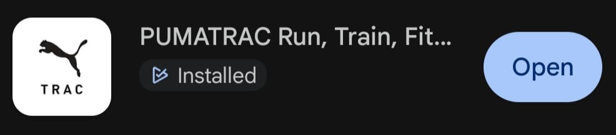
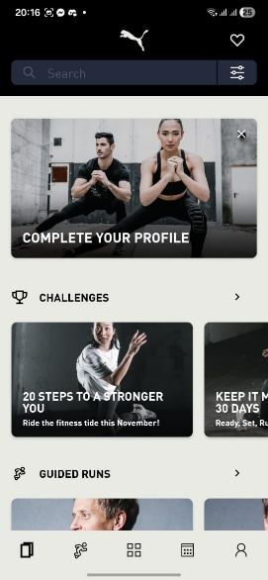 | 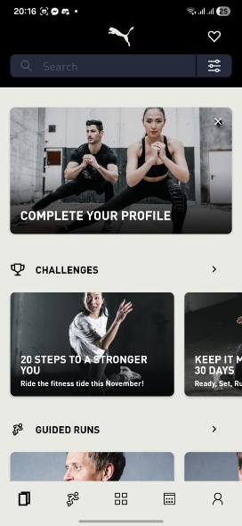
Figure 5: PUMATRAC
- Main Features & Functionality:
  - Free video-guided home workouts (HIIT, strength, yoga).
  - Customizable plans based on fitness goals.
- What It Lacks / Areas for Improvement:
  - No automatic tracking — users must manually start/stop sessions.
  - No integration with nutrition or recovery data.
  - No motion detection to passively log informal workouts.
- How NutriLift Improves Upon It:
  - Uses accelerometer and gyroscope data to detect reps and sets during unplanned workouts (e.g., quick home routine).
  - Links detected activity to nutritional needs — suggesting post-workout meals.
  - Automatically records effort even if the app isn’t open.
- Conclusion:
Nike Training Club delivers great content, but NutriLift goes further by recognizing spontaneous movement and connecting it to holistic health.

Summary of Literature Review:

The reviewed literature consistently demonstrates that effective digital health interventions must do more than collect data they must guide, engage, and support users through intelligent, human-centered design. Studies show that personalization increases relevance, automation reduces friction, gamification sustains motivation, and community fosters accountability. Technologies such as AI-powered food recognition, multi-modal data integration, and adaptive feedback systems are proving valuable in real-world applications.
However, critical gaps remain:
- Most apps rely on manual input, increasing burden and reducing engagement.
- Few offer true behavioral adaptation recommendations rarely evolve with the user.
- Gamification is often poorly implemented, causing burnout or comparison anxiety.
- Social features are either missing or inadequately moderated.
- Diet and fitness tracking are typically siloed, preventing integrated insights.
- Workout tracking usually requires wearables or manual initiation excluding passive or informal exercise.
NutriLift addresses these limitations by:
- Using AI-powered image recognition to simplify meal logging.
- Implementing smartphone motion detection to automatically track home workouts without wearables.
- Delivering adaptive feedback that evolves with user behavior.
- Incorporating inclusive, non-competitive gamification to sustain motivation.
- Building moderated community spaces for peer support.
- Unifying nutrition, fitness, mood, and energy into a single, cohesive dashboard.
By synthesizing cutting-edge research and addressing the shortcomings of current systems, NutriLift delivers a truly sustainable, empathetic, and innovative digital health experience—one that doesn’t just track life, but helps improve it.

References
Seid, A., Fufa, D. D. & Bitew, Z. W., 2024. The use of internet-based smartphone apps to improve healthy eating behaviours: A systematic review. Frontiers in Digital Health, Volume 6, p. 1282570.
Abdul Khalil, N. M., 2023. Healthy adults’ experiences of behaviour-change apps: The role of social support and community feature. PLOS ONE, 18(5), p. e0285679.
Abeltino, A. et al., 2024. Unraveling the gut microbiota: implications for precision nutrition and personalized medicine. Nutrients, 16(22), p. 3806.
Berger, M. & Jung, C., 2024. Gamification preferences in nutrition apps: Toward healthier diets and food choices. Frontiers in Public Health, Volume 12, p. 1367529.
Bermingham, K. M. et al., 2024. Effects of a personalized nutrition programme on cardiometabolic health: A randomized controlled trial. Nature Medicine, 30(2), p. 1888–1897.
Bushey, E., Wu, Y., Wright, A. & Pescatello, L., 2024. Influence of physical activity and diet mobile apps on cardiometabolic risk factors: A systematic review. Digital Health, Volume 10, pp. 1-10.
Buss, V. H. et al., 2024. Mobile App Intervention of a Randomized Controlled Trial for Patients With Obesity and Those Who Are Overweight in General Practice: User Engagement Analysis Quantitative Study. JMIR mHealth and uHealth, Volume 12, p. p. e32647.
Dalakleidi , K. . V., Papadelli , M., Kapolos , I. & Papadimitriou, K., 2022. Applying image-based food-recognition systems for dietary assessment: A systematic rev. Appetite, Volume 177, p. 106148.
Mortazavi, B. J. & Gutierrez-Osuna, . R., 2023. Digital innovations for diet monitoring and precision nutrition: A review. Nutrition Reviews, 17(1), p. e574–e591.
Nishi , S. K. et al., 2024. Effect of digital health applications with or without gamification on physical activity and cardiometabolic risk factors: a systematic review and meta-analysis. EClinicalMedicine, Volume 70, p. 102798.
Oei, K. et al., 2024. An image-recognition dietary assessment app (E4W): usability and feasibility for adolescents with obesity. JMIR Formative Research, Volume 8, p. e58682.

