June, 2020

**Team**

**Anna  
Latyr  
Lujane  
Prajakta  
Stephen**

# Internet Disparity

**User Guide**

**Contents**

Internet Disparity 0

1 Extract 2

1.1 Notebook 2

1.2 Path 2

1.3 Complementary files 2

2 Transform 3

2.1 Notebook 3

2.2 Path 3

2.3 Update the password & the database name 3

3 Load 4

3.1 PgAdmin (SQL) 4

4 Flask app 5

4.1 Python code 5

5 Api 5

5.1 Default url 5

5.2 Use a specific route 5

6 Json files 6

6.1 Jupyter Notebook & Create Json Files 6

7 Create the python server to render the html pages 7

7.1 Terminal & Server 7

7.2 Localhost 7

7.3 Go to the website 7

# Extract

## Notebook

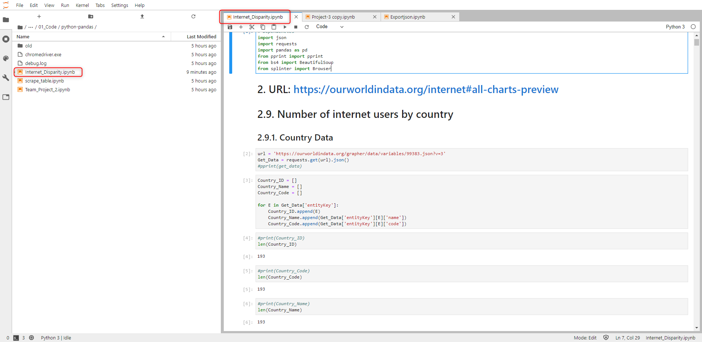

## Path

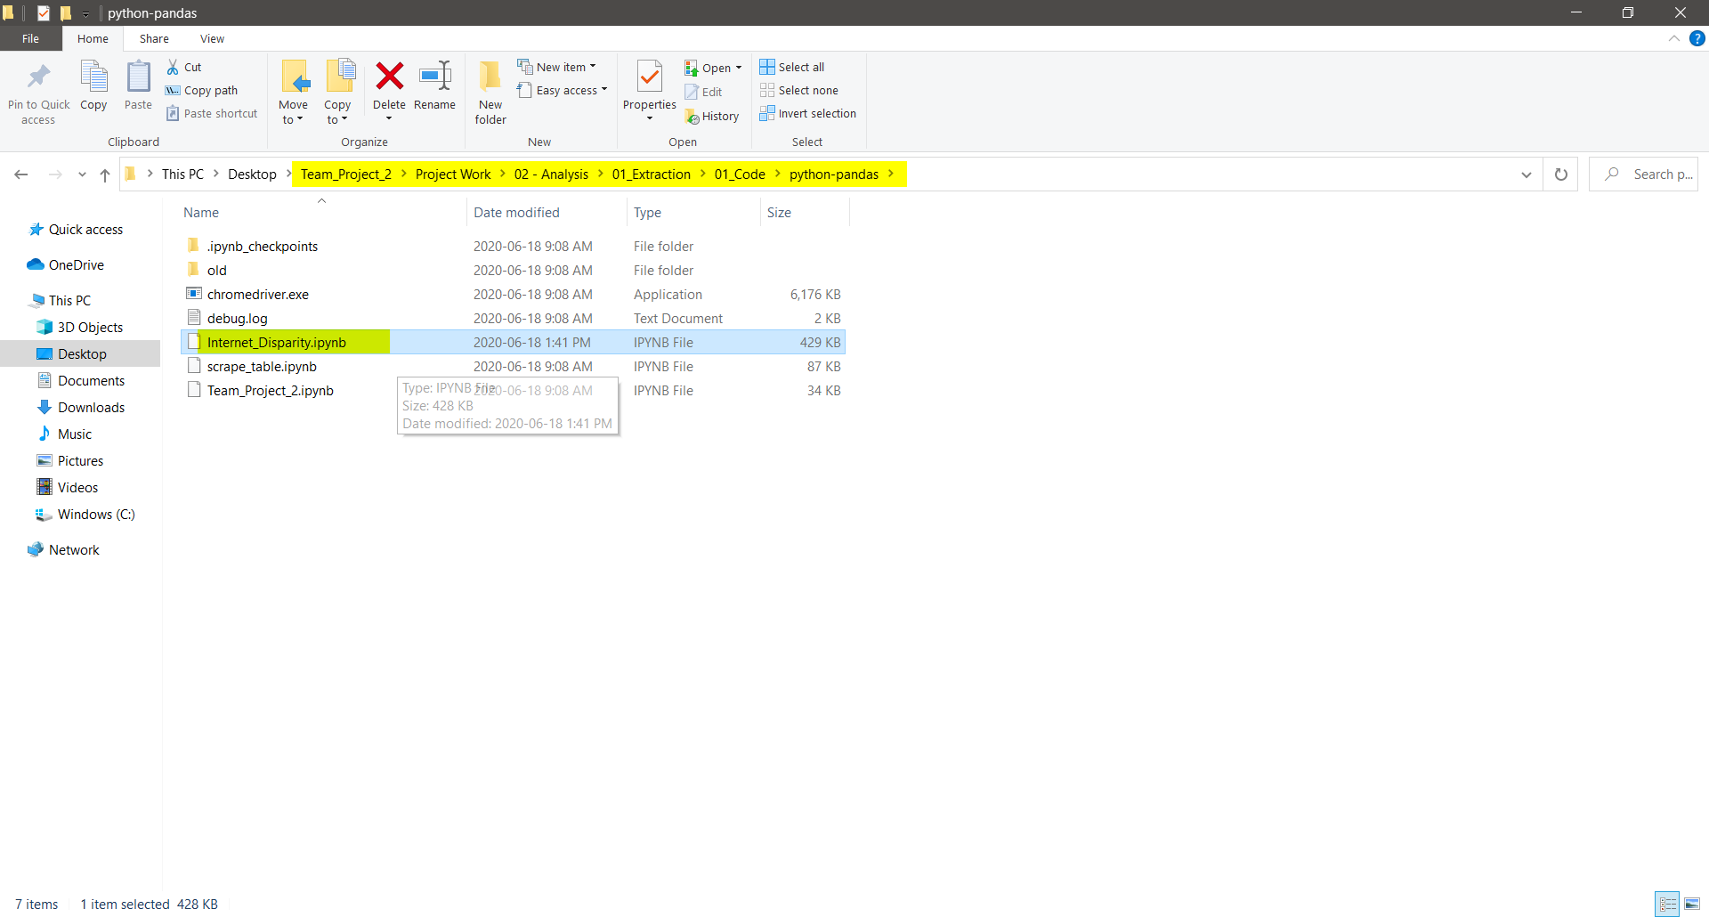

## Complementary files

All files are automatically downloaded using the python/pandas code. 2 files out of 16 are stored in the default download folder. Users will have to copy/paste those 2 files into folder below(‘02_Data_Output’).

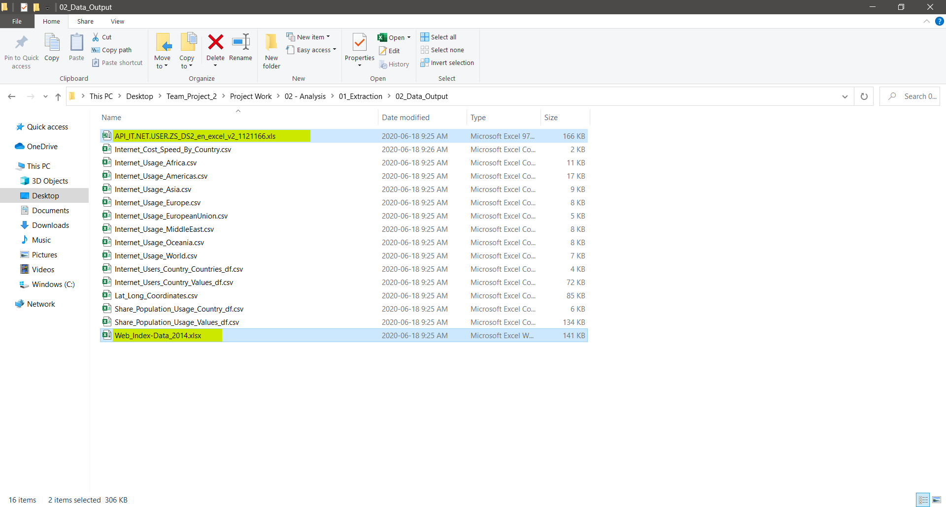

# Transform

## Notebook

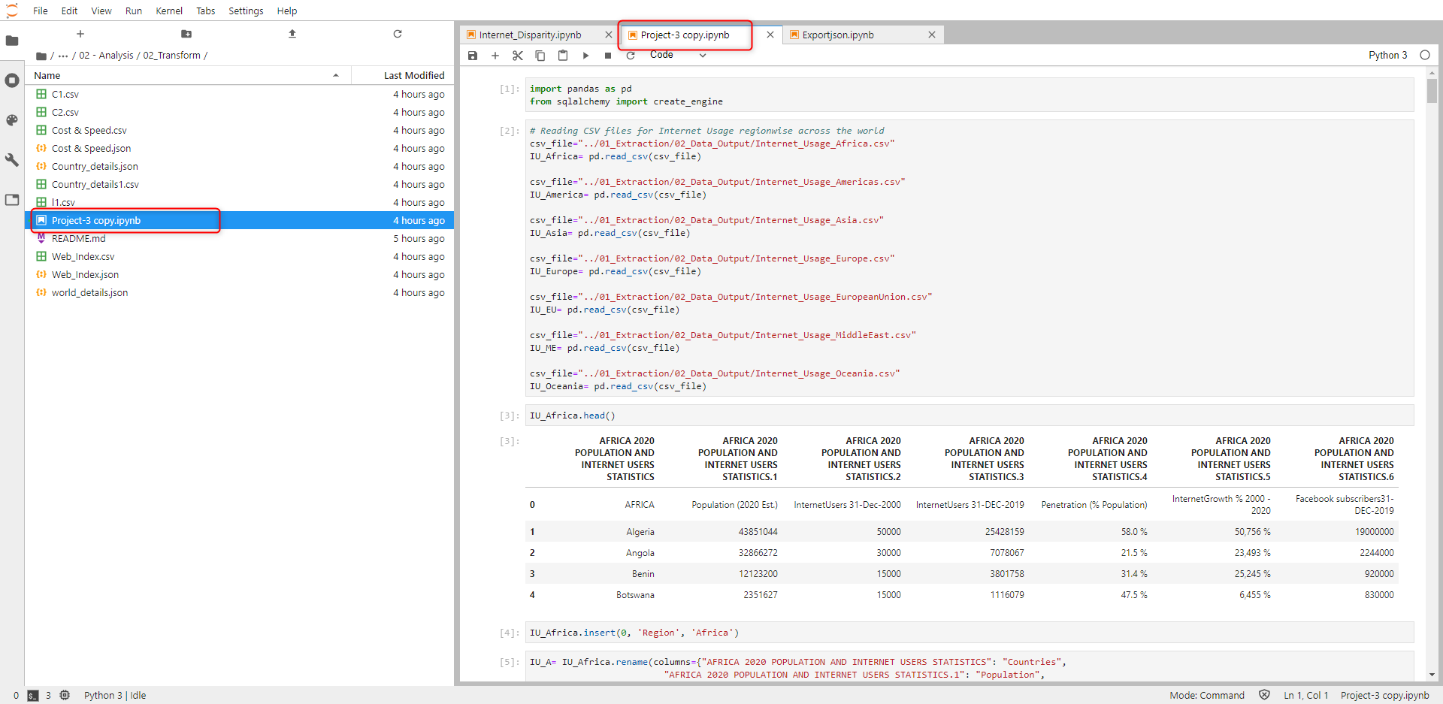

## Path

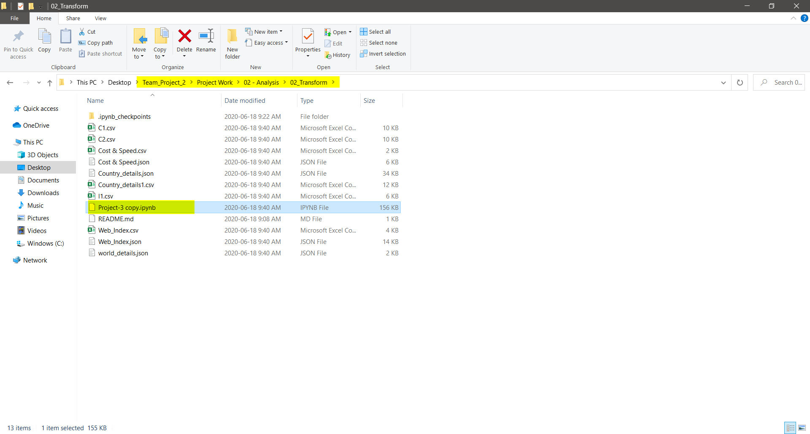

## Update the password & the database name

Use your personal password to connect to the database.

***Pre-requisite:***

*User must have created a database named ‘Internet_DB’, prior to connecting to running the code on this Jupyter Notebook*

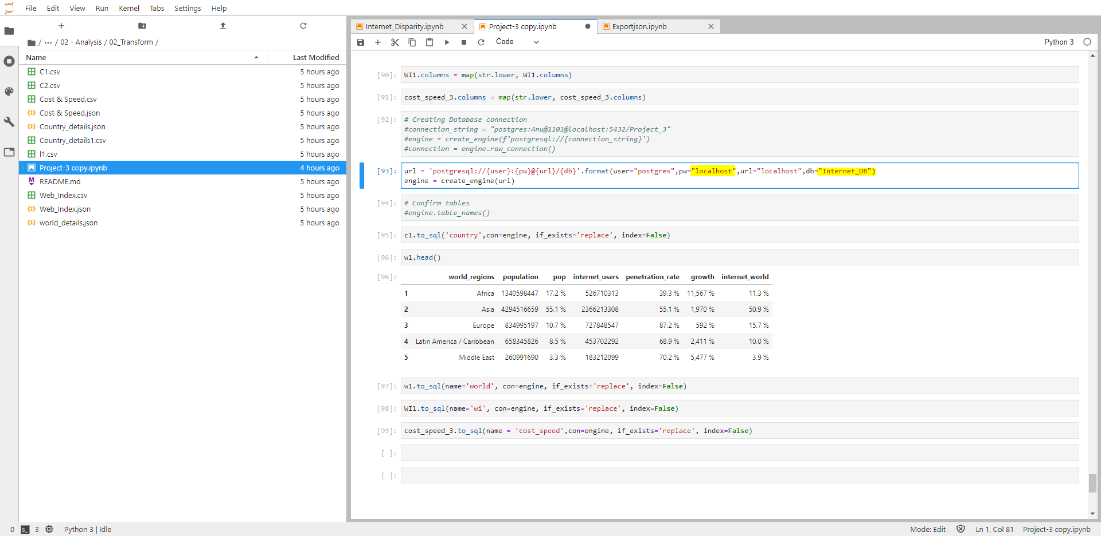

# Load

## PgAdmin (SQL)

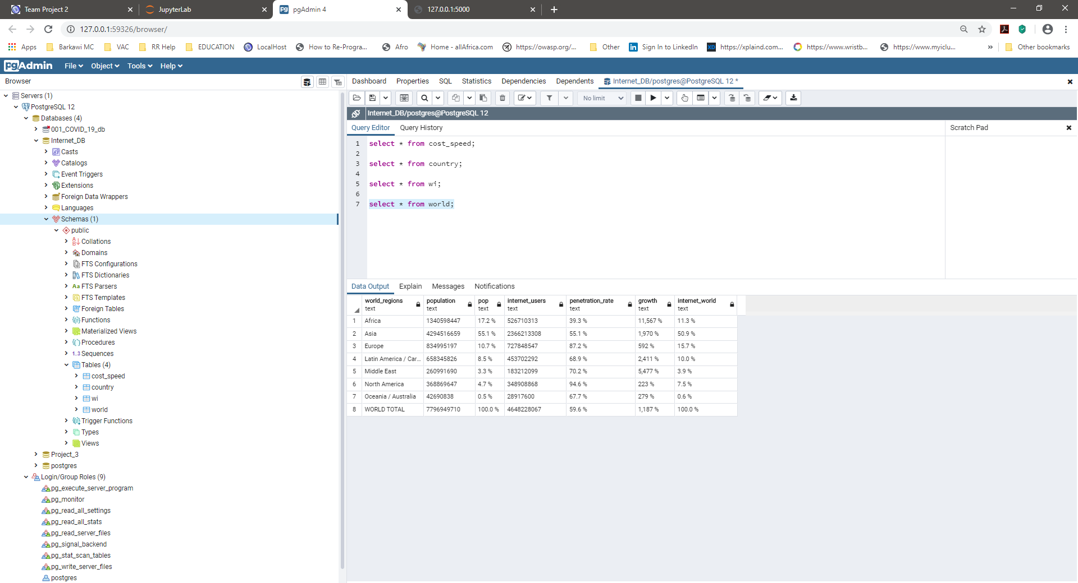

# Flask app

## Python code

Use your personal password to connect to the database.

***Pre-requisite:***

*User must have created a database named ‘Internet_DB’, prior to connecting to running the code on this Jupyter Notebook*

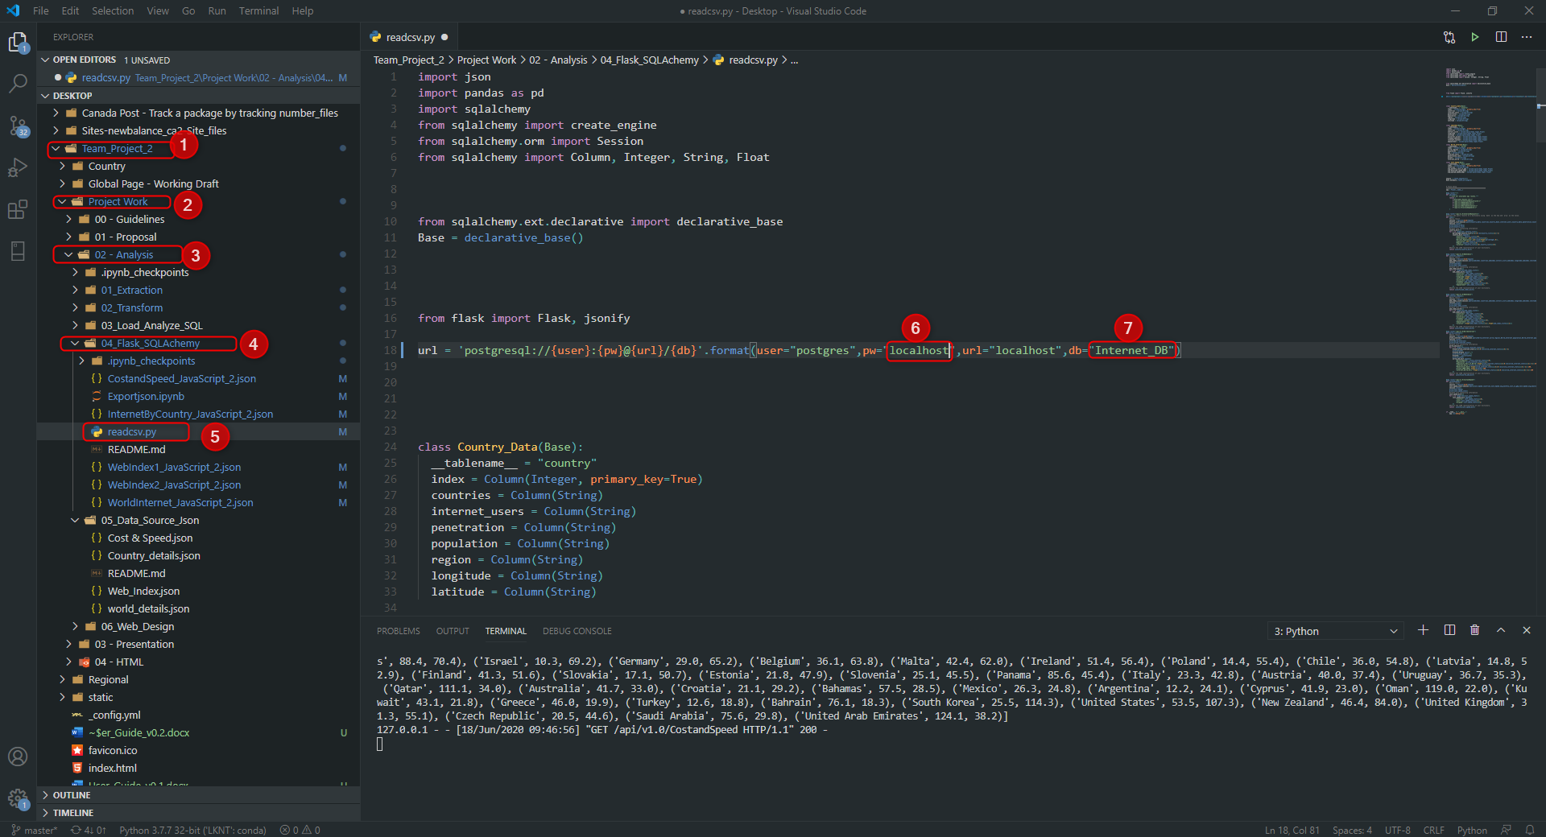

# Api

## Default url

url = <http://127.0.0.1:5000/>

Use the above url to see json data using your web browser

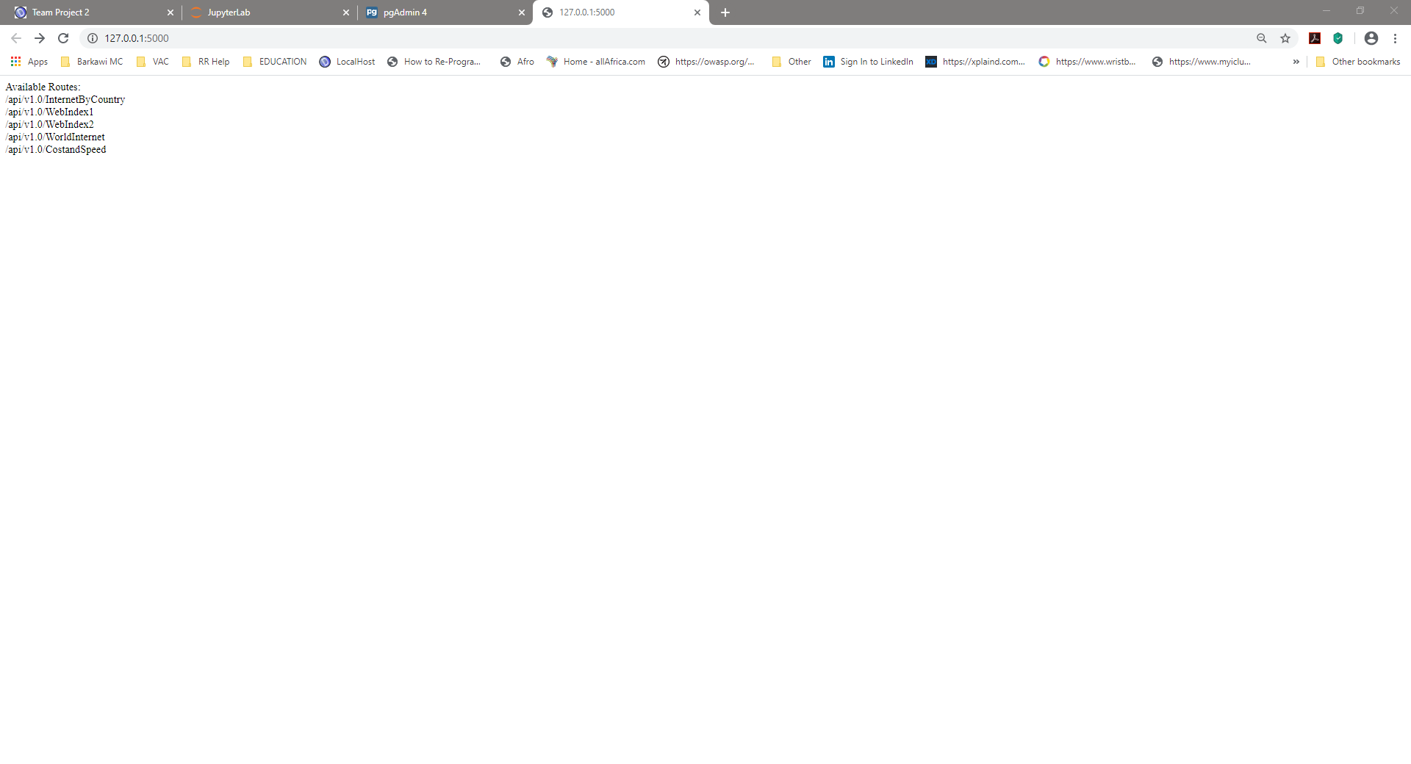

## Use a specific route

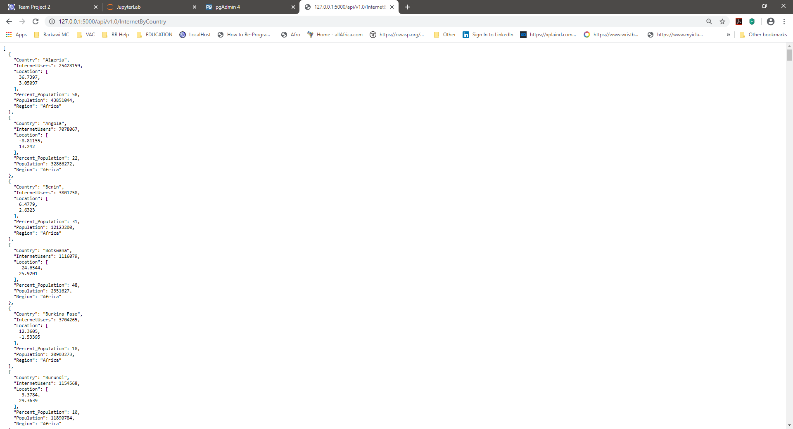

# Json files

## Jupyter Notebook & Create Json Files

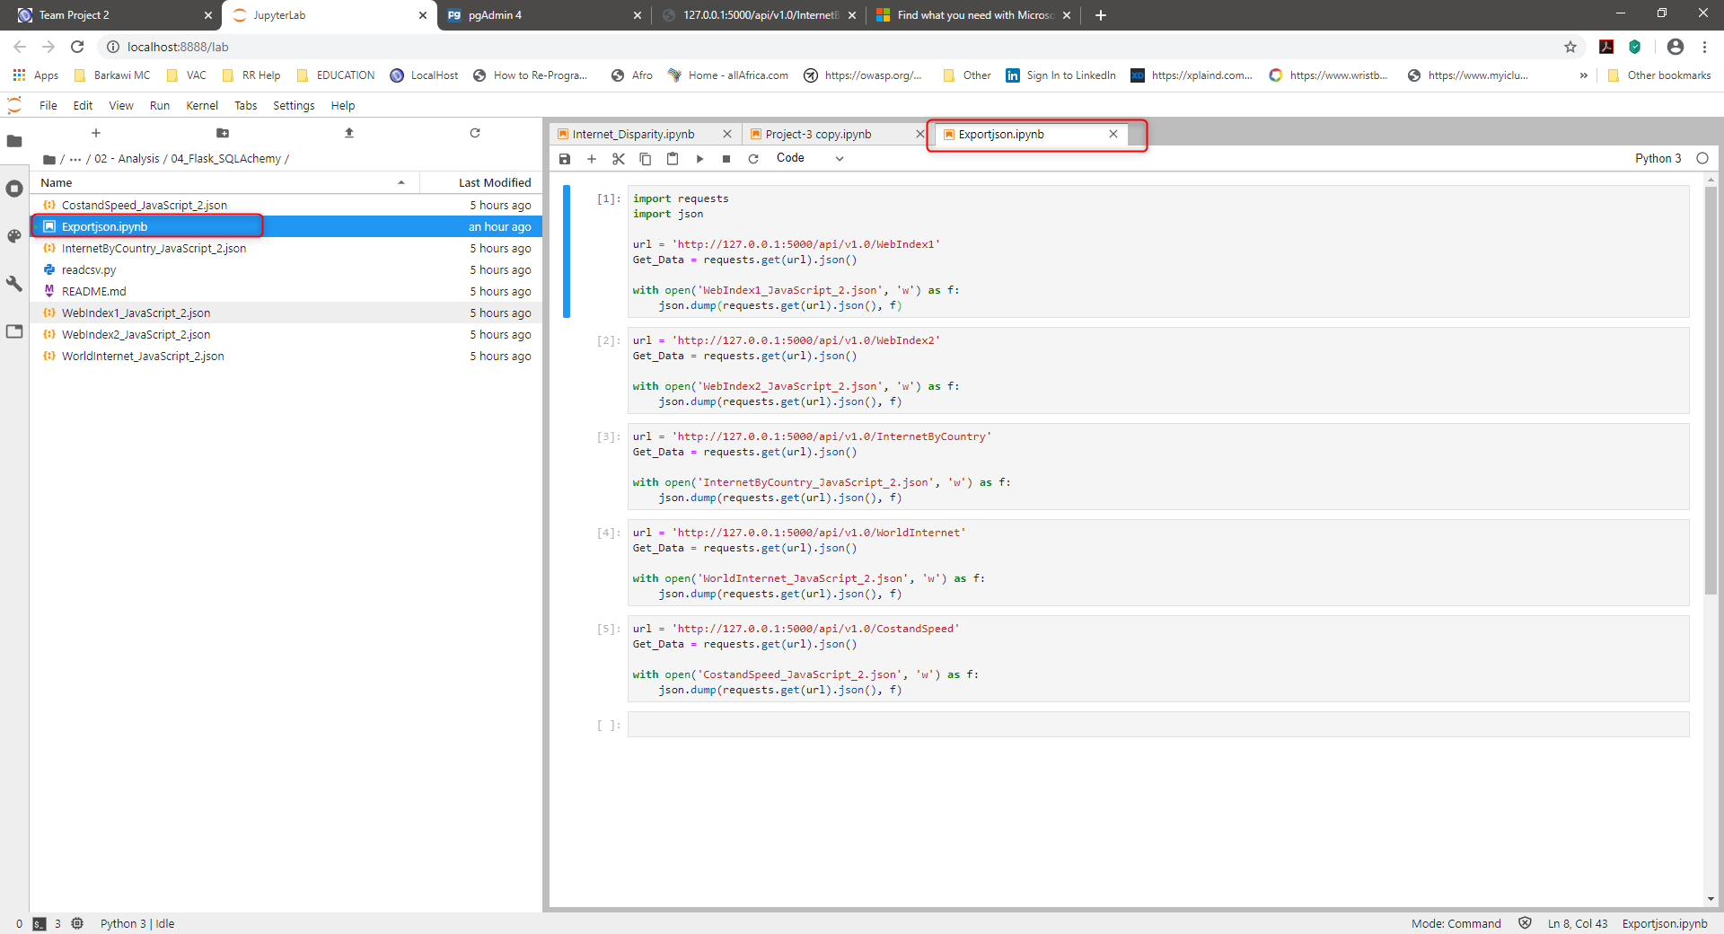

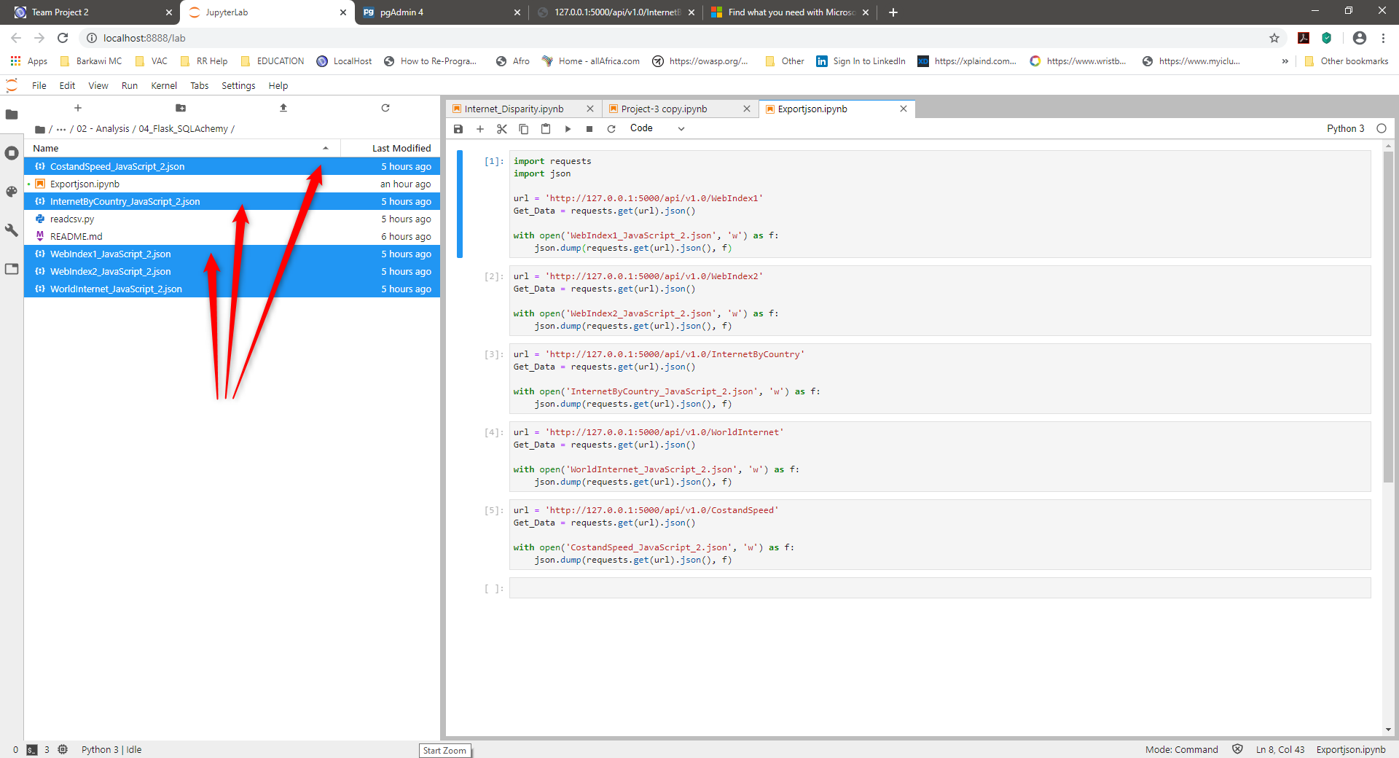

# Create the python server to render the html pages

## Terminal & Server

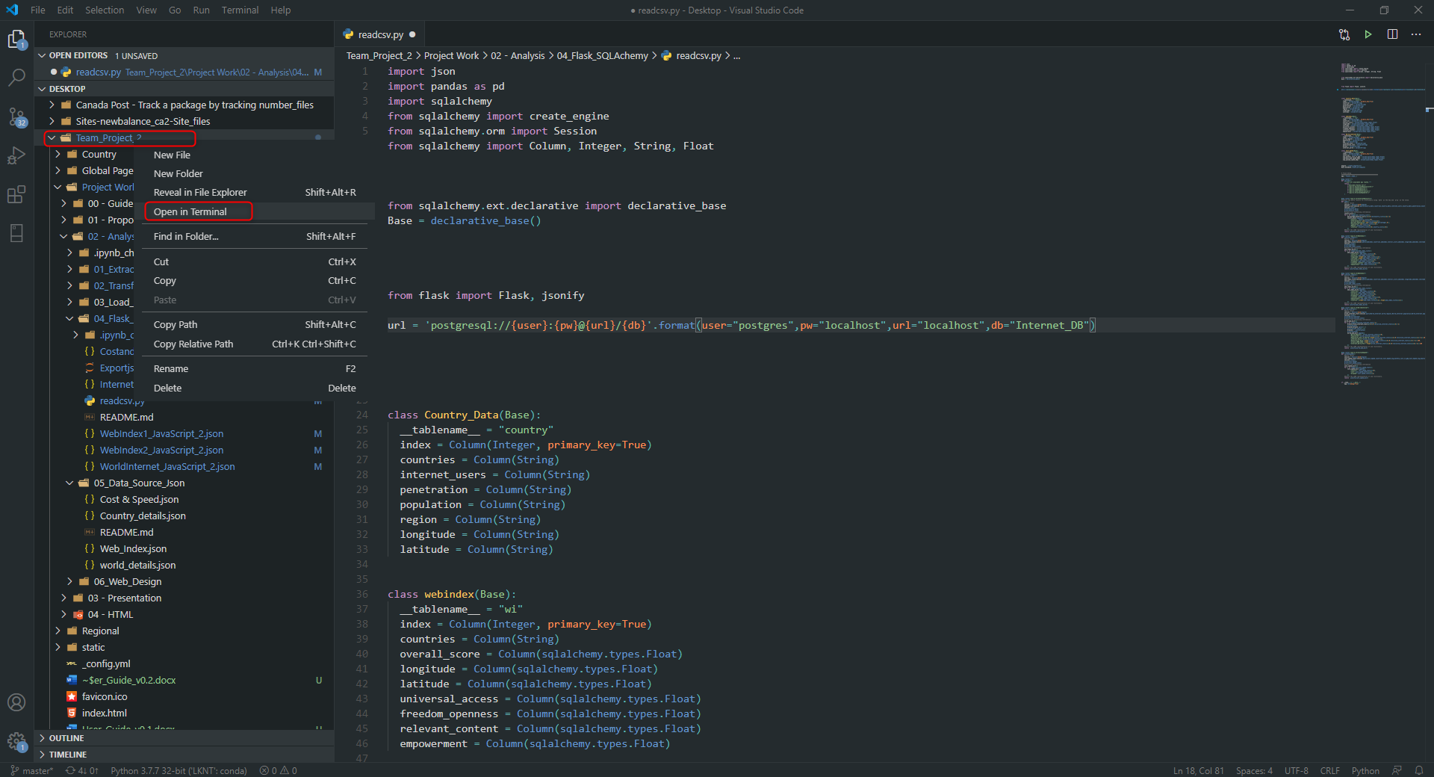

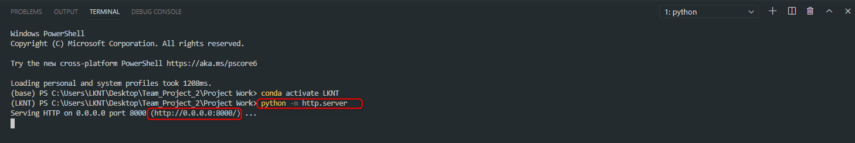

## Localhost

If the above server does not work, please use the following: <http://localhost:8000/>

## Go to the website

