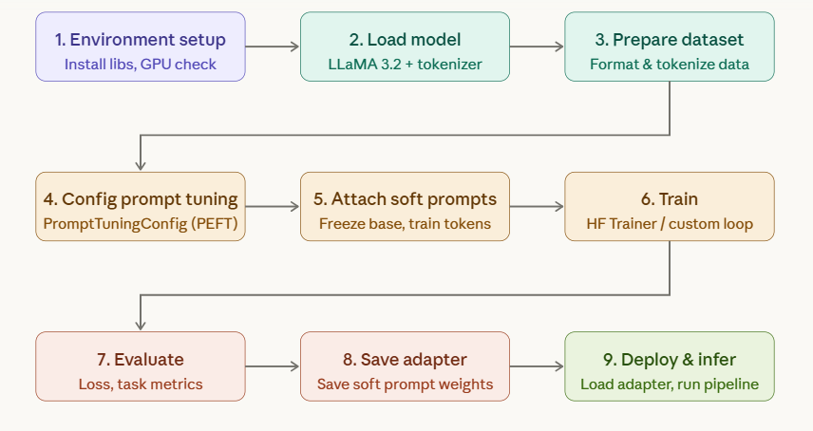

Step 1 — Environment setup
Install the required libraries. You need transformers, peft (for prompt tuning), datasets, and accelerate.
bash
pip install transformers peft datasets accelerate bitsandbytes
Verify GPU availability:
python
import torch
print(torch.cuda.is_available()) # True
print(torch.cuda.get_device_name(0)) # e.g., NVIDIA A100

Step 2 — Load LLaMA 3.2 and tokenizer
python
from transformers import AutoModelForCausalLM, AutoTokenizer

model_id = "meta-llama/Llama-3.2-3B" # or 1B, 11B, 90B

tokenizer = AutoTokenizer.from_pretrained(model_id)
tokenizer.pad_token = tokenizer.eos_token

model = AutoModelForCausalLM.from_pretrained(
model_id,
torch_dtype=torch.float16,
device_map="auto"
)
You need a HuggingFace account with access approved at meta-llama/Llama-3.2 gated repo. Run huggingface-cli login first.

Step 3 — Prepare your dataset
Format your data as input-output pairs and tokenize them:
python
from datasets import load_dataset

dataset = load_dataset("json", data_files={"train": "train.jsonl", "test": "test.jsonl"})

def tokenize(example):
prompt = f"Input: {example['input']}\nOutput: {example['output']}"
return tokenizer(prompt, truncation=True, max_length=512, padding="max_length")

tokenized = dataset.map(tokenize, batched=True)
tokenized.set_format("torch", columns=["input_ids", "attention_mask"])

Step 4 — Configure prompt tuning (PEFT)
This is the core step. You define a small set of learnable "soft prompt" tokens prepended to every input. The base model weights are completely frozen.
python
from peft import PromptTuningConfig, PromptTuningInit, TaskType, get_peft_model

peft_config = PromptTuningConfig(
task_type=TaskType.CAUSAL_LM,
prompt_tuning_init=PromptTuningInit.TEXT, # or RANDOM
prompt_tuning_init_text="Classify the sentiment:", # seed text
num_virtual_tokens=20, # number of soft tokens
tokenizer_name_or_path=model_id,
)

Step 5 — Attach soft prompts to the model
python
model = get_peft_model(model, peft_config)
model.print_trainable_parameters()
# Output: trainable params: ~20K | all params: ~3B | trainable%: ~0.0007%

Step 6 — Train
python
from transformers import TrainingArguments, Trainer

args = TrainingArguments(
output_dir="./llama32-prompt-tuned",
num_train_epochs=5,
per_device_train_batch_size=4,
learning_rate=3e-2, # higher LR works well for prompt tuning
warmup_steps=100,
fp16=True,
logging_steps=50,
save_strategy="epoch",
evaluation_strategy="epoch",
)

trainer = Trainer(
model=model,
args=args,
train_dataset=tokenized["train"],
eval_dataset=tokenized["test"],
)
trainer.train()

Step 7 — Evaluate
python
results = trainer.evaluate()
print(f"Eval loss: {results['eval_loss']:.4f}")
For task-specific metrics (BLEU, F1, accuracy), add a compute_metrics function to the Trainer.

Step 8 — Save the adapter
Only the soft prompt weights are saved (~tens of KB, not the full model):
python
model.save_pretrained("./llama32-prompt-adapter")
tokenizer.save_pretrained("./llama32-prompt-adapter")

Step 9 — Deploy and run inference
Load the frozen base model and attach the saved adapter:
python
from peft import PeftModel

base_model = AutoModelForCausalLM.from_pretrained(model_id, torch_dtype=torch.float16, device_map="auto")
model = PeftModel.from_pretrained(base_model, "./llama32-prompt-adapter")

inputs = tokenizer("The movie was absolutely brilliant", return_tensors="pt").to("cuda")
outputs = model.generate(**inputs, max_new_tokens=50)
print(tokenizer.decode(outputs[0], skip_special_tokens=True))

Key tips
Learning rate — use a high LR (1e-2 to 3e-2). Prompt tuning trains far fewer parameters than full fine-tuning, so it needs a stronger gradient signal.
Number of virtual tokens — 10–100 is the typical range. More tokens give more capacity but take longer to converge.
Initialization — TEXT init (seeding with a meaningful phrase) almost always outperforms RANDOM init, especially on smaller datasets.
Memory — because only ~20K parameters are trained, you can run this on a single A10 (24GB) even for the 3B model. For the 11B variant, use 4-bit quantization via bitsandbytes.

1. Sentiment classification
Each example maps a piece of text to a label. This is one of the simplest formats and great for getting started.
jsonl
{"input": "The product arrived damaged and customer support was useless.", "output": "negative"}
{"input": "Absolutely loved the experience, will definitely come back!", "output": "positive"}
{"input": "The package arrived on time but the quality was just okay.", "output": "neutral"}
{"input": "This is the worst software I've ever had to use.", "output": "negative"}
{"input": "Decent product for the price, nothing extraordinary.", "output": "neutral"}
{"input": "Exceeded all my expectations. Highly recommend!", "output": "positive"}
Loading it:
python
# train.jsonl — 200–500 examples minimum recommended
dataset = load_dataset("json", data_files={"train": "sentiment_train.jsonl"})

2. Text summarization
The model learns to compress long content into a concise output.
jsonl
{
"input": "The Federal Reserve raised interest rates by 0.25% on Wednesday, the tenth increase since March 2022. Officials signaled this could be the last hike in the current cycle as inflation has cooled from a 40-year high of 9.1% in June 2022 to around 3%. However, they left the door open for additional increases if needed. Markets rallied on the news, with the S&P 500 closing up 1.2%.",
"output": "The Fed raised rates by 0.25%, possibly its last hike this cycle, as inflation has fallen sharply from its 2022 peak. Markets reacted positively."
}
{
"input": "Scientists at MIT have developed a new battery technology using sodium ions instead of lithium. The prototype stores 40% less energy by weight compared to lithium-ion batteries but uses materials that are 50 times cheaper and far more abundant globally. The team believes this could drastically reduce the cost of electric vehicles and grid-scale energy storage within five years.",
"output": "MIT researchers created a cheaper sodium-ion battery that stores less energy than lithium-ion but uses far more abundant materials, potentially cutting EV and storage costs."
}
Key tip: keep your summary-to-input ratio consistent (e.g., always 15–20% of the input length). Inconsistent ratios confuse the soft prompt.

3. Question answering (extractive)
The model reads a context passage and answers a specific question.
jsonl
{
"input": "Context: The Eiffel Tower was built between 1887 and 1889 as the entrance arch for the 1889 World's Fair. It stands 330 metres tall and was designed by engineer Gustave Eiffel.\nQuestion: Who designed the Eiffel Tower?",
"output": "The Eiffel Tower was designed by engineer Gustave Eiffel."
}
{
"input": "Context: Python was created by Guido van Rossum and first released in 1991. It emphasizes code readability and supports multiple programming paradigms including procedural, object-oriented, and functional programming.\nQuestion: When was Python first released?",
"output": "Python was first released in 1991."
}
{
"input": "Context: Photosynthesis is the process by which plants convert sunlight, water, and carbon dioxide into glucose and oxygen. It occurs primarily in the chloroplasts of plant cells.\nQuestion: Where does photosynthesis take place in plant cells?",
"output": "Photosynthesis takes place in the chloroplasts of plant cells."
}

4. Named Entity Recognition (NER)
The model extracts and classifies entities from text. Use a consistent structured output format — JSON works well here.
jsonl
{
"input": "Extract entities from: Apple CEO Tim Cook announced a new product line in Cupertino on Tuesday.",
"output": "{\"persons\": [\"Tim Cook\"], \"organizations\": [\"Apple\"], \"locations\": [\"Cupertino\"], \"dates\": [\"Tuesday\"]}"
}
{
"input": "Extract entities from: The WHO reported that Dr. Maria Santos led a study in Geneva examining COVID-19 variants.",
"output": "{\"persons\": [\"Dr. Maria Santos\"], \"organizations\": [\"WHO\"], \"locations\": [\"Geneva\"], \"dates\": []}"
}
{
"input": "Extract entities from: Amazon acquired MGM Studios for $8.45 billion in May 2021.",
"output": "{\"persons\": [], \"organizations\": [\"Amazon\", \"MGM Studios\"], \"locations\": [], \"dates\": [\"May 2021\"]}"
}

5. Translation
Structured as source → target language pairs.
jsonl
{"input": "Translate English to French: The weather is beautiful today.", "output": "Le temps est magnifique aujourd'hui."}
{"input": "Translate English to French: Please submit your report by end of day.", "output": "Veuillez soumettre votre rapport avant la fin de la journée."}
{"input": "Translate English to French: The meeting has been rescheduled to 3 PM.", "output": "La réunion a été reportée à 15h00."}
{"input": "Translate English to Spanish: Can you help me find the nearest hospital?", "output": "¿Puede ayudarme a encontrar el hospital más cercano?"}
{"input": "Translate English to Spanish: We need to review the quarterly results.", "output": "Necesitamos revisar los resultados trimestrales."}

Dataset construction script
This Python snippet generates and saves a properly formatted .jsonl file from a list of examples:
import json examples = [ {"input": "The movie was a total waste of time.", "output": "negative"}, {"input": "Best purchase I've made this year!", "output": "positive"}, ] with open("train.jsonl", "w") as f: for ex in examples: f.write(json.dumps(ex) + "\n") print(f"Saved {len(examples)} examples")

Practical guidelines for quality datasets
Minimum size — prompt tuning needs fewer examples than full fine-tuning, but aim for at least 200–500 examples per class for classification tasks, and 500–1000 for generation tasks (summarization, QA).
Balance — for classification, ensure roughly equal examples per label. A dataset with 900 "positive" and 50 "negative" examples will produce a heavily biased model.
Consistency — always use the same prompt template (e.g. "Input: ... \nOutput: ...") for every example. Mixing templates confuses the soft prompt tokens.
Output length — keep outputs consistent in length and style. For summarization, don't mix 1-sentence summaries with 5-sentence summaries in the same dataset.
Diversity — vary sentence structures, vocabulary, and domains within your task. Repetitive examples reduce generalization even if you have many of them.

LCC/LOG parser

What your dataset likely looks like
Before formatting, let's assume your raw dataset has three columns:
raw_log | parsed_pieces | classification
----------------|--------------------------------------|----------------
"2024-01-15 ERROR [auth] Login failed for user admin" | ["2024-01-15", "ERROR", "auth", "Login failed for user admin", "admin"] | ["timestamp", "level", "component", "message", "entity"]

Step 1 — Define your output schema
Decide on a single, consistent JSON structure your model will always output. This is critical — prompt tuning works best when the output format never varies.
python
# Target output schema for every example
{
"timestamp": "2024-01-15 08:23:11",
"level": "ERROR",
"component": "auth",
"message": "Login failed for user admin",
"entities": {
"user": "admin"
},
"classification": "authentication_failure"
}

Step 2 — Define log categories
Map your classification labels upfront. Consistent labels are essential:
python
LOG_CATEGORIES = [
"authentication_failure",
"authentication_success",
"connection_error",
"connection_success",
"database_error",
"service_start",
"service_stop",
"request_error",
"request_success",
"null_reference_error",
"timeout",
"disk_io",
"unknown"
]

Step 3 — Build the dataset preparation script
python
import json
import re
from datasets import Dataset

# ── your raw data ──────────────────────────────────────────────
raw_data = [
{
"raw_log": "2024-01-15 08:23:11 ERROR [auth] Login failed for user admin from 192.168.1.10",
"parsed_pieces": ["2024-01-15 08:23:11", "ERROR", "auth", "Login failed for user admin from 192.168.1.10", "admin", "192.168.1.10"],
"piece_labels": ["timestamp", "level", "component", "message", "user", "ip_address"],
"classification": "authentication_failure"
},
{
"raw_log": "2024-01-15 08:24:05 INFO [auth] User admin logged in successfully",
"parsed_pieces": ["2024-01-15 08:24:05", "INFO", "auth", "User admin logged in successfully", "admin"],
"piece_labels": ["timestamp", "level", "component", "message", "user"],
"classification": "authentication_success"
},
# ... more examples
]

# ── format each example into input/output strings ──────────────
def format_example(row):
# Build structured output from parsed pieces + labels
pieces_dict = dict(zip(row["piece_labels"], row["parsed_pieces"]))

# Separate entities (non-standard fields) from core fields
core_fields = {"timestamp", "level", "component", "message"}
entity_fields = {k: v for k, v in pieces_dict.items() if k not in core_fields}

output_obj = {
"timestamp": pieces_dict.get("timestamp", ""),
"level": pieces_dict.get("level", ""),
"component": pieces_dict.get("component", ""),
"message": pieces_dict.get("message", ""),
"entities": entity_fields,
"classification": row["classification"]
}

return {
"input": f"Parse this log entry:\n{row['raw_log']}",
"output": json.dumps(output_obj, indent=2)
}

formatted = [format_example(r) for r in raw_data]

# ── tokenize ───────────────────────────────────────────────────
from transformers import AutoTokenizer
tokenizer = AutoTokenizer.from_pretrained("meta-llama/Llama-3.2-3B")
tokenizer.pad_token = tokenizer.eos_token

PROMPT_TEMPLATE = "Parse this log entry:\n{log}\n\nOutput:\n"

def tokenize(example):
full_text = f"{example['input']}\n\nOutput:\n{example['output']}"
return tokenizer(full_text, truncation=True, max_length=512, padding="max_length")

dataset = Dataset.from_list(formatted)
dataset = dataset.map(tokenize, batched=True)
dataset.set_format("torch", columns=["input_ids", "attention_mask"])
train_test = dataset.train_test_split(test_size=0.1)

Step 4 — Full training dataset examples (JSONL)
Here are realistic, diverse examples across multiple log types — save these as log_parser_train.jsonl:
jsonl
{"input": "Parse this log entry:\n2024-01-15 08:23:11 ERROR [auth] Login failed for user admin from 192.168.1.10", "output": "{\"timestamp\": \"2024-01-15 08:23:11\", \"level\": \"ERROR\", \"component\": \"auth\", \"message\": \"Login failed for user admin from 192.168.1.10\", \"entities\": {\"user\": \"admin\", \"ip_address\": \"192.168.1.10\"}, \"classification\": \"authentication_failure\"}"}

{"input": "Parse this log entry:\n2024-01-15 09:01:44 INFO [db] Connection pool exhausted, waiting for available connection", "output": "{\"timestamp\": \"2024-01-15 09:01:44\", \"level\": \"INFO\", \"component\": \"db\", \"message\": \"Connection pool exhausted, waiting for available connection\", \"entities\": {}, \"classification\": \"connection_error\"}"}

{"input": "Parse this log entry:\n2024-01-15 09:15:30 CRITICAL [app] NullPointerException at OrderService.java:142", "output": "{\"timestamp\": \"2024-01-15 09:15:30\", \"level\": \"CRITICAL\", \"component\": \"app\", \"message\": \"NullPointerException at OrderService.java:142\", \"entities\": {\"file\": \"OrderService.java\", \"line\": \"142\"}, \"classification\": \"null_reference_error\"}"}

{"input": "Parse this log entry:\n2024-01-15 10:00:00 INFO [scheduler] CronJob backup_daily started successfully", "output": "{\"timestamp\": \"2024-01-15 10:00:00\", \"level\": \"INFO\", \"component\": \"scheduler\", \"message\": \"CronJob backup_daily started successfully\", \"entities\": {\"job\": \"backup_daily\"}, \"classification\": \"service_start\"}"}

{"input": "Parse this log entry:\n2024-01-15 10:45:12 WARN [api] POST /checkout responded with 503 after 30012ms", "output": "{\"timestamp\": \"2024-01-15 10:45:12\", \"level\": \"WARN\", \"component\": \"api\", \"message\": \"POST /checkout responded with 503 after 30012ms\", \"entities\": {\"method\": \"POST\", \"endpoint\": \"/checkout\", \"status_code\": \"503\", \"duration_ms\": \"30012\"}, \"classification\": \"timeout\"}"}

{"input": "Parse this log entry:\n2024-01-15 11:02:58 ERROR [storage] Disk write failed on /dev/sdb1: No space left on device", "output": "{\"timestamp\": \"2024-01-15 11:02:58\", \"level\": \"ERROR\", \"component\": \"storage\", \"message\": \"Disk write failed on /dev/sdb1: No space left on device\", \"entities\": {\"device\": \"/dev/sdb1\", \"error\": \"No space left on device\"}, \"classification\": \"disk_io\"}"}

{"input": "Parse this log entry:\n2024-01-15 11:30:00 INFO [auth] User jdoe logged in successfully from 10.0.0.5", "output": "{\"timestamp\": \"2024-01-15 11:30:00\", \"level\": \"INFO\", \"component\": \"auth\", \"message\": \"User jdoe logged in successfully from 10.0.0.5\", \"entities\": {\"user\": \"jdoe\", \"ip_address\": \"10.0.0.5\"}, \"classification\": \"authentication_success\"}"}

{"input": "Parse this log entry:\n2024-01-15 12:00:01 ERROR [db] Query timeout after 5000ms on table orders", "output": "{\"timestamp\": \"2024-01-15 12:00:01\", \"level\": \"ERROR\", \"component\": \"db\", \"message\": \"Query timeout after 5000ms on table orders\", \"entities\": {\"duration_ms\": \"5000\", \"table\": \"orders\"}, \"classification\": \"timeout\"}"}

{"input": "Parse this log entry:\n2024-01-15 13:15:44 INFO [app] Service payment-service stopped gracefully", "output": "{\"timestamp\": \"2024-01-15 13:15:44\", \"level\": \"INFO\", \"component\": \"app\", \"message\": \"Service payment-service stopped gracefully\", \"entities\": {\"service\": \"payment-service\"}, \"classification\": \"service_stop\"}"}

{"input": "Parse this log entry:\n2024-01-15 14:22:10 ERROR [api] GET /users/99 returned 404 Not Found", "output": "{\"timestamp\": \"2024-01-15 14:22:10\", \"level\": \"ERROR\", \"component\": \"api\", \"message\": \"GET /users/99 returned 404 Not Found\", \"entities\": {\"method\": \"GET\", \"endpoint\": \"/users/99\", \"status_code\": \"404\"}, \"classification\": \"request_error\"}"}

Step 5 — Configure and run prompt tuning
python
from peft import PromptTuningConfig, PromptTuningInit, TaskType, get_peft_model
from transformers import AutoModelForCausalLM, TrainingArguments, Trainer

model = AutoModelForCausalLM.from_pretrained(
"meta-llama/Llama-3.2-3B",
torch_dtype=torch.float16,
device_map="auto"
)

peft_config = PromptTuningConfig(
task_type=TaskType.CAUSAL_LM,
prompt_tuning_init=PromptTuningInit.TEXT,
# Seed text directly describes the task — critical for fast convergence
prompt_tuning_init_text="Parse system log entries and extract timestamp, level, component, message, entities, and classify the event type as JSON:",
num_virtual_tokens=30, # more tokens = more capacity for complex structured output
tokenizer_name_or_path="meta-llama/Llama-3.2-3B",
)

model = get_peft_model(model, peft_config)

trainer = Trainer(
model=model,
args=TrainingArguments(
output_dir="./llama32-log-parser",
num_train_epochs=10, # log parsing needs more epochs than simple classification
per_device_train_batch_size=4,
learning_rate=3e-2,
fp16=True,
logging_steps=20,
save_strategy="epoch",
evaluation_strategy="epoch",
load_best_model_at_end=True,
),
train_dataset=train_test["train"],
eval_dataset=train_test["test"],
)

trainer.train()
model.save_pretrained("./llama32-log-parser-adapter")

Step 6 — Inference
python
from transformers import AutoModelForCausalLM, AutoTokenizer, pipeline
from peft import PeftModel

base = AutoModelForCausalLM.from_pretrained("meta-llama/Llama-3.2-3B", device_map="auto", torch_dtype=torch.float16)
model = PeftModel.from_pretrained(base, "./llama32-log-parser-adapter")
tokenizer = AutoTokenizer.from_pretrained("./llama32-log-parser-adapter")

def parse_log(log_line: str) -> dict:
prompt = f"Parse this log entry:\n{log_line}\n\nOutput:\n"
inputs = tokenizer(prompt, return_tensors="pt").to("cuda")

with torch.no_grad():
output = model.generate(
**inputs,
max_new_tokens=200,
temperature=0.1, # low temperature = more deterministic JSON output
do_sample=True,
eos_token_id=tokenizer.eos_token_id,
pad_token_id=tokenizer.eos_token_id,
)

decoded = tokenizer.decode(output[0], skip_special_tokens=True)
# Extract only the JSON part after "Output:"
json_str = decoded.split("Output:\n")[-1].strip()

try:
return json.loads(json_str)
except json.JSONDecodeError:
return {"raw_output": json_str, "parse_error": True}

# Test it
result = parse_log("2024-01-16 03:55:00 ERROR [auth] Brute force detected for user root from 45.33.12.100")
print(json.dumps(result, indent=2))
Expected output:
json
{
"timestamp": "2024-01-16 03:55:00",
"level": "ERROR",
"component": "auth",
"message": "Brute force detected for user root from 45.33.12.100",
"entities": {
"user": "root",
"ip_address": "45.33.12.100"
},
"classification": "authentication_failure"
}

Dataset size and quality recommendations
For a log parser specifically, the most important factors are coverage and format consistency. Aim for at least 50–100 examples per log category, and make sure every single output is valid JSON — even one malformed output can significantly degrade the soft prompt's ability to learn the schema. A dataset of 800–1,200 well-formed examples across 8–12 categories will outperform 5,000 inconsistent ones.
Want to be notified when Claude responds?

Better alternatives, ranked by fit for log parsing
V
visualize show_widget

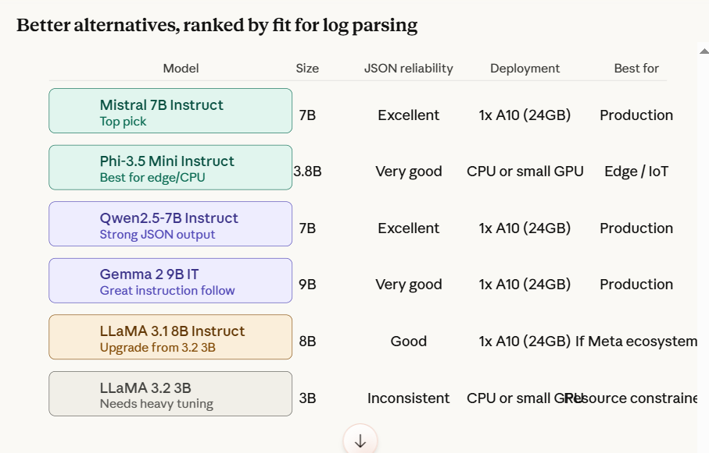

Why Mistral 7B Instruct is the top pick
Three specific reasons it beats LLaMA 3.2 3B for this task:
JSON output reliability. Mistral 7B was fine-tuned with strong instruction following, and it generates well-formed JSON far more consistently than smaller LLaMA variants — even before any prompt tuning. For log parsing where a malformed output breaks your downstream pipeline, this matters enormously.
Sliding window attention. Mistral uses grouped-query attention with a sliding window, which means it handles long log files or batched log lines efficiently without blowing up memory.
Prompt tuning convergence. Because Mistral 7B already has a strong prior on structured output tasks, the soft prompt tokens need to do less heavy lifting. You'll get good results with fewer training examples (200–300) versus LLaMA 3.2 3B (which needs 800+).

Why Phi-3.5 Mini is worth considering
If you're deploying on-premise without a GPU — on a logging server, an edge node, or inside a container with limited resources — Phi-3.5 Mini (3.8B) is remarkable. Microsoft specifically trained it on synthetic structured-output tasks, so its JSON generation is disproportionately good for its size. It runs comfortably on CPU with 8–12GB RAM using llama.cpp or ollama.
bash
# Run Phi-3.5 locally with ollama — no GPU needed
ollama run phi3.5

