Data Center Demand Growth and Generation-Interconnection Queue Congestion
Luke W. Jones · August 2026
Companion memo to the accompanying Technical Appendix, which contains the full methodology, EDA, and robustness-check record.
The Question
Do US regions absorbing faster AI- and data center-driven electricity demand growth also experience slower clearing of generation-interconnection queues, evidence that the demand surge itself is straining the approval pipeline for new power supply?
No. Across 23 region-years spanning four major US grid regions (PJM, ERCOT, MISO, and SPP, 2020–2025), regional demand growth shows no detectable relationship with how quickly a region’s generation queue clears, once the region itself is accounted for. What does predict queue performance is in which region a project sits. ERCOT, for instance, clears its backlog at a substantially higher rate than the other three, the only effect in the analysis that is statistically distinguishable from zero. Demand growth, by contrast, is not.
Why This Question?
Under FERC's post-2023 rules, US generation interconnection processes now prioritize commercial readiness rather than, say, strategic importance or, like in the past, the next-in-line project; in effect, there is no mechanism for treating a power plant's request differently because it happens to be serving an AI data center. The UK, facing similar congestion, chose the opposite path in 2025, creating an explicit fast lane for data centers and other “strategically important” projects. The US has no such equivalent, the most direct workaround (co-locating a data center at an existing power plant to bypass at least partly the shared grid) itself legally unsettled, as FERC's 2024 rejection of an expanded Talen-Amazon arrangement at the Susquehanna nuclear plant illustrates. Against that backdrop, financing entirely new, purpose-built generation—such as the enhanced-geothermal capacity Google has contracted from Fervo Energy specifically to serve its data centers—sidesteps both the queue and the co-location dilemma simultaneously.
How visible is that pressure empirically—are the regions absorbing the fastest, largely data center-driven demand growth also the regions where the generation queue is clearing more slowly? It is worth being precise about what test this question warrants. FERC Order no. 2023 governs how new generation and storage connect to the grid—to be clear, it is not a data center or large-load policy, and a data center's own connection to the grid remains a largely separate, historically state-regulated process that the federal government has only recently begun addressing through a newer and still-forming track (namely, the DOE's October 2025 large-load directive and FERC's subsequent 2026 region-specific orders). This memo's finding concerns the health of the supply side (i.e., how fast new power plants can be added where demand is rising) as opposed to how quickly a data center itself gets connected.
What Was Done?
We combined two public data sources: hourly electricity demand by balancing authority from EIA’s Hourly Electric Grid Monitor (EIA-930) and project-level interconnection-queue records from LBNL’s “Queued Up” dataset. Demand growth was measured as each region's year-over-year change in mean hourly demand. Queue performance was measured as clearance rate (MW reaching commercial operation in a year divided by the region’s active queue backlog in MW, expressed as a percentage of that backlog cleared per year).
FIGURE 1
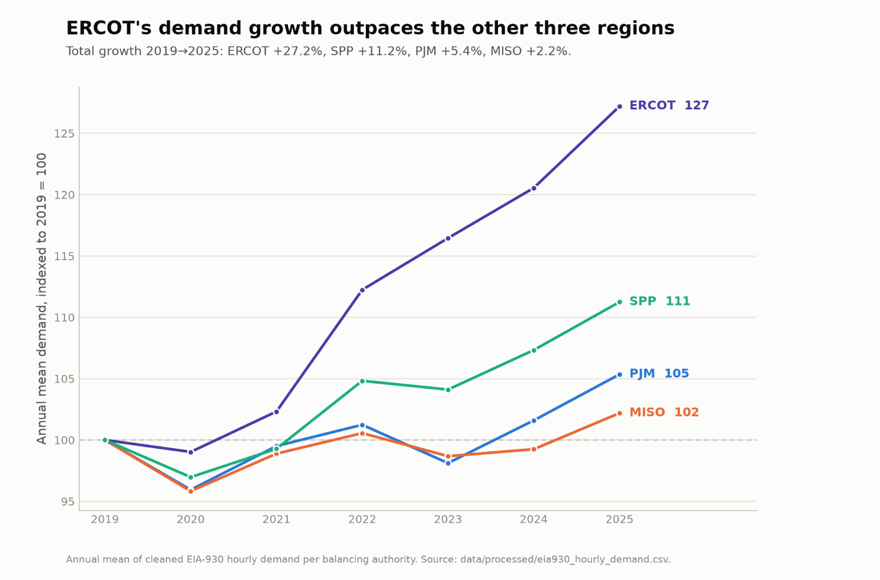
Annual mean demand by region, indexed to 2019 = 100. ERCOT’s growth (+27.2% by 2025) runs more than 2× that of SPP, the next-fastest region, and more than 10× that of MISO.
The resulting analysis panel covers 23 region-years (PJM 6, ERCOT 6, SPP 6, MISO 5) from 2020 through 2025, regressed as: clearance rate ~ demand growth + region fixed effects.
What Was Found?
Demand growth’s estimated effect on clearance rate is −0.114 percentage points, with a standard error of 0.118; a 95% confidence interval running from −0.363 to +0.134, comfortably contains zero (p = 0.35). Adding demand growth to the model including region provides virtually no payoff because R² rises from 0.221 (region alone) to 0.260, a gain of about 4 points for the additional parameter, and the increase is not statistically meaningful (F = 0.94, p = 0.35).

FIGURE 2
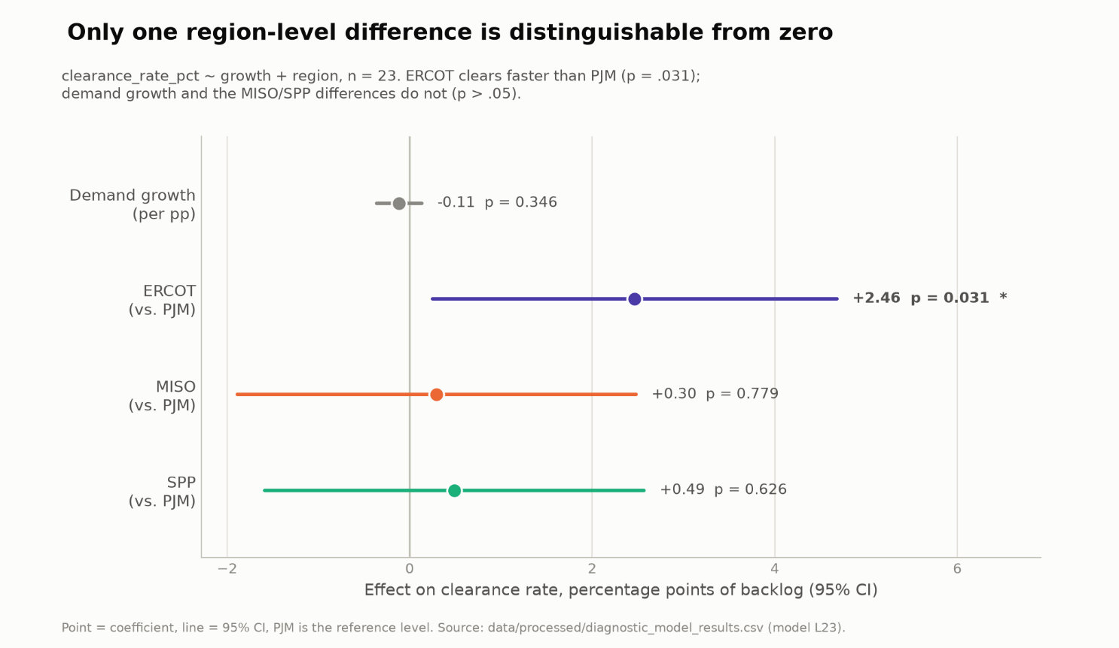
Point estimates and 95% confidence intervals from clearance_rate ~ growth + region (n = 23, PJM as reference). Only the ERCOT effect is distinguishable from zero (p = 0.031); the demand-growth coefficient’s interval spans −0.36 to +0.13 and comfortably contains zero.
ERCOT clears its backlog at a rate ~2.5 percentage points higher than PJM, the reference region, and ERCOT is also the only coefficient in the model that clears conventional statistical significance (p = 0.031). MISO and SPP are statistically indistinguishable from PJM on average, which matters because MISO’s clearance rate fell 92% and that of SPP fell 80% over the study window whereas PJM stayed essentially flat and ERCOT rose, and such a divergence cannot be captured by a simple regional average—the average captures each region’s overall level but not its trajectory.

FIGURE 3
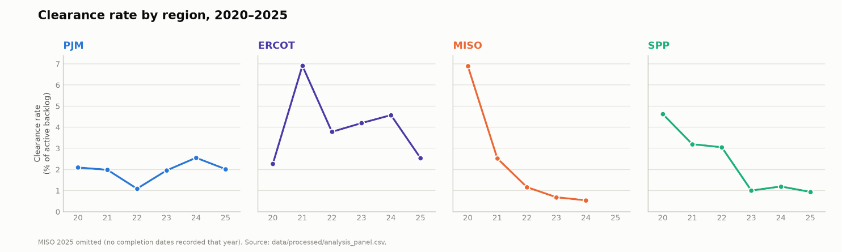
Queue clearance rate by region, 2020–2025. MISO and SPP fall 92% and 80%, respectively, over the period; PJM is roughly flat (−4%) and ERCOT rises slightly after swings (+12%). Such divergence in regional trends is the largest pattern in the data.
Why This Is a Credible Null
A null result is only as convincing as the effort to find something and come up empty. Several specific risks were identified and closed off individually:
- Data corruption. Fourteen corrupted hours in the raw EIA-930 series (including a likely integer-overflow error that briefly reported PJM’s demand at over two billion MWh) were identified through a three-test screen and excluded. Left in place, they would have inflated PJM's measured annual demand by roughly two-thirds in the affected year and, thereby, its computed year-over-year growth rates, fabricating a cross-regional difference in the study's largest region.
- Uneven data quality across regions. Interconnection-queue reporting is not equally reliable everywhere, for ERCOT’s withdrawal dates are missing for ~60% of its withdrawn capacity, concentrated in early years. Left unflagged, this would read as ERCOT having unusually few withdrawals rather than unusually poor record-keeping.
- A 2023 federal reform reshaping the outcome variable. FERC’s Order no. 2023 triggered a wave of administrative, one-time project purges across the three FERC-jurisdictional regions in this study, unrelated to demand, landing squarely inside the analysis window. These region-years were identified and flagged.
- A difference-in-differences was attempted and abandoned. Because the reform binds three of the four regions but not ERCOT, a before-and-after comparison using ERCOT as an untreated control was a natural design warranting consideration. It was specified, tested against its own precondition (namely, that the regions move similarly before the reform) and found not to hold, for three independent reasons, so it was not estimated.

FIGURE 4
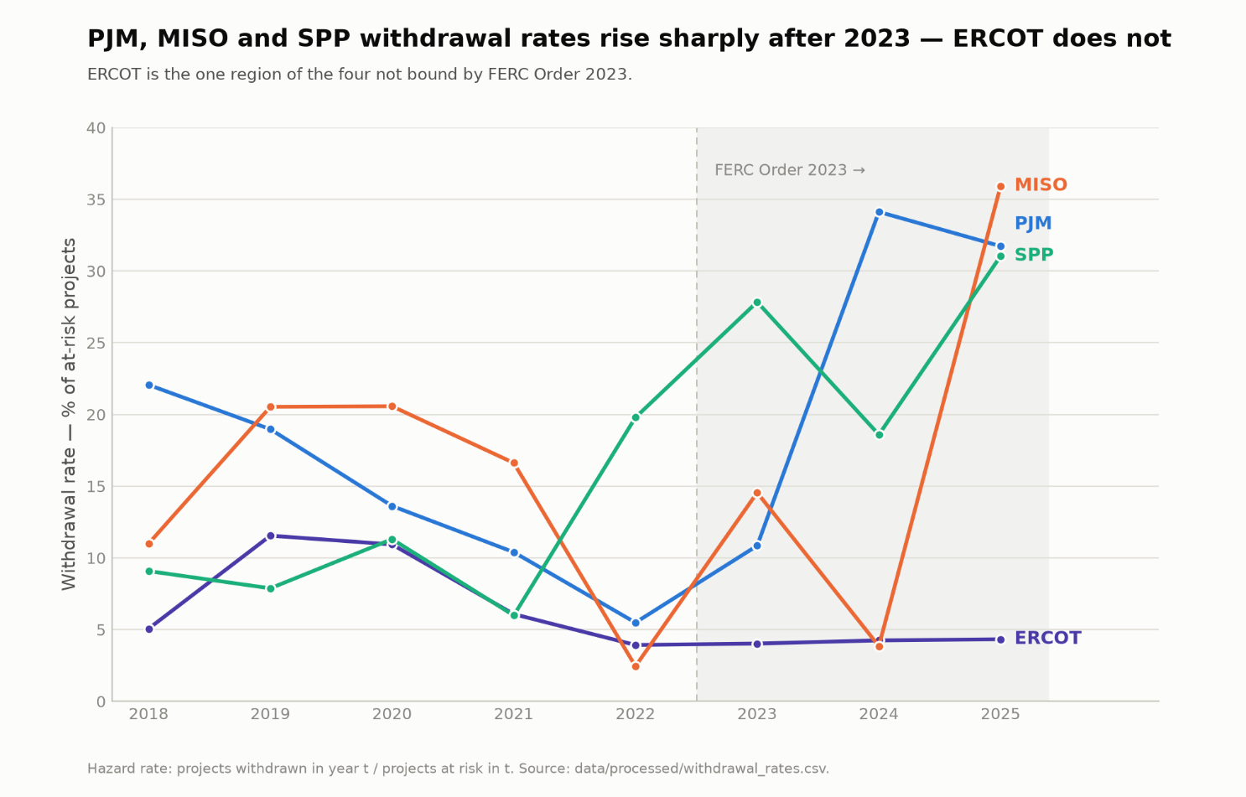
Withdrawal rate by region, 2018–2025. The three FERC-jurisdictional regions rise sharply after 2023; ERCOT, exempt from FERC Order no. 2023, stays flat. The regions' pre-2023 trends move independently of one another, which is why a formal before/after comparison using this contrast was tested and not used (see appendix §5).
- An apparent curved relationship was found, tested, and rejected. An exploratory pass suggested clearance was lowest at moderate growth rates and higher at both extremes, indicating a U-shape. Formally tested, the curvature proved statistically insignificant in every specification, had no plausible mechanism behind it, and was traceable to two unrelated regions that happened to share a high value in different years for unrelated reasons. Thus, it was not carried into the final result.
What This Means
For grid planners, developers, and hyperscalers, the practical read is narrower and more useful than the belief that growth strains queues. Which regulatory regime and market design a region runs, and not how much of the regional demand growth is a developer’s own footprint, is a predictor of how fast new power supply can be added there. A developer cannot control a region’s aggregate demand growth, but region selection is a deliberate choice. This analysis suggests that the latter is more consequential in gauging how quickly new supply will arrive, consistent with the broader structure of the US electricity grid that comprises many regionally-assigned authorities overseeing different aspects of the grid (transmission, interconnection, network upgrades, etc.).
It is worth restating that this is a finding about the supply side, specifically how fast new generation clears the queue to connect. It does not provide explicit information on how quickly a data center’s own connection to the grid gets approved, which is a separate and still-developing regulatory question the data used here cannot answer.
Limitations
The central limitation is statistical power, for 23 observations and a confidence interval spanning roughly half of a percentage point around the point estimate mean that this analysis could not have detected anything short of a very large effect. Hence, this is a weak null, and the correct reading is that this design cannot detect a relationship, not that no relationship exists per se.
Furthermore, ERCOT carries both the study’s most extreme demand-growth figure and its only statistically significant coefficient, while also being the region with the weakest underlying data quality, so the result is somewhat sensitive to ERCOT’s measurement quality. The largest pattern in the data (the sharp divergence between MISO/SPP’s declining clearance rates and PJM/ERCOT’s flat-to-rising ones) remains unexplained by anything in this specification—it is not demand growth, not FERC jurisdiction, and not the 2023 reform.

The full methodology, every data-quality decision, and the complete robustness-check record are documented in the accompanying technical appendix.

