Technical Appendix
Data Center Demand Growth & Generation-Interconnection Queue Congestion
Luke W. Jones · appendix compiled 02 August 2026
This document is the organized methodological record for the accompanying memo. It is written for a first-time reader encountering the project, structured by topic. Every figure quoted here is traceable to a script in the repository root and an artifact in data/processed/.
DECISIONS.md remains the chronological working log, including dead ends and superseded drafts. Where the two differ in emphasis, this document is the reference; where they differ in fact, DECISIONS.md records how the result was found.
Headline result: Across 23 region-years (four regions, 2020–2025), the rate at which generation interconnection queues clear has no detectable relationship with regional demand growth. The estimated slope is negative, is small relative to its standard error, and does not survive any significance threshold. The variation in clearance rates is organized by both region and within-region trajectory, not by demand growth. Sections 7–9 give the evidence and support for why this is a weak null rather than a strong one.

Contents
1. Data sources 4
EIA-930 — Hourly Electric Grid Monitor 4
LBNL “Queued Up” — interconnection queue data through 2025 4
2. EIA-930 data quality 6
The problem 6
Design constraint: no absolute thresholds 6
The three tests 6
Calibration evidence for the baseline choice 7
The 14 excluded hours 8
Decision: drop, do not interpolate or substitute 8
Validation 9
The resulting demand series 10
Retained data-quality notes 11
3. Panel construction 12
Why tab 03 and not tabs 09, 21 or 22 12
The regional reporting-quality audit 13
The project_type trap 14
Tab 09 as control: the 2020 hybrid break 14
Validation 15
4. The 2023 FERC reform 16
Why it needs handling in the first place 16
Detection method 16
Why this baseline, after testing alternatives 17
Why a flag and not a filter 18
5. The abandoned difference-in-differences 19
Why it was attempted 19
Rate definition 19
Three independent reasons the pre-test failed 19
What was done instead 20

6. Analysis panel construction 22
Variable definitions 22
The guard cascade 22
First look before any model 23
7. The apparent U-shape 26
How it appeared 26
The diagnostics 26
The formal tests 27
Why it was rejected 27
8. Final specification and result 28
Specification 28
Coefficient table 28
Interpretation 28
9. Limitations 30
Statistical power is the binding limitation 30
The outcome variable is a ratio of two differently-sourced quantities 30
The dominant variation in the data is unexplained 30
ERCOT is not cleanly comparable to the other three 30
The reform confound is controlled descriptively, not causally 31
Withdrawal-side outcomes are not usable cross-regionally 31
Smaller items carried forward 31
10. Reproduction 32

1. Data sources
The two datasets used to address the relationship between interconnection queue congestion and demand growth are regional electricity demand at sufficient time resolution to measure growth and regional interconnection queue outcomes. Two sources were selected.

EIA-930 — Hourly Electric Grid Monitor
What does it provide? Hourly electricity demand by balancing authority (BA), pulled from the EIA API v2 route electricity/rto/region-data. Four BAs were pulled, matching the four queue regions’ scope:
EIA-930 code | Queue region | Role
PJM | PJM | FERC-jurisdictional
MISO | MISO | FERC-jurisdictional
SWPP | SPP | FERC-jurisdictional
ERCO | ERCOT | not FERC-jurisdictional

Coverage: 266,181 as-reported rows spanning 01 JAN 2019 to 04 AUG 2026.
Why chosen? It is the only public source giving consistent, high-frequency, BA-level demand across all four regions on a single definition. Hourly resolution is more than what this analysis needs, the outcome variable an annual mean, yet it is what makes the data-quality screening in §2 possible—corruption that is invisible in an annual aggregate is more noticeable against neighboring hours.
Why does the series start in 2019? The API route reports startPeriod = 2019-01-01T00, and a test request for JAN 2018 returns total:0. EIA-930 history back to JUL 2015 exists only in the separate Hourly Grid Monitor bulk CSV downloads, a different pipeline that was not employed. This is a binding constraint on the size of the final analysis panel (see §6).

LBNL “Queued Up” — interconnection queue data through 2025
What does it provide? data/raw/LBNL_Ix_Queue_Data_File_thru2025.xlsx, 43 tabs, two of which are used:
- Tab 03, “Complete Queue Data” — more granular data, 38,201 rows × 30 columns. Carries region, q_date (queue entry), on_date (online operation), wd_date (withdrawal), ia_date (interconnection agreement), q_status, project_type, type_clean, and mw_1. This is the source for all outcome flows.
- Tab 09, “Active Capacity. Region+Type” — LBNL's own aggregation, 840 rows, a balanced 10 regions × 12 years (2014–2025) × 7 resource types. Used as the backlog-size control (denominator of the outcome variable).
Why chosen? Lawrence Berkeley National Laboratory’s (LBNL) dataset is the standard reference for US interconnection queue research, standardizing region and resource-type labels across 57 transmission providers. In addition, it publishes the project-level dates needed to convert queue status into annual flows, whereas aggregated alternatives do not.
Why four regions? PJM, MISO, SPP span the FERC-jurisdictional boundary, so all four regions cover both sides of the FERC, on which §4 and §5 turn; additionally, these four are single markets rather than utility aggregations. The remaining LBNL regions (CAISO, ISO-NE, NYISO, Southeast, West) were excluded because Southeast and West are non-ISO aggregations of many utilities rather than single markets and their outcome-date coverage is lower, with 18% and 59% on_date completeness nationally (see §3). CAISO’s exclusion is due to the EIA-930 demand pull, adding a constraint to the study given CAISO’s superior date coverage.

2. EIA-930 data quality

The problem
The as-reported series contains corrupt values, concentrated in PJM whose mean hourly demand reads 154,050 MWh as-reported against 92,219 MWh after cleaning—the raw figure is inflated by 67.04%, and 99.97% of that inflation comes from three consecutive hours on 19 OCT 2021.
Left in place, these hours would have inflated PJM’s annual mean demand and, thereby, the YoY growth rate later used as the regression’s explanatory variable (see §8), while leaving ERCOT and MISO unaffected to the MW.

Design constraint: no absolute thresholds
Every rule is a ratio against the individual BA’s rolling history. There are no fixed MW ceilings anywhere in the method.
A fixed ceiling in a project about demand growth would eventually be crossed by real load and begin deleting relevant data. An absolute per-BA ceiling (e.g., PJM ≈ 170,000 MWh) was considered and rejected on these grounds, even though it would have cleanly isolated the surviving corrupt hours at the time.

The three tests
Each catches a different failure mode, none subsuming any of the others. Two corrupt hours are invisible to the spike test but caught by peak-level; one is the reverse.
Test 1 — peak-level. Compare each hour to the 99.9th percentile of its own BA over a centered 731-day window, the region's demonstrated peak level around that time. Flag above 1.15×.
 | ratio to own 2-yr p99.9
Highest legitimate annual peak (ERCO 2026 1.02×, MISO 2024 1.04×, SWPP 2026 1.04×, PJM 2025 1.05×) | 1.05×
Lowest corrupt hour | 1.21×

1.15 sits in that gap with roughly 10 percentage points of headroom on the legitimate side. All four BAs independently agree on where peaks sit relative to their own history, demonstrating that the threshold need not be tuned to a single region.
The window is centered, not trailing, for a sustained step up in load raises the baseline from both directions and is therefore not flagged; only an isolated spike above the surrounding two years trips it. This analysis is retrospective, so using later data in the baseline removes the cold-start problem a trailing window would face in 2019.
Test 2 — isolated-spike. Compare each hour to the mean of the immediately adjacent hours. Flag above 1.35×.
 | ratio to mean of adjacent hours
Typical legitimate hours (ERCOT and MISO never exceed 1.06× even on the steepest morning ramps) | 1.00–1.06×
Highest legitimate value anywhere in the series | 1.22×
Corrupt spikes | 1.42–113×

This test exists because the peak-level test can encounter a spike landing just below the annual peak, which is indistinguishable from a record. Aggregate load is physically continuous; it cannot, say, rise 50% in one hour and fall back the next. The isolated-spike test is applied only where both neighbors are exactly one hour away so that the three daylight savings time (DST) reporting gaps do not read as false discontinuities.
Test 3 — level-collapse. Below 0.33× a centered 7-day median. This test catches zeros, negatives and dropouts, which neither high-side test can see, though it currently detects nothing, itself an informative finding.
Iteration. Applied iteratively: a corrupt hour is part of the percentile used to judge it, so the first pass computes a baseline inflated by the values it is trying to catch. Because each pass can only remove hours that were inflating the baseline, iteration can only tighten it; for example, a previously-flagged hour can never fall back below the threshold. On this series, no new hours were flagged on a second pass, so the test converges in a single iteration.

Calibration evidence for the baseline choice
Candidate baselines were evaluated empirically against the known-corrupt set. p99.9 over a centered 731-day window separated widest, selected on that basis:
baseline | lowest corrupt ratio | highest legitimate ratio | gap
p99.9 / 731d | 1.212× | 1.052× | 0.160
p99.5 / 731d | 1.263× | 1.111× | 0.152
p99.0 / 731d | 1.296× | 1.144× | 0.153

The 14 excluded hours
PJM 13 · SWPP 1 · ERCO 0 · MISO 0. Full audit trail with the firing test, baseline, and ratio in data/processed/excluded_hours.csv.
BA | Timestamp (UTC) | Reported (MWh) | Baseline | Ratio | Test
PJM | 2021-10-19 04:00 | 2,147,480,000 | 146,695 | 14,639.04× | peak-level
PJM | 2021-10-19 03:00 | 1,527,760,000 | 146,695 | 10,414.51× | peak-level
PJM | 2021-10-19 05:00 | 431,044,000 | 146,695 | 2,938.36× | peak-level
SWPP | 2023-06-13 02:00 | 3,621,097 | 54,120 | 66.91× | peak-level
PJM | 2019-12-11 20:00 | 417,669 | 148,147 | 2.82× | peak-level
PJM | 2020-07-24 16:00 | 262,651 | 145,243 | 1.81× | peak-level
PJM | 2020-09-03 21:00 | 250,825 | 147,144 | 1.70× | peak-level
PJM | 2020-07-27 22:00 | 245,799 | 145,243 | 1.69× | peak-level
PJM | 2020-07-13 23:00 | 224,345 | 147,961 | 1.52× | peak-level
PJM | 2019-12-12 22:00 | 155,276 | 103,637 | 1.50× | isolated-spike
PJM | 2020-04-10 04:00 | 215,682 | 147,419 | 1.46× | peak-level
PJM | 2020-08-13 13:00 | 138,575 | 99,324 | 1.40× | isolated-spike
PJM | 2020-07-28 17:00 | 192,229 | 145,243 | 1.32× | peak-level
PJM | 2020-07-29 21:00 | 176,085 | 145,243 | 1.21× | peak-level

Each was inspected in its surrounding hours before acceptance. None are borderline calls:
- The three 2021-10-19 PJM hours are probably an upstream integer overflow, the largest (2,147,480,000) sitting just below the signed 32-bit ceiling of 2,147,483,647.
- 2019-12-11 20:00 reads 417,669 between neighbors of 99,567 and 99,613.
- 2019-12-12 22:00 reads 155,276 between 98,466 and 108,808, the same DEC 2019 fault a day later. This was PJM's reported 2019 annual maximum and a DEC one in a summer-peaking RTO.
- 2020-08-13 13:00 reads 138,575 mid-way through a smooth, monotonic morning ramp (85.7 → 87.8 → 91.1 → 95.3 → 138.6 → 103.4 → 108.9 → 114.1 GW).

Decision: drop, do not interpolate or substitute
14 hours of 266,181 is 0.0053% of the series. The study needs from EIA-930 multi-year regional growth rates, rather than hour-by-hour dynamics, so removing a handful of identified hours has no material effect on an annual aggregate. Interpolation would mean inventing values the analysis, again, does not need. EIA's own adjusted/imputed series exists as a fallback but introduces a second, less transparent pipeline to fix fourteen rows.
Raw data is never modified. data/raw/eia930_hourly_demand.csv is immutable; cleaning is a separate derived step (clean_eia930.py) writing 266,167 rows plus the 14-row exclusion log. Any exclusion can be re-examined or reversed against an untouched original, making the exclusions merely auditable. The detection rules live in one module (eia930_quality.py), imported by both the reporting and the dropping script so that the hours reported and the hours excluded cannot silently diverge.

Validation
Evidence of correct calibration is that the rule fixes exactly the years that were wrong and leaves the rest untouched. ERCOT and MISO are unchanged across all years.
Annual peak demand, GW (before → after):
Year | PJM | ERCO | MISO | SWPP
2019 | 417.7 → 152.3 | 74.5 | 116.6 | 50.5
2020 | 262.7 → 145.4 | 74.2 | 112.9 | 48.7
2021 | 2,147,480 → 149.6 | 73.5 | 114.2 | 50.8
2022 | 148.5 | 79.8 | 116.4 | 53.0
2023 | 147.6 | 85.4 | 120.8 | 3,621.1 → 56.0
2024 | 153.1 | 85.5 | 121.6 | 54.2
2025 | 160.6 | 83.6 | 118.7 | 54.7

Two independent confirmations: (1) PJM's corrected peaks sit in a coherent 145–163 GW band below its ~165 GW all-time record, and its corrected 2020 peak of 145.4 GW matches PJM's actually-reported 2020 summer peak of ~144–145 GW; (2) correcting 2019 moves PJM's annual peak from a DEC hour to a JUL afternoon, the right seasonal shape for a summer-peaking region.
Effect on annual mean demand:
BA | raw mean (MWh) | clean mean (MWh) | change
ERCO | 49,318 | 49,318 | 0.00%
MISO | 73,945 | 73,945 | 0.00%
PJM | 154,050 | 92,219 | −40.14%
SWPP | 32,124 | 32,070 | −0.17%

The resulting demand series
Annual mean demand, GW, from the cleaned series:
Year | Hours | ERCO | MISO | PJM | SWPP
2019 | 8,760 | 43.80 | 74.15 | 91.35 | 30.76
2020 | 8,784 | 43.37 | 71.05 | 87.64 | 29.83
2021 | 8,760 | 44.81 | 73.32 | 90.90 | 30.54
2022 | 8,760 | 49.16 | 74.56 | 92.48 | 32.25
2023 | 8,760 | 51.00 | 73.17 | 89.63 | 32.03
2024 | 8,784 | 52.80 | 73.59 | 92.81 | 33.02
2025 | 8,760 | 55.71 | 75.77 | 96.24 | 34.23
2026 (PARTIAL) | 5,178 | 57.07 | 77.34 | 99.73 | 35.17

Headline growth, 2019 → 2025 (both complete calendar years, so no seasonal bias):
Region | 2019 (GW) | 2025 (GW) | Total growth | CAGR
ERCOT | 43.80 | 55.71 | +27.2% | 4.09%
SPP | 30.76 | 34.23 | +11.2% | 1.79%
PJM | 91.35 | 96.24 | +5.4% | 0.87%
MISO | 74.15 | 75.77 | +2.2% | 0.36%

ERCOT is growing more than an order of magnitude faster than MISO. This cross-regional variation is the spread that the corrupt PJM hours would have distorted. The regional ranking is stable whether measured 2019→2025 on full years or 2019→2026 on a like-for-like 01 JAN–AUG window (+33.3% / +15.2% / +7.8% / +4.0%). Only the magnitudes shift; the analysis relies on the cross-regional ranking, which does not change over both windows.
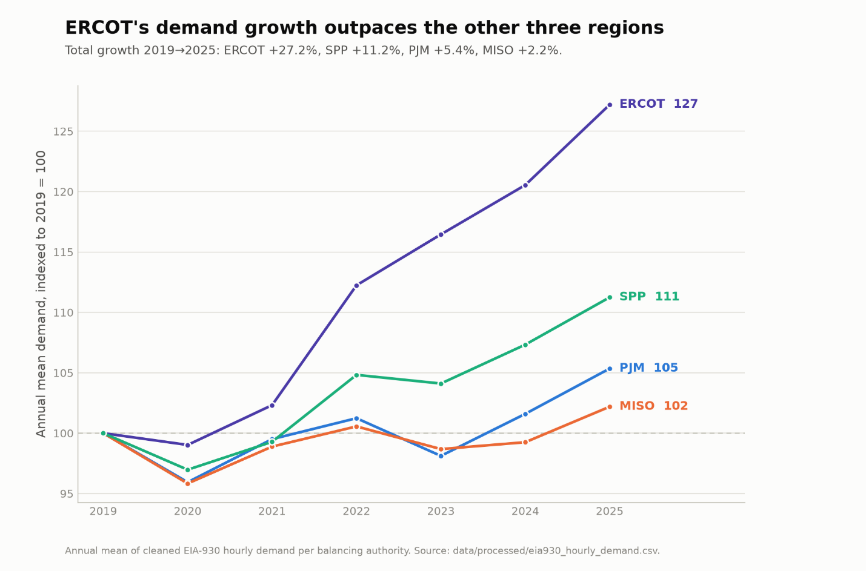
Annual mean demand by region, indexed to 2019 = 100. ERCOT's growth (+27.2% by 2025) runs more than 2× that of SPP, the next fastest region, and more than 10× that of MISO. Source: cleaned EIA-930 hourly series.

Retained data-quality notes
- 176 null demand values (PJM 116, MISO 35, SWPP 25) are retained, for they are missing but not wrong. Call .mean() directly and never divide an annual total by an assumed hour count, given hours per BA-year are not uniform (leap years, the 14 exclusions, 3 DST gaps, etc.), and sum() / len(group) silently treats missing hours as zero-demand hours.
- Three missing DST hours (ERCOT and SWPP 2021-11-07 06:00 UTC; PJM 2023-11-06 05:00 UTC) are left as-is, artifacts of BAs submitting in local time to a UTC-indexed series.
- UTC is canonical, so local time is used for display only.

3. Panel construction

Why tab 03 and not tabs 09, 21 or 22
Four candidate LBNL tabs were inspected for a region-by-year join against the demand series. Three have no region dimension at all:
Tab | Layout | Actual breakout | Usable for region-year?
21. Operational Volume Trend | 26 rows, 2000–2025 | year × data source (queue vs. EIA) | No (national)
22. Withdrawn Volume Trend | 26 rows, 2000–2025 | year only (+ project count) | No (national)
07. Active Capacity by Year | 24 rows, 2014–2025 | year × vintage (new vs. carryover) | No (national)
09. Active Cap. Region+Type | 840 rows | region × year × type (10 × 12 × 7, balanced) | Yes

Their second dimensions are easy to mistake for a regional split when reading tab descriptions rather than the tabs themselves. These are, in fact, data source, vintage, and project count. Allocating a national total across four regions would have required inventing an assumption.
Only tab 09 is broken out by both region and year, but tab 09 reports the capacity sitting active at year end rather than the flows that this project seeks to use as outcomes. Year-over-year deltas in a stock mix new entries, withdrawals, and completions into a single number, meaning a stock cannot differentiate between a fast-clearing and slow-clearing queue.
Decision. Aggregate flows from tab 03’s data, and tab 09 is retained as the backlog-size control. Output: data/processed/queue_outcomes_panel.csv, 108 region-year rows (4 regions × 2000–2026), 18 columns.
Capacity field. mw_1. The hybrid co-location fields mw_2/mw_3 are entirely unpopulated for all four regions because LBNL excludes its imputed hybrid storage from the published data. The build sums all three regardless, so the measure stays correct if a region is later added; at present the sum equals mw_1.
The panel does not reconcile to tab 09. Tab 09’s totals include imputed hybrid storage that tab 03 omits. That is to say, the two measure from different inputs.

The regional reporting-quality audit
This was run before anything was built on top of the dates and is a consequential finding. From data/processed/queue_date_coverage.csv:
Region | operational projects | with on_date | by MW | withdrawn projects | with wd_date | by MW
PJM | 1,192 | 99.4% | 99.1% | 5,226 | 98.4% | 96.2%
MISO | 515 | 96.5% | 97.1% | 3,263 | 93.8% | 91.7%
SPP | 299 | 96.3% | 98.4% | 1,846 | 72.8% | 68.1%
ERCOT | 613 | 84.7% | 82.1% | 1,158 | 48.7% | 39.8%

on_date is reasonably even (82–99% by MW) and supports cross-regional comparison. wd_date does not. ERCOT carries no withdrawal date for 60% of its withdrawn capacity.
The gap is concentrated in early vintages, ERCOT's coverage by queue-entry cohort running 0–20% before 2016, then 80–97% for 2017–2022. Because the panel is indexed on outcome year, an undated project cannot be placed in any year and drops out of the panel entirely. This causes the following:
- ERCOT records zero placeable withdrawals in every year before 2018 against 1,158 withdrawn ERCOT projects in the file.
- MISO records no on_date after 2024, so MISO 2025 reads as zero completions while PJM and ERCOT report 47 and 76. This is a reporting lag.
Decision: flag the structural zeros, do not emit them as plain data. operational_series_usable and withdrawn_series_usable mark every region-year outside that region's observed reporting window. The window comes from the first and last year with any dated outcome, per region and outcome, rather than universally hard-coded, so that a re-pull that shifts coverage updates the flags.
Inferred windows:
Outcome | PJM | ERCOT | MISO | SPP
operational | 2000–2025 | 2012–2025 | 2000–2024 | 2002–2025
withdrawn | 2000–2026 | 2018–2025 | 2002–2026 | 2004–2026

Without these flags, a region-and-year fixed-effects specification would read ERCOT's missing pre-2018 withdrawals as a regional difference in withdrawal behavior. That is structurally the same failure mode as the corrupt PJM demand hours.
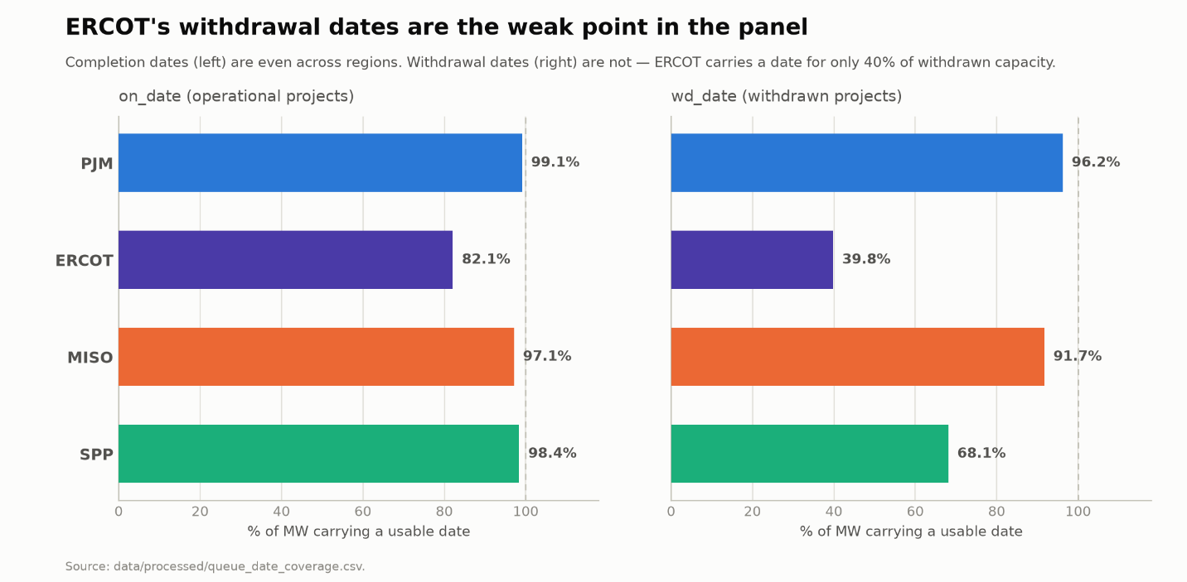
Share of capacity carrying a usable outcome date, by region. Completion dates (on_date) are consistently high across all four regions. Withdrawal dates (wd_date) are not, ERCOT carrying a date for only 40% of withdrawn capacity, and the coverage gap underlying the abandoned DiD in §5.

The project_type trap
Filtering to project_type==“Generation” looks obviously correct but is wrong.
876 in-scope rows have a blank project_type, and 854 of them are ERCOT (the remaining 22 are SPP). They are plainly generation—type_clean reads Wind, Solar, Gas, Battery, Coal, Nuclear—and they carry 208 GW, including 42 GW operational and 166 GW withdrawn.
A !=“Generation” filter drops all of them, deleting roughly a third of ERCOT's outcome capacity and none of PJM's. Indeed, the first build understated ERCOT 2025 completions as 60 projects / 7.4 GW relative to a corrected 76 projects / 9.2 GW.
Decision. Exclude only rows labeled Upgrade, Surplus, or Replacement: 174 rows across the four regions (Surplus 100, Upgrade 53, Replacement 21), none of which is new capacity reaching the grid. Blanks are treated as generation and the count is reported on every run. 19,510 generation requests remain.
In general, a null-valued exclusion filter is only safe when the nulls are spread evenly across regions, which is not the case here.

Tab 09 as control: the 2020 hybrid break
Tab 09 note (1) states that hybrid-storage capacity not only is estimated from storage-to-generator ratios but is also only included from 2020. The workbook carries an “NA” for hybrid storage in 2014–2019 (60 cells, all 10 regions). Offshore wind is likewise only broken out from 2020.
Therefore, active_gw_total has a level break in 2020. PJM 2020 reads 152.8 GW with hybrid, 144.7 GW without. The panel ships both active_gw_total and active_gw_excl_hybrid plus a hybrid_in_active_total flag. active_gw_excl_hybrid is used throughout the analysis because the panel spans the 2019–2020 boundary and the totals are not like-for-like across it.
“All Regions” is dropped from tab 09; it is LBNL's national total, so retaining it would double-count when considering regions.

Validation
The four regions sum to a stable and plausible share of LBNL's own national totals across 2015–2025: 61–86% of tab 21 operational capacity and 37–77% of tab 22 withdrawn capacity. These are the four largest queue regions, and the shortfall sits where expected, West and Southeast having 18% and 59%, respectively, on_date coverage nationally, so the national denominators are themselves understated.

4. The 2023 FERC reform

Why it needs handling in the first place
FERC Order no. 2023 reforms interconnection for new generation and storage (i.e., the grid’s supply side); this is not a large-load policy. A load’s own connection to the grid has historically been a state matter and is only now being addressed at the federal level through the DOE’s OCT 2025 large-load directive and FERC’s subsequent region-specific 2026 orders, which lie outside the data used in this study. That said, the 2023 order reshaped the generation queue that the outcome variable measures, coincidentally in the window during which demand was surging, not because it deliberately targets data center growth. FERC Order no. 2023 forced cluster restructuring and mass resubmission across the FERC-jurisdictional RTOs, purging speculative projects wholesale. Thus, the resulting withdrawals are not demand-driven attrition but merely administrative, and they coincide with the analysis window. Uncontrolled, they would enter the outcome variable as if they were market behavior.

Detection method
Test. A region-year is flagged when its withdrawal count or withdrawn MW exceeds 3× that region’s own median, where the median is taken over that region's usable, complete years only.
Both ratios ship as columns (n_withdrawn_vs_median, mw_withdrawn_vs_median) so that the threshold remains a parameter; a reader can re-threshold from the CSV without re-running anything, the same principle illustrated by excluded_hours.csv carrying the ratio and the firing test.
Restricting the median to usable years is load-bearing: ERCOT's structural pre-2018 zeros would otherwise drag its median toward zero and flag its entire series. The reporting-window flags of §3 must be computed first.
Eight region-years flagged:
Region | Year | n withdrawn | vs. median | MW withdrawn | vs. median
MISO | 2023 | 268 | 4.1× | 41,892 | 2.9×
MISO | 2025 | 938 | 14.2× | 171,737 | 11.8×
PJM | 2024 | 821 | 5.4× | 67,653 | 3.5×
PJM | 2025 | 655 | 4.3× | 78,517 | 4.0×
SPP | 2022 | 134 | 3.2× | 23,550 | 3.6×
SPP | 2023 | 257 | 6.1× | 50,688 | 7.8×
SPP | 2024 | 137 | 3.3× | 27,614 | 4.2×
SPP | 2025 | 280 | 6.7× | 65,049 | 10.0×

Independent corroboration: ERCOT is the only region with no flagged year. Its largest deviation is 1.32×, nowhere near the threshold. ERCOT is also the one region of the four to which Order no. 2023 does not apply as it lies outside of FERC’s jurisdictional domain. The screen indeed recovers the jurisdictional boundary, which is meaningful evidence that it is detecting the reform rather than noise. Seven of the eight flagged years fall in 2023–2025; the eighth, SPP 2022, is the one requiring manual judgment.

Why this baseline, after testing alternatives
The baseline choice changes the answer more than the threshold does, so three were tried.
Centered rolling median — the idiom used for the peak-level test in §2 is the wrong tool here because a centered window allows a sustained step-up to raise its own baseline. The reform, in contrast to load increases, is a sustained multi-year regime, so a centered window suppresses its own detection. At a seven-year centered window, PJM 2025, SPP 2023, and SPP 2025 all fall below 2×, with 2024's spike sitting inside 2025's baseline.
Trailing median (five- and ten-year) picks up ordinary change as readily as reform, flagging PJM 2008–2012 and SPP 200–2016, though for different reasons, only one of which is expansion.
 | PJM 20082012 | SPP 20102016
New requests | −27% | +171%
New capacity | −42% | +174%
Active capacity | +0.6% (116.0→116.7 GW) | +176%
Withdrawal hazard rate | +118% (13.2%→28.8%) | +282%

SPP's flag is indeed queue expansion. PJM's, by contrast, is a result of new entries that were contracting while its withdrawal rate more than doubled off of a 2000–2007 median of 33 withdrawals/year (post-financial crisis coal and gas attrition, unrelated to growth or to FERC Order no. 2023). If anything, this strengthens the case against a trailing baseline because it fires on any sustained step-up in withdrawals regardless of cause, neither cause being one the test is trying to isolate. For example, PJM's full-window median is 152, so the 3× threshold (456) never picks up its 2012 peak of 272.
Own-median over the full usable window is, frankly, the simplest and separates cleanest empirically (seven of eight hits in the reform era, zero hits in the one exempt region). Restricting the median to 2019+ was rejected because the reform years sit inside that window and inflate the median against which they are being tested. MISO’s 2019+ median is 179 against a full-window 66, which suppresses MISO 2023 entirely.

Why a flag and not a filter
Dropping the flagged rows would do more damage than keeping them. Because ERCOT is exempt, the flag is not evenly distributed across regions; the flag removes the late period from the FERC-jurisdictional regions and nothing from ERCOT:
Region | 2019 | 2020 | 2021 | 2022 | 2023 | 2024 | 2025 | kept
PJM | ✓ | ✓ | ✓ | ✓ | ✓ | — | — | 5
ERCOT | ✓ | ✓ | ✓ | ✓ | ✓ | ✓ | ✓ | 7
MISO | ✓ | ✓ | ✓ | ✓ | — | ✓ | — | 5
SPP | ✓ | ✓ | ✓ | — | — | — | — | 3
kept | 4 | 4 | 4 | 3 | 2 | 2 | 1

2025 would retain ERCOT alone, so in effect a regression on the filtered panel would compare ERCOT’s 2023–2025 against everyone else's 2019–2022, a region-period confound worse than the one the filter was meant to remove. The flag is therefore carried merely as a column into the analysis panel, and §8 uses it as a robustness check.

5. The abandoned difference-in-differences

Why it was attempted
FERC Order no. 2023 binds PJM, MISO and SPP but not ERCOT. That is an unusually clean jurisdictional discontinuity, and it invites a naïve difference-in-differences estimate of the reform’s effect on queue withdrawal behavior, ERCOT the untreated control. The design was specified and pre-tested before being estimated.
It was pre-tested and failed, so it was not estimated.

Rate definition
A hazard rate:
withdrawal rate(region ,t) = projects withdrawn in t / projects at risk in t
A project is considered to be at risk in year t if it was in the queue at any point during t (entered in year t or earlier and had not already exited, withdrawn, or reached operation in a prior year). A project that both entered and exited within the same year t counts as at risk in t, with its exit attributed to t’s numerator, the standard construction for a discrete-time hazard rate. Active and suspended projects remain at risk through the end of the sample given that they haven't exited yet. Projects that exited with no usable date are dropped from numerator and denominator alike (1,505 total: ERCOT 688, SPP 508, MISO 219, PJM 90). Leaving them in the denominator would count them as perpetually at risk and deflate every later year.
Series: data/processed/withdrawal_rates.csv (84 region-years).

Three independent reasons the pre-test failed
1. The treated regions do not move together with each other. Pre-reform OLS slopes over the common 2018–2022 window disagree in both sign and magnitude:
Region | slope, pp/yr
PJM | −4.17 | treated
MISO | −2.10 | treated
SPP | +1.95 | treated
ERCOT | −0.78 | control

SPP rises through the pre-period while PJM and MISO fall. A diff-in-diffs requires the treated group to share a trend before it can share a treatment effect.
2. Co-movement is negative where it most needs to be positive. Correlation of year-over-year changes, 2018–2022:
 | PJM | MISO | SPP | ERCOT
PJM | 1.00 | 0.51 | −0.73 | 0.28
MISO | 0.51 | 1.00 | −0.67 | 0.76
SPP | −0.73 | −0.67 | 1.00 | −0.09
ERCOT | 0.28 | 0.76 | −0.09 | 1.00

SPP is negatively correlated with both of its own treatment-group partners. Worse for the design: the strongest pair in the matrix is MISO↔ERCOT at 0.76. The supposed control tracks one treated region better than the treated regions track each other, so the treated/control split does not match the data's own correlation structure. Extending the window to 2014–2022 does not rescue it (PJM↔MISO −0.16, PJM↔SPP −0.62, MISO↔SPP −0.32).
3. The control's post-period is measured with a known, one-sided error. ERCOT's withdrawal rate sits at 3.9–4.3% across 2022–2025 while the other three swing between 4% and 36%. ERCOT’s wd_date coverage degrades in recent cohorts—97% of its 2018 entrants carry a withdrawal date versus 56% (2023), 56% (2024) and 24% (2025). Allocating ERCOT’s 594 undated withdrawals at its own median two-year queue-to-withdrawal duration implies roughly +18 / +16 / +37 additional withdrawals in 2023 / 2024 / 2025 against 72 / 88 / 96 observed, a 25%, 18%, and 39% understatement in 2023, 2024, and 2025, respectively, concentrated in the post period. Consequently, a diff-in-diffs would book reporting lag as the treatment effect. This is the most serious of the three, for it biases in the direction that would flatter the hypothesis.

What was done instead
The three regions under FERC jurisdiction all show a sharp post-2023 rise in withdrawal rate (PJM 5.5% → 31.7%, MISO 2.4% → 35.9%, SPP 19.8% → 31.0% by 2025) while ERCOT stays flat. That contrast probably does reflect FERC Order no. 2023. It is simply not cleanly identified by a four-region region-level diff-in-diffs because the pre-period provides no stable baseline against which to difference and the control’s post-period carries one-sided measurement error.
The reform is hence treated as a descriptive regime break for which to control rather than an outright treatment effect to estimate. This is consistent with the flag-don’t-filter decision in §4 and its collinearity finding, namely in that ERCOT’s exemption renders reform-affected status and being under FERC’s jurisdiction effectively the same variable in the late sample.
A causal read would need within-region variation that FERC Order no. 2023 itself created (e.g., cluster-cycle timing differences across RTOs or project-level exposure by queue-entry cohort).
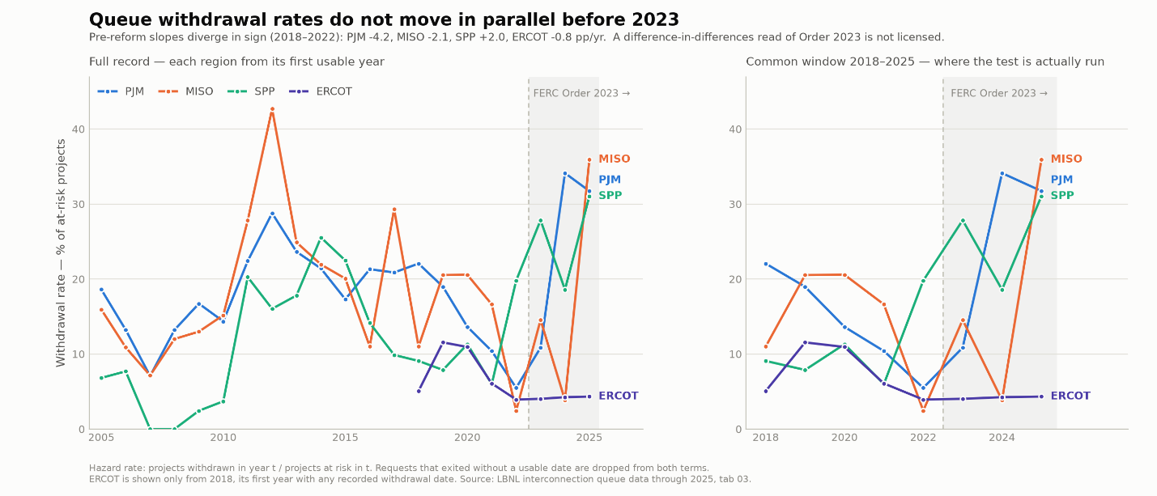
A two-panel exploratory chart (full 2005–2025 record plus a 2018–2025 zoom); the longer left panel is useful for establishing that the non-parallelism is not a short-window artifact.

6. Analysis panel construction

Variable definitions
build_analysis_panel.py → data/processed/analysis_panel.csv, 23 region-years, 2020–2025, 9 columns.
Variable | Definition | Units | Source
region | PJM, ERCOT, MISO, SPP | — | both
year | calendar year | — | both
mean_demand_gw | annual mean of hourly demand | GW | EIA-930, cleaned
demand_growth_yoy | (mean t − mean t−1) / mean t−1 | fraction | derived
mw_operational | capacity reaching operational status in the year | MW | LBNL tab 03
active_gw_excl_hybrid | active queue capacity at year end, hybrid storage excluded | GW | LBNL tab 09
clearance_rate | (100×mw_operational) / (1000×active_gw_excl_hybrid) | % | derived
ferc_jurisdictional | False for ERCOT, True otherwise | bool | —
likely_reform_driven | §4 screen | bool | derived

Two definitional cautions on clearance_rate:
- It crosses two sources. The numerator is aggregated from tab 03 microdata; the denominator is LBNL's tab 09 series, which includes imputed hybrid storage omitted by tab 03. active_gw_excl_hybrid is used specifically to keep the denominator on a consistent basis across the 2020 hybrid break, but numerator and denominator remain different aggregations and are not expected to reconcile.
Reuse of the Phase 1 demand means. Because no annual-mean artifact was persisted during the data-quality work (those figures existing only in DECISIONS.md), the means are recomputed from the cleaned hourly series using the documented method (.mean() directly in lieu of 8,760) and then checked value-by-value against the published table. The largest deviation is 0.0050 GW inside the table's two-decimal quoting precision. The check is a hard assertion, for a future re-pull that moves the series fails the build instead of publishing a second, divergent demand history.

The guard cascade
Two distinct cascades appear in the working log and are easy to conflate. Both are given here.
(a) The actual path to the analysis panel — 108 region-years down to 23:
Step | Rows | Why
Queue panel universe (4 regions × 2000–2026) | 108 | —
− 2026 (year_complete) | 104 | wd_date runs only to 2026-01-16; a 16-day stub
− pre-2019 (demand_years_available) | 28 | EIA-930 has no pre-2019 history on this API route
− 2019 (no prior year for a YoY growth rate) | 24 | base year, not a missing observation
− MISO 2025 (operational_series_usable=False) | 23 | no on_date records that year
− ERCOT 2022 (leverage-robustness fit only) | 22 | §7–8; not a sample restriction

Composition: n = 23 constitutes PJM 6, SPP 6, ERCOT 6, MISO 5; n = 22 PJM 6, SPP 6, ERCOT 5, MISO 5.
withdrawn_series_usable removes nothing additional inside the 2019+ window (ERCOT's withdrawal-coverage gap is entirely pre-2018).
The binding constraint is the demand window: the 2019+ restriction costs 76 of the 85 rows lost. The remaining 9 are the 2026 stub (4, one per region), the base-year requirement (4), and the quality guards (1, MISO 2025).
(b) The hypothetical if the reform flag were applied as a filter — this is whither the figure 20 in the working log comes; it is not the analysis panel:
Step | Rows
after year_complete, 2019+, and both usability flags | 27
− likely_reform_driven | 20

That cascade retains 2019 (it does not require a growth rate). In the analysis panel’s own frame, dropping the 7 flagged rows would leave 16. Neither 20 nor 16 is used (see §4).

First look before any model
Recorded before fitting so that the models could be judged against it:
- No relationship visible. At comparable demand growth (≈+3.5%), clearance ranges from 0.54 (MISO 2024) to 6.91 (ERCOT 2021), an order of magnitude.
- Region separates the data far more cleanly than growth. ERCOT occupies the high-clearance band in every year; MISO and SPP fall to single digits by 2023–2025.
- Clearance collapses in MISO and SPP but not in PJM or ERCOT. First observed year to last: MISO −92% (6.91 → 0.54), SPP −80% (4.63 → 0.94), PJM −4% (2.09 → 2.01), ERCOT +12% (2.27 → 2.54). This rules out the obvious reading; that is, PJM is FERC-jurisdictional and flat, so the split is not FERC vs. non-FERC.
- The collapse largely predates the reform flags. MISO falls 6.91 → 2.52 → 1.17 across 2020–2022, all three unflagged; its flagged 2023 continues a trend already nearly complete. SPP falls 4.63 → 3.20 → 3.05 before its first flagged year.
- The denominator does much of the work. MISO's backlog grows 90 → 397 GW while its completions fall 6,250 → 2,136 MW. Both movements push the ratio down, so a falling clearance rate is not evidence of slowing completions on its own.
- Year drifts the cloud downward but does not sort it. Pooled median clearance runs 3.45 → 2.86 → 2.11 → 1.48 → 1.87 → 2.01 (2020→2025)—down, then partially back up. 2024 contains both the lowest observation in the panel (MISO 5.4) and the second highest (ERCOT 45.7).

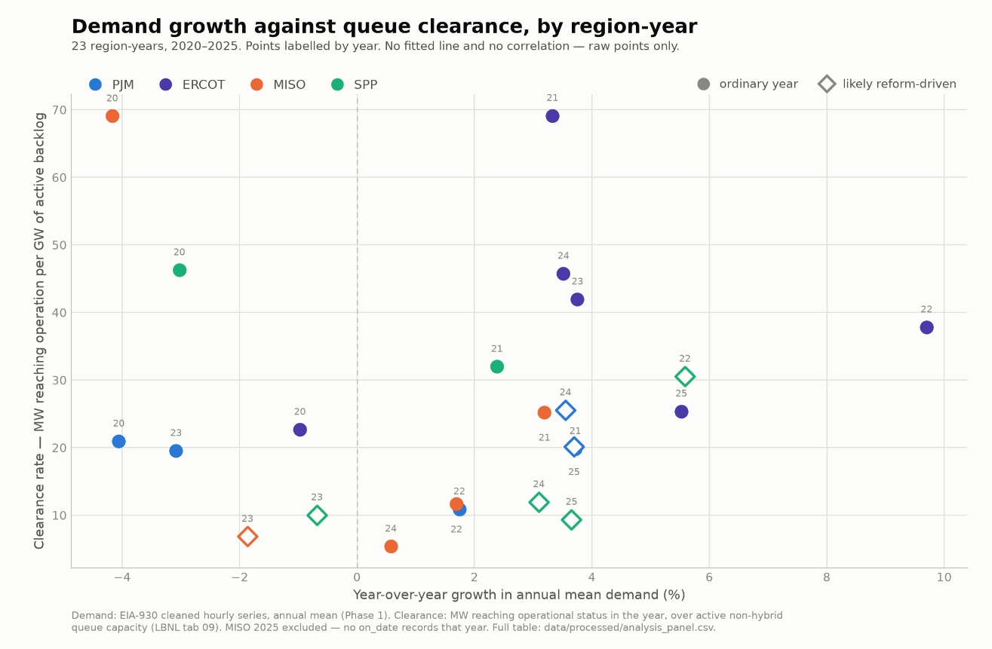
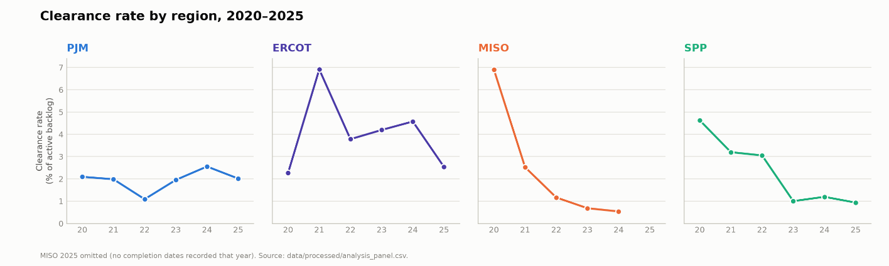
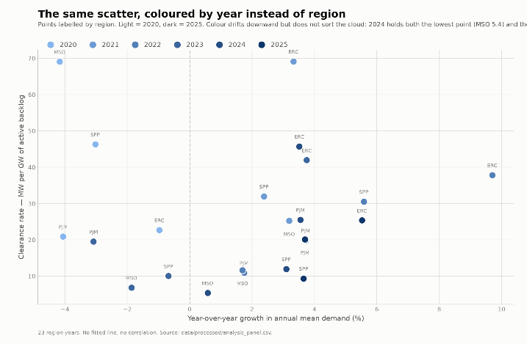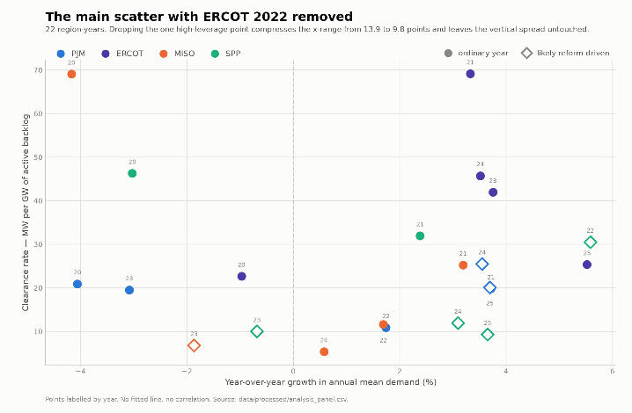
From top to bottom, left to right: figures/demand_growth_vs_clearance.png (the main scatter), figures/diag_clearance_by_year.png (per-region small multiples), figures/diag_scatter_by_year.png (scatter colored by year), figures/diag_scatter_no_ercot2022.png (leverage point removed). All four are exploratory. Every point carries a year label.

7. The apparent U-shape

How it appeared
The scatter showed low clearance in the middle of the growth range and high clearance at both ends. Fitting a quadratic on the n = 22 set confirmed a U with a positive growth² coefficient in every specification tried, and its magnitude barely moved when region was added, the opposite of what a confounded term does.
All figures below come from data/processed/diagnostic_model_results.csv. Growth and clearance rate are in percentage points.
 | M1 pooled | M2 + region | M0 region only
intercept | 1.7734 (0.6276) p=.011 | 1.0913 (0.8428) p=.214 | 1.9477 (0.7129) p=.014
growth | −0.1371 (0.1350) p=.323 | −0.2130 (0.1319) p=.126 | —
growth² | 0.0962 (0.0500) p=.070 | 0.0915 (0.0475) p=.072 | —
ERCOT | — | 2.3883 (1.0185) p=.032 | 2.1493 (1.0574) p=.057
MISO | — | 0.6199 (1.0081) p=.547 | 0.4155 (1.0574) p=.699
SPP | — | 0.5754 (0.9458) p=.551 | 0.3873 (1.0082) p=.705
R² | 0.1658 | 0.3904 | 0.2082
adj R² | 0.0780 | 0.1998 | 0.0762

The diagnostics
It is not absorbed by region. Adding region moves growth² from 0.962 to 0.915 (a ~5% change) with p essentially static (0.070 → 0.072). The hypothesis that the curvature was cross-regional level differences is rejected by the data.
Region and growth are close to orthogonal in this sample. Region alone buys R² 0.208; growth terms alone buy 0.166; together they buy 0.390, slightly more than the sum of the parts, so the two blocks are not competing for the same variance. Incrementally, growth adds 0.182 on top of region, and region adds 0.225 on top of growth.
It is not driven by one or two points. Cook's D on M2, screened at 4/n = 0.182, flags three observations: MISO 2020 (0.780), ERCOT 2025 (0.499), ERCOT 2021 (0.205). Refitting without all three (n = 19) moves growth² only to 0.795 with p = 0.073, R² rising to 0.516. The coefficient is stable across every specification and subsample tried.

The formal tests
Neither variable block earns its degrees of freedom:
Nested F-test | F | df | p
growth terms given region | 2.391 | (2, 16) | 0.1235
region given growth terms | 1.964 | (3, 16) | 0.1601

growth² itself never clears p < 0.05 in any fit: p = 0.070 (M1), 0.072 (M2), 0.073 (n = 19 refit). Adjusted R² for region-only (0.076) and growth-only (0.078) is essentially nil.

Why it was rejected
Despite being the most stable coefficient in the project, it was rejected on three grounds:
- It never reaches significance. p ≈ 0.07 in every specification, on 22 observations with 6 parameters, yet stable and underpowered does not automatically imply statistical significance.
- The vertex sits inside the data. The fitted minimum is at +0.71 pp growth (M1) and +1.16 pp (M2). The model is asserting that clearance is lowest at about 1% demand growth and rises both as growth falls toward zero and as it accelerates. No clear mechanism in queue economics predicts the U-shape.
- A simpler account fits. The parabola is accommodating high-clearance early years at both extremes of the growth axis: MISO 2020 at −4.17% and ERCOT 2021 at +3.33%, both at exactly 69.1 clearance. The curvature is picking up the early-period/late-period contrast documented in §6, positioned along a growth axis that happens to have early observations at both ends. Cook's D confirms the mechanism even though removing those points does not remove the term given there are further early-high/late-low pairs behind them.
A coefficient that is stable, insignificant, and shaped like nothing any obvious mechanism predicts is a description of this particular 22-point cloud. It is not carried into the final specification.

8. Final specification and result

Specification
clearance_rate = β₀ + β₁ · growth + region fixed effects + ε
Linear in growth, region fixed effects, OLS, PJM as the reference level. Growth (and clearance rate) are in percentage points (of backlog).
Dropping growth² is not a neutral simplification because the quadratic’s vertex sat inside the data and, therefore, the linear term in M2 was the slope of a parabola at zero rather than an average slope. The specification below estimates an average slope, which is the quantity the research question targets.
The full n = 23 set is preferred, the n = 22 set reported as a robustness check. ERCOT 2022 was excluded during diagnostics as a high-leverage point; §8’s own results show that it is not influential once region is in the model, so there is no basis for excluding it from the headline fit.

Coefficient table
From data/processed/diagnostic_model_results.csv. SEs in parentheses.
Term | L23 (preferred, n = 23) | L22 (robustness, n = 22)
Intercept (PJM) | 2.0537 (0.7042) p = .009 | 2.0672 (0.7251) p = .011
growth (pp) | −0.1144 (0.1183) p = .346 | −0.1290 (0.1340) p = .349
ERCOT | 2.4644 (1.0546) p = .031 | 2.4205 (1.0964) p = .041
MISO | 0.2962 (1.0391) p = .779 | 0.2810 (1.0688) p = .796
SPP | 0.4911 (0.9896) p = .626 | 0.5043 (1.0176) p = .627
R² | 0.2595 | 0.2491
adjusted R² | 0.0950 | 0.0724
region-only R² | 0.2211 | 0.2082
R² added by growth | +0.0385 | +0.0409
F(growth | region) | 0.935, df (1, 18), p = .346 | 0.926, df (1, 17), p = .349
95% CI on growth | [−0.3629, +0.1341] | [−0.4118, +0.1538]

Interpretation
- Demand growth has no detectable relationship with queue clearance. The point estimate is −0.114 percentage points of demand growth, with a standard error of 0.118. The 95% confidence interval runs from −0.363 to +0.134, p = .35.
- Growth does not earn its place in the model. It adds 3.9 points of R² for one degree of freedom (F(1, 18) = 0.94, p = .35). Adjusted R² at n = 22 (0.0724) sits below region-only (0.0762, from §7’s M0), meaning that on the penalized measure the growth term is worthless.
- The sign is negative. Both fits put more demand growth alongside marginally lower clearance. The interval is far too wide to support this as a finding, but it is worth stating that the data do not even weakly point in the direction the hypothesis anticipated.
- A single regional level difference registers. The ERCOT dummy is the only coefficient in the model clearing p < .05 (+2.46 pp, p = .031). ERCOT clears its backlog at a substantially higher rate than PJM throughout. MISO and SPP are statistically indistinguishable from PJM on average, which is itself informative as §6 demonstrated that both collapse over the window while PJM stays flat. A region fixed effect absorbs the level but not the trajectory, where the real variation is.
- The leverage point does not matter once region is in the model. The slope moves −1.290 → −1.144 between n = 22 and n = 23 (11% shift, sign unchanged, each estimate inside the other's 95% CI). This corrects the expectation set during EDA where ERCOT 2022 looked influential in the pooled scatter because it was being compared to the pooled cloud; with region in the model it is judged against ERCOT's own mean clearance of 40.4, so at 37.8 it is an entirely ordinary ERCOT year. In effect, its extreme growth gives it leverage on the x-axis, its unremarkable within-region clearance leaving it almost nothing with which to pull.
- This is a weak null, not a strong one. With 23 observations, 5 parameters and a 95% CI spanning −0.36 to +0.13, the specification cannot rule out an effect of real practical size in either direction. The correct reading is, frankly, that this design cannot detect a relationship, not that a relationship does not exist, per se. §9 sets out what would be needed.
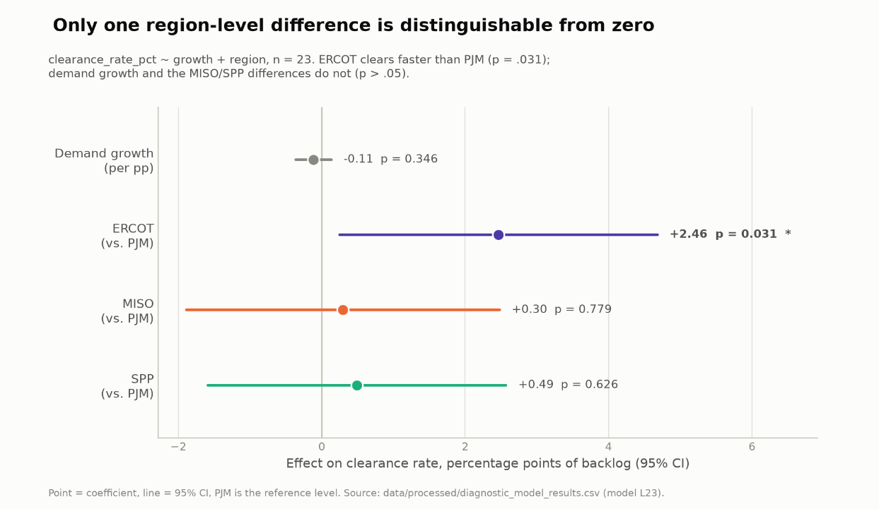
Point estimates and 95% confidence intervals from clearance_rate ~ growth + region (n = 23, PJM as reference). Only the ERCOT dummy is distinguishable from zero (p = .031); the demand-growth coefficient's interval spans −0.36 to +0.13 and comfortably contains zero.

9. Limitations
Ordered by how much they constrain the conclusion.

Statistical power is the binding limitation
23 observations, four cross-sectional units, six years. With region fixed effects consuming three degrees of freedom, the specification has 18 residual degrees of freedom and a 95% CI on the coefficient of interest spanning roughly ±0.25 percentage points around a point estimate of −0.11. Nothing short of a very large effect would be detectable. The null in §8 is a statement merely about the design's resolution.
The cause is documented and not fixable within this data, for the EIA-930 API route provides no history before 2019, costing 76 of the 85 region-years to get dropped from the queue panel. Extending backwards requires the separate Hourly Grid Monitor bulk-CSV pipeline, which would roughly double the panel to 2015 and is the single highest-value extension available.

The outcome variable is a ratio of two differently-sourced quantities
clearance_rate divides a flow computed from tab 03 microdata by a stock published in tab 09, whose hybrid-storage treatment differs. Movements in the ratio can originate in either term, and §6 shows the denominator frequently dominates. MISO’s backlog, for instance, quadrupled over the window while its completions fell by two-thirds, and both push the ratio the same way. Hence, a falling clearance rate by itself is not sufficient evidence of slowing completions. Reporting completions and backlog separately alongside the ratio would indicate which term moved.

The dominant variation in the data is unexplained
MISO fell 92% and SPP 80% while PJM stayed flat and ERCOT rose 12%. The largest and most robust pattern in the panel, it is not explained by FERC jurisdiction (PJM is jurisdictional and flat), it is not explained by the reform flag (both collapses begin before their first flagged year), and it is not explained by demand growth. It is, in fact, currently unmodeled. Any confidence in the growth coefficient is limited by something much larger happening for reasons this specification does not capture.

ERCOT is not cleanly comparable to the other three
ERCOT is non-FERC-jurisdictional and runs its own generator-interconnection process (a batch-study model, distinct from FERC Order no. 2023's cluster-study reform), which is the relevant distinction for the queue data used here; it also, separately, has its own newer large-load-specific rules (e.g., Texas SB6) that lie outside this project's data. ERCOT also has the worst outcome-date coverage of the four (82.1% of operational capacity dated, 39.8% of withdrawn). It carries the headline demand result (+27.2% against MISO's +2.2%), is the only region contributing a significant coefficient, and is the region whose data quality is weakest. Thus, the results are relatively sensitive to ERCOT's measurement quality.

The reform confound is controlled descriptively, not causally
§5 establishes that a DiD is not identified here. The reform is handled by flagging affected region-years and verifying that the results do not depend on them, which is weaker than estimating and removing its effect. Because ERCOT’s exemption makes being reform-affected nearly collinear with being under FERC jurisdiction in the late sample, the two cannot be separated within this design.

Withdrawal-side outcomes are not usable cross-regionally
Only 39.8% of ERCOT's withdrawn capacity carries a usable date, and coverage degrades in recent cohorts (24% for 2025 entrants). Any withdrawal-based outcome would be biased against ERCOT in exactly the period of interest. The analysis therefore rests on the completion side (on_date, 82–99% coverage), which is sound but leaves roughly half of the queue dynamic unmeasured.

Smaller items carried forward
- The finding concerns supply-side queue speed rather than data centers’ own grid connection. The outcome variable throughout this appendix is the generation interconnection queue (namely, how fast new power plants clear the process to connect to the grid), used here as a proxy for how responsive a region’s power supply is to rising demand. It is not a measure of how quickly a data center itself can be connected to draw power; that is a separate, historically state-regulated process only now beginning to be addressed federally. The result that jurisdiction predicts generation-queue clearance is not directly informative of how the load-connection process performs in those same regions; that question would need the load-side data that the newer federal dockets are only beginning to generate.
- CAISO is excluded simply because it was not included in the EIA-930 demand pull; were it included in the study, attention would have been paid to the 2024 mass-withdrawal event in tab 09. Note that its FERC jurisdiction would not have added much jurisdictional contrast.
- Detection thresholds are empirically calibrated to the corruption present in this pull (1.15× and 1.35× separate with good margins, but they are not derived rigorously). One ought to check excluded_hours.csv after any re-pull rather than assuming the count stays at 14.
- 2026 is a partial year (5,178 hours to 2026-08-04) and excluded from all growth endpoints; usable only against a like-for-like calendar window.
- 13 in-scope tab 03 rows report mw≤0, retained as reported.
- MISO 2025 is excluded twice over — no on_date records after 2024 and a 14.2× withdrawal spike. It is the worst single region-year in the panel.
- Sub-BA parent mapping is unaddressed. All four BAs used are parents, so it has not bitten; adding regions would require it.

10. Reproduction
Run in order from the project root. Each script prints its own diagnostics and writes its artifacts; none modifies data/raw/.
Stage | Script | Output
Pull | pull_eia930_demand.py | data/raw/eia930_hourly_demand.csv — 266,181 rows, immutable
Detect | eia930_quality.py | the three rules; imported, not run directly
Clean | clean_eia930.py | data/processed/eia930_hourly_demand.csv (266,167) + excluded_hours.csv (14)
Inspect | plot_demand_week.py | figures/demand_week_*.png
Queue panel | build_queue_panel.py | queue_outcomes_panel.csv (108) + queue_date_coverage.csv (8)
DiD pre-test | plot_withdrawal_parallel_trends.py | withdrawal_rates.csv (84) + figures/withdrawal_rate_parallel_trends.png
Analysis set | build_analysis_panel.py | analysis_panel.csv (23) + figures/demand_growth_vs_clearance.png
Diagnostics | plot_analysis_diagnostics.py | figures/diag_*.png (3)
Models | fit_diagnostic_models.py | diagnostic_model_results.csv (23 rows, 5 models)

Dependencies: pandas, numpy, matplotlib, openpyxl, statsmodels, requests.
build_analysis_panel.py contains a hard assertion that the recomputed annual demand means match the published table to within 0.01 GW. If a re-pull changes the demand series, then that assertion fails the build rather than allowing propagation of a divergent history.

