如何用 Markdown + Pandoc 写毕业论文

陆伟成

2018-03-18

Table of Contents

# 摘要

本文用简明的样例，介绍如何使用 Markdown 和 Pandoc 等自动化工具帮你处理数学公式、参考文献引用、图片交叉索引等学术论文写作中常见的棘手问题。

**关键词：** pandoc pandoc-crossref markdown

# Abstract

This is a tutorial file for writing a undergraduate thesis using Markdown and pandoc.

**Keywords:** pandoc, pandoc-crossref markdown

# 第一章 绪论

## §1.1 pandoc

Pandoc is a Haskell library for converting from one markup format to another, and a command-line tool that uses this library. It can read Markdown and write Word docx.

## §1.2 pandoc-crossref filter

With this filter[1], you can cross-reference figures (see 图 3.1), display equations (see 公式 3.1), tables (see 表 3.1) and sections (§ 1, 2, 4.1, 4.2)

There is also support for code blocks, for example, 列表 4.1, 4.2.

Subfigures are supported, see 图 5.1, 5.1 (b)

## §1.3 pandoc --reference-doc

Use the specified file as a style reference in producing a docx file. For best results, the reference docx should be a modified version of a docx file produced using pandoc. The contents of the reference docx are ignored, but its stylesheets and document properties (including margins, page size, header, and footer) are used in the new docx.

# 第二章 List Items

List items may include other lists. In this case the preceding blank line is optional. The nested list must be indented four spaces or one tab:

* fruits
  1. apples
     + macintosh
     + red delicious
  2. pears
  3. peaches
* vegetables
  + broccoli
  + chard

Pandoc also pays attention to the type of list marker used, and to the starting number:

1. Ninth
2. Tenth
3. Eleventh
   1. subone
   2. subtwo
   3. subthree

Pandoc supports definition lists, using the syntax of PHP Markdown Extra with some extensions.

Term 1

Definition 1

Term 2

Definition 2

# 第三章 图、表、公式

## §3.1 图

An image occurring by itself in a paragraph will be rendered as a figure with a caption.

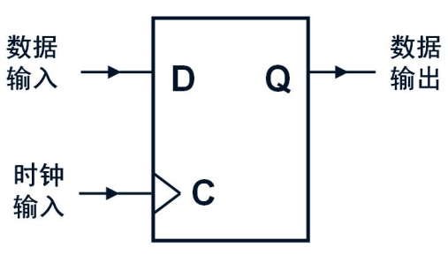

图 3.1: This is the caption

(source)

![This is the caption](media/image2.jpeg){#fig:figure0}

If you just want a regular inline image, just make sure it is not the only thing in the paragraph. One way to do this is to insert a nonbreaking space after the image:



(source)

![No caption](media/image2.jpeg)\

## §3.2 表

Simple tables can be generated using Markdown.

*表 3.1*: Table example

|  |  |  |
| --- | --- | --- |
|  | 28nm | 20nm |
| Fab Costs | $3B | $4B - $7B |
| Process R&D | $1.2B | $2.1B - $3B |
| Mask Costs | $2M - $3M | $5M - $8M |
| Design Costs | $50M - $90M | $120M - $500M |

(source)

| | 28nm | 20nm |  
|--------------|:-------------:|:---------------:|  
| Fab Costs | \$3B | \$4B - \$7B |  
| Process R&D | \$1.2B | \$2.1B - \$3B |  
| Mask Costs | \$2M - \$3M | \$5M - \$8M |  
| Design Costs | \$50M - \$90M | \$120M - \$500M |  
  
: Table example {#tbl:table1}

## §3.3 公式

Display equations are labelled and numbered:

(source)

$$P(x) = \sum_i a_i x^i$$ {#eq:eqn1}

Those can also appear in the middle of paragraph like this.

(source)

Those can also appear in the middle of   
paragraph $x^2 = 0$ like this.

# 第四章 Code blocks

There are a couple options for code block labels. Those work only if code block id starts with lst:, e.g. {#lst:label}

## §4.1 caption attribute

caption attribute will be treated as code block caption. If code block has both id and caption attributes, it will be treated as numbered code block.

列表 4.1: Listing caption A

main :: IO ()  
main = putStrLn "Hello World!"

## §4.2 Table-style captions

Enabled with codeBlockCaptions metadata option. If code block is immediately adjacent to paragraph, starting with Listing: or :, said paragraph will be treated as code block caption.

列表 4.2: Listing caption B

main :: IO ()  
main = putStrLn "Hello World!"

# 第五章 Subfigures

It’s possible to group figures as subfigures:

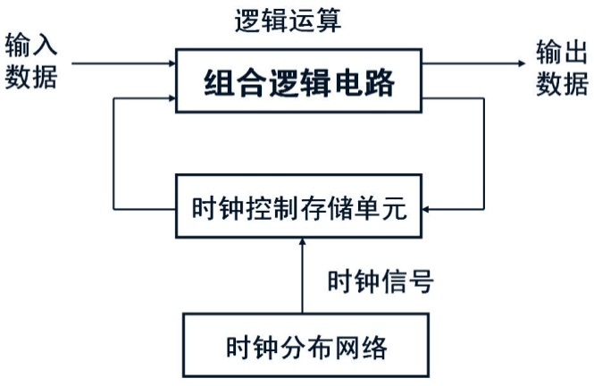

a



b

图 5.1: Caption of figure. a — subfigure 1 caption, b — subfigure 2 caption

(source)

<div id="fig:subfigures">  
![subfigure 1 caption](media/image1.jpeg){#fig:subfigureA}  
  
![subfigure 2 caption](media/image2.jpeg){#fig:subfigureB}  
  
Caption of figure  
</div>

To sum up, subfigures are made with a div having a figure id. Contents of said div consist of several paragraphs. All but last paragraphs contain one subfigure each, with captions, images and (optionally) reference attributes. Last paragraph contains figure caption.

# 第五章 文献综述

王国成阐述了大数据的特性变迁过程[1]。

其他学者讲述了大数据的价值和处理方式[2,3]。

# 附表一：crossref.yaml

---  
cref: False  
chapters: True  
chaptersDept: 2  
codeBlockCaptions: True  
figureTitle: "图 "  
tableTitle: "表 "  
listingTitle: "列表 "  
tableTemplate: "*$$tableTitle$$ $$i$$*$$titleDelim$$ $$t$$"  
autoSectionLabels: True  
figPrefix:  
 - "图"  
eqnPrefix:  
 - "公式"  
tblPrefix:  
 - "表"  
lstPrefix:  
 - "列表"  
secPrefix:  
 - "§"  
...

# 致谢

thanks everyone

# 参考文献

[1] 王国成. 从3V到5V:大数据助推经济行为的深化研究[J]. 天津社会科学, 2017(2): 94–99.

[2] 于晓龙, 王金照. 大数据的经济学涵义及价值创造机制[J]. 中国国情国力, 2014(2): 28–30.

[3] 徐计, 王国胤, 于洪. 基于粒计算的大数据处理[J]. 计算机学报, 2015(8): 1497–1517.

1. This file is generated by the command:

   pandoc -F pandoc-crossref -F pandoc-citeproc –bibliography=reference.bib –csl=chinese-gb7714-2005-numeric.csl –reference-doc=fd_bylw_t.docx –toc demo.md crossref.yaml -o temp.docx