# Introduction

## Common Perspective of Ellipsoid Method

* It is commonly believed that it is inefficient in practice for large-scale problems.
  + The convergent rate is slow, even with the use of deep cuts.
  + Cannot exploit sparsity.
* Since then, it was supplanted by interior-point methods.
* Only treated as a theoretical tool for proving the polynomial-time solvability of combinatorial optimization problems.

## But…

* The ellipsoid method works very differently compared with the interior point method.
* Only require a *separtion oracle*. Can play nicely with other techniques.
* The ellipsoid method itself cannot exploit sparsity, but the oracle can.

## Consider Ellipsoid Method When…

* The number of optimization variables is moderate, e.g. ECO flow, analog circuit sizing, parametric problems
* The number of constraints is large, or even infinite
* Oracle can be implemented efficiently.

class: middle, center

# Cutting-plane Method Revisited

## Basic Idea

.pull-left70[

* Let $K⊆R^{n}$ be a convex set.
* Consider the feasibility problem:
  + Find a point $x^{*}∈R^{n}$ in $K$,
  + or determine that $K$ is empty (i.e., no feasible solution)

] .pull-right30[

img

img

]

## Separation Oracle

.pull-left70[

* When a separation oracle $Ω$ is *queried* at $x_{0}$, it either
  + asserts that $x_{0}∈K$, or
  + returns a separating hyperplane between $x_{0}$ and $K$:

$$g^{T}(x−x_{0})+β≤0,β≥0,g≠0, ∀x∈K$$

] .pull-right30[

img

img

]

## Separation oracle (cont’d)

* $(g,β)$ is called a *cutting-plane*, or cut, since it eliminates the halfspace $\{x∣g^{T}(x−x_{0})+β>0\}$ from our search.
* If $β=0$ ( $x_{0}$ is on the boundary of halfspace that is cut), cutting-plane is called *neutral cut*.
* If $β>0$ ( $x_{0}$ lies in the interior of halfspace that is cut), cutting-plane is called *deep cut*.
* If $β<0$ ( $x_{0}$ lies in the exterior of halfspace that is cut), cutting-plane is called *shallow cut*.

## Subgradient

* $K$ is usually given by a set of inequalities $f_{j}(x)≤0$ or $f_{j}(x)<0$ for $j=1⋯m$, where $f_{j}(x)$ is a convex function.
* A vector $g≡∂f(x_{0})$ is called a subgradient of a convex function $f$ at $x_{0}$ if $f(z)≥f(x_{0})+g^{T}(z−x_{0})$.
* Hence, the cut $(g,β)$ is given by $(∂f(x_{0}),f(x_{0}))$

Remarks:

* If $f(x)$ is differentiable, we can simply take $∂f(x_{0})=∇f(x_{0})$

## Key components of Cutting-plane method

* Cutting plane oracle $Ω$
* A search space $S$ initially big enough to cover $K$, e.g.
  + Polyhedron $P$ = $\{z∣Cz≼d\}$
  + Interval $I$ = $[l,u]$ (for one-dimensional problem)
  + Ellipsoid $E$ = $\{z∣(z−x_{c})P^{−1}(z−x_{c})≤1\}$

## Generic Cutting-plane method

* **Given** initial $S$ known to contain $K$.
* **Repeat**
  1. Choose a point $x_{0}$ in $S$
  2. Query the cutting-plane oracle at $x_{0}$
  3. **If $x_{0}∈K$** , quit
  4. **Else**, update $S$ to a smaller set that covers:
 $$S^{+}=S∩\{z∣g^{T}(z−x_{0})+β≤0\}$$

 5. **If $S^{+}=∅$** or it is small enough, quit.

## Corresponding Python code

.small[

def cutting_plane_feas(Omega, S, options=Options())  
 feasible = False  
 status = 0  
 for niter in range(options.max_it):  
 cut = Omega(S.xc) # query the oracle at S.xc  
 if cut is None: # feasible sol'n obtained  
 feasible = True  
 break  
 status, tsq = S.update(cut) # update S  
 if status != 0:  
 break  
 if tsq < options.tol:  
 status = 2  
 break  
 return CInfo(feasible, niter + 1, status)

]

## From Feasibility to Optimization

$$\begin{matrix}\text{minimize} & f_{0}(x), \\ \text{subject to} & x∈K\end{matrix}$$

* The optimization problem is treated as a feasibility problem with an additional constraint $f_{0}(x)≤t$
* $f_{0}(x)$ could be a convex function or a *quasiconvex function*.
* $t$ is also called the *best-so-far* value of $f_{0}(x)$.

## Convex Optimization Problem

* Consider the following general form:
$$\begin{matrix}\text{minimize} & t, \\ \text{subject to} & Φ(x,t)≤0, \\ & x∈K,\end{matrix}$$

* where $K′_{t}=\{x∣Φ(x,t)≤0\}$ is the $t$-sublevel set of $\{x∣f_{0}(x)≤t\}$.
* 👉 Note: ${K′}_{t}⊆{K′}_{u}$ if and only if $t≤u$ (monotonicity)
* One easy way to solve the optimization problem is to apply the binary search on $t$.

.small[

def bsearch(Omega, I, options=Options()):  
 # assume monotone  
 lower, upper = I  
 u_orig = upper  
 for niter in range(options.max_it):  
 t = lower + (upper - lower) / 2  
 if Omega(t): # feasible sol'n obtained  
 upper = t  
 else:  
 lower = t  
 tau = (upper - lower) / 2  
 if tau < options.tol:  
 break  
 ret = CInfo(upper != u_orig, niter + 1, 0)  
 ret.value = upper  
 return ret

]

.small[

class bsearch_adaptor:  
 def __init__(self, P, S, options=Options()):  
 self.P = P  
 self.S = S  
 self.options = options  
  
 @property  
 def x_best(self):  
 return self.S.xc  
  
 def __call__(self, t):  
 S = self.S.copy()  
 self.P.update(t)  
 ell_info = cutting_plane_feas(self.P, S, self.options)  
 if ell_info.feasible:  
 self.S.xc = S.xc  
 return True  
 return False

]

## Shrinking

* Another possible way is, to update the best-so-far $t$ whenever a feasible solution $x′$ is found by solving the equation:
$$Φ(x′,t_{\text{new}})=0 .$$

* If the equation is difficuit to solve but $t$ is also convex w.r.t. $Φ$, then we may create a new varaible, say $z$ and let $z≤t$.

## Generic Cutting-plane method (Optim)

* **Given** initial $S$ known to contain $K_{t}$.
* **Repeat**
  1. Choose a point $x_{0}$ in $S$
  2. Query the separation oracle at $x_{0}$
  3. **If $x_{0}∈K_{t}$** , update $t$ such that $Φ(x_{0},t)=0$.
  4. Update $S$ to a smaller set that covers:
 $$S^{+}=S∩\{z∣g^{T}(z−x_{0})+β≤0\}$$

 5. **If $S^{+}=∅$** or it is small enough, quit.

.small[

def cutting_plane_dc(Omega, S, t, options=Options()):  
 x_best = S.xc # this is copy  
 t_orig = t  
  
 for niter in range(options.max_it):  
 cut, t1 = Omega(S.xc, t)  
 if t != t1: # best t obtained  
 t = t1  
 x_best = S.xc  
 status, tsq = S.update(cut)  
 if status != 0:  
 break  
 if tsq < options.tol:  
 status = 2  
 break  
  
 ret = CInfo(t != t_orig, niter + 1, status)  
 ret.value = t  
 return x_best, ret

]

## Example - Profit Maximization Problem

This example is taken from [@Aliabadi2013Robust].

$$\begin{matrix}\text{maximize} & p(Ax_{1}^{α}x_{2}^{β})−v_{1}x_{1}−v_{2}x_{2} \\ \text{subject to} & x_{1}≤k.\end{matrix}$$

* $p(Ax_{1}^{α}x_{2}^{β})$: Cobb-Douglas production function
* $p$: the market price per unit
* $A$: the scale of production
* $α,β$: the output elasticities
* $x$: input quantity
* $v$: output price
* $k$: a given constant that restricts the quantity of $x_{1}$

## Example - Profit maximization (cont’d)

* The formulation is not in the convex form.
* Rewrite the problem in the following form:

$$\begin{matrix}\text{maximize} & t \\ \text{subject to} & t+v_{1}x_{1}+v_{2}x_{2}≤pAx_{1}^{α}x_{2}^{β} \\ & x_{1}≤k.\end{matrix}$$

## Profit maximization in Convex Form

* By taking the logarithm of each variable:
  + $y_{1}=\text{log}x_{1}$, $y_{2}=\text{log}x_{2}$.
* We have the problem in a convex form:

$$\begin{matrix}\text{max} & t \\ \text{s.t.} & \text{log}(t+v_{1}e^{y_{1}}+v_{2}e^{y_{2}})−(αy_{1}+βy_{2})≤\text{log}(pA) \\ & y_{1}≤\text{log}k.\end{matrix}$$

.small[

class profit_oracle:  
 def __init__(self, params, a, v):  
 p, A, k = params  
 self.log_pA = np.log(p * A)  
 self.log_k = np.log(k)  
 self.v = v  
 self.a = a  
  
 def __call__(self, y, t):  
 fj = y[0] - self.log_k # constraint  
 if fj > 0.:  
 g = np.array([1., 0.])  
 return (g, fj), t  
 log_Cobb = self.log_pA + self.a @ y  
 x = np.exp(y)  
 vx = self.v @ x  
 te = t + vx  
 fj = np.log(te) - log_Cobb  
 if fj < 0.:  
 te = np.exp(log_Cobb)  
 t = te - vx  
 fj = 0.  
 g = (self.v * x) / te - self.a  
 return (g, fj), t

]

.small[

# Main program  
  
import numpy as np  
from ellpy.cutting_plane import cutting_plane_dc  
from ellpy.ell import ell  
from .profit_oracle import profit_oracle  
  
p, A, k = 20., 40., 30.5  
params = p, A, k  
alpha, beta = 0.1, 0.4  
v1, v2 = 10., 35.  
a = np.array([alpha, beta])  
v = np.array([v1, v2])  
y0 = np.array([0., 0.]) # initial x0  
r = np.array([100., 100.]) # initial ellipsoid (sphere)  
E = ell(r, y0)  
P = profit_oracle(params, a, v)  
yb1, ell_info = cutting_plane_dc(P, E, 0.)  
print(ell_info.value, ell_info.feasible)

]

## Area of Applications

* Robust convex optimization
  + oracle technique: affine arithmetic
* Parametric network potential problem
  + oracle technique: negative cycle detection
* Semidefinite programming
  + oracle technique: Cholesky or $LDL^{T}$ factorization

class: middle, center

# Robust Convex Optimization

## Robust Optimization Formulation

* Consider:
$$\begin{matrix}\text{minimize} & \underset{q∈Q}{\text{sup}}f_{0}(x,q), \\ \text{subject to} & f_{j}(x,q)≤0, ∀q∈Q, j=1,2,⋯,m,\end{matrix}$$

* where $q$ represents a set of varying parameters.
* The problem can be reformulated as:

$$\begin{matrix}\text{minimize} & t \\ \text{subject to} & f_{0}(x,q)<t \\ & f_{j}(x,q)≤0, ∀q∈Q, j=1,2,⋯,m.\end{matrix}$$

## Example - Profit Maximization Problem (convex)

$$\begin{matrix}\text{max} & t \\ \text{s.t.} & \text{log}(t+{\hat{v}}_{1}e^{y_{1}}+{\hat{v}}_{2}e^{y_{2}})−(\hat{α}y_{1}+\hat{β}y_{2})≤\text{log}(\hat{p} A) \\ & y_{1}≤\text{log}\hat{k},\end{matrix}$$

* Now assume that:
  + $\hat{α}$ and $\hat{β}$ vary $\overset{‾}{α}±e_{1}$ and $\overset{‾}{β}±e_{2}$ respectively.
  + $\hat{p}$, $\hat{k}$, ${\hat{v}}_{1}$, and ${\hat{v}}_{2}$ all vary $±e_{3}$.

## Example - Profit Maximization Problem (oracle)

By detail analysis, the worst case happens when:

* $p=\overset{‾}{p}−e_{3}$, $k=\overset{‾}{k}−e_{3}$
* $v_{1}={\overset{‾}{v}}_{1}+e_{3}$, $v_{2}={\overset{‾}{v}}_{2}+e_{3}$,
* if $y_{1}>0$, $α=\overset{‾}{α}−e_{1}$, else $α=\overset{‾}{α}+e_{1}$
* if $y_{2}>0$, $β=\overset{‾}{β}−e_{2}$, else $β=\overset{‾}{β}+e_{2}$

.small[

class profit_rb_oracle:  
 def __init__(self, params, a, v, vparams):  
 e1, e2, e3, e4, e5 = vparams  
 self.a = a  
 self.e = [e1, e2]  
 p, A, k = params  
 params_rb = p - e3, A, k - e4  
 self.P = profit_oracle(params_rb, a, v + e5)  
  
 def __call__(self, y, t):  
 a_rb = self.a.copy()  
 for i in [0, 1]:  
 a_rb[i] += self.e[i] if y[i] <= 0 else -self.e[i]  
 self.P.a = a_rb  
 return self.P(y, t)

]

## Oracle in Robust Optimization Formulation

* The oracle only needs to determine:
  + If $f_{j}(x_{0},q)>0$ for some $j$ and $q=q_{0}$, then
    - the cut $(g,β)$ = $(∂f_{j}(x_{0},q_{0}),f_{j}(x_{0},q_{0}))$
  + If $f_{0}(x_{0},q)≥t$ for some $q=q_{0}$, then
    - the cut $(g,β)$ = $(∂f_{0}(x_{0},q_{0}),f_{0}(x_{0},q_{0})−t)$
  + Otherwise, $x_{0}$ is feasible, then
    - Let $q_{\text{max}}={\text{argmax}}_{q∈Q}f_{0}(x_{0},q)$.
    - $t:=f_{0}(x_{0},q_{\text{max}})$.
    - The cut $(g,β)$ = $(∂f_{0}(x_{0},q_{\text{max}}),0)$

Remark:

* for more complicated problems, affine arithmetic could be used [@liu2007robust].

class: middle, center

# Multi-parameter Network Problem

## Parametric Network Problem

Given a network represented by a directed graph $G=(V,E)$.

Consider:

$$\begin{matrix}\text{find} & x,u \\ \text{subject to} & u_{j}−u_{i}≤h_{ij}(x), ∀(i,j)∈E,\end{matrix}$$

* $h_{ij}(x)$ is the concave function of edge $(i,j)$,
* Assume: network is large but the number of parameters is small.

## Network Potential Problem (cont’d)

Given $x$, the problem has a feasible solution if and only if $G$ contains no negative cycle. Let $C$ be a set of all cycles of $G$.

$$\begin{matrix}\text{find} & x \\ \text{subject to} & w_{k}(x)≥0,∀C_{k}∈C,\end{matrix}$$

* $C_{k}$ is a cycle of $G$
*.

## Negative Cycle Finding

There are lots of methods to detect negative cycles in a weighted graph [@cherkassky1999negative], in which Tarjan’s algorithm [@Tarjan1981negcycle] is one of the fastest algorithms in practice [@alg:dasdan_mcr; @cherkassky1999negative].

## Oracle in Network Potential Problem

* The oracle only needs to determine:
  + If there exists a negative cycle $C_{k}$ under $x_{0}$, then
    - the cut $(g,β)$ = $(−∂w_{k}(x_{0}),−w_{k}(x_{0}))$
  + Otherwise, the shortest path solution gives the value of $u$.

## Python Code

.small[

class network_oracle:  
 def __init__(self, G, dist, h):  
 self.G = G  
 self.dist = dist  
 self.h = h  
 self.S = negCycleFinder(G)  
  
 def update(self, t):  
 self.h.update(t)  
  
 def __call__(self, x):  
 def get_weight(G, e):  
 return self.h.eval(G, e, x)  
  
 C = self.S.find_neg_cycle(self.dist, get_weight)  
 if C is None:  
 return None  
 f = -sum(self.h.eval(self.G, e, x) for e in C)  
 g = -sum(self.h.grad(self.G, e, x) for e in C)  
 return g, f

]

## Example - Optimal Matrix Scaling [@orlin1985computing]

* Given a sparse matrix $A=[a_{ij}]∈R^{N×N}$.
* Find another matrix $B=UAU^{−1}$ where $U$ is a nonnegative diagonal matrix, such that the ratio of any two elements of $B$ in absolute value is as close to 1 as possible.
* Let $U=diag([u_{1},u_{2},…,u_{N}])$. Under the min-max-ratio criterion, the problem can be formulated as:

$$\begin{matrix}\text{minimize} & π/ψ \\ \text{subject to} & ψ≤u_{i}|a_{ij}|u_{j}^{−1}≤π, ∀a_{ij}≠0, \\ & π,ψ,u, \text{positive} \\ \text{variables} & π,ψ,u .\end{matrix}$$

## Optimal Matrix Scaling (cont’d)

By taking the logarithms of variables, the above problem can be transformed into:

$$\begin{matrix}\text{minimize} & t \\ \text{subject to} & π′−ψ′≤t \\ & u_{i}′−u_{j}′≤π′−a_{ij}′, ∀a_{ij}≠0 , \\ & u_{j}′−u_{i}′≤a_{ij}′−ψ′, ∀a_{ij}≠0 , \\ \text{variables} & π′,ψ′,u′ .\end{matrix}$$

where $k′$ denotes $\text{log}(|k|)$ and $x=(π′,ψ′)^{T}$.

.small[

class optscaling_oracle:  
 def __init__(self, G, dist):  
 class ratio:  
 def eval(self, G, e, x):  
 u, v = e  
 cost = G[u][v]['cost']  
 return x[0] - cost if u < v else cost - x[1]  
  
 def grad(self, G, e, x):  
 u, v = e  
 return np.array([1., 0.] if u < v else [0., -1.])  
  
 self.network = network_oracle(G, dist, ratio())  
  
 def __call__(self, x, t):  
 cut = self.network(x)  
 if cut:  
 return cut, t  
 s = x[0] - x[1]  
 fj = s - t  
 if fj < 0.:  
 t = s  
 fj = 0.  
 return (np.array([1., -1.]), fj), t

]

## Example - clock period & yield-driven co-optimization

$$\begin{matrix}\text{minimize} & T_{\text{CP}}/β \\ \text{subject to} & u_{i}−u_{j}≤T_{\text{CP}}−F_{ij}^{−1}(β), & ∀(i,j)∈E_{s} , \\ & u_{j}−u_{i}≤F_{ij}^{−1}(1−β), & ∀(j,i)∈E_{h} , \\ & T_{\text{CP}}≥0, 0≤β≤1 , \\ \text{variables} & T_{\text{CP}},β,u.\end{matrix}$$

* 👉 Note that $F_{ij}^{−1}(x)$ is not concave in general in $[0,1]$.
* Fortunately, we are most likely interested in optimizing circuits for high yield rather than the low one in practice.
* Therefore, by imposing an additional constraint to $β$, say $β≥0.8$, the problem becomes convex.

## Example - clock period & yield-driven co-optimization

The problem can be reformulated as:

$$\begin{matrix}\text{minimize} & t \\ \text{subject to} & T_{\text{CP}}−βt≤0 \\ & u_{i}−u_{j}≤T_{\text{CP}}−F_{ij}^{−1}(β), & ∀(i,j)∈E_{s} , \\ & u_{j}−u_{i}≤F_{ij}^{−1}(1−β), & ∀(j,i)∈E_{h} , \\ & T_{\text{CP}}≥0, 0≤β≤1 , \\ \text{variables} & T_{\text{CP}},β,u.\end{matrix}$$

class: middle, center

# Matrix Inequalities

## Problems With Matrix Inequalities

Consider the following problem:

$$\begin{matrix}\text{find} & x, \\ \text{subject to} & F(x)≽0,\end{matrix}$$

* $F(x)$: a matrix-valued function
* $A≽0$ denotes $A$ is positive semidefinite.

## Problems With Matrix Inequalities

* Recall that a matrix $A$ is positive semidefinite if and only if $v^{T}Av≥0$ for all $v∈R^{N}$.
* The problem can be transformed into:
$$\begin{matrix}\text{find} & x, \\ \text{subject to} & v^{T}F(x)v≥0, ∀v∈R^{N}\end{matrix}$$

* Consider $v^{T}F(x)v$ is concave for all $v∈R^{N}$ w. r. t. $x$, then the above problem is a convex programming.
* Reduce to *semidefinite programming* if $F(x)$ is linear w.r.t. $x$, i.e., $F(x)=F_{0}+x_{1}F_{1}+⋯+x_{n}F_{n}$

## Oracle in Matrix Inequalities

The oracle only needs to:

* Perform a *row-based* LDLT factorization such that $F(x_{0})=LDL^{T}$.
* Let $A_{:p,:p}$ denotes a submatrix $A(1:p,1:p)∈R^{p×p}$.
* If the process fails at row $p$,
  + there exists a vector $e_{p}=(0,0,⋯,0,1)^{T}∈R^{p}$, such that
    - $v=R_{:p,:p}^{−1}e_{p}$, and
    - $v^{T}F_{:p,:p}(x_{0})v<0$.
  + The cut $(g,β)$ = $(−v^{T}∂F_{:p,:p}(x_{0})v,−v^{T}F_{:p,:p}(x_{0})v)$

## Lazy evaluation

* Don’t construct the full matrix at each iteration!
* Only O($p^{3}$) per iteration, independent of $N$!

.small[

class lmi_oracle:  
 ''' Oracle for LMI constraint F*x <= B '''  
  
 def __init__(self, F, B):  
 self.F = F  
 self.F0 = B  
 self.Q = chol_ext(len(self.F0))  
  
 def __call__(self, x):  
 n = len(x)  
  
* def getA(i, j):  
* return self.F0[i, j] - sum(  
* self.F[k][i, j] * x[k] for k in range(n))  
*  
* self.Q.factor(getA)  
 if self.Q.is_spd():  
 return None  
 v, ep = self.Q.witness()  
 g = np.array([self.Q.sym_quad(v, self.F[i])  
 for i in range(n)])  
 return g, ep

]

## Google Benchmark Comparison

2: ----------------------------------------------------------  
2: Benchmark Time CPU Iterations  
2: ----------------------------------------------------------  
2: BM_LMI_Lazy 131235 ns 131245 ns 4447  
2: BM_LMI_old 196694 ns 196708 ns 3548  
2/4 Test #2: Bench_BM_lmi ..................... Passed 2.57 sec

## Example - Matrix Norm Minimization

* Let $A(x)=A_{0}+x_{1}A_{1}+⋯+x_{n}A_{n}$
* Problem ${\text{min}}_{x}∥A(x)∥$ can be reformulated as
$$\begin{matrix}\text{minimize} & t, \\ \text{subject to} & \left(\begin{matrix}t I & A(x) \\ A^{T}(x) & t I\end{matrix}\right)≽0,\end{matrix}$$

* Binary search on $t$ can be used for this problem.

.small[

class qmi_oracle:  
 t = None  
 count = 0  
  
 def __init__(self, F, F0):  
 self.F = F  
 self.F0 = F0  
 self.Fx = np.zeros(F0.shape)  
 self.Q = chol_ext(len(F0))  
  
 def update(self, t): self.t = t  
  
 def __call__(self, x):  
 self.count = 0; nx = len(x)  
  
 def getA(i, j):  
 if self.count < i + 1:  
 self.count = i + 1  
 self.Fx[i] = self.F0[i]  
 self.Fx[i] -= sum(self.F[k][i] * x[k]  
 for k in range(nx))  
 a = -self.Fx[i].dot(self.Fx[j])  
 if i == j: a += self.t  
 return a  
  
 self.Q.factor(getA)  
 if self.Q.is_spd(): return None  
 v, ep = self.Q.witness()  
 p = len(v)  
 Av = v.dot(self.Fx[:p])  
 g = np.array([-2*v.dot(self.F[k][:p]).dot(Av)  
 for k in range(nx)])  
 return (g, ep)

]

## Example - Estimation of Correlation Function

$$\begin{matrix}\underset{κ,p}{\text{min}} & ∥Σ(p)+κI−Y∥ \\ \text{s. t.} & Σ(p)≽0,κ≥0 .\end{matrix}$$

* Let $ρ(h)=\sum_{i}^{n}{p_{i}}Ψ_{i}(h)$, where
  + $p_{i}$’s are the unknown coefficients to be fitted
  + $Ψ_{i}$’s are a family of basis functions.
* The covariance matrix $Σ(p)$ can be recast as:
$$Σ(p)=p_{1}F_{1}+⋯+p_{n}F_{n}$$

* where $\{F_{k}\}_{i,j}=Ψ_{k}(∥s_{j}−s_{i}∥_{2})$

## 🔬 Experimental Result

.pull-left[

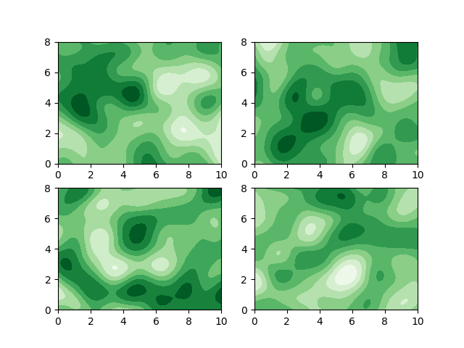

Data Sample (kern=0.5)

] .pull-right[

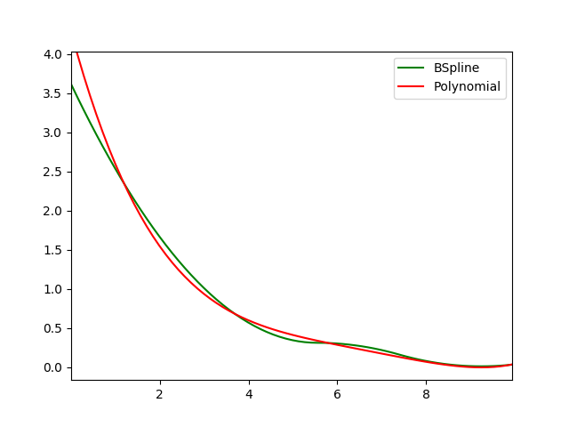

Least Square Result

]

## 🔬 Experimental Result II

.pull-left[

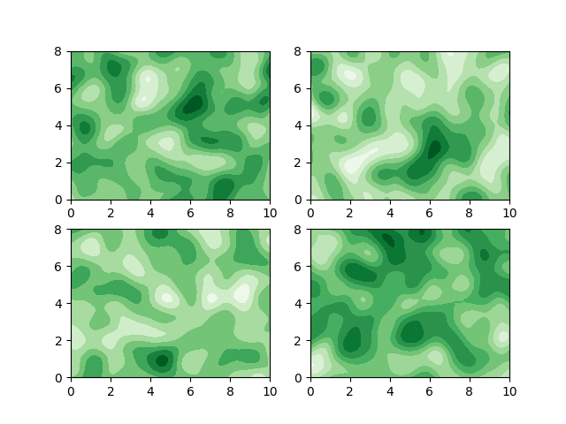

Data Sample (kern=1.0)

] .pull-right[

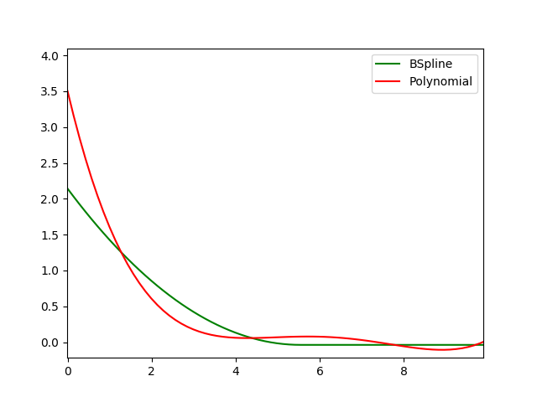

Least Square Result

]

## 🔬 Experimental Result III

.pull-left[

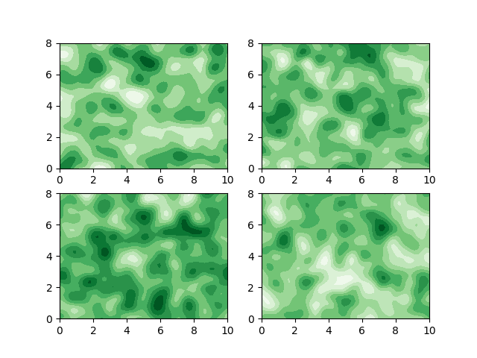

Data Sample (kern=2.0)

] .pull-right[

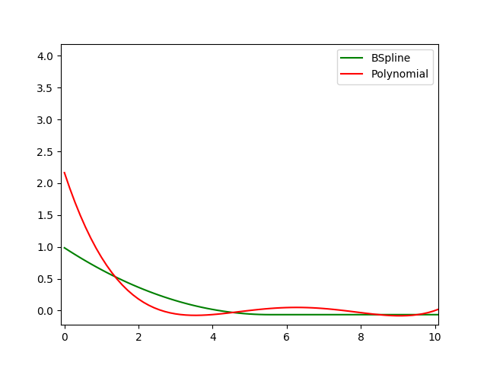

Least Square Result

]

# Q & A 🗣️