Lubuntu 18.04 LTS

@luk036

## Why and Why not?

Why Lubuntu?

* Lightweight.
  + Can be run on an old PC computer.
  + Can be run on a USB drive.
* Open source.
* Less virus. No need antivirus software.
* Software development.
* 18.04 LTS is a long-term-support version.

Why not?

* [Online Microsoft’s Office](https://office.com) is not good enough.
* VPN
* Wi-Fi Hotspot

# ⚙️ Setup

## Adjust the Display Settings (optional)

In case you are using a laptop with an external monitor:

* Select Preferences → Monitor Settings from main menu.
* Select Turn off laptop LCD and use external monitor only.
* Click Apply.
* Then re-select Show the same screen on both laptop LCD and external monitor only
* Click Apply and Save

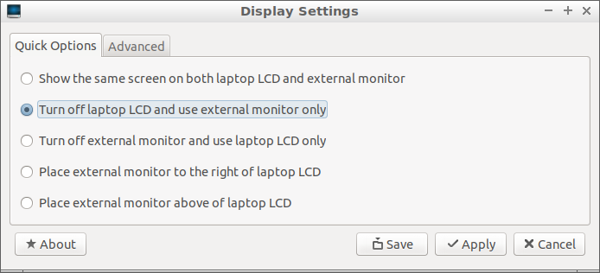

image

## 📶 Network Connections

* More or less the same as in Windows.
* Note that some networks may require a login from a web browser.

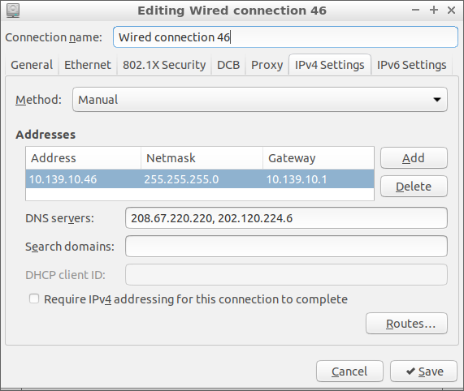

image

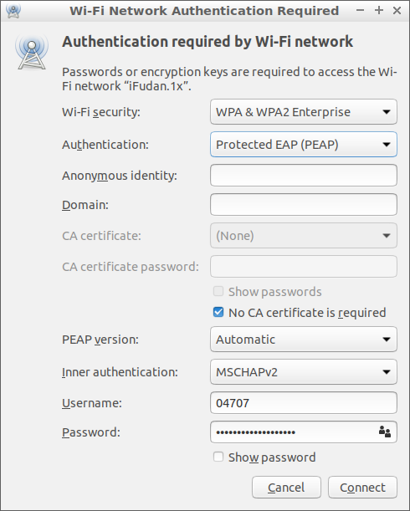

image

## Configure Software Updates Download Server

* Much faster than the main server.
* Select Preferences → Software & Updates from main menu.
* Select Download from: Other...
* Choose a Download Server near your location.

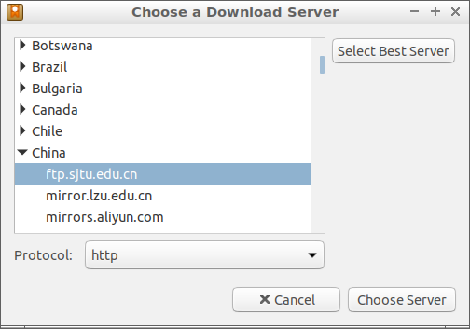

image

## 📅 Adjust Time and Date

* Press Ctrl-Alt-T to open a terminal.
* Type sudo apt install ntp to install a synchronization service.
* Select Sytem Tools → Time and Date
* Choose the Time zone of your location.
* Make sure Keep synchronized with Internet servers
* Wait a few seconds to make it take effective.

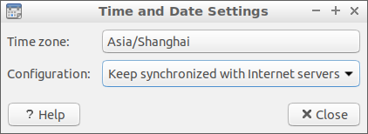

image

## Install shadowsocks

* sudo apt install shadowsocks
* edit /etc/shadowsocks.json
* exec sslocal -c /etc/shadowsocks.json

You may need Firefox Addon FoxyProxy Standard to use shadowsocks:

* SOCKS5: 127.0.0.1:1080

## Firefox Web Browser

* Built-in with Lubuntu.
* Sign-in to sync with other machines.
* Always enabled Add-ons:
  + Redirector, uBlock Origin, Redirector, Vimium, 百度广告屏蔽,
* Installed Add-ons: Chirpy, Evernote Web Clipper, Google Scholar Button, Grammarly for Firefox, Mendeley Importer, New Tong Wen Tang, QiuReader, Stylish, Tomato Clock, Zotero Connector

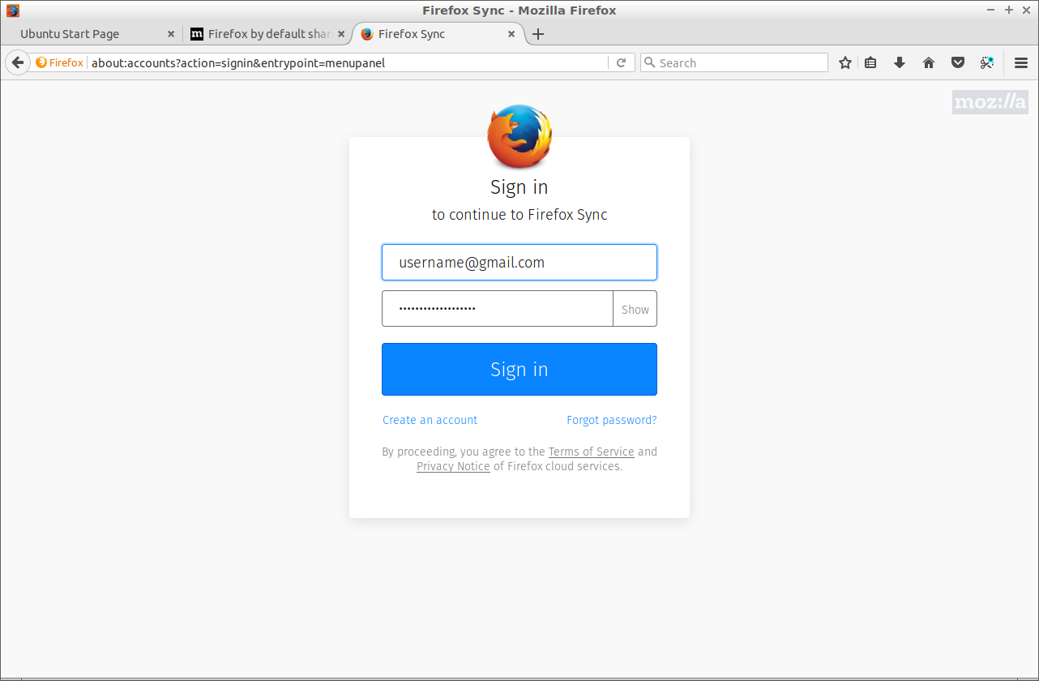

image

## 🀄 Chinese Input Methods

* IBus is better than Fcitx
* Press Ctrl-Alt-T to open a terminal.
* Type sudo apt install ibus-pinyin to install Pinyin method.
* You may want ibus-cangjie for 仓颉 or 速成。
* Select Preferences → Language Support from main menu.
* Ignore the warning The language support is not installed completely. Click Remind Me Later.
* Choose IBus from Keyboad input method system.
* Select Preferences → IBusPreferences from main menu.
* Select Input Method then Add. Select Chinese and then Pinyin.
* Reboot the System. Press <Super>-Space to switch the input methods.

## Display Emoji ⌨️

* sudo apt install fonts-emojione
* sudo apt install fonts-noto-color-emoji
* Reboot the system.

## 🔧 Tools

* aria2
* Chrome, Firefox (web browser)
* Stacer
* simplescreenrecorder
* asciinema
* tmux
* git, gh
* vscode
* neovim
* miniconda

## MiniConda Installation

* Assume install to a USB stick, in which the file system is mounted to $USB, and is read/write accessible.
* Use Conda to install Python and Python-related C++’s libraries:

wget "http://repo.continuum.io/miniconda/Miniconda3-latest-Linux-x86_64.sh" \  
 -O miniconda.sh  
export CONDA_PREFIX=$USB/miniconda3  
bash miniconda.sh -b -p $CONDA_PREFIX  
export PATH="$CONDA_PREFIX/bin:$PATH" # overwrite the system python  
export LD_LIBRARY_PATH="$CONDA_PREFIX/lib"

## conda install

conda install cmake ninja  
conda install -c conda-forge boost

## Useful Tips 💡

* Share programs between Systems:

export USB=/media/lubuntu/USBDISK  
export CONDA_PREFIX=$USB/miniconda3  
export PATH=$USB/VSCode-linux-x64/bin:$CONDA_PREFIX/bin:$PATH  
  
# optinal for advanced software development  
export LD_LIBRARY_PATH=$CONDA_PREFIX/lib  
export LDFLAGS="$LDFLAGS -lrt"

* Share files between Systems:

ln -s $USB/github .  
ln -s $USB/loksu .

## Useful keyboard shortcuts

* Ctrl-Alt-T: open Terminal
* Ctrl-Alt-Del: open Task Manager
* Alt-Tab: Switch window
* Win-D

## Useful Terminal Commands

* history
* df
* sudo apt install your-app

## Configure ssh for GitHub check-ins

ssh-keygen -t rsa -b 4096 -C "username@example.com"  
eval "$(ssh-agent -s)"  
ssh-add ~/.ssh/id_rsa  
sudo apt-get install xclip  
xclip -sel clip < ~/.ssh/id_rsa.pub  
(Paste the clipboard text to the github.com ssh setting)  
  
ssh -T git@github.com # check the connection  
  
cd your-repository  
vim .git/config  
(change "https://github.com/repository"  
 to "ssh://git@github.com/repository)

## Common git commands

* git clone ssh://git@github.com/your-repository.git
* git status
* git pull
* git add --all
* git rm your-file
* git mv your-file /new/location/
* git commit -m "message"
* git push

## 🌐 Websites

* jianguoyun.com
* Dropbox.com
* github.com
* google.com
* facebook.com

## 📚 Further Reading

* [Beginning Ubuntu for Windows and Mac Users (2017)](https://rd.springer.com/book/10.1007/978-1-4842-3000-8)
* [Visual Studio Code Distilled (2019)](https://rd.springer.com/book/10.1007/978-1-4842-4224-7)

# Q & A 🙋