*VISOKA ŠKOLA STRUKOVNIH STUDIJA ZA INFORMACIONE I KOMUNIKACIONE TEHNOLOGIJE*

DOKUMENTACIJA



Web programiranje 1

*Dinamički web sajt*

[*https://lukaantic12.github.io/drive-motive/*](https://lukaantic12.github.io/drive-motive/)

***Ime i Prezime***: *Luka Antić* ***Broj indeksa***: *38/20*

SADRŽAJ

SADRŽAJ

1. Uvod 3

1.1 Korišćeni programski jezici 3

1.2 Opis funkcionalnosti 3

1.3 Template 3

1.4 Izgled sajta 4

2. Organizacija 8

2.1 Organizaciona šema 8

2.2 SITEMAP 8

2.3 Slike stranica i opis funkcionalnosti 9

3. Kodovi 14

HTML 14

3.1 CSS & MediaQuery 23

JavaScript & jQuery 50

# Uvod

## Korišćeni programski jezici

Za izradu sajta korišćeni su HTML, CSS, Javascript, jQuery, Bootstrap i XML(sitemap).

## Opis funkcionalnosti

* + - Dinamički ispasan header u kom se menjaju slike u vidu slajdera u JS-u
    - Dinamički je učitan i plugin za menjanje slika kao slider, gde je ručno

napisana cela logika

* + - Dinamički ipisan tekst, umesto preko HTML-a, unet dinamički JS-om
    - Dinamički ispisano Featured Cars
    - Dinamički ispisano Newest Cars
    - Dinamički ispisano Clients
    - Dinamički uneta forma za validiranje uz regularne izraze
    - Kada se klikne na dugme „Send“, izvršava se validacija unetih

podataka

## Template

Za izradu sajta korišćen je gotov template koji je preuzet sa sajta:

<https://www.free-css.com/free-css-templates/page296/carvilla>

Ali *menjan je CSS kod (njihov glavni je ostao isti)*, odnosno dodavan nov, *menjan je HTML. Dodat je fajl sa ekstenzijom main.js* koji sam pisao kako bih upotrebio JavuScript i jQuery i implementirao ga u moj sajt. Dodatno sam uneo *folder admin* i fajl *robots.txt* koji je dobar za spidera. Takođe sam napisao *sitemap.xml*, sajt mi je jednostranični (single/one page stranica), odnosno ima samo *index.html*.

## Izgled sajta

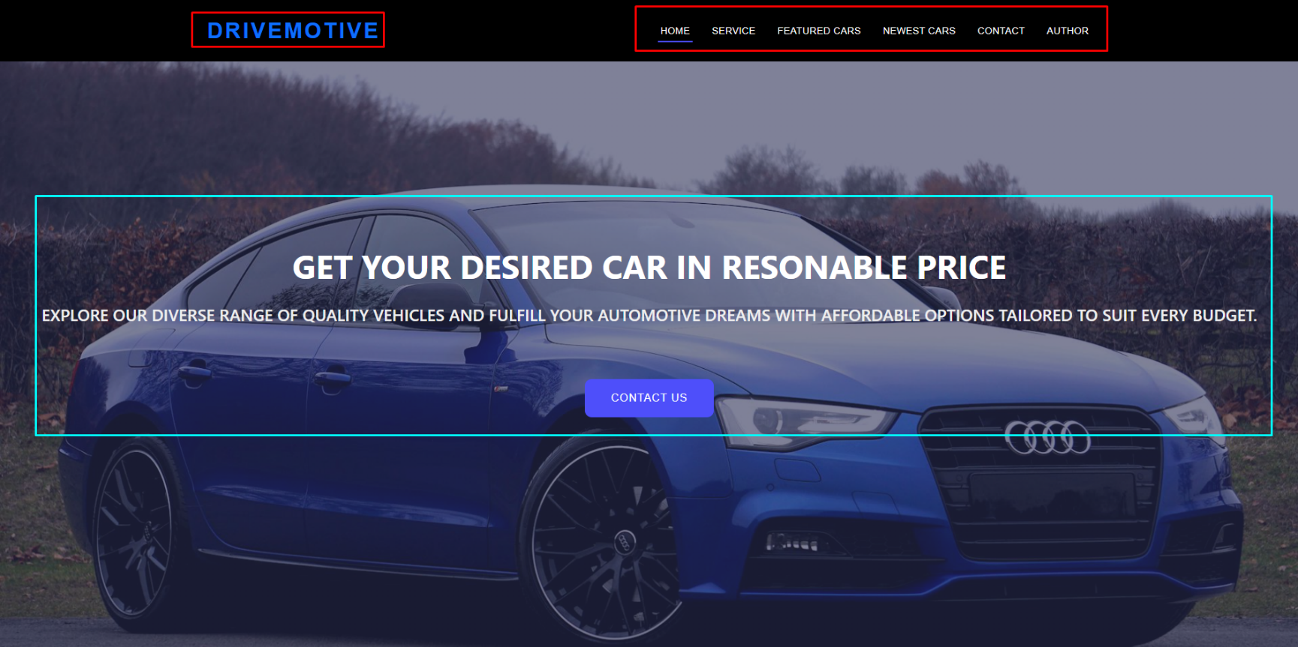

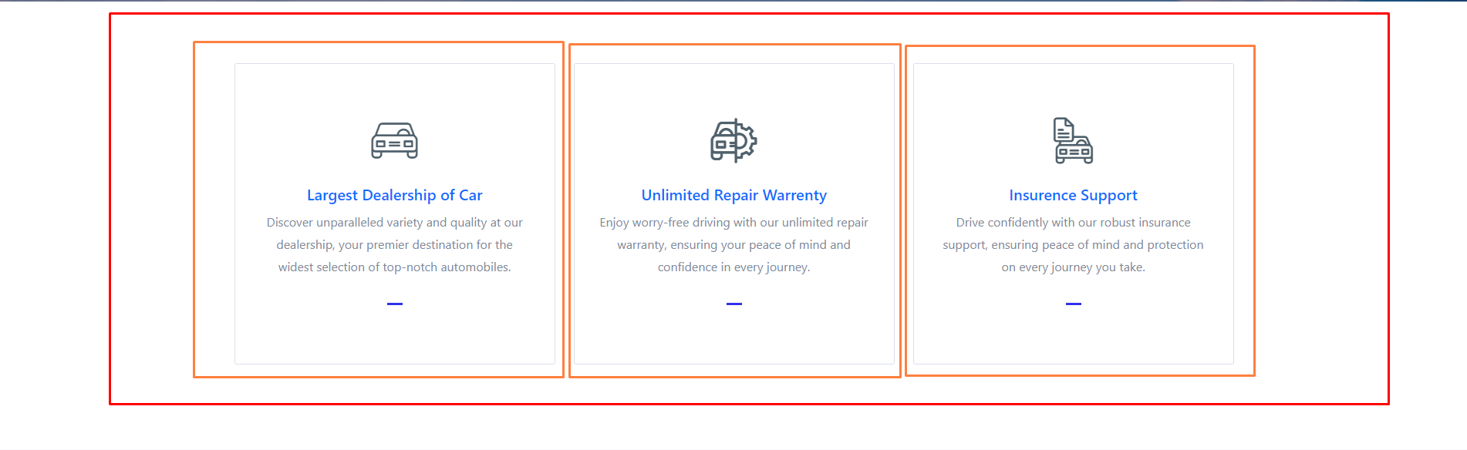

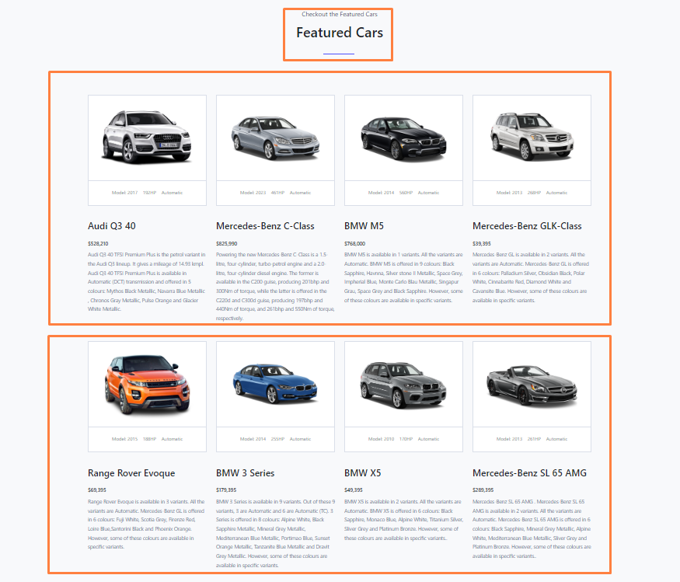

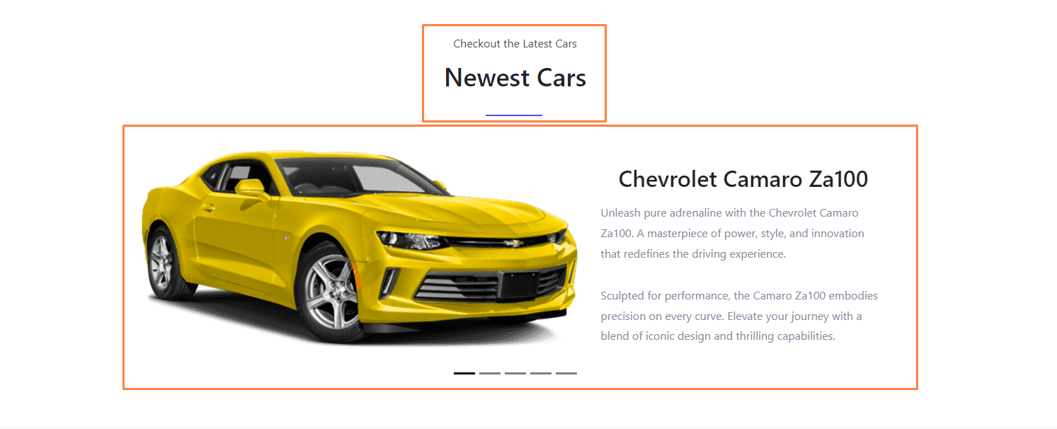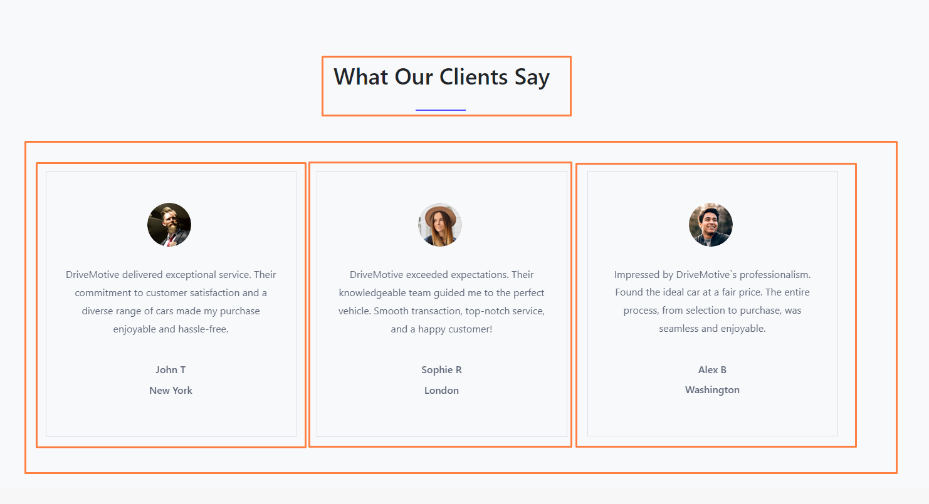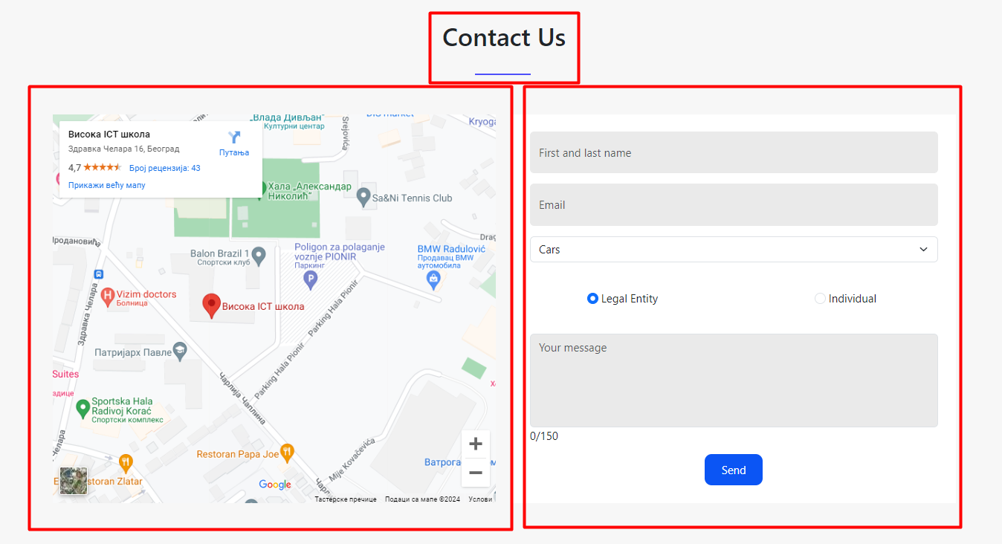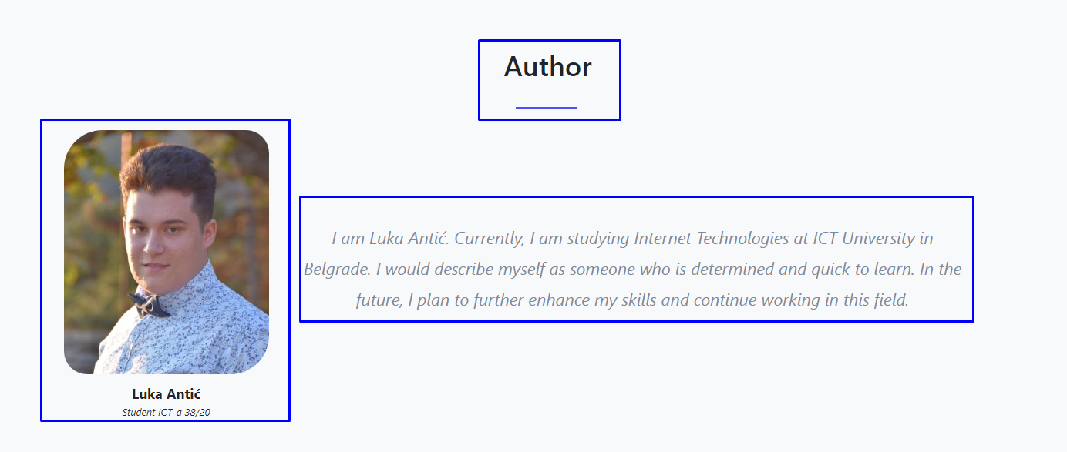

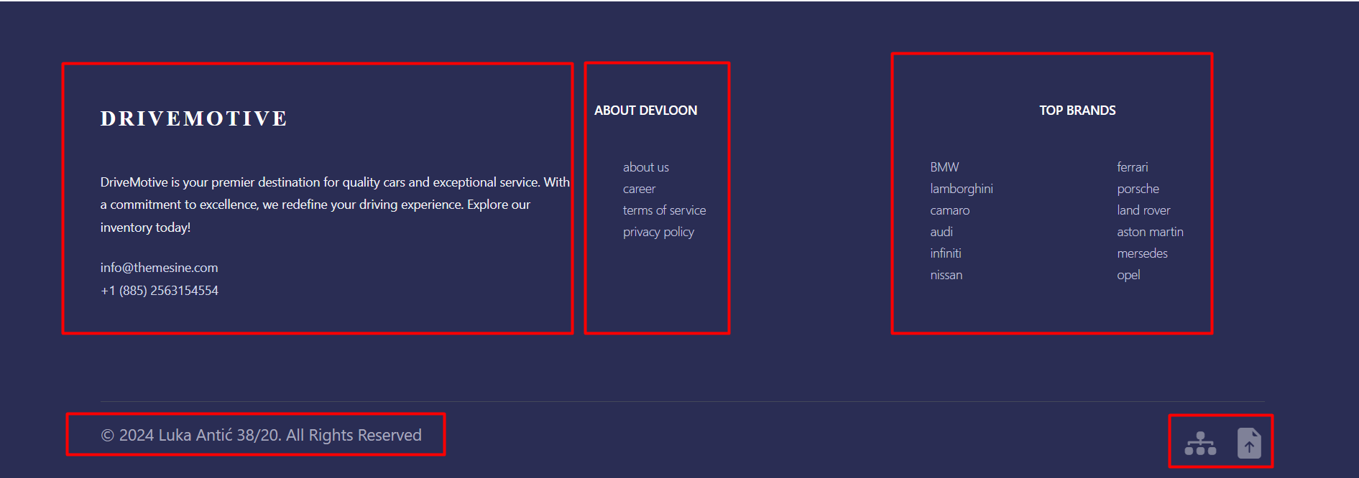

# Organizacija

Sajt je rađen kao single/one page stranica. Jednostraničan

## Organizaciona šema

Index.html

## SITEMAP

<?xml version="1.0" encoding="utf-8"?>

  <urlset xmlns="http://www.sitemaps.org/schemas/sitemap/0.9">

    <url>

      <loc>https://lukaantic12.github.io/drive-motive/</loc>

      <lastmod>2024-03-04</lastmod>

      <changefreq>daily</changefreq>

      <priority>1.00</priority>

  </url>

</urlset>

## Slike stranica i opis funkcionalnosti



U pozadini se nalazi slider gde se naizmenično menjaju tri slike unete dinamički kroz niz, pomoću tajmera. U gornjem levom uglu se nalazi Logo, a u gornjem desnom uglu navigacioni meni sa linkovima koje nas šalju na određene delove sajta. Na sredini je blok koji je centriran i ispisuje tekst i dugme.



Service



Oblast Featured Cars napisana je dinamički u js



Oblast Newest Cars napisana dinamički u js sa dodatnim sliderom preko jq



Oblast Clients napisana je dinamički pomocu js, pomeraju se pomoću tajmera



Mapa i kontakt forma. Forma za validaciju koja se nalazi sa desne strane, kada se klikne na dugme „Send“, vrši se validacija unetih podataka, ukoliko je podatak pogrešno unet ili uopšte nije unet ispisaće se nekoli vrsta grešaka korisniku i pocrveneće sva polja koja nisu ispravno napisana, odnosno vratiće se poruka o lošoj validaciji.



Deo o autoru



U footer-u se nalaze linkovi koji vode do SITEMAP-a i Dokumentacije za sajt.

# Kodovi

## HTML

<!DOCTYPE html>

<html lang="en">

<head>

    <meta charset="UTF-8">

    <meta name="viewport" content="width=device-width, initial-scale=1.0">

    <title>Drive Motive</title>

    <meta name="description" content="DriveMotive - Your premier destination for quality cars and exceptional service. Explore our inventory today!">

    <meta name="keywords" content="cars, dealership, repair warranty, insurance support, DriveMotive">

    <meta name="author" content="Luka Antić">

    <link rel="shortcut icon" href="assets/img/logo.png" type="image/x-icon">

    <link rel="stylesheet" href="assets/css/style.css">

    <link href="https://cdn.jsdelivr.net/npm/bootstrap@5.3.3/dist/css/bootstrap.min.css" rel="stylesheet" integrity="sha384-QWTKZyjpPEjISv5WaRU9OFeRpok6YctnYmDr5pNlyT2bRjXh0JMhjY6hW+ALEwIH" crossorigin="anonymous">

    <link rel="stylesheet" href="https://cdnjs.cloudflare.com/ajax/libs/OwlCarousel2/2.3.4/assets/owl.carousel.min.css">

    <link rel="stylesheet" href="assets/css/flaticon.css">

    <link href="assets/bootstrap-icons/bootstrap-icons.css" rel="stylesheet"/>

    <script src="https://code.jquery.com/jquery-3.6.4.min.js"></script>

</head>

<body>

    <header id="header" class="fixed-top d-flex align-items-center header-transparent">

        <div class="container d-flex justify-content-between align-items-center">

          <div id="logo">

            <h1><a href="index.html">DriveMotive</a></h1>

          </div>

          <nav id="navbar" class="navbar1">

            <i class="bi bi-list mobile-nav-toggle"></i>

          </nav><!-- .navbar -->

        </div>

    </header><!-- End Header -->

    <section id="hero" class="hero">

        <div class="hero-container animate__animated animate__fadeInUp">

          <h1>GET YOUR DESIRED CAR IN RESONABLE PRICE</h1>

          <h3>Explore our diverse range of quality vehicles and fulfill your automotive dreams with affordable options tailored to suit every budget.

          </h3>

          <a href="#contact" class="btn-get-started">Contact us</a>

        </div>

    </section><!-- End Hero Section -->

    <section id="service" class="service">

        <div class="container">

            <div class="service-content">

                <div class="row">

                    <div class="col-md-4 col-sm-6">

                        <div class="single-service-item">

                            <div class="single-service-icon">

                                <i class="flaticon-car"></i>

                            </div>

                            <h2><a href="#">largest dealership <span> of</span> car</a></h2>

                            <p>

                                Discover unparalleled variety and quality at our dealership, your premier destination for the widest selection of top-notch automobiles.

                            </p>

                        </div>

                    </div>

                    <div class="col-md-4 col-sm-6">

                        <div class="single-service-item">

                            <div class="single-service-icon">

                                <i class="flaticon-car-repair"></i>

                            </div>

                            <h2><a href="#">unlimited repair warrenty</a></h2>

                            <p>

                                Enjoy worry-free driving with our unlimited repair warranty, ensuring your peace of mind and confidence in every journey.                           </p>

                        </div>

                    </div>

                    <div class="col-md-4 col-sm-6">

                        <div class="single-service-item">

                            <div class="single-service-icon">

                                <i class="flaticon-car-1"></i>

                            </div>

                            <h2><a href="#">insurence support</a></h2>

                            <p>

                                Drive confidently with our robust insurance support, ensuring peace of mind and protection on every journey you take.

                            </p>

                        </div>

                    </div>

                </div>

            </div>

        </div><!--/.container-->

    </section>

    <section id="featured-cars" class="featured-cars">

        <div class="container">

            <div class="section-header">

                <p>checkout <span>the</span> featured cars</p>

                <h2>featured cars</h2>

            </div><!--/.section-header-->

            <div class="featured-cars-content row" id="featuredCarsContent">

                <!-- Dynamically generated content will be placed here -->

            </div>

        </div><!--/.container-->

    </section>

    <section id="new-cars" class="new-cars">

        <div class="container" data-aos="fade-up">

            <div class="section-header pt-5">

                <p>checkout <span>the</span> latest cars</p>

                <h2>Newest Cars</h2>

            </div>

        <div id="newCars" class="container-fluid px-0 py-3 pb-5 text-dark">

            <div class="container">

            <div class="row mt-4">

                <div class="col-lg-10 offset-lg-1 col-md-12 offset-md-0 col-sm-10 offset-sm-1 col-10 offset-1">

                <div id="carouselCommentControls" class="carousel carousel-dark slide" data-bs-ride="carousel">

                    <div class="carousel-indicators">

                        <button type="button" data-bs-target="#carouselCommentControls" data-bs-slide-to="0" class="active" aria-label="Slide 1"></button>

                        <button type="button" data-bs-target="#carouselCommentControls" data-bs-slide-to="1" aria-label="Slide 2" class=""></button>

                        <button type="button" data-bs-target="#carouselCommentControls" data-bs-slide-to="2" aria-label="Slide 3" class=""></button>

                        <button type="button" data-bs-target="#carouselCommentControls" data-bs-slide-to="3" aria-label="Slide 4" class=""></button>

                        <button type="button" data-bs-target="#carouselCommentControls" data-bs-slide-to="4" aria-label="Slide 5" class=""></button>

                    </div>

                    <div class="carousel-inner">

                    <div class="carousel-item active">

                        <div class="mb-3">

                        <div class="row g-0">

                        </div>

                        </div>

                    </div>

                    <div class="carousel-item">

                        <div class="mb-3">

                        <div class="row g-0">

                        </div>

                        </div>

                    </div>

                    <div class="carousel-item">

                        <div class="mb-3">

                        <div class="row g-0">

                        </div>

                        </div>

                    </div>

                    <div class="carousel-item">

                        <div class="mb-3">

                        <div class="row g-0">

                        </div>

                        </div>

                    </div>

                    <div class="carousel-item">

                        <div class="mb-3">

                        <div class="row g-0">

                        </div>

                        </div>

                    </div>

                    </div>

                </div>

                </div>

            </div>

            </div>

        </div>

        </div>

    </section>

    <section id="clients-say" class="clients-say">

        <div class="container">

            <div class="section-header">

                <h2>what our clients say</h2>

            </div><!--/.section-header-->

            <div class="row mt-5 pt-5">

                <div class="owl-carousel testimonial-carousel" id="testimonial-carousel">

                </div><!--/.testimonial-carousel-->

            </div><!--/.row-->

        </div><!--/.container-->

    </section>

    <section id="contact">

        <div class="container mt-5">

            <div class="section-header">

                <h2>Contact us</h2>

            </div>

            <div class="forma pt-5">

                <div class="row pb-5">

                    <div class="col-md-6 ">

                        <iframe src="https://www.google.com/maps/embed?pb=!1m18!1m12!1m3!1d2830.358486992937!2d20.48222611537871!3d44.81426094829133!2m3!1f0!2f0!3f0!3m2!1i1024!2i768!4f13.1!3m3!1m2!1s0x475a7a9609031735%3A0xc17ed71f59ac4725!2z0JLQuNGB0L7QutCwINCY0KbQoiDRiNC60L7Qu9Cw!5e0!3m2!1ssr!2srs!4v1639063780924!5m2!1ssr!2srs" width="100%" height="100%" style="border:0;" allowfullscreen="" loading="lazy"></iframe>

                    </div>

                    <div class="col-md-6">

                        <div class="form">

                            <div id="sendmessage">Podaci su prosleđeni. Hvala Vam!</div>

                            <div id="errormessage"></div>

                            <div class="row">

                        <form name="contactForm" action="#" method="post" role="form" class="contactForm" onsubmit="return validateForm()" novalidate>

                            <div class="form-group">

                                <input type="text" name="name" class="form-control" id="name" placeholder="First and last name" />

                                <div class="validation"></div>

                            </div>

                            <div class="form-group">

                                <input type="email" class="form-control" name="email" id="email"placeholder="Email"/>

                                <div class="validation"></div>

                            </div>

                            <div class="form-group">

                            <select id="ddlUsluga" class="form-select mb-3" aria-label=".form-select-lg example">

                                <option class="d-flex align-bottom" selected="selected" value="0">Cars</option>

                                <option class="d-flex align-bottom" value="1">Mercedes-Benz</option>

                                <option value="2">BMW</option>

                                <option value="3">Audi</option>

                                <option value="4">Chevrolet Camaro</option>

                                <option value="5">Ferrari</option>

                                <option value="6">Porsche</option>

                                <option value="7">Aston Martin</option>

                                <option value="8">Range Rover</option>

                            </select>

                            </div>

                            <div id="productError" class="validation"></div>

                            <div class="form-group">

                            <div class="row" id="cuvaj"></div>

                            <div class="row mt-2"></div>

                            </div>

                            <div class="col-md-12 pb-4">

                                <div class="row ">

                                    <div class="col-6 text-center">

                                        <input class="form-check-input" checked="checked" type="radio" name="kupac" id="kontaktSMS" value="SMS" />

                                        <label class="form-check-label" for="kontaktSMS">Legal Entity

                                        </label>

                                        <div class="validation"></div>

                                    </div>

                                    <div class="col-6 text-center">

                                        <input class="form-check-input" type="radio" name="kupac" id="kontaktMail" value="Email" />

                                        <label class="form-check-label" for="kontaktMail">Individual

                                        </label>

                                    </div>

                                    <div id="contactMethodError" class="validation mt-3"></div>

                                </div>

                            </div>

                            <div class="form-group">

                                <textarea class="form-control" name="message" rows="5" placeholder="Your message" id="komentar" maxlength="200"></textarea>

                                <div class="validation"></div>

                                <div id="brojSlova">0/200</div>

                            </div>

                            <div class="text-center pb-3"><button type="submit">Send</button></div>

                        </form>

                        </div>

                    </div>

                    </div>

                </div>

            </div>

        </div>

    </section><!-- End Contact Section -->

    <section id="author">

        <div class="container wow fadeInUp">

          <div class="section-header">

            <h2>author</h2>

          </div>

          <div class="row">

            <div class="col-lg-3 col-md-6">

              <div class="member">

                <div class="pic">

                  <img src="assets/img/autor.jpg" alt="Luka Antić"/>

                </div>

                <h4>Luka Antić</h4>

                <span>Student ICT-a 38/20</span>

              </div>

            </div>

            <div id="autor" class=" col-lg-8 col-md-5 col-sm-12">

              <p class="section-description">I am Luka Antić. Currently, I am studying Internet Technologies at ICT University in Belgrade. I would describe myself as someone who is determined and quick to learn. In the future, I plan to further enhance my skills and continue working in this field.</p>

            </div>

          </div>

        </div>

    </section>

    <footer>

            <div class="container">

                <div class="footer-top">

                    <div class="row">

                        <div class="col-md-5 col-sm-6">

                            <div class="single-footer-widget">

                                <div class="footer-logo">

                                    <a href="index.html">DriveMotive</a>

                                </div>

                                <p>

                                    DriveMotive is your premier destination for quality cars and exceptional service. With a commitment to excellence, we redefine your driving experience. Explore our inventory today!

                                </p>

                                <div class="footer-contact">

                                    <p>info@themesine.com</p>

                                    <p>+1 (885) 2563154554</p>

                                </div>

                            </div>

                        </div>

                        <div class="col-md-3 col-sm-6">

                            <div class="single-footer-widget">

                                <h2>about devloon</h2>

                                <ul>

                                    <li><a href="#">about us</a></li>

                                    <li><a href="#">career</a></li>

                                    <li><a href="#">terms <span> of service</span></a></li>

                                    <li><a href="#">privacy policy</a></li>

                                </ul>

                            </div>

                        </div>

                        <div class="col-md-4 col-xs-12">

                            <div class="single-footer-widget">

                                <h2 class="text-center">top brands</h2>

                                <div class="container">

                                    <div class="row">

                                        <div class="col-md-6 col-sm-3">

                                            <ul>

                                                <li><a href="#">BMW</a></li>

                                                <li><a href="#">lamborghini</a></li>

                                                <li><a href="#">camaro</a></li>

                                                <li><a href="#">audi</a></li>

                                                <li><a href="#">infiniti</a></li>

                                                <li><a href="#">nissan</a></li>

                                            </ul>

                                        </div>

                                        <div class="col-md-6 col-sm-3">

                                            <ul>

                                                <li><a href="#">ferrari</a></li>

                                                <li><a href="#">porsche</a></li>

                                                <li><a href="#">land rover</a></li>

                                                <li><a href="#">aston martin</a></li>

                                                <li><a href="#">mersedes</a></li>

                                                <li><a href="#">opel</a></li>

                                            </ul>

                                        </div>

                                    </div>

                                </div>

                            </div>

                        </div>

                    </div>

                </div>

                <div class="footer-copyright">

                    <div class="row">

                        <div class="col-sm-6">

                            <p>

                                &copy; 2024 Luka Antić 38/20. All Rights Reserved

                            </p><!--/p-->

                        </div>

                        <div class="col-sm-6">

                            <div class="footer-social">

                                <a href="sitemap.xml"><i class="bi bi-diagram-3-fill"></i></a>

                                <a href="dokumentacija.pdf"><i class="bi bi-file-earmark-arrow-up-fill"></i></a>

                            </div>

                        </div>

                    </div>

                </div><!--/.footer-copyright-->

            </div><!--/.container-->

    </footer><!--/.contact-->

    <script src="assets/js/main.js"></script>

    <script src="https://cdn.jsdelivr.net/npm/bootstrap@5.3.3/dist/js/bootstrap.bundle.min.js" integrity="sha384-YvpcrYf0tY3lHB60NNkmXc5s9fDVZLESaAA55NDzOxhy9GkcIdslK1eN7N6jIeHz" crossorigin="anonymous"></script>

    <script src="https://cdnjs.cloudflare.com/ajax/libs/OwlCarousel2/2.3.4/owl.carousel.min.js"></script>

</body>

</html>

## CSS & MediaQuery

*{

  padding: 0;

  margin: 0;

  -webkit-box-sizing:border-box;

-moz-box-sizing:border-box;

-o-box-sizing:border-box;

-ms-box-sizing:border-box;

box-sizing:border-box;

}

body{

font-family: 'Poppins', sans-serif;

font-size:16px;

color:#818998;

  text-transform:initial;

  max-width:1920px;

  margin:0 auto;

overflow-x:hidden;

}

h1,h2,h3,h4,h5,h6 {

margin: 0;

color:#444a57;

  font-size: 20px;

  font-weight: 500;

  text-transform: capitalize;

}

p {

margin: 0;

color:#818998;

font-size:16px;

  line-height: 1.8;

  text-transform: initial;

}

img{border:none;max-width:100%; height:auto;}

ul{

padding: 0;

  margin: 0 auto;

  list-style: none;

}

ul li {

list-style: none;

  display: inline-block;

}

 @media screen and (max-width: 768px) {

    [data-aos-delay] {

      transition-delay: 0 !important;

    }

    .flex{

      margin-bottom: 0px !important;

    }

  }

  .form{

    background-color: #fff;

    padding: 10px;

  }

  .form-group{

    margin: 15px;

  }

  .form-group input{

    outline: 0 !important;

    box-shadow: none;

    border: 1px solid #eaeaea;

    background: #eaeaea;

    height: 60px;

  }

  textarea{

    background: #eaeaea !important;

  }

  .form-group input[type="checkbox"]{

    height: 20px;

  }

  a{

    text-decoration: none !important;

  }

  /*--------------------------------------------------------------

  # Header

  --------------------------------------------------------------*/

  #header {

    height: 90px;

    transition: all 0.5s;

    z-index: 997;

    background: #000;

  }

  #header #logo h1 {

    font-size: 32px;

    margin: 0;

    line-height: 1;

    font-family: "Poppins", sans-serif;

    font-weight: 700;

    letter-spacing: 3px;

    text-transform: uppercase;

    color: #fff;

  }

  #header #logo h1 a:hover {

    color: #4e4ffa;

    transition: 0.3s;

  }

  #header #logo{

    padding: 0;

    margin: 0;

  }

  #header.header-scrolled {

    background: rgba(52, 59, 64, 0.9);

    height: 70px;

    transition: all 0.5s;

  }

  .scrolled-offset {

    margin-top: 70px;

  }

  /*--------------------------------------------------------------

  # Navigation Menu

  --------------------------------------------------------------*/

  /**

  * Desktop Navigation

  */

  .navbar1 {

    padding: 0;

  }

  .navbar1 ul {

    margin: 0;

    padding: 0;

    display: flex;

    list-style: none;

    align-items: center;

  }

  .navbar1 li {

    position: relative;

  }

  .navbar1 > ul > li {

    white-space: nowrap;

    padding: 10px 0 10px 24px;

  }

  .navbar1 a, .navbar1 a:focus {

    display: flex;

    align-items: center;

    justify-content: space-between;

    font-family: "Poppins", sans-serif;

    color: #fff;

    font-size: 14px;

    padding: 0 4px;

    white-space: nowrap;

    transition: 0.3s;

    letter-spacing: 0.4px;

    position: relative;

    text-transform: uppercase;

  }

  .navbar1 a i, .navbar1 a:focus i {

    font-size: 12px;

    line-height: 0;

    margin-left: 5px;

  }

  .navbar1 > ul > li > a:before {

    content: "";

    position: absolute;

    width: 100%;

    height: 2px;

    bottom: -6px;

    left: 0;

    background-color: #4e4ffa;

    visibility: hidden;

    transform: scaleX(0);

    transition: all 0.3s ease-in-out 0s;

  }

  .navbar1 a:hover:before, .navbar1 li:hover > a:before, .navbar1 .active:before {

    visibility: visible;

    transform: scaleX(1);

  }

  .navbar1 a:hover, .navbar1 .active, .navbar1 .active:focus, .navbar1 li:hover > a {

    color: #fff;

  }

  .navbar1 .dropdown ul {

    display: block;

    position: absolute;

    left: 24px;

    top: calc(100% + 30px);

    margin: 0;

    padding: 10px 0;

    z-index: 99;

    opacity: 0;

    visibility: hidden;

    background: #fff;

    box-shadow: 0px 0px 30px rgba(127, 137, 161, 0.25);

    transition: 0.3s;

  }

  .navbar1 .dropdown ul li {

    min-width: 200px;

  }

  .navbar1 .dropdown ul a {

    padding: 10px 20px;

    font-size: 14px;

    text-transform: none;

    color: #666666;

  }

  .navbar1 .dropdown ul a i {

    font-size: 12px;

  }

  .navbar1 .dropdown ul a:hover, .navbar1 .dropdown ul .active:hover, .navbar1 .dropdown ul li:hover > a {

    color: #4e4ffa;

  }

  .navbar1 .dropdown:hover > ul {

    opacity: 1;

    top: 100%;

    visibility: visible;

  }

  .navbar1 .dropdown .dropdown ul {

    top: 0;

    left: calc(100% - 30px);

    visibility: hidden;

  }

  .navbar1 .dropdown .dropdown:hover > ul {

    opacity: 1;

    top: 0;

    left: 100%;

    visibility: visible;

  }

  @media (max-width: 1366px) {

    .navbar1 .dropdown .dropdown ul {

      left: -90%;

    }

    .navbar1 .dropdown .dropdown:hover > ul {

      left: -100%;

    }

  }

  /**

  * Mobile Navigation

  */

  .mobile-nav-toggle{

    color: #fff;

    font-size: 28px;

    cursor: pointer;

    display: none;

    line-height: 0;

    transition: 0.5s;

  }

  @media (max-width: 991px) {

    .mobile-nav-toggle {

      display: block;

    }

    .navbar1 ul {

      display: none;

    }

  }

  .navbar-mobile {

    position: fixed;

    overflow: hidden;

    top: 0;

    right: 0;

    left: 0;

    bottom: 0;

    background: rgba(77, 77, 77, 0.9);

    transition: 0.3s;

    z-index: 999;

  }

  .navbar-mobile .mobile-nav-toggle {

    position: absolute;

    top: 15px;

    right: 15px;

  }

  .navbar-mobile ul {

    display: flex;

    position: absolute;

    top: 55px;

    right: 15px;

    bottom: 15px;

    left: 15px;

    padding: 10px 0;

    background-color: #fff;

    overflow-y: auto;

    transition: 0.3s;

    flex-direction: column;

  }

  .navbar-mobile > ul > li {

    padding: 0;

  }

  .navbar-mobile a:hover:before, .navbar-mobile li:hover > a:before, .navbar-mobile .active:before {

    visibility: hidden;

  }

  .navbar-mobile a, .navbar-mobile a:focus {

    padding: 10px 20px;

    font-size: 15px;

    color: #666666;

  }

  .navbar-mobile a:hover, .navbar-mobile .active, .navbar-mobile li:hover > a {

    color: #4e4ffa;

  }

  .navbar-mobile .getstarted, .navbar-mobile .getstarted:focus {

    margin: 15px;

  }

  .navbar-mobile .dropdown ul {

    position: static;

    display: none;

    margin: 10px 20px;

    padding: 10px 0;

    z-index: 99;

    opacity: 1;

    visibility: visible;

    background: #fff;

    box-shadow: 0px 0px 30px rgba(127, 137, 161, 0.25);

  }

  .navbar-mobile .dropdown ul li {

    min-width: 200px;

  }

  .navbar-mobile .dropdown ul a {

    padding: 10px 20px;

  }

  .navbar-mobile .dropdown ul a i {

    font-size: 12px;

  }

  .navbar-mobile .dropdown ul a:hover, .navbar-mobile .dropdown ul .active:hover, .navbar-mobile .dropdown ul li:hover > a {

    color: #2dc997;

  }

  .navbar-mobile .dropdown > .dropdown-active {

    display: block;

  }

/*--------------------------------------------------------------

# Hero Section

--------------------------------------------------------------*/

#hero {

    width: 100%;

    height: 100vh;

    overflow: hidden;

    position: relative;

  }

  .hero {

    display: flex;

    flex-direction: column;

    align-items: center;

    justify-content: center;

    text-align: center;

    background-size: cover;

    background-repeat: no-repeat;

    background-attachment: fixed;

    background-position: center;

    position: relative;

    transition: background-image 1s ease-in-out; /* Dodato za glatki prelazak */

  }

  @media (min-width: 1024px) {

    #hero {

      background-attachment: fixed;

    }

  }

  /* boja: #4e4ffa */

  #hero h1 {

    margin: 30px 0 10px 0;

    font-size: 48px;

    font-weight: 700;

    line-height: 56px;

    text-transform: uppercase;

    color: #fff;

  }

  @media (max-width: 768px) {

    #hero h1 {

      font-size: 28px;

      line-height: 36px;

    }

    .service {

      padding: 0px !important;

      padding-top: 45px !important;

  }

  footer{

    text-align: center;

  }

  }

  #hero h3 {

    color: #eee;

    margin-bottom: 50px;

    font-size: 24px;

    text-transform: uppercase;

    padding: 20px;

  }

  @media (max-width: 768px) {

    #hero h3 {

      font-size: 18px;

      line-height: 24px;

      margin-bottom: 30px;

    }

  }

  @media (max-width: 575px) {

    .footer-social {

      text-align: center !important;

  }

  }

  #hero .btn-get-started {

    font-family: "Poppins", sans-serif;

    text-transform: uppercase;

    font-weight: 500;

    font-size: 16px;

    letter-spacing: 1px;

    display: inline-block;

    padding: 16px 38px;

    border-radius: 10px;

    transition: 0.5s;

    margin: 10px;

    color: #fff;

    background: #4e4ffa;

  }

  #hero .btn-get-started:hover {

    background: #0b55f4;

  }

  /*--------------------------------------------------------------

  # Sections

  --------------------------------------------------------------*/

  section {

    overflow: hidden;

  }

  /* Sections Header

  --------------------------------*/

  .section-header .section-title {

    font-size: 32px;

    color: #111;

    text-transform: uppercase;

    text-align: center;

    font-weight: 700;

    margin-bottom: 5px;

  }

  .section-header .section-description {

    text-align: center;

    padding-bottom: 40px;

    color: #999;

  }

/*-------------------------------------

    1.General css (Reset code)

--------------------------------------*/

select,input,textarea,button,.form-control{box-shadow:none;outline:0!important;}

button {background: transparent;border: 0;font-size: 16px;text-transform: capitalize;}

html,body{height: 100%;}

[placeholder]:focus::-webkit-input-placeholder {

  -webkit-transition: opacity 0.3s 0.3s ease;

  -moz-transition: opacity 0.3s 0.3s ease;

  -ms-transition: opacity 0.3s 0.3s ease;

  -o-transition: opacity 0.3s 0.3s ease;

  transition: opacity 0.3s 0.3s ease;

  opacity: 0;

}

.owl-carousel {z-index: 0;}

/* section-header */

.section-header{

    position: relative;

    text-align: center;

}

.section-header h2{

    position: relative;

    font-size: 36px;

    font-weight: 500;

    padding-bottom: 35px;

}

.section-header h2:before {

    position: absolute;

    content: "";

    width: 80px;

    height: 2px;

    bottom: 0;

    left: 50%;

    margin-left: -42px;

    background: #4e4ffa;

}

.section-header p{color: #444a57;text-transform: capitalize;margin-bottom:10px;}

.section-header h2 span,.section-header p span{text-transform: lowercase;}

/* section-header */

/*=============Style css=========*/

/*-------------------------------------

        2. Top-area

--------------------------------------*/

nav.navbar.bootsnav {

    background-color: transparent;

    border-bottom: transparent;

}

.wrap-sticky nav.navbar.bootsnav.sticked {background-color: #000;box-shadow: 0 2px 5px rgba(0,0,0,.2);}

/*.navbar-brand*/

.navbar-header a.navbar-brand,.navbar-header a.navbar-brand:hover,.navbar-header a.navbar-brand:focus{

    display: inline-block;

    color: #fff;

    font-size: 24px;

    letter-spacing: 3px;

    font-family: 'Rufina', serif;

    font-weight: 700;

    padding: 45px 0px;

    text-transform:uppercase;

}

.navbar-header a.navbar-brand span{display: inline-block;color:#4e4ffa;text-transform:capitalize;}

.wrap-sticky nav.navbar.bootsnav.sticked .navbar-header a.navbar-brand,.wrap-sticky nav.navbar.bootsnav.sticked .navbar-header a.navbar-brand:hover,.wrap-sticky nav.navbar.bootsnav.sticked .navbar-header a.navbar-brand:focus {padding:30px 0px;}

/*.navbar-brand*/

/*.nav li*/

nav.navbar.bootsnav ul.nav > li > a {

    color: #f5f7fa;

    font-size: 16px;

    font-weight: 500;

    text-transform:uppercase;

    -webkit-transition: 0.3s linear;

    -moz-transition: 0.3s linear;

    -ms-transition: 0.3s linear;

    -o-transition: 0.3s linear;

    transition: 0.3s linear;

}

nav.navbar.bootsnav ul.nav > li > a {padding: 48px 21px;}

nav.navbar.bootsnav ul.nav > li > a:hover,nav.navbar.bootsnav ul.nav > li > a:focus{color:#4e4ffa;}

nav.navbar.bootsnav ul.nav > li.active>a {color: #4e4ffa;}

nav.navbar.bootsnav ul.nav > li.dropdown > a.dropdown-toggle:after {

    content: "";

}

nav.navbar.bootsnav ul.nav > li.dropdown span {

    font-size: 8px;

    margin-left: 15px;

}

.wrap-sticky nav.navbar.bootsnav.sticked ul.nav > li > a{padding:30px 25px;}

/*.nav li*/

/*.menu-ui-design*/

.menu-ui-design{overflow-y:scroll;height: 350px;}

.menu-ui-design::-webkit-scrollbar {

    width:5px;

}

.menu-ui-design::-webkit-scrollbar-track {

    -webkit-box-shadow: inset 0 0 8px #000;

}

.menu-ui-design::-webkit-scrollbar-thumb {

  background-color: #4e4ffa;

}

/*.menu-ui-design*/

/*.navbar-toggle */

nav.navbar.bootsnav .navbar-toggle {

    position: relative;

    background-color: transparent;

    border: 1px solid #4e4ffa;

    padding: 10px;

    top: 0;

}

nav.navbar.bootsnav .navbar-toggle i{color: #4e4ffa;}

/*.navbar-toggle */

/*-------------------------------------

        3.  Welcome-hero

--------------------------------------*/

.welcome-hero {

    position: relative;

    background:url(../images/welcome-hero/welcome-banner.jpg)no-repeat;

    background-position: center;

    background-size: cover;

    z-index: 1;

}

.welcome-hero:before {

    position: absolute;

    content: "";

    top: 0;

    left: 0;

    width: 100%;

    height: 100%;

    background: rgba(42,45,84,.60);

}

.header-area{position: absolute;top:0;left:0;width: 100%;z-index: 99;}

/*.welcome-hero-txt*/

.welcome-hero-txt{text-align: center;padding:290px 0 372px;}

.welcome-hero-txt h2 {

    font-size: 42px;

    color: #fff;

    font-weight: 700;

    text-transform: uppercase;

    margin-bottom: 45px;

}

.welcome-hero-txt p {

    font-size: 18px;

    text-transform: initial;

    color: #fff;

    font-weight: 500;

    max-width: 735px;

    margin: 0 auto;

}

.welcome-btn {

    display: inline-block;

    width: 230px;

    height: 60px;

    background: #4e4ffa;

    color: #fff;

    border-radius: 3px;

    margin-top: 55px;

    -webkit-transition: .3s linear;

    -moz-transition:.3s linear;

    -ms-transition:.3s linear;

    -o-transition:.3s linear;

    transition: .3s linear;

}

.welcome-btn:hover{

    background: #0102fa;

}

/*.welcome-hero-txt*/

/*-------------------------------------

        4. Model-Search

--------------------------------------*/

#contact{

    background: #f8f9fb;

}

.model-search-content .col-sm-12 {padding: 0;}

.model-search-content {

    padding: 40px 0;

    background: #fff;

    box-shadow:0 10px 40px 0px rgba(38,40,64,.2);

    position: absolute;

    bottom: -150px;

    width: 100%;

    border-radius: 3px;

}

/*.single-model-search*/

.single-model-search{margin-bottom: 30px;}

.single-model-search:last-child {margin-bottom: 0;}

.single-model-search h2 {

    font-size: 16px;

    font-weight: 400;

    text-transform: capitalize;

    margin-bottom: 20px;

}

/*model-select-icon*/

.model-select-icon{

    position:relative;

}

.model-select-icon .form-control {

    outline: 0!important;

    box-shadow: none;

    border: 1px solid #f8f8f8;

    background: #f8f8f8;

    height: 60px;

}

.model-select-icon select {

    font-size: 16px;

    color: #888f9d;

    text-transform: capitalize;

}

.model-select-icon:after{

    position: absolute;

    content: "\f103";

    right: 0px;

    top: 0;

    font-size: 10px;

    color: #888f9d;

    background: #f8f8f8;

    height: 60px;

    line-height: 60px;

    width: 50px;

    text-align: center;

    font-family: "Flaticon";

    pointer-events: none;

    border: transparent;

}/*model-select-icon*/

.welcome-btn.model-search-btn {

    width: 160px;

    margin-top: 80px;

    margin-left: 53px;

}

/*.single-model-search*/

/*-------------------------------------

        5. Service

--------------------------------------*/

.service { padding: 80px;}

.single-service-item{

    text-align: center;

    padding:55px 30px 60px;

    border-radius: 3px;

    margin-bottom: 30px;

    border: 1px solid #dadfe9;

    -webkit-transition: .3s linear;

    -moz-transition:.3s linear;

    -ms-transition:.3s linear;

    -o-transition:.3s linear;

    transition: .3s linear;

}

.single-service-icon {

    display: inline-block;

    color: #50616c;

}

.single-service-item h2 a {

    font-size:20px;

    margin: 35px 0 20px;

}

.single-service-item h2 a span {text-transform:  lowercase;}

.single-service-item p {padding-bottom: 35px;text-transform: initial;position: relative;}

.single-service-item p:before {

    position: absolute;

    content: "";

    width: 20px;

    height: 3px;

    background: #3030ea;

    bottom: 0;

    left: 50%;

    margin-left: -10px;

}

.single-service-icon [class^="flaticon-"]:before,.single-service-icon[class*=" flaticon-"]:before,.single-service-icon [class^="flaticon-"]:after,.single-service-icon [class*=" flaticon-"]:after {font-size:60px;}

.single-service-item:hover .single-service-icon [class^="flaticon-"]:before,.single-service-item:hover .single-service-icon [class*=" flaticon-"]:before,.single-service-item:hover .single-service-icon [class^="flaticon-"]:after,.single-service-item:hover .single-service-icon [class*=" flaticon-"]:after {color:#fff;}

.single-service-item:hover h2 a,.single-service-item:hover p{color: #fff;}

.single-service-item:hover  p:before {background: #fff;}

.single-service-item:hover{box-shadow: 0 12px 30px 0px rgba(0,1,193,.2);background: #4e4ffa;border: 1px solid #4e4ffa;}

/*-------------------------------------

        6. New-cars

--------------------------------------*/

#komentari{

    padding:112px 0 120px;

}

.new-cars-content{padding-top:96px;}

/*.new-cars-txt*/

.new-cars-txt {margin-left: 29px;margin-bottom: 30px;}

.new-cars-txt h2 a {

    font-size:  30px;

    font-weight:  500;

    margin-bottom: 26px;

}

.new-cars-txt h2 a span {text-transform:  uppercase;}

.new-cars-para2 {margin-top: 30px;}

.welcome-btn.new-cars-btn {

    width: 176px;

    margin-top: 32px;

}

/*.new-cars-txt*/

/*.owl-dots */

.new-cars .owl-theme .owl-dots .owl-dot span {

    width: 8px;

    height: 8px;

    margin: 0px 4px;

    background: transparent;

    border: 1px solid #6a7781;

    border-radius: 50%;

}

.new-cars .owl-theme .owl-dots .owl-dot.active span,.new-cars .owl-theme .owl-dots .owl-dot:hover span {background: #6a7781;}

.new-cars .owl-theme .owl-nav.disabled+.owl-dots {margin-top: 62px;}

/*.owl-dots */

/*-------------------------------------

        7. Featured-cars

--------------------------------------*/

.featured-cars{

    padding:112px 0 120px;

    background: #f8f9fb;

}

.featured-cars-content{padding-top:96px;}

/*.single-featured-cars*/

.featured-img-box {

    border: 1px solid #dadfe9;

    background-color: #fff;

}

.featured-cars-img {

    display: flex;

    align-items: center;

    justify-content: center;

    padding: 0 30px;

    height: 220px;

    border-bottom: 1px solid #dadfe9;

}

.featured-model-info{padding:12px 7px;}

.featured-model-info p {

    font-size: 12px;

    color: #8c92a0;

    text-transform: capitalize;

}

.featured-mi-span{display: inline-block;margin:0 10px;}

.featured-hp-span{display: inline-block;margin-right: 10px;}

.featured-cars-txt{margin:21px 0 47px;}

.featured-cars-txt h2 a{font-size: 16px;margin-bottom: 15px;}

.featured-cars-txt h2 a span{text-transform: uppercase;}

.featured-cars-txt h3{margin-bottom: 10px;}

.featured-cars-txt h3,.featured-cars-txt p{font-size: 13px;}

/*.single-featured-cars*/

/*-------------------------------------

        8. Clients-say

--------------------------------------*/

.clients-say{padding:115px 0 80px;background: #f8f9fb;}

/*single-testimonial-box */

.single-testimonial-box  {

    padding: 50px 30px 57px;

    text-align: center;

    border: 1px solid #dadfe9;

    overflow-x: hidden;

    -webkit-transition: .3s;

    -moz-transition:.3s;

    -ms-transition:.3s;

    -o-transition:.3s;

    transition: .3s;

}

/*testimonial-description*/

.clients-say .testimonial-carousel .col-sm-3,

.clients-say .testimonial-carousel .col-xs-12{

    width:100%;

    height:auto;

}

/* testimonial-info */

.testimonial-img {

    margin-right: 5px;

    border-radius:50%;

    -webkit-transition: .3s;

    -moz-transition:.3s;

    -ms-transition:.3s;

    -o-transition:.3s;

    transition: .3s;

}

.testimonial-person h2 a,.testimonial-person h4 {

    font-size: 16px;

    color: #5e6778;

    font-weight: 600;

}

.testimonial-person h4{

    margin-top: 10px;

}/* testimonial-info */

/* testimonial-comment */

.testimonial-comment p {

    font-size: 16px;

    color: #5e6778;

    margin-top: 30px;

    margin-bottom: 25px;

}/* testimonial-comment */

/*testimonial-description*/

.single-testimonial-box:hover h2 a,.single-testimonial-box:hover h4, .single-testimonial-box:hover p{color: #fff;}

.single-testimonial-box:hover{

    background: #4e4ffa;

    border: 1px solid #4e4ffa;

    box-shadow: 0 12px 30px 0px rgba(0,1,193,.2);

}

/*owl carousel*/

.clients-say .owl-carousel .owl-stage {

    position: relative;

}

.clients-say .owl-carousel .owl-item img {

    display: block;

    width: 70px;

    height: 70px;

    border-radius:50%;

    margin:0 auto;

}

/*owl carousel*/

/*-------------------------------------

        9. Brand

--------------------------------------*/

.brand{

    padding: 120px 0;

}

.brand-area {

    position:relative;

}

.brand-area .item {

    padding: 0 40px 0;

}

.brand .brand-area .owl-carousel .owl-item img {

    display: block;

    width: 100%;

    height:72px;

    border-radius:0;

}

/*-------------------------------------

        10. Blog

--------------------------------------*/

/*-------------------------------------

        12. Contact

--------------------------------------*/

footer {

    background: #2a2d54;

}

.footer-top {padding: 112px 0 72px;}

/*.footer-logo*/

.footer-logo a,.footer-logo a:hover,.footer-logo a:focus{

    display: inline-block;

    color: #fff;

    font-size: 24px;

    letter-spacing: 3px;

    font-family: 'Rufina', serif;

    font-weight: 700;

    text-transform:uppercase;

}

.single-footer-widget p {

    font-size: 14px;

    color: #eeeff6;

    margin:40px 0 20px;

}

.footer-contact p {

    margin: 0;

    color: #d1d7e9;

}

/*.footer-logo*/

.single-footer-widget {margin-bottom: 40px;}

.single-footer-widget h2 {

    font-size: 14px;

    color: #fff;

    text-transform: uppercase;

    margin-bottom: 43px;

}

.single-footer-widget ul li {

    display:  inherit;

    -webkit-transition: .5s;

    -moz-transition:.5s;

    -ms-transition:.5s;

    -o-transition:.5s;

    transition: .5s;

}

.single-footer-widget ul li:hover{

    -webkit-transform:translateX(10px);

    -moz-transform:translateX(10px);

    -ms-transform:translateX(10px);

    -o-transform:translateX(10px);

    transform:translateX(10px);

}

.single-footer-widget ul li a {

    font-size:  14px;

    color:  #cfd0e3;

    font-weight:  300;

    padding-bottom: 13px;

}

.single-footer-widget ul li a span {text-transform: lowercase;}

.footer-newsletter p{

    color: #aeafc2;

    font-size: 14px;

    font-weight: 300;

    margin: 0 0 15px;

}

/*hm-foot-email*/

.hm-foot-email{position: relative;}

.foot-email-box .form-control {

    background:#26294d;

    display: block;

    padding: 15px 20px;

    outline:0!important;

    box-shadow:0 5px 15px rgba(0,0,0,.2);

    border:0;

}

.foot-email-box input[type="text"]{

    font-size: 12px;

    color: #666c81;

    font-weight: 300;

}

.foot-email-subscribe {

    position: absolute;

    top: 0;

    right: 0;

    width: 50px;

    height: 100%;

    background: transparent;

    color: #666c81;

    font-size: 12px;

    display: flex;

    align-items: center;

    justify-content: center;

}

.foot-email-box .form-control:hover{

    box-shadow:0 5px 15px rgba(0,0,0,.4);

}

/*hm-foot-email*/

/*.footer-copyright */

.footer-copyright {

    padding: 20px 0 17px;

    border-top: 1px solid #434859;

}

.footer-copyright p,.footer-copyright p a {

    color: #a8a9bf;

    font-size: 18px;

    font-weight: 400;

    text-transform: capitalize;

}

.footer-social{text-align: right;}

.footer-social a i {

    color: #fff;

    opacity: .40;

    font-size: 34px;

    margin-left: 16px;

    -webkit-transition: .3s;

    -moz-transition:.3s;

    -ms-transition:.3s;

    -o-transition:.3s;

    transition: .3s;

}

.footer-social i:hover{opacity: .70;}

/*.footer-copyright */

/*===============================

    Scroll Top

===============================*/

#scroll-Top  .return-to-top {

    position: fixed;

    right: 30px;

    bottom: 30px;

    display: none;

    width: 40px;

    line-height: 40px;

    height: 40px;

    text-align: center;

    font-size: 20px;

    cursor: pointer;

    color: #fff;

    background:#4e4ffa;

  border:1px solid #4e4ffa;

  border-radius:50%;

  -webkit-transition: .5s;

  -moz-transition:.5s;

  -ms-transition:.5s;

  -o-transition:.5s;

    transition: .5s;

  z-index: 2;

}

#scroll-Top  .return-to-top:hover {

    background:#fff;

    color: #4e4ffa;

  border:1px solid #4e4ffa;

}

#scroll-Top  .return-to-top i{

    position:relative;

    bottom:0;

}

#scroll-Top  .return-to-top i{

    position: relative;

    animation-name: example;

    animation-direction: alternate;

    animation-iteration-count: infinite;

    animation-duration:1s;

}

@keyframes example {

    0%   {bottom:0px;}

    100%  {bottom:7px;}

}

#contact .form #sendmessage {

  color: #4e4ffa;

  border: 1px solid #4e4ffa;

  display: none;

  text-align: center;

  padding: 15px;

  font-weight: 600;

  margin-bottom: 15px;

}

#contact .form #errormessage {

  color: red;

  display: none;

  border: 1px solid red;

  text-align: center;

  padding: 15px;

  font-weight: 600;

  margin-bottom: 15px;

}

#contact .form #sendmessage.show, #contact .form #errormessage.show, #contact .form .show {

  display: block;

}

#contact .form .validation {

  color: red;

  display: none;

  margin: 0 0 20px;

  font-weight: 400;

  font-size: 13px;

  text-align: center;

}

#contact .form #contactMethodError {

  color: red;

  display: none;

  margin: 0 0 20px;

  font-weight: 400;

  font-size: 13px;

  text-align: center;

}

textarea{

  resize: none !important;

}

.az-invisible{

  display: none;

}

/* Team Section

--------------------------------*/

#author {

  background: #f8f9fb;

  padding: 80px 0 60px 0;

}

  #author .member {

    text-align: center;

    margin: 20px;

  }

  #author .member .pic {

    margin-bottom: 15px;

  }

  #author .member .pic img {

    max-width: 100%;

    border-radius: 50px 30px;;

  }

  #author .member h4 {

    font-weight: 700;

    margin-bottom: 2px;

    font-size: 18px;

  }

  #author .member span {

    font-style: italic;

    display: block;

    font-size: 13px;

  }

  #autor{

    display: flex;

    flex-direction: column;

    justify-content: center;

    font-style: italic;

    text-align: center;

  }

  #autor p{

    font-size: 22px;

  }

  /* Contact Section

  --------------------------------*/

  #contact {

    background: #f7f7f7;

    padding: 80px 0 40px 0;

  }

  #contact #google-map {

    height: 300px;

    margin-bottom: 20px;

  }

  .flex{

    display: flex;

    flex-direction: column;

    justify-content: center;

    align-items: center;

    margin-bottom: 110px;

  }

  #contact .info {

    color: #333333;

  }

  #contact .info i {

    font-size: 32px;

    color: #4e4ffa;

    float: left;

    line-height: 0;

  }

  #contact .info p {

    padding: 0 0 10px 50px;

    margin-bottom: 20px;

    line-height: 22px;

    font-size: 14px;

  }

  #contact .info .email p {

    padding-top: 5px;

  }

  #contact .social-links {

    padding: 20px 0;

  }

  #contact .form button {

    background: #0b55f4;

    color: #fff;

    border-radius: 10px;

    border: 0;

    transition: 0.5s;

    padding: 10px 24px;

  }

  #contact .form button:hover {

    background: #4e4ffa;

  }

  @-webkit-keyframes animate-loading {

    0% {

      transform: rotate(0deg);

    }

    100% {

      transform: rotate(360deg);

    }

  }

  @keyframes animate-loading {

    0% {

      transform: rotate(0deg);

    }

    100% {

      transform: rotate(360deg);

    }

  }

## JavaScript & jQuery

var meni = [

    { text: 'Home', link: '#hero' },

    { text: 'Service', link: '#service' },

    { text: 'Featured Cars', link: '#featured-cars' },

    { text: 'Newest Cars', link: '#new-cars' },

    { text: 'Contact', link: '#contact' },

    { text: 'Author', link: '#author' }

  ];

  function generateMenu() {

    var navbar = document.getElementById('navbar');

    var ul = document.createElement('ul');

    meni.forEach(function (item) {

      var li = document.createElement('li');

      var a = document.createElement('a');

      a.setAttribute('href', item.link);

      a.setAttribute('class', 'nav-link scrollto');

      a.textContent = item.text;

      li.appendChild(a);

      ul.appendChild(li);

    });

    navbar.appendChild(ul);

    navbarlinks = document.querySelectorAll('#navbar .scrollto');

  }

  const navbarlinksActive = () => {

    let position = window.scrollY + 200;

    let found = false;

    if (navbarlinks) {

      navbarlinks.forEach(navbarlink => {

        navbarlink.classList.remove('active');

        if (!navbarlink.hash) return;

        let section = document.querySelector(navbarlink.hash);

        if (!section) return;

        if (!found && position >= section.offsetTop && position <= (section.offsetTop + section.offsetHeight)) {

          navbarlink.classList.add('active');

          found = true;

        }

      });

    }

  };

  window.addEventListener('load', function () {

    generateMenu();

    navbarlinksActive();

  });

  window.addEventListener('scroll', navbarlinksActive);

  $(document).ready(function () {

    $('.mobile-nav-toggle').on('click', function (e) {

      $('#navbar').toggleClass('navbar-mobile');

      $(this).toggleClass('bi-list bi-x');

    });

  });

var pocetnaCover=['assets/img/slider.jpg','assets/img/slider2.jpg','assets/img/slider3.jpg'];

var currentImageIndex = 0;

function menjaj() {

  document.getElementById("hero").style.backgroundImage = "linear-gradient(rgba(42, 45, 84, .60), rgba(42, 45, 84, .60)), url('" + pocetnaCover[currentImageIndex] + "')";

  document.getElementById("hero").classList.add("slide-in-left");

  currentImageIndex = (currentImageIndex + 1) % pocetnaCover.length;

  setTimeout(function() {

    document.getElementById("hero").classList.remove("slide-in-left");

  }, 500);

}

menjaj();

setInterval(function() {

  menjaj();

}, 5000);

const automobili = [

      {

      imgSrc: 'assets/img/audi-q3.png',

      year: '2017',

      hp:'192HP',

      transmition:'automatic',

      model: 'Audi Q3 40',

      price: '$528,210',

      description: 'Audi Q3 40 TFSI Premium Plus is the petrol variant in the Audi Q3 lineup. It gives a mileage of 14.93 kmpl. Audi Q3 40 TFSI Premium Plus is available in Automatic (DCT) transmission and offered in 5 colours: Mythos Black Metallic, Navarra Blue Metallic , Chronos Gray Metallic, Pulse Orange and Glacier White Metallic.'

    },

    {

      imgSrc: 'assets/img/mercedes-benz-c-class.png',

      year: '2023', hp:'461HP',

      transmition:'automatic',

      model: 'Mercedes-Benz C-Class',

      price: '$825,990',

      description: 'Powering the new Mercedes-Benz C-Class is a 1.5-litre, four-cylinder, turbo-petrol engine and a 2.0-litre, four-cylinder diesel engine. The former is available in the C200 guise, producing 201bhp and 300Nm of torque, while the latter is offered in the C220d and C300d guise, producing 197bhp and 440Nm of torque, and 261bhp and 550Nm of torque, respectively.'

    },

    {

      imgSrc: 'assets/img/bmw-m5.png',

      year: '2014',

      hp:'560HP',

      transmition:'automatic',

      model: 'BMW M5',

      price: '$768,000 ',

      description: 'BMW M5 is available in 1 variants. All the variants are Automatic. BMW M5 is offered in 9 colours: Black Sapphire, Havnna, Silver stone II Metallic, Space Grey, Impherial Blue, Monte Carlo Blau Metallic, Singapur Grau, Space Grey and Black Sapphire. However, some of these colours are available in specific variants.'

    },

    {

      imgSrc: 'assets/img/mercedes-benz-glk-class.png',

      year: '2013', hp:'268HP',

      transmition:'automatic',

      model: 'Mercedes-Benz GLK-Class',

      price: '$39,395',

      description: 'Mercedes-Benz GL is available in 2 variants. All the variants are Automatic. Mercedes-Benz GL is offered in 6 colours: Palladium Silver, Obsidian Black, Polar White, Cinnabarite Red, Diamond White and Cavansite Blue. However, some of these colours are available in specific variants.'

    },

    {

      imgSrc: 'assets/img/range-rover.png',

      year: '2015', hp:'188HP',

      transmition:'automatic',

      model: 'Range Rover Evoque',

      price: '$69,395',

      description: 'Range Rover Evoque is available in 3 variants. All the variants are Automatic. Mercedes-Benz GL is offered in 6 colours: Fuji White, Scotia Grey, Firenze Red, Loire Blue,Santorini Black and Phoenix Orange. However, some of these colours are available in specific variants.'

    },

    {

      imgSrc: 'assets/img/bmw-3.png',

      year: '2014',

      hp:'255HP',

      transmition:'automatic',

      model: 'BMW 3 Series',

      price: '$179,395',

      description: 'BMW 3 Series is available in 9 variants. Out of these 9 variants, 3 are Automatic and 6 are Automatic (TC). 3 Series is offered in 8 colours: Alpine White, Black Sapphire Metallic, Mineral Grey Metallic, Mediterranean Blue Metallic, Portimao Blue, Sunset Orange Metallic, Tanzanite Blue Metallic and Dravit Grey Metallic. However, some of these colours are available in specific variants.'

    },

    {

      imgSrc: 'assets/img/bmw-x5.png',

      year: '2010',

      hp:'170HP',

      transmition:'automatic',

      model: 'BMW X5',

      price: '$49,395',

      description: 'BMW X5 is available in 2 variants. All the variants are Automatic. BMW X5 is offered in 6 colours: Black Sapphire, Monaco Blue, Alpine White, Titanium Silver, Sliver Grey and Platinum Bronze. However, some of these colours are available in specific variants..'

    },

    {

      imgSrc: 'assets/img/mercedes-benz-sl-65-amg.png',

      year: '2013',

      hp:'261HP',

      transmition:'automatic',

      model: 'Mercedes-Benz SL 65 AMG',

      price: '$289,395',

      description: 'Mercedes-Benz SL 65 AMG . Mercedes-Benz SL 65 AMG is available in 2 variants. All the variants are Automatic. Mercedes-Benz SL 65 AMG is offered in 6 colours: Black Sapphire, Mineral Grey Metallic, Alpine White, Mediterranean Blue Metallic, Sliver Grey and Platinum Bronze. However, some of these colours are available in specific variants..'

    },

];

function createFeaturedCarElement(carData) {

    const div = document.createElement('div');

    div.className = 'col-lg-3 col-md-4 col-sm-6';

    div.innerHTML = `

        <div class="single-featured-cars">

            <div class="featured-img-box">

                <div class="featured-cars-img">

                    <img src="${carData.imgSrc}" alt="cars">

                </div>

                <div class="featured-model-info text-center">

                    <p class="mb-0 p-2">

                        <span class="featured-hp-span">model: ${carData.year}</span>

                        <span class="featured-hp-span">${carData.hp}</span>

                        <span>${carData.transmition}</span>

                    </p>

                </div>

            </div>

            <div class="featured-cars-txt">

                <h4 class="py-3">${carData.model}</h4>

                <h3>${carData.price}</h3>

                <p >${carData.description}</p>

            </div>

        </div>

    `;

    return div;

}

function initializeFeaturedCars() {

    const featuredCarsContent = document.getElementById('featuredCarsContent');

    automobili.forEach(carData => {

        const featuredCarElement = createFeaturedCarElement(carData);

        featuredCarsContent.appendChild(featuredCarElement);

    });

}

let nizNovihauta = document.querySelectorAll("#newCars .row.g-0");

let nAutaObj = [];

  nAutaObj.push(

    {ime:"chevrolet camaro za100",

    opis1:'Unleash pure adrenaline with the Chevrolet Camaro Za100. A masterpiece of power, style, and innovation that redefines the driving experience.',

    opis2: "Sculpted for performance, the Camaro Za100 embodies precision on every curve. Elevate your journey with a blend of iconic design and thrilling capabilities.",

    link:"assets/img/chevrolet-camaro.png",

    alt:"chevrolet camaro"

    });

  nAutaObj.push({

    ime:"BMW series-3 wagon",

    opis1:'Indulge in luxury and versatility with the BMW Series-3 Wagon. A fusion of sophistication and functionality, offering an unparalleled driving experience.',

    opis2: "The Series-3 Wagon exemplifies BMW's commitment to excellence, combining cutting-edge technology with spacious elegance for a journey that seamlessly blends style and practicality.",

    link:"assets/img/bmw-series-3.png",

    alt:"BMW series-3"

  });

  nAutaObj.push({

    ime:"ferrari 488 superfast",

    opis1:'Unleash unparalleled speed and elegance with the Ferrari 488 Superfast. A symbol of precision engineering, delivering an extraordinary blend of power and sophistication.',

    opis2: "Experience the epitome of automotive artistry. The Ferrari 488 Superfast, where innovation meets aerodynamic excellence, defining a new era of high-performance luxury on the road.",

    link:"assets/img/ferrari-488.png",

    alt:"ferrari 488"

  });

  nAutaObj.push({

    ime:"Porsche 911",

    opis1:'Embark on a journey of precision and power with the Porsche 911. A driving icon that seamlessly merges performance, heritage, and innovation.',

    opis2: "Incomparable agility meets timeless design. The Porsche 911, a testament to engineering brilliance, delivering an unrivaled experience with every exhilarating ride.",

    link:"assets/img/porsche-911.png",

    alt:"Porsche 911"

  });

  nAutaObj.push({

    ime:"Aston Martin Vantage",

    opis1:'Elevate your driving experience with the Aston Martin Vantage. A symphony of performance and style, epitomizing luxury and cutting-edge engineering.',

    opis2: "Crafted for the passionate driver, the Aston Martin Vantage fuses exquisite design with dynamic capabilities, promising a thrilling journey every time you take the wheel.",

    link:"assets/img/aston-martin-vantage.png",

    alt:"Aston Martin Vantage"

  });

function ispisnAuta(objects,objDiv){

objDiv.forEach((element,indeks) =>{

var cuvarTeksta=``;

cuvarTeksta+=   `<div class="col-lg-7 col-md-12 d-flex align-items-center mb-5">

                    <div class="new-cars-img">

                        <img src="${objects[indeks].link}" class="img-fluid" alt="${objects[indeks].alt}"/>

                    </div>

                </div>`;

cuvarTeksta+=   `<div class="col-lg-5 col-md-12 p-1">

                    <div class="new-cars-txt">

                        <h2 class="pt-3 text-center">${objects[indeks].ime}</h2>`;

cuvarTeksta+=`          <p class="pt-2">${objects[indeks].opis1}</p>

                        <p class="new-cars-para2">${objects[indeks].opis2}</p>

                    </div>

                </div>`;

element.innerHTML = cuvarTeksta;

});

}

ispisnAuta(nAutaObj, nizNovihauta);

$(document).ready(function(){

    $('#carouselCommentControls').carousel();

});

initializeFeaturedCars();

document.addEventListener('DOMContentLoaded', function () {

    const klijenti = [

        {

            name: 'John T',

            location: 'new york',

            imageSrc: 'assets/img/john.png',

            comment: 'DriveMotive delivered exceptional service. Their commitment to customer satisfaction and a diverse range of cars made my purchase enjoyable and hassle-free.'

        },

        {

            name: 'Sophie R',

            location: 'london',

            imageSrc: 'assets/img/sophie.png',

            comment: 'DriveMotive exceeded expectations. Their knowledgeable team guided me to the perfect vehicle. Smooth transaction, top-notch service, and a happy customer!'

        },

        {

            name: 'Alex B',

            location: 'washington',

            imageSrc: 'assets/img/alex.png',

            comment: 'Impressed by DriveMotive`s professionalism. Found the ideal car at a fair price. The entire process, from selection to purchase, was seamless and enjoyable.'

        }

    ];

    const klijentiCarousel = document.getElementById('testimonial-carousel');

    klijenti.forEach(klijenti => {

        const klijentiHTML = `

            <div class="col-sm-4 col-xs-12 px-3">

                <div class="single-testimonial-box">

                    <div class="testimonial-description">

                        <div class="testimonial-info">

                            <div class="testimonial-img">

                                <img src="${klijenti.imageSrc}" alt="image of clients person" />

                            </div>

                        </div>

                        <div class="testimonial-comment">

                            <p>${klijenti.comment}</p>

                        </div>

                        <div class="testimonial-person">

                            <h2><a href="#">${klijenti.name}</a></h2>

                            <h4>${klijenti.location}</h4>

                        </div>

                    </div>

                </div>

            </div>

        `;

        klijentiCarousel.innerHTML += klijentiHTML;

    });

    var owl=$('#testimonial-carousel');

        owl.owlCarousel({

            items:3,

            margin:0,

            loop:true,

            autoplay:true,

            smartSpeed:1000,

            dots:false,

            autoplayHoverPause:false,

            responsiveClass:true,

                responsive:{

                    0:{

                        items:1

                    },

                    640:{

                        items:2

                    },

                    992:{

                        items:3

                    }

                }

        });

});

let nizRb = document.querySelectorAll('input[name="kupac"]');

function validateForm() {

  let form = document.forms['contactForm'];

  let passed = true;

  let nameRegex = new RegExp(/^[A-Z][a-z]{2,14}(\s[A-Z][a-z]{2,19})+$/);

  let emailRegex = new RegExp(/^[\w-\.]+@([\w-]+\.)+[\w-]{2,4}$/);

  let selectedkupac = form['kupac'].value;

  function showError(elem, message) {

    elem.classList.add('error');

    if (elem.nextElementSibling) {

      elem.nextElementSibling.innerText = message;

      elem.nextElementSibling.style.display = 'block';

    }

  }

  form.querySelectorAll("input").forEach(function (el) {

    el.classList.remove("error");

  });

  form.querySelector('textarea').classList.remove("error");

  form.querySelectorAll('.validation').forEach(function (el) {

    el.innerText = '';

    el.style.display = "none";

  });

  var adresaMessage = '';

  if (form['kupac'].value === '') {

    adresaMessage = "Please fill out this field!";

  }

    let ddlUsluga = form.querySelector('#ddlUsluga');

    if (ddlUsluga.value === '0') {

        showError(ddlUsluga, 'You must select at least one car!');

        passed = false;

        document.getElementById('productError').innerText = 'Choose car!';

        document.getElementById('productError').style.display = 'block';

    } else {

        ddlUsluga.classList.add('validate');

        showError(ddlUsluga, '');

        document.getElementById('productError').innerText = '';

        document.getElementById('productError').style.display = 'none';

    }

let checkboxes = document.querySelectorAll('#cuvaj input[type="checkbox"]');

let checked = Array.from(checkboxes).some(checkbox => checkbox.checked);

if (!checked) {

    let errorElement = document.getElementById('productError');

    errorElement.innerText = 'You must select at least one product!';

    errorElement.style.display = 'block';

    passed = false;

} else {

    let errorElement = document.getElementById('productError');

    errorElement.innerText = '';

    errorElement.style.display = 'none';

}

var nameMessage = '';

if (form['name'].value === '') {

  nameMessage = "Please fill out this field!";

} else if (!nameRegex.test(form['name'].value)) {

  nameMessage = "You did not enter the first and last name correctly: (Luka Antic)";

}

if (nameMessage) {

  showError(form['name'], nameMessage);

  passed = false;

}

  var emailMessage = '';

  if (form['email'].value === '') {

    emailMessage = "Please fill out this field!";

  } else if (!emailRegex.test(form['email'].value)) {

    emailMessage = "You have entered an incorrect email format: example@gmail.com.";

  }

  if (emailMessage) {

    showError(form['email'], emailMessage);

    passed = false;

  }

    if (passed) {

        document.querySelector("#sendmessage").style.display = 'block';

        form['name'].value = '';

        form['email'].value = '';

        nizRb.forEach(rb => {

        rb.checked = false;

        });

        document.querySelector("#brojSlova").textContent = '0/200';

        nizRb.forEach(rb => {

          rb.checked = false;

        });

        checkboxes.forEach(checkbox => checkbox.checked = false);

        document.querySelector("#komentar").value = '';

        document.querySelector("#brojSlova").textContent = '0/200';

        form.querySelector("#ddlUsluga").value = '0';

        prikazCheckBoxova(0);

      }

      return false;

    }

document.querySelector("#komentar").addEventListener("keyup", function () {

    document.querySelector("#brojSlova").textContent = `${document.querySelector("#komentar").value.length}/200`;

});

document.getElementById("ddlUsluga").addEventListener("change", function () {

    prikazCheckBoxova(parseInt(this.value));

});

function handleIzborUsluge(selectElement) {

    let izabranaVrednost = parseInt(selectElement.value);

    prikazCheckBoxova(izabranaVrednost);

}

function prikazCheckBoxova(pom) {

    let cuvaj = document.getElementById("cuvaj");

    if (pom === 0) {

        cuvaj.innerHTML = '';

        return;

    }

    cuvaj.innerHTML = '';

    switch (pom) {

        case 1: // Mercedes-Benz

            brElem = 3;

            prikaziCheckboxOpcije(["Mercedes-Benz C-Class", "Mercedes-Benz GLK-Class", "Mercedes-Benz SL 65 AMG"]);

            break;

        case 2: // BMW

            brElem = 4;

            prikaziCheckboxOpcije(["BMW Series-3 Wagon", "BMW M5", "BMW 3 Series", "BMW X5"]);

            break;

        case 3: // Audi

            brElem = 1;

            prikaziCheckboxOpcije(["Audi Q3 40"]);

            break;

        case 4: // Chevrolet Camaro

            brElem = 1;

            prikaziCheckboxOpcije(["Chevrolet Camaro Za100"]);

            break;

        case 5: // Ferrari

            brElem = 1;

            prikaziCheckboxOpcije(["Ferrari 488 Superfast"]);

            break;

        case 6: // Porsche

            brElem = 1;

            prikaziCheckboxOpcije(["Porsche 911"]);

            break;

    case 7: // Aston Martin

            brElem = 1;

            prikaziCheckboxOpcije(["Aston Martin Vantage"]);

            break;

    case 8: // Range Rover

            brElem = 1;

            prikaziCheckboxOpcije(["Range Rover Evoque"]);

            break;

        default:

            brElem = 6;

    }

    function prikaziCheckboxOpcije(opcije) {

        for (let i = 0; i < opcije.length; i++) {

            let divObj = document.createElement("div");

            divObj.classList.add("col-12","pt-1");

            let inputCbx = document.createElement("input");

            let idCbx = opcije[i].replace(/\s+/g, '-').toLowerCase();

            inputCbx.setAttribute("id", idCbx);

            inputCbx.setAttribute("type", "checkbox");

            inputCbx.setAttribute("value", `${i}`);

            inputCbx.classList.add("form-check-input", "me-2");

            let lblCbx = document.createElement("label");

            lblCbx.setAttribute("for", idCbx);

            lblCbx.classList.add("form-check-label");

            lblCbx.innerText = opcije[i];

            divObj.appendChild(inputCbx);

            divObj.appendChild(lblCbx);

            cuvaj.appendChild(divObj);

            if (i == 2) {

            }

        }

    }

}