Task 1:
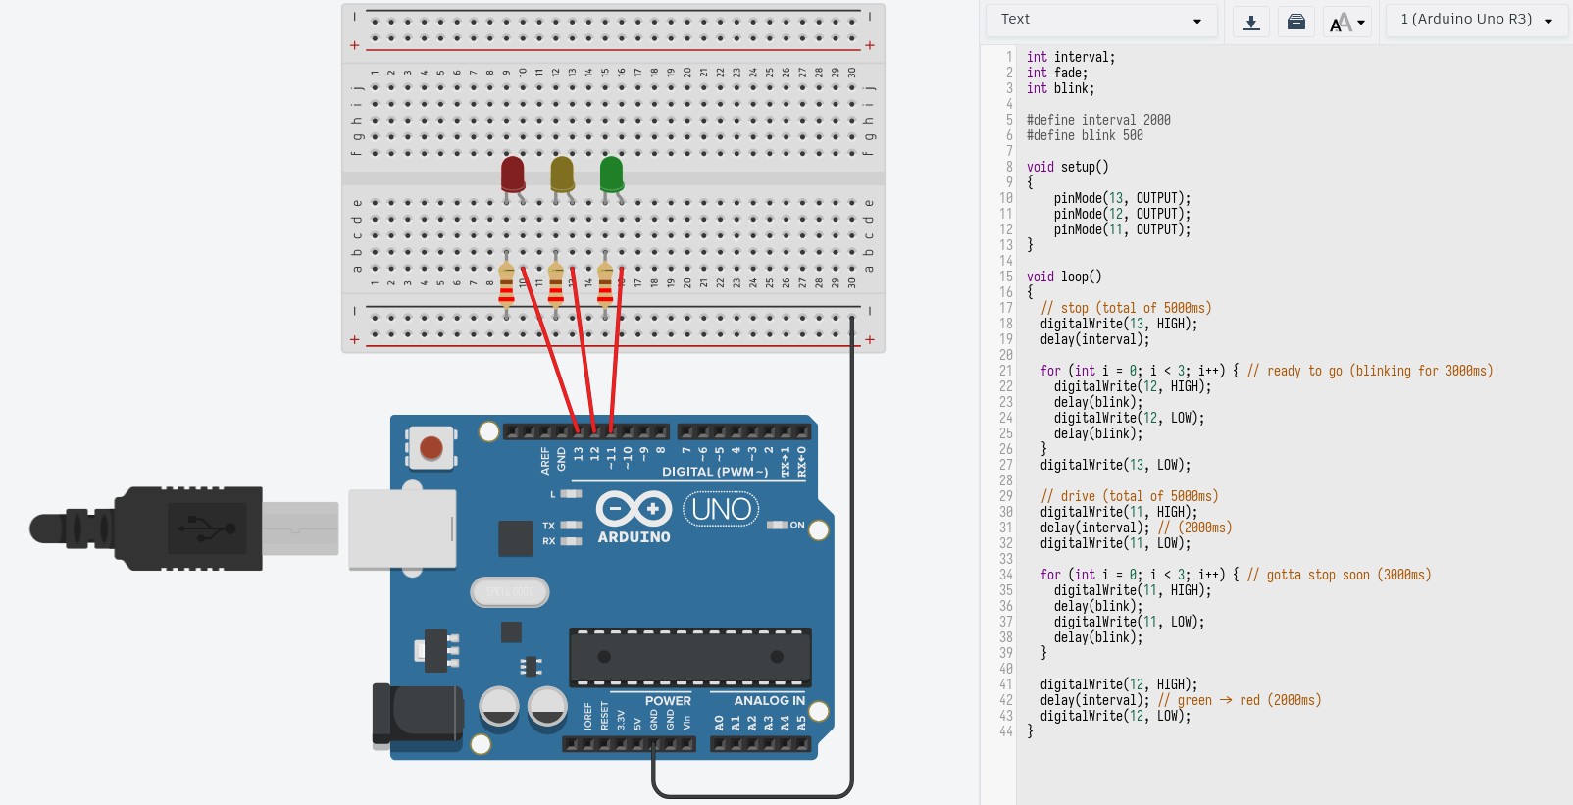
Based on the youtube material, I decided to make a traffic light that tries to imititate a real life version of it, with some unrealistic time intervals, just to make it quicker to showcase.

Program starts with the red light turning on (2 seconds by itself, and then for 3 seconds with yellow light blinking, signaling drivers to get moving soon). I made the yellow light blink with the inner for loop, and as the loop finishes, yellow blinkning ends too and red light turns off.

After that, green light turns on for 2 seconds, then it blinks for 3 seconds (indicating that the green will be off soon, again using the inner for loop), green light turns off, yellow light turns off for 2 seconds, giving drivers more time to realise that they have to stop. Yellow light turns off and the main loop starts again, turning the red light on.

All the anodes of the LEDs receive electricity through pins 11, 12, 13 and are also controlled refering to those numbers via the script. All the LEDs’ cathodes are connected to grounding pin through resistor. Connection to the ground makes the electricity go through the LEDs, making them light up, and the resistors protect the lamps from having to receive too much energy, that could result in them being destroyed.

