Task 2:
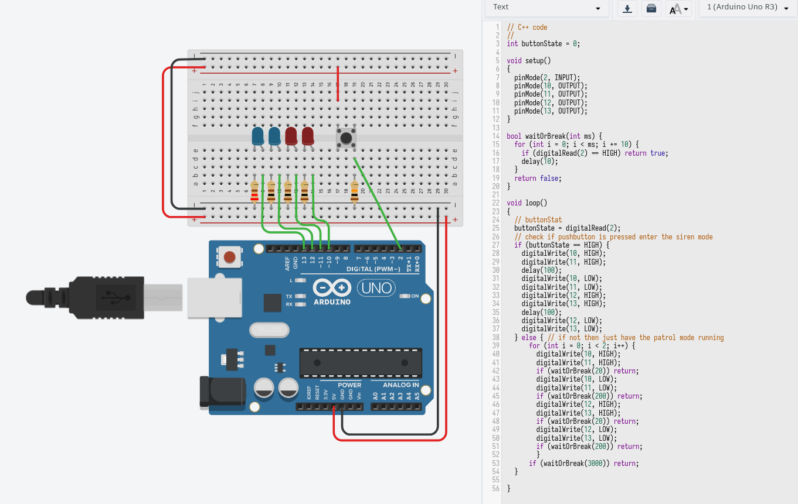
For this task, according to the instructions (with slight deviation from description), I created a simulation of the police lights, entering the siren mode when pressing the button.

I connected pins 10, 11, 12, 13 to cathodes of 4 LEDs and grounded anodes of those LEDs via resistors.

Added the pushbutton to the breadboard, and connected one of the diagonal legs to the 5V and another to the pin 2. When pressing the button, electrical connection is made between power and arduino pin 2. Additionally, I’ve added slightly larger resistor (10 kΩ), and in this case it would be called a pull-down resistor, that gives the pin 2 weaker grounding so that the pin is never floating. Because the electricity takes the path of the least resistance, when the button is pressed, due to the high resistor in the path to the ground, the pin will sense the power of electricity stronger and will ignore the weak connection to the ground. The resistor prevents the pin from being affected by static electricity and gives more reliable readings (source: https://youtu.be/PC15jBx2UxI?si=2WPp5ZMPTblLA44R).

To make the pins react when the button is pressed, I created a variable “buttonState” (as demonstrated on one fo the lectures) that reads the state of the button, basically detecting whenever the electricity goes through it and when not.

In the main loop, when the button is pressed, the lights enter the siren mode, blinking alternatively (red and blue) with almost no delay, to imitate the emergency situation.

When the button is not pressed, the light are in “patrol mode”, blinking twice (using the for loop) “lightly” (achieved by smaller interval between HIGH and LOW of both red and blue lamps) with 3 second intervals between the patrol modes. I’ve also implemented the function that makes this delay not a consecutive 3 seconds, but checking the state of the button 300 (in this instance) times every 10 ms, which I needed to detect when if the button is pressed, so that I can break out of the loop within the error margin of 10ms. I use this function in every instance of “delay call” of the patrol mode.

