Task 3:
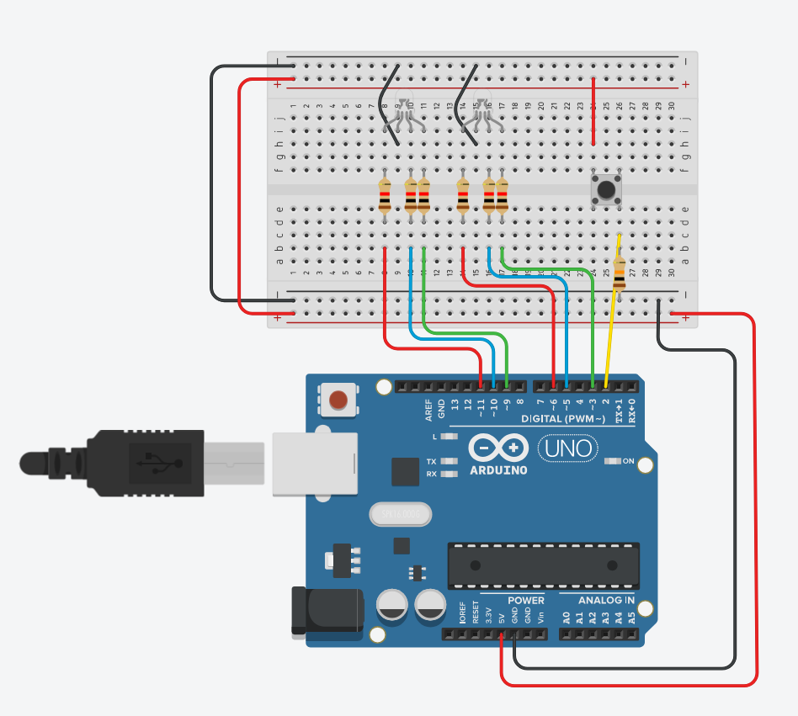

int buttonState = 0;
int inten = 0;
int slow = 400;
int rapid = 150;
int state = 0;

void setup()
{
pinMode(2, INPUT);
// left
pinMode(11, OUTPUT); // R
pinMode(10, OUTPUT); // B
pinMode(9, OUTPUT); // G
// right
pinMode(6, OUTPUT); // R
pinMode(5, OUTPUT); // B
pinMode(3, OUTPUT); // G
}

bool waitOrBreak(int ms) {
for (int i = 0; i < ms; i += 10) {
if (digitalRead(2) == HIGH) {
state = !state;
while (digitalRead(2) == HIGH);
delay(50);
return true;
}
delay(10);
}
return false;
}

void red_left(int intens) {
analogWrite(11, intens);
analogWrite(10, 0);
analogWrite(9, 0);
}

void green_left(int intens) {
analogWrite(11, 0);
analogWrite(10, 0);
analogWrite(9, intens);
}

void blue_left(int intens) {
analogWrite(11, 0);
analogWrite(10, intens);
analogWrite(9, 0);
}

void red_right(int intens) {
analogWrite(6, intens);
analogWrite(5, 0);
analogWrite(3, 0);
}

void green_right(int intens) {
analogWrite(6, 0);
analogWrite(5, 0);
analogWrite(3, intens);
}

void blue_right(int intens) {
analogWrite(6, 0);
analogWrite(5, intens);
analogWrite(3, 0);
}

void slowFade() {
inten = 255;
for (int i = 0; i < 5; i++) {
red_left(inten);
green_right(inten);
inten /= 2;
if (waitOrBreak(slow)) return;
}
inten = 255;
for (int i = 0; i < 5; i++) {
green_left(inten);
red_right(inten);
inten /= 2;
if (waitOrBreak(slow)) return;
}
inten = 255;
for (int i = 0; i < 5; i++) {
blue_left(inten);
red_right(inten);
inten /= 2;
if (waitOrBreak(slow)) return;
}
inten = 255;
for (int i = 0; i < 5; i++) {
green_left(inten);
blue_right(inten);
inten /= 2;
if (waitOrBreak(slow)) return;
}
}

void rapidBlink() {
inten = 255;
for (int i = 0; i < 5; i++) {
red_left(inten);
blue_right(inten);
if (waitOrBreak(rapid)) return;
red_left(0);
blue_right(0);
if (waitOrBreak(rapid)) return;
}
for (int i = 0; i < 5; i++) {
red_right(inten);
blue_left(inten);
if (waitOrBreak(rapid)) return;
red_right(0);
blue_left(0);
if (waitOrBreak(rapid)) return;
}
for (int i = 0; i < 5; i++) {
green_right(inten);
red_left(inten);
if (waitOrBreak(rapid)) return;
green_right(0);
red_left(0);
if (waitOrBreak(rapid)) return;
}
for (int i = 0; i < 5; i++) {
green_left(inten);
red_right(inten);
if (waitOrBreak(rapid)) return;
green_left(0);
red_right(0);
if (waitOrBreak(rapid)) return;
}
for (int i = 0; i < 5; i++) {
blue_left(inten);
green_right(inten);
if (waitOrBreak(rapid)) return;
blue_left(0);
green_right(0);
if (waitOrBreak(rapid)) return;
}
}

void loop() {
if (state == 0) {
rapidBlink();
} else {
slowFade();
}
}

For this task I decided to make a simulation of christmas lights using two LED RGB lamps. Cathodes are grounded, and Red, Blue, and Green legs are connected to pins 11, 10, and 9 for the lamp on the left, and pins 6, 5, and 3 to the lamp on the right (these pins are reliable for LED RBG value manipulation according to the information from genAI).

I connected button’s one of the legs to the 5V and it’s diagonal leg to pin 2 and to ground via 10 kohm resistor, so that the readings are reliable. I read the flow of the electricity throught the button to control LED RGBs.

I defined simple color configurations using functions which receive intensity as arguments to update the color and it’s brightness. I am using these mini functions in two of the modes that I implement to simulate “christmas lights”.

Function slowFade uses for loops to change the brightness of colors in each lamp by dividing the value of intensity by 2 each iteration. Each for loop uses different variations of colors for demonstration purposes.

Function rapidBlink has the similar logic, but instead of halving the color intensity value, during each iteration, values go from 255 to 0, basically blinking.

Both of the functions above use the helper waitOrBreak, which accepts the interval as the argument.
This helper is used to read the state of the button and change the value of the global variable “state” whenever the button is pressed, which plays part in defining which of the modes above will be running in the main loop. It is used instead of every delay instance when “blinking” or switching between colors.

It is worth considering that the waitOrBreak loop runs much quicker than the time it takes for us to press the button and release it. For this reason, we use `while (digitalRead(2) == HIGH);` inside of the loop so that it waits until the button is released before leaving the for loop. `delay(50);` takes care of any debounce that may occur when pressing the button.

