Task 5:
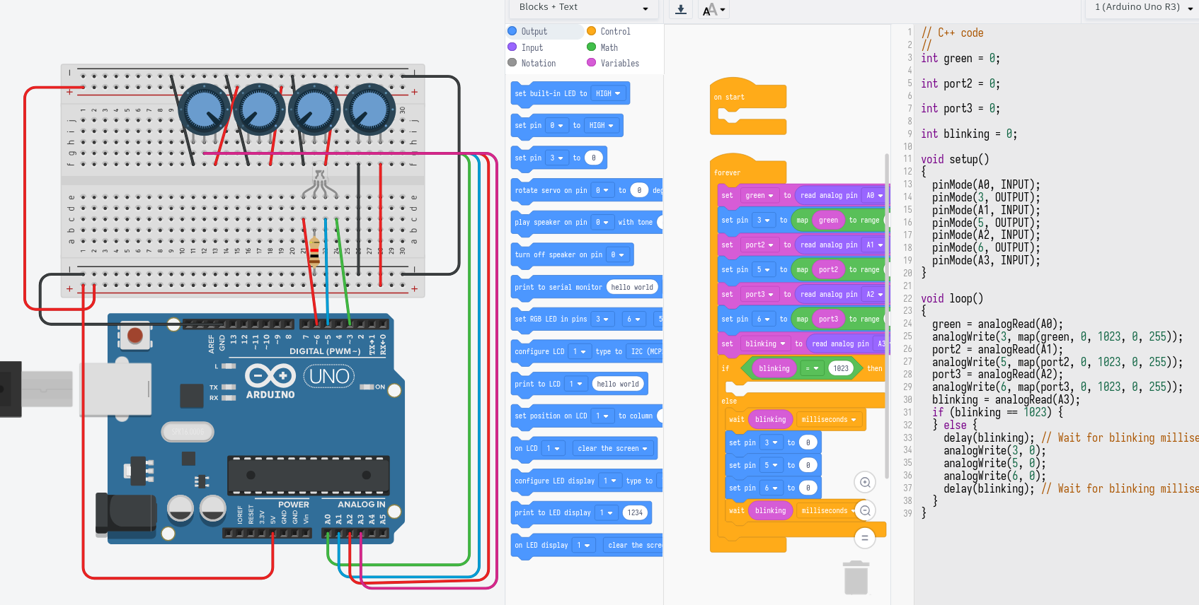
For this task, according to the lecture, I connected RGB LED legs to PWM pins on the arduino, and cathode leg to the ground through resistor. I also connected four potentiometers’ Terminal 1 and Terminal 2 to 5V and ground pins, and the wiper leg to A0, A1, A2, and A3 pins.
We use potentiometers to read the flow of the elctricity through them. We can change manipulate the value that we will read by moving the handwheel (changing the resistance inside the tool) which we will use to change the intensity of RGB colors on LED lamp. From three potentiometers we will read instensity of red, green and blue colors, and on the fourth one rate of blinking (or no blinking if value is 1023 which is maximum).
To make sure that the values map correctly from 0 – 1023, to 0 – 255, we use map function.
With all this, we can increase/decrease the intensity of red, green, blue colors, and blinking rate of the RGB LED by changing the resistance of the potentiometers.

