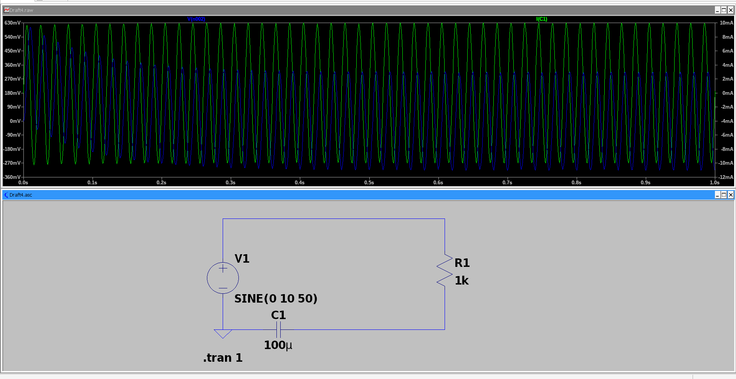Figure 1: Figure 1: V(n002) = voltage across capacitor C1 (green, ~630mV peak); I(C1) = current through capacitor (blue, ~10mA peak); both are sine waves, meaning capacitor passes AC freely.
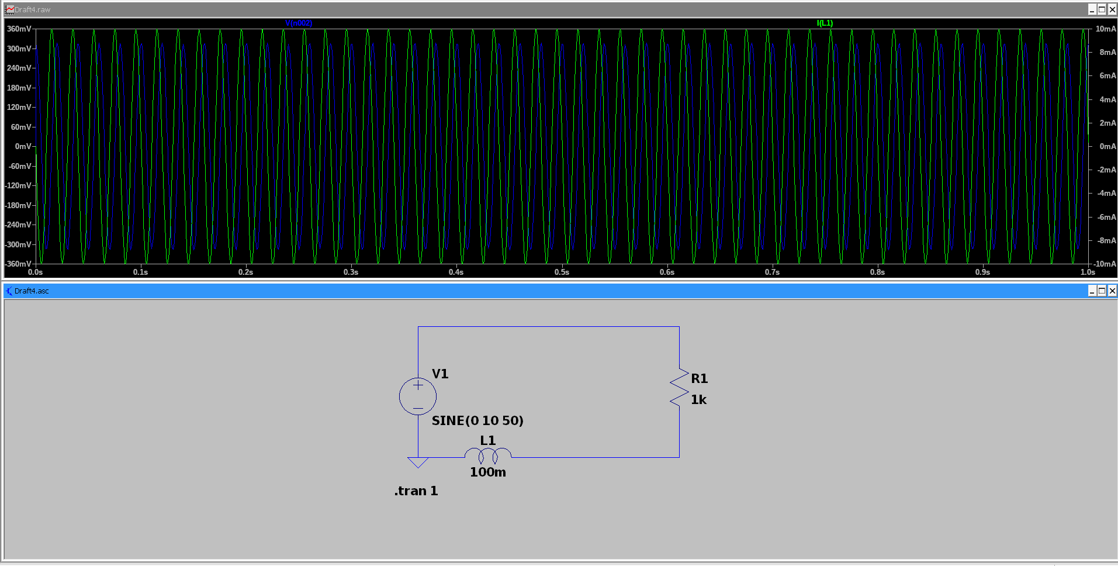Figure 2: Figure 4: V(n002) = voltage across inductor L1 (blue, ~360mV peak); I(L1) = current through inductor (green, ~10mA peak); both are sine waves, meaning inductor passes AC. Current slightly lags voltage, characteristic inductor behavior.
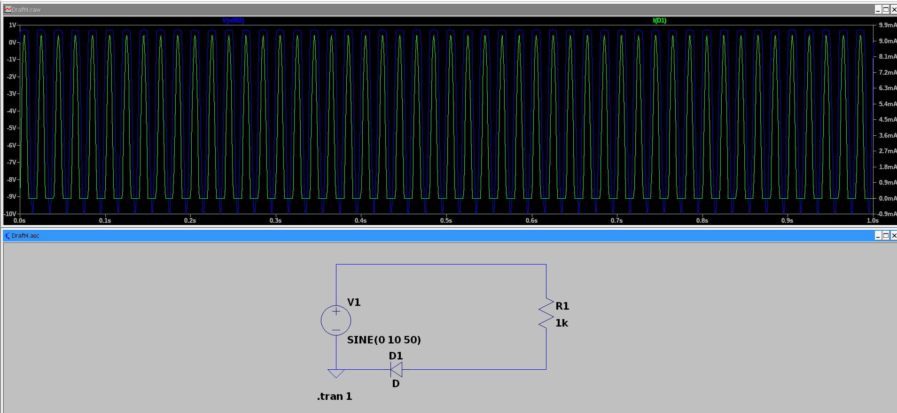Figure 3: Figure 5: V(n002) = voltage across diode D1 (blue); I(D1) = current through diode (green, ~9mA peaks); current flows only during positive half-cycles. Diode rectifies AC, blocking the negative half completely.

