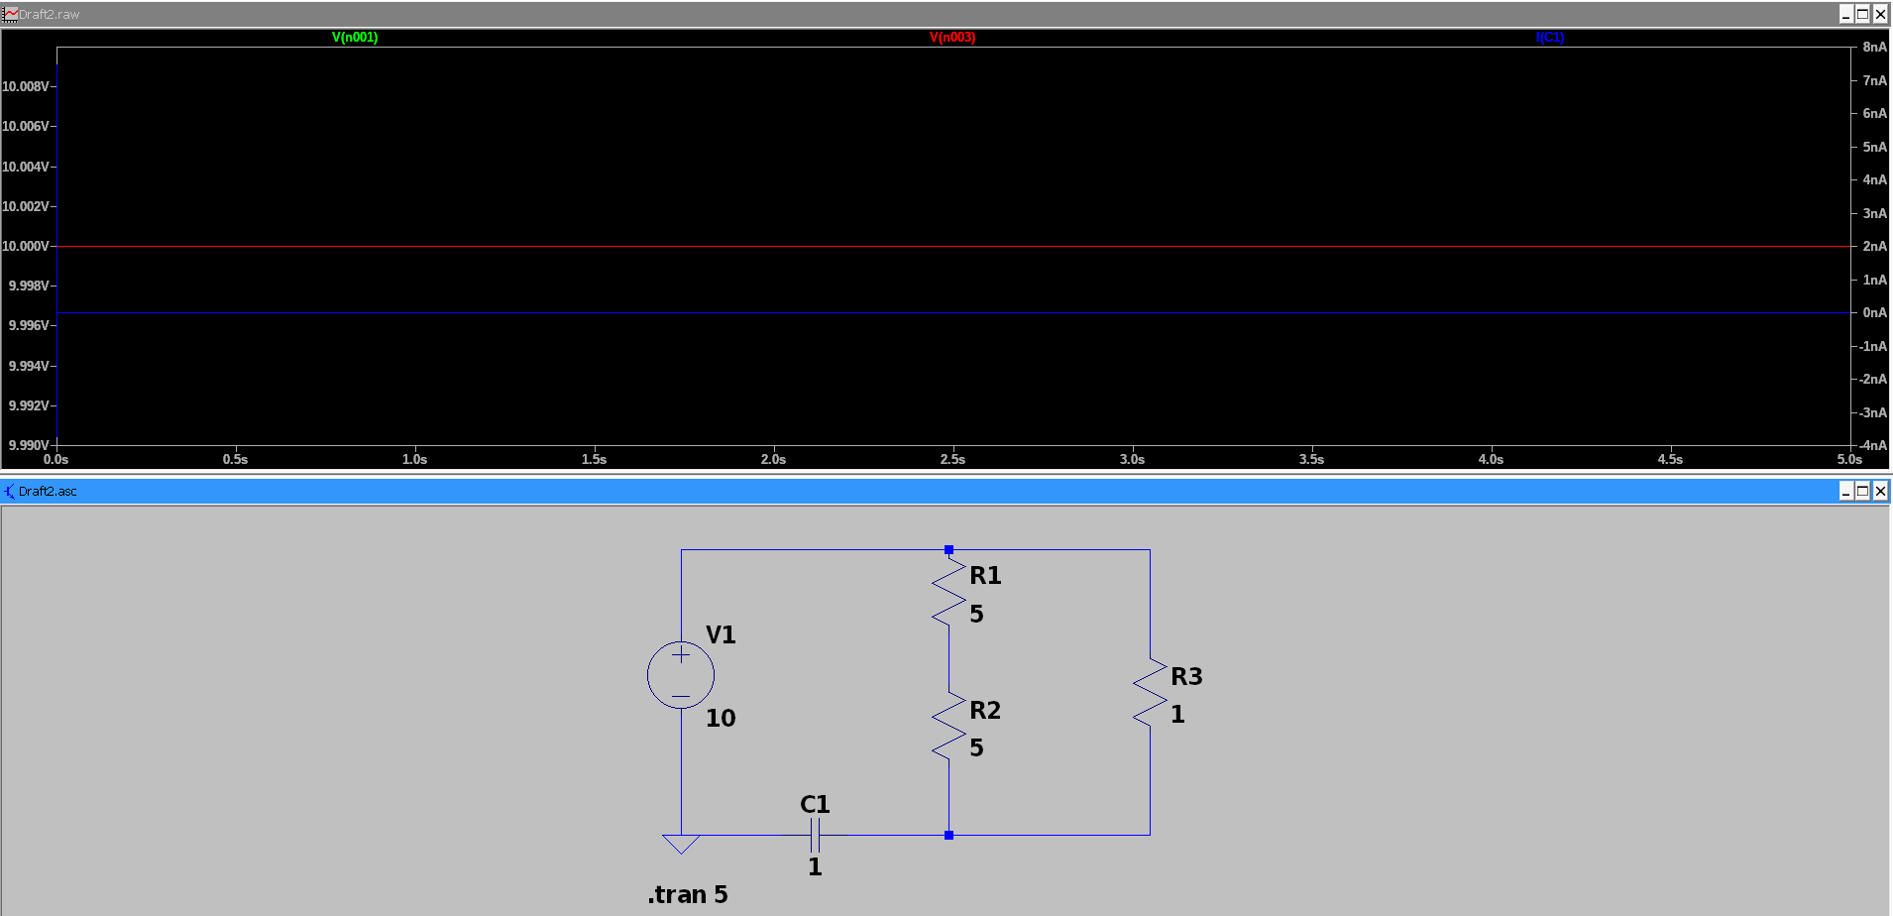Figure 1: Voltage across capacitor = ~10V, Current through capacitor = 0A; meanong that capacitor blocks DC
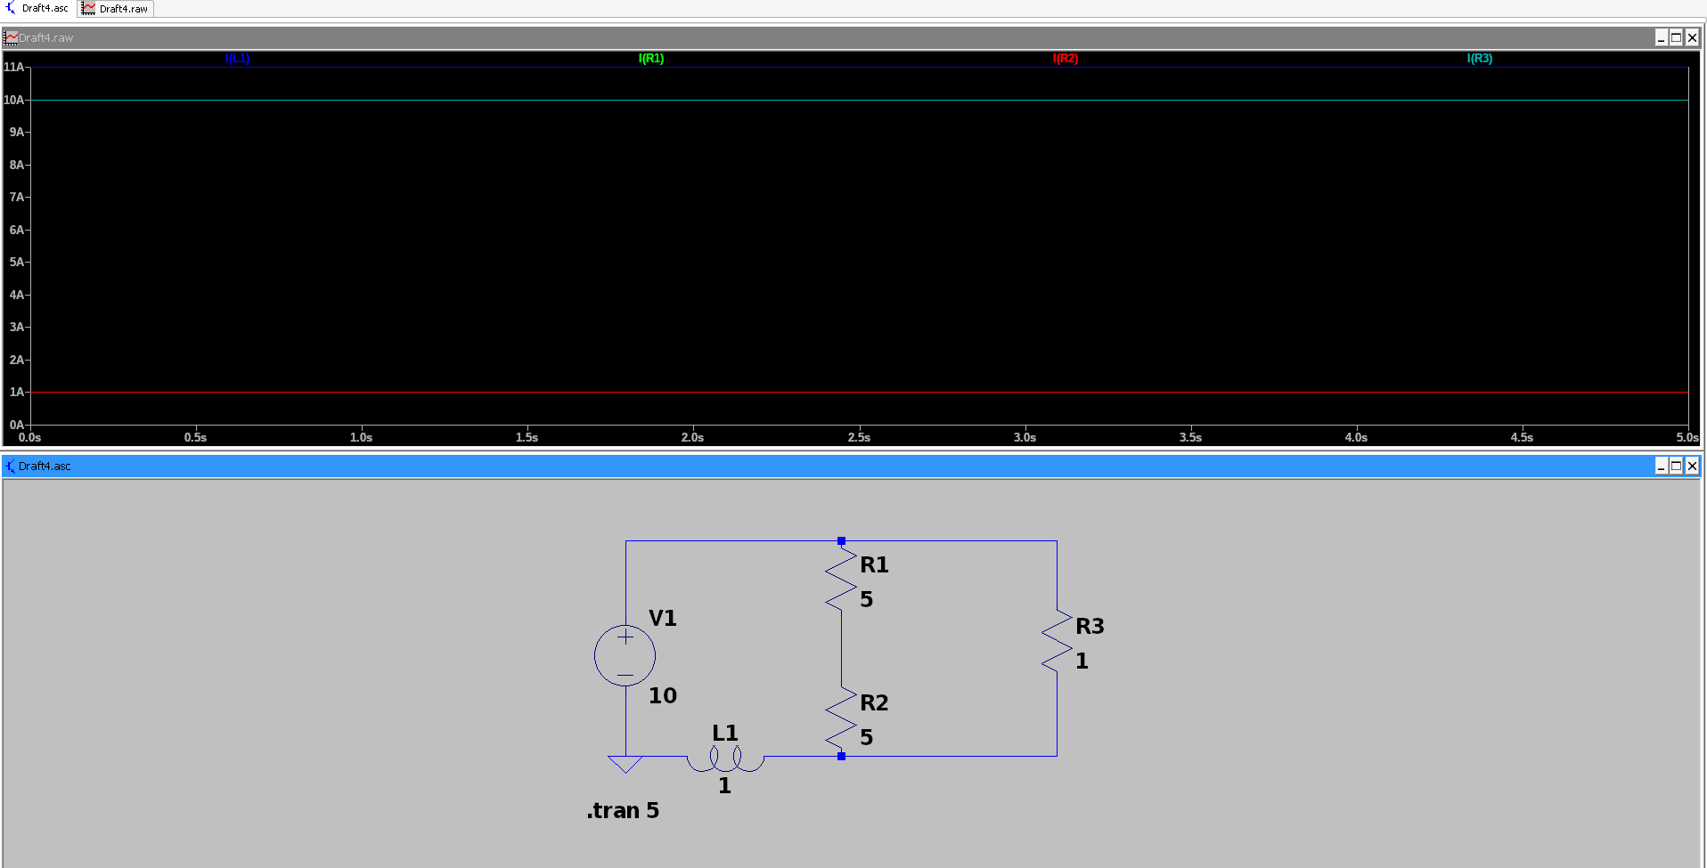Figure 2: Currents I(L1) = 11A, I(R1) = 1A, I(R3) = 10A are all flat across the entire 5s simulation, meaning the inductor passes DC freely and acts as a short circuit.

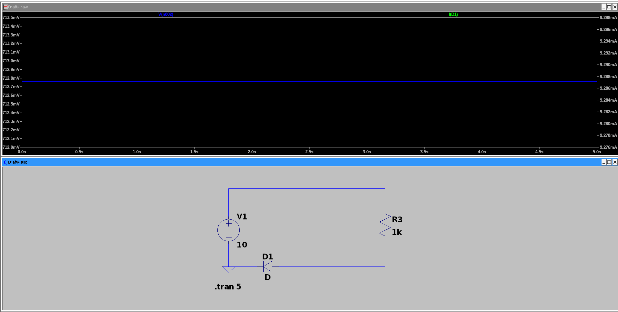Figure 3: V(n002) = ~712.8mV (voltage across diode D1 in forward bias); I(D1) = ~9.29mA (current flows through the diode); meaning that diode conducts DC in forward bias direction.

