When the upper AC terminal of source V1 is positive, current flows through diode D3, then through resistor R1, and returns through diode D1.
When the lower AC terminal of source V1 is positive, current flows through diode D4, then through resistor R1, and returns through diode D2.
In both cases, current flows through R1 in the same direction, so the AC input is converted into a full-wave rectified output.
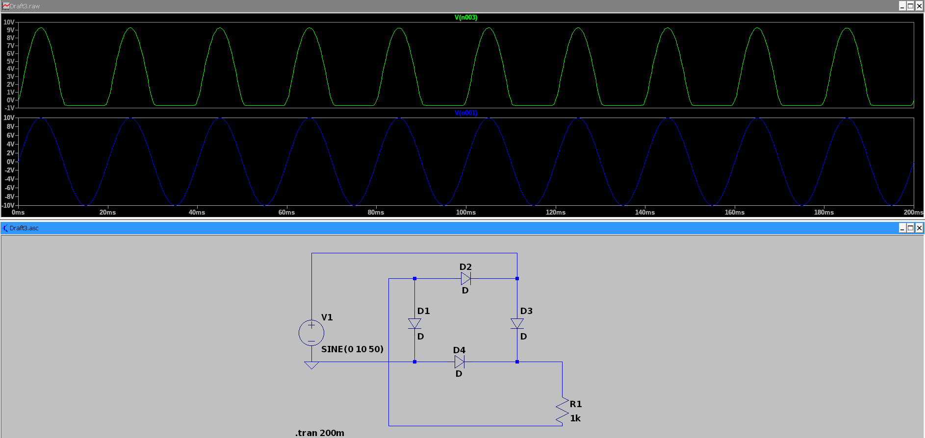Figure 1: Graetz bridge rectifier in LTSpice. When the upper AC terminal of V1 is positive, diodes D3 and D1 conduct; when the lower AC terminal is positive, diodes D4 and D2 conduct. Current through R1 always flows in the same direction, so the sinusoidal AC input is converted into a positive pulsating output (full-wave rectification).
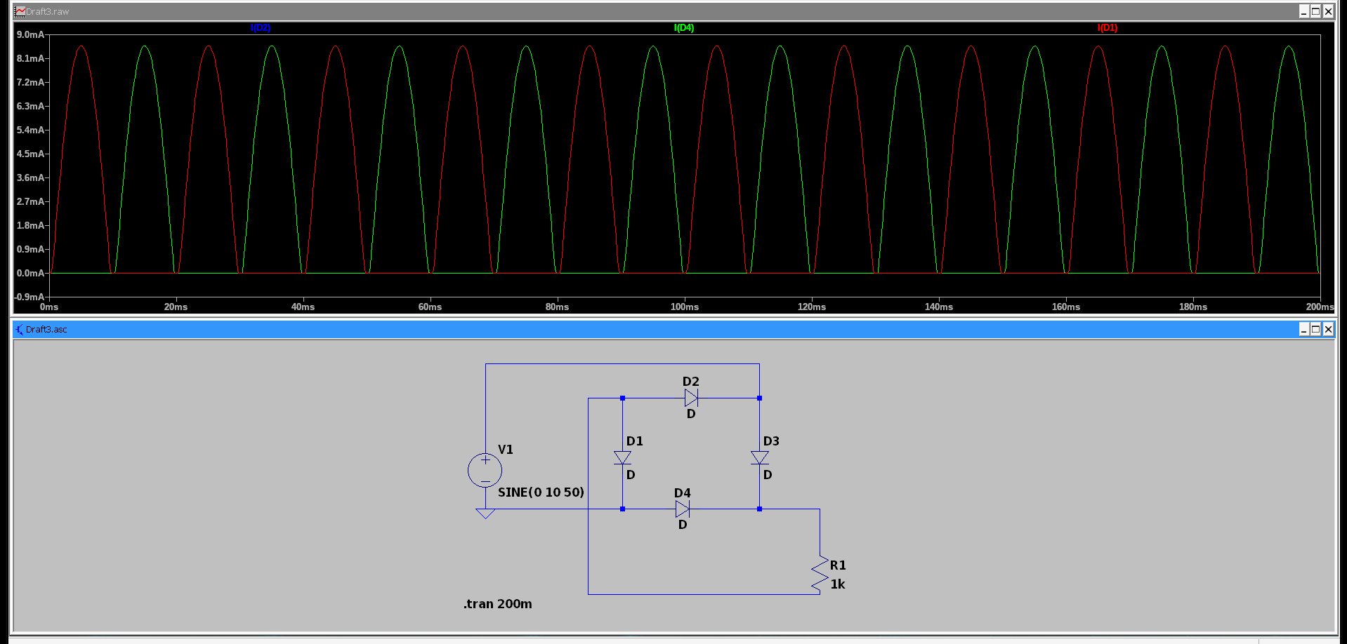Figure 2: Alternating conduction of diode pairs in the Graetz bridge. In opposite half-cycles, different diode pairs conduct, but current through R1 remains in the same direction, producing full-wave rectification.

