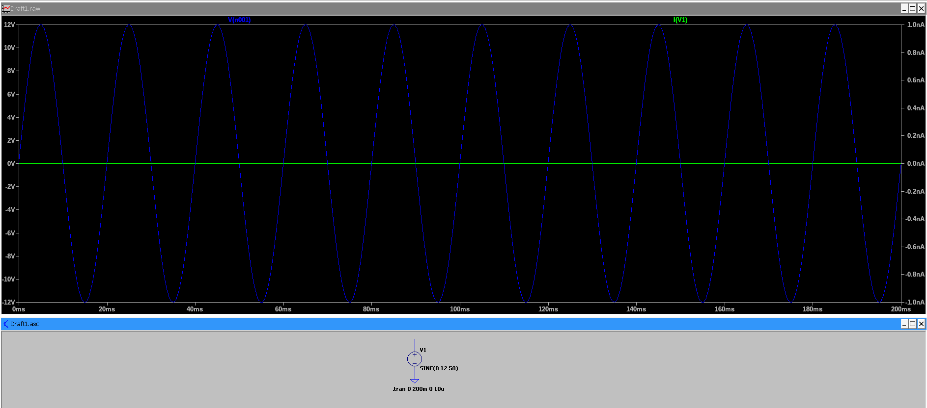Figure 1: Input AC voltage from source V1 defined as SINE(0 12 50). The waveform is sinusoidal, swings between approximately −12 V and +12 V, has a period of about 20 ms, and a frequency of 50 Hz.
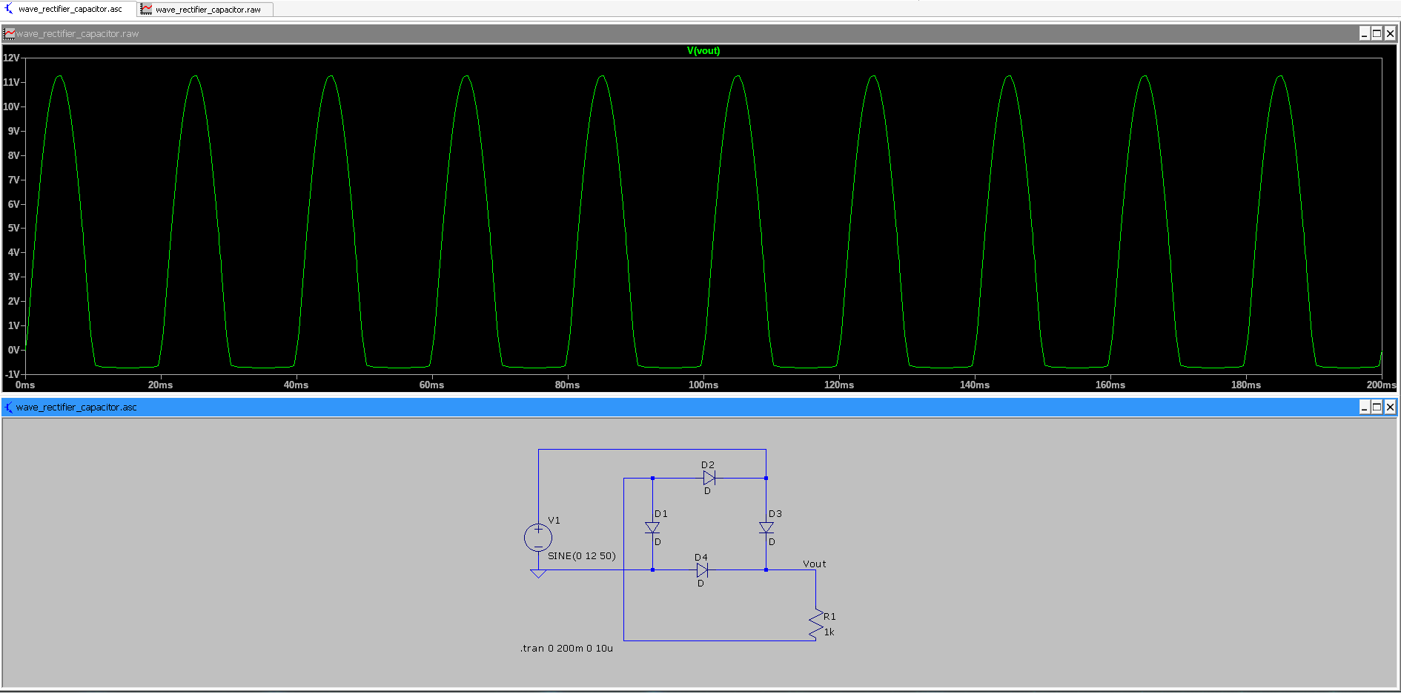Figure 2: Graetz bridge rectifier without capacitor (V1 = SINE(0 12 50), R1 = 1 kΩ). Output voltage Vout is almost always positive and has a pulsating shape. The voltage peaks at about 11.3 V and briefly dips to around −0.7 V between pulses, so it is not an ideal DC voltage. The effective ripple frequency is about 100 Hz (one main pulse every 10 ms).
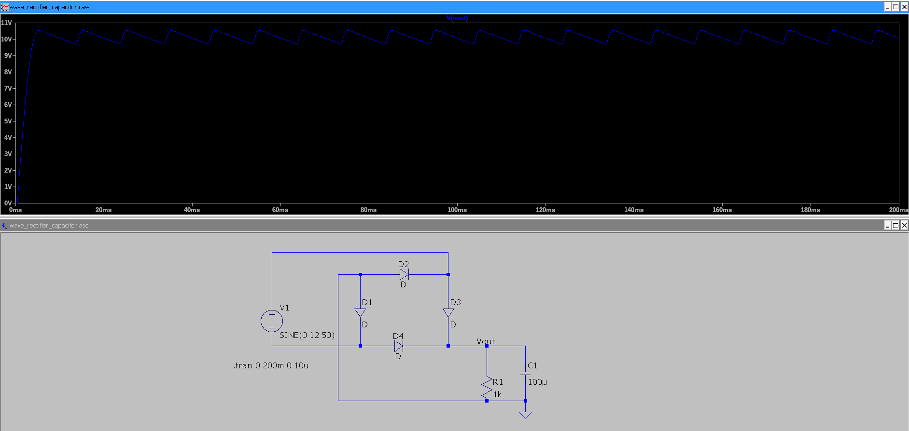Figure 3: Graetz bridge rectifier with 100 µF filter capacitor (V1 = SINE(0 12 50), R1 = 1 kΩ, C1 = 100 µF). Output voltage Vout is approximately 10.5 V with a small ripple. The measured maximum voltage is about 10.53 V and the minimum about 9.69 V, giving a ripple ΔV ≈ 0.84 V. The ripple frequency is about 100 Hz (one pulse every 10 ms).

Capacitor | Load resistance | Vmax | Vmin | Delta V
None | 1 kOhm | 11.3 | -0.7 | 12.0
100 uF | 1 kOhm | 10.53 | 9.69 | 0.84
470 uF | 1 kOhm | 10.48 | 10.28 | 0.2
1000 uF | 1 kOhm | 10.45 | 10.36 | 0.09
470 uF | 470 Ohm | 10.47 | 10.07 | 0.4
470 uF | 100 Ohm | 10.43 | 8.82 | 1.61
As the capacitance increases, the ripple voltage ΔV decreases because the capacitor holds charge between rectified peaks. For a fixed capacitor, reducing the load resistance (heavier load) increases the ripple, as the capacitor discharges more between peaks.

