Task 6:
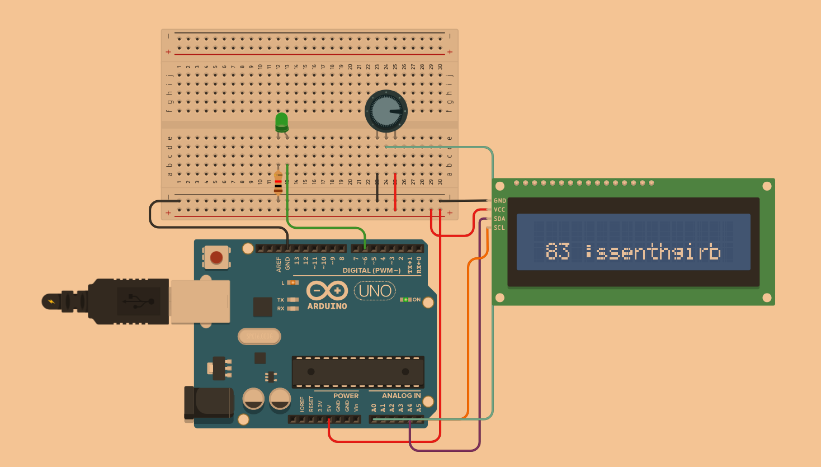
#include <Adafruit_LiquidCrystal.h>

int brightness = 0;

Adafruit_LiquidCrystal lcd_1(0);

void setup()
{
pinMode(A0, INPUT);
pinMode(LED_BUILTIN, OUTPUT);
pinMode(6, OUTPUT);
lcd_1.begin(16, 2);
}

void loop()
{
brightness = analogRead(A0);
digitalWrite(LED_BUILTIN, HIGH);
analogWrite(6, brightness);
lcd_1.setCursor(0, 0);
lcd_1.print("brightness: ");
lcd_1.print(map(brightness, 0, 1023, 0, 100));
delay(1000); // Wait for 1000 millisecond(s)
lcd_1.clear();
digitalWrite(LED_BUILTIN, LOW);
analogWrite(6, 0);
delay(1000); // Wait for 1000 millisecond(s)
brightness = analogRead(A0);
lcd_1.clear();
digitalWrite(LED_BUILTIN, HIGH);
analogWrite(6, brightness);
lcd_1.setCursor(1, 1);
lcd_1.print(map(brightness, 0, 1023, 0, 100));
lcd_1.print(" :ssenthgirb");
delay(1000); // Wait for 1000 millisecond(s)
lcd_1.clear();
digitalWrite(LED_BUILTIN, LOW);
analogWrite(6, 0);
}

In this project, I decided to follow the image from the moodle, relatively close. I made minimal modification: text is displayed in reverse and goes back to the normal display every iteration.
Electricity going through potentiometer is read and is modifying the brightness of the LED lamp, and also we get this information to display the corresponding values to LCD. I also mapped values from the potentiometer to 0 – 100, to make the display more “user friendly”.

