Task 7:
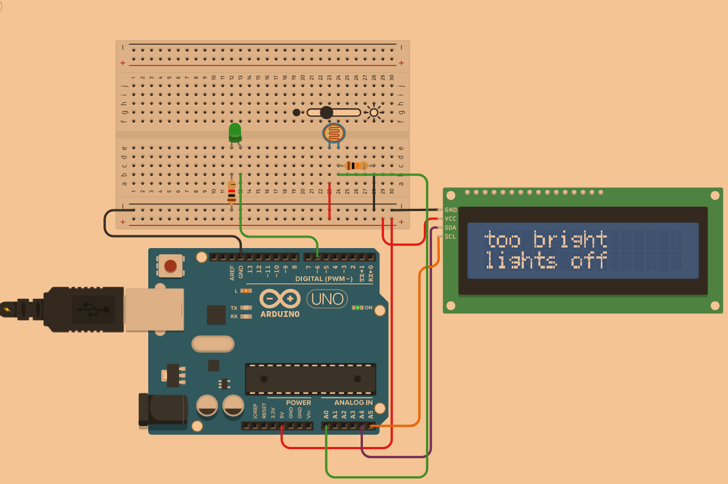
// C++ code
//
#include <Adafruit_LiquidCrystal.h>

int brightness = 0;

Adafruit_LiquidCrystal lcd_1(0);

void setup()
{
pinMode(A0, INPUT);
pinMode(LED_BUILTIN, OUTPUT);
pinMode(6, OUTPUT);
Serial.begin(9600);
lcd_1.begin(16, 2);
}

void loop()
{
brightness = analogRead(A0);
digitalWrite(LED_BUILTIN, HIGH);
analogWrite(6, map(brightness, 0, 1023, 255, 0));
Serial.println(brightness);
if (brightness >= 900) {
lcd_1.setCursor(0, 0);
lcd_1.print("too bright");
lcd_1.setCursor(0, 1);
lcd_1.print("lights off");
} else {
if (brightness >= 100) {
lcd_1.setCursor(0, 0);
lcd_1.print("okay sun");
lcd_1.setCursor(0, 1);
lcd_1.print("low lights on");
} else {
lcd_1.setCursor(0, 0);
lcd_1.print("dark");
lcd_1.setCursor(0, 1);
lcd_1.print("lights on");
}
}
delay(1000); // Wait for 1000 millisecond(s)
lcd_1.clear();
digitalWrite(LED_BUILTIN, LOW);
analogWrite(6, 0);
}
For this task I combined photoresistor and LCD. I take the light intensity as a number, reading it from A0, and depending on its value, I display corresponding messages on the screen. Additionally, the number also affects how bright the LED is lit up. Photoresistor reads weak numbers, lights are up in LED, and if it’s “too sunny”, LED light dims.

