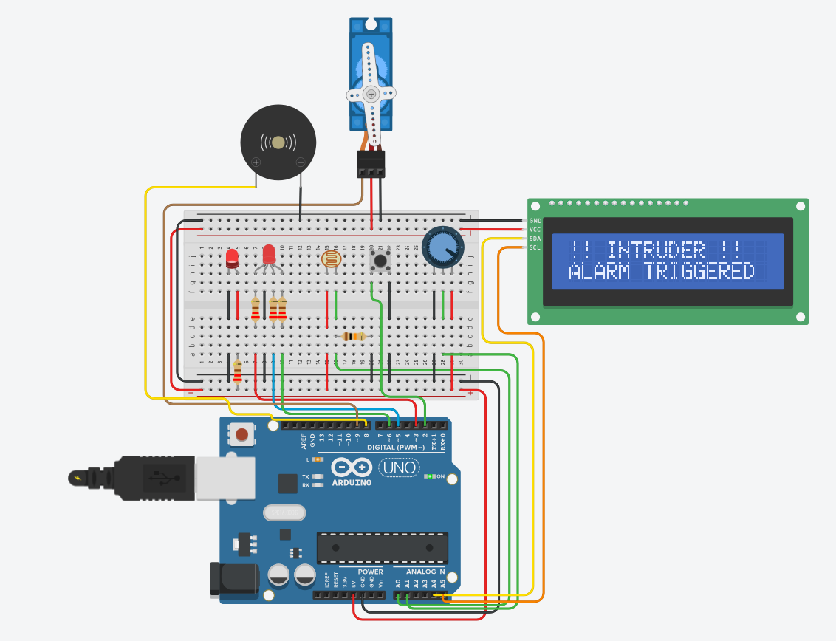
For this project I built a security alarm station using eight programmable components: a photoresistor, potentiometer, push button, red LED, RGB LED, LCD 16×2 display, servo motor, and a piezo buzzer.
The photoresistor is connected in a voltage divider with a 10kΩ pull-down resistor to the GND rail, with its output going to analog pin A0. In darkness the resistance of the LDR increases, which lowers the voltage at A0, giving us a low analog reading (0–1023). We compare this reading against a sensitivity threshold to detect intrusion.
The potentiometer wiper connects to pin A1, and its outer terminals to 5V and GND. By turning the dial we change the internal resistance, which changes the voltage on A1. We use the map() function to convert this 0–1023 range into a threshold value between 50 and 650. This lets the user adjust how sensitive the alarm is.
The push button connects to pin D2 with INPUT_PULLUP mode, meaning no external resistor is needed. The pin reads HIGH by default and LOW when pressed. To avoid reading a single press multiple times due to electrical bouncing, we implement software debouncing and we only react when the button transitions from HIGH to LOW and at least 50ms have passed since the last trigger.
The RGB LED cathode connects to GND, and each colour leg connects through a 220Ω resistor to PWM-capable pins D3, D5, and D6. Using analogWrite() on these pins lets us control brightness of each colour channel independently, giving us red when armed, green when disarmed, and a breathing blue pulse in standby.
The servo motor signal wire connects to pin D9. We write position values using lockServo.write(): 0° represents the locked state when armed, and 90° represents the open state when disarmed. The buzzer on pin D8 and the red LED on D13 strobe together during an alarm using a timer-based beat pattern derived from millis(), avoiding any use of delay() in the main loop so the system stays responsive at all times.
*The source code is available as a separate attachment.

