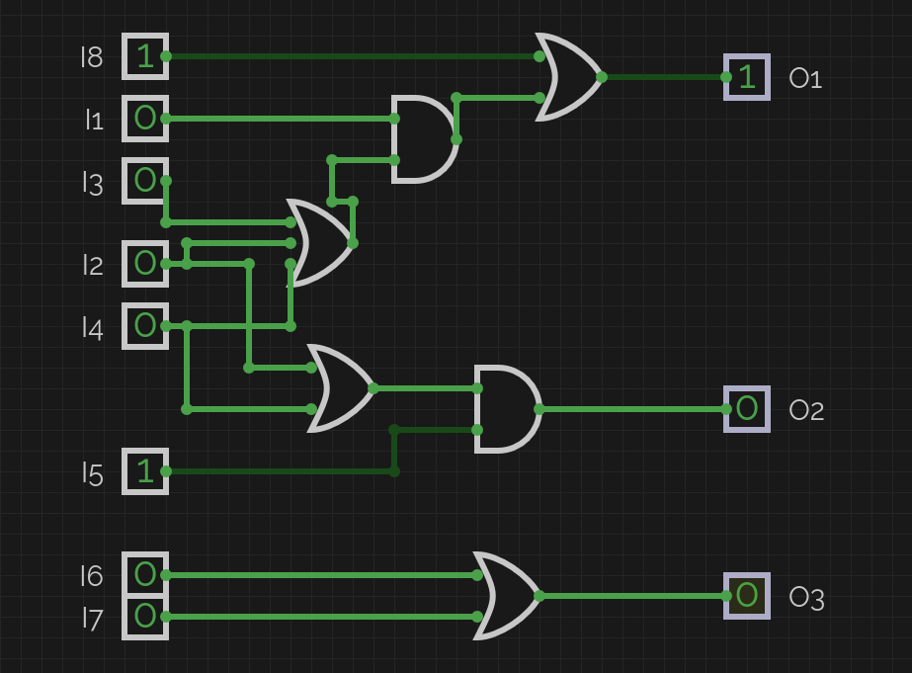
Boolean expressions:
O1 = (I1 · (I2 + I3 + I4)) + I8
O2 = I5 · (I2 + I4)
O3 = I6 + I7

For this task I designed a smart home control system using logic gates in CircuitVerse, with 8 inputs and 3 outputs.
The security alarm output O1 is implemented using a 3-input OR gate, a 2-input AND gate, and a final 2-input OR gate. The OR gate combines the door, window, and motion signals and if any one of them is active, it passes a 1 to the AND gate. The AND gate requires both the alarm-armed signal and the OR output to be 1, ensuring the alarm only triggers when the system is armed and an intrusion event occurs. The emergency button bypasses this entirely through the final OR gate, so pressing it always activates the alarm regardless of armed state.
The smart light output O2 uses a 2-input OR gate and a 2-input AND gate. The OR gate checks whether the door is open or motion is detected, and the AND gate ensures the light only turns on if it is also dark (I5 = 1). This way the light activates automatically when presence is detected in a dark room.
The kitchen warning output O3 is implemented with a single 2-input OR gate, since either an open fridge or detected smoke alone is enough to trigger the warning.
Unlike the traffic light system from the previous task, no NOT gates were required here, because all output conditions are based purely on positive (active) signals.

Due to the platform being buggy, I manually entered values to test mostsignificant cases.
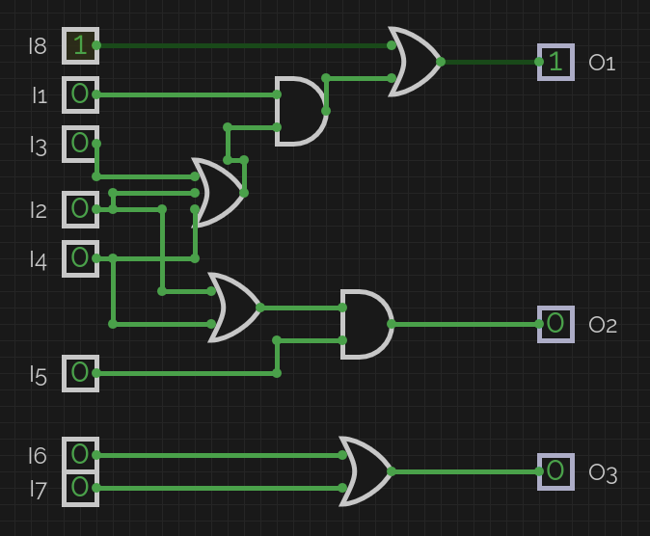Figure 2: Emergency
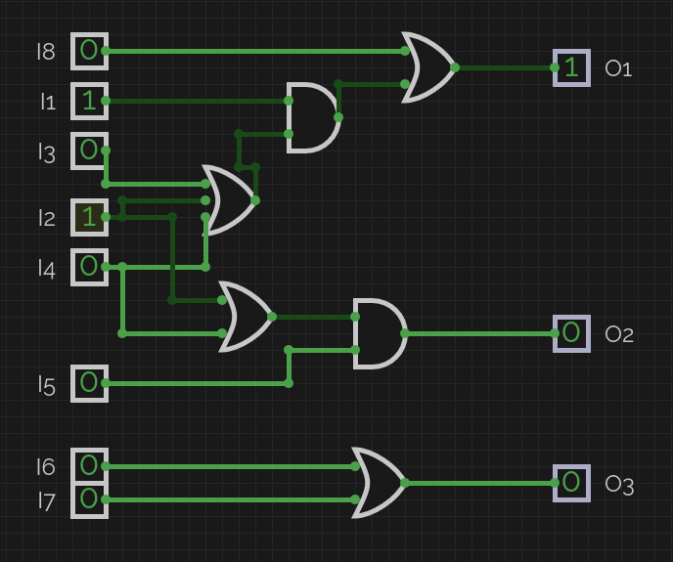Figure 3: Armed + door

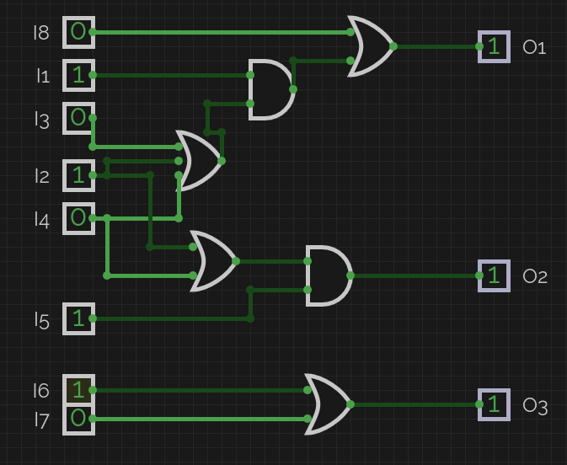Figure 5: All three on
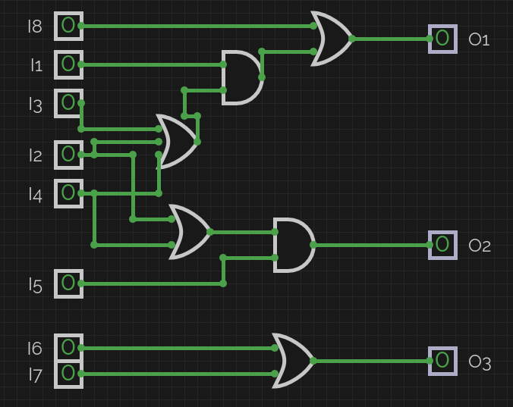Figure 1: All off
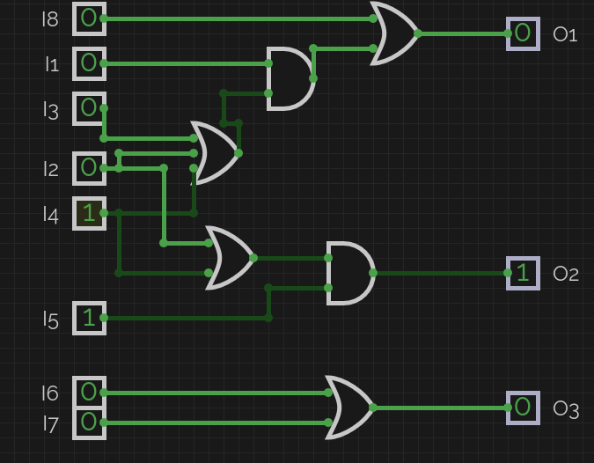Figure 4: Dark + motion

