**Letter Rarities**

|  |  |  |  |
| --- | --- | --- | --- |
| E | 0.111606 | M | 0.030129 |
| A | 0.084966 | H | 0.030034 |
| R | 0.075809 | G | 0.024705 |
| I | 0.075448 | B | 0.020720 |
| O | 0.071635 | F | 0.018121 |
| T | 0.069509 | Y | 0.017779 |
| N | 0.066544 | W | 0.012899 |
| S | 0.057351 | K | 0.011016 |
| L | 0.054893 | V | 0.010074 |
| C | 0.045388 | X | 0.002902 |
| U | 0.036308 | Z | 0.002722 |
| D | 0.033844 | J | 0.001965 |
| P | 0.031671 | Q | 0.001962 |

**Background Rarities**

|  |  |
| --- | --- |
| Bubblegum | 0.11 |
| City | 0.11 |
| Cowboy | 0.11 |
| Desert | 0.11 |
| Heaven | 0.11 |
| Hell | 0.11 |
| Moon | 0.11 |
| Nature | 0.11 |
| Ocean | 0.11 |
| Gold | 0.01 |

**Total Font and Font Colour rarity**

|  |  |  |  |
| --- | --- | --- | --- |
| **Colour** | **Font** | **Rarity** | **Colour rarity** |
| **Amber** | Sans Serif | 0.3300 | 0.5744 |
| Serif | 0.1372 |
| Calligraphy | 0.1072 |
| **Red** | Sans Serif | 0.2022 | 0.3616 |
| Serif | 0.0872 |
| Calligraphy | 0.0722 |
| **Silver** | Sans Serif | 0.0250 | 0.05 |
| Serif | 0.0150 |
| Calligraphy | 0.0100 |
| **Gold** | Sans Serif | 0.0080 | 0.014 |
| Serif | 0.0040 |
| Calligraphy | 0.0020 |

**Hat Rarity**

|  |  |
| --- | --- |
| Bubblegum | 0.0108 |
| City | 0.0108 |
| Cowboy | 0.0108 |
| Desert | 0.0108 |
| Heaven | 0.0108 |
| Hell | 0.0108 |
| Moon | 0.0108 |
| Nature | 0.0108 |
| Ocean | 0.0108 |
| Gold | 0.0028 |

**Design of the NFTs**

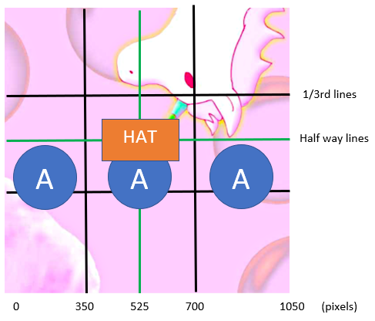

**Metadata**

Example: EEA, Sans Serif, Amber, Desert, Desert hat

Each NFT should have the following metadata:

* Letter: E (% rare)
* Letter: E (% rare)
* Letter: A (% rare)
* Letter combination: EEA (% rare)
* Font: Sans Serif (% rare)
* Font Colour: Amber (% rare)
* Font and Font Colour Combination: (% rare)
* Background: Desert (% rare)
* Hat: Desert (% rare) (if no hat, this field should read “None”)
* Special: (this might be for gold borders, or any collaborations we might have in the future. Most will read “None”)

**Rules for the smart contract**

1. All letters are 350x350, and should be placed touching one another. There is invisible space between the letters so there should be no issue in the letters overlapping.
2. Place letters and hats on the background like in the diagram shown above using appropriate x,y coordinates.
3. Hats should be placed approximately in the middle of the image. They are all 350x350. Hats should appear only on the middle letter.
4. **Calligraphy font cannot have hats!**
5. The smart contract must allow for doubles of letter combinations (eg. EEA), but no doubles of final metadata values. Ie. No two “EEA, Sans Serif, Amber, Desert, Desert Hat” images.
6. The letter font and colour must be the same for all 3 letters. No “Red calligraphy E, Amber Sans Serif E, Gold Serif A.”
7. The final image should be generated with the name: ABCs #x (where x is the number of the image generated).
8. Each generated batch should have a price attached to it. The first 500, will cost 0 ETH, the next 500 are 0.01 ETH. Each batch of 1000 will increase incrementally by 0.005 (ie. 0.015, 0.02, 0.025 etc.). This is subject to change, however.
9. The final NFT image should be a high quality lossless .png file, 1050x1050.