**Account creation and management:**

* Users (players and TO) must create an account with a unique username and password.
* System sends authentication request to the database to verify login credentials.
* Users should be able to change their username and password.

**Tournament creation and Management:**

* TO create tournaments, set rules and they decide when it starts
* The system stores tournament details in the database.
* Organizers can modify or delete tournaments details before they start

**Tournament registration and matchmaking:**

* Players can browse for tournaments, and they can register for any tournament if they meet the requirements (location, age restriction)
* The system Verifies eligibility and stores it in the database and then generates brackets based on the registered participants

**Score Reporting and verification**

* Players must be able to report the results of their matches and the TO must verify these results.

**Bracket Management**

* TO Should be able to delay certain matches or even cancel tournaments.
* The system automatically updates brackets as matches are completed

Conceptual ERD:

Logical ERD: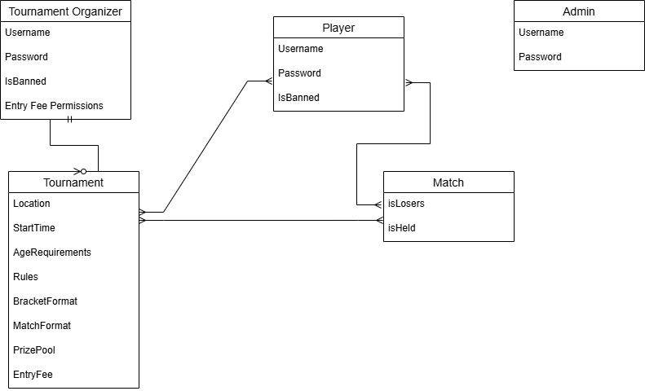

Physical ERD (Incomplete):

<https://github.com/lukaro707/Project-for-webdev-Software>