Lukas Folkman, PhD
CeMM Research Center for Molecular Medicine LFolkman@cemm.oeaw.ac.at
Lazarettgasse 14, AKH BT 25.3 +43-677-629-349-77
1090 Vienna, Austria https://lukas-folkman.github.io
Education

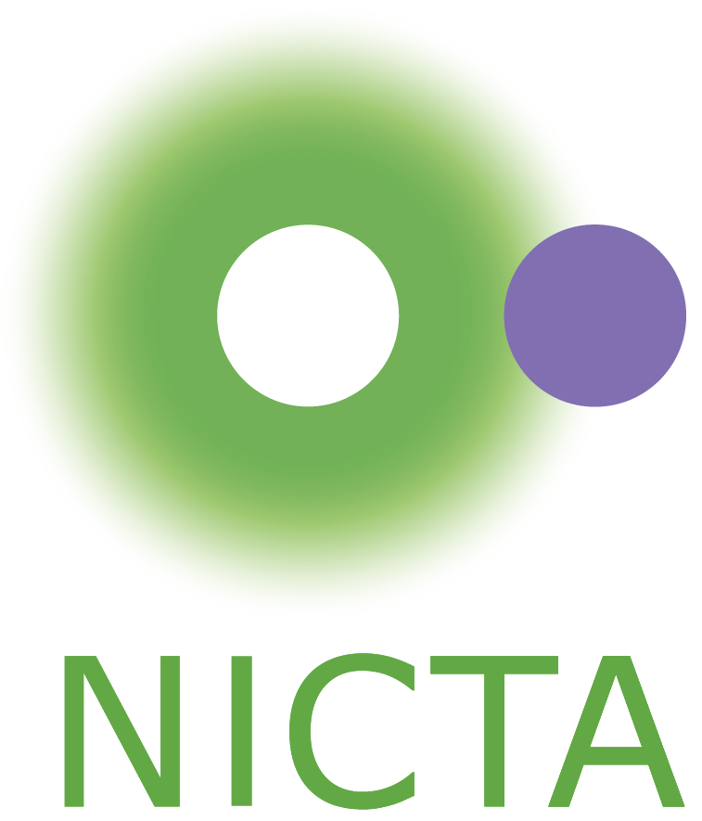
2011–2015 PhD Candidate^{1,2}
¹Institute for Integrated and Intelligent Systems, Griffith University, Australia
²NICTA – Australia's ICT Research Centre of Excellence, Australia
research area: machine learning and computational biology
thesis: Predicting stability and functional changes induced by protein
mutations with a machine learning approach
advisers: Prof Bela Stantic¹, Prof Yaoqi Zhou¹, Prof Abdul Sattar^{1,2}

2007–2010 Student of Informatics (Master’s Degree)
Faculty of Informatics, Masaryk University, Czech Republic
study area: information technology security
awards: Dean’s awards for excellent study results and outstanding thesis
thesis: Neighbour-based intrusion detection in wireless sensor networks
adviser: Dr Andrij Stetsko

2007 Visiting Student
School of Computer Science, University College Dublin, Ireland
awards: Erasmus Student Exchange Scholarship
2004–2007 Student of Applied Informatics (Bachelor’s Degree)
Faculty of Informatics, Masaryk University, Czech Republic
study area: information technology security
awards: average grade ranked within the best 2% of 2006 and 2007 graduates
thesis: Use of power analysis for influencing PIN verification on cryptographic smart cards
adviser: Dr Petr Švenda
Professional Experience

2018–now Postdoctoral Researcher
CeMM Research Center for Molecular Medicine, Austrian Academy of Sciences, Austria
projects: integrative statistical and bioinformatics analysis of high-dimensional molecular data; deep-learning methods for analysis of single-cell transcriptomics
adviser: Prof Christoph Bock (https://www.bocklab.org)

2016–2018 Postdoctoral Researcher
Department of Biosystems Science and Engineering, ETH Zurich, Switzerland
project: machine-learning methods for personalised drug recommendation systems
adviser: Prof Karsten Borgwardt (https://bsse.ethz.ch/mlcb)
2015–2016 Visiting Researcher
Institute for Integrated and Intelligent Systems, Griffith University, Australia
project: machine-learning methods for prediction of disease-causing genomic variants
adviser: Prof Yaoqi Zhou (https://sparks-lab.org)
2008–2010 Software Developer and Consultant
ARTIN, Czech Republic
Funding
2019–now Marie Skłodowska-Curie Actions Individual Fellowship (186,000 EUR)
success rate of 12.4%; competitive fellowship sponsored by the European Commission
project: deep-learning methods for analysis of single-cell transcriptomics datasets
2011–2014 NICTA Project Award Scholarship (28,000 AUD)
2011–2014 Griffith University Postgraduate Research Scholarship (74,000 AUD)
2011–2014 Griffith University International Postgraduate Research Scholarship (tuition fees waiver)
Dec 2010 NICTA Summer Research Scholarship (5,000 AUD)
Awards
Sep 2017 Online Poster Award (1st place) at [BC]² Basel Computational Biology Conference 2017 for “Kernelized rank learning for personalized drug recommendation”, Basel, Switzerland
Jul 2017 F1000Research Poster Award at the international conference ISMB/ECCB 2017 for “Kernelized rank learning for personalized drug recommendation”, Prague, Czech Rep.
Jun 2014 Winner of Three-Minutes Thesis Competition, School of ICT, Griffith University
Apr 2014 Gold Coast Association of Postgraduates Conference Funding Award, Griffith University
Jan 2013 Griffith University Conference Travel Grant, Griffith University
Dec 2010 2nd best paper in the workshop Keymaker 2010, Brno, Czech Rep.
May 2010 2nd place in Czech and Slovak university research competition, Ostrava, Czech Rep.
Mar 2010 Dean's award for outstanding thesis, Faculty of Informatics, Masaryk University
Mar 2010 Dean's award for excellent study results, Faculty of Informatics, Masaryk University
Research Interests
Applied machine learning
deep learning for single-cell transcriptomics
personalised drug recommendation systems
prediction of disease-causing and functionally-relevant genomic variants
Data science for the life sciences
integrative statistical analysis of high-dimensional molecular data
First-Author Publications
# These authors contributed equally
He# X, Folkman# L, Borgwardt K: “Kernelized rank learning for personalized drug recommendation”.
Bioinformatics (2018), 34(16), 2808–2816. [22 citations]
Livingstone# M, Folkman# L, Yang Y, Zhang P, Mort M, Cooper DN, Liu Y, Stantic B, Zhou Y: “Investigating DNA-, RNA-, and protein-based features as a means to discriminate pathogenic synonymous variants”.
Human Mutation (2017), 38(10), 1336–1347. [22 citations]
Folkman L, Stantic B, Sattar A, Zhou Y: “EASE-MM: sequence-based prediction of mutation-induced stability changes with feature-based multiple models”.
Journal of Molecular Biology (2016), 428(6), 1394–1405. [75 citations]
Folkman L, Yang Y, Li Z, Stantic B, Sattar B, Mort M, Cooper DN, Liu Y, Zhou Y: “DDIG-in: detecting disease-causing genetic variations due to frameshifting indels and nonsense mutations by sequence and structural properties at nucleotide and protein levels”.
Bioinformatics (2015) 31(10), 1599–1606. [46 citations]
Folkman L, Stantic B, Sattar A: “Feature-based multiple models improve classification of mutation-induced stability changes”.
BMC Genomics (2014) 15(Suppl 4), S6. [16 citations]
Folkman L, Stantic B, Sattar A: “Towards sequence-based prediction of mutation-induced stability changes in unseen non-homologous proteins”.
BMC Genomics (2014) 15(Suppl 1), S4. [11 citations]
Folkman L, Stantic B, Sattar, A: “Sequence-only evolutionary and predicted structural features for the prediction of stability changes in protein mutants”.
BMC Bioinformatics (2013) 14(Suppl 2), S6. [16 citations]

Co-Author Publications
de Bree LCJ, Mourits VP, Koeken VACM, Moorlag SJCFM, Janssen R, Folkman L, …, Netea MG: “Circadian rhythm influences induction of trained immunity by BCG vaccination”.
The Journal of Clinical Investigation (2020), 130(10), 5603–5617. [5 citations]
Pejaver V, Babbi G, Casadio R, Folkman L, Katsonis P, Kundu K, …, Bromberg Y:
“Assessment of methods for predicting the effects of PTEN and TPMT protein variants”.
Human Mutation (2019), 40(9), 1495–1506. [8 citations]
Savojardo C, Petrosino M, Babbi G, Bovo S, Corbi‐Verge C, Casadio R, Fariselli P, Folkman L, …, Capriotti E: “Evaluating the predictions of the protein stability change upon single amino acid substitutions for the FXN CAGI5 challenge”.
Human Mutation (2019), 40(9), 1392–1399. [6 citations]
Clark WT, Kasak L, Bakolitsa C, Hu Z, Andreoletti G, Babbi G, Bromberg Y, Casadio R, Dunbrack R, Folkman L, …, LeBowitz JH: “Assessment of predicted enzymatic activity of alpha‐N‐acetyl-glucosaminidase (NAGLU) variants of unknown significance for CAGI 2016”.
Human Mutation (2019) 40(9), 1519–1529. [3 citations]

Conference Proceedings
Folkman L, Pullan W, Stantic B: “Generic parallel genetic algorithm framework for protein optimisation”.
in ‘Algorithms and architectures for parallel processing’,Vol. 7017 of LNCS, pp. 64–73,
Springer, 2011. [1 citation]
Stetsko A, Folkman L, Matyas V: “Neighbor-based intrusion detection in wireless sensor networks”.
in ‘Wireless and Mobile Communications (ICWMC)’, pp. 420–425, IEEE, 2010. [97 citations]

Oral Presentations
2014 Asia-Pacific Bioinformatics Conference, Vancouver, Canada
“Towards sequence-based prediction of mutation-induced stability changes in unseen non-homologous proteins”
2013 Conference on Intelligent Systems for Molecular Biology & European Conference on Computational Biology (ISMB/ECCB), SNP Special Interest Group, Berlin, Germany
“Feature-based multiple models improve classification of mutation-induced stability changes”
2013 Asia-Pacific Bioinformatics Conference, Vancouver, Canada
“Sequence-only evolutionary and predicted structural features for the prediction of stability changes in protein mutants”
2011 Advances of Distributed Computing and Networking Symposium, Melbourne, Australia
“Generic parallel genetic algorithm framework for protein optimisation”

Poster Presentations
2018 German Conference on Bioinformatics, Vienna, Austria
“Kernelized rank learning for personalized drug recommendation”
2017 [BC]² Basel Computational Biology Conference, Basel, Switzerland
“Kernelized rank learning for personalized drug recommendation”
2017 International Conference on Intelligent Systems for Molecular Biology & European Conference on Computational Biology (ISMB/ECCB), Prague, Czech Republic
“Kernelized rank learning for personalized drug recommendation”

Teaching
2020 Teaching Assistant
CeMM Research Center for Molecular Medicine, Austrian Academy of Sciences, Austria
- one-day machine-learning workshop for first-year PhD students
2016 Teaching Assistant
Department of Biosystems Science and Engineering, ETH Zurich, Switzerland
- Data Mining I (master’s degree course)
2012–2013 Teaching Assistant
School of Information and Communication Technology, Griffith University, Australia
- Introduction to Programming (bachelor’s degree course)
- Object-Oriented Programming (bachelor’s degree course)
- Database Systems and Administration (bachelor’s degree course)
  - Received mean score of 4.78 (out of 5) and 5 (out of 12) award nominations
“Lukas was also an excellent tutor. He explains things so clearly and breaks up complex subjects into something simple which helped me understand topics better.”
- Database Technology (master’s degree course)
  - Received mean score of 4.48 (out of 5) and 2 (out of 7) award nominations
“The nature of this lecturer was very engaging, and kept the students focused and interested.”
Student Supervision
2017 Elli Tzini, Master’s thesis, ETH Zurich, Basel, Switzerland
continued her career as a machine learning engineer
2016 Caroline Weis, Master’s thesis, ETH Zurich, Basel, Switzerland
continued her research as a PhD candidate at ETH Zurich
2013 Mark Livingstone, Honours thesis, Griffith University, Southport, Australia
continued his research as a PhD candidate at Griffith University
Institutional Service
2020–now Data ambassador and manager, part of a working group for implementing institute-wide “FAIR” data principles and transferring 650 TB of molecular biology data to new storage
2020 Initiated and contributed to the redesign of Bock Lab’s website for research dissemination
2017 Contributed to the conceptualisation and presentation of a video game to popularise machine learning for medicine at the Swiss national scientific outreach event Scientifica
2012–2013 Founding chair of the IIIS/ICT Higher-Degree-Research Student Community
Reviewing
- Bioinformatics (rank 3 out of 59 mathematical and computational biology journals)
- Journal of Machine Learning Research
- Journal of Molecular Biology
- Scientific Reports
- European Conference on Machine Learning
Scientific Societies
International Society for Computational Biology
Skills
Languages English – advanced (IELTS band score 8, 2010), German – beginner, Slovak – native
Coding Python, Java, C, C++, R, SQL, Bash (Unix shell)

